

|  |
| --- |
| Safer Care Victoria Corporate plan  2017-2018  Our priorities for this year to lead improvement  in quality and safety in healthcare |
|  |

Department of Health

|  |
| --- |
| Safer Care Victoria Corporate plan  2017-2018 |

|  |
| --- |
|  |
| To receive this publication in an accessible format phone 03 9096 1384, using the National Relay Service 13 36 77 if required, or email [Safer Care Victoria](mailto:mailto:safercarevictoria@dhhs.vic.gov.au) <safercarevictoria@dhhs.vic.gov.au>  Authorised and published by the Victorian Government, 1 Treasury Place, Melbourne  © State of Victoria, Safer Care Victoria, October, 2017  ISSN 2208-6927 (online)  Available at [Safer Care Victoria](http://www.safercare.vic.gov.au) <www.safercare.vic.gov.au>  (1709046) |
|  |

Contents

Our story 7

SCV Strategic plan 2017–2020 8

What we did first 10

Partnering with consumers 11

Consumer voices and choices are central to own care 11

Consumer voices and experiences improve health services and the health system 12

Partnering with clinicians 13

Our chief clinicians 13

Reductions in unwarranted variation in practice and outcome 13

Clinicians’ voices and experiences improve health services and the health system 15

Leadership 16

Healthy culture driven by strong leaders 16

Quality and safety governance embedded throughout health services 17

Review and response 18

Robust response and review of serious incidents 18

Dissemination of learnings from serious incidents, and local best practice 19

Quality and safety data analysis drives system oversight and response 19

System improvement and innovation 21

Lead improvements in priority areas 21

Enable innovation in priority areas 22

Safer Care Victoria is a national and international leader in quality and safety 23

References 24

# Our story

Safer Care Victoria (SCV) was established in January 2017 in response to the discovery of a cluster of preventable stillbirths at a Victorian health service that had occurred in 2013 and 2014.

The establishment of SCV was one of the key structural reforms recommended by Targeting Zero1, the final report of the review that investigated what needed to be done to prevent such tragedies from occurring again in our state.

Our purpose at SCV is both simple and complex: simple, in that we exist to support health services to provide outstanding healthcare to Victorians. Always.

Complex, in that achieving this goal will require us to work closely with consumers, their families and carers, clinicians, health service executives and management, our universities and research institutes, professional colleges and other regulatory authorities. Alongside these stakeholders, we will also be working with our colleagues in the Department of Health and Human Services (the department) and other government departments and agencies – such as the Victorian Agency for Healthcare Information (VAHI) and the Australian Commission on Safety and Quality in Health Care.

We know that Victoria has a world class healthcare system, with many examples of best practice and innovation. Our task is to shine the light on these many pockets of excellence and share them across the system.

We also know that avoidable harms continue to occur in our health services, as they do within all sophisticated healthcare systems2. Our role is to lead the state in driving down such harm – with the goal of zero avoidable harm. Targeting zero.

As an Administrative Office of the department we are accountable for contributing to the delivery of several of the department’s strategic directions and priority actions3. However, the deliberate separation of quality and safety from other departmental functions, which was achieved with our establishment, requires us to be independent-minded and forthright in our approach to leading change and improving the quality and safety of our health system.

# SCV Strategic plan 2017–2020

| Strategic priority | Strategic objectives | What success looks like in three years |
| --- | --- | --- |
| **Partnering with consumers** | Consumer voices and choices are central to own care | Consumer-defined outcome measures and improvement goals being delivered at a health service level and within SCV |
| **Partnering with consumers** | Consumer voices and experiences improve health services and the health system | Demonstrable improvement in patient experience |
| **Partnering with clinicians** | Reductions in unwarranted variation in practice and outcome | Reduction in variation in specific clinical conditions – to be identified with clinicians and consumers |
| **Partnering with clinicians** | Clinicians’ voices and experiences improve health services and the health system | SCV chief clinicians, the Victorian Clinical Council and clinical networks are utilised to inform policy and planning |
| **Leadership** | Healthy culture driven by strong leaders | System-wide approach to developing and sustaining current and future leaders |
| **Leadership** | Quality and safety governance embedded throughout health services | Evidence that accountability of health services’ governing bodies and executives is strengthened |
| **Review and response** | Robust response and review of serious incidents | A just culture: demonstrable improvements in the number of serious events reported to SCV |
| **Review and response** | Dissemination of learnings from serious incidents, and local best practice | Measurable reductions in avoidable harm |
| **Review and response** | Quality and safety data analysis drives system oversight and response | New quality and safety measures in clinician-driven reports for sector and public |
| **System improvement and innovation** | Lead improvements in priority areas | Demonstrable reductions in avoidable harm in priority areas |
| System **improvement and innovation** | Enable innovation in priority areas | Evidence of local innovation scaled across the system |
| **System improvement and innovation** | SCV is a national and international leader in quality and safety | Publications and presentations evidencing SCV impact |

Organisational structure

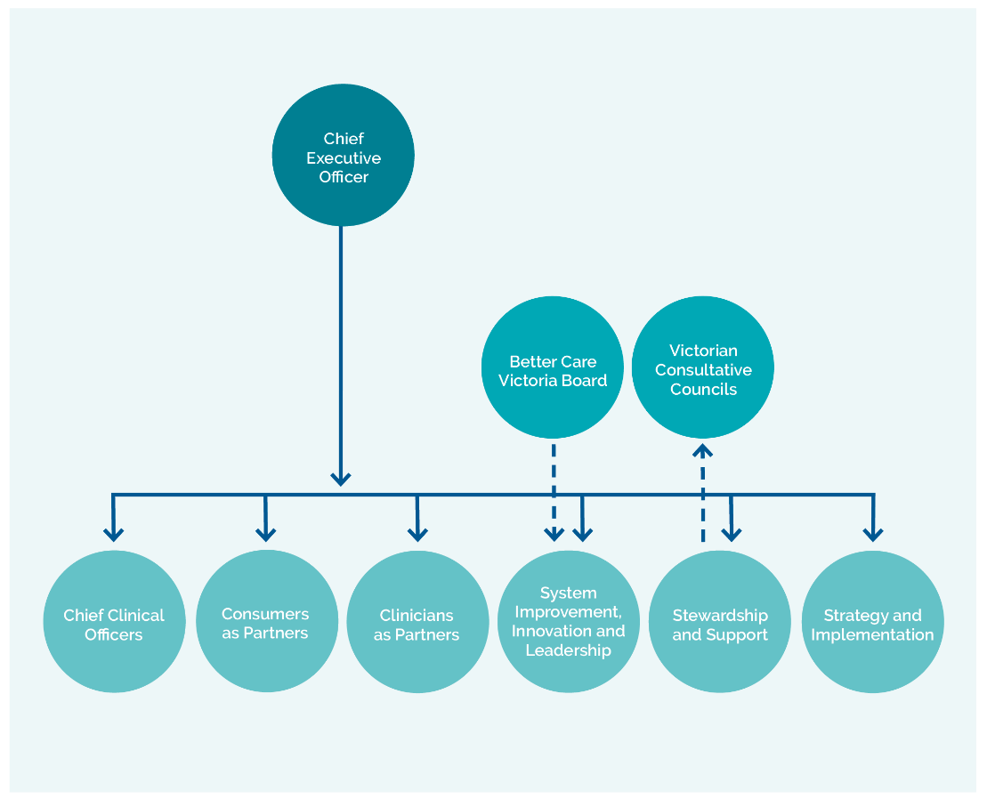

# What we did first

Since our establishment in January 2017, our Chief Executive Officer Professor Euan Wallace, our chief clinicians and other SCV leaders have travelled the state, visiting health services, meeting consumers, board members, clinicians and health service executives. It has been our privilege to meet the many Victorians who care so passionately about our health services, and hear the many views on what our first priorities should be.

We convened a forum in July 2017 attended by more than 350 consumers, clinicians and health service executives and board members. At this forum, attendees were asked to identify which health issues SCV should prioritise. The criteria for the selection of the issues was that there must be existing data to enable measurement of the impact of change.

The resounding response from the forum was that our priorities should be:

A. improving patient safety culture

B. repeated communication breakdowns

C. unwarranted variation in practice

D. unwarranted variation in patient experience.

Other core activities are also being undertaken to ensure SCV delivers on the 79 recommendations directly related to us within the Targeting Zero report and recent reports by the Victorian Auditor-General.

Our work plans align with, but are often interdependent of, activities underway at VAHI, the Department of Health and Human Services, and other agencies such as the Australian Commission on Safety and Quality in Health Care.

# Partnering with consumers

Commitment to the involvement of consumers and community stakeholders, and ensuring they have an equal voice, in quality and safety improvement activities is essential. A key aspect of our work is supporting a person-centred approach to quality and safety improvement initiatives, including to health service incident responses and patient complaints, and to develop the capacity for people to participate fully in their care.

## Consumer voices and choices are central to own care

| Focus area 17–18 | Key activities | Success looks like | Sector priority area |
| --- | --- | --- | --- |
| **Partnering in Healthcare Framework** | Co-design the development of a statewide framework underpinning and promoting consumer participation and engagement | Implementation commenced with clear priorities in each domain identified  Piloting of priority strategies  in health services | A, D |
| **Patient and family escalation of care** | Develop and trial a centralised system for patient and family escalation of care | Trial results inform planning  and implementation of statewide model | A, D |
| **Open disclosure** | Review existing guidelines and training available for health services | 100% of reported serious incidents have documented evidence that open disclosure has occurred | B |

**Key**

A Improve patient safety culture

B repeated communication breakdowns

C unwarranted variation in practice

D unwarranted variation in patient experience

## Consumer voices and experiences improve health services and the health system

| Focus area 17–18 | Key activities | Success looks like | Sector priority area |
| --- | --- | --- | --- |
| **Consumer representation** | Increase the number of consumer representatives across SCV and health services  Review induction and training programs for healthcare consumer representatives | SCV Patient and Family Council established  Demonstrable increase in number of trained consumer representatives in health services | A |
| **Transvaginal mesh response** | Coordinate a Victorian response to consumer concerns relating to complications suffered as a result of transvaginal mesh | Evidence of consumer-defined supports and clinical pathways for Victorian women impacted by transvaginal mesh surgery | C, D |
| **Centralising healthcare complaints** | Commence the development of a platform to share statewide information relating to patient feedback between SCV, the Health Complaints Commissioner, the Mental Health Commissioner and the department  Establish a common approach to complaints management between the above agencies | Formal agreement between SCV, VAHI, Health Complaints Commissioner and Mental Health Complaints Commissioner underpinning a statewide taxonomy for complaints response  Development of minimum standards for complaints management | D |

**Key**

A Improve patient safety culture

B repeated communication breakdowns

C unwarranted variation in practice

D unwarranted variation in patient experience

# Partnering with clinicians

Support, engagement and coordination with clinicians are required to enable authentic partnership and leadership on quality and safety improvement.

Via our clinical networks, we will drive reductions in unwarranted variation, establish clinical practice guidelines and lead specific improvement programs and projects.

The Victorian Clinical Council, together with the clinical networks, has a crucial role in bringing the clinician and consumer voice to the forefront of SCV work, as well as providing advice to the department and other agencies.

## Our chief clinicians

Our chief clinicians provide frontline experiences and knowledge within SCV as we deliver our reform agenda, ensuring it is relevant to current-day practice concerns. Our chiefs are connected to their colleagues across the nation and, via regular events and bulletins, link clinicians from across the Victorian public and private sectors.

## Reductions in unwarranted variation in practice and outcome

| Focus area 17–18 | Key activities | Success looks like | Sector priority area |
| --- | --- | --- | --- |
| **Amplify the work of clinical networks** | Design and implement new framework for clinical networks  Develop and deliver two new clinical networks | Full implementation of framework  Mental Health Clinical Network and Infection Clinical Network established, with improvement goals identified | C |
| **Utilise our clinical networks to drive reductions in unnecessary clinical practice variation** | Clinical networks to identify three-year improvement goals, targeting unnecessary clinical practice variation | Improvement goals defined, implementation underway | C |
| **Actively facilitate the spread of best practice across the state** | Review and publish clinical guidelines in priority areas | Publish 15 new maternity clinical practice guidelines, 15 revisions of newborn clinical practice guidelines and 5 new newborn clinical practice guidelines  Publish guideline for use of critical care medications (inotropes) | C |

**Key**

A Improve patient safety culture

B repeated communication breakdowns

C unwarranted variation in practice

D unwarranted variation in patient experience

## Clinicians’ voices and experiences improve health services and the health system

| Focus area 17–18 | Key activities | Success looks like | Sector priority area |
| --- | --- | --- | --- |
| **Clinician engagement strategy for Safer Care Victoria** | Include People Matter survey measures relating to clinician engagement in the Inspire report | Increased response rate for People Matter survey in May 2018 | A |
| **Utilise the Victorian Clinical Council and clinical networks for advice on health policy and planning** | Establish and develop the Victorian Clinical Council to be an active and respected adviser to SCV and the department  Clinical networks engaged on health policy and planning agenda | Workplan delivered | A |
| **Provide relevant outcome measures to clinicians** | Clinical networks to identify the best clinical outcome measures for success in their speciality area for inclusion in Inspire and to guide the work in variation | Identification of clinical outcome measures (currently viable and future) | C |

**Key**

A Improve patient safety culture

B repeated communication breakdowns

C unwarranted variation in practice

D unwarranted variation in patient experience

# Leadership

Healthy cultures are driven by strong leadership across all levels of an organisation to enable quality and safety governance to be embedded throughout health services. We are partnering with the sector to develop a strategy and series of programs to enhance, support and connect senior and frontline leaders within and across health services and the health system.

## Healthy culture driven by strong leaders

| Focus area 17–18 | Key activities | Success looks like | Sector priority area |
| --- | --- | --- | --- |
| **Leadership programs** | Delivery of a suite of leadership courses targeted to different career stages of individuals  Support an improvement scholars course that couples the development of key leadership and influencing skills with improvement science methodology | Continued interest in future rounds of the programs due to the ability to articulate benefits of the investment  Evidence of knowledge application in the workplace | A |
| **Mentoring and alumni programs** | Co-design a mentoring program with sector representatives  Develop an alumni program  for leadership program graduates to establish and support peer networks and knowledge sharing | Alumni program valued as a peer support and networking environment  Programs are well supported and attended | A |
| **Develop high-performing leadership teams** | Co-design and pilot a leadership coaching program targeting executive teams in rural or regional services | A pilot group of health services complete the program with demonstrated evidence and evaluation of positive impact and outcomes | A |

**Key**

A Improve patient safety culture

B repeated communication breakdowns

C unwarranted variation in practice

D unwarranted variation in patient experience

## Quality and safety governance embedded throughout health services

| Focus area 17–18 | Key activities | Success looks like | Sector priority area |
| --- | --- | --- | --- |
| **Leadership for quality and safety** | Co-design and pilot a Leadership for Quality and Safety program that builds organisational and system level capability for clinical quality management and governance | Strong program design leading to a high degree of interest and recognised value in completing the program  Diverse group (metro, regional and rural) of participants involved in the pilot  Evidence of integration with other key work streams within SCV including incident response and clinical governance | A |

**Key**

A Improve patient safety culture

B repeated communication breakdowns

C unwarranted variation in practice

D unwarranted variation in patient experience

# Review and response

We are responsible for the oversight of quality and safety in Victorian health services and, in partnership with VAHI, monitoring and reviewing data, and providing advice to health services and the department. We support the sector to respond to system issues including Therapeutic Goods Administration (TGA) alerts. We also engage with national committees and agencies to drive the quality and safety reform agenda. Our legislated consultative councils conduct case reviews, identifying trends and themes, and provide recommendations and advice on how to prevent avoidable harm.

## Robust response and review of serious incidents

| Focus area 17–18 | Key activities | Success looks like | Sector priority area |
| --- | --- | --- | --- |
| **Incident response program** | Establish the SCV Academy of expert clinical reviewers to support health services to investigate systemic clinical concerns  Establish the Panel of External Expert Reviewers (PEER network) to support health services to review serious incidents  Refresh of sentinel event program, expand to include serious events not sentinel events (SENSE events)  Support for consumer participation in serious event investigations | SCV Academy in operation  Minimum of 20 PEER reviewers in operation  Knowledge shared across the system, including from coronial recommendations  Increased number of serious (sentinel and SENSE) events reported to SCV  Evidence of consumer participation in serious incident investigation | A |

**Key**

A Improve patient safety culture

B repeated communication breakdowns

C unwarranted variation in practice

D unwarranted variation in patient experience

## Dissemination of learnings from serious incidents, and local best practice

| Focus area 17–18 | Key activities | Success looks like | Sector priority area |
| --- | --- | --- | --- |
| **Safer Care Victoria knowledge sharing** | Develop SCV – VAHI website, bulletins and enewsletters  Program of knowledge-sharing events and webinars | Website analytics identify strong user interactivity and downloads  Improved patient outcomes  Attendance and analytics demonstrate take up and engagement | A, B, C, D |

**Key**

A Improve patient safety culture

B repeated communication breakdowns

C unwarranted variation in practice

D unwarranted variation in patient experience

## Quality and safety data analysis drives system oversight and response

| Focus area 17–18 | Key activities | Success looks like | Sector priority area |
| --- | --- | --- | --- |
| **Support for health services whose quality and safety indicators are flagging a possible problem** | Analysis of quality and safety data informs SCV participation in regular performance meetings between health services and the department | Improved patient outcomes | A, C |
| **Analysis of relationship between procedure volumes and quality outcomes** | Work closely with the department system planners to identify and prioritise procedures requiring volume-outcome analysis | Advice provided to the department on:   * Cardiothoracic surgery * Bariatric surgery * Maternity services | A |
| **Consultative councils** | Publish:   * Victorian Consultative Council on Anaesthetic Mortality and Morbidity (VCCAMM) 2015–17 report in August 2018 * Victorian Surgical Consultative Council (VSCC) 2016 report in November 2017 * Consultative Council on Obstetric and Paediatric Mortality and Morbidity (CCOPMM) 2016 reporting November 2017 * Perinatal Services Performance Indicator (PSPI) 2016–17 report in December 2017 * Victoria Congenital Abnormalities Register 2015–16 report in February 2018 | Report findings are used to support quality and safety improvement | A, C |

**Key**

A Improve patient safety culture

B repeated communication breakdowns

C unwarranted variation in practice

D unwarranted variation in patient experience

# System improvement and innovation

We support the development, implementation and scaling of improvement and innovation programs and projects. Time-limited quality and safety programs and projects, including those funded by the Better Care Victoria Innovation Fund and by clinical networks, help us deliver on this strategic priority.

## Lead improvements in priority areas

| Focus area 17–18 | Key activities | Success looks like | Sector priority area |
| --- | --- | --- | --- |
| **Improvement partnerships** | Implement two improvement partnerships focused on timely access to emergency care and specialist clinics services | Improve timely access to emergency departments in participating hospitals  Improve timely access to specialist clinics | A, D |
| **Improvement and innovation program** | Work with the existing 32 improvement and innovation advisors in health services to identify and target priority health issues at a system level | Improvement goals defined, implementation underway |  |
| **Reducing delirium-related harm** | Support health services to improve screening, prevention and management of delirium  Introduce a statewide clinical practice guideline for delirium | The prevalence and impact of delirium in Victorian public hospitals is quantified  Health services are working with SCV to decrease the incidence of delirium and to minimise the risk of harm to patients when delirium occurs | C |
| **Reducing third and fourth degree perineal tears** | Support 10 Victorian sites to participate in national collaborative to reduce third and fourth degree perineal tears | 20% reduction in third and fourth degree perineal tears by December 2018 at the 10 sites |  |
| **Prevention of fetal growth restriction** | Co-design training to support early identification of fetal growth restriction | Training commenced |  |
| **Prevention of paediatric clinical deterioration** | Roll out a standardised Medical Emergency Team (MET) form for paediatrics | Evaluation of use of the Victorian children’s tool for observation and response (ViCTOR chart) in paediatrics shows improvement in patient outcomes |  |

**Key**

A Improve patient safety culture

B repeated communication breakdowns

C unwarranted variation in practice

D unwarranted variation in patient experience

## Enable innovation in priority areas

| Focus area 17–18 | Key activities | Success looks like | Sector priority area |
| --- | --- | --- | --- |
| **Better Care Victoria Innovation Fund** | Support the implementation and evaluation of innovation projects funded through the Better Care Victoria Innovation Fund | Evidence of projects demonstrating benefits on patient experience, quality and safety and/or access  Sector-led projects are tested and evaluated, local innovations and improvements are sustained | A, B, C, D |
| **Scale successful innovation projects** | Scale at least one innovation project beyond the trial site | Replicate positive patient and service outcomes and achieve a broader statewide impact on key priorities |  |

**Key**

A Improve patient safety culture

B repeated communication breakdowns

C unwarranted variation in practice

D unwarranted variation in patient experience

## Safer Care Victoria is a national and international leader in quality and safety

| Focus area 17–18 | Key activities | Success looks like | Sector priority area |
| --- | --- | --- | --- |
| **Credentialling – medical practitioners** | Publish a refreshed SCV Credentialling of senior medical practitioners policy that is expanded in scope to cover private health services, with tools and resources to support implementation | All Victorian health services have implemented credentialling and scope of practice processes | A, C |
| **Clinical governance** | Update and publish Delivering high-quality healthcare – Victorian clinical governance framework  Develop a standardised clinical governance reporting approach to further support sector implementation of Delivering high-quality healthcare – Victorian clinical governance framework  Scope existing external clinical governance resources/educational tools to create a central SCV-endorsed repository for health services | Delivering high-quality healthcare – Victorian clinical governance framework is implemented in health services and embedded in clinical governance courses and programs  Standardised reporting approach in use within health services  Menu of SCV-endorsed governance resources published on SCV website | A, B, C, D |
| **Conference** | Host a conference showcasing improvement and innovation in Victoria | Conference attendance and feedback | A, B, C, D |

**Key**

A Improve patient safety culture

B repeated communication breakdowns

C unwarranted variation in practice

D unwarranted variation in patient experience

# References

1. Duckett S., Cuddihy M., Newnham H. Targeting Zero: supporting the Victorian hospital system to eliminate avoidable harm and strengthen quality of care. Report of the review of hospital safety and quality assurance in Victoria. Victorian Government; October 2016
2. Baker, G. R., Norton, P. G., Flintoft, V., Blais, R., Brown, A., Cox, J., Etchells, E., Ghali, W. A., Hebert, P. and Majumdar, S. R. (2004) ‘The Canadian Adverse Events Study: the incidence of adverse events among hospital patients in Canada’, Canadian medical association journal, 170(11), p 1678-1686

Davis, P., Lay-Yee, R., Briant, R., Ali, W., Scott, A. and Schug, S. (2002) ‘Adverse events in New Zealand public hospitals I: occurrence and impact’, New Zealand Medical Journal, 115(1167)

Vincent, C., Neale, G. and Woloshynowych, M. (2001) ‘Adverse events in British hospitals: preliminary retrospective record review’, BMJ, 322(7285), p 517-519

Institute of Medicine (2000) To err is human: Building a safer health system, National Academy Press Washington, DC

1. Department of Health and Human Services strategic plan. Victorian Government (2017)