|  |
| --- |
| Safer Care Victoria - State Government Victoria  Organisational Strategy for Improvement Matrix (OSIM)  Administration guide |
|  |

|  |
| --- |
|  |
| To receive this publication in an accessible format phone 03 9096 2761,  using the National Relay Service 13 36 77 if required, or [email Safer Care Victoria](mailto:bcv@safercare.vic.gov.au) <bcv@safercare.vic.gov.au>  Authorised and published by the Victorian Government, 1 Treasury Place, Melbourne.  © State of Victoria (Safer Care Victoria) and State of New South Wales (Clinical Excellence Commission) 2018    This work, Organisational Strategy for Improvement Matrix (OSIM) administration guide, is licensed under a Creative Commons Attribution 4.0 licence [link to http://creativecommons.org/licenses/by/4.0/]. You are free to re-use the work under that licence, on the condition that you credit the State of Victoria (Safer Care Victoria) and the State of New South Wales (Clinical Excellence Commission) as author, indicate if changes were made and comply with the other licence terms. The licence does not apply to any branding, including the Victorian Government logo and the Safer Care Victoria logo.  ISBN 978-1-76069-215-5 (pdf/online/MS word)  Available at Better Care Victoria <https://www.bettercare.vic.gov.au>  Suggested citation: Murray, C 2018, Organisational Strategy for Improvement Matrix (OSIM) Administration Guide, Safer Care Victoria, State Government of Victoria, Melbourne. |
|  |

Contents

Foreword 4

Acknowledgements 5

1. Purpose 6

1.1. Purpose and vision 6

1.2. What is improvement, innovation and capability? 6

1.3. Why measure and monitor organisational capability for improvement? 8

2. High-level OSIM overview 9

3. Introduction to OSIM 10

3.1. What is OSIM? 10

3.2. What is the value of using OSIM? 12

3.3. Who participates in OSIM? 12

3.4. How does OSIM link with strategic plans and priorities? 13

3.5. What do we mean by consumers? 14

3.6. What do we mean by departments and units? 14

3.7. Can the OSIM be used for specific departments or units? 14

4. Key components of OSIM 15

4.1. Domains and criteria 15

4.2. Levels of improvement capability maturity 18

5. Using the OSIM 20

5.1. Timeline of activities – what is the process? 21

5.2. Checklist – are we ready? 22

5.3. Workbook – how do we use it? 24

5.4. Reference guide – what could we look for? 25

5.5. Leadership, staff and consumer participation – who should be invited? 25

5.6. Administration – how do we do it? 26

5.7. Using the findings from OSIM 30

5.8. Further information 33

Appendix 34

Bibliography 39

# Foreword

Safer Care Victoria was born out of a review of Victoria’s hospital quality and safety assurance – *Targeting zero: Supporting the Victorian hospital system to eliminate avoidable harm and strengthen quality of care*. The review itself was undertaken in response to a major health service governance failure. A failure that none of us ever wish to witness again.

Safer Care Victoria is committed to supporting health services in providing outstanding care for all Victorians. Always.

Developing capability across the system to continuously improve and innovate is essential if we are to deliver consistently safe, high-quality care. We know that improvement is most successful where health services have well-developed organisational capability.

To create an organisational environment and culture that delivers outstanding care, health services need to have a clear understanding of where they are in their improvement journey and where they want to be.

The Organisational Strategy for Improvement Matrix (OSIM) is designed to support health services in this journey, helping:

* prompt discussion about organisational strengths and areas for potential development
* reflect on ways to improve capability
* inform strategic goals and priorities.

Completing the OSIM will better position your health service to purposefully plan how to close the gap between where you are and where you want to be. It will also shine a light on capability for improvement at all levels of your organisation, helping you to identify potential areas to strengthen.

For you to get the most out of the OSIM, you and your team need to be honest about your current abilities. There are no right or wrong answers, but only an honest assessment will help your health service derive the greatest benefits and accelerate your improvement journey. If you determine that your health service’s improvement capability is less than you would like it to be, that’s okay. It is a learning opportunity that will give you a target to aim for a measureable vision.

Be brave. We look forward to working with you in your improvement journey.



**Professor Euan Wallace AM**

Chief Executive Officer

# Acknowledgements

Safer Care Victoria would like to acknowledge the contribution of the following individuals and groups who provided input into the development of the OSIM:

* Professor Euan Wallace (CEO, Safer Care Victoria) and Ms Carrie Marr (CEO, Clinical Excellence Commission) for their contributions and commitment to the OSIM and its pivotal role in helping health services achieve operational excellence.
* Professor Danny Samson, Department of Management and Marketing, University of Melbourne, for his formal academic review of the OSIM second edition.
* Dr Lynne Maher, Director of Innovation, Ko Awatea, for her review of the OSIM second edition
* The Safer Care Victoria (SCV) and Clinical Excellence Commission (CEC) cross-jurisdictional working group participants for their collaboration in developing the OSIM third edition:
* SCV – Ms Rebecca Power, Ms Natalie Bemrose, Ms Carla Murray
* CEC – Ms Alison Starr, Ms Collette Davies, Mr Ian Richards, Mr Thomas Loveday, Ms Debby Shea, Ms Claire Hey-Shipton, Ms Sarah Fischer
* Better Care Victoria Improvement and Innovation Advisors – Ms Jane Evans (Eastern Health), Ms Elizabeth Paul (Eastern Health), Mr James Kirsner (Austin Health) and Mr Neil O’Donnell (Western District Health Service).
* The NSW local health districts and specialty health networks that tested and provided valuable feedback on the OSIM language, value and utility during 2017.
* Representatives from Victorian health services participating in the Better Care Victoria (BCV) 2017–18 Improvement and Innovation Program who contributed their feedback on the use of OSIM at their respective health services.

# Purpose

## Purpose and vision

Safer Care Victoria (SCV) is committed to optimising patient health outcomes and experiences, and recognises improvement and innovation as the key to driving reform and realising our vision. SCV places patients, their carers and families, the community, clinicians and healthcare providers at the heart of improvement and innovation, working to enable and sustain system-wide improvement.

Our Capability for innovation and improvement strategy 2017–20 (the strategy) aims to create an environment and culture within organisations and across the health sector that supports improvement and innovation. This three-year strategy acknowledges that developing individual, team, organisation and system capability for improvement and innovation is a long-term agenda.

Building organisational capability is recognised in this strategy as a priority area for 2017–20. Creating an improvement and innovation-orientated culture in organisations is critical to embed, sustain and grow capability. It requires systems, structures, resources and processes within health services to operate collectively, and promotes behaviours and a culture that fosters improvement and innovation.

The Organisational Strategy for Improvement Matrix (OSIM) aims to support health services in measuring and monitoring their organisation’s culture and capability for improvement.

The purpose of this document is to:

* introduce the OSIM
* describe how the OSIM can be valuable to health services
* instruct health services in how to administer the OSIM at their organisations.

## What is improvement, innovation and capability?

For the purpose of this document, the term **improvement** is typically incremental change in the quality, safety and/or value of healthcare, with each cycle building on the next. It is evolutionary, not revolutionary. Improvement in this context relates to the range of activities to design and redesign work practices, processes and systems that deliver services in a healthcare organisation with better outcomes and lower cost, wherever this can be achieved. This is not limited to clinical practices, processes and systems, but is also inclusive of non-clinical supporting areas of a healthcare organisation, such as training, information systems, finance, cleaning and logistics.

**Innovation** is a step change that enables a fundamentally new way of doing things. The context may shift, or the limits of an incremental approach may be reached and something different in a new or novel way is required.

Improvement and innovation in healthcare are not mutually exclusive, and can work in tandem. Both require the capability to instigate, drive, manage and sustain change. Developing a continuous improvement foundation can provide the groundwork for systematic innovation to build on.

The term **organisational capability** is an organisation’s ability to perform a coordinated task, utilising organisational resources, for the purpose of achieving a particular end result. Organisational capability refers to the ways in which the skills, knowledge, abilities and behaviours of individuals combine with organisational systems, processes, norms and values to meet the strategic intent of the organisation.

In the context of improvement, organisational capability means:

* the skills, knowledge, abilities and behaviours of a healthcare organisation’s staff and health service consumers in improvement methodology
* the healthcare organisation’s systems, processes, norms and values in place to support and drive organisational improvement.

This capability must be supported by a culture of continuous improvement, to effectively enable new ideas and creative solutions to problems in healthcare to be actively embraced, implemented, scaled and sustained over time.

Capability within an organisation exists at three levels as described in the figure below.

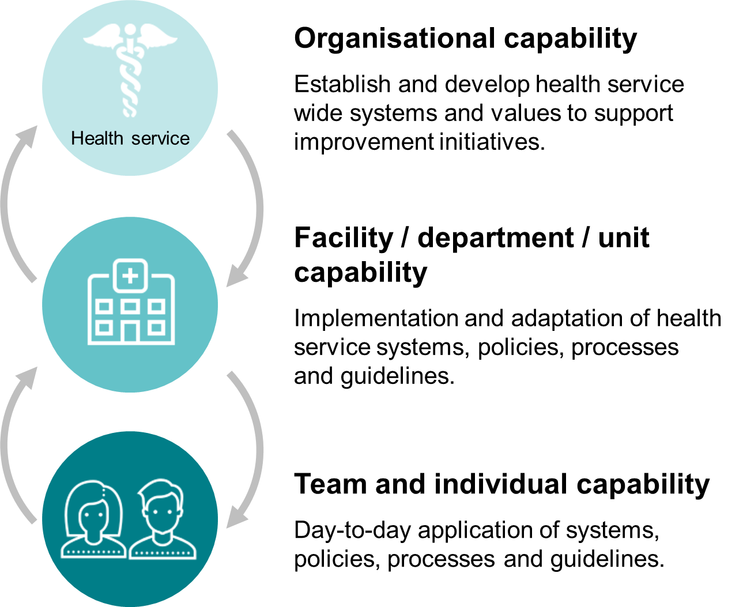

Figure 1 – Capability levels

## Why measure and monitor organisational capability for improvement?

Improvements and innovations are most successful where health services have well-developed organisational capability. Enhancing health service capability for improvement is a critical element to achieving positive change in service quality, safety and value, and supports embedding, sustaining and scaling improvement and innovative practice across Victoria’s health system.

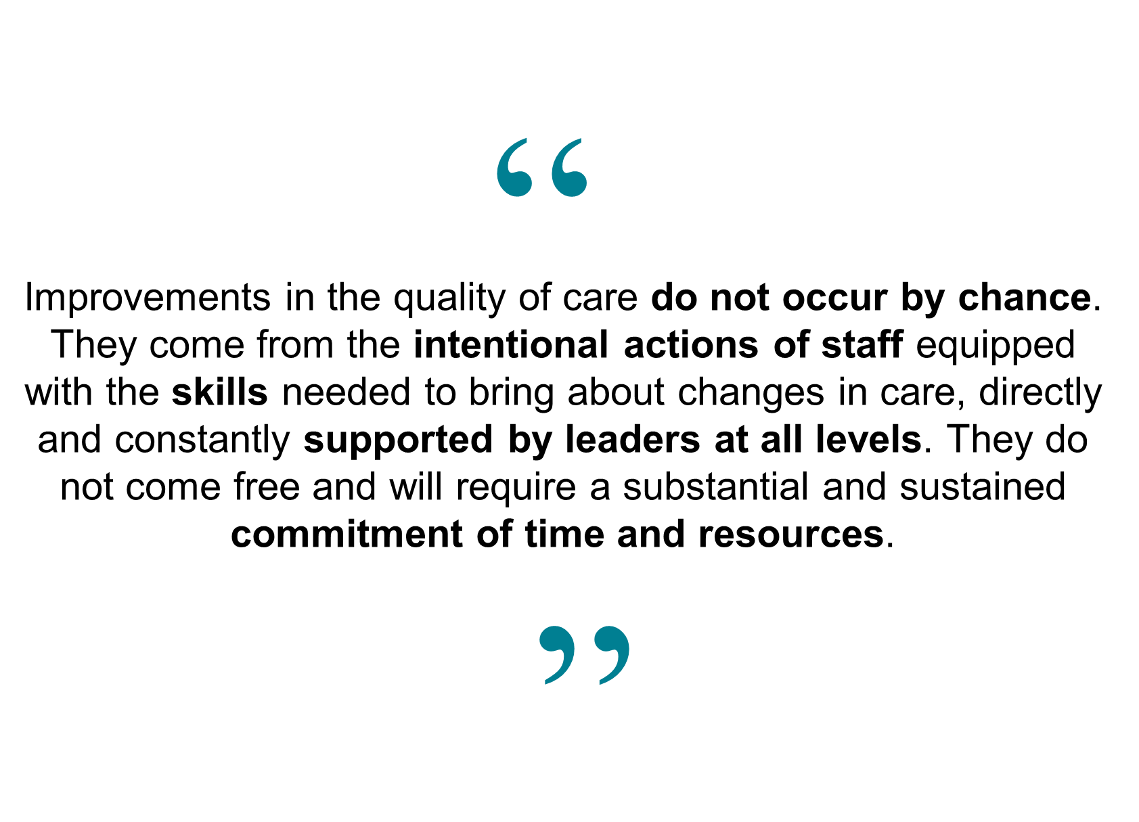

Figure 2 – High-performing health care organisations[1]

For individual health services, measuring and monitoring organisational capability for improvement provides:

* a ‘health check’ opportunity to identify strengths to build on and areas for potential development
* an opportunity to align health service training and development programs with an identified need
* evidence of ongoing health service maturity in relation to organisational capability for improvement
* a vehicle to commence a dialogue about, and a common understanding of, organisational improvement and how the health service can improve its capability
* evidence to inform the development of a health service’s strategic goals and priorities.

# High-level OSIM overview

The figure below provides a high-level overview of OSIM and how it fits into an organisation’s strategic, improvement and innovation planning activities.

Further details are provided throughout this document.

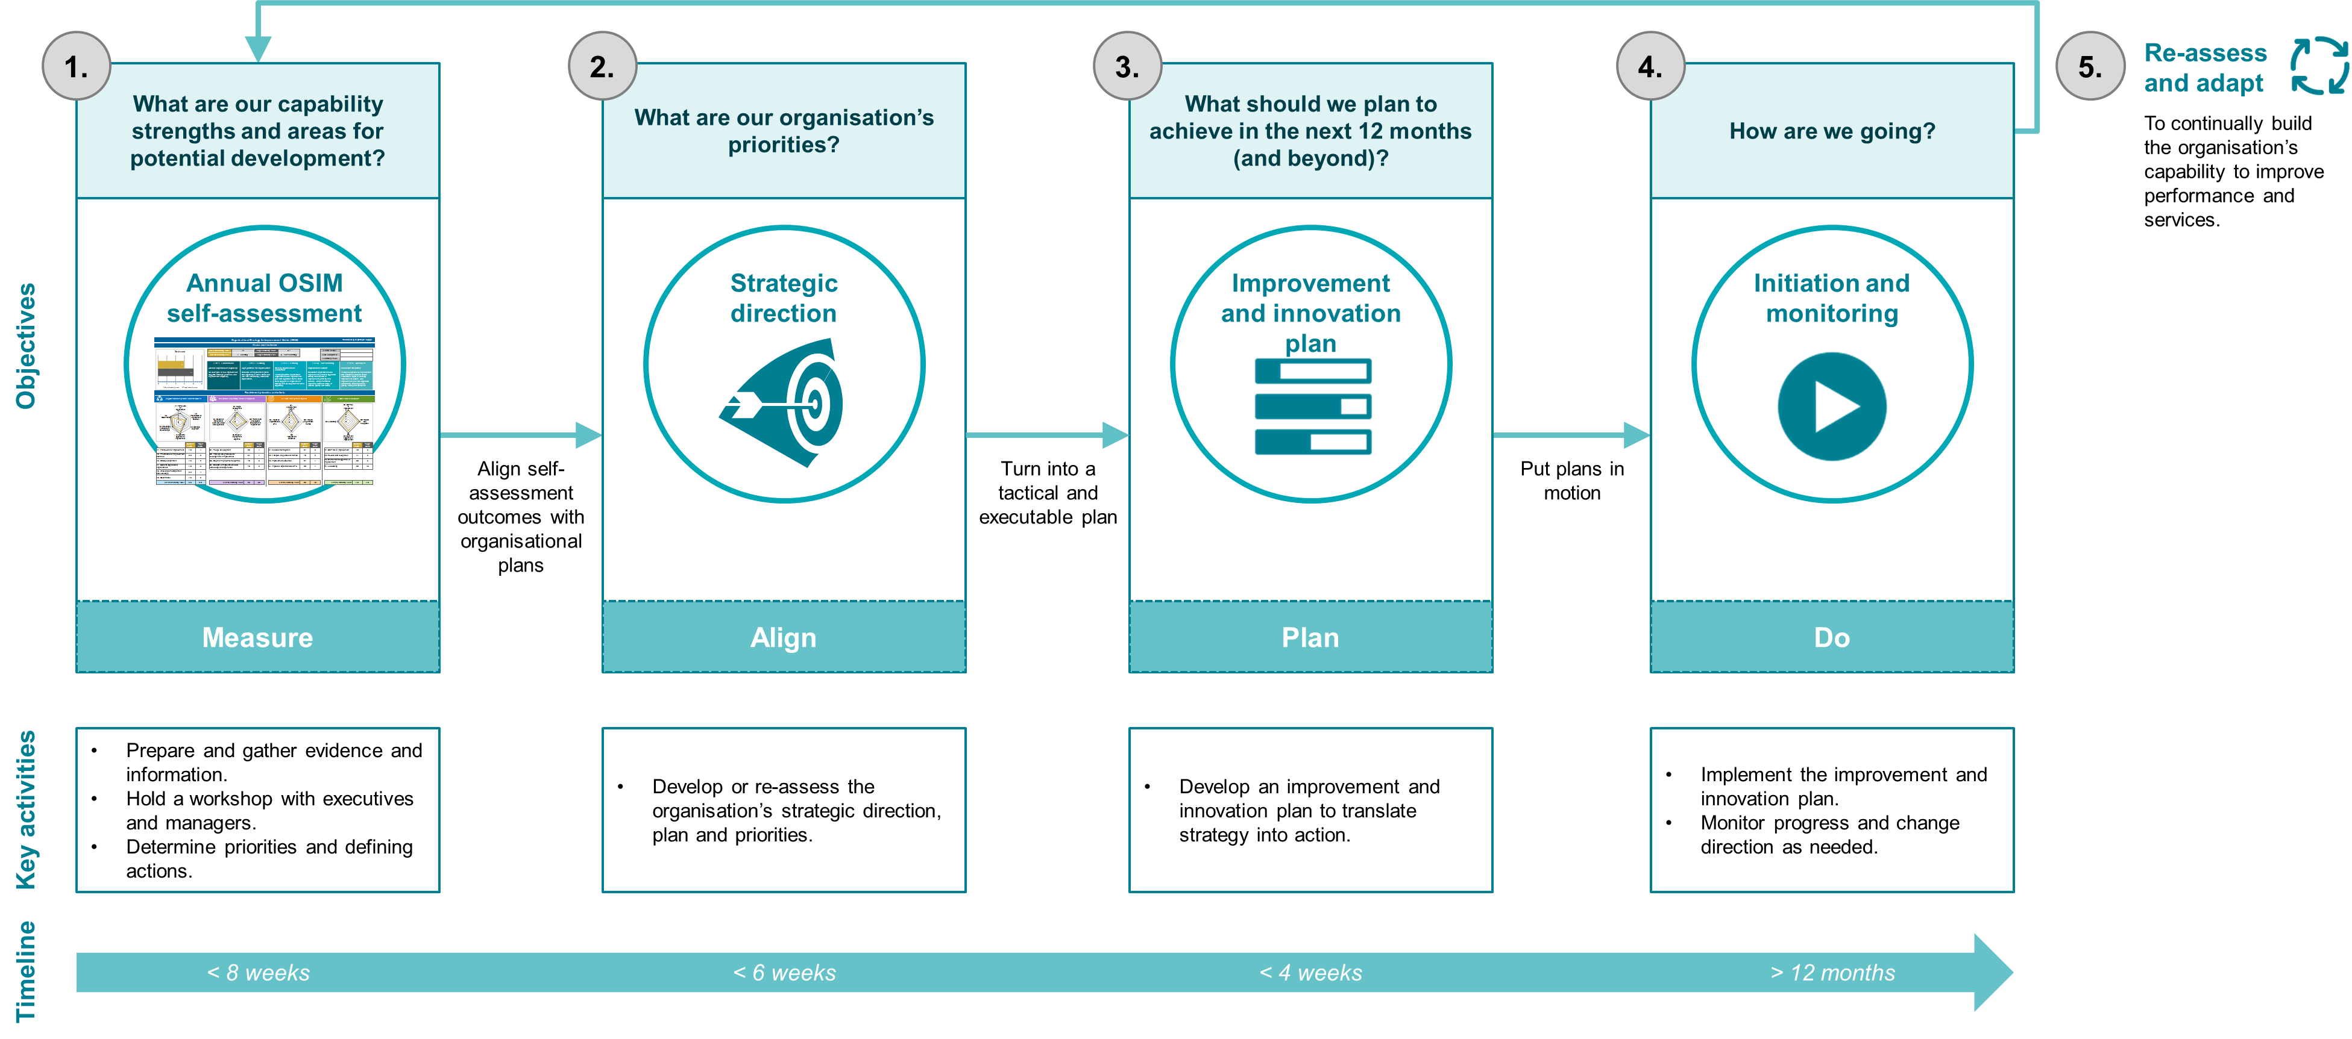

Figure 3 – High-level OSIM overview

# Introduction to OSIM

## What is OSIM?

The OSIM is a **capability measurement tool** designed to help health services identify, measure and monitor organisational accelerators and barriers to improvement. In other words, it can help health services determine how supportive of improvement or ‘change friendly’ their organisation is at a point in time.

It is structured around four key areas, referred to as ‘domains’, determined based on an extensive literature review and analysis of operational excellence models including the Baldridge Award[2] and Shingo Prize[3].

These four domains are recognised as common to high-performing organisations, and framed in the context of improvement include:

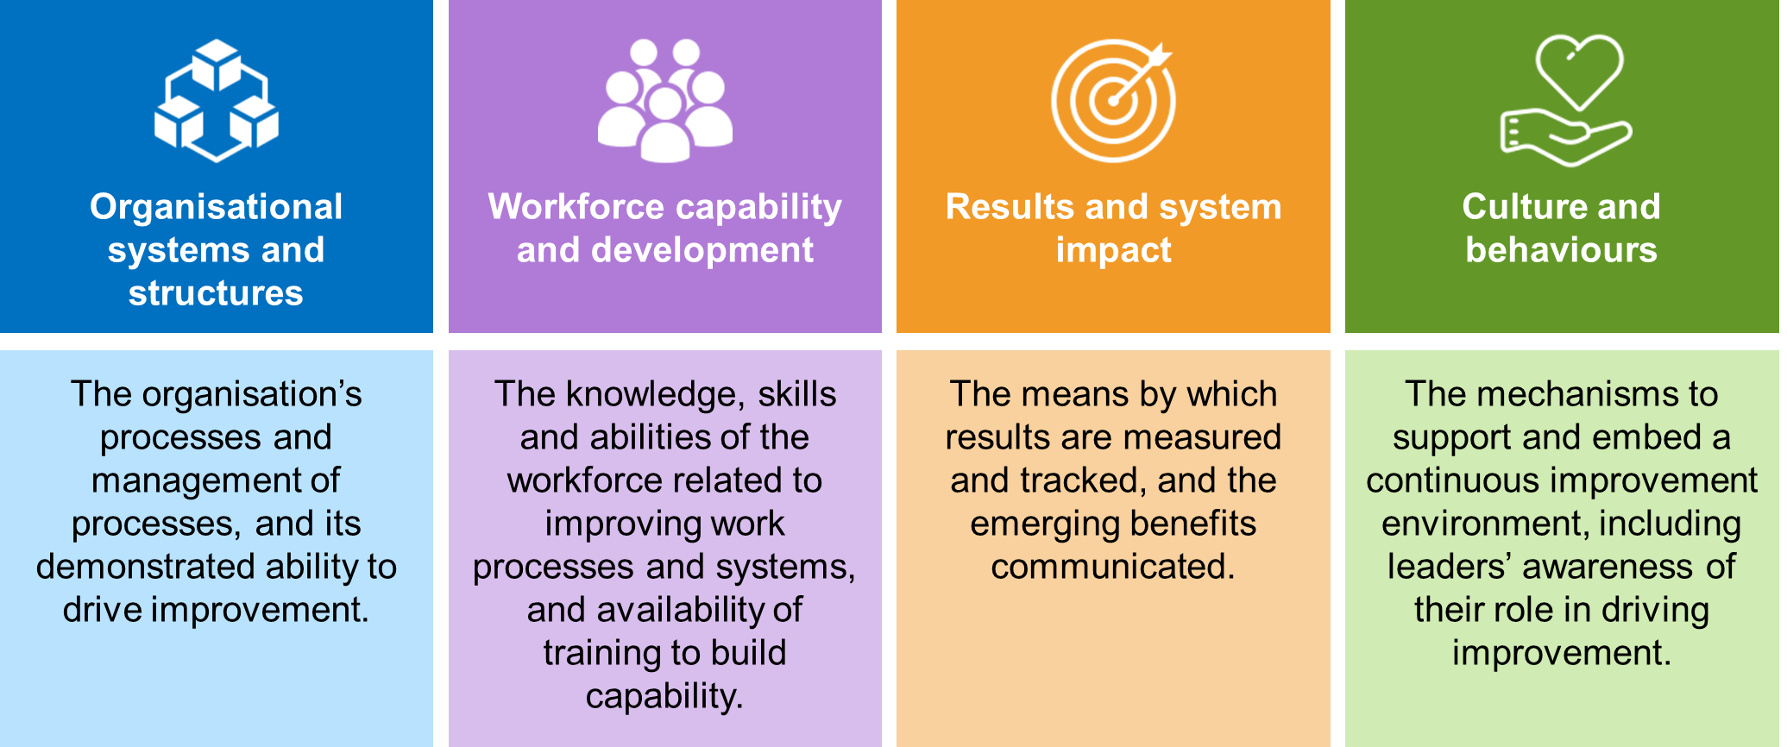

Figure 4 – Four OSIM domains

Each of these four domains consist of specific ‘criteria’ (18 in total) – the levers in an organisation that impact on or promote improvement capability. To administer the OSIM, health services use the provided workbook to self-assess against each criterion. This involves asking the question, ‘How well does our health service meet this criterion?’ and then assigning a maturity level (level 1 – foundational to level 5 – advanced) to each criterion. Completing the OSIM produces a score indicative of the health service’s overall maturity level for improvement capability, providing a picture of organisational strengths and areas to focus on.

### Evolution of OSIM

The first edition of the OSIM, originally referred to as the Health Improvement Capability Quotient (Health ICQ), was developed in 2012 by Victoria’s (former) Department of Health. The second edition of Health ICQ was developed in 2014 following an independent review by Professor Danny Samson (University of Melbourne) and Dr Lynne Maher (Director of Innovation, Ko Awatea), and feedback received from Victorian health services that had completed the Health ICQ.

The management of the Health ICQ shifted from the Department of Health and Human Services to Better Care Victoria (BCV) in 2016. BCV Secretariat integrated into SCV in mid-2017, which included integrating the management of Health ICQ. This provided an opportunity to broaden the scope of BCV to work with SCV to drive further integration of the improvement and quality agenda across Victoria.

The NSW Clinical Excellence Commission (CEC) adopted the Health ICQ in 2016 as a tool for measuring and monitoring the organisational capability for quality improvement of each local health district across their state’s jurisdiction. Through a collaborative working relationship, CEC, SCV and selected Victorian health services formed a working group in 2017 to review the Health ICQ and develop the third edition.

The tool was enhanced to keep it up-to-date with current and emerging indicators of organisational capability for improvement, based on the learnings of CEC, SCV and Victorian health services in administering the Health ICQ and using the outcomes to inform strategic direction, plans and priorities. Updates included bringing in consumer involvement in improvement, refining the domain and criteria, changing the maturity levels and scoring approach, revising the workbook format and dashboard views, and developing additional supporting material.

The name change from Health ICQ to OSIM is reflective of the renewed focus of this tool in helping health services understand their organisation’s accelerators and barriers to improvement and develop informed strategic goals and priorities to target improvement efforts.

## What is the value of using OSIM?

The OSIM workbook is an easy-to-use tool for self-assessing improvement capability. The OSIM workbook:

* provides a structured and guided way to have a conversation and consider a broad range of organisational levers of improvement capability
* can be administered in many ways, depending on health service preference
* is available using Microsoft Excel, a commonly used software program broadly available across health services
* contains pre-designed, easy-to-use spreadsheets, formulas and charts
* can easily be printed or projected for presentation in a meeting or workshop (e.g. for live-administration), with a dashboard view that visualises the assessment outcomes
* includes a feature to set a target score for each criterion that the health service aims to achieve in the next 12 months
* includes a template for capturing and tracking the status of actions that may help the health service achieve a higher assessment outcome
* has been found to be most effective with a group approach, involving executive, clinical and non-clinical leadership.

There is no prescribed time of the year that OSIM should be completed. Rather, it is recommended that health services complete the OSIM annually as part of an ongoing improvement cycle, at a time that suits their organisation, such as prior to developing the organisation’s annual improvement and innovation plan, strategic plan, and/or statement of priorities.

The OSIM does not replicate or replace existing tools that seek greater depth of assessment in organisational culture, workforce competencies or leadership. Rather, it enables an integrated view and dialogue about the organisation’s capability to deliver systematic improvement.

## Who participates in OSIM?

The figure below describes the recommended role of Victoria’s health services as it relates to OSIM.

It is recommended that a senior executive owns the OSIM process, and that the chief executive officer communicates its value in supporting strategic goals, improvement plans and organisational capability development.

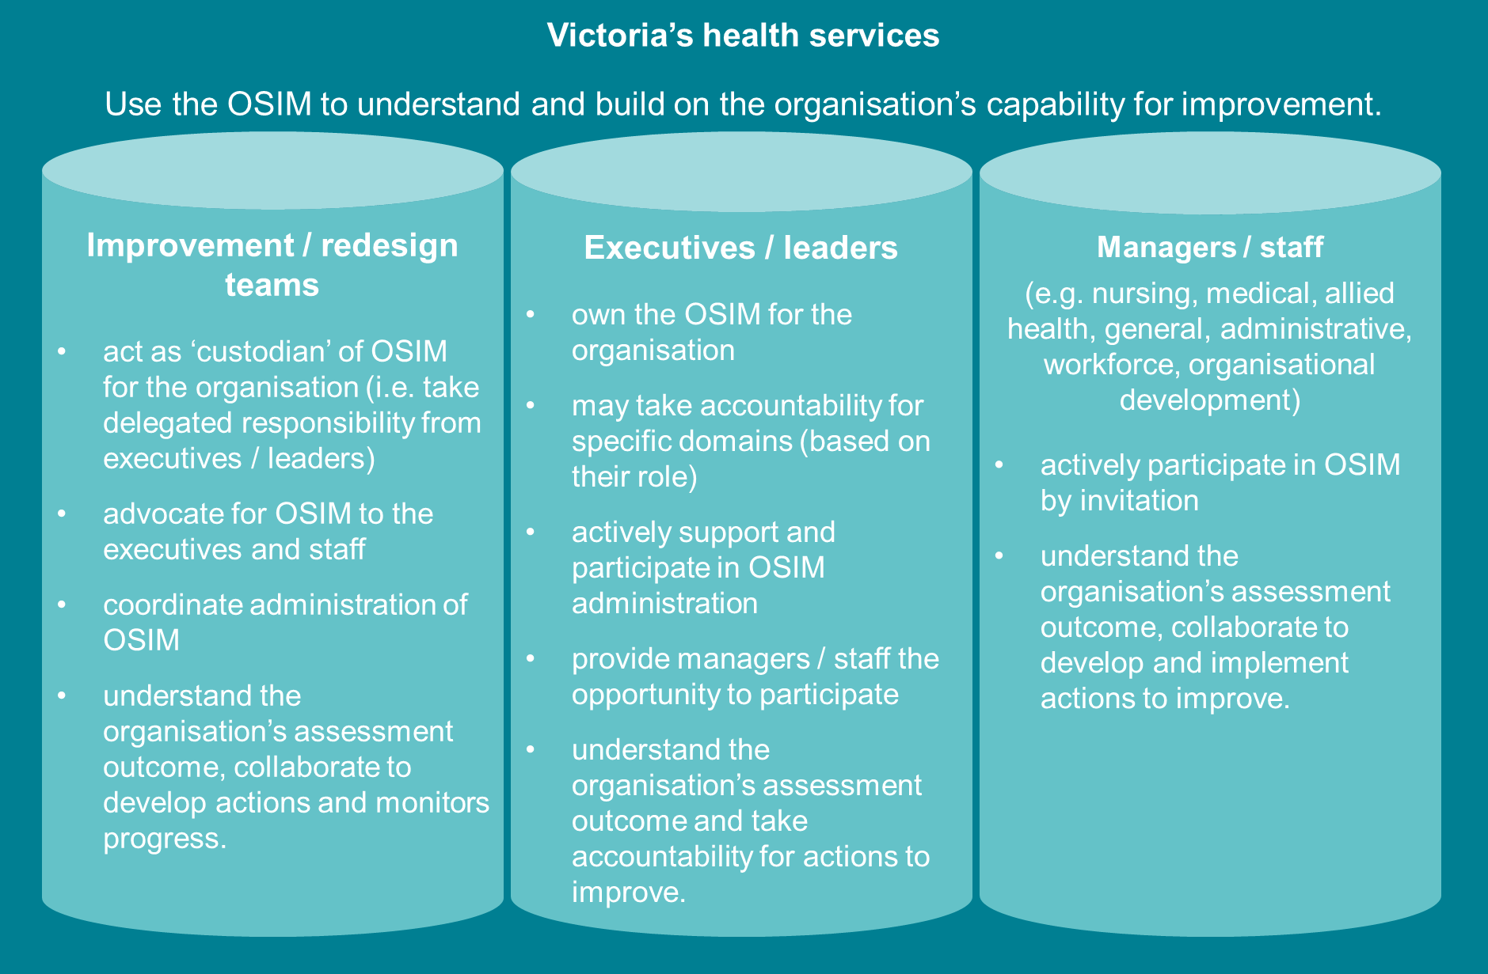

Figure 5 – OSIM participants

## How does OSIM link with strategic plans and priorities?

Completing the OSIM produces a consolidated view of organisational accelerators and barriers to improvement, which can be used to identify priority areas to further strengthen their improvement capability. The OSIM workbook facilitates this prioritisation analysis through a dashboard view – enabling a visual way of understanding hotspots to focus on – and a template for defining and monitoring action plans.

These action plans can serve as a useful input into the development of a health service’s improvement and innovation plan, strategic plan, and annual statement of priorities. The OSIM action plans can also be used to reflect on progress and celebrate progress toward improving the health service’s improvement capability.

## What do we mean by consumers?

Meaningfully involving consumers of health services in the planning, design, delivery and evaluation of their care is a key aspect of providing safe and effective healthcare.

This document uses the term **consumers** to capture all actual or potential patients, clients and service users, as well as their family members, friends and carers across the care continuum.

It is important to consider the context of each criterion where this term is used, and that health services, in consultation with consumers, should carefully consider the best ways to involve consumers in their organisation’s improvement activities. For example, this may include use of consumer representatives, consumer advisory groups or broader consumer consultation.

## What do we mean by departments and units?

Healthcare organisational structures are complex. There is no common term that captures how all health services refer to the components of their organisation’s structure (e.g. campuses, wards, departments, units, divisions, clinics, sites, facilities, teams, functions).

For simplicity, this document uses the term **departments and units** to refer to all of these structural components, and should be considered in the context of each criterion where this term is used.

## Can the OSIM be used for specific departments or units?

The OSIM has been developed to examine the health service as a whole; however health services can adapt the OSIM for specific departments, units, facilities or sites if required. When administering the tool and interpreting the assessment outcomes, bear in mind the level of the organisation to which the tool is applied.

# Key components of OSIM

This section describes the three key components of the OSIM – domains, criteria and maturity levels.

## Domains and criteria

The OSIM is structured around four areas, referred to as ‘domains’. These four domains are recognised as common to high-performing organisations. Each of the domains is divided into a set of ‘criteria’ – the levers in an organisation that impact on, or promote improvement capability.

The following sections briefly describe each domain and their respective set of criteria. Further details about each criterion can be found in the OSIM workbook.

### Organisational systems and structures

An organisation is a system comprised of people and interconnected sub-systems, structures and processes, working together to achieve one or more objectives. This domain explores how a health service’s systems, structures and processes support improvement.

|  |  |  |
| --- | --- | --- |
|  | Criterion | Definition |
|  | Framework for improvement | The organisation’s standard approach to engaging in improvement initiatives to instigate, implement and sustain change, used as a mechanism to develop workforce capability. |
|  | Prioritisation of improvement activities | The decision-making process that directs improvement efforts to achieve organisational goals, including use of metrics, business cases and learnings from previous improvement initiatives. |
|  | Strategic alignment | The way people, processes and systems support the organisation’s strategic goals, and alignment of resources to strategic priorities. |
|  | Systems approach to improvement | The application of systems thinking – the interdependence and interaction of areas within and between organisations, to understand relationships, context, behaviours and impacts. |
|  | Knowledge management and exchange | The approach to capturing, sharing and maintaining insights and information across the organisation so that successful solutions and interventions are shared and adopted. |
|  | Governance of improvement | The arrangements in place that control and direct the organisation and its improvement initiatives. |

Table 1 – Organisational systems and structures – Criterion descriptions

### Workforce capability and development

Workforce capability and development explores the depth and breadth of improvement awareness, knowledge and skills, and the opportunities to develop and apply this to improvement initiatives. Development of improvement capability across all levels of staff is critical to embedding and sustaining improvement practice across health services.

|  |  |  |
| --- | --- | --- |
|  | Criterion | Definition |
|  | People development | The approach to engaging people in improvement to achieve the right skill mix to deliver the strategic vision, including position descriptions, orientation and performance plans. |
|  | Training and professional development in improvement | The embedment of improvement education and mentoring in an organisational people strategy and capability framework, and access to improvement skills development opportunities. |
|  | Depth of improvement expertise | Improvement experts embedded in the organisation with the skills required by the organisation’s improvement framework to provide subject matter expertise, coaching and mentoring. |
|  | Breadth of improvement knowledge, skills and experience | The number and range of people across the organisation who have the knowledge, skills and experience necessary to enable improvements. |

Table 2 – Workforce capability and development – Criterion descriptions

### Results and system impact

The results and systems impact domain explores the application of measurement systems, operational information and data, and project outcomes to drive decision-making, ownership and improvement across the health service.

|  |  |  |
| --- | --- | --- |
|  | Criterion | Definition |
|  | Measurement system | The mechanisms to measure, monitor and communicate operational metrics and organisational performance, critical for identifying areas for improvement and impact of change. |
|  | Analysis of operational metrics | The use of data from measurement systems to understand the current state of performance and make decisions about improvement priorities. |
|  | Improvement outcomes | The approach to delivering and monitoring improvement project outcomes against pre-determined operational, process and check measures. |
|  | Impact on organisational KPIs | The relationship between improvement initiatives and organisational KPIs, and approach to mapping and monitoring outcomes and impacts. |

Table 3 – Results and system impact – Criterion descriptions

### Culture and behaviours

Culture and behaviours are critical components of organisational capability for improvement. This domain explores areas that foster an improvement culture, expectations and actions of leadership and staff, and the health service’s capacity to learn from past improvement project outcomes.

|  |  |  |
| --- | --- | --- |
|  | Criterion | Definition |
|  | Staff role in improvement | The expectations of everyone in an organisation to both do their work and improve their work, and availability of time and opportunity to participate in improvement initiatives. |
|  | Reward and recognition | The mechanisms used to motivate people to participate in improvement initiatives and acknowledge their actions and behaviour. |
|  | Environment supportive of improvement | The level of resilience, energy, effort and initiative that people bring to improvement initiatives, and the conditions for encouraging and enabling people to participate in improvement. |
|  | Leadership | The creation and sharing of a common vision, provision of resources to fulfil that vision, and the capabilities to influence behaviours and ultimately outcomes. |

Table 4 – Culture and behaviours – Criterion descriptions

## Levels of improvement capability maturity

A health service will self-assess their maturity for each criterion according to a five point scale (level 1 – foundational to level 5 – advanced). The OSIM workbook calculates the score given to each criterion and produces a maturity level indicative of the health service’s overall capability for improvement.

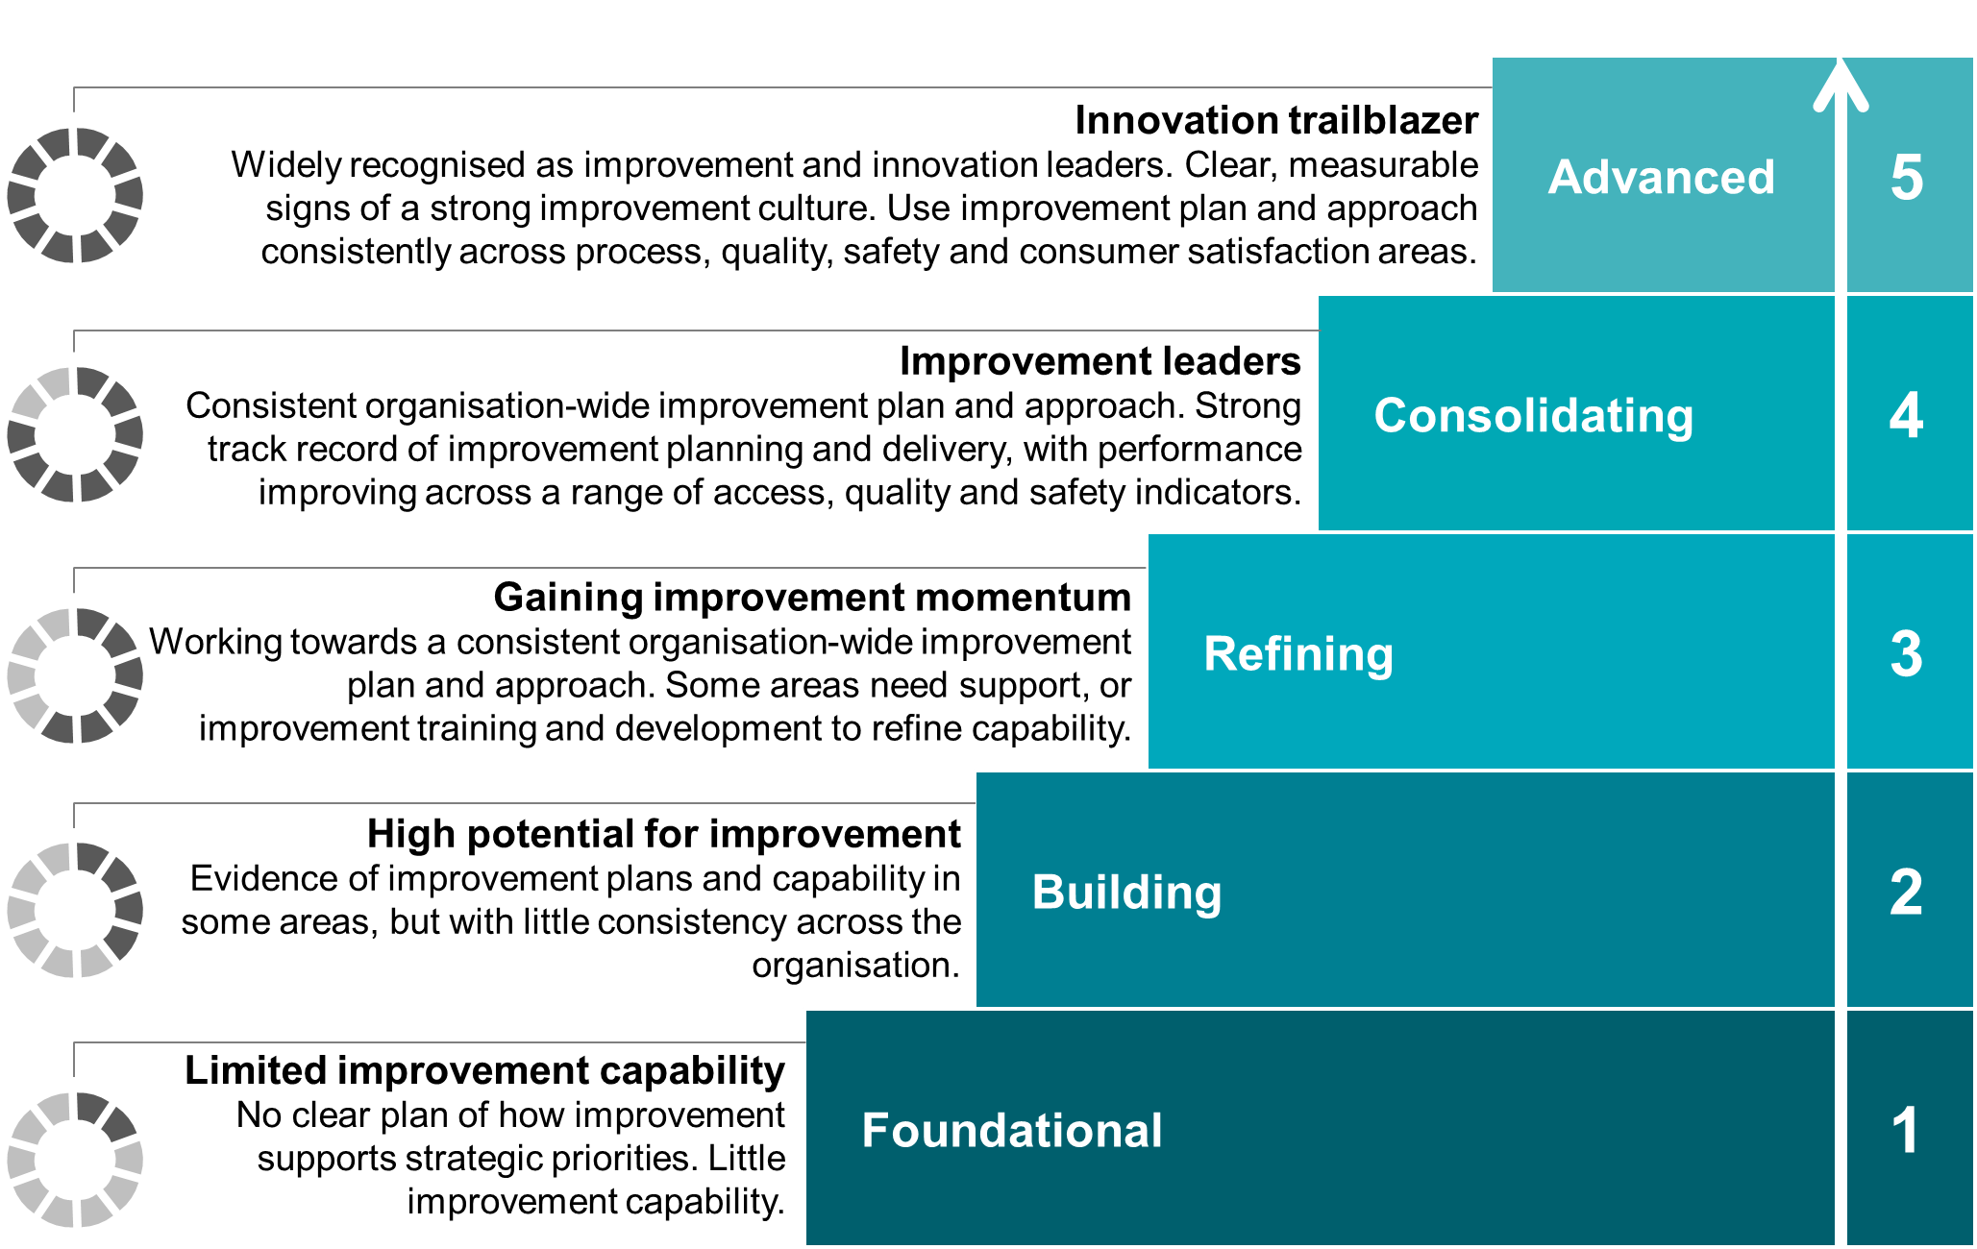

Figure 6 – OSIM maturity levels

To assign a maturity level to a criterion, it is recommended that you refer to Table 1 below, and then use the OSIM workbook for all indicators listed under each criterion to:

1. decide which of the maturity levels is most descriptive of your health service’s current state – this is based on a consideration of the evidence available
2. assign one of the maturity levels using the drop-down options
3. record a brief explanation to support your maturity level selection.

**Note:** The OSIM workbook automatically calculates the average maturity level for each criterion and produces summary charts.

| Maturity level | | Score | Indicators  (Example only – indicators are contextualised for each criterion.) |
| --- | --- | --- | --- |
|  | Level 5: Advanced | 5 | * Consistent * Leading innovation * Exemplar |
|  | Level 4: Consolidating | 4 | * Consistent across all areas |
|  | Level 3: Refining | 3 | * Evident in most areas, with a few areas that need support * Gaining a critical mass for consistency |
|  | Level 2: Building | 2 | * Evident in a few areas, but not most * Lack of consistency across the health service |
|  | Level 1: Foundational | 1 | * No or minimal evidence of the criterion in the health service * Lack of clarity across the health service |

Table 5 – OSIM maturity level scores and indicators

# Using the OSIM

This section provides recommendations for how to practically use the OSIM at your health service, and references other materials that can help you to share information about OSIM with executives, staff and other key stakeholders, complete the OSIM and take steps to improve your OSIM assessment outcomes.

**Note:** The figure below summarises the supporting materials available to you and referred to in this section. This document – the OSIM administration guide – is highlighted in orange.

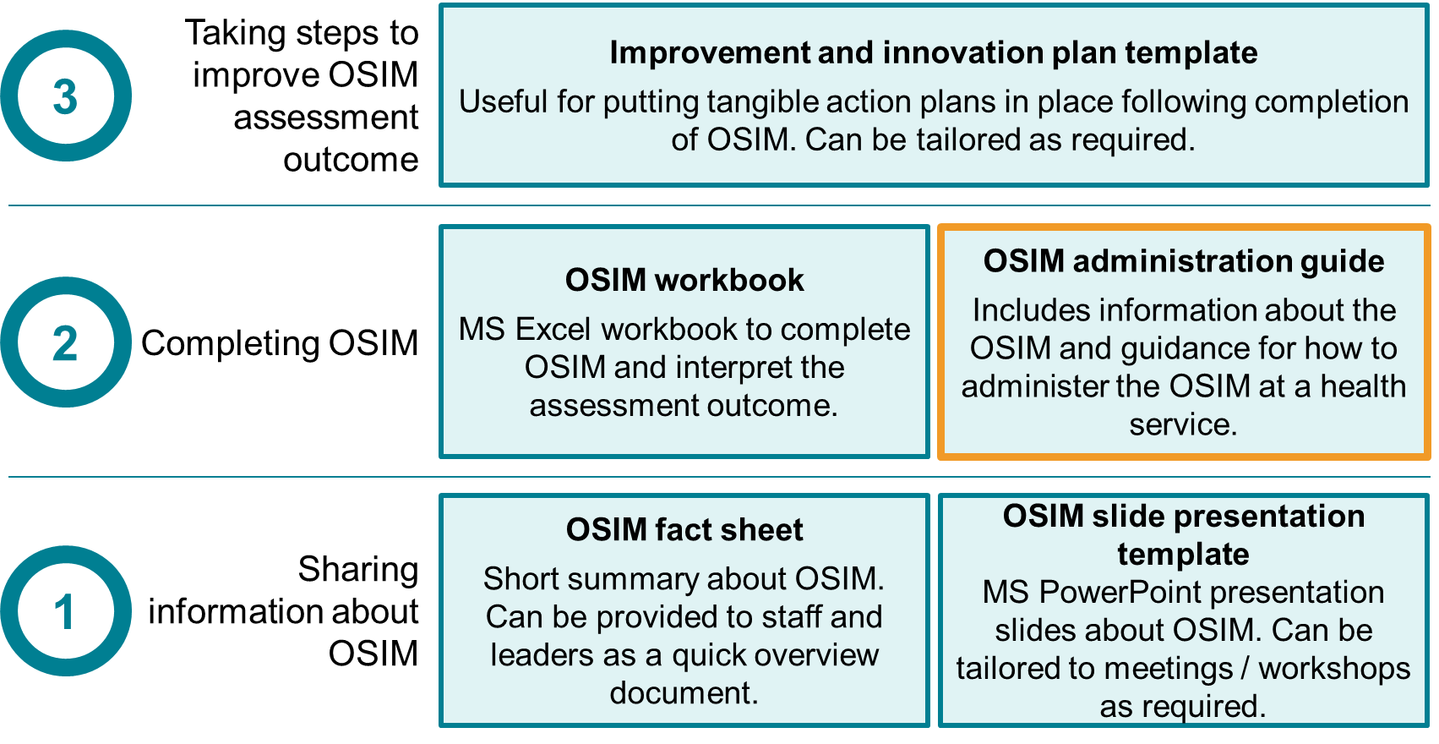

Figure 7 – OSIM supporting materials

These supporting materials are available via [www.bettercare.vic.gov.au](http://www.bettercare.vic.gov.au).

Before you complete the OSIM, make sure you have read Section 3 – Introduction to OSIM and Section 4 – Key components of OSIM so that you have a thorough understanding of OSIM, and the most effective approach to using OSIM at your health service.

## Timeline of activities – what is the process?

Using OSIM is a light-touch process, and involves four stages as described in the figure below. The recommended stages and timeframes are indicative only, and should be tailored to the needs of your health service. For example, the four to six week timeframe recommended for stage three may help to maintain momentum, however health services should consider how analysing the assessment outcomes and defining actions aligns with the development or annual re-assessment of the organisation’s strategic direction, plans and priorities.

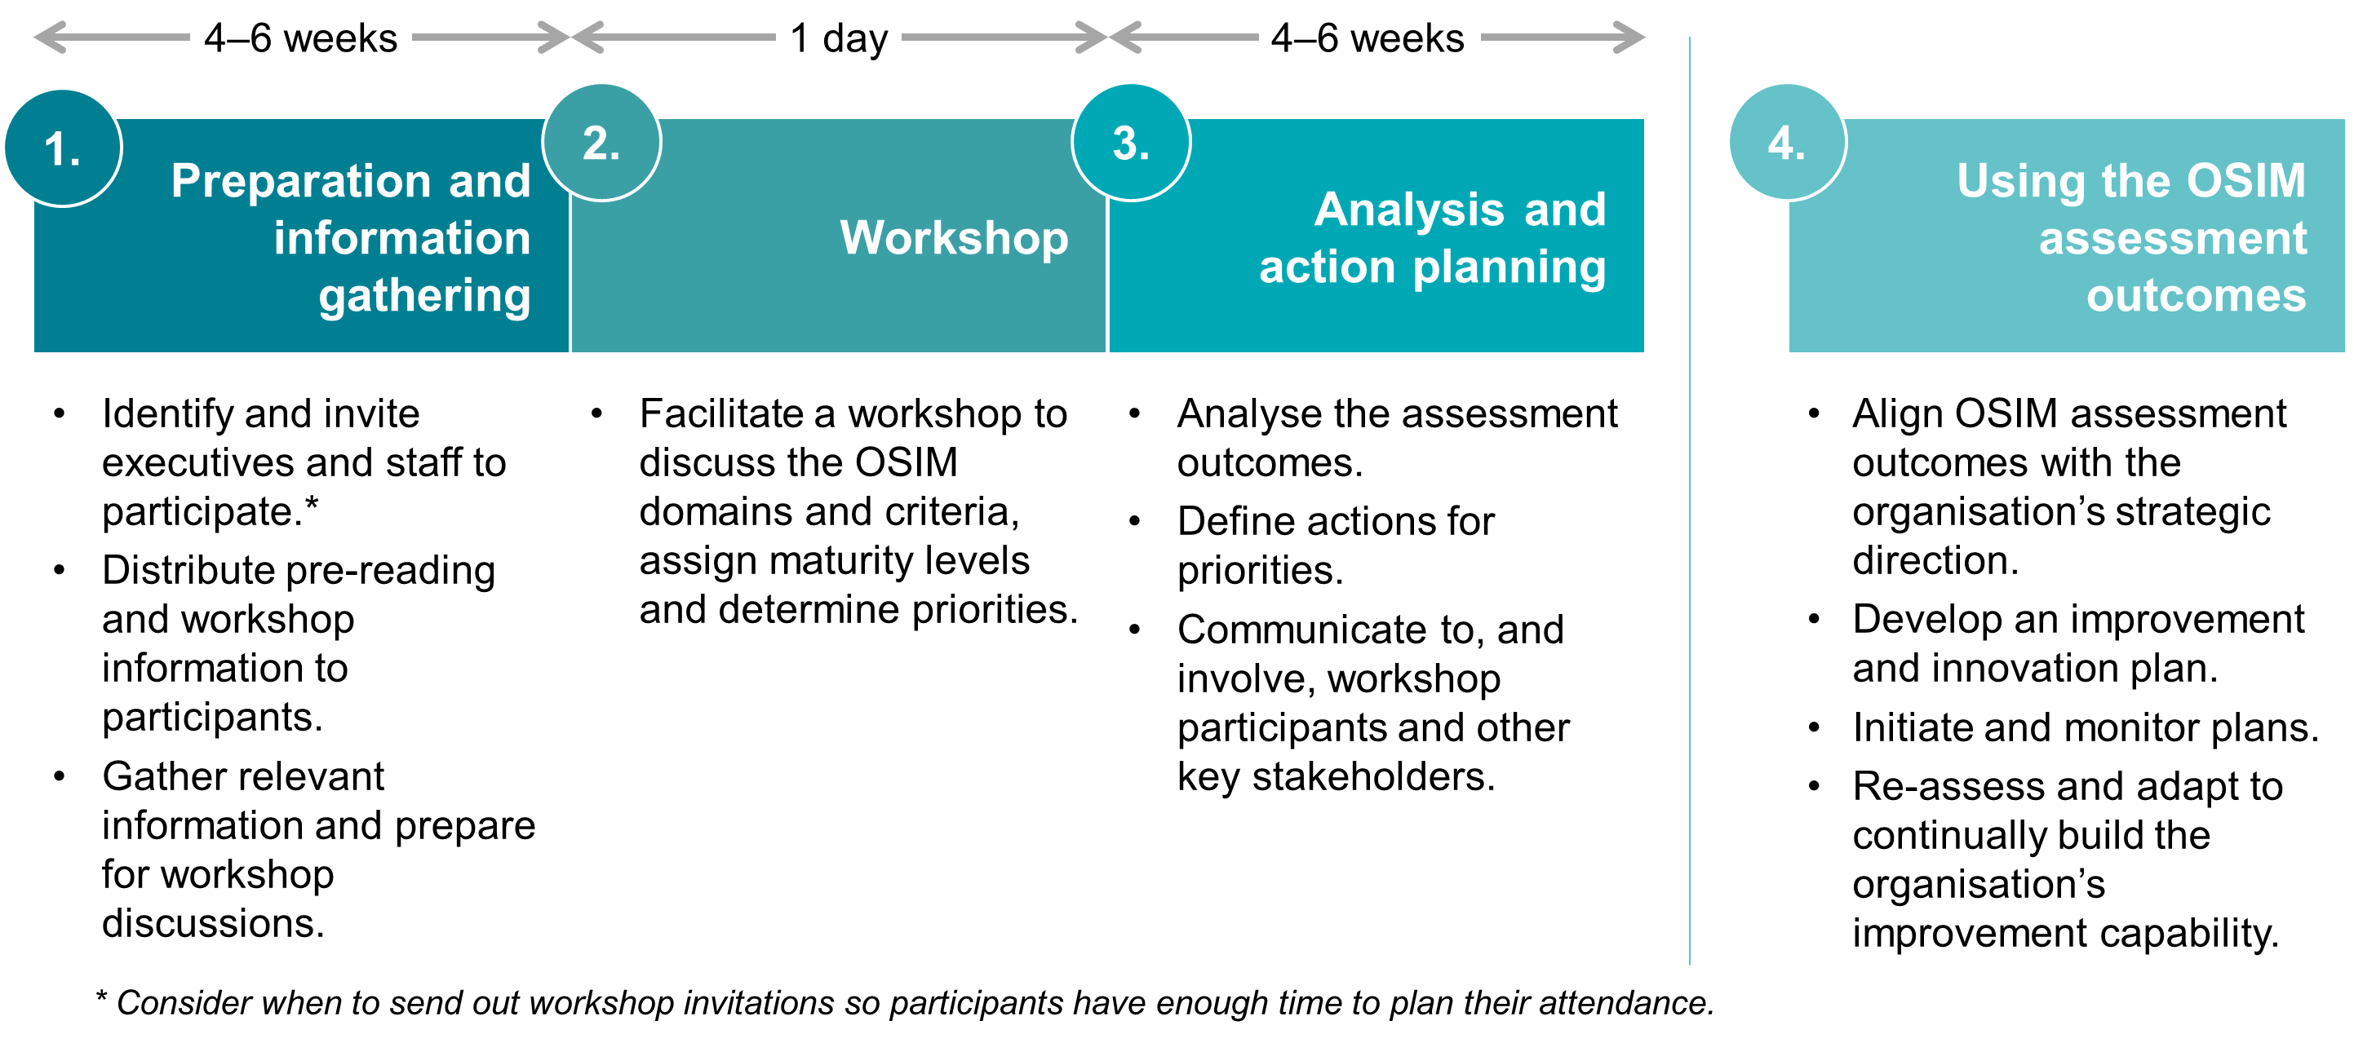

Figure 8 – OSIM process

Further questions for you to consider when defining your timeline:

* Will you need to host any meetings to promote OSIM, gain executive buy-in for the process or brief desired participants about OSIM?
* How will you adapt the administration method to work for your organisation? What pre-work is required?
* Will you need to prepare a report summarising the OSIM assessment outcomes and priorities, e.g. for executive sign-off?
* How will OSIM link in with your organisation’s strategic planning processes?

## Checklist – are we ready?

Below is a sample checklist that lists the key activities within each of the OSIM stages. These activities are indicative only, and should be tailored to the needs of your health service. Links to other sections of this document are provided to help you complete some activities.

| Stage | Activity | Where to find help? |
| --- | --- | --- |
| Pre-planning | | |
| 1. Planning | * Form an OSIM facilitation team (e.g. persons in the improvement / redesign team) responsible for completing the OSIM process | |
| * Hold a planning meeting with the facilitation team and other key stakeholders as required | |
| * Create a plan for using OSIM, considering the following questions:   + Why do we want to use it?   + When should we use it?   + Who should be involved?   + How should we use it? | |
| 1. Organisational sponsorship | * Identify local executive sponsor(s) and seek confirmation to use OSIM and their support | |
| * Brief executive sponsor(s) and chief executive officer as required (e.g. hold a briefing meeting) | |
| * Confirm executive sponsor(s) and chief executive officer are on-board with OSIM and agree with the plan | |
| Stages of OSIM | | |
| 1. Preparation and information gathering | * Establish a workshop date | Section 0 -   * What is the value of using OSIM? |
| * Identify and invite workshop participants | * Section 3.3 - Who participates in OSIM? * Section 5.5 – Leadership, staff and consumer participation – who should be invited? |
| * Organise workshop logistics (e.g. room booking, table layout) | * Section 5.6 – Administration – how do we do it?Administration |
| * Provide information sheets to workshop participants and offer initial briefing / overview meetings as required | * Appendix |
| * Define workshop roles and responsibilities (e.g. facilitators, note-takers, projector) and prepare (e.g. hold a briefing meeting) | * Section 5.6 – Administration – how do we do it? |
| * Create workshop materials as required (e.g. slide presentation) | * Download via [www.bettercare.vic.gov.au](http://www.bettercare.vic.gov.au) |
| * Familiarise yourself with how the OSIM workbook works | * Section 5.3 - Workbook – how do we use it? |
| * Gather relevant information and prepare for workshop discussions (e.g. consider provisional maturity levels) | * Section 5.4 – Reference guide – what could we look for? |
| 1. Workshop | * Hold workshop | * Section 5.6 – Administration – how do we do it? |
| 1. Analysis and action planning | * Gather any additional information (e.g. evidence) identified in the workshop | - |
| * Consolidate workshop notes and OSIM workbook * Analyse the assessment outcomes and priority focus areas (e.g. hold a de-briefing meeting with facilitation team) | * Section 5.7.1 - Interpreting the assessment outcomes |
| * Define actions and accountabilities for priority areas. Circulate with workshop participants and other key stakeholders for input as required | * Section 5.7.2 - Analysis and action planning |
| * Maintain communications and involvement of workshop participants and other key stakeholders, as required.   This may include holding a post-workshop de-briefing and way-forward meeting with key stakeholders and agreeing on how progress and success will be measured and reported | * Section 5.7.5 - Sharing feedback with participants |
| 1. Using the OSIM assessment outcomes | * Align priorities and actions with the organisation’s strategic direction.   This may include broader organisational discussions to agree a way forward, and developing or re-assessing the organisation’s strategic plan and priorities | * Section 0 - * Aligning with strategic direction |
| * Develop an improvement and innovation plan.   This is to turn strategy into a tactical and executable plan, using the OSIM assessment outcomes, priorities and actions | * Section 5.7.4 - Developing an improvement and innovation plan |
| * Initiate and monitor the improvement and innovation plan | - |
| * Monitor, report, review and communicate progress * Re-assess and adapt as required | - |

Table 6 – OSIM checklist

## Workbook – how do we use it?

The OSIM workbook, designed in MS Excel, is used to capture the self-assessment.

Features include:

* Instructions tab – read this first to understand how to use the workbook
* Criteria definitions tab – provides brief definitions for each criterion
* Dashboard tab – visualises the OSIM assessment outcomes using radar charts and summary tables
* Summary view – All criteria tab – visualises all domain and criteria assessment outcomes on a single radar chart (useful for executive-level presentations)
* Action tracker tab – template to capture and track actions coming out of completing OSIM (e.g. to improve the assessment outcomes)
* Action summary – provides a summary of the actions that can be easily filtered
* One tab for each criterion – capture the maturity level score and supporting explanation for each criterion.

Screenshots of the Dashboard tab, Summary view – All criteria tab and one criterion tab are provided in the Appendix for example purposes (sample data only).

**Important note:** The workbook contains embedded calculations between tabs, and each tab is designed to be printed (e.g. for workshop participants). Care should be taken when making changes to the format and structure of these tabs.

## Reference guide – what could we look for?

In the OSIM workbook, each criterion includes a list of reference points to consider. In assessing your health service against the criterion, you could draw on these reference points to prompt your thinking.

Examples of reference points include:

* strategic, operational, clinical services and improvement plans
* tools and processes to prioritise and plan improvement activities – is there a systematic and strategic approach or is it opportunistic?
* terms of reference for governance and other committees
* improvement framework and supporting plans for implementation of improvement framework, includes knowledge and application of the framework and a methodology for improvement
* management reporting tools (metrics) – how is the information reported, communicated and actioned?
* workforce development strategy and deployment – are there explicit expectations and recognition of improvement, including knowledge, skills and behaviours?
* performance plans and position descriptions
* information from staff and consumer surveys
* organisational report card or scorecard – use of metrics at multiple levels across the organisation (including metrics focused on the interface between areas along with operational, process and check measures)
* People Matter survey conversations with stakeholders.

## Leadership, staff and consumer participation – who should be invited?

The number and breadth of participants in an OSIM workshop will vary depending on the size of the health service and scope of the assessment. It is recommended that a broad representation of perspectives, from executives through to frontline, be involved in the OSIM self-assessment, so that there is:

* a deep, diverse and informed assessment
* an organisation-wide view, rather than making assumptions about the whole organisation
* credibility in the OSIM self-assessment process to support seeking executive buy-in and ownership of post-OSIM priorities and action plans.

The table below lists the leaders, staff and consumers you may consider inviting to the OSIM workshop.

|  |
| --- |
| Recommended participants |
| Executives |
| General managers |
| Nursing leaders |
| Medical managers |
| Allied health leaders |
| Quality, safety, risk and performance leaders |
| Board members |
| Consumer representatives / patient liaison leaders |
| Workforce / organisational development leaders |
| Improvement, innovation and redesign teams |
| Representatives from other corporate functions, including (but not limited to):   * Corporate communications * Medical and nursing education * Decision support or central data management area * Finance |

Table 7 – Recommended participants for OSIM workshop

To support sharing information with leaders, staff and consumers about OSIM and the OSIM workshop, a sample participant information sheet is available in the Appendix.

## Administration – how do we do it?

Health services can choose how to administer the OSIM based on their local organisational context and preferences. For example, the interest and buy-in of executives in OSIM, experience in workshop facilitation, ability to get a broad cross-section of representatives together.

The benefit of OSIM is in the conversation. It is recommended that health services host an OSIM workshop to get the most value out of the OSIM process, although this method is not mandatory; health services are encouraged to tailor the workshop method to work best for their organisation.

The OSIM workshop involves bringing together organisation-wide representatives for a collaborative workshop to complete the OSIM assessment and determine priority areas as a group.

It provides an opportunity for executives, managers and other key stakeholders to do a ‘health check’ of the organisation together – to share different perspectives and come to a common understanding of how well the organisation currently performs in each of the OSIM domains and criteria. Without this broad perspective, a siloed approach may produce a siloed view of the whole organisation based on assumptions, and not achieve a true picture of organisational strengths and areas to focus on.

**Note:** There are increasingly available digital tools to support interactive workshop facilitation (e.g. to live poll participants and project live-assessment). The OSIM workshop can be easily adapted to incorporate these digital tools.

### Workshop characteristics

The following table provides an overview of the workshop characteristics.

| Characteristic | Description |
| --- | --- |
| Facilitation | A primary facilitator manages the room and the final larger group discussion to agree assessment. Multiple group facilitators orchestrate table-level assessments (approximately one group facilitator to a table of five to six participants). |
| Timing | It should be scheduled at the most effective time for the organisation, to align with, and input into, the organisation’s annual strategic planning timelines. |
| Information gathering and readiness facilitator(s) pre-work | The facilitation team should collate some evidence and brainstorm the assessment to help with table discussion prompts. |
| Workshop length | 3.5–4 hours. |
| Workshop materials | Introductory slide presentation.  Empty OSIM workbook printed per group facilitator for table discussions (or per participant), and projected for live-updates during the larger group discussion. |
| Number and spread of workshop participants for maximum effectiveness | Approximately 30 for large health services, from diverse functions, roles and levels, scaled appropriately to the size of the health service (e.g. small health services with a small number of participants can have workshop with no or fewer table break-outs). |
| Note-taker(s) | A person(s) should be nominated to capture discussion points and scores. |
| Criterion prioritisation as part, or outcome, of workshop | Participants rate the priority of each criterion during the workshop, highest rating is taken forward post-workshop for action identification and planning (may not be lowest scoring criterion). |
| Action identification and planning as part, or outcome, of workshop | Determined post-workshop. |
| Relationship and integration with strategic planning | Assessment, criterion prioritisation and actions become inputs into organisational strategic planning and the development of an improvement and innovation plan. |

Table 8 – Workshop method characteristics

### Sample workshop agenda

This agenda is an example only and can be tailored as required.

| **Time** | **Agenda Item** | **Materials** | **Presenter** |
| --- | --- | --- | --- |
| 10:00–10:10am | Welcome and opening   * Why are we here? * Who is in the room? | Projected slide presentation | Local sponsor |
| 10:10 –10:40am | Using OSIM to measure organisational capability for improvement   * What is organisational capability for improvement, and why measure and monitor this? * What is OSIM and how can it help us? * How does this all fit into our organisation’s strategy, frameworks and processes? | Projected slide presentation | Primary facilitator |
| 10:40–10:50am | OSIM group activity preparation   * Provide ‘world café’ activity instructions (see instructions below this table) * Instruct participants to break into five even groups and move to the designated zone | Projected slide presentation | Primary facilitator |
| 10:50am–12:30pm | OSIM group activity  Conduct ‘world café’ style activity (see Section 5.6.3 for instructions) | Printed OSIM workbook (per participant or a few to share) | Group facilitators (x5) – supported by primary facilitator as time-keeper |
| 12:30–12:45pm | Comfort break |  |  |
| 12:45–1:15pm | Return to larger group   * Primary facilitator orchestrates ‘round-robin’ style feedback – each group facilitator provides feedback on the maturity level discussed per criterion, and raises any areas of contention for larger group discussion * Larger group agrees on the criterion maturity level * Designated note-taker updates the agreed criterion maturity level live using the projected OSIM workbook | Projected OSIM workbook | Primary facilitator – supported by Group Facilitators (x5) |
| 1:15–1:45pm | Key priorities activity, discussion and confirmation   * Identify and discuss lowest scoring criterion using the projected OSIM workbook dashboard view * Voting activity * Place one poster per criterion around the room * Provide each participant with 5x sticky dots * Instruct participants to reflect and place the sticky dots on the criterion which they believe the organisation should focus on (5 minutes). Participants can place the sticky dots however they like (e.g. spread across 5 criterion, or clustered on selected criterion). This does not need to be the lowest scoring criterion * Primary facilitator counts the sticky dot votes and discusses what this means for the organisation as a group. Any interesting vote results? * Designated note-taker captures the sticky dot votes and discussion points | Projected OSIM workbook / Criterion posters | Primary facilitator |
| 1:45–1:55pm | Next steps.  Facilitation team will:   * analyse assessment outcomes * seek additional information as required * work with participants, and other stakeholders as required, to develop actions into an improvement and innovation plan * share plans for implementation * monitor and report progress. | Projected slide presentation | Primary facilitator |
| 1:55–2:00pm | Final commitment – wrap up and thank you | Projected slide presentation | Local sponsor |

Table 9 – Sample workshop agenda

### World Café activity instructions

World Café is a simple and flexible workshop format for hosting a large group dialogue.

* Decide whether the activity will be sit-down or stand-up.
* If sit-down, ensure there are five tables, each with enough space/chairs for a fifth of your workshop participants.
* If stand-up, ensure there is enough space at each wall zone for a fifth of your workshop participants.
* Split participants evenly into five groups and move each group to one of the tables or wall zones
* Designate each table or wall zone one of the following domains:
* Organisational systems and structures (first three of six criterion).
* Organisational systems and structures (second three of six criterion).
* Workforce capability and development.
* Results and system impact.
* Culture and behaviour.

**Tip:** Print and place a poster of each of these designated domains and their criteria at each table or wall zone.

* Each designated domain will have had a group facilitator assigned prior to the workshop.
* Group facilitator provides a quick overview of the domain and one-by-one for each criterion, facilitates a group discussion to assign a maturity level.
* It is up to the facilitation team whether the target maturity level is also set during these break-out discussions, or if this information will be determined following the workshop.
* Group facilitator takes notes on a large A3 print out of the workbook
* Primary facilitator acts as time-keeper and rotates the groups through each table or wall zone every 20 minutes, until each group has gone through all tables or wall zones
* Group facilitator can review the previous group’s discussion and suggest focusing the discussion on further feedback or missed discussion opportunities

**Tip:** Projecting a count-down timer can help set expectations for the group rotations.

## Using the findings from OSIM

### Interpreting the assessment outcomes

The self-assessment can be used to reflect on and celebrate progress in your improvement journey. It is important to know that there are no right or wrong answers. If the workshop’s assessment determines your health service is not where it wants to be, you are encouraged to take this as a learning and action planning opportunity.

You can interpret the assessment outcomes using the OSIM workbook by navigating to the Dashboard tab or Summary view – All criteria tab to visualise the current year’s assessment outcomes. The next time you complete OSIM (e.g. in 12 months), you can reflect on whether or not your health service achieved the targets set for each criterion.

Questions to prompt your analysis:

* What criteria have we scored the lowest in? Why? What can we do to improve?
* What criteria have we scored the highest in? Why? How can we sustain? Do we want to exceed our performance?
* What criteria assessment outcomes are we not satisfied with? Why? How can we improve?
* What criteria have we not met our targets for? Why? What can we do to improve?
* Do we need more information before we lock in a maturity level for any criterion?
* What maturity level do we aspire to reaching for each criterion and by when? What is realistic for our organisation?
* What can be achieved within existing capability, capacity and budgets? Would we need more resources to help us achieve what we want?

### Analysis and action planning

Following the workshop, the next step is to shift discussion to analysing the assessment outcomes and planning how to improve the assessment outcomes of prioritised criteria.

Criteria will have been discussed and prioritised in the OSIM workshop, however further analysis and discussion with other key stakeholders (e.g. those who could not attend the workshop) may be required following the workshop. It may be appropriate to organise a follow-up meeting(s) with all or some workshop participants and other key stakeholders to agree priorities and define actions and accountabilities.

The OSIM workbook contains an Action tracker tab you can use to record the actions against specific domains and criteria, and an Action summary tab to view a summary of the number of actions. It is optional whether you use this workbook feature, and you can tailor it to suit your needs. Alternatively, your organisation may have existing action tracking tools or processes (e.g. through a project management office).

Actions may be defined to specifically strengthen one or more criteria, or it may be a strategic piece of work that has the potential to impact a range of criteria.

All actions should have a person assigned as the owner / lead and their agreement sought. This person would be responsible for implementing the action and reporting progress. It is also good practice for actions to have an accountable executive who supports the action owner / lead to implement the action and drive executive level decisions related to the action.

### Aligning with strategic direction

The OSIM assessment outcomes, priorities and actions should be aligned with the organisation’s strategic direction. Depending on the time of year you administer the OSIM, the OSIM assessment outcomes can be used to inform the development or annual re-assessment of the organisation’s strategic direction, plans and priorities. If any OSIM priorities or actions conflict with the organisation’s strategic direction, this is an opportunity to revise the OSIM priorities and actions.

### Developing an improvement and innovation plan

It is recommended that you develop an improvement and innovation plan, informed by the OSIM assessment outcomes, priorities and actions, and alignment with the organisation’s strategic direction. This plan consolidates all improvement and innovation activities for the next 12 months (or beyond), including the actions that come out of the OSIM process, and all planned improvement and innovation projects and initiatives. This consolidated view is a tactical and useful resource that translates strategy into action, to understand organisation-wide activities, communicate the organisation’s improvement and innovation agenda, and monitor and report progress to leadership.

Specific departments and units may elect to have an improvement and innovation plan to define and track improvement and innovation actions, projects and initiatives specific to their area of the organisation. It is up to the health service if this information feeds into a consolidated organisation-wide view.

It is recommended that the OSIM be completed annually as part of an ongoing improvement cycle. The improvement and innovation plan is useful to track progress against targets throughout a 12 month period (or beyond), and serve as an input into the next annual OSIM process.

A sample improvement and innovation plan template is available via [www.bettercare.vic.gov.au](http://www.bettercare.vic.gov.au).

### Sharing feedback with participants

Communication is an essential step to enable the OSIM assessment outcomes to be owned by the organisation and be seen as a fair representation of the current state of organisational capability for improvement. Expectations should be set early for how workshop participants will be communicated with and involved in the OSIM process.

It is important to continue the dialogue with workshop participants, so they understand how they have contributed to the OSIM process, the way the organisation will act on the assessment outcomes and take ownership of the outcomes and actions. This may involve sharing the consolidated OSIM assessment outcomes and improvement and innovation plan. You may choose to provide the final OSIM workbook, or create a document summarising the OSIM assessment outcomes, priorities and actions.

## Further information

For further information about building organisational capability for improvement in Victoria’s health services or the OSIM, contact the Safer Care Victoria team at bcv@safercare.vic.gov.au or call   
03 9096 2761.

# Appendix

Includes:

* Appendix 1: Sample participant information sheet
* Appendix 2: Sample OSIM workbook – Dashboard tab
* Appendix 3: Sample OSIM workbook – Summary view – All criteria tab
* Appendix 4: Sample OSIM workbook – Criterion tab (A1. Framework for improvement)

**Appendix 1: Sample participant information sheet**

**Organisational Strategy for Improvement Matrix (OSIM)**

**Participant information sheet**

**The Organisational Strategy for Improvement Matrix (OSIM) is a capability measurement tool and process used to identify organisational accelerators and barriers to improvement.**

It is a strategic priority for us to create an organisational environment and culture that delivers consistently safe, high-quality care, and it is important that we have a clear understanding of where we are currently in this improvement journey and where we want to be.

**What is the OSIM and where do I come in?**

The OSIM reviews the areas, referred to as ‘domains’, of a health service known to enhance capability for quality, safety and value improvement, including:

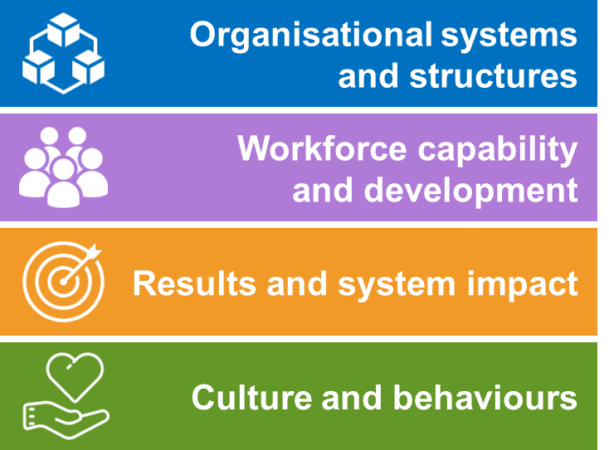

We are using the OSIM like a ‘health check’ – to help us understand how we are currently performing and to set the strategic goals and improvement plans for the next 12 months.

You will be invited to attend a <XX> hour workshop which will be facilitated by the <team name> team to share your perspective on how well we currently perform in these four domains. As a participant, you will be a valuable contributor to the workshop.

**Who will be at the workshop?**

We have invited executives, staff and consumers from a range of departments and units, including <functions / areas, e.g. senior executives, clinical governance, quality and improvement, consumer representatives, workforce, operations, finance>.

**How do I prepare myself for the workshop?**

We will provide the OSIM workbook in advance. You are welcome to familiarise yourself with the content and structure. However, it is not expected that you do any pre-work.

**What does the process look like?**

The <team name> will coordinate the OSIM process and gather the information needed for the workshop. This may involve brainstorming our current maturity in the four domains as a starting point for the workshop discussions.

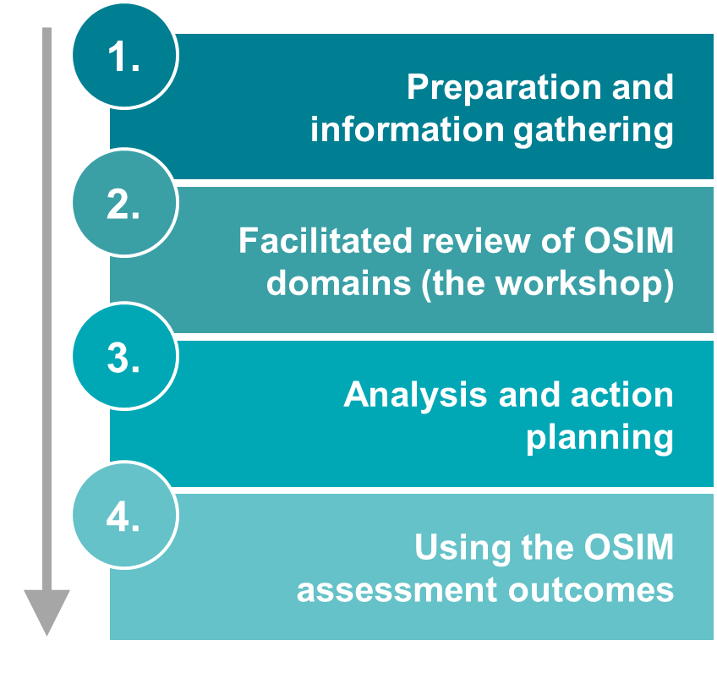

At the workshop, you will have the opportunity to review the OSIM domains and give feedback. The outcomes of the workshop will be used to set improvement priority areas and define actions for the next 12 months.

**How can I find out more?**

Please contact <Name>, <Position>, via <contact details>.

**Appendix 2: Sample OSIM workbook – Dashboard tab**



Figure 9 – Sample OSIM workbook – Dashboard tab(sample data only)

**Appendix 3: Sample OSIM workbook – Summary view – All criteria tab**



Figure 10 – Sample OSIM workbook – Summary view – All criteria tab(sample data only)

**Appendix 4: Sample OSIM workbook – Criterion tab (A1. Framework for improvement)**



Figure 11 – Sample OSIM workbook – Criterion tab – A1. Framework for improvement(sample data only)

# Bibliography

Baldrige Performance Excellence Program, *2011–2012 Health Care Criteria for Performance Excellence*, viewed 21 May 2011, <www.baldrigepe.org>.

Better Care Victoria 2016, *Health Improvement Capability Quotient (Health ICQ) Guide Second Edition*, available from Safer Care Victoria on request via [bcv@safercare.vic.gov.au](mailto:bcv@safercare.vic.gov.au). This document was developed in 2014 by Victoria’s (former) Department of Health. The management of this document transferred to Better Care Victoria in 2016.

Ham, C, Berwick, D & Dixon, J 2016, *Improving quality in the English NHS – A strategy for action*, The King’s Fund, London.

Huntmans, JC 2010, *The Shingo prize for operational excellence – model and application guidelines*, viewed 21 May 2011, <www.shingoprize.org>.

1. Ham, C, Berwick, D & Dixon, J 2016, *Improving quality in the English NHS – A strategy for action*, The King’s Fund, London.
2. Baldrige Performance Excellence Program, *2011–2012 Health Care Criteria for Performance Excellence*, viewed 21 May 2011, <www.baldrigepe.org>.
3. Huntmans, JC 2010, *The Shingo prize for operational excellence – model and application guidelines*, viewed 21 May 2011, <www.shingoprize.org>.