**Organisational Strategy for Improvement Matrix (OSIM)**

Measuring and creating capability for improvement in health services

**The Organisational Strategy for Improvement Matrix (OSIM) is a capability measurement tool and process used to identify organisational accelerators and barriers to improvement.**

Safer Care Victoria is our state’s healthcare quality and safety improvement agency. We are committed to supporting health services in providing outstanding care for all Victorians. Always.

To create an organisational environment and culture that delivers outstanding care, health services need to have a clear understanding of where they are in their improvement journey and where they want to be.

OSIM is designed to support health services in this journey, and can help to:

* prompt discussion about organisational strengths and areas of potential development
* reflect on ways to improve capability
* inform strategic goals.

Completing OSIM will put health services in a better position to determine ways to close the gap between where their organisation is and where they want it to be. It will also shine a light on capability for improvement at all levels of the organisation, helping to identify potential areas to strengthen.

It is a learning opportunity and gives health services a target to aim for.

**What is OSIM?**

OSIM is a tool health services can use to self-assess their organisation’s level of improvement capability.

It is structured around four key areas, known as ‘domains’, referred to in literature as common to high-performing organisations, and framed in the context of improvement include:

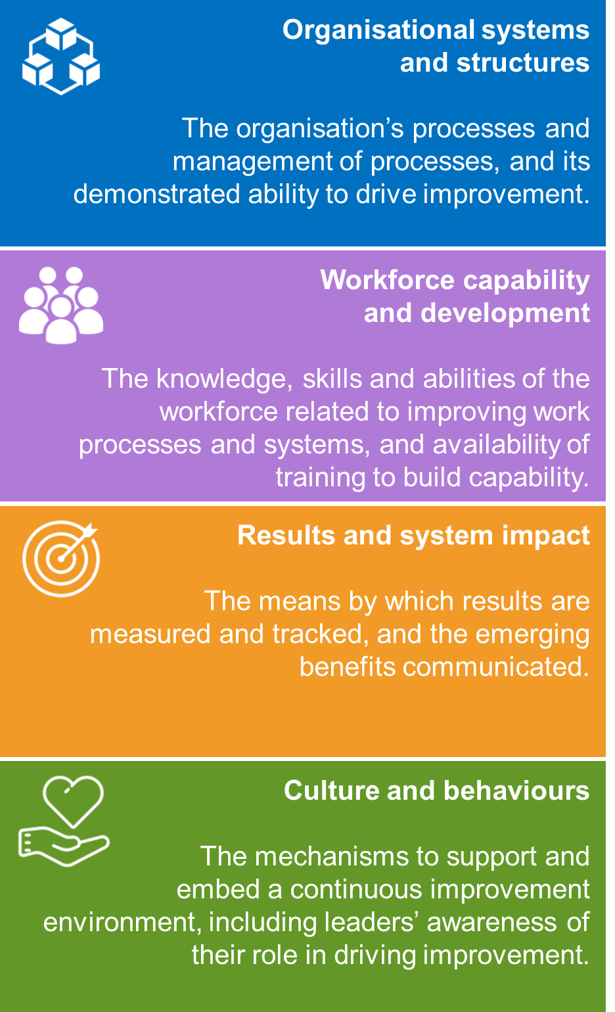

Each domain comprises a set of criteria – the levers in an organisation that impact on or promote improvement capability.

**How is OSIM used?**

Health services use the provided workbook to self-assess against each criterion. This involves asking the question, ‘How well does our health service meet this criterion?’ and then assigning a maturity level (from Level 1 – Foundational to Level 5 – Advanced).

Completing OSIM produces a score indicative of the health service’s overall maturity level for improvement capability, providing a picture of organisational strengths and areas of potential development.

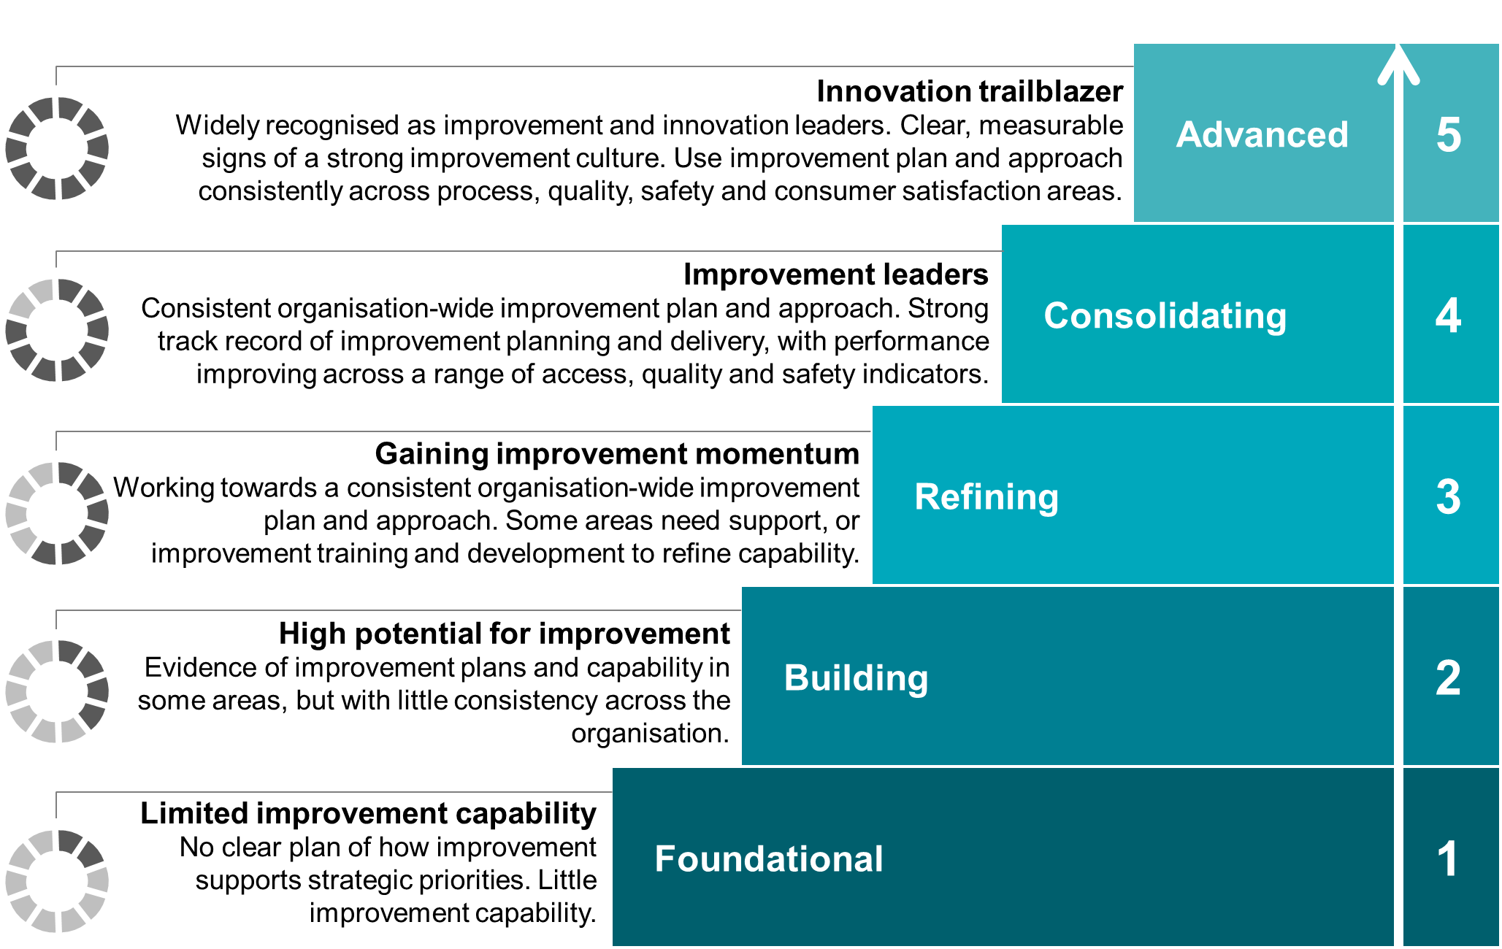

**What are the benefits of using OSIM?**

Improvement is most successful where health services have well-developed organisational capability. OSIM provides a structured and guided way to consider a broad range of organisational levers of improvement capability.

By understanding and developing the elements that contribute to organisational capability for improvement, health services are better placed to make sustainable improvements. OSIM has been designed to enable health services to assess and monitor their organisational capability for improvement over time, and set capability targets for the future.

**Who gets involved with OSIM?**

Safer Care Victoria recommends health services invite a broad representation of the organisation, from executives through to frontline, to be involved in the OSIM self-assessment, so that there is:

* a deep, diverse and informed assessment
* an organisation-wide view, rather than making assumptions about the whole organisation
* credibility in the OSIM self-assessment process to support seeking executive buy-in and ownership of post-OSIM priorities and action plans.

**Further information**

The OSIM workbook and supporting materials are available for download at [www.bettercare.vic.gov.au](http://www.bettercare.vic.gov.au).

For further information, contact the Safer Care Victoria team at bcv@safercare.vic.gov.au or call   
03 9096 2761.

To receive this publication in an accessible format phone 03 9096 2761,   
using the National Relay Service 13 36 77 if required, or [email Safer Care Victoria](mailto:bcv@safercare.vic.gov.au)   
<bcv @safercare.vic.gov.au>

Authorised and published by the Victorian Government, 1 Treasury Place, Melbourne.

© State of Victoria (Safer Care Victoria) and State of New South Wales (Clinical Excellence Commission) 2018

ISBN 978-1-76069-216-2 (pdf/online/MS word)

Available at [Better Care Victoria](https://www.bettercare.vic.gov.au/) [www.bettercare.vic.gov.au](http://www.bettercare.vic.gov.au)