Victorian perinatal services performance indicators
2018–19

Suggested citation:
Hunt RW, Ryan-Atwood TE, Davey M-A, Gaston J, Wallace E, Anil S on behalf of the Maternal and Newborn Clinical Network INSIGHT Committee 2019, Victorian perinatal services performance indicators 2018–19, Safer Care Victoria, Victorian Government, Melbourne.
To receive this publication in an accessible format phone (03) 9096 1384, using the National Relay Service 13 36 77 if required, or email Safer Care Victoria <info@safercare.vic.gov.au>. | Authorised and published by the Victorian Government, 1 Treasury Place, Melbourne.  © State of Victoria, Australia, Safer Care Victoria, November 2019  ISSN 2207-3558 (online)  Available from the Safer Care Victoria website <https://bettersafercare.vic.gov.au>. | 


Contents
Foreword 5
About this report 6
What’s new? 7
How to use this report 8
Compare your performance 8
Inform quality improvement activities 9
Engage with your clinicians 10
Share with your community 10
Contact us 10
Summary of results 11
Where we are getting better 11
Where we are doing less well 12
Performance indicators and outcomes 15
Indicator 1a: Induction of labour in standard primiparae 15
Indicator 1b: Caesarean sections in primiparae 17
Indicator 1c: Perineal tears in primiparae 21
Indicator 1d: Episiotomies in primiparae 25
Indicator 2: Term babies without congenital anomalies who required additional care 29
Indicator 3: Severe fetal growth restriction 32
Indicators 4a and 4b: Vaginal birth after primary caesarean section 35
Indicator 5: Five-year gestation standardised perinatal mortality ratio 39
Indicators 6a and 6b: Readmissions during the postnatal period 42
Indicator 7: Smoking cessation 50
Indicators 8a, 8b and 8c: Breastfeeding in hospital 54
Indicator 9: First antenatal visit 62
Indicator 10: Low Apgar score 65
Indicators 11a and 11b: Women’s experiences of care 68
Indicators 12a and 12b: Maternal vaccination 71
Trial indicator 13: Severe postpartum haemorrhage 74
Appendix 1: Data sources and reporting rules 76
Appendix 2: Definitions and data sources 77
Indicator 1a: Rate of induction of labour in standard primiparae 77
Indicators 1bi and 1bii: Caesarean sections in primiparae 78
Indicators 1ci and 1cii: Perineal tears in primiparae 79
Indicators 1di and dii: Episiotomies in primiparae 80
Indicator 2: Term babies without congenital anomalies who required additional care 81
Indicator 3: Severe fetal growth restriction 83
Indicator 4: Vaginal birth after primary caesarean section 86
Indicator 5: Five-year gestation standardised perinatal mortality ratio 87
Indicator 6a: Maternal readmissions during the postnatal period 89
Indicator 6b: Newborn readmissions during the postnatal period 91
Indicator 7: Smoking cessation 93
Indicator 8: Breastfeeding in hospital 94
Indicator 9: First antenatal visit 95
Indicator 10: Low Apgar score 96
Indicator 11: Women’s experiences of care 97
Indicators 12a and 12b: Maternal immunisation 98
Trial indicator 13: Severe postpartum haemorrhage 99
Appendix 3: Total women and babies in Victorian maternity services, 2018 100
Appendix 4: Overview of results 104
Terminology 108
Acknowledgements 112
INSIGHT Committee members 112
References 113
Contact us 113

Foreword
Victoria is one of the safest places in the world to have a baby. This is thanks to the dedicated health practitioners who provide safe high quality care to us and our families – our midwives, nurses, obstetricians, anaesthetists, paediatricians, paramedics, physiotherapists, social workers, general practitioners, Aboriginal health workers and others. However, sometimes the care that we receive could and should be better. This report provides insights into where we are providing exceptional care and where improvements can be made across our services. It provides data on the antenatal, intrapartum and postnatal periods, allowing health services to compare results and monitor variation against their peers.
I am pleased to see that for the third consecutive year we have seen a decrease in the statewide rate of severe fetal growth restricted babies undelivered by 40 weeks’ gestation. We collectively should be proud of the efforts made by our clinicians and our health services to reduce this rate. We look forward to seeing further improvements as this area remains a priority focus for Safer Care Victoria and the Department of Health and Human Services.
We have seen an increase in the rate of women attending their first antenatal visit by 12 weeks’ gestation in both our public and private services. This is encouraging as early detection, prevention and management of complications of pregnancy means better health outcomes for mothers and babies. Likewise, an increase in women being vaccinated for pertussis and influenza during pregnancy provides protection for women and their babies from infections that can cause serious complications during pregnancy. We still have a way to go to improve influenza vaccination rates, however improvements are reassuring.
We have seen an increase in rates of induction of labour and third-and-fourth-degree perineal tears. While induction may be necessary for some women, safely reducing the rate may reduce the need for further interventions during and after birth. Smoking cessation rates in pregnant women remains unchanged. Smoking is a preventable cause of morbidity and mortality in pregnant women and their babies and it is important that we continue to provide support to pregnant women that is sensitive and appropriate. The advice provided to new mothers around breastfeeding is clearly variable and conflicting and may be contributing to perinatal distress. Examining perinatal mental health will be a key priority in upcoming reports.
I encourage health services to prioritise performance improvement by review of practices and identifying areas of improvement. The Perinatal Services Performance Indicators report can assist with this. I hope you find the information of benefit on our journey of continued improvement.
Professor Rod Hunt
Chair INSIGHT committee, Safer Care Victoria Maternity and Newborn Clinical Network

About this report
This report presents and discusses data from Victorian maternity services on 25 performance indicators across 13 key performance areas (Figure 1). Through transparently reporting these data, we can paint a picture of the care provided to pregnant women and their babies – from antenatal and intrapartum (labour and birth), to postnatal care.
These performance indicators are widely accepted as appropriate, useful and insightful measures of the quality of care, including the experience of care. They continue to be refined over time.
Figure 1. Perinatal services performance indicators by key performance area
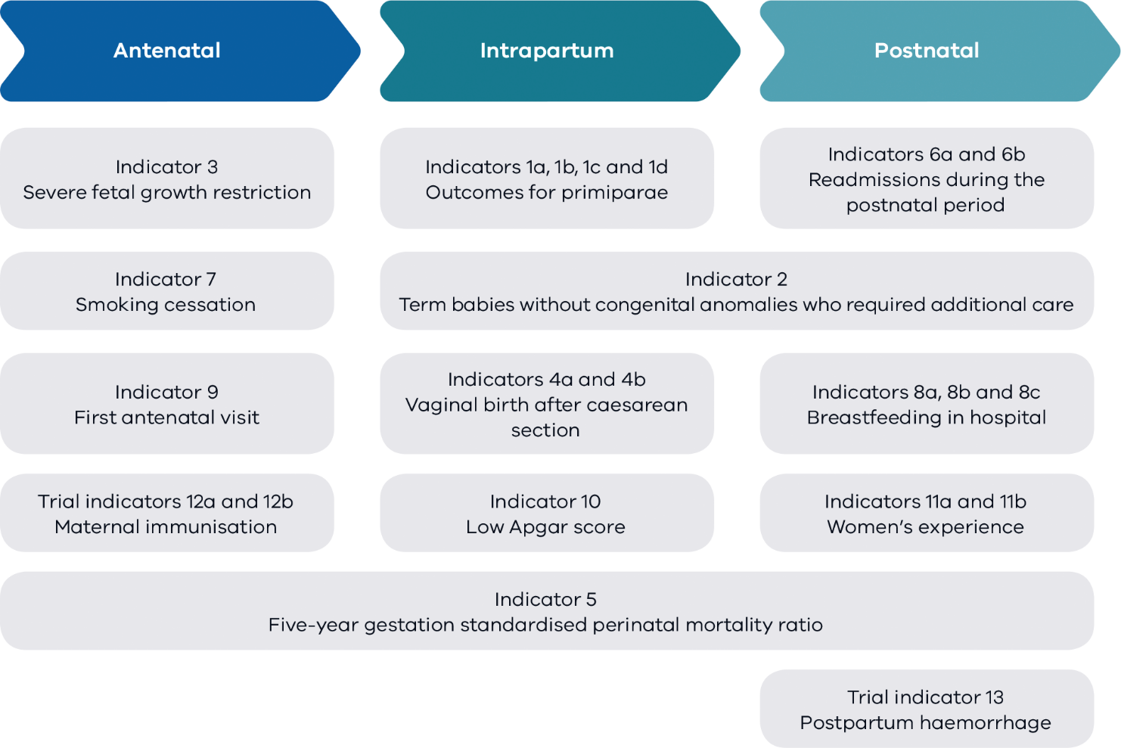
The main section of this report details statewide data observations, strategies for improvement for health services and key information for pregnant women and families.
- Appendix 1 details the data sources for this report.
- Appendix 2 specifies the definition of each indicator.
- Appendix 3 lists Victoria’s maternity services and the number of women and babies cared for in 2018.
- Appendix 4 contains the detailed results for each individual health service.

What’s new?

Perinatal mortality reported against the statewide rate
For the first time, we are reporting the gestation standardised perinatal mortality ratio for every hospital and comparing it with the statewide ratio. Perinatal mortality is adjusted for gestation to compare hospitals that have a different casemix. We specifically look at babies born at, or after, 32 weeks’ gestation and average ratios over a five-year period to get a better sense of the perinatal care a hospital provides. Previously this indicator was reported by comparing all hospitals with the statewide public hospital ratio.

New indicators
Indicators 12a and 12b report the proportion of women who were vaccinated against pertussis (whooping cough) and influenza (flu) at any time during pregnancy. These vaccines protect women from infections that can cause serious complications during pregnancy and affect the health of their babies. These indicators were trialled in the 2017–18 perinatal services performance indicators report and reported that 77.5 and 53.7 per cent of women were vaccinated during pregnancy for pertussis and influenza respectively, leaving significant room for improvement.

We are trialling a new indicator
Trial indicator 13 reports the rate of women who had a severe postpartum haemorrhage (PPH). PPH is an increasingly common and potentially serious complication following birth. While the majority of PPH cases are minor, severe PPH (defined in this report as blood loss of 1,500 mL or more) is a major cause of maternal morbidity and one of the causes of mortality in Victoria.

We are working on targets
Targets can be used to provide guidance and drive quality improvement activities. They can support a reduction in variation in clinical practice and outcomes. We are working hard to develop targets that will be specific, achievable and appropriate to the sector. We need your help, because no one knows your service better than you do. In 2020 we will begin consultation with the sector to co-design targets that work for you, your services and for women and babies.
If you are currently using targets for any of the indicators in this report, we would like to hear from you. Please email Safer Care Victoria <info@safercare.vic.gov.au>.

How to use this report
Outcomes are reported here by comparing services with each other and over time, identifying best care and practices. We call this comparison ‘benchmarking’. It can be done internally to identify best practice within a health service and compare practice over time.
Done externally, benchmarking can:
- allow you to assess performance relative to other health services
- identify services that are providing best practice that you may want to connect with
- highlight opportunities for improvements, particularly where improvement activities have led to success in other organisations.
[Break out box text:
Interpreting the data
Data for this report come from the Victorian Perinatal Data Collection (VPDC), the Victorian Healthcare Experience Survey (VHES) and the Victorian Admitted Episodes Dataset (VAED). The VPDC and VHES are reported by calendar year for 2018. VAED data are reported for the financial year 2018–19.
Statewide rates provide an average of all hospitals combined (public and private). The public rate is the average of all public hospitals combined and the private rate is the average of all private hospitals combined. They do not represent a desired target. In most cases, even where a hospital appears to be doing well, there are often opportunities for improvement.
Interquartile ranges represent variation between services. The graphs throughout this report use purple and blue vertical lines to show the least (purple) and most (blue) favourable 25 per cent of services. The most favourable rate may be high or low depending on the indicator. For example, we want rates of severe fetal growth restriction to be low and rates of smoking cessation to be high.
Trend graphs are provided only when at least three years of data are available.
End of break out box text.]

Compare your performance
Each health service will receive their own profile detailing their individual results. These are confidential to each health service and some services do choose to share their results with others. Consider sharing your service profile with others to help identify trends and opportunities for learning together. Collaborating with neighbouring health and community services may also help with appropriate referrals where required.
[Break out box text:

Capability levels
We have clustered health services by capability level (see Figure 2) so you can easily compare your service with others that care for mothers and babies with a similar level of complexity.
Figure 2. Levels of maternity and neonatal care
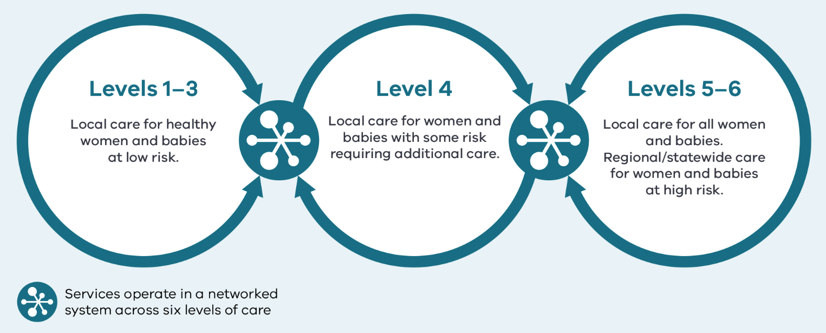
Source: Capability framework for Victorian maternity and newborn services.
End of break out box text.]

Inform quality improvement activities
Analysis provided in this report can guide, inform and assist with prioritising local audits that can be further discussed at your mortality and morbidity committee. Use this report to identify areas for improvement and ensure you measure the impact of your improvement programs.
If you are seeing great results from your improvement activities, let us know. We would love to share your experience with other health services.
[Break out box text:

Suggested improvements
We have provided a list of strategies for improvement under each indicator. You can use these as a starting point to support performance improvement.

Need help?
We are happy to work with you to understand the drivers for your performance, identify opportunities for improvement and share positive examples of good practice.
End of break out box text.]

Engage with your clinicians
Share your service’s maternity and newborn outcomes with your clinical workforce, this strengthens clinician engagement.

Share with your community
We encourage you to share this report with women, their partners, families and carers. Explain your outcomes and seek their suggestions for improvements and co-design projects with them. Think about producing an easy-to-read summary for women and their partners.
[Break out box text:

What pregnant women and families need to know
While this report is primarily for maternity services, we want to make sure women and their families can read and understand it too. We’ve included a list of terminology to help you understand and read this report. A consumer summary is also available.
Please speak to your maternity service if you want more information about their results.
End of break out box text.]

Contact us
Email Safer Care Victoria <info@safercare.vic.gov.au>.

Summary of results

Where we are getting better
Compared with previous years, the following indicators have improved in 2018.

Severe fetal growth restriction

Indicator 3
For the third consecutive year there was a decrease in the statewide rate of severe fetal growth restricted (FGR) babies undelivered by 40 weeks’ gestation.
The statewide (combined public and private) rate of undetected FGR dropped from 28.1 per cent in 2017 to 24.3 per cent in 2018 (p = 0.025). In public hospitals the rate decreased from 28.0 per cent in 2017 to 23.0 per cent in 2018 (p = 0.007). In private hospitals the rate was essentially unchanged, 28.8 per cent in 2017 and 30.2 per cent in 2018 (p = 0.750). Statewide detection of severe FGR has improved significantly since it was first reported (35.6 per cent in 2013 to 24.3 per cent in 2018).
FGR remains a priority focus for SCV’s Maternity and Newborn Clinical Network. If you are interested in improving your health service’s outcomes in this area, please visit the Maternity and Newborn Clinical Network webpage <https://bettersafercare.vic.gov.au/about-us/about-scv/our-clinical-networks/maternity-and-newborn-clinical-network> or email Safer Care Victoria <maternityclinicalnetwork@safercare.vic.gov.au>.

First antenatal visit

Indicator 9
The rate of women attending their first antenatal visit by 12 weeks’ gestation has increased from 54.1 per cent in 2017 to 59.5 per cent in 2018 (p < 0.001). The rate increased in public hospitals from 44.5 per cent in 2017 to 51.5 per cent in 2018 (p < 0.001). In private hospitals the rate increased slightly, from 86.9 per cent in 2017 to 87.1 per cent in 2018 (p = 0.579).

Maternal vaccination

Indicators 12a and 12b
The statewide rate of women vaccinated for pertussis (whooping cough) during pregnancy (Indicator 12a) has increased from 77.5 per cent in 2017 to 81.8 per cent in 2018 (p < 0.001). In public hospitals this rate increased from 83.0 per cent in 2017 to 88.2 per cent in 2018. In private hospitals this rate remained unchanged and significantly lower than in public hospitals, 59.9 per cent in 2017 and 60.4 per cent in 2018.
The statewide rate of women vaccinated for influenza (flu) during pregnancy (Indicator 12b) has increased from 53.7 per cent in 2017 to 67.1 per cent in 2018 (p < 0.001). In public hospitals this rate increased from 53.9 per cent in 2017 to 67.8 per cent in 2018. In private hospitals this rate increased from 53.4 per cent in 2017 to 65.0 per cent in 2018.
These vaccines protect pregnant women from infections that can cause serious complications during pregnancy and affect the health of their babies. The ideal immunisation rate is 100 per cent.

Where we are doing less well
The following outcomes suggest the need for health services to comprehensively review their practices and identify and actively plan for performance improvement. This includes improvements to data collection.

Induction of labour

Indicator 1a
The statewide rate of induction of labour in standard primiparae increased from 11.3 per cent in 2017 to 13.6 per cent in 2018 (p < 0.001). The rate across public hospitals increased from 7.4 per cent in 2017 to 9.4 per cent in 2018 (p < 0.001). The rate in private hospitals also increased from 18.1 per cent in 2017 to 21.1 per cent in 2018 (p = 0.002). While induction of labour is sometimes necessary, it can increase the need for further intervention. Safely reducing the number of primiparous women who have an induced labour may reduce the number who require birthing interventions overall.

Third- and fourth-degree perineal tears

Indicators 1ci and 1cii
The statewide rate of third- and fourth-degree perineal tears during unassisted vaginal births to primiparae (Indicator 1ci) increased slightly from 3.2 per cent in 2017 to 3.8 per cent in 2018 (p = 0.011). In public hospitals the rate increased from 3.6 per cent in 2017 to 4.4 per cent in 2018 (p = 0.004). The rate in private hospitals remained unchanged at 1.0 per cent. The statewide rate of third- and fourth-degree perineal tears during assisted vaginal births to primiparae (Indicator 1cii) has remained stable at 4.7 per cent in 2017 and 5.0 per cent in 2018 (p = 0.338). In public hospitals the rate was 5.5 per cent in 2017 and 6.0 per cent in 2018 (p = 0.208). The rate in private hospitals was 2.5 per cent in 2017 and 2.4 per cent in 2018 (p = 0.818).

Smoking cessation in pregnancy

Indicator 7
The statewide rate of smoking cessation in pregnancy has remained unchanged from 27.1 per cent in 2017 to 28.0 per cent in 2018 (p = 0.758). The rate in public hospitals was 25.5 per cent in 2017 and 26.6 per cent in 2018 (p = 0.704). The cessation rate in private hospitals dropped slightly from 65.2 per cent in 2017 to 60.3 per cent in 2018 (p = 0.204). There was, however, a decrease in the number of women who smoked at the start of pregnancy from 8.4 per cent in 2017 to 7.8 per cent in 2018 (p < 0.001). This is a very encouraging result.
It is important to continue efforts to encourage and support smoking cessation among pregnant women. Smoking is a preventable cause of morbidity and mortality in pregnant women and babies. Ideally, no woman would smoke.
Table 1 summarises statewide public and private maternity hospital rates for 2018–19.
Table 1. Summary of statewide public and private maternity hospital rates, 2018–19
Indicator number | Indicator description | Statewide 2017–18* | Statewide 2018–19* | Statewide public 2018–19 | Statewide private 2018–19 | Least favourable quartile | Most favourable quartile
1a | Rate of induction of labour in standard primiparae | 11.3% | 13.6% | 9.4% | 21.1% | 18.4% | 7.7%
1bi | Rate of caesarean section in Robson group 1 | 16.7% | 16.7% | 15.3% | 21.8% | 21.3% | 13.3%
1bii | Rate of caesarean section in modified Robson group 2 | 30.1% | 30.6% | 30.2% | 31.9% | 38.1% | 26.0%
1ci | Rate of third- and fourth-degree perineal tears during unassisted vaginal births to primiparae | 3.2% | 3.8% | 4.4% | 1.0% | 5.3% | 0.6%
1cii | Rate of third- and fourth-degree perineal tears during assisted vaginal births to primiparae | 4.7% | 5.0% | 6.0% | 2.4% | 7.7% | 1.0%
1di | Rate of primiparae who received an episiotomy during unassisted vaginal births | 26.2% | 26.5% | 25.3% | 33.9% | 30.3% | 15.3%
1dii | Rate of primiparae who received an episiotomy during assisted vaginal births | 81.9% | 83.1% | 87.0% | 72.3% | 72.8% | 88.4%
2 | Rate of term babies without congenital anomalies who required additional care† | NA | NA | 9.2% | NA | 9.8% | 3.5%
3 | Rate of severe fetal growth restriction in a singleton pregnancy undelivered by 40 weeks | 28.1% | 24.3% | 23.0% | 30.2% | 30.0% | 16.7%
4a | Rate of women who planned a vaginal birth after a primary caesarean section | 23.7% | 23.4% | 27.1% | 14.7% | 14.9% | 26.1%
4b | Rate of women who achieved a planned vaginal birth after a primary caesarean section | 52.4% | 53.5% | 55.0% | 46.9% | 44.5% | 59.0%
5 | Five-year gestation standardised perinatal mortality ratio for babies born at ≥ 32 weeks | 1.0 | 1.0 | 1.1 | 0.8 | NA | NA
6a | Rate of maternal readmissions during the postnatal period | 2.5% | 2.6% | 2.7% | 2.0% | 3.4% | 1.8%
6b | Rate of newborn readmissions during the postnatal period† | NA | NA | 4.1% | NA | 3.9% | 1.6%
7 | Rate of smoking cessation during pregnancy | 27.1% | 28.0% | 26.6% | 60.3% | 10.8% | 38.3%
8a | Rate of breastfeeding initiation for babies born at ≥ 37 weeks’ gestation | 95.4% | 95.7% | 95.4% | 96.7% | 93.7% | 97.6%
8b | Rate of use of infant formula in hospital by breastfed babies born at ≥ 37 weeks’ gestation | 28.2% | 29.4% | 27.0% | 37.8% | 33.3% | 18.0%
8c | Rate of final feed being taken directly from the breast by breastfed babies born at ≥ 37 weeks’ gestation | 75.1% | 74.1% | 75.3% | 69.6% | 72.7% | 88.4%
9 | Rate of women attending their first antenatal visit prior to 12 weeks’ gestation | 54.1% | 59.5% | 51.5% | 87.1% | 49.7% | 85.7%
10 | Rate of term babies without congenital anomalies with an Apgar score < 7 at five minutes | 1.3% | 1.3% | 1.3% | 1.1% | 1.6% | 0.8%
11a | Rate of women who felt involved, as much as they wanted to be, in decisions about their care during labour and birth | 78.9% | NA | 80.0% | NA | NA | NA
11b | Rate of women who felt that midwives and other health professionals gave them consistent advice about feeding their baby | 49.5% | NA | 49.0% | NA | NA | NA
12a | Rate of women vaccinated for pertussis during pregnancy | 77.5% | 81.8% | 88.2% | 60.4% | 83.7% | 93.5%
12b | Rate of women vaccinated for influenza during pregnancy | 53.7% | 67.1% | 67.8% | 65.0% | 60.8% | 74.6%
13 | Rate of women with severe postpartum haemorrhage | NA | 2.2% | 2.5% | 1.0% | 2.6% | 0.9%
* Result includes public and private services.
NA – not applicable
† The number of admitted (unqualified or qualified) neonates discharged from hospital forms the denominator of this indicator. As VAED reporting of unqualified neonate admissions is optional for private hospitals, it is not possible to establish an accurate denominator (that includes public and private hospitals) for this indicator. Therefore, Indicator 6b will only report the performance of public hospitals.
Note: Quartiles are calculated for statewide public and private health services combined, unless stated otherwise.
Indicator 13 is a trial indicator.

Performance indicators and outcomes

Indicator 1a: Induction of labour in standard primiparae

Definition
This indicator shows the rate of induction of labour for standard primiparae. Standard primiparae in this indicator are defined as women aged between 20 and 39 years, with no obstetric complications, and who do not have pre-existing hypertension, diabetes, heart disease or serious psychiatric conditions, giving birth to their first child who is singleton, not growth restricted and presenting head-first at 37 to 40 completed weeks’ gestation.
Excluding women with complicated pregnancies, this indicator controls for complexity and compares similar women at all hospitals. These women would be expected to need little intervention.

Clinical significance
Induction of labour is sometimes necessary. However, Victorian data show it can increase the need for further intervention, such as caesarean (refer to Indicator 1bii). Safely reducing the number of primiparous women who have an induced labour may reduce the number who require birthing interventions overall.

Observations on the data
In 2018 the statewide rate of standard primiparae having an induced labour was 13.6 per cent. The rate was lower in public hospitals than in private hospitals (9.4 per cent and 21.1 per cent respectively, p < 0.001). There was considerable variation between hospitals, from zero to 34.9 per cent (Figure 3).

Strategies for improvement
- Provide information (verbal and written) to women regarding the benefits and risks of induction of labour based on best evidence.
- Ensure your health service is aligned with evidence-based guidelines for induction.
- Undertake regular multidisciplinary audit and review of the indications for induction of labour (weekly or monthly depending on the size of the service).
- Undertake a review of the local booking, prioritisation and authorisation processes for induction of labour including escalation in the absence of clinical indication.
- Verify a sample of unit records with SCV to ensure local coding of standard primiparae is correct (when local data varies from rates published in this report).
Figure 3. Indicator 1a: Rate of induction of labour in standard primiparae, 2018
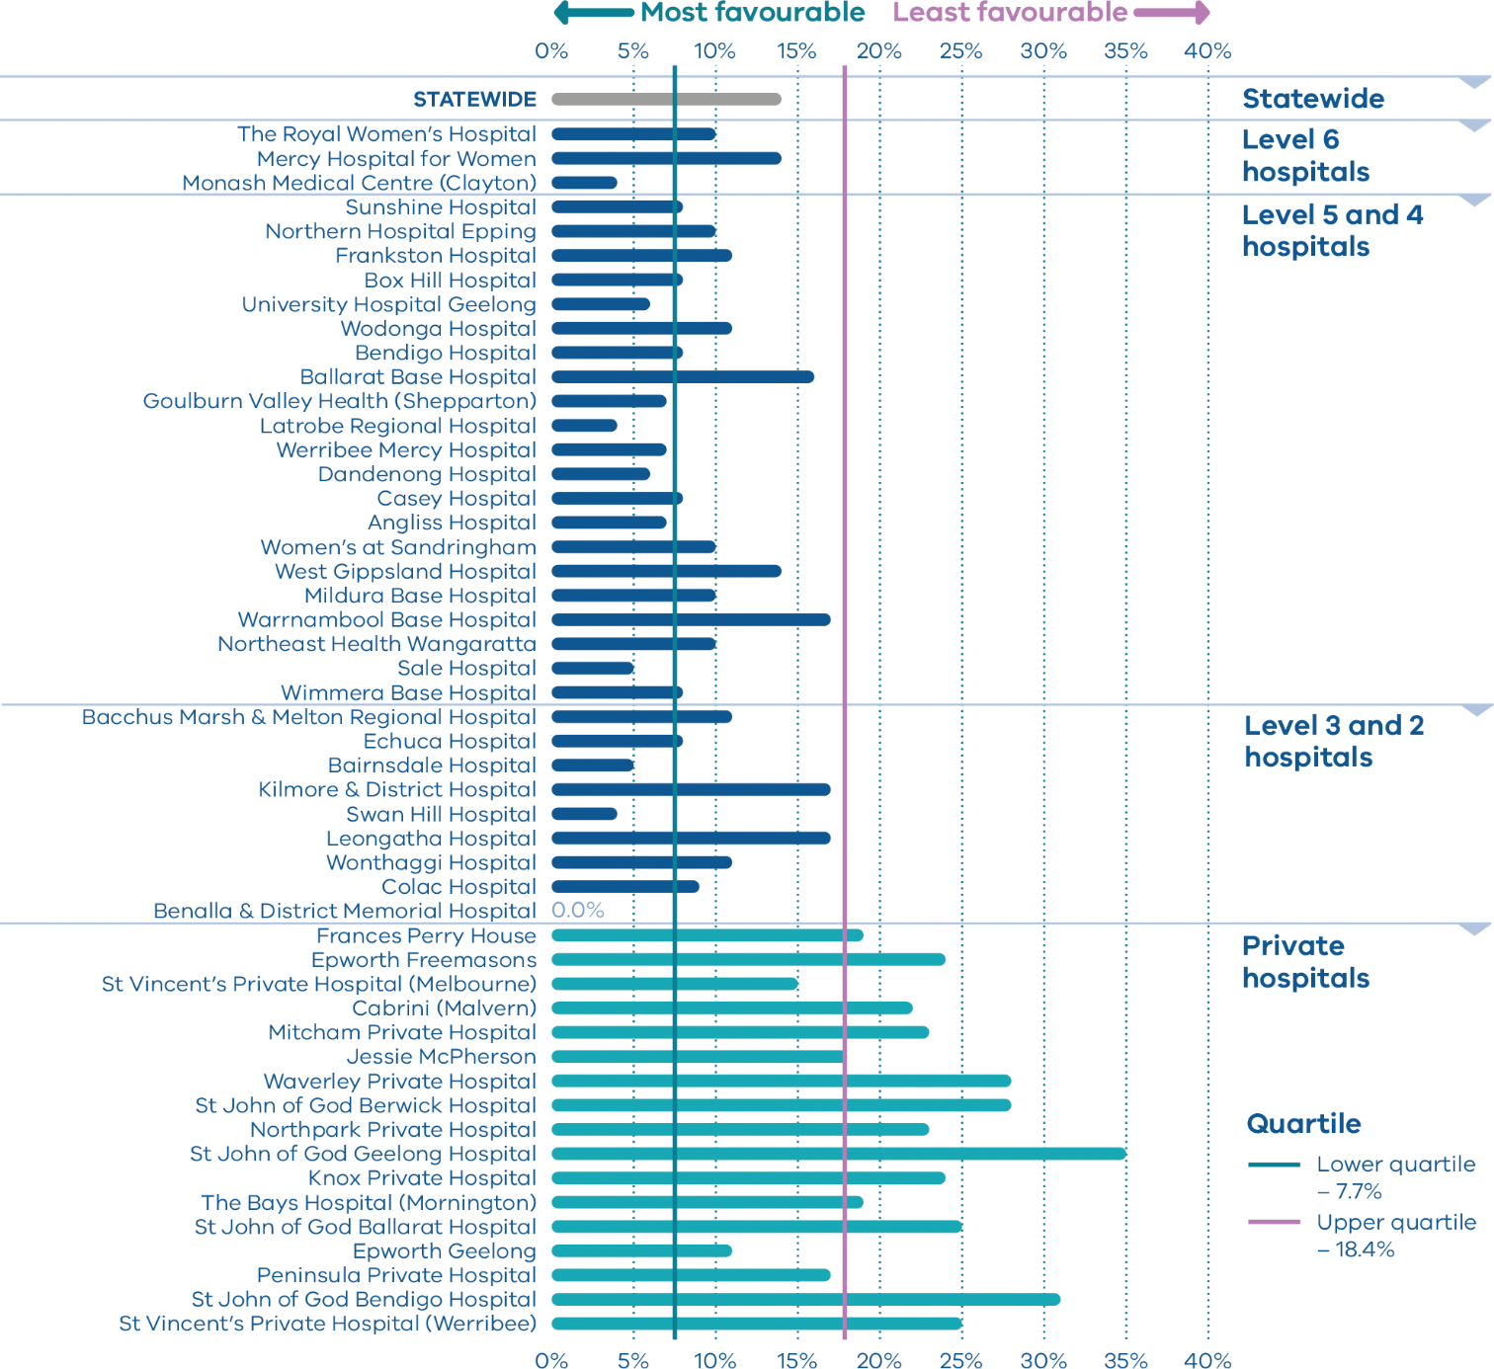

Indicator 1b: Caesarean sections in primiparae

Definition
This indicator shows the rate of caesarean sections in primiparae giving birth to one baby at more than 37 weeks’ gestation with cephalic (head-first) presentation in:
1bi. Robson group 1 (spontaneous labour)
1bii. Modified Robson group 2 (induced labour).
The Robson classification system (also known as the 10-group classification) categorises all women into one of 10 groups that are mutually exclusive and exhaustive based on basic obstetric characteristics.
Robson group 1 (Indicator 1bi) includes first-time birthing women with a singleton cephalic pregnancy, at greater than or equal to 37 weeks’ gestation in spontaneous labour.
Modified Robson group 2 (Indicator 1bii) includes women having their first baby with a singleton cephalic pregnancy, at greater than or equal to 37 weeks’ gestation who had labour induced. Modified Robson group 2 excludes pre-labour caesareans, which are included in the standard Robson group 2.

Clinical significance
Caesarean sections are lifesaving in some situations. They are accompanied by higher morbidity for women and babies, slower recovery, increased risk of placental complications in subsequent births and increased cost to the healthcare system. A caesarean birth for the first baby increases the risk of caesarean birth for subsequent babies.

Observations on the data
The statewide rate of primiparae in Robson group 1 who gave birth by caesarean section (following a spontaneous labour) (Indicator 1bi) was 16.7 per cent. The rate was lower across public hospitals (15.3 per cent) than private hospitals (21.8 per cent, p < 0.001) (Figure 4).
The statewide rate of primiparae in modified Robson group 2 who gave birth by caesarean section (following an induced labour) (Indicator 1bii) was 30.6 per cent and was also lower in public than private hospitals (30.2 and 31.9 per cent respectively, p = 0.076) (Figure 5).

Strategies for improvement
- Undertake regular multidisciplinary audit and review of the indications for and outcomes of caesarean section (weekly or monthly depending on the size of the service).
- Provide information (verbal and written) to women regarding the benefits and risks of caesarean section based on current evidence.
- Consider processes to have a second opinion prior to interventions.
Figure 4. Indicator 1bi: Rate of caesarean section in Robson group 1, 2018
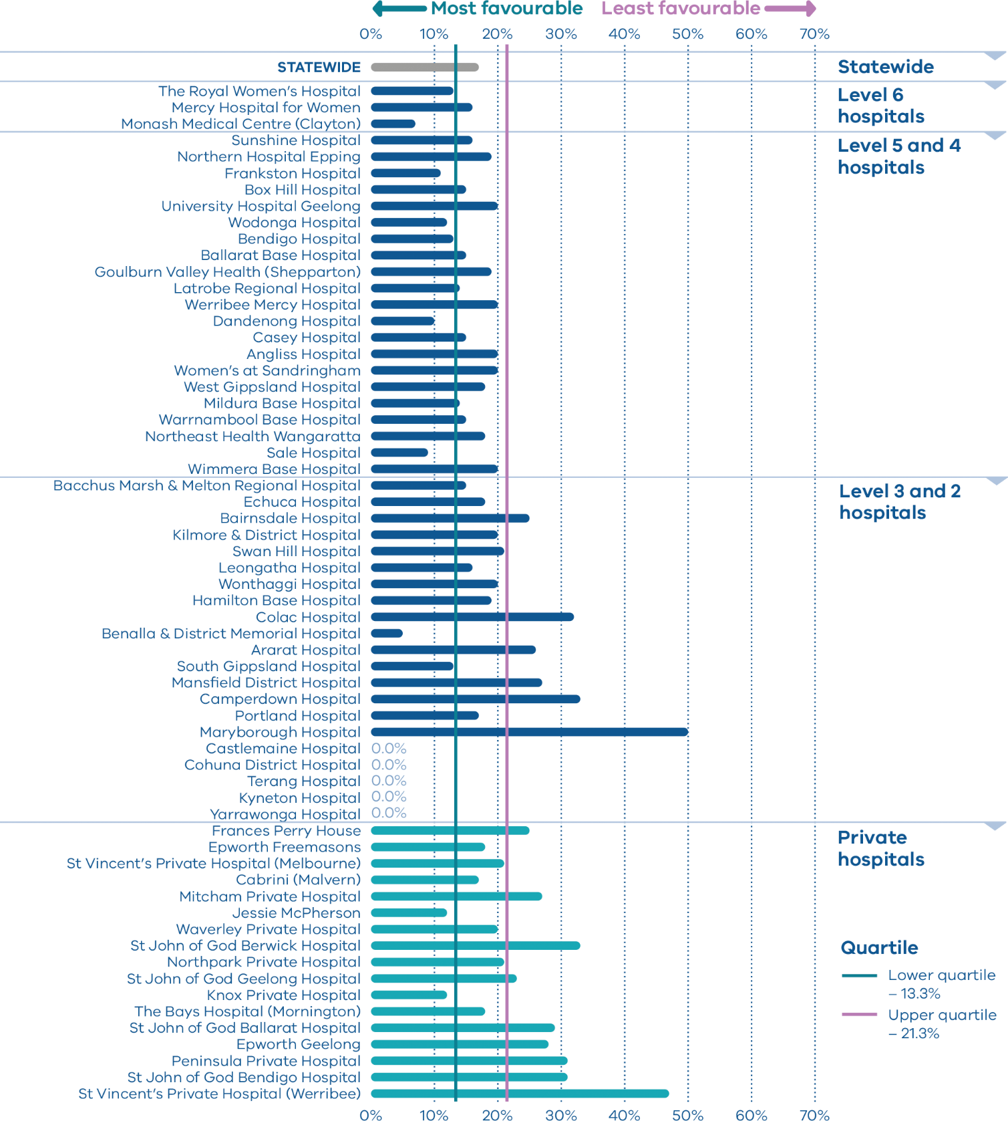
Figure 5. Indicator 1bii: Rate of caesarean section in modified Robson group 2, 2018
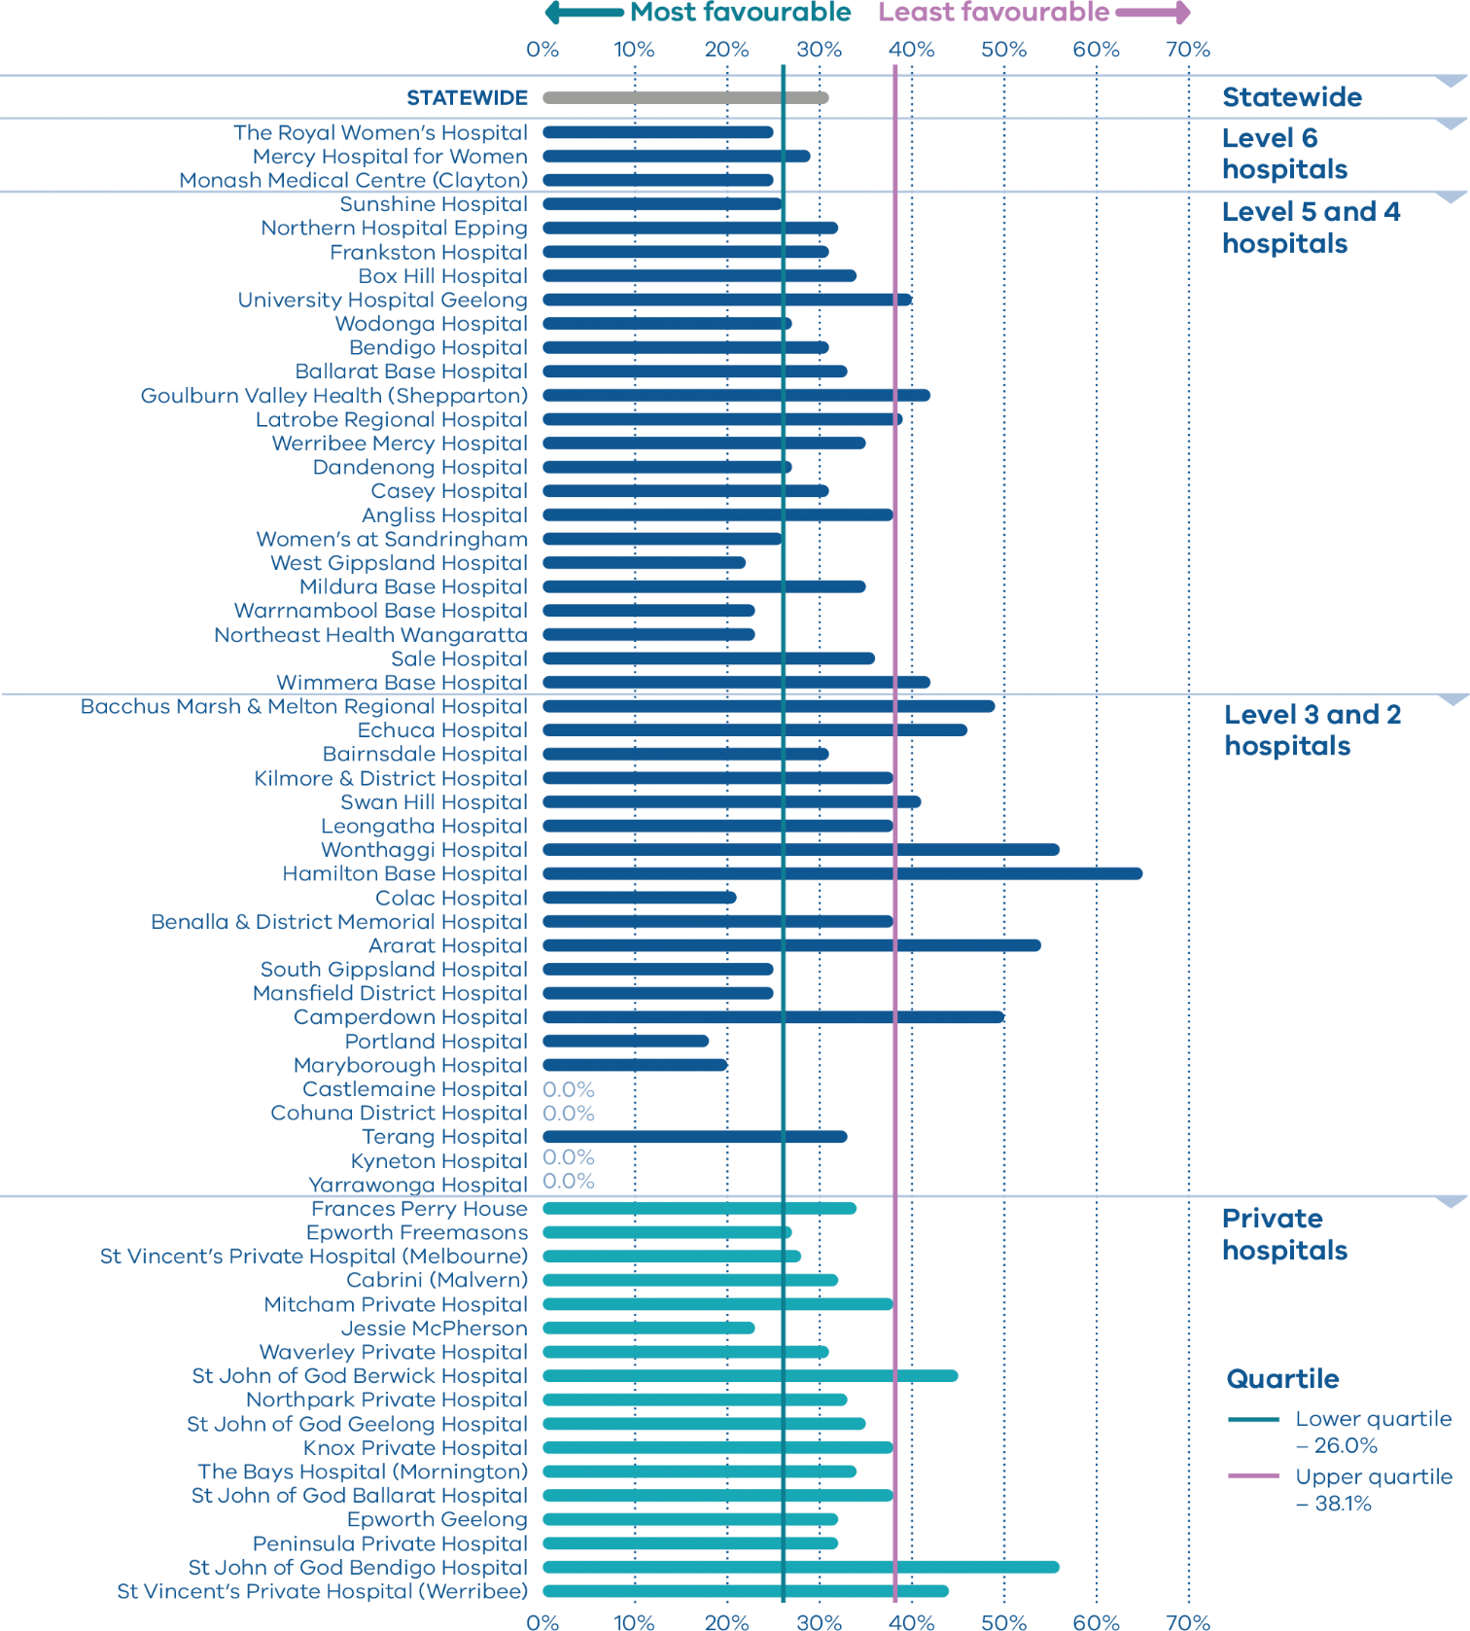
Table 2. Rate of caesarean section in Robson groups 1 and modified Robson group 2 between 2016 and 2018
 | Robson Group 1 |  |  | Modified Robson Group 2
 | 2016 | 2017 | 2018 | 2016 | 2017 | 2018
Public | 14.9% | 15.0% | 15.3% | 30.4% | 29.6% | 30.2%
Private | 21.7% | 22.5% | 21.8% | 32.8% | 32.3% | 31.9%
Combined | 16.4% | 16.7% | 16.7% | 31.0% | 30.1% | 30.6%

Indicator 1c: Perineal tears in primiparae

Definition
This indicator shows the rate of third- and fourth-degree perineal tears in primiparae in:
(1ci) unassisted vaginal births
(1cii) assisted vaginal births.

Clinical significance
Third- and fourth-degree perineal tears are a significant birth-related complication that may lead to long-term disability. Women having their first birth vaginally in Victoria are four times more likely to experience a severe (third- or fourth degree) perineal laceration compared with those having a subsequent birth vaginally. It is important that, where possible, they are prevented from happening and, where they do happen, they are recognised so that appropriate treatment can be provided. Third- and fourth-degree tear rates may reflect the quality of intrapartum care or differences in the accuracy of identification and reporting. The SCV Better births for women collaborative <https://www.bettersafercare.vic.gov.au/our-work/clinical-improvement-and-innovation/reducing-perineal-tears> in partnership with the Institute for Healthcare Improvement is testing evidence-based clinical care bundles to reduce third- and fourth-degree perineal tear rates.

Observations on the data
The statewide rate of third- and fourth-degree perineal tears in unassisted vaginal births (Indicator 1ci) was 3.8 per cent. The rate was higher in public hospitals (4.4 per cent) than private hospitals (1.0 per cent, p < 0.001) (Figure 6).
The statewide rate of third- and fourth-degree tears in assisted vaginal births (Indicator 1cii) was 5.0 per cent. The rate was again higher in public hospitals (6.0 per cent) than private hospitals (2.4 per cent, p < 0.001) (Figure 7).
There was significant variation between individual hospitals in both unassisted and assisted vaginal births, from zero to 20.0 per cent and zero to 25.0 per cent respectively.

Strategies for improvement
- Ensure clinicians are following best practice including:
  - applying warm perineal compresses during the second stage of labour at the start of perineal stretching
  - with a spontaneous vaginal birth, using gentle verbal guidance to encourage a slow controlled birth of the fetal head and shoulders
  - episiotomy if indicated
  - a genito-anal examination following birth
  - accurate diagnosis and grading of perineal trauma by experienced clinicians.
- Communicating with women is essential in achieving success. Ensure women are informed and engaged in birth planning decisions.
- Ensure clinicians identify women at risk of perineal tears.
- Hospitals with high rates of perineal tears should review their practices.
- Ensure systems are in place to provide clinical follow-up to women affected post-discharge and to monitor their outcomes over time.
Figure 6. Indicator 1ci: Rate of third- and fourth-degree perineal tears during unassisted vaginal births to primiparae, 2018
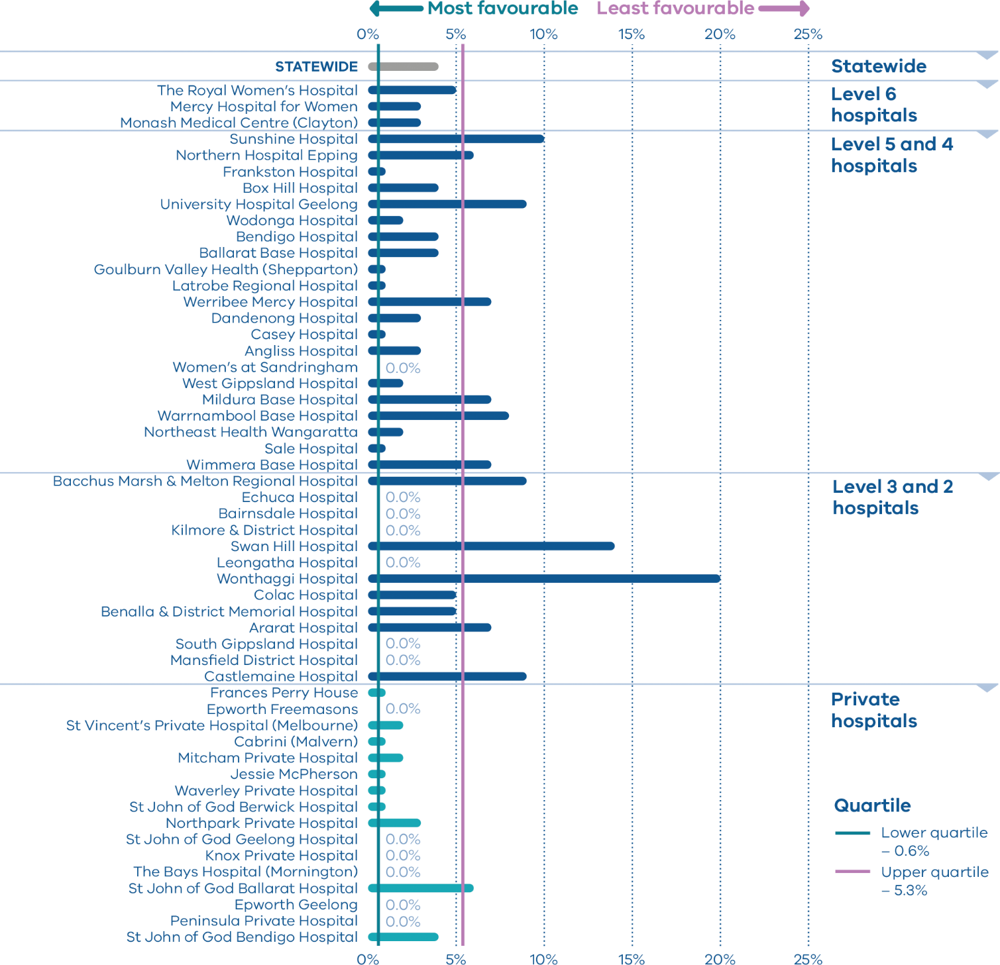
Figure 7. Indicator 1cii: Rate of third- and fourth-degree perineal tears during assisted vaginal births to primiparae, 2018
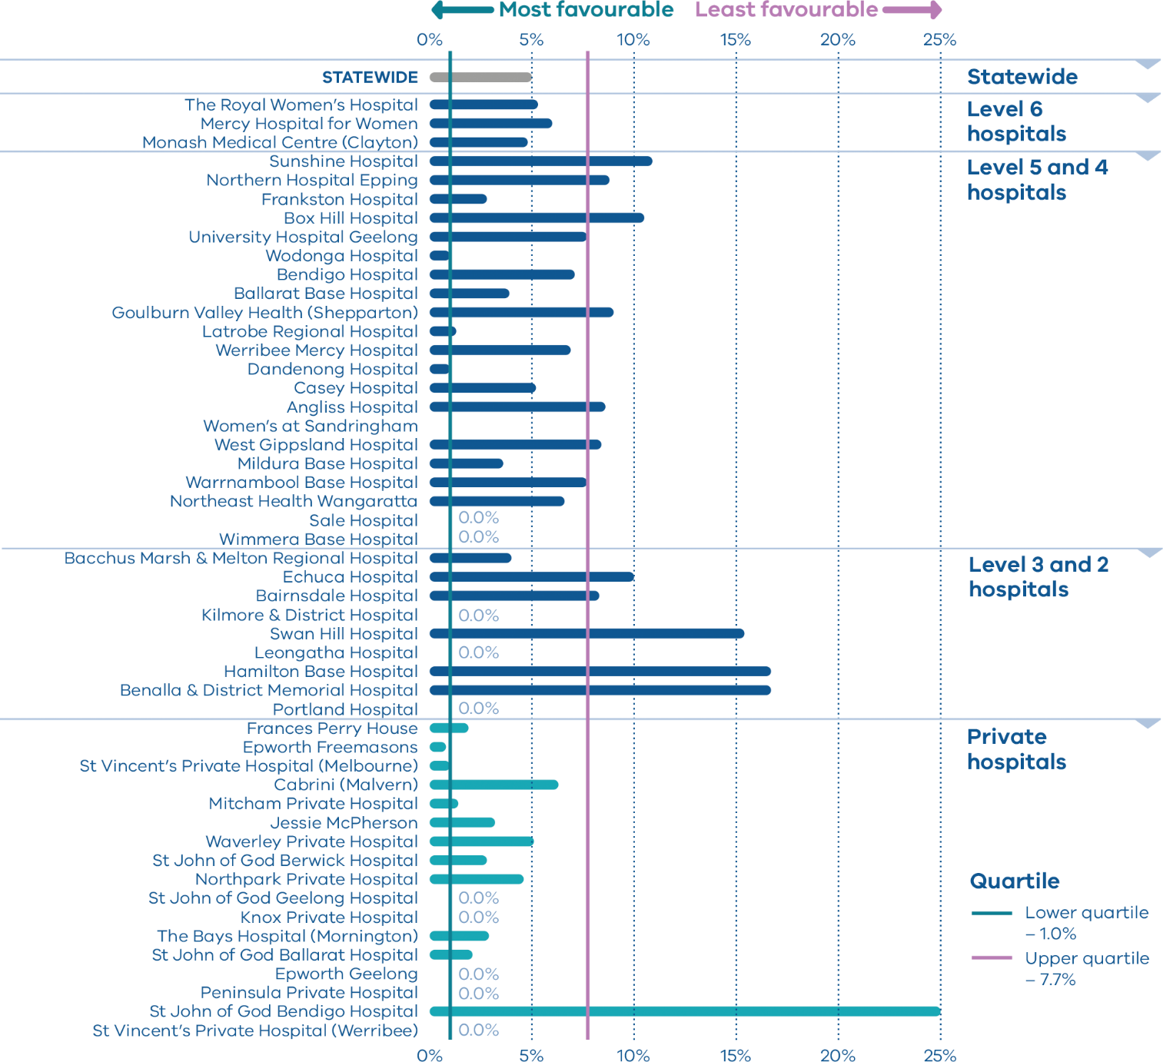
Table 3. Rate of third- and fourth-degree perineal tears, 2016–2018
 | During unassisted vaginal births |  |  | During assisted vaginal births
 | 2016 | 2017 | 2018 | 2016 | 2017 | 2018
Public | 4.9% | 3.6% | 4.4% | 7.7% | 5.5% | 6.0%
Private | 1.3% | 1.0% | 1.0% | 2.5% | 2.5% | 2.4%
Combined | 4.3% | 3.2% | 3.8% | 6.2% | 4.7% | 5.0%

Indicator 1d: Episiotomies in primiparae

Definition
This indicator shows the rate of episiotomy in primiparae for:
(1di) unassisted vaginal births
(1dii) assisted vaginal births.

Clinical significance
An episiotomy should only be performed when clinically indicated, such as in an instrumental birth, suspected fetal compromise, or when severe perineal trauma is anticipated.

Observations on the data
The statewide rate of episiotomy in unassisted vaginal births (Indicator 1di) was 26.5 per cent. The rate was lower in public hospitals (25.3 per cent) than private hospitals (33.9 per cent, p < 0.001) (Figure 8).
The statewide rate of episiotomy in assisted vaginal births (Indicator 1dii) was 83.1 per cent. The rate was higher in public hospitals than private hospitals at 87.0 and 72.3 per cent respectively (p < 0.001) (Figure 9).
There was significant variation between individual hospitals in both unassisted and assisted vaginal births, including those of similar size and capability level.

Strategies for improvement
- Undertake regular multidisciplinary audits and reviews of the indications for and outcomes of episiotomy for all unassisted vaginal births (weekly or monthly depending on the size of the service).
- Provide information (verbal and written) to women regarding the benefits and risks of an episiotomy based on best evidence.
- Ensure systems are in place to provide information for women regarding care of episiotomy after discharge.
Figure 8. Indicator 1di: Rate of primiparae who received an episiotomy during unassisted vaginal births, 2018
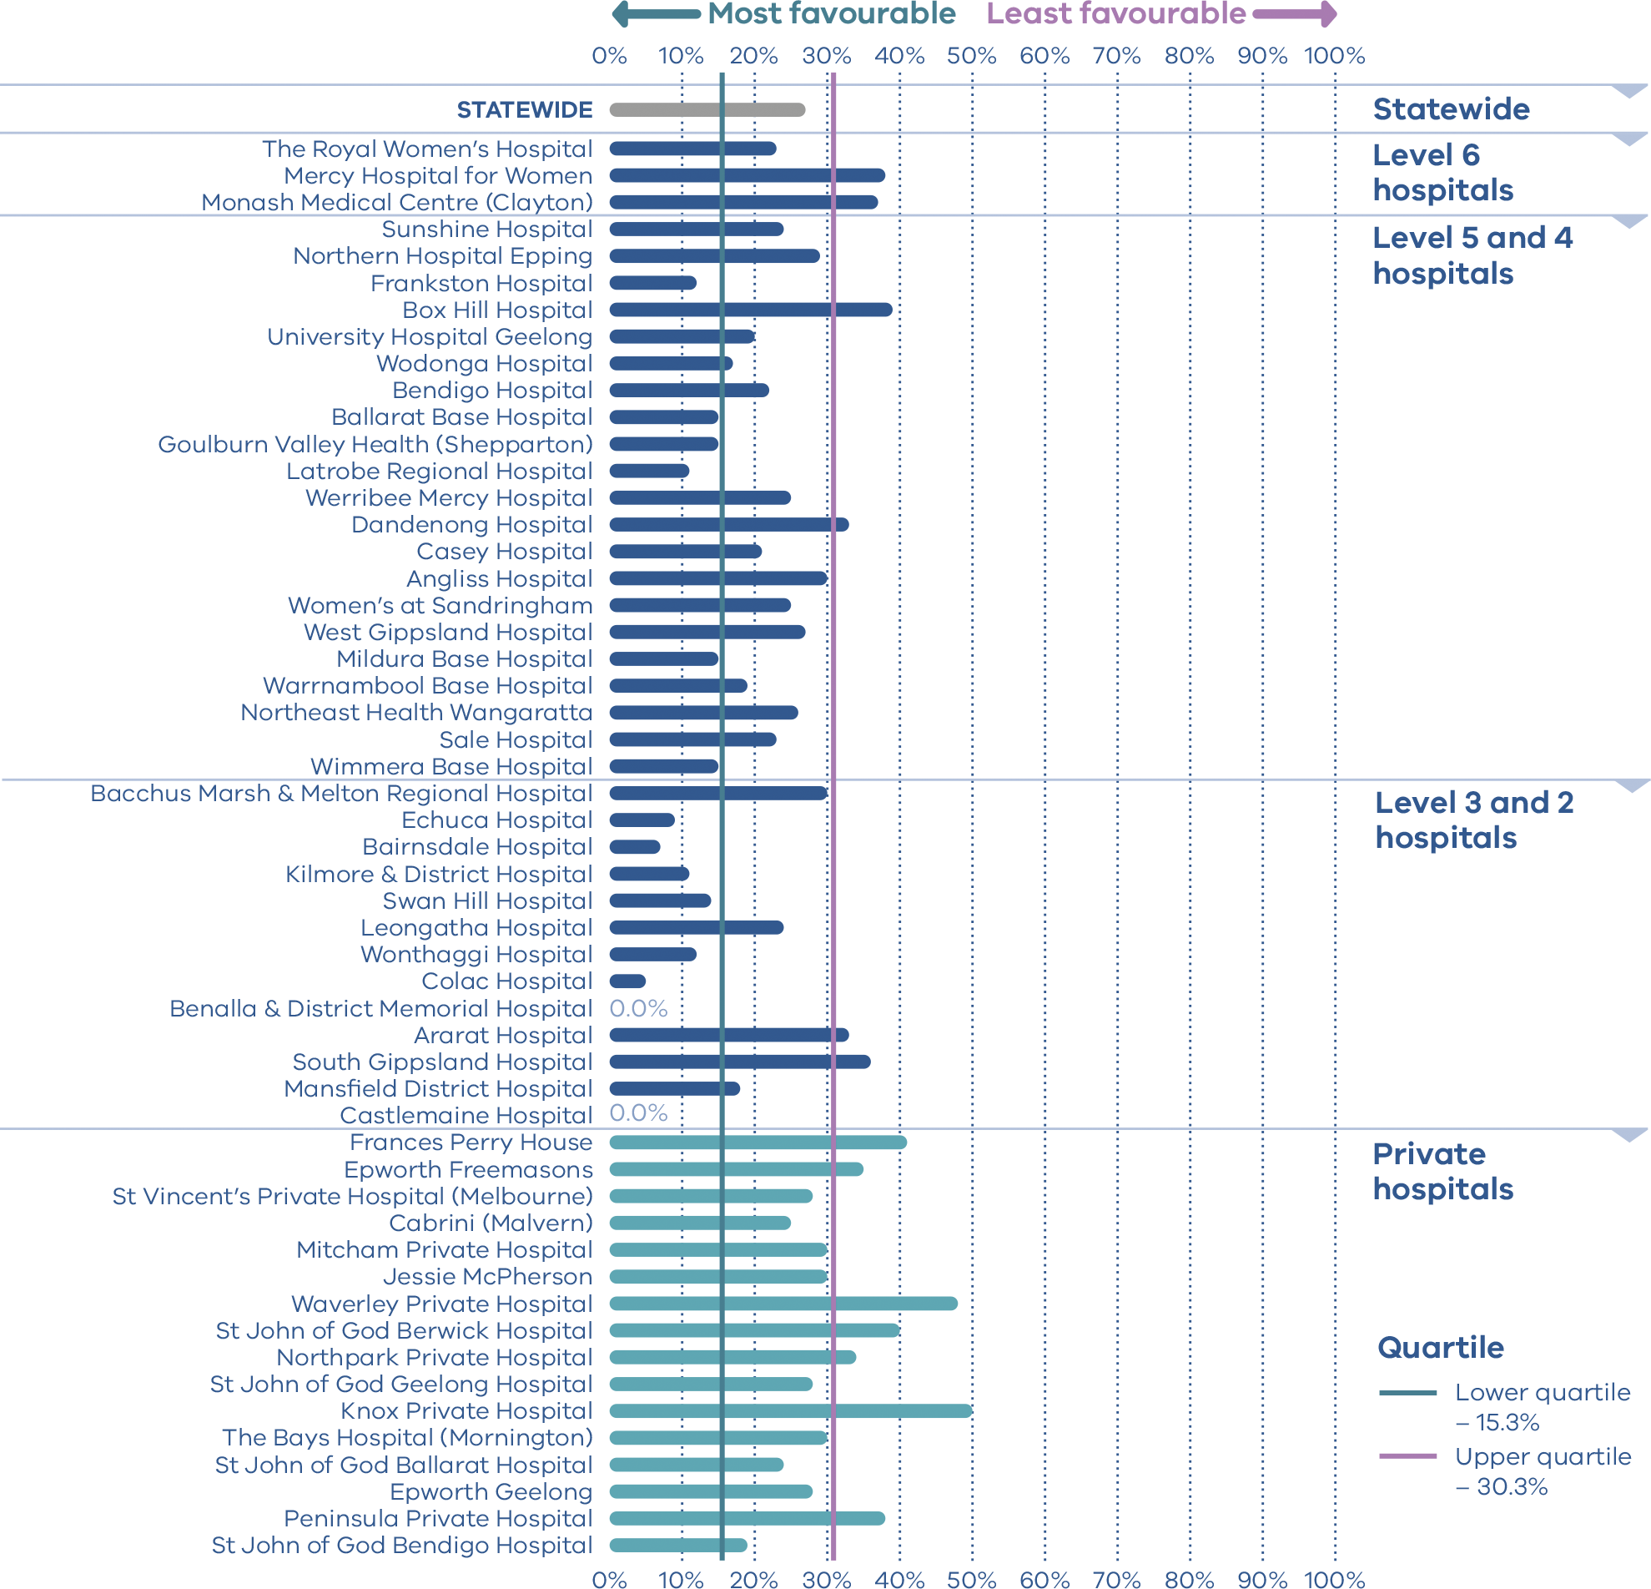
Figure 9. Indicator 1dii: Rate of primiparae who received an episiotomy during assisted vaginal births, 2018
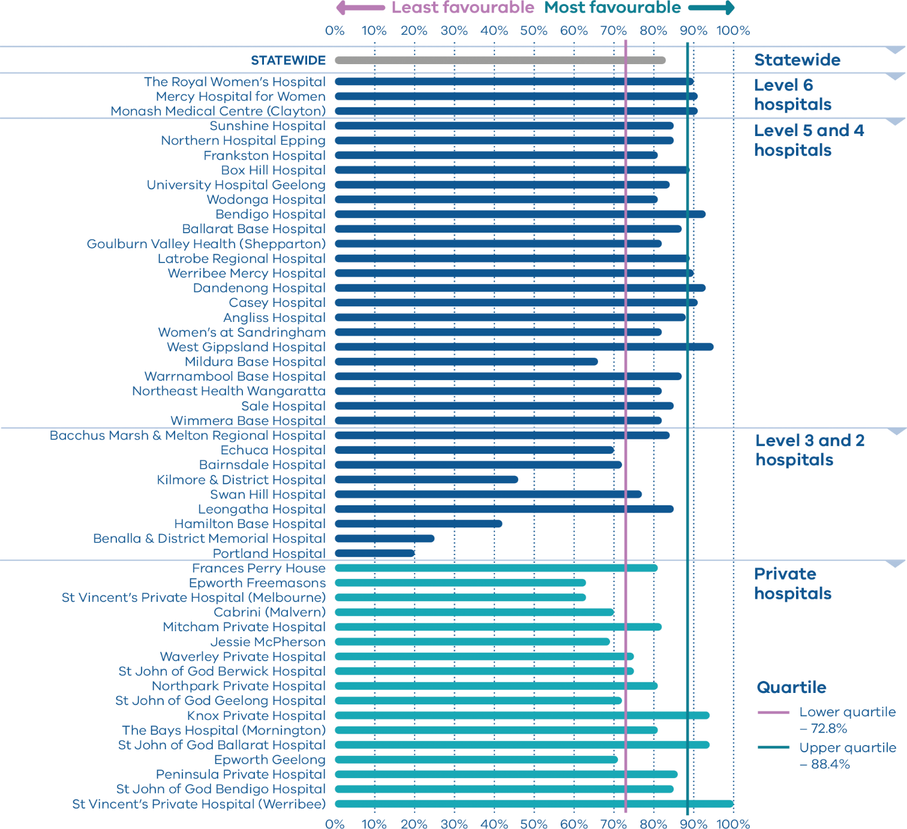
Table 4. Rate of primiparae who received an episiotomy, 2016–2018
 | During unassisted vaginal births |  |  | During assisted vaginal births
 | 2016 | 2017 | 2018 | 2016 | 2017 | 2018
Public | 24.8% | 25.4% | 25.3% | 85.6% | 85.7% | 87.0%
Private | 32.8% | 31.1% | 33.9% | 72.0% | 71.7% | 72.3%
Combined | 26.0% | 26.2% | 26.5% | 81.7% | 81.9% | 83.1%

Indicator 2: Term babies without congenital anomalies who required additional care

Definition
This indicator aims to highlight variations in the care required for term babies (born at 37 weeks or more) without congenital anomalies.
While we know some babies will experience medical conditions following birth that require admission to hospital for additional care (for example, jaundice, low Apgar score, sepsis or seizures), we expect the need for additional care and treatment in this cohort to be low.
Higher rates may indicate quality of care issues during labour, birth and/or the immediate neonatal period.

Clinical significance
Most inborn babies, born at 37 weeks or more, with a birthweight of at least 2,500 grams and without the presence of a congenital anomaly are not expected to require additional care following birth.
As such, the indicator indirectly measures the quality of care provided during pregnancy, labour and birth and in the early neonatal period.

Observations on the data
The statewide public hospital rate of term babies without congenital anomalies who required additional care in 2018–19 was 9.2 per cent. Data show variation between hospitals, ranging from zero to 17.6 per cent (Figures 10 and 11).

Strategies for improvement
- Undertake multidisciplinary reviews of adverse events and outcomes to identify areas for clinical practice or system improvement.
- Monitor the competency and confidence of clinicians in fetal surveillance during labour and in neonatal resuscitation.
- Ensure the availability and use of senior clinicians to supervise junior clinicians and that care is escalated both during and after hours.
- Review reporting to the VAED to ensure accurate capture and reporting of diagnostic treatment codes relevant to the newborn.
Figure 10. Indicator 2: Rate of term babies without congenital anomalies who required additional care, 2018–19
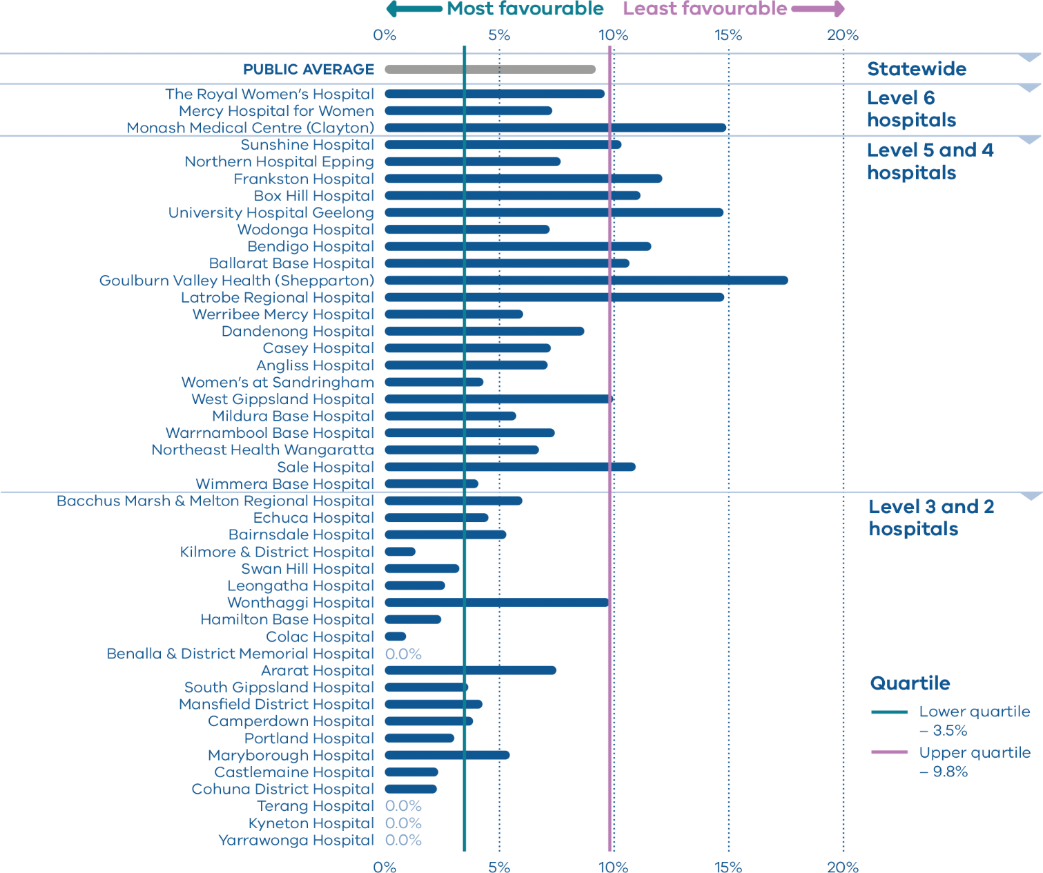
Note: Reporting of unqualified neonate admissions to the VAED for private hospitals is optional. It is therefore not possible to establish an accurate denominator (that includes public and private hospitals) for this indicator. As such, only public hospitals are included in the results.
Figure 11. Rate of term babies without congenital anomalies who required additional care, by financial year, 2014–15 to 2018–19
 | 2014–15 | 2015–16 | 2016–17 | 2017–18 | 2018–19
Public | 8.5% | 8.6% | 9.4% | 8.7% | 9.2%
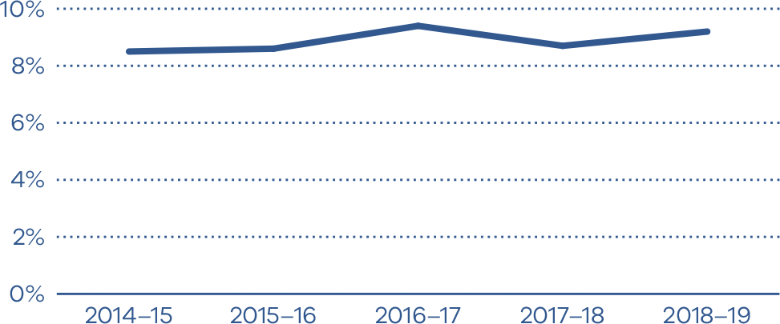

Indicator 3: Severe fetal growth restriction

Definition
This indicator shows the proportion of severely growth restricted singleton babies (defined as birthweight below the third centile, corrected for gestational age, plurality and sex) who were born at or after 40 weeks’ gestation.

Clinical significance
Undetected FGR is the strongest risk factor for stillbirth and is associated with poor perinatal and long-term outcomes, including low Apgar scores, birth asphyxia and neurodevelopmental delay. These risks are heightened in severe FGR.
The timely detection of severe FGR allows appropriate fetal surveillance and timing of birth to optimise short and longer term outcomes for the child. The Safer Baby Collaborative <https://www.bettersafercare.vic.gov.au/our-work/clinical-improvement-and-innovation/reducing-stillbirth> is aiming to significantly reduce the rate of stillbirths in Victoria by focusing on five key aspects of care including improving the diagnosis and management of FGR.

Observations on the data
In 2018, 24.3 per cent of singleton babies with severe FGR were born at 40 or more weeks’ gestation in Victorian public and private hospitals. This is an improvement from 28.1 per cent in 2017 (p = 0.025). The rate was significantly lower in public hospitals compared with private hospitals (23.0 and 30.2 per cent respectively, p = 0.025). However, there is wide variation between individual hospitals, from 8.3 per cent to 50.0 per cent (Figures 12 and 13).

Strategies for improvement
Improved detection of severe FGR and improved monitoring and management of these pregnancies is important.
- A severely growth restricted baby born at 40 or more weeks’ gestation implies that the growth restriction was not recognised. Monitor rates and outcomes of growth-restricted babies delivered at or after 40 weeks at regular intervals (monthly or quarterly depending on the size of the service) including the possible reasons for the lack of detection.
- Contact SCV’s Maternity and Newborn Clinical Network for support.
- Risk-screen women for FGR.
- Inform women and clinicians about FGR as a risk factor for stillbirth.
- Measure fetal growth consistently during pregnancy.
- Plot symphyseal fundal height and estimated fetal weight on growth charts. Escalate any abnormal findings.
- Provide direct feedback to clinicians following multidisciplinary case review.
- Support clinicians to optimise their competency and confidence in assessing fetal size during pregnancy.
- Educate and train clinicians in FGR.
- Review and update local fetal surveillance procedures and FGR guidelines to ensure there is a clear and evidence-based course of action.
- Provide clinicians with consistent clinical guidance on FGR.
- Ensure obstetric ultrasound procedures to monitor fetal wellbeing and growth are of high quality and according to current clinical standards.
- Refer women with higher risk pregnancies to the most appropriate level of service, within or outside of the organisation.
Figure 12. Indicator 3: Rate of severe fetal growth restriction in a singleton pregnancy undelivered by 40 weeks, 2018
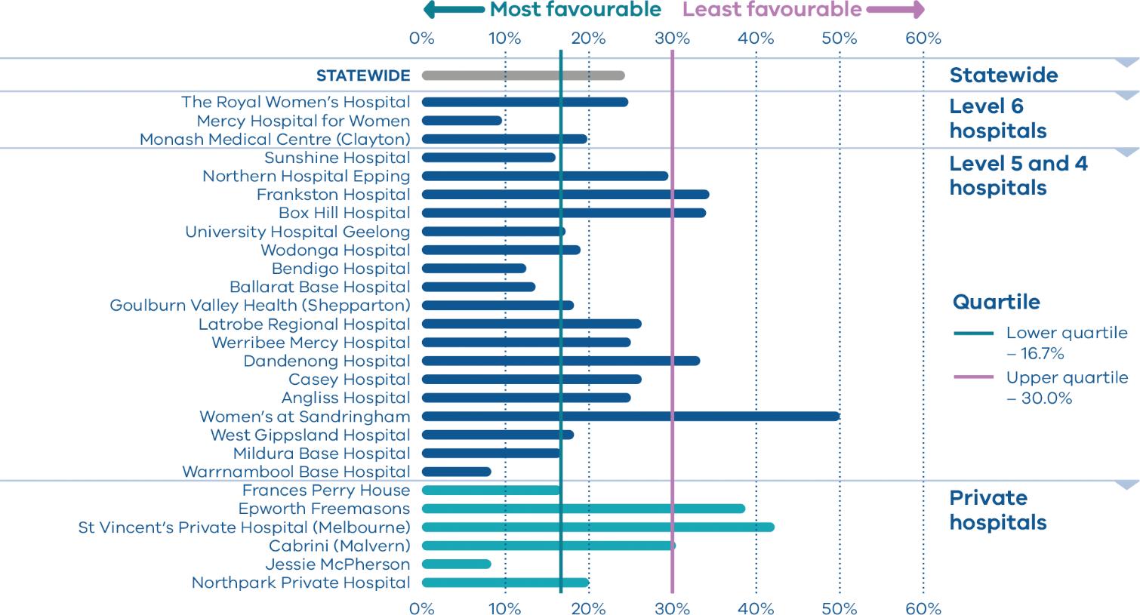
Figure 13. Rate of severe fetal growth restriction in a singleton pregnancy undelivered by 40 weeks, 2015–2018
 | 2015 | 2016 | 2017 | 2018
Public | 34.9% | 30.6% | 28.0% | 23.0%
Private | 36.3% | 31.1% | 28.8% | 30.2%
Combined |  | 30.8% | 28.1% | 24.3%
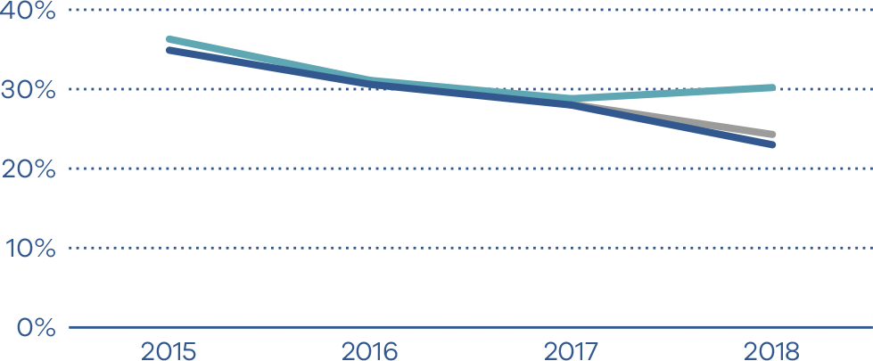

Indicators 4a and 4b: Vaginal birth after primary caesarean section

Definition
Indicator 4a identifies the proportion of women who planned for a vaginal birth for their second baby after a caesarean section for their first (VBAC).
Indicator 4b shows the proportion of women who planned a VBAC who achieved a VBAC.

Clinical significance
Caesarean sections are often necessary and can improve outcomes for women and babies. However, caesareans can prolong recovery after birth and can increase the chance of long-term health risks and major complications in subsequent pregnancies.
Two main strategies can be used to increase the rate of vaginal birth after primary caesarean section:
- Safely preventing a women’s first caesarean section will reduce the need for caesarean in subsequent births.
- If there are no contraindications, women who have had prior caesareans should be encouraged to consider and plan a VBAC.
For health services, caesarean sections require additional resources and add costs. Not all health services are equipped to provide women with the opportunity to attempt a VBAC. Level 1 and 2 services are not able to provide VBACs under the Capability frameworks for Victorian maternity and newborn services (2019).

Observations on the data
The proportion of women planning a VBAC (Indicator 4a) decreased from 27.8 per cent in 2017 to 27.1 per cent in 2018 for public hospitals (p = 0.420) but increased slightly from 14.3 per cent in 2017 to 14.7 per cent in 2018 for private hospitals (p = 0.698). There was wide variation between hospitals, from zero to 55.6 per cent (Figures 14 and 15). Women in public hospitals were more likely than those in private hospitals to attempt a VBAC (p < 0.001).
The proportion of women who achieved a planned VBAC (Indicator 4b) increased from 2017 in both public (54.4 per cent in 2017, 55.0 per cent in 2018, p = 0.746) and private hospitals (42.8 per cent in 2017, 46.9 per cent in 2018, p = 0.283). Again, there was wide variation in rates between hospitals, from 31.7 per cent to 79.3 per cent (Figures 16 and 17).

Strategies for improvement
- Women requesting a VBAC should be referred to a service with the capability to perform this.
- Ensure your health service is aligned with evidence-based clinical guidelines for induction of labour.
- Report on the capability of the health service to offer a VBAC to women without contraindications.
- Undertake a review of the VBAC pathway offered and report on identified deficiencies to accessing facilities, specialists or standards of care.
- Provide evidence-based information (verbal and written) to women regarding the benefits and risks of VBACs.
Figure 14. Indicator 4a: Rate of women who planned a vaginal birth after a primary caesarean section, 2018
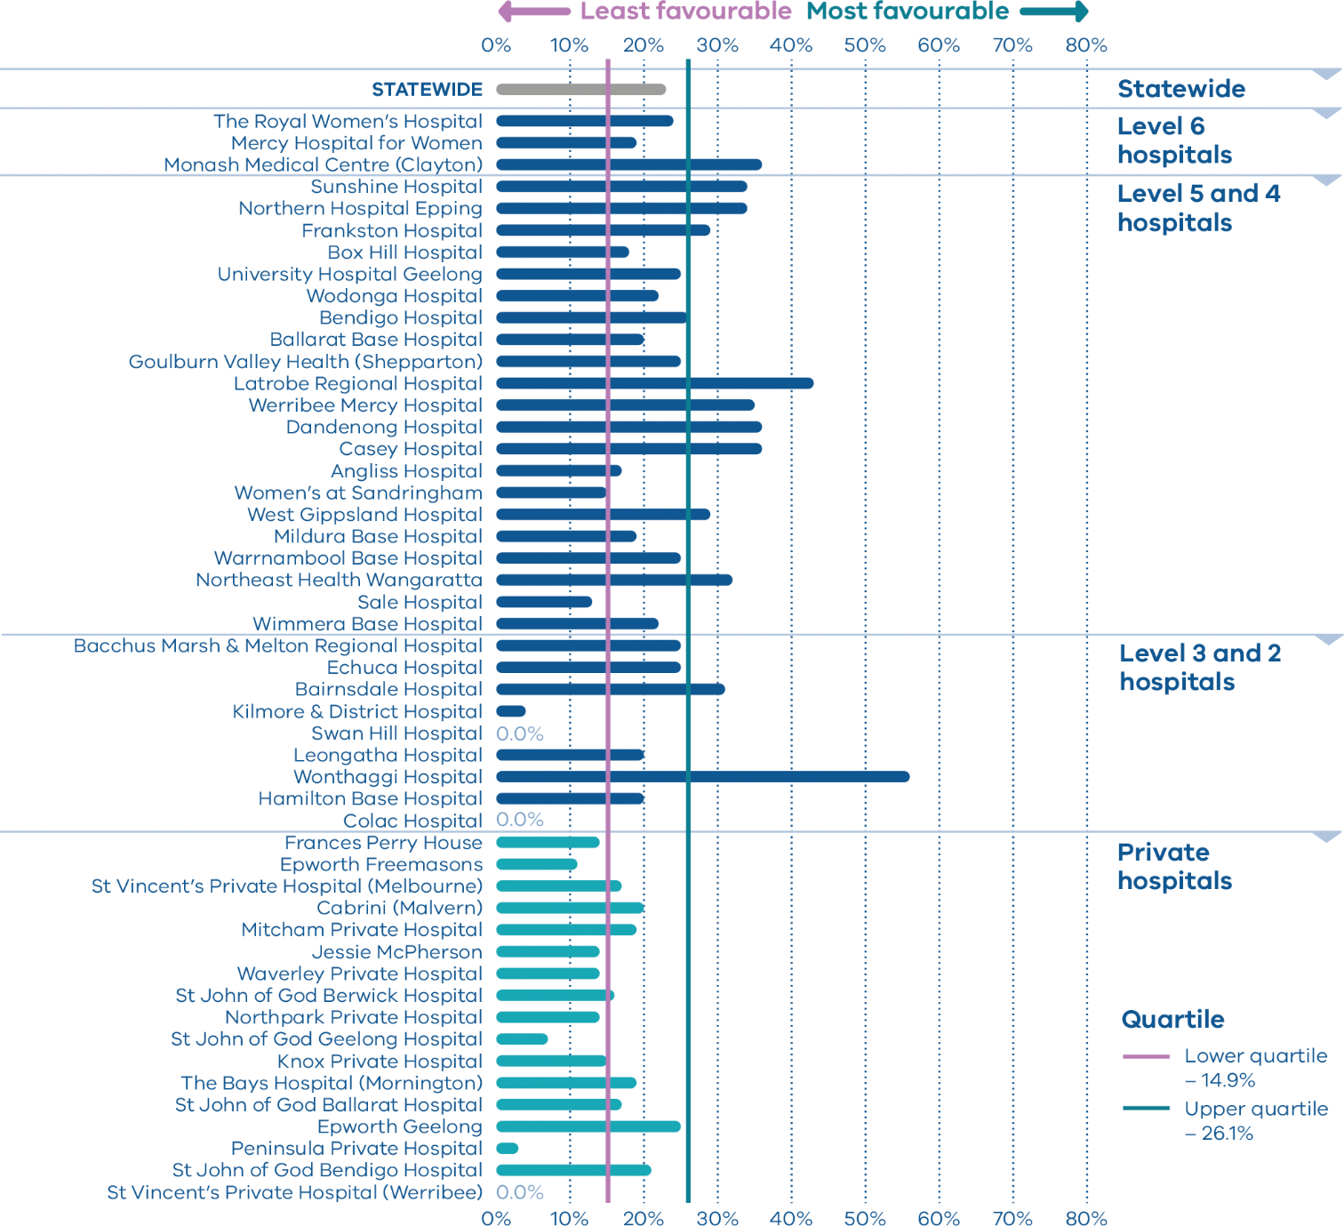
Figure 15. Rate of women who planned a vaginal birth after a primary caesarean section, 2014–2018
 | 2014 | 2015 | 2016 | 2017 | 2018
Public | 27.4% | 29.3% | 30.0% | 27.8% | 27.1%
Private | 15.4% | 15.8% | 16.3% | 14.3% | 14.7%
Combined |  |  | 25.5% | 23.7% | 23.4%
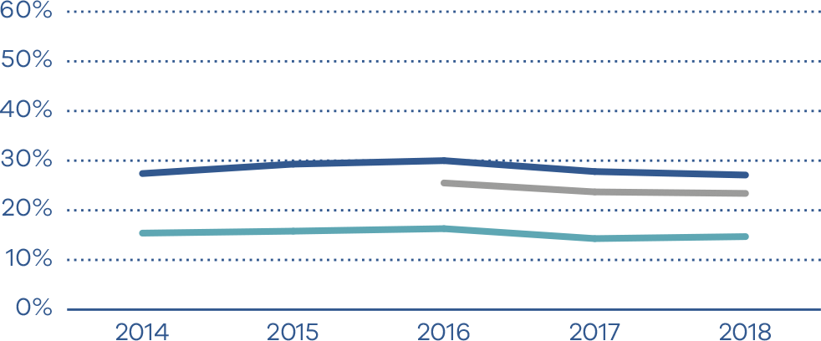
Figure 16. Indicator 4b: Rate of women who achieved a planned vaginal birth after a primary caesarean section, 2018
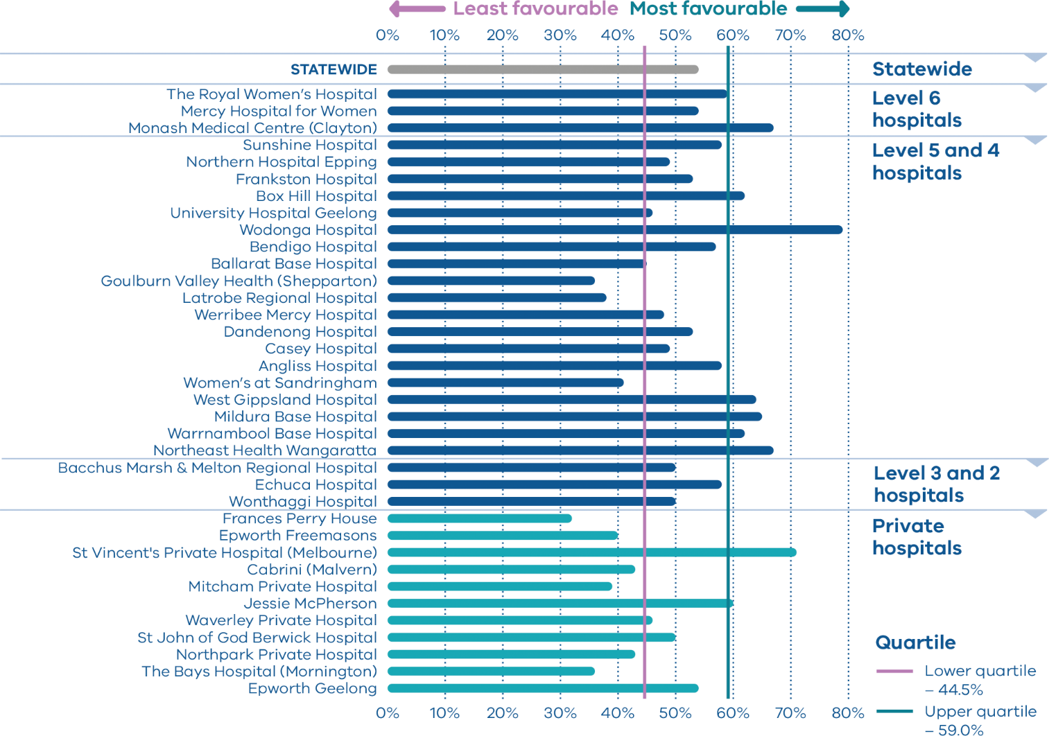
Figure 17. Rate of women who achieved a planned vaginal birth after a primary caesarean section, 2014–2018
 | 2014 | 2015 | 2016 | 2017 | 2018
Public | 54.2% | 57.7% | 56.4% | 54.4% | 55.0%
Private | 48.9% | 50.8% | 48.8% | 42.8% | 46.9%
Combined |  |  | 54.8% | 52.4% | 53.5%
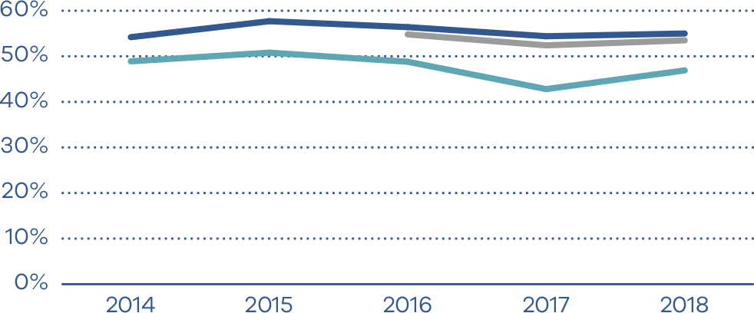

Indicator 5: Five-year gestation standardised perinatal mortality ratio

Definition
Gestation standardised perinatal mortality ratio (GSPMR) is a measure of perinatal mortality that compares the observed perinatal mortality rate for babies born at individual hospitals with what would be expected, accounting for the gestation at birth. It is a partially risk-adjusted calculation, enabling hospitals with higher proportions of births at lower gestations (and therefore higher likelihood of perinatal mortality) to be validly compared with hospitals that have a different casemix.
Perinatal mortality includes stillbirths (death before birth) and deaths in the first 28 days of babies born alive.
Pooling the data over five-year periods adds stability to the data and reduces the risk of over-interpretation of chance fluctuations.
The indicator provides a visual representation of the variation in perinatal mortality occurring across Victorian public and private hospitals compared with the statewide rate.

How to interpret the ratio
The statewide ratio (the reference population) is set at ‘1’. A GSPMR of 1 indicates that the observed number of perinatal deaths at that hospital is exactly what would be expected, considering the gestation of babies born there.
An individual hospital with a ratio of:
- 0.5 has a perinatal mortality that is half the statewide rate
- 1 has a perinatal mortality that is equal to the statewide rate
- 1.5 has a perinatal mortality that is 50 per cent above the statewide rate
- 2 represents perinatal mortality that is double the statewide rate.
These rates include only babies who were born at 32 or more weeks’ gestation.

What does the GSPMR tell us?
It shows where there is variation in perinatal mortality rates for hospitals of similar capability or size.
It adjusts for gestation, the most important risk factor for perinatal death.

What can’t the GSPMR tell us?
The GSPMR does not indicate:
- statewide or individual hospital perinatal mortality rates
- whether the results for a given hospital are improving over the five-year period
- the reasons for the deaths or how the babies died (a baby may have died before arriving at the birth hospital, while in the hospital or following discharge from hospital, for example, due to SIDS, a car accident or injury)
- whether the death could have been avoided
- whether the care around the time of death was provided by a different hospital (transfer) or health professional than the birth hospital
- where the baby died – it only tells us where the baby was born
- the safety of a maternity service
- the contribution of important risk factors associated with perinatal mortality such as obesity, smoking, pre-existing illness of the mother, low socioeconomic status and ethnicity.
Figure 18. Indicator 5: Funnel plot of five-year GSPMR compared with statewide public rate, 2014–2018
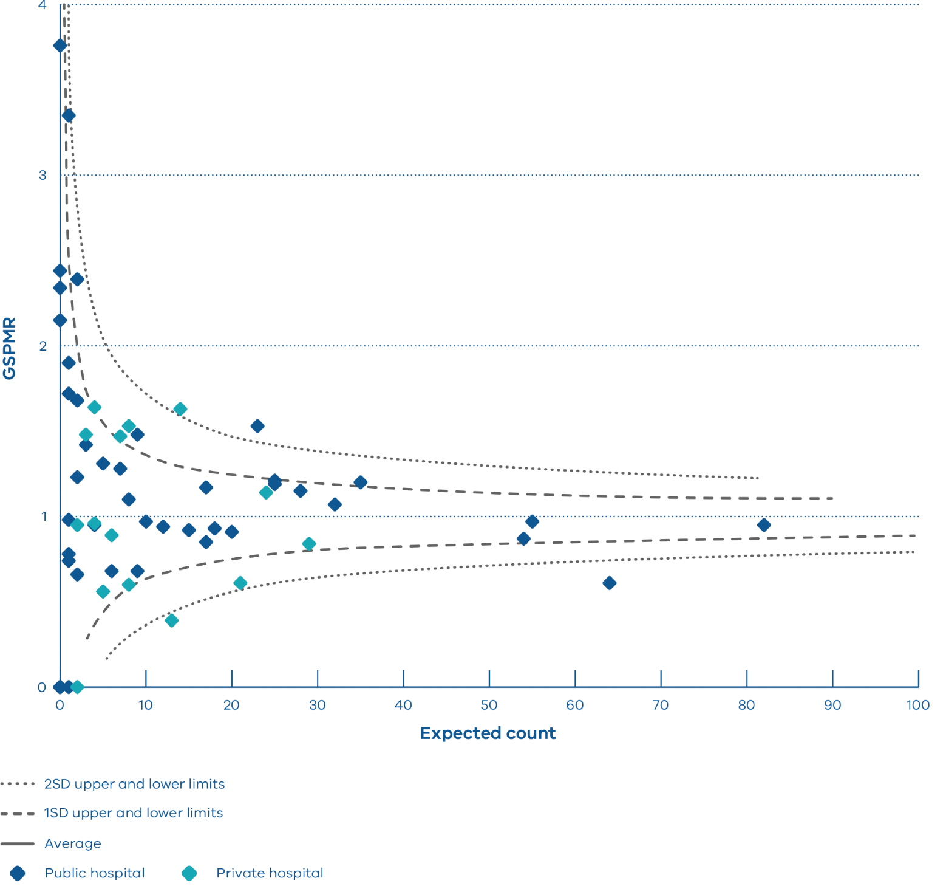
All health services are represented on the funnel plot. Those with results above or below one standard deviation from the mean are labelled. The GSPMRs for individual health services are given in Appendix 4.
The published GSPMR is moving progressively toward using the statewide (public and private combined) rates of death at each gestation as the comparator for public and private hospitals. 2018 results use this statewide comparator, while 2014-2017 use the public hospitals comparator for both public and private hospitals (as in previous reports).
How to read this plot
A funnel plot shows variation (differences) and how it compares with an average.
Each dot represents one hospital.
The solid horizontal line represents the average GSPMR of all hospitals. Hospitals (dots) that are above this line (above 1) have a GSPMR that is higher than the hospital average. Hospitals that are below this line (below 1) have a GSPMR that is lower than the hospital average. It is desirable to have a GSPMR of less than 1; however, due to the nature of this indicator, around half of all hospitals will always have a GSPMR greater than 1 and around half will have a GSPMR less than 1.
The dashed and dotted lines represent one and two standard deviation limits respectively. The standard deviations measure how different individual results are from the average, taking the size of the hospital into consideration. If a hospital falls outside of the two-standard deviation limit of the plot it is considered to be significantly different. Cabrini Malvern and Dandenong Hospital are higher than two standard deviations above the average. This shows they have a GSPMR that is significantly higher than the statewide average. Jessie McPherson and the Mercy Hospital for Women have a GSPMR that is significantly lower than the statewide average.
It is important to note that the GSPMR is adjusted only for the gestation at birth. Many other factors also put babies at higher and lower risk of perinatal death, including the socioeconomic situation of the woman. This may explain some of these results that are lower than average.

Indicators 6a and 6b: Readmissions during the postnatal period

Definition
These indicators measure the rate of unplanned and potentially preventable readmissions of pregnant women (Indicator 6a) and newborns (Indicator 6b) within 28 days of discharge from hospital.
High-quality care means most women and their babies should not return to hospital during the postnatal period. Unplanned and preventable hospital stays during this period reflects a deviation from the normal course of postnatal recovery. This results in increased healthcare costs and possible impacts on health and wellbeing for women and their babies.

Clinical significance
Postnatal care supports women to recover and adjust following birth, establish breastfeeding and develop early parenting skills. Providing high-quality and timely postnatal care can have a positive effect on the long-term health and wellbeing of women and their families.
Higher readmission rates are sometimes associated with inconsistent discharge procedures, poor postnatal care and limited support in the community. The transition from hospital to community-based maternity, newborn and maternal and child health services is a key point of care following birth. For most women and babies admitted as public patients, this transition usually occurs after at least one home visit by a hospital midwife. This visit should occur between 24 and 48 hours of discharge.

Observations on the data
In 2018–19 the statewide average rate of unplanned maternal readmissions within 28 days of discharge (Indicator 6a) was 2.6 per cent (Figures 19–21). The rate was higher in public hospitals at 2.7 per cent compared with private hospitals at 2.0 per cent (p < 0.0001).
The public hospital statewide average rate of unplanned newborn readmissions within 28 days of discharge (Indicator 6b) was 4.1 per cent (Figures 22–24).

Strategies for improvement
The reasons for local variation in practice can be multifactorial and encompass population differences, models of care, the influence of community care and readmission thresholds.
Use these data and your local analysis to review and improve postnatal care programs and links with community-based services such as maternal and child health services. This review should focus on women and newborns at higher risk of readmission to ensure they are receiving tailored and responsive care.
Specifically, health services should consider:
- whether the length of stay in hospital following birth is appropriate to the needs of women and babies considering their individual needs
- which groups of women and babies have higher readmission rates
- providing information and education tools for women and their families at discharge
- the number of home-based visits and the extent of care different groups of women can expect from hospital midwives
- an analysis of the reasons for readmission of pregnant women and newborns
- a review of the effectiveness of postnatal programs, including identifying areas of risk to women and babies.
Figure 19. Indicator 6a: Rate of maternal readmissions during the postnatal period, 2018–19
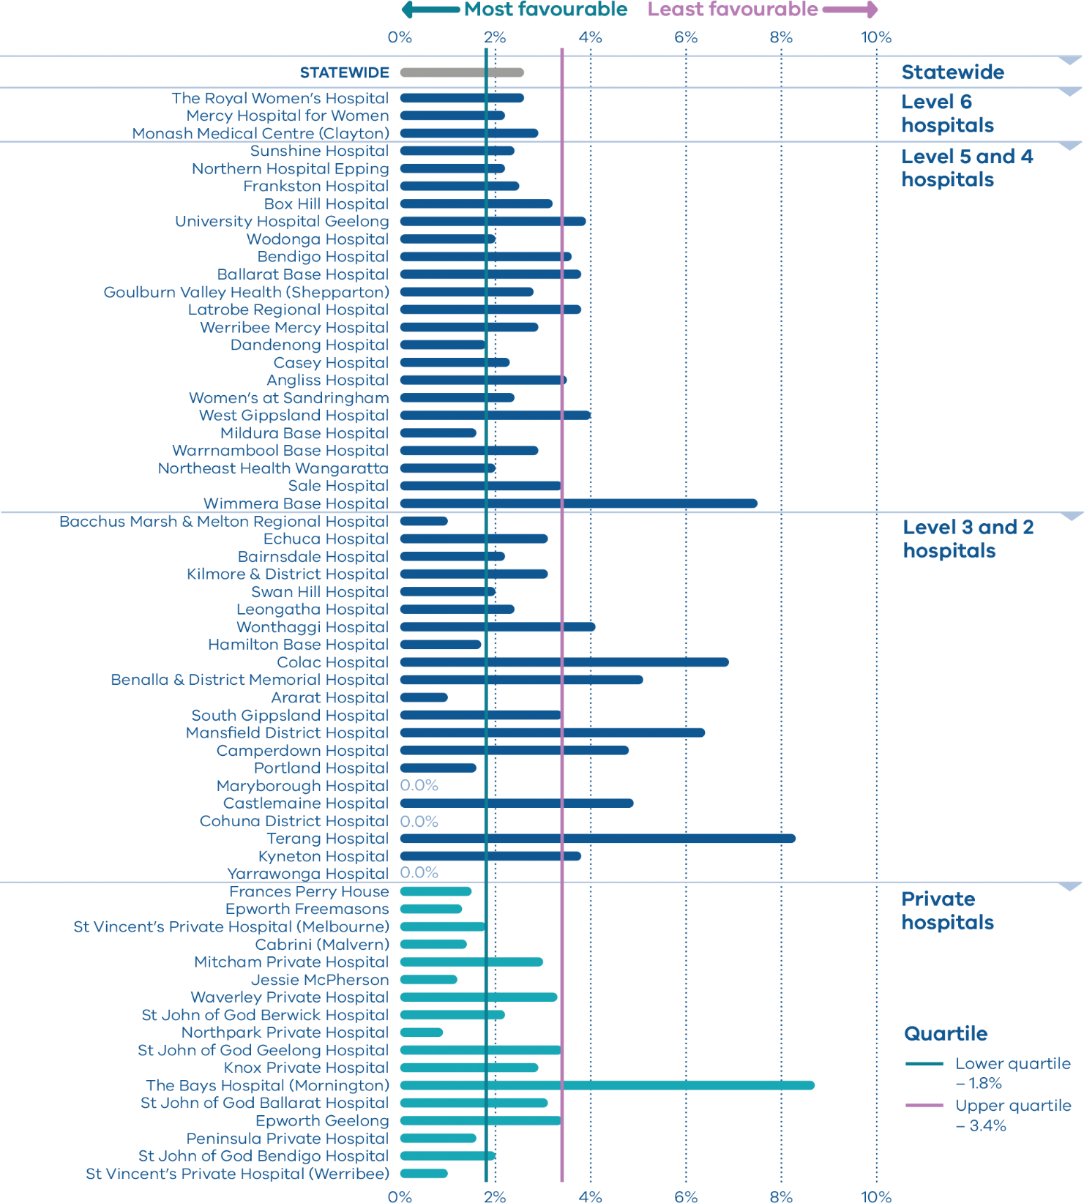
Figure 20. Rate of maternal readmissions during the postnatal period, by financial year, 2015–16 to
2018–19
 | 2015–16 | 2016–17 | 2017–18 | 2018–19
Public | 2.4% | 2.5% | 2.5% | 2.7%
Private |  | 2.5% | 2.5% | 2.0%
Combined |  | 2.5% | 2.5% | 2.6%
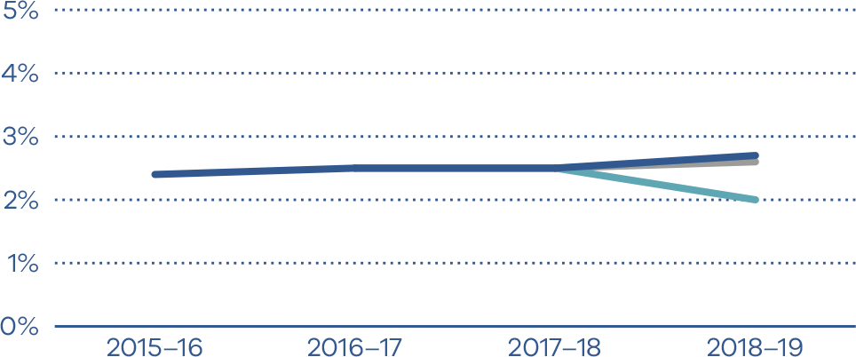
Figure 21. Funnel plot of maternal readmissions during the postnatal period, 2018–19
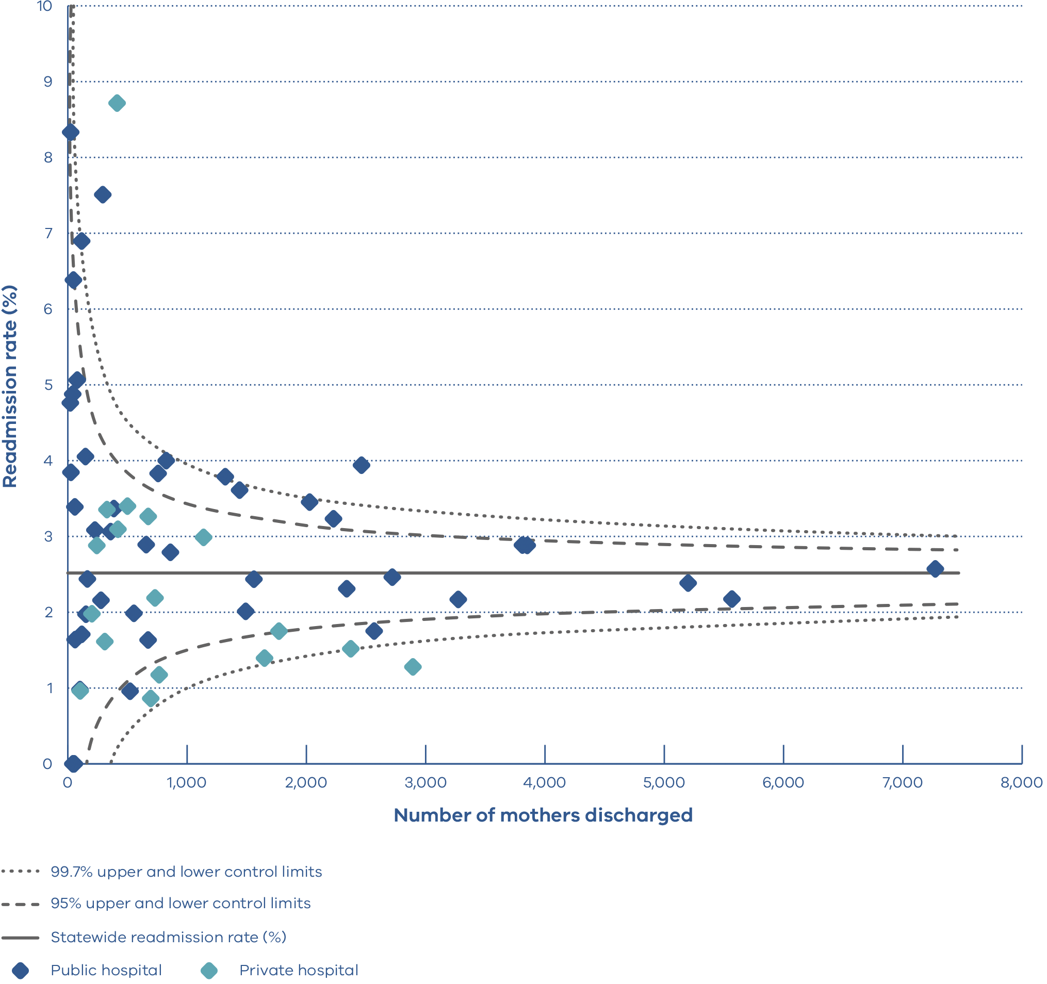
How to read this plot
A funnel plot shows variation (differences) and how it compares with an average.
Each dot represents the readmission rate for one hospital.
The solid horizontal line represents the average maternity readmission rate of all hospitals. Hospitals (dots) that are above this line have a maternal readmission rate that is higher than the statewide average. Hospitals that are below this line have a maternal readmission rate that is lower than the statewide average. It is desirable to have a maternal readmission rate below the solid line.
The dashed and dotted lines represent 95 per cent and 99.7 per cent confidence intervals respectively. Confidence intervals measure how different individual results are from the average, taking the size of the hospital into consideration. If a hospital falls outside of the 99.7 per cent confidence interval of the plot it is considered to be significantly different. Wimmera Base Hospital, The Bays Hospital and University Hospital Geelong have maternal readmission rates higher than the statewide average. Epworth Freemasons has a maternal readmission rate that is significantly lower than the statewide average.
Figure 22. Indicator 6b: Rate of newborn readmissions during the postnatal period, 2018–19
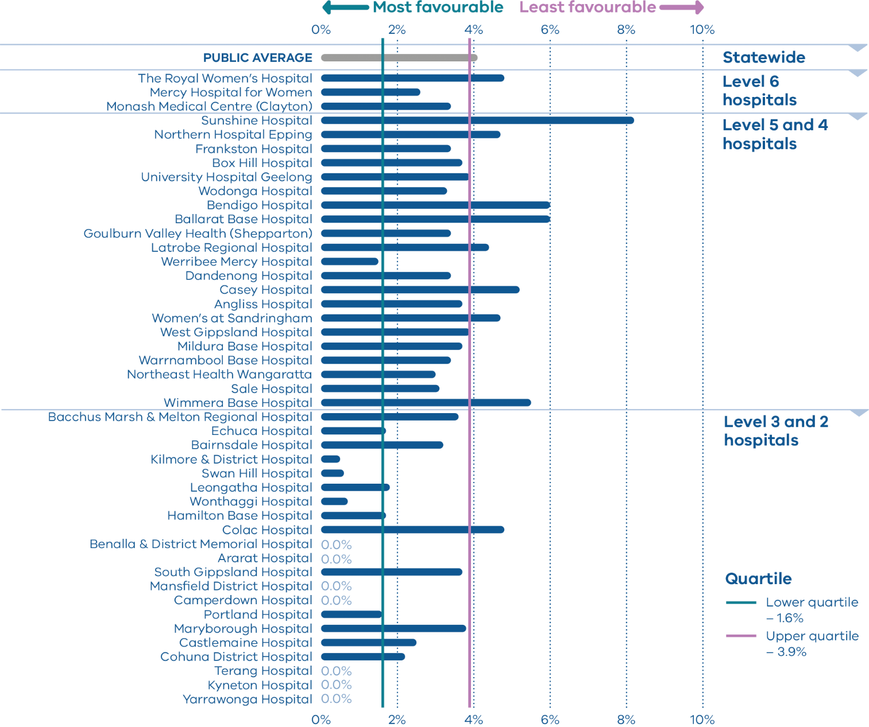
Note: Reporting of unqualified neonate admissions to the VAED for private hospitals is optional. It is therefore not possible to establish an accurate denominator (that includes public and private hospitals) for this indicator. As such, only public hospitals are included in the results.
Figure 23. Rate of newborn readmissions during the postnatal period, by financial year, 2015–16 to
2018–19
 | 2015–16 | 2016–17 | 2017–18 | 2018–19
Public | 4.0% | 4.2% | 4.1% | 4.1%
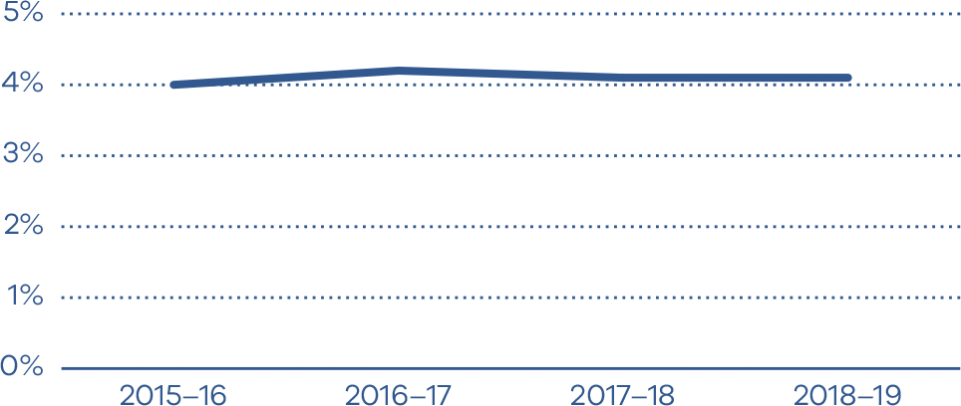
Figure 24. Funnel plot of newborn readmissions during the postnatal period, 2018–19
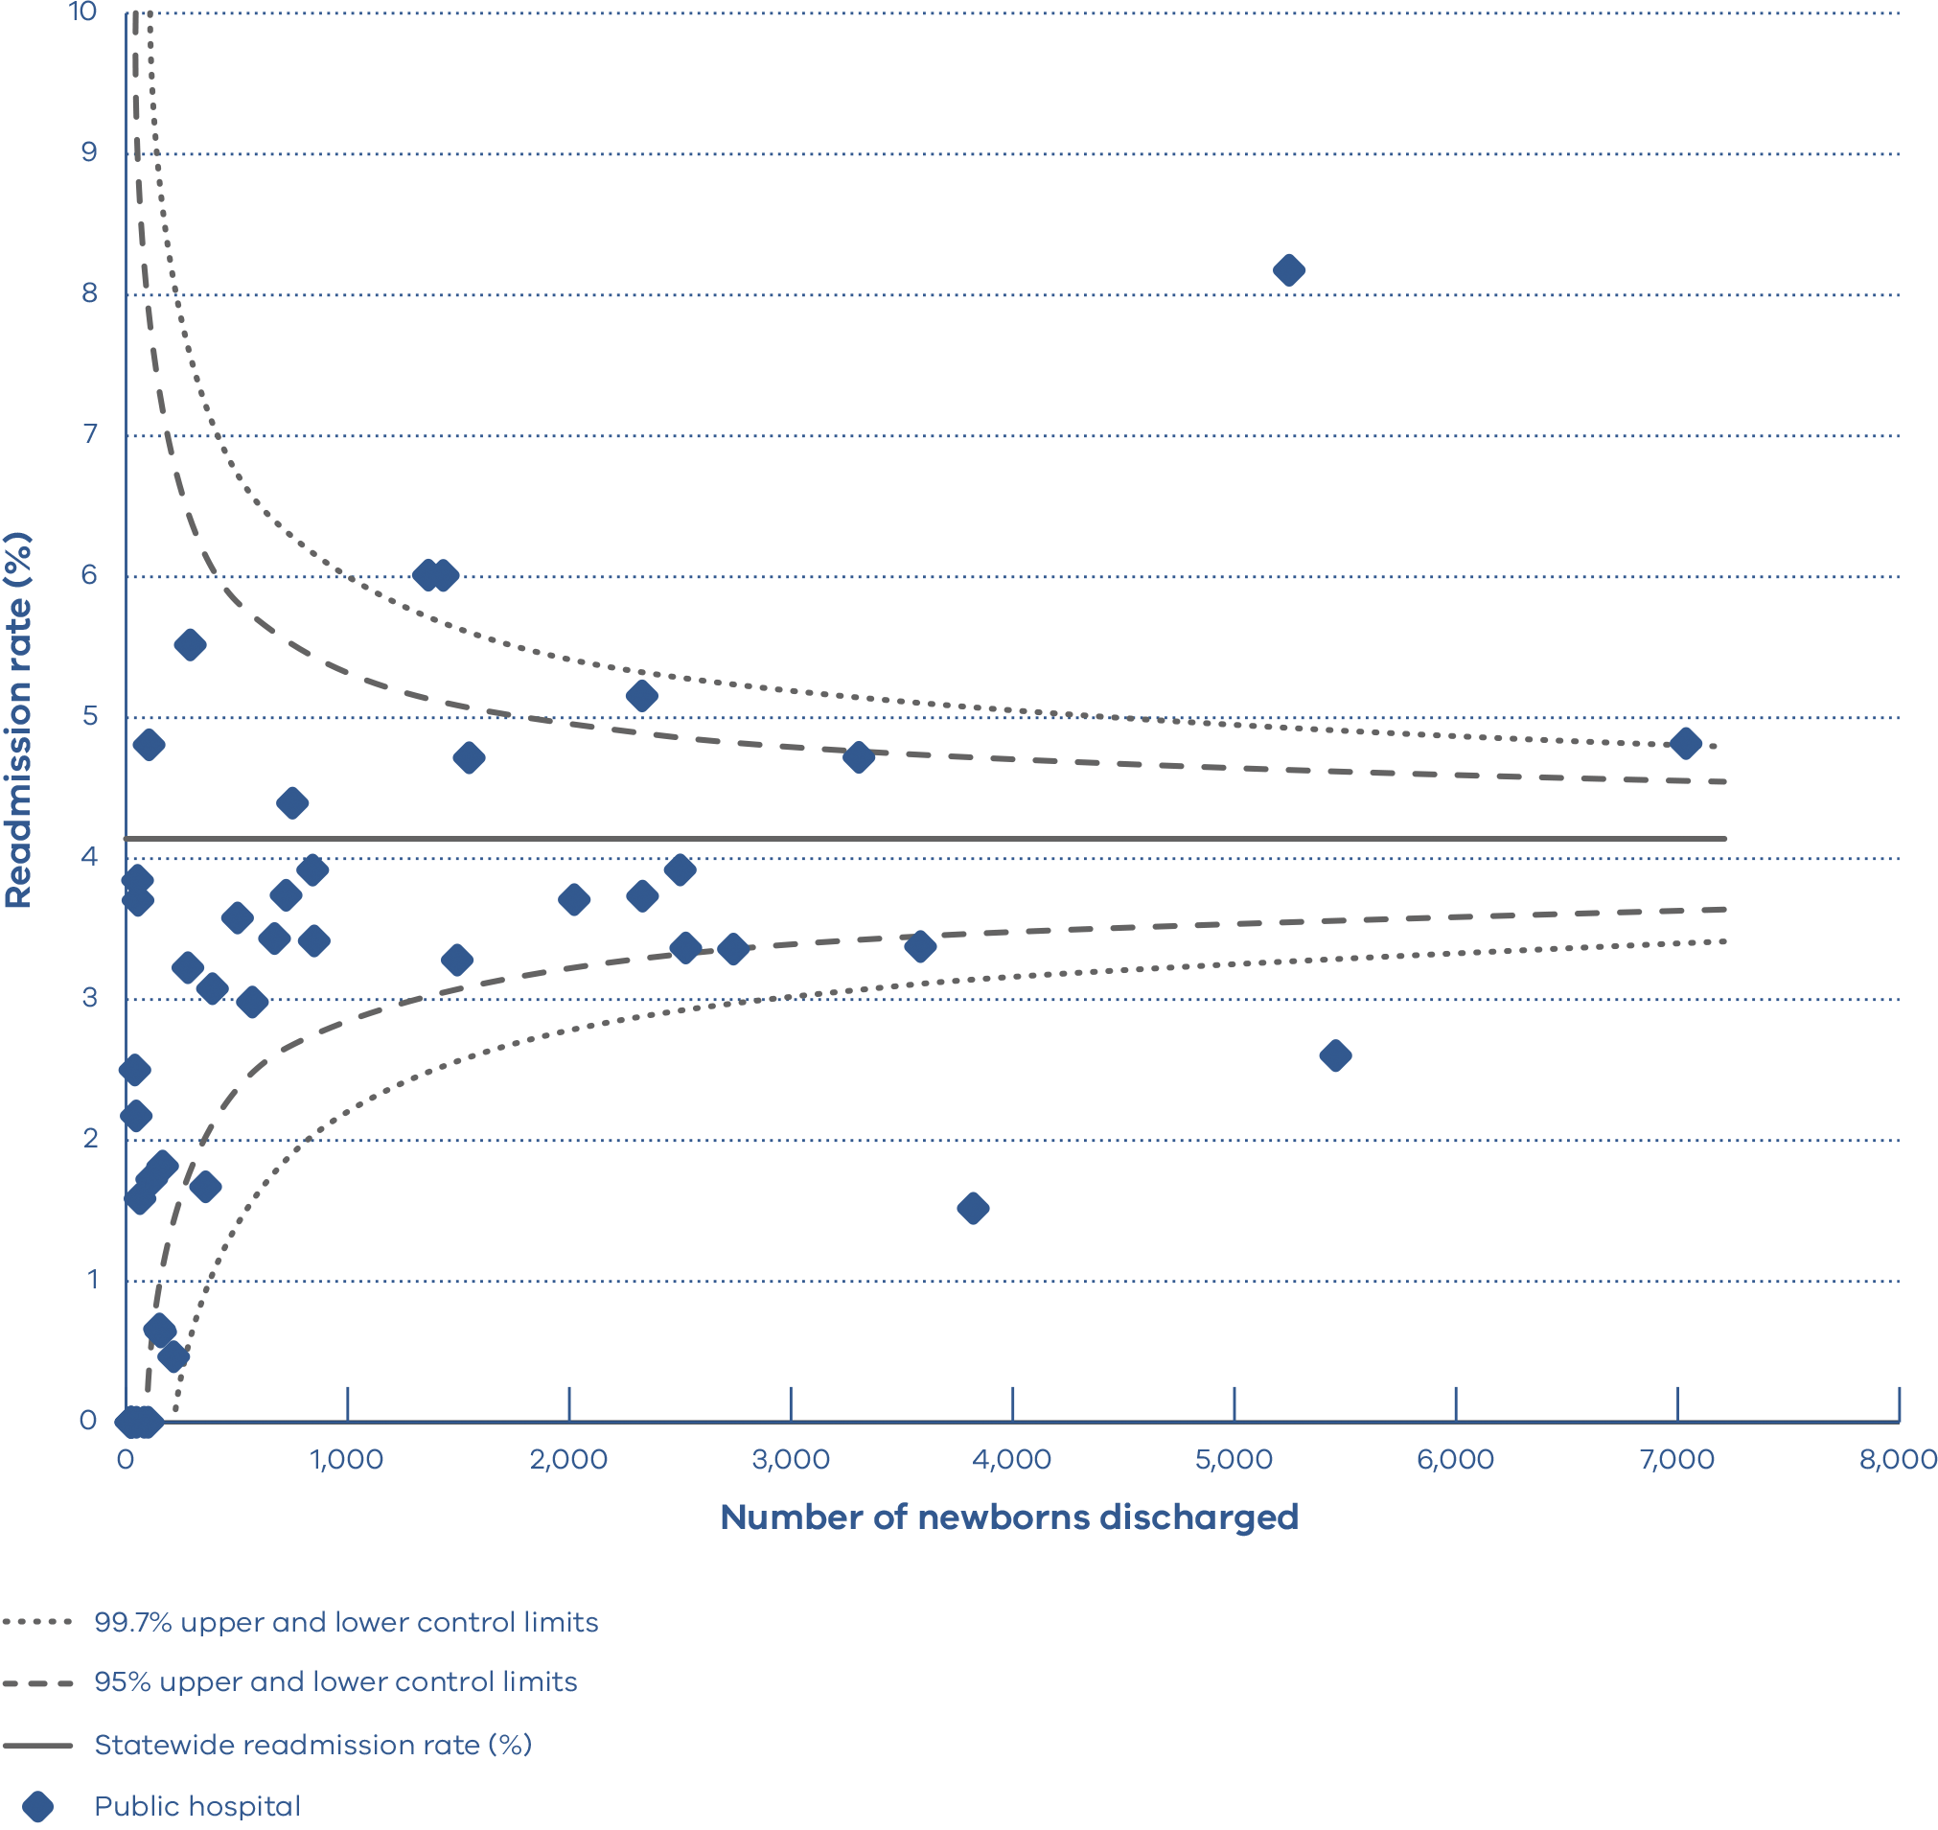
How to read this plot
A funnel plot shows variation (differences) and how it compares with an average.
Each dot represents the readmission rate of one hospital.
The solid horizontal line represents the average newborn readmission rate of all public hospitals. Hospitals (dots) that are above this line have a newborn readmission rate that is higher than the public hospital average. Hospitals that are below this line have a newborn readmission rate that is lower than the public hospital average. It is desirable to have a newborn readmission rate below the solid line.
The dashed and dotted lines represent 95.0 per cent and 99.7 per cent confidence intervals respectively. Confidence intervals measure how different individual results are from the average, taking the size of the hospital into consideration. If a hospital falls outside of the 99.7 per cent confidence interval of the plot it is considered to be significantly different. Ballarat Base Hospital, Bendigo Hospital and Sunshine Hospital have newborn readmission rates higher than the public hospital average. Werribee Mercy Hospital and the Mercy Hospital for Women have newborn readmission rates that are significantly lower than the public hospital average.

Indicator 7: Smoking cessation

Definition
This indicator assesses the effectiveness of health services in providing support for women who smoke in early pregnancy to quit. This includes smoking cessation advice, assistance and follow-up during the antenatal period. The aim is to reduce both the rate of smoking among pregnant women and the risk of smoking-associated adverse health outcomes for women and their babies.
The data in this report relates to the percentage of women who were reported as not smoking after 20 weeks’ gestation among those who smoked before 20 weeks.
This indicator is limited by its focus on smoking cessation during pregnancy and does not capture data on whether women continue to not smoke after their pregnancy.
Services with more than 10 per cent missing data for smoking in the second half of pregnancy have been excluded from the indicator because missing data affects the accuracy of reporting. Missing data in individual services ranged from none to 75 per cent.

Clinical significance
Women who smoke while pregnant, and their babies, are at risk of various preventable adverse outcomes and health complications including stillbirth, FGR and pre-term birth.
During pregnancy, women are motivated to protect their baby’s health. It is therefore an important time for health professionals to help women quit smoking. Hospitals can use this indicator to measure how effective their interventions are, and it recognises hospitals making the greatest impact towards smoking cessation.

Observations on the data
In 2018, 28.0 per cent of women who smoked in the first 20 weeks of their pregnancy did not smoke in the last 20 weeks of their pregnancy (Figure 25). This is a slight increase from 2017, where 27.1 per cent of women ceased smoking (p = 0.258) (Figure 26).
The smoking cessation rate between individual hospitals ranged from zero to 91.7 per cent. There was wide variation between public and private hospitals, averaging 26.6 and 60.3 per cent respectively.

Strategies for improvement
Health services with low smoking cessation rates should undertake regular multidisciplinary reviews of smoking cessation interventions provided to women. This includes, but is not limited to:
- Screen women for smoking behaviours during pregnancy. Continue to ask, advise and support women throughout pregnancy and after birth.
- Conduct carbon monoxide analysis at booking and repeat at 28 weeks’ gestation.
- Share information with women about smoking as a risk factor for stillbirth.
- Educate clinicians about smoking in pregnancy.
- Examine the smoking cessation interventions provided to women during pregnancy and ensuring culturally appropriate information is available.
- Identify gaps in service provision including the success of interventions/programs.
- Monitor and support the competency and confidence of clinicians in providing smoking cessation advice and interventions.
- Develop and report on evidence-based strategies to improve rates to the health service executive.
- Ensure data collection systems allow for asking about and recording smoking at each visit.

Figure 25. Indicator 7: Rate of smoking cessation during pregnancy, 2018
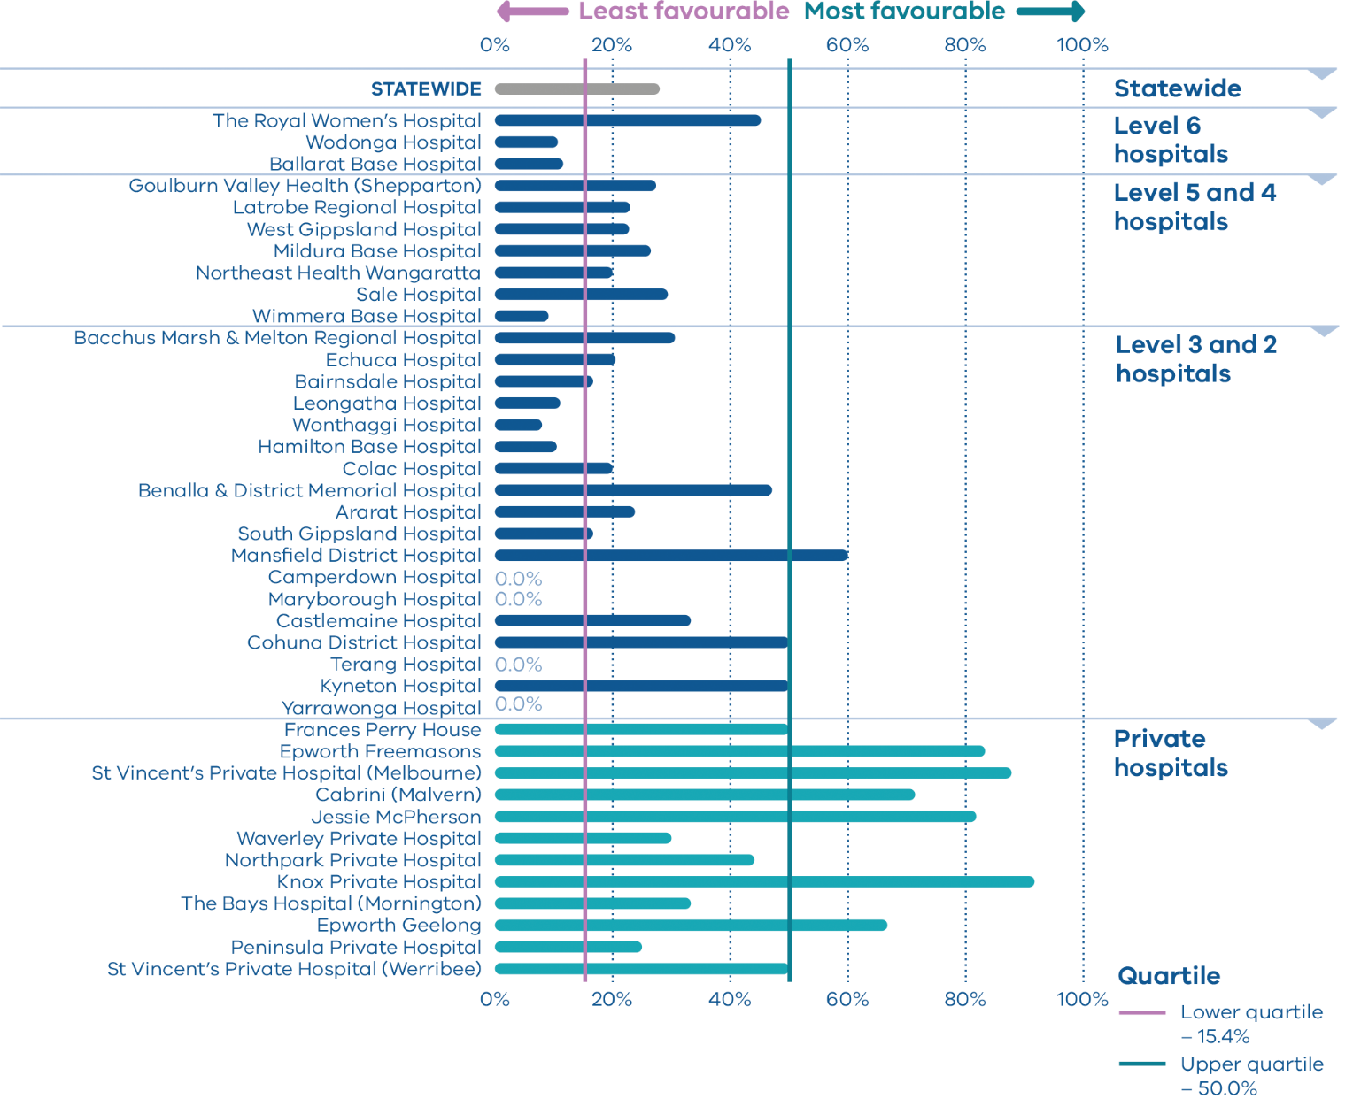
Note: The following services had more than 10.0 per cent missing data for smoking in the second half of pregnancy. As such they have been excluded from the publishable range: Mercy Hospital for Women, Monash Medical Centre, Sunshine Hospital, Northern Hospital Epping, Frankston Hospital, Box Hill Hospital, University Hospital Geelong, Bendigo Hospital, Werribee Mercy Hospital, Dandenong Hospital, Casey Hospital, Angliss Hospital, The Women’s at Sandringham, Warrnambool Base Hospital, The Kilmore & District Hospital, Swan Hill Hospital, Portland Hospital, Mitcham Private Hospital, St John of God Berwick Hospital, St John of God Geelong Hospital, St John of God Ballarat Hospital and St John of God Bendigo Hospital. The statewide rate of missing data for smoking in the second half of pregnancy was 11.6 per cent.
Figure 26. Rate of smoking cessation during pregnancy, 2016–2018
 | 2016 | 2017 | 2018
Public | 24.4% | 25.5% | 26.6%
Private | 66.1% | 65.2% | 60.3%
Combined | 26.1% | 27.1% | 28.0%
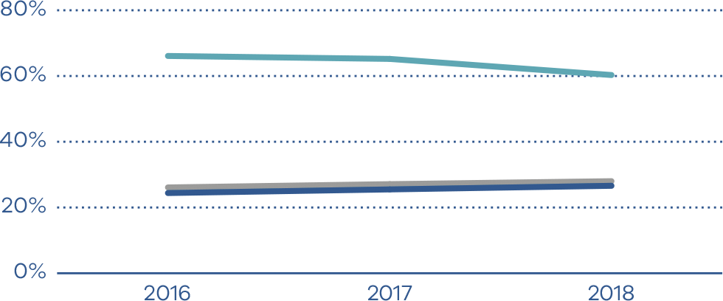

Indicators 8a, 8b and 8c: Breastfeeding in hospital

Definition
These indicators assess the initiation of breastfeeding in Victorian hospitals during the birthing episode (hospital admission only), namely:
- Indicator 8a: rate of breastfeeding initiation in mothers of term babies
- Indicator 8b: rate of use of infant formula in hospital in term breastfed babies
- Indicator 8c: rate of final feed before discharge taken exclusively from the breast for term breastfed babies.
These indicators do not capture data on whether breastfeeding is maintained longer term.

Clinical significance
There are short- and long-term health benefits for women and their babies associated with breastfeeding. Breastfeeding provides optimal nourishment for a growing baby’s physical, cognitive and immunological development. It improves the bond between mother and baby and lowers the risk of various long-term health issues for both mothers and babies.
Health services have a responsibility to promote and support breastfeeding. Clinicians should assist women to recognise when their babies need feeding and offer help if required. Offering tips and advice on successful breastfeeding can help mothers learn to breastfeed. Providing women with accurate information about the importance of breastfeeding to their health and their babies’ health can influence infant feeding decisions.

Observations on the data
The statewide rate of women with term babies who initiated breastfeeding (Indicator 8a) in 2018 was 95.7 per cent (Figures 27 and 28). This rate has been relatively consistent over time.
Figure 30 shows that 29.4 per cent of term breastfed babies were given infant formula in hospital (Indicator 8b). The rate varied between hospitals including those providing a similar level of care (Figure 29). Overall, private hospitals had a higher rate of use of infant formula compared with public hospitals (37.8 and 27.0 per cent respectively, p < 0.001).
The statewide rate of final feed exclusively from the breast for term breastfed babies (Indicator 8c) fell for the third consecutive year from 76.8 per cent in 2016, 75.1 per cent in 2017 to 74.1 per cent in 2018 (p < 0.001) (Figures 31 and 32). This rate varied from 50.4 per cent to 100 per cent.

Strategies for improvement
- Examine where policies and practices do not align with the Promoting breastfeeding – Victorian breastfeeding guidelines.
- Ensure referral pathways to specialist lactation services are clear and accessible.
- Consider achieving and maintaining Baby Friendly Health Initiative accreditation.
- Analyse the factors associated with reduced rates of breastfeeding in hospital.
- Ensure formula use for breastfed babies is limited to those who have a clear medical indication. Educate women on the reasons for this.
- Assess, monitor and support the competency and confidence of midwives and other clinicians in providing breastfeeding support and education.
- Provide women of culturally diverse backgrounds with additional support. This may include providing accurate and appropriately translated (verbal and written) information about the importance of breastfeeding.
Figure 27. Indicator 8a: Rate of breastfeeding initiation for babies born at ≥ 37 weeks’ gestation, 2018
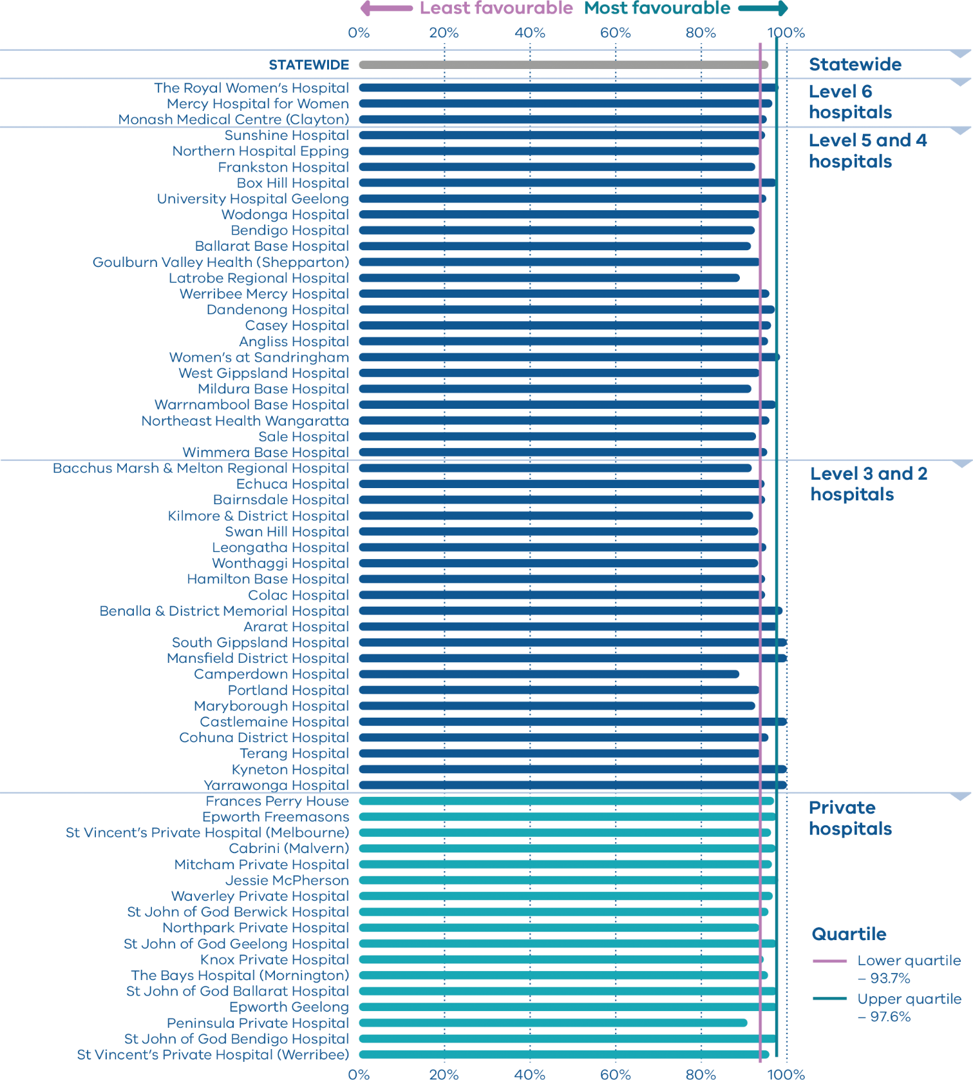
Figure 28. Rate of breastfeeding initiation for babies born at ≥ 37 weeks’ gestation, 2014–2018
 | 2014 | 2015 | 2016 | 2017 | 2018
Public | 94.7% | 94.8% | 95.1% | 95.0% | 95.4%
Private | 96.7% | 96.7% | 96.4% | 96.5% | 96.7%
Combined |  | 95.2% | 95.4% | 95.4% | 95.7%
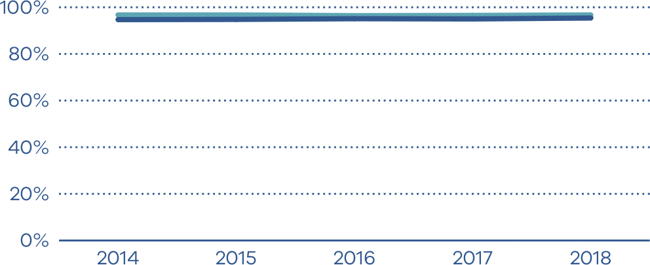
Figure 29. Indicator 8b: Rate of use of infant formula in hospital by breastfed babies born at ≥ 37 weeks’ gestation, 2018
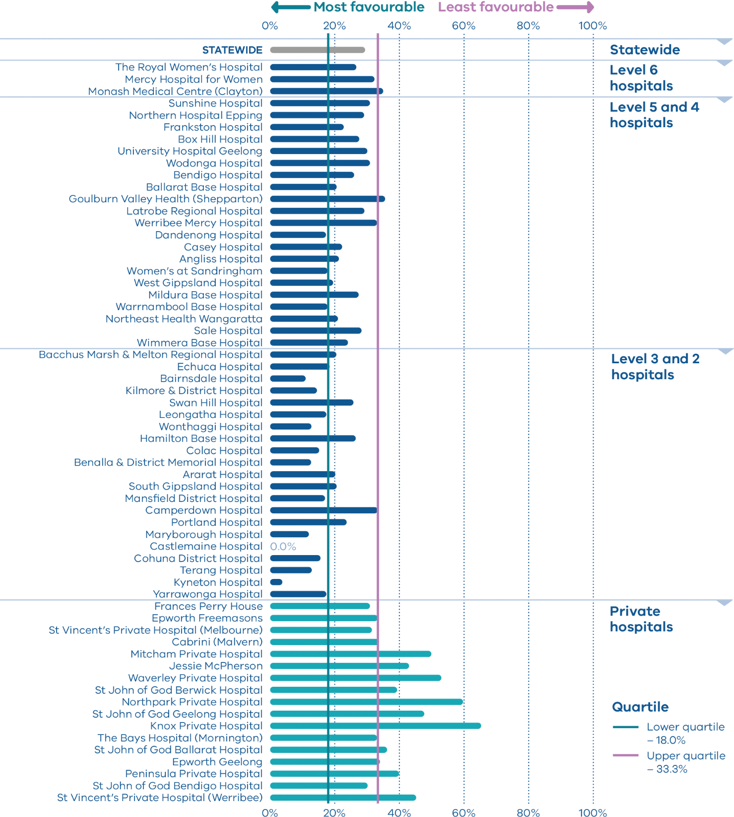
Figure 30. Rate of use of infant formula in hospital by breastfed babies born at ≥ 37 weeks’ gestation, 2014–2018
 | 2014 | 2015 | 2016 | 2017 | 2018
Public | 25.2% | 25.2% | 25.1% | 25.2% | 27.0%
Private | 39.5% | 38.7% | 38.4% | 38.2% | 37.8%
Combined |  | 28.6% | 28.2% | 28.2% | 29.4%
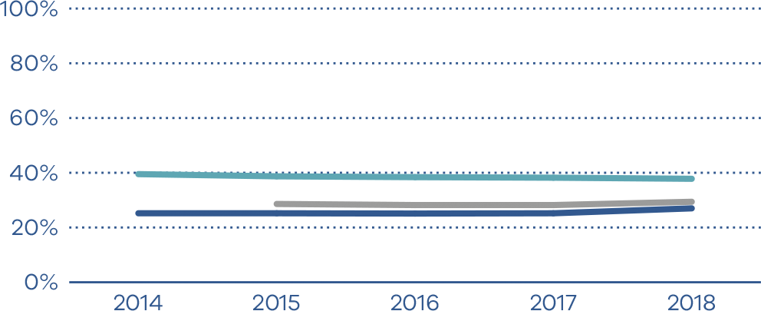
Figure 31. Indicator 8c: Rate of final feed being taken directly from the breast by breastfed babies born at ≥ 37 weeks’ gestation, 2018
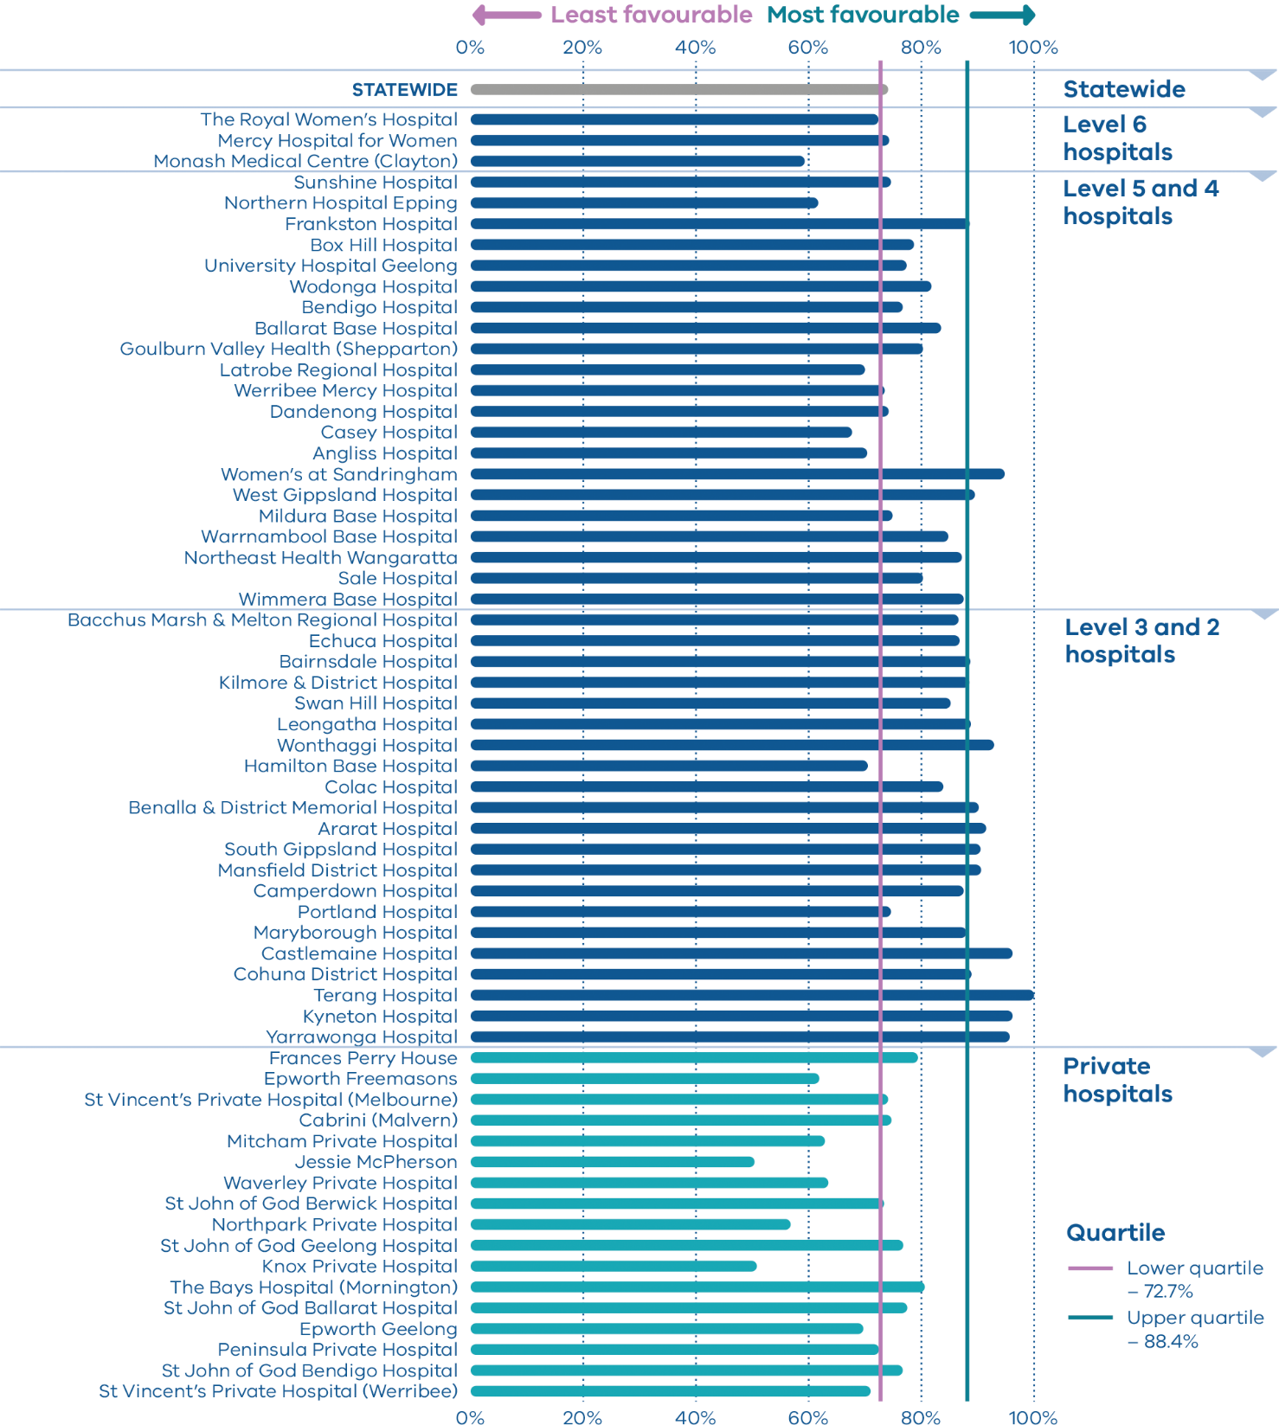
Figure 32. Rate of final feed being taken directly from the breast by breastfed babies born at ≥ 37 weeks’ gestation, 2014–2018
 | 2014 | 2015 | 2016 | 2017 | 2018
Public | 80.0% | 79.7% | 78.2% | 76.1% | 75.3%
Private | 73.3% | 72.9% | 72.2% | 71.5% | 69.6%
Combined |  | 78.0% | 76.8% | 75.1% | 74.1%
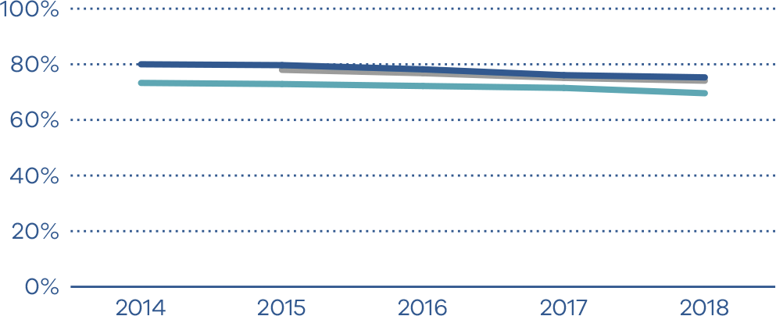

Indicator 9: First antenatal visit

Definition
This indicator reports the rate of women who had their first antenatal visit with a maternity care provider prior to 12 weeks’ gestation. The first antenatal visit is defined as the first visit to a midwife or doctor arranged specifically for providing pregnancy care.
This first antenatal visit may occur in the community or at a hospital and may be facilitated by a range of health professional groups. This diversity is important as it allows different approaches to care and choices for women.

Clinical significance
It is recommended that women attend their first antenatal care visit within the first 10 weeks of pregnancy. Timely access to care allows for early detection of certain conditions and appropriate management of the pregnancy.
Late access to antenatal care is associated with less favourable outcomes for women and their babies.

Observations on the data
The overall proportion of women who had their first antenatal visit recorded as occurring before 12 weeks’ gestation increased to 59.5 per cent from 54.1 per cent in 2017 (p ≤ 0.001) (Figures 33 and 34). The rate varied significantly between public and private hospitals (51.5 and 87.1 per cent respectively, p ≤ 0.001).
The data reported to the VPDC for this measure has limitations. Data may not include early antenatal visits to a general practitioner that include referral for antenatal investigations or may include visits for reasons other than pregnancy care. Given this, hospitals should review their data collection processes to ensure accurate capture of care provided in the community.

Strategies for improvement
- Develop strategies to address barriers to early antenatal care and report on this to the health service executive.
- Identify high-risk women who may require a more focused approach to ensure early and ongoing access to antenatal care.
- Improve the accuracy of data by educating maternity staff to ask about antenatal care provided in the community – for example, by a general practitioner.
- Agree on local targets to guide incremental improvement and monitor progress.
- Explore links between the access to and quality of antenatal care to outcomes on other performance indicators.
Figure 33. Indicator 9: Rate of women attending their first antenatal visit prior to 12 weeks’ gestation, 2018
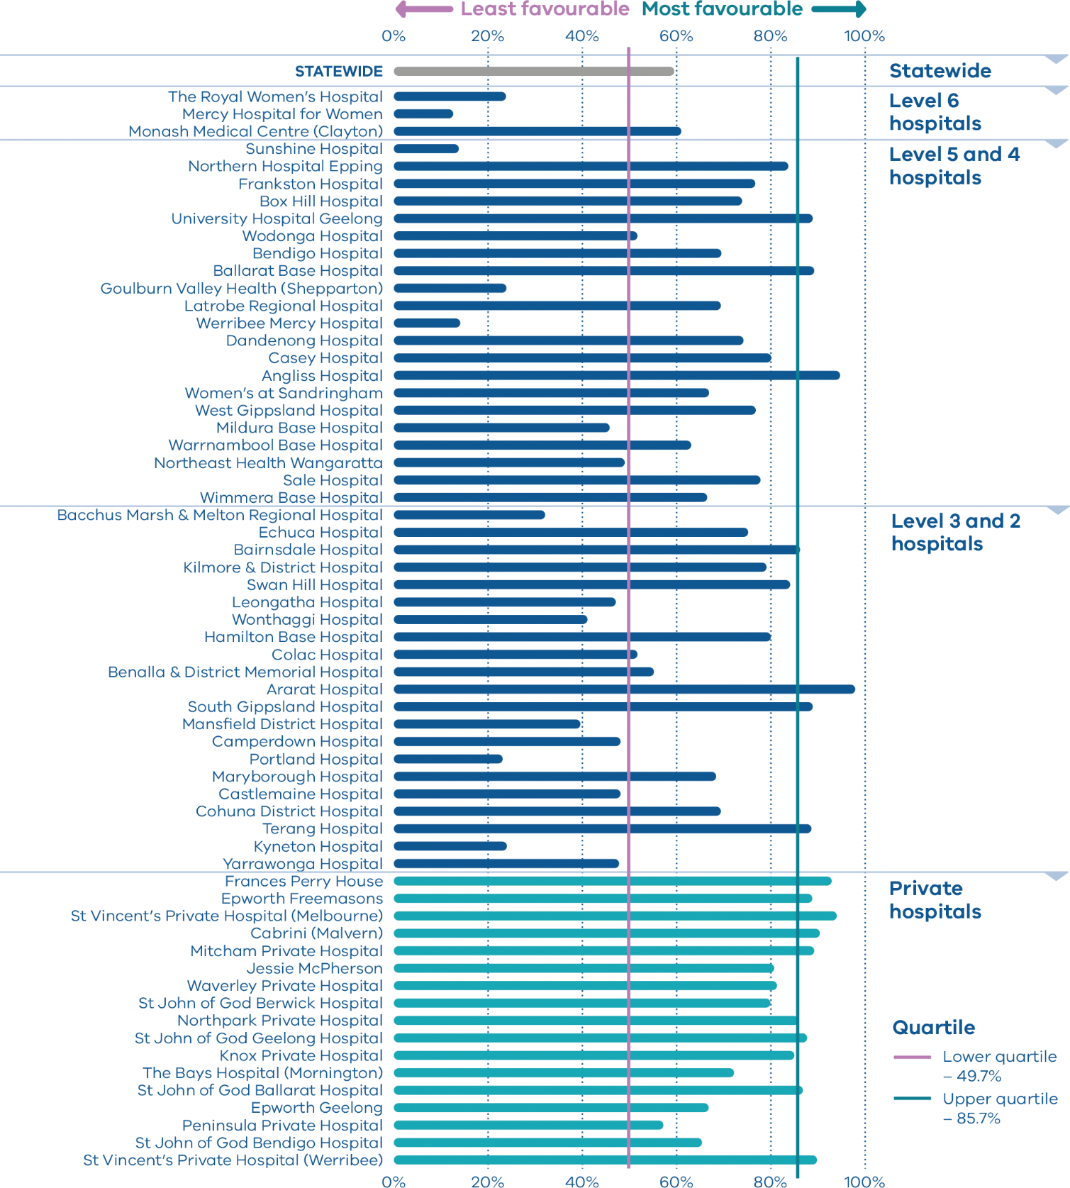
Figure 34. Rate of women attending their first antenatal visit prior to 12 weeks’ gestation, 2014–2018
 | 2014 | 2015 | 2016 | 2017 | 2018
Public | 20.0% | 20.2% | 32.3% | 44.5% | 51.5%
Private | 85.4% | 85.6% | 86.7% | 86.9% | 87.1%
Combined |  |  | 45.4% | 54.1% | 59.5%
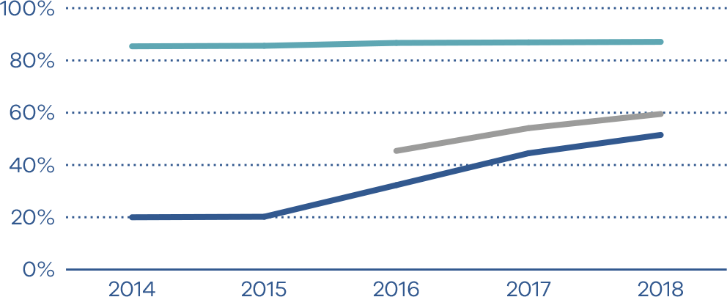

Indicator 10: Low Apgar score

Definition
This indicator measures the wellbeing of babies at 37 or more weeks’ gestation and without congenital anomalies at birth. It is used as a proxy for the quality of care during labour and birth and neonatal resuscitation, where necessary, following birth. The Apgar score is a validated measure of adverse long-term outcomes. This is potentially an important indicator for longer term infant outcomes.

Clinical significance
We expect babies who are born at 37 or more weeks’ gestation and without congenital anomalies to show a healthy physiological adaption to birth (be born in a healthy state) and not require significant resuscitation or immediate medical care.
The Apgar score is an assessment of a newborn’s wellbeing at birth based on five physiological attributes. This is recorded at one and five minutes (and longer if applicable). The five attributes are colour (circulation), breathing, heart rate, muscle tone and reflexes.
Each attribute is given a score of 0, 1 or 2, with a total minimum score of 0 (indicating no or greatly diminished signs of life) and a maximum score of 10 (indicating optimal outcome). An Apgar score below 7 at five minutes indicates a baby who requires ongoing resuscitation measures or additional care. This may be due to avoidable factors during labour, birth or resuscitation.

Observations on the data
In 2018 a five-minute Apgar score less than 7 was reported for 1.3 per cent of singleton, term babies across public and private hospitals combined. The rate varied between individual hospitals, from 0 per cent to 3.7 per cent; however, overall rates have remained stable over time (Figures 35 and 36).

Strategies for improvement
- Undertake a multidisciplinary review of care of all women whose baby was born with a five-minute Apgar score under 7 to identify areas for clinical practice or system improvement.
- Monitor and support the competency and confidence of clinicians in neonatal resuscitation and fetal surveillance during labour.
- Review the availability and use of senior clinicians to both supervise junior clinicians when care is escalated both during and after hours.
- Refer women with a higher risk of complications to appropriate specialist services during pregnancy.
- Ensure clinicians are correctly and consistently identifying and reporting Apgar scores to the VPDC.
- Ensure there are adequate mechanisms to capture, review and report on adverse labour, birth and neonatal resuscitation events and outcomes.
Figure 35. Indicator 10: Rate of term inborn babies without congenital anomalies with an Apgar score < 7 at five minutes, 2018
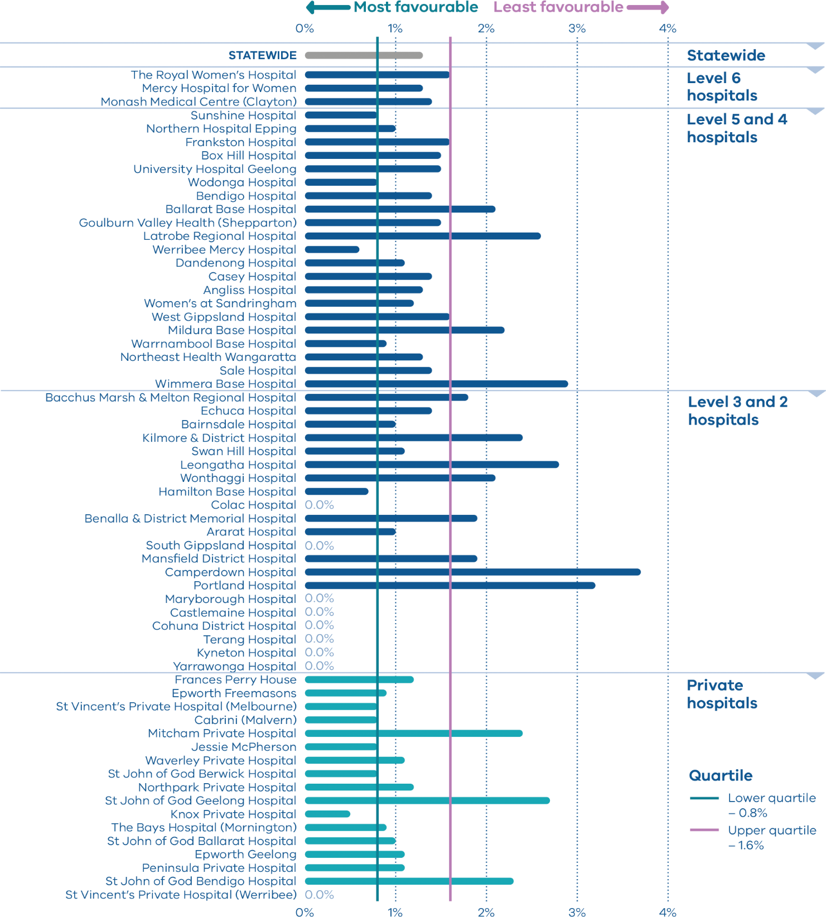
Figure 36. Rate of term inborn babies without congenital anomalies with an Apgar score < 7 at five minutes, 2014–2018
 | 2014 | 2015 | 2016 | 2017 | 2018
Public | 1.5% | 1.5% | 1.6% | 1.5% | 1.3%
Private | 0.9% | 0.9% | 0.9% | 1.0% | 1.1%
Combined |  |  | 1.4% | 1.3% | 1.3%
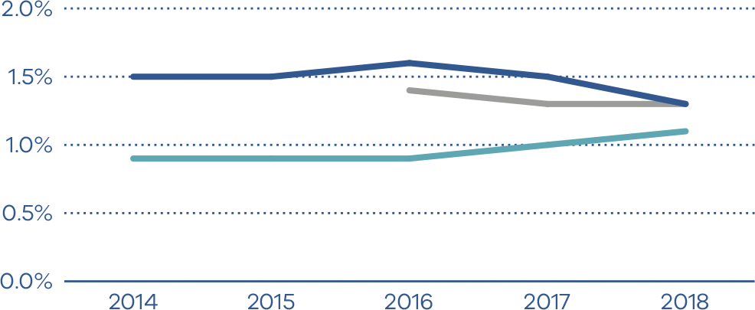

Indicators 11a and 11b: Women’s experiences of care

Definition
These indicators assess the experience of women who received care from Victorian public hospital services during their labour and birth episode. The indicators are derived from two questions in the maternity questionnaire of the VHES, namely:
- Indicator 11a: Question 36: Thinking about your care during labour and birth, were you involved, as much as you wanted to be, in decisions about your care?
- Indicator 11b: Question 51: Did you feel that midwives and other health professionals gave you consistent advice about feeding your baby?
Note: The VHES only collects data from public hospitals and reports only on services with more than 42 responses in a year. As such, this indicator is only reported for public health services that meet this criteria.

Clinical significance
Any report on maternity and newborn outcomes cannot be complete without women’s voices being present, guiding plans for future improvement. Women are uniquely positioned to provide insightful comments about their care. Acknowledging that health outcomes and perceptions are not only influenced by the nature and quality of the clinical care provided but how that care is delivered, patient experience is critical to providing and improving health care.
Through monitoring indicators of experience, it is possible to improve our understanding of women’s experiences of care and to identify areas for quality improvements and service redesign.

Observations on the data
In 2018, 80.0 per cent of women responded that they felt involved, as much as they wanted to be, in decisions about their care (Indicator 11a). This rate was relatively consistent between hospitals (Figure 37). The proportion of women who felt they received consistent advice about feeding their baby from midwives and other health professionals (Indicator 11b) was lower, at 49.0 per cent. There was variation across hospitals, from 40.0 per cent to 74.0 per cent (Figure 38). The results of Indicators 11a and 11b were similar in 2017 (Tables 5 and 6).

Strategies for improvement
- Teach women and families skills for self-advocacy and self-escalation.
- Identify care team members and a single point of contact.
- Develop care plans that can be owned by the woman and used by any care team.
- Define a model of care.
- Dedicate adequate time for antenatal appointments.
- Work in partnership with women to deliver women-centred, coordinated care.
- Ensure there are adequate mechanisms to capture, review and report on feedback.
- Monitor and track feedback and actions arising from feedback.
- Engage with women, carers and families to hear first-hand about their experiences.
Figure 37. Indicator 11a: Rate of women who felt involved, as much as they wanted to be, in decisions about their care during labour and birth, 2018
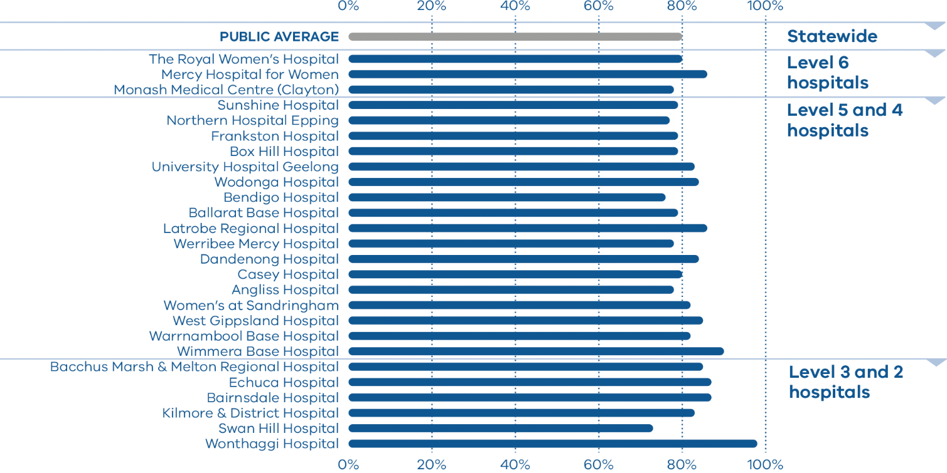
Note: No quartiles are presented with Indicator 11 because there is minimal variation.
Table 5. Rate of women who felt involved, as much as they wanted to be, in decisions about their care during labour and birth, 2016–2018
 | 2016 | 2017 | 2018
Public | 80.0% | 78.9% | 80.0%
Figure 38. Indicator 11b: Rate of women who felt that midwives and other health professionals gave them consistent advice about feeding their baby, 2018
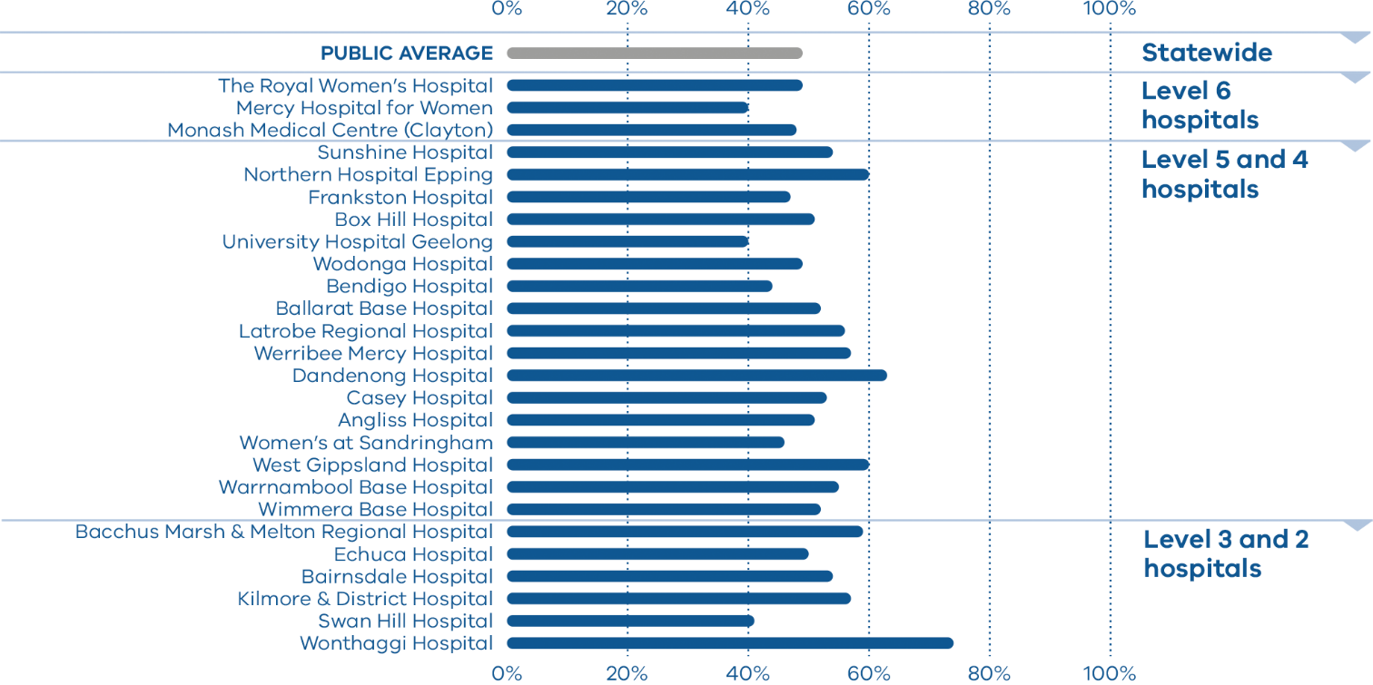
Note: No quartiles are presented with Indicator 11 because there is minimal variation.
Table 6. Rate of women who felt that midwives and other health professionals gave them consistent advice about feeding their baby, 2016–2018
 | 2016 | 2017 | 2018
Public | 51.0% | 49.5% | 49.0%

Indicators 12a and 12b: Maternal vaccination

Definition
These indicators present the proportion of women who were vaccinated against pertussis (whooping cough) and influenza (flu) at any time during their pregnancy. Specifically:
- Indicator 12a: the rate of women vaccinated for pertussis
- Indicator 12b: the rate of women vaccinated for influenza.

Clinical significance
Influenza and pertussis vaccines protect pregnant women and babies from infections. These vaccines are available free to all pregnant women in Victoria. Influenza vaccination is recommended for all pregnant women during any trimester, while pertussis vaccination is recommended during the third trimester. The indicator includes women vaccinated at any point during their pregnancy.

Observations on the data
In 2018, 81.8 per cent of women were vaccinated for pertussis during pregnancy (Indicator 12a). The rate varied between public and private hospitals, with 88.2 per cent and 60.4 per cent respectively. There was variation between individual hospitals, ranging from 2.3 to 100.0 per cent (Figure 39).
The rate for influenza was lower, with only 67.1 per cent of women receiving vaccination for influenza during their pregnancy (Indicator 12b). This was an improvement from 2017 where only 53.7 per cent of women received vaccination for influenza (p < 0.001). The rate was similar between public and private hospitals, with 67.8 and 65.0 per cent respectively. There was variation between individual hospitals, ranging from 3.0 to 88.5 per cent (Figure 40).
For both vaccination indicators, the level of missing data in individual hospitals was high. This affects the accuracy of the data and reduces the extent to which it can be used. It is important for hospitals to minimise missing data to increase the validity of the data.

Strategy for improvement
- Offer all women vaccination against pertussis and influenza.
- Provide women and their families with information about the risks associated with pertussis and influenza during pregnancy and the risks of these infections to their baby after birth.
Figure 39. Indicator 12a: Rate of women vaccinated for pertussis during pregnancy, 2018
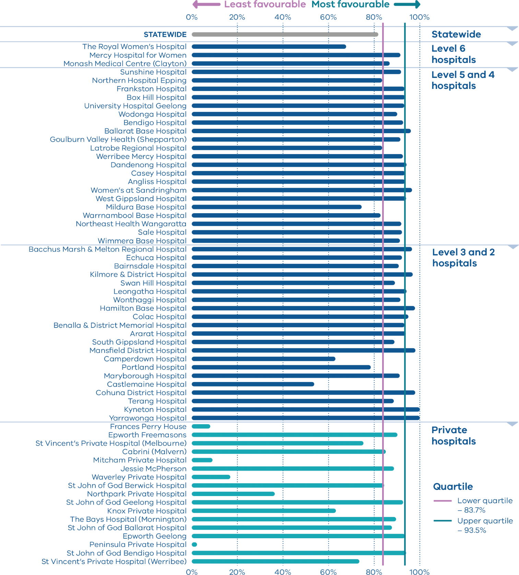

Figure 40. Indicator 12b: Rate of women vaccinated for influenza during pregnancy, 2018
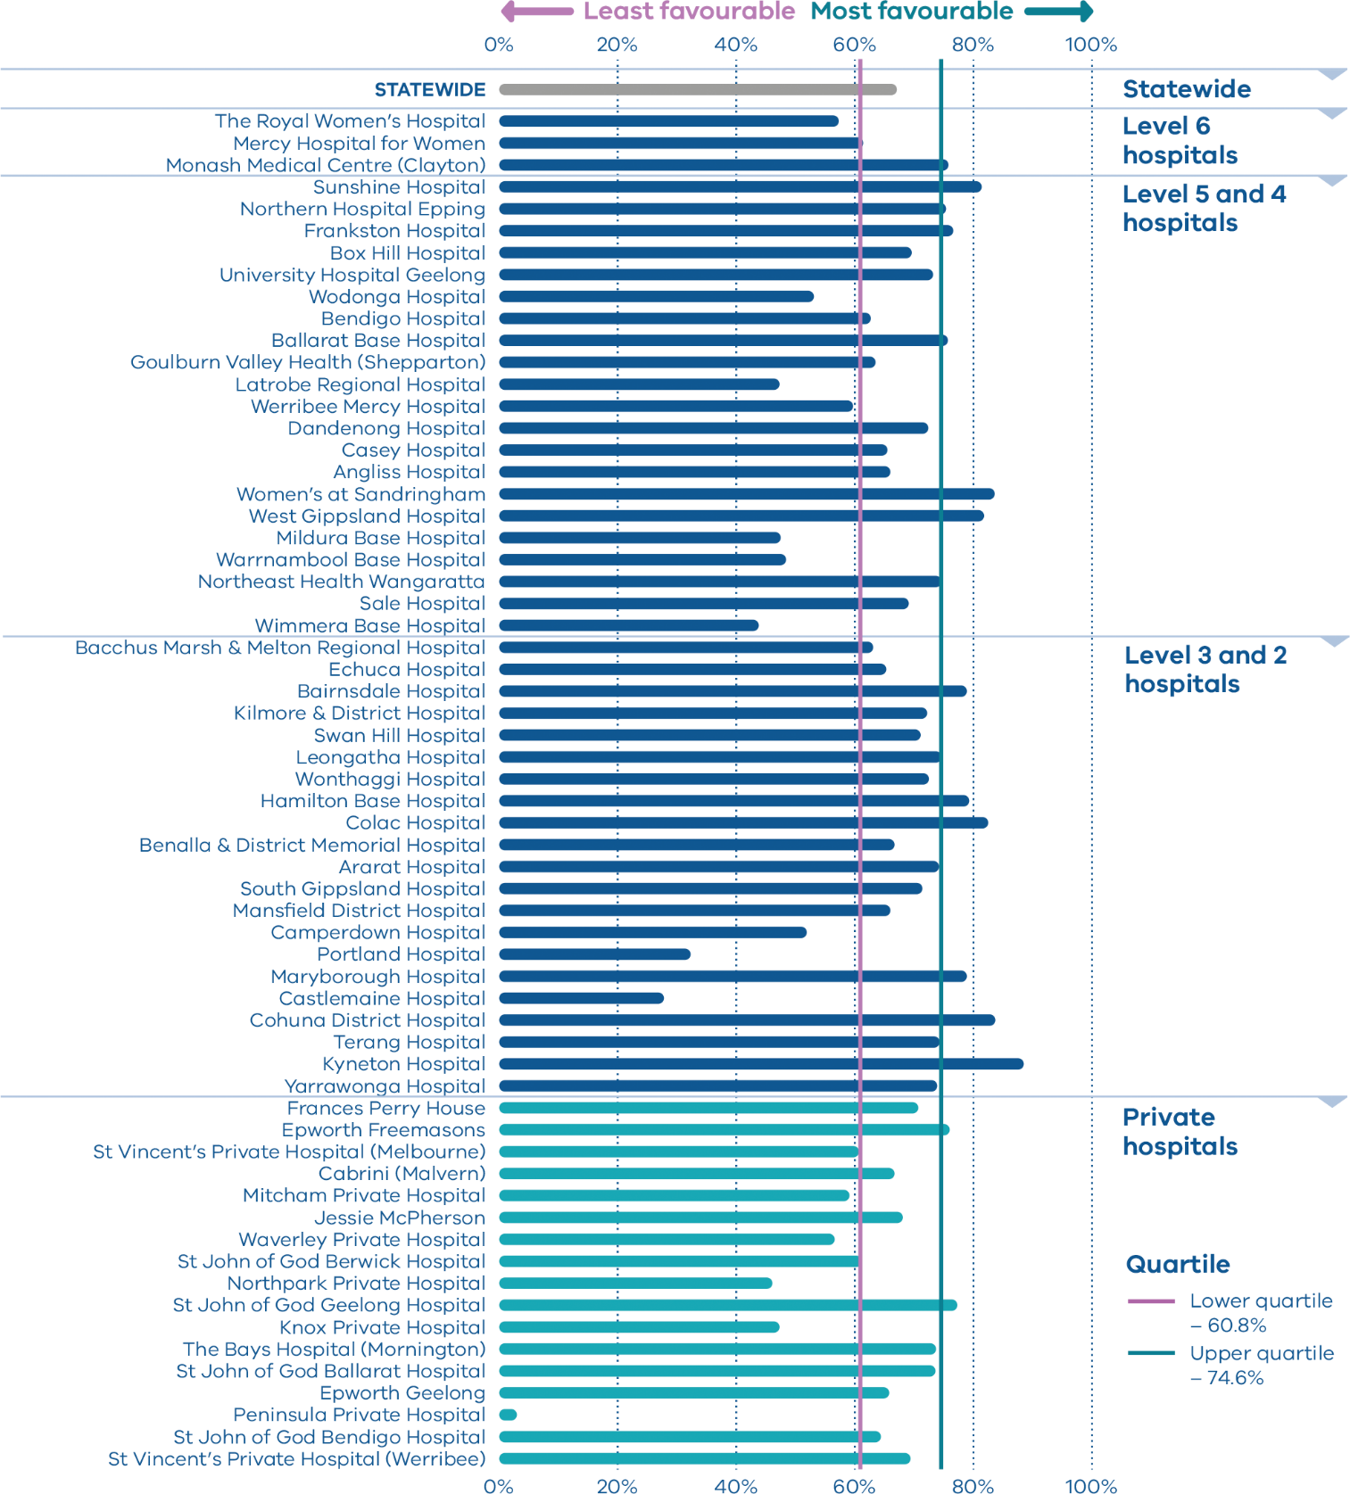

Trial indicator 13: Severe postpartum haemorrhage

Definition
This indicator presents the proportion of women who had a severe postpartum haemorrhage (defined in this report as blood loss of 1,500ml or more) within the 24 hours following birth.

Clinical significance
PPH is a common and potentially serious complication of pregnancy. While the majority of PPH cases are minor, severe PPH is a major cause of maternal mortality and morbidity in Victoria. It is important that clinicians can prevent, recognise and treat PPH.

Observations on the data
In 2018, 2.2 per cent of women had a severe PPH. The rate varied between public and private hospitals, with 2.5 per cent and 1.0 per cent respectively (p ≤ 0.001). There was variation between individual hospitals, ranging from zero to 4.3 per cent (Figure 41).

Strategy for improvement
- Identify women at risk of PPH.
- Have processes in place to recognise and manage PPH early, including escalation processes that are consistent 24/7.
- Ensure staff are appropriately trained in identifying and managing PPH.
- Detailed information on preventing, assessing and managing PPH is available from the Maternity ehandbook <https://www.bettersafercare.vic.gov.au/resources/clinical-guidance/maternity-ehandbook/postpartum-haemorrhage-pph-prevention-assessment-and-management>.
Figure 41. Trial indicator 13: Rate of women with severe postpartum haemorrhage, 2018
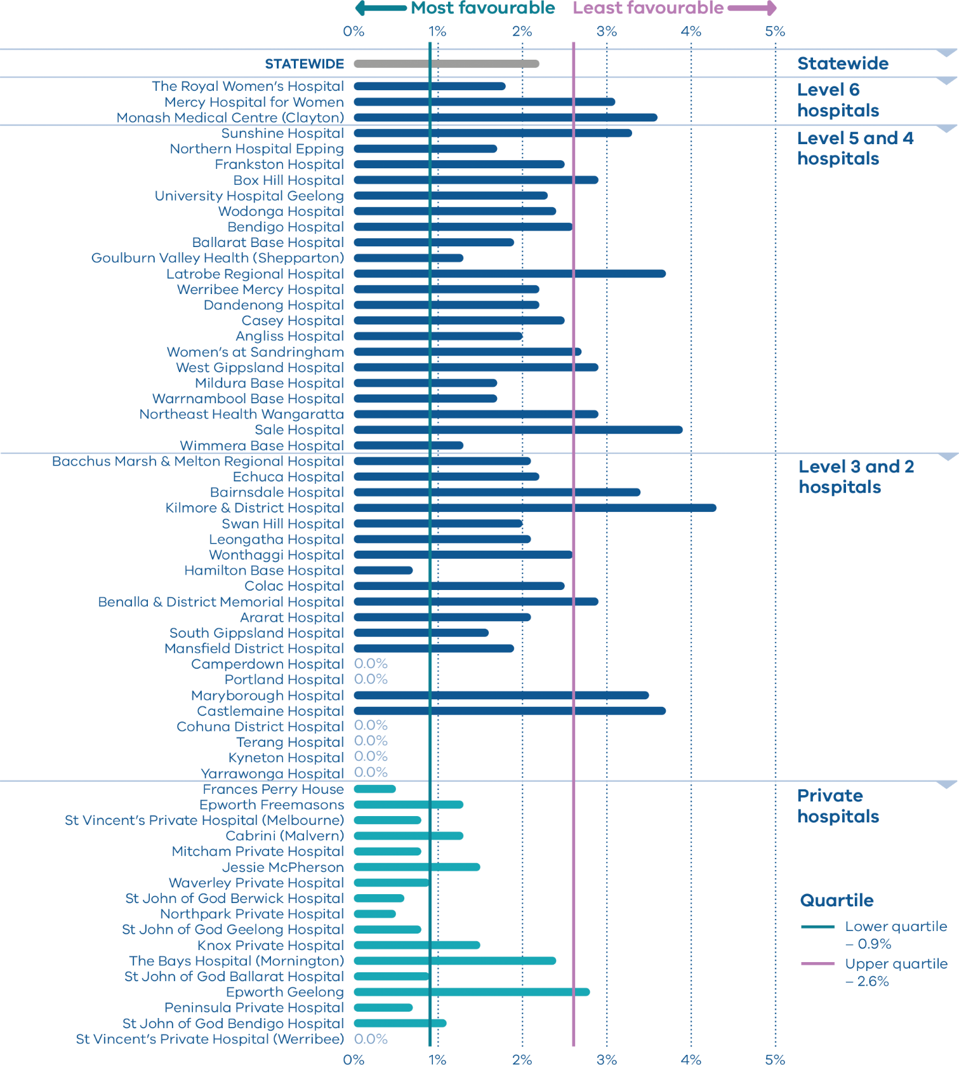

Appendix 1: Data sources and reporting rules
Safer Care Victoria and the Department of Health and Human Services manage the health data collections used for this report:
- Victorian Perinatal Data Collection (VPDC): Victorian public and private health services are required to submit specific data to the Consultative Council on Obstetric and Paediatric Mortality and Morbidity.
- Victorian Healthcare Experience Survey (VHES): The survey collects data on public services only.
- Victorian Admitted Episodes Dataset (VAED): Victorian public and private health services are required to submit specific data.
More information about the data sources and the business rules for each indicator can be found in Appendix 2.
There is an unavoidable time lag between data submission by health services and performance reporting. Safer Care Victoria’s Maternity and Newborn Clinical Network, in collaboration with the Victorian Managed Insurance Authority, has implemented the ‘Maternity dashboard’ within all public birthing maternity services to using the Birthing Outcomes System address this time lag and allow services to regularly monitor their own performance. This report should be used to supplement performance and improvement evaluation.
When interpreting the data in this report, it is important to note the following:
- Apart from Indicators 5, 11a and 11b, data are only reported when a health service has had a minimum of 10 occasions for an event (denominator). For example, a hospital that has not had 10 standard primiparae give birth in 2018 (denominator) will not be included in the results for Indicator 1a.
- Due to small numbers, data from smaller health services are subject to wide variation and should be interpreted with caution.
- Private patients admitted to a public health service are reported in the results for the relevant public health service.
- Outcomes for public health services are presented in order of clustered maternity service capability and then by the number of women who gave birth at each health service in 2018 (in descending order so hospitals with more births in each capability level appear first).
- Outcomes for private health services are presented in descending order according to the number of women who gave birth at each health service in 2018.
- Although the statewide rates provided for each indicator are a suitable measure for comparing health services, they do not necessarily represent the optimal rate.
- The indicators in this report do not adjust for maternal characteristics such as obesity, mental health conditions, chronic illnesses, socioeconomic status or IVF pregnancies. Health services should consider individual patient profiles when reviewing their data.
- Some of the variation between hospitals may reflect incomplete reporting. To ensure the accuracy of indicators, health services should make sure they have accurate capture and reporting of diagnostic and treatment codes.

Appendix 2: Definitions and data sources

Indicator 1a: Rate of induction of labour in standard primiparae

Definition
The standard primipara is defined as a woman, 20–39 years of age, free of obstetric and specified medical complications (pre-existing hypertension, diabetes, cardiac disease or serious psychiatric conditions), giving birth for the first time with a singleton pregnancy between 37 and 40 weeks completed gestation (259–286 days), with a non-small for gestational age (greater than 10th centile) infant and a cephalic presentation.

Data source: Victorian Perinatal Data Collection
Data from the VPDC are reported by calendar year from 1 January 2018 to 31 December 2018.
These data are routinely submitted by each health service on each birth.
The indicators are derived using the following VPDC variables: ‘Parity’, ‘Maternal age’, ‘Plurality’, ‘Estimated gestational age’, ‘Birth presentation’, ‘Obstetric complications – ICD-10-AM code’, ‘Maternal medical conditions – ICD-10-AM code’, ‘Indication for induction – ICD-10-AM code’, ‘Indications for operative delivery – ICD-10-AM code’, ‘Birthweight’ and ‘Labour type’.
The inclusion criteria for the standard primipara have been reviewed. The upper age limit has been increased to 39 years. The medical conditions that exclude women are now limited to pre-existing hypertension, diabetes, cardiac disease or serious psychiatric conditions (schizophrenia, other psychotic disorders and bipolar disorder). Women are excluded if they have any obstetric conditions recorded in the ‘Complications of pregnancy’ or ‘Indication for induction’ field (any condition listed in the ‘O’ chapter of ICD-10 that occurs before the onset of labour but not those related to gestation or spurious labour).

Numerator/denominator
Indicator | Numerator | Denominator
Indicator 1a: Rate of induction of labour in standard primiparae | The number of standard primiparae who give birth undergoing induction of labour | The number of standard primiparae

Indicators 1bi and 1bii: Caesarean sections in primiparae

Definition
Indicator 1 measures outcomes for women having their first birth. Indicators 1bi and 1bii report the proportion of caesarean births for women pregnant for the first time, who give birth to a singleton, cephalic-presenting, term baby. The definitions are based on the Ten Group Classification System but use the modified classification proposed by Zhang et al. so as to exclude women having a planned caesarean section.
- Indicator 1bi considers women whose labour commenced spontaneously.
- Indicator 1bii considers women whose labour was induced (excluding pre-labour caesarean).

Data source: Victorian Perinatal Data Collection
Data from the VPDC are reported by calendar year from 1 January 2018 to 31 December 2018.
These data are routinely submitted by each health service on each birth.
The indicators are derived using the following VPDC variables: ‘Parity’, ‘Plurality’, ‘Birth presentation’, ‘Estimated gestational age’, ‘Onset of labour’ and ‘Method of birth’.

Numerator/denominator
Indicator | Numerator | Denominator
Indicator 1bi: Rate of caesarean section in Robson group 1 | The number of women giving birth for the first time, with spontaneous onset of labour and a singleton, cephalic-presenting baby born at 37 or more weeks by caesarean section | The number of women giving birth for the first time, with spontaneous onset of labour and a singleton, cephalic-presenting baby born at 37 or more weeks
Indicator 1bii: Rate of caesarean section in modified Robson group 2 | The number of women giving birth for the first time, with induced labour (excluding pre-labour caesarean) and a singleton, cephalic-presenting baby born at 37 or more weeks by caesarean section | The number of women giving birth for the first time, with induced labour (excluding pre-labour caesarean) and a singleton, cephalic-presenting baby born at 37 or more weeks

Indicators 1ci and 1cii: Perineal tears in primiparae

Definition
For all primiparae, the proportion who have a third- or fourth-degree perineal tear during an unassisted vaginal birth (Indicator 1ci), and the proportion who had a third- or fourth-degree perineal tear during an assisted vaginal birth (Indicator 1cii).
Assisted (or operative/instrumental) vaginal birth refers to a forceps- or vacuum-assisted birth. Operative intervention in the second stage of labour may be indicated by conditions of the fetus or the mother. Maternal indication includes inadequate progress in labour, congestive heart failure and cerebral vascular malformations.
Included are those women who gave birth for the first time and had a vaginal birth, with or without instruments. Women who had a multiple birth are included if this was the first time they had given birth.
Excluded are those women who did not give birth for the first time or gave birth by caesarean section.
‘Third-degree perineal tear’ means a perineal laceration, rupture or tear also involving anal sphincter, rectovaginal septum and/or sphincter not otherwise specified. Excludes lacerations involving the anal or rectal mucosa.
‘Fourth-degree perineal tear’ means a perineal laceration, rupture or tear occurring during delivery, also involving anal mucosa and/or rectal mucosa.
The rates for third- and fourth-degree tears includes episiotomies extended by a laceration of a third- and fourth-degree type.

Data source: Victorian Perinatal Data Collection
Data from the VPDC are reported by calendar year from 1 January 2018 to 31 December 2018.
These data are routinely submitted by each health service on each birth.

Numerator/denominator
Indicator | Numerator | Denominator
Indicator 1ci: Rate of third- or fourth-degree perineal tears during unassisted vaginal births to primiparae | The number of primiparae who had a third- or fourth-degree perineal laceration during an unassisted vaginal birth | The number of primiparae who had an unassisted vaginal birth
Indicator 1cii: Rate of third- or fourth-degree perineal tears during assisted vaginal births to primiparae | The number of primiparae who had a third- or fourth-degree perineal laceration during an assisted (instrumental) vaginal birth | The number of primiparae who had an assisted vaginal birth

Indicators 1di and dii: Episiotomies in primiparae

Definition
For all primiparae, the proportion who received an episiotomy during an unassisted vaginal birth (Indicator 1di), and the proportion who received an episiotomy during an assisted vaginal birth (Indicator 1dii).
Episiotomy is defined as an incision of the perineum and vagina made during vaginal birth.
Included are those women who gave birth for the first time and had a vaginal birth, with or without instruments. Women who had a multiple birth are included if this was the first time they had given birth.
Excluded are those women who did not give birth for the first time or gave birth by caesarean section.
Assisted (or operative/instrumental) vaginal birth refers to a forceps- or vacuum-assisted birth. Operative intervention in the second stage of labour may be indicated by conditions of the fetus or the mother. Maternal indication includes inadequate progress in labour, congestive heart failure and cerebral vascular malformations.

Data source: Victorian Perinatal Data Collection
Data from the VPDC are reported by calendar year from 1 January 2018 to 31 December 2018.
These data are routinely submitted by each health service on each birth.

Numerator/denominator
Indicator | Numerator | Denominator
Indicator 1di: Rate of primiparae who received an episiotomy during unassisted vaginal births | The number of primiparae who had an episiotomy during an unassisted vaginal birth | The number of primiparae who had an unassisted vaginal birth
Indicator 1dii: Rate of primiparae who received an episiotomy during assisted vaginal births | The number of primiparae who had an episiotomy during an assisted vaginal birth | The number of primiparae who had an assisted (instrumental) vaginal birth

Indicator 2: Term babies without congenital anomalies who required additional care

Definition
This indicator includes inborn term babies. An inborn term baby is an infant born at the reporting hospital at a gestational age of 37 weeks or more. Term babies without congenital anomalies who require additional care are defined as newborns who:
- are not less than 37 weeks 0 days’ gestation
- weigh not less than 2,500 grams
- are without congenital anomalies
- are grouped to Victorian diagnostic-related groups (VIC-DRGs) representing the need for more than normal care (see list of VIC-DRGs provided below).
Excluded are:
- babies born at another hospital
- pre-term newborn babies
- infants with congenital anomalies
- babies with a birthweight less than 2,500 grams
- stillborn babies
- readmissions (separations not related to the birth episode).
The denominator for the 2018–19 reporting period is episodes grouped to the Version 7.0 VIC-DRGs:
- P68A (v7): Neonate, AdmWt >=2500g W/O Sig OR Proc >=37 Comp Wks Gest W Mult Major Probs
- P68B (v7): Neonate, AdmWt >=2500g W/O Sig OR Proc >=37 Comp Wks Gest W Major Problem
- P68C (v7) Neonate, AdmWt >=2500g W/O Sig OR Proc >=37 Comp Wks Gest W Other Problem
- P68D (v7) Neonate, AdmWt >=2500g W/O Sig OR Proc >=37 Comp Wks Gest W/O Problem
- P06A Neonate, Admission weight > 2499g with Significant Operating Room Procedure with Multi Major Problems
- P06B Neonate, Admission weight > 2499g with Significant Operating Room Procedure without Multi Major Problems
- P60A Neonate, Died or Transferred < 5 days of admission, without Significant Operating Room Procedure, Newborn
- P60B Neonate, Neonate W/O Sig OR Proc, Died or Transferred to Acute Facility Same Day.

Data source: Victorian Admitted Episodes Dataset
Data from the VAED are reported by financial year from 1 July 2018 to 30 June 2019.

Numerator/denominator
Indicator | Numerator | Denominator
Indicator 2: Rate of term babies without congenital anomalies who required additional care | The number of inborn term babies without birth defects grouped to VIC‑DRG P68A, P68B, P68C, P06A, P06B, P60A# and P60B# | The number of inborn term babies without congenital anomalies grouped to VIC-DRG P68A, P68B, P68C, P68D, P06A, P06B, P60A# and P60B#
# All newborns initially grouped to P60A and P60B were regrouped to the next logical VIC-DRG following removal of the separation mode ‘Died or Transferred’ and replaced with the separation mode of ‘Home’. This was done so that only those babies in P60A and P60B who require additional care are counted in the numerator. To include the whole of P60A and P60B in the numerator would overestimate the rate of newborns requiring additional care because some healthy newborns are transferred for other reasons.

Indicator 3: Severe fetal growth restriction

Definition
Severe FGR is defined as a birthweight less than the third centile for gestation and sex whether liveborn or stillborn.
Excluded are:
- babies without severe FGR
- multiple births
- births at earlier gestations (less than 32 weeks).

Data source: Victorian Perinatal Data Collection
Data from the VPDC are reported by calendar year from 1 January 2018 to 31 December 2018.
The indicator is derived using the following VPDC variables: ‘Baby sex’, ‘Gestation’, ‘Birth weight’ and ‘Plurality’.

Numerator/denominator
Indicator | Numerator | Denominator
Indicator 3: Rate of severe FGR in a singleton pregnancy undelivered by 40 weeks | Birth at 40 or more weeks’ gestation of a singleton baby with severe FGR | Singleton births (live and stillborn) with severe FGR born at and beyond 32 weeks’ gestation
For this indicator, a baby is considered to be severely growth-restricted when their birthweight is below the third centile for gestation, sex and plurality. It is calculated based on the study by Dobbins et al., which gives the tables for birthweight centiles according to the gestational week for live singleton male and female babies in Australia. If a male singleton baby weighing 1,700 grams is born at 35 weeks, it falls below the third centile for gestation, sex and plurality. The baby is then considered severely growth restricted (refer to Appendix 2, Indicator 3). The Australian national birthweight percentiles by sex and gestational age, 1998–2007 (Dobbins et al. 2012) is used to calculate the birthweight centiles for this indicator (see Tables 7 and 8).

Table 7. Birthweight centiles for live singleton male infants, Australia, 1998–2007
Gestational age (weeks) | Number of births | Mean (SD) birthweight (g) | Birthweight percentile (g)
 |  |  | 1st | 3rd | 5th | 10th | 25th | 50th | 75th | 90th | 95th | 97th | 99th
20 | 230 | 349 (60) | 210 | 248 | 254 | 273 | 310 | 340 | 390 | 430 | 450 | 470 | 500
21 | 335 | 418 (66) | 270 | 290 | 300 | 335 | 375 | 420 | 460 | 500 | 540 | 542 | 575
22 | 401 | 505 (76) | 350 | 370 | 390 | 410 | 460 | 500 | 554 | 600 | 630 | 650 | 690
23 | 395 | 595 (82) | 390 | 450 | 470 | 500 | 540 | 588 | 650 | 700 | 730 | 756 | 800
24 | 640 | 681 (105) | 426 | 470 | 500 | 550 | 618 | 684 | 750 | 810 | 850 | 875 | 970
25 | 715 | 783 (131) | 440 | 505 | 530 | 620 | 700 | 785 | 865 | 944 | 995 | 1030 | 1100
26 | 937 | 894 (152) | 500 | 576 | 621 | 680 | 802 | 900 | 996 | 1078 | 1130 | 1155 | 1210
27 | 1069 | 1016 (194) | 510 | 605 | 660 | 752 | 904 | 1030 | 1138 | 1250 | 1320 | 1352 | 1440
28 | 1345 | 1146 (217) | 591 | 680 | 735 | 844 | 1030 | 1165 | 1295 | 1395 | 1470 | 1522 | 1640
29 | 1524 | 1301 (252) | 662 | 782 | 860 | 964 | 1150 | 1311 | 1463 | 1620 | 1700 | 1757 | 1860
30 | 2105 | 1474 (283) | 774 | 900 | 984 | 1091 | 1300 | 1498 | 1650 | 1800 | 1920 | 1980 | 2182
31 | 2576 | 1666 (304) | 915 | 1055 | 1126 | 1270 | 1480 | 1680 | 1855 | 2028 | 2142 | 2230 | 2435
32 | 3895 | 1867 (331) | 1075 | 1214 | 1294 | 1430 | 1659 | 1880 | 2080 | 2270 | 2405 | 2503 | 2710
33 | 5599 | 2106 (371) | 1200 | 1381 | 1473 | 1638 | 1880 | 2106 | 2340 | 2560 | 2710 | 2845 | 3070
34 | 9824 | 2340 (385) | 1400 | 1580 | 1690 | 1860 | 2100 | 2340 | 2580 | 2810 | 2990 | 3120 | 3343
35 | 16,054 | 2585 (408) | 1600 | 1795 | 1920 | 2080 | 2330 | 2578 | 2835 | 3095 | 3275 | 3410 | 3665
36 | 32,747 | 2826 (428) | 1805 | 2015 | 2120 | 2295 | 2550 | 2820 | 3095 | 3360 | 3550 | 3690 | 3930
37 | 73,986 | 3093 (449) | 2050 | 2265 | 2372 | 2540 | 2800 | 3080 | 3378 | 3670 | 3865 | 3990 | 4235
38 | 230,003 | 3344 (439) | 2340 | 2540 | 2640 | 2800 | 3050 | 3330 | 3625 | 3910 | 4090 | 4215 | 4445
39 | 293,109 | 3486 (430) | 2510 | 2700 | 2800 | 2950 | 3195 | 3470 | 3765 | 4040 | 4220 | 4335 | 4560
40 | 409,976 | 3632 (434) | 2650 | 2840 | 2940 | 3090 | 3340 | 3620 | 3915 | 4195 | 4370 | 4490 | 4708
41 | 192,154 | 3769 (438) | 2780 | 2970 | 3070 | 3220 | 3470 | 3755 | 4060 | 4340 | 4515 | 4630 | 4850
42 | 19,804 | 3832 (462) | 2760 | 2980 | 3095 | 3250 | 3520 | 3820 | 4130 | 4430 | 4615 | 4740 | 4970
43 | 797 | 3761 (540) | 2615 | 2785 | 2935 | 3085 | 3380 | 3750 | 4100 | 4470 | 4670 | 4825 | 5180
44 | 53 | 3715 (563) | — | — | — | 3110 | 3300 | 3620 | 4070 | 4415 | — | — | —
Source: Dobbins et al. 2012

Table 8. Birthweight centiles for live singleton female infants, Australia, 1998–2007
Gestational age (weeks) | Number of births | Mean (SD) birthweight (g) | Birthweight percentile (g)
 |  |  | 1st | 3rd | 5th | 10th | 25th | 50th | 75th | 90th | 95th | 97th | 99th
20 | 197 | 333 (65) | 190 | 210 | 230 | 265 | 290 | 320 | 374 | 410 | 450 | 490 | 525
21 | 256 | 386 (69) | 210 | 250 | 270 | 300 | 340 | 390 | 433 | 470 | 510 | 515 | 530
22 | 333 | 474 (72) | 260 | 325 | 355 | 400 | 425 | 480 | 520 | 560 | 589 | 610 | 620
23 | 376 | 558 (89) | 320 | 375 | 400 | 445 | 506 | 560 | 615 | 660 | 700 | 725 | 800
24 | 528 | 637 (95) | 380 | 430 | 480 | 520 | 580 | 641 | 700 | 754 | 793 | 815 | 860
25 | 599 | 730 (128) | 410 | 470 | 498 | 559 | 645 | 740 | 817 | 884 | 940 | 975 | 992
26 | 809 | 825 (166) | 428 | 490 | 520 | 594 | 717 | 840 | 940 | 1026 | 1072 | 1106 | 1186
27 | 879 | 949 (188) | 500 | 568 | 598 | 675 | 840 | 965 | 1077 | 1175 | 1240 | 1280 | 1390
28 | 1136 | 1073 (230) | 495 | 622 | 675 | 764 | 928 | 1090 | 1230 | 1347 | 1410 | 1470 | 1610
29 | 1188 | 1215 (252) | 572 | 712 | 790 | 870 | 1055 | 1240 | 1380 | 1494 | 1595 | 1680 | 1840
30 | 1656 | 1394 (277) | 725 | 870 | 918 | 1030 | 1220 | 1400 | 1571 | 1715 | 1840 | 1920 | 2130
31 | 2052 | 1582 (302) | 880 | 1000 | 1060 | 1190 | 1385 | 1590 | 1780 | 1948 | 2065 | 2146 | 2338
32 | 3119 | 1772 (322) | 970 | 1140 | 1230 | 1348 | 1570 | 1780 | 1970 | 2170 | 2290 | 2400 | 2620
33 | 4421 | 2014 (356) | 1180 | 1330 | 1424 | 1560 | 1790 | 2011 | 2235 | 2450 | 2616 | 2746 | 2970
34 | 8108 | 2242 (375) | 1331 | 1525 | 1615 | 1764 | 2005 | 2240 | 2470 | 2705 | 2870 | 2995 | 3220
35 | 13,104 | 2486 (403) | 1525 | 1710 | 1820 | 1980 | 2230 | 2480 | 2735 | 2995 | 3175 | 3300 | 3516
36 | 28,386 | 2720 (420) | 1750 | 1940 | 2040 | 2198 | 2445 | 2710 | 2980 | 3250 | 3450 | 3575 | 3810
37 | 66,928 | 2979 (439) | 1970 | 2175 | 2275 | 2430 | 2690 | 2965 | 3255 | 3545 | 3735 | 3865 | 4100
38 | 214,002 | 3215 (425) | 2256 | 2440 | 2540 | 2690 | 2930 | 3200 | 3490 | 3770 | 3945 | 4062 | 4290
39 | 282,046 | 3351 (415) | 2420 | 2600 | 2690 | 2830 | 3070 | 3340 | 3620 | 3890 | 4060 | 4175 | 4390
40 | 398,257 | 3493 (416) | 2566 | 2740 | 2830 | 2975 | 3210 | 3480 | 3765 | 4030 | 4200 | 4316 | 4525
41 | 181,434 | 3619 (424) | 2680 | 2855 | 2945 | 3090 | 3330 | 3605 | 3900 | 4170 | 4340 | 4455 | 4670
42 | 17,701 | 3665 (445) | 2670 | 2850 | 2950 | 3110 | 3360 | 3650 | 3955 | 4240 | 4420 | 4545 | 4760
43 | 801 | 3579 (463) | 2660 | 2800 | 2865 | 3010 | 3240 | 3560 | 3880 | 4210 | 4385 | 4560 | 4760
44 | 52 | 3705 (523) | — | — | — | 3070 | 3403 | 3695 | 3965 | 4230 | — | — | —
Source: Dobbins et al. 2012

Indicator 4: Vaginal birth after primary caesarean section

Definition
Definitions for this indicator may differ from vaginal birth after caesarean (VBAC) indicators reported by other organisations. Primary caesarean is often defined as the first caesarean regardless of parity, whereas this indicator selects women having a singleton second birth at term, whose only prior birth was by caesarean.
The VPDC collects outcomes for women at term whose only previous birth was a caesarean section; any of these women who entered labour and did not have a subsequent planned caesarean is assumed to have planned a VBAC.
Excluded are:
- some hospitals – not all hospitals in Victoria offer VBAC, and those that do not have been excluded from the indicator
- women who had a pre-labour unplanned caesarean
- multiple births
- women who had a vaginal birth for their previous birth
- women not having their second birth.

Data source: Victorian Perinatal Data Collection
Data from the VPDC are reported by calendar year from 1 January 2018 to 31 December 2018.
The indicators are derived using the following VPDC variables: ‘Parity’, ‘Total number of previous caesareans’, ‘Last birth by CS indicator’, ‘Plurality’, ‘Estimated gestational age’, ‘Labour type’ and ‘Method of birth’.

Numerator/denominator
Indicator | Numerator | Denominator
Indicator 4a: Rate of women who planned a vaginal birth after a primary caesarean section | The number of women (second-time mothers and at term with a singleton pregnancy) whose previous birth was a caesarean section and who enter labour with a plan for a vaginal birth | The number of women (second-time mothers and at term with a singleton pregnancy) whose previous birth was a caesarean section
Indicator 4b: Rate of women who achieved a planned vaginal birth after a primary caesarean section | The number of women (second-time mothers at term with a singleton pregnancy) whose previous birth was a caesarean and who enter labour with a plan for a vaginal birth and who achieve a vaginal birth | The number of women (second-time mothers at term with a singleton pregnancy) whose previous birth was a caesarean and who enter labour with a plan for a vaginal birth

Indicator 5: Five-year gestation standardised perinatal mortality ratio

Definition
The GSPMR is standardised according to the gestational age-specific perinatal mortality rates of the total population in Victorian hospitals. The standardisation does not adjust for inter-hospital transfers, and deaths are ascribed to the birth hospital regardless of the timing of the death in relation to the transfer.
The data in this report:
- is calculated from five years of pooled data between 2014 and 2018
- is standardised using gestational age
- excludes births earlier than 32 weeks and 0 days
- excludes birthweights less than 150 grams regardless of gestation
- excludes all deaths due to congenital anomalies and all terminations of pregnancy.
These exclusions provide a more sensitive indicator to reflect the quality of care.
The GSPMR for 2018 is presented with data for individual public and private hospitals being shown in relation to the statewide (combined public and private) hospital perinatal mortality rate for each week of gestation as the standard or reference population. Years 2014–2017 use the public hospitals comparator for both public and private hospitals (as in previous reports). The GSPMR of the individual health service is published in this report only if there are five or more perinatal deaths (stillbirths and neonatal deaths) in at least one year of the five pooled years (2014–2018).
A GSPMR of 1 indicates that the observed number of perinatal deaths at that hospital is exactly what would be expected, considering the number of births and the gestation of babies born there. The statewide rate (1) does not necessarily represent the optimal or clinically appropriate rate for perinatal mortality. A rate greater than 1 indicates more deaths occurred than were expected, and a rate less than 1 indicates fewer deaths occurred than were expected.

Data source: Victorian Perinatal Data Collection
Data from the VPDC are reported by calendar year from 1 January 2014 to 31 December 2018.

Observed/expected
Indicator | Observed | Expected
Indicator 5: Perinatal mortality ratio for babies born at 32 or more weeks (gestation standardised, excluding all terminations of pregnancy and deaths due to congenital anomalies) using five years’ pooled data in Victorian public and private hospitals (32 weeks or more GSMPR) | Observed perinatal deaths from 32 weeks 0 days (by weeks’ gestation at birth) | Expected perinatal deaths from 32 weeks 0 days (by weeks’ gestation at birth)

Indicator 6a: Maternal readmissions during the postnatal period

Definition
The readmission rate is calculated for the hospital that discharged the mother from the birth episode. The rate includes admissions to any Victorian health service after the birth episode, not just a readmission to the birthing service.
Women transferred to another health service following a birth separation are excluded from the numerator total. Women who present to an emergency department or urgent care centre, but who are not admitted, are excluded from the numerator total. Women who are readmitted and have a primary diagnosis related to their pregnancy and/or birth are included in the numerator total. However, diagnosis codes that are associated with a complexity that cannot be prevented (or managed) through postnatal care and/or that are associated with a condition that manifests after discharge from hospital without any indication of its presence prior to this time are excluded (see list below).
The denominator is the total number of birth episodes at a health service. The only exclusion is maternal death.
Potentially preventable readmission primary diagnosis codes are limited to the following:
- O722 – Delayed and secondary postpartum haemorrhage
- O860 – Infection of obstetric surgical wound
- O85 – Puerperal sepsis
- O9120 – Non-purulent mastitis without attachment difficulties
- Z466 – Fitting and adjustment of urinary device
- O894 – Spinal epidural headache during puerperium
- O901 – Disruption of perineal obstetric wound
- O149 – Pre-eclampsia (unspecified)
- O16 – Unspecified maternal hypertension
- O9903 – Anaemia complicating childbirth and the puerperium
- O731 – Retained portion placenta and membranes without haemorrhage
- O721 – Other immediate postpartum haemorrhage
- O902 – Haematoma of obstetric wound
- O862 – Urinary tract infection following delivery
- O900 – Disruption of caesarean section wound
- Z391 – Care and examination of lactating mother
- O13 – Gestational hypertension
- N390 – Urinary tract infection (site not specified)
- O9121 – Non-purulent mastitis with attachment difficulty
- F531 – Severe mental and behavioural disorder associated with puerperium (not elsewhere classified)
- F530 – Mild mental and behavioural disorder associated with puerperium (not elsewhere classified)
- G971 – Other reaction to spinal and lumbar puncture
- R509 – Fever (unspecified)
- R33 – Retention of urine
- O152 – Eclampsia in the puerperium
- O720 – Third-stage haemorrhage.

Data source: Victorian Admitted Episodes Dataset
Data from the VAED are reported by financial year from 1 July 2018 to 30 June 2019.

Numerator/denominator
Indicator | Numerator | Denominator
Indicator 6a: Readmission of a mother within 28 days of discharge from a birthing episode admission in a Victorian public or private hospital | The number of women readmitted to any health service within 28 days with a potentially preventable readmission diagnosis code | The total number of birth episodes at a health service

Indicator 6b: Newborn readmissions during the postnatal period

Definition
Readmissions that meet the criteria for inclusion are attributed to the health service that provided postnatal care as part of the birthing episode.
The readmission rate is calculated for the hospital that discharged the neonate from the birth episode. The rate includes admissions to any Victorian health service after birth, not just a readmission to the birthing service. Babies transferred to another health service following a birth separation are excluded from the numerator total.
Neonates who are readmitted on the same day of discharge are also excluded. This is because it is not possible to determine from the dataset whether these are genuine readmissions or a new separation following a planned transfer of care.
Neonates who present to an emergency department or urgent care centre, but who are not admitted, are excluded from the numerator total.
Neonates who are readmitted and have a primary diagnosis related to their pregnancy and/or birth are included in the numerator total. However, diagnosis codes that are associated with a complexity that cannot be prevented (or managed) through postnatal care and/or that are associated with a condition(s) that manifests after discharge from hospital without any indication of its presence prior to this time are excluded (see list below).
The denominator includes the total number of neonates discharged from a health service. Stillbirths and neonatal deaths prior to discharge are excluded. Qualified and unqualified neonates are included – irrespective of their accommodation type during the birth episode (if they spent time in neonatal intensive care or in a special care nursery).
Potentially preventable readmissions are limited to the following list of primary diagnoses:
- P599 – Neonatal jaundice (unspecified)
- P929 – Feeding problem of newborn (unspecified)
- R628 – Other lack of expected normal physiological deviation
- P369 – Bacterial sepsis of newborn (unspecified)
- P928 – Other feeding problems of newborn
- P590 – Neonatal jaundice with pre-term delivery
- P598 – Neonatal jaundice from other specific causes
- P0732 – Other pre-term infant ≥ 32 weeks’ gestation but < 37 completed weeks
- P551 – ABO isoimmunisation of fetus and newborn
- Z0371 – Observation of newborn for suspected infectious condition
- P2840 – Apnoea of newborn, unspecified
- P282 – Cyanotic attacks of newborn
- A870 – Enteroviral meningitis
- P38 – Omphalitis newborn with or without mild haemorrhage
- P741 – Dehydration of newborn
- P809 – Hypothermia of newborn unspecified
- P90 – Convulsions of newborn
- R634 – Abnormal weight loss.

Data source: Victorian Admitted Episodes Dataset
Data from the VAED are reported by financial year from 1 July 2018 to 30 June 2019.

Numerator/denominator
Indicator | Numerator | Denominator
Indicator 6b: Readmission of a newborn within 28 days of discharge from a birthing episode admission in a Victorian public hospital | The number of neonates readmitted to any health service with a potentially preventable readmissions diagnosis code within 28 days of birth | The number of neonates provided with admitted postnatal care prior to discharge

Indicator 7: Smoking cessation

Definition
The percentage of women who were reported as having stopped smoking after 20 weeks’ gestation among those who were reported as having smoked before 20 weeks. Women who were reported as not smoking before 20 weeks and women whose smoking status before 20 weeks was missing are excluded from the denominator. Women whose smoking status at 20 or more weeks was not reported are included in the denominator. Services with 10 per cent or more missing data in smoking after 20 weeks are excluded from the publishing range.

Data source: Victorian Perinatal Data Collection
Data from the VPDC are reported by calendar year from 1 January 2018 to 31 December 2018.
The indicators are derived using the following VPDC variables: ‘Maternal smoking at less than 20 weeks’ and ‘Maternal smoking at more than or equal to 20 weeks’.

Numerator/denominator
Indicator | Numerator | Denominator
Indicator 7: Rate of smoking cessation during pregnancy | The number of women who were reported as having stopped smoking after 20 weeks’ gestation among those who smoked before 20 weeks | The number of women who smoked before 20 weeks’ gestation

Indicator 8: Breastfeeding in hospital

Definition
This group of measures assesses aspects of breastfeeding in Victorian hospitals during the birthing episode, namely:
- Indicator 8a: rate of breastfeeding initiation for babies born at ≥ 37 weeks’ gestation
- Indicator 8b: rate of use of infant formula in hospital by breastfed babies born at ≥ 37 weeks’ gestation
- Indicator 8c: rate of final feed being taken directly from the breast by breastfed babies born at ≥ 37 weeks’ gestation.

Data source: Victorian Perinatal Data Collection
Data from the VPDC are reported by calendar year from 1 January 2018 to 31 December 2018.
These data are routinely submitted by each health service on each birth.
The indicators are derived using the following VPDC variables: ‘Breastfeeding attempted’, ‘Formula given in hospital’, ‘Last feed before discharge taken exclusively from the breast’, ‘Estimated gestational age’, ‘Birth status’ and ‘Birth order’.

Numerator/denominator
Indicator | Numerator | Denominator
Indicator 8a: Rate of breastfeeding initiation for babies born at ≥ 37 weeks’ gestation | The number of women giving birth at 37 or more weeks’ gestation attempting to breastfeed at least once (regardless of the success of the attempt) | The number of women giving birth at 37 or more weeks’ gestation
Indicator 8b: Rate of use of infant formula in hospital by breastfed babies born at ≥ 37 weeks’ gestation | The number of babies born at 37 or more weeks’ gestation whose mother initiated breastfeeding and was given infant formula in hospital | The number of babies born at 37 or more weeks’ gestation whose mother initiated breastfeeding
Indicator 8c: Rate of final feed being taken directly from the breast by breastfed babies born at ≥ 37 weeks’ gestation | The number of babies born at 37 or more weeks’ gestation whose mother initiated breastfeeding and who fed directly and entirely from the breast at the last feed before discharge | The number of babies born at 37 or more weeks’ gestation whose mother initiated breastfeeding

Indicator 9: First antenatal visit

Definition
The first antenatal visit is the first visit to a midwife or doctor arranged specifically for the purpose of providing maternity care. It excludes visits for confirmation of pregnancy unless some maternity care is provided (for example, referral for first-trimester screening) and medical visits for incidental problems while pregnant.
A maternity or antenatal care provider is defined as a clinician who provides care to pregnant women and includes midwives, general practitioners and obstetricians.
This includes antenatal visits that may occur in the community (midwives, general practitioners or obstetricians practising privately or at a community health centre) and is not therefore necessarily the date of the first antenatal visit at the hospital.

Data source: Victorian Perinatal Data Collection
Data from the VPDC are reported by calendar year from 1 January 2018 to 31 December 2018.
The indicator is derived using the VPDC variables: ‘Gestational age at first antenatal visit’ and ‘Birth order’.

Numerator/denominator
Indicator | Numerator | Denominator
Indicator 9: Rate of women attending their first antenatal visit prior to 12 weeks’ gestation | The number of women who had antenatal care prior to 12 weeks’ gestation with a maternity care provider (including care in the community by GPs) and who birthed at the health service | The number of women who gave birth

Indicator 10: Low Apgar score

Definition
The rate of term babies without congenital anomalies with an Apgar score of less than 7 at five minutes in Victorian hospitals. It excludes babies born at less than 37 weeks’ gestation, infants born with congenital anomalies, stillbirths and babies born before arrival at hospital.
The Apgar score is used to evaluate the fitness of a newborn infant based on heart rate, respiration, muscle tone, reflexes and colour. The maximum or best score is 10. The Apgar score should be determined consistently and reliably according to best practice guidelines. Rates for this indicator should show little variation among peer-group services, and inter-rater reliability should be high within health services. This supports quality reporting of neonatal outcomes for meaningful comparisons.
Inborn is defined as a baby born at the reporting hospital.

Data source: Victorian Perinatal Data Collection
Data from the VPDC are reported by calendar year from 1 January 2018 to 31 December 2018.
These data are routinely collected for every birth at each health service.
The indicator is derived using the following VPDC variables: ‘Apgar score at 5 minutes’, ‘Estimated gestational age’, ‘Birth status’, ‘Setting of birth actual’ and ‘Congenital anomalies indicator’.

Numerator/denominator
Indicator | Numerator | Denominator
Indicator 10: Rate of term babies without congenital anomalies with an Apgar score  < 7 at five minutes | The number of inborn, liveborn, term babies without congenital anomalies with an Apgar score < 7 at five minutes | The number of inborn, liveborn, term babies without congenital anomalies

Indicator 11: Women’s experiences of care

Definition
This pair of measures assesses the experience of maternity consumers who received care from a Victorian public hospital during the labour and birth episode:
- Indicator 11a: Question 36: Thinking about your care during labour and birth, were you involved, as much as you wanted to be, in decisions about your care?
- Indicator 11b: Question 51: Did you feel that midwives and other health professionals gave you consistent advice about feeding your baby?

Data source: IPSOS Social Research Institute analysis of the Victorian Healthcare Experience Survey
VHES data are reported by calendar year from 1 January 2018 to 31 December 2018.
Results are not reported when there are fewer than 42 responses for a health service over a year, or when the health service did not provide data.
Note: The VHES maternity questionnaire is distributed to a random sample of consumers following a hospital admission for pregnancy and birth.

Numerator/denominator
Indicator | Numerator | Denominator
Indicator 11a: Rate of women who felt involved, as much as they wanted to be, in decisions about their care during labour and birth | The number of women who answered ‘yes, always’ to question 36 of the VHES maternity questionnaire | The number of women who answered question 36 of the VHES maternity questionnaire
Indicator 11b: Rate of women who felt that midwives and other health professionals gave them consistent advice about feeding their baby | The number of women who answered ‘yes, always’ to question 51 of the VHES maternity questionnaire | The number of women who answered question 51 of the VHES maternity questionnaire

Indicators 12a and 12b: Maternal immunisation

Definition
The proportion of women who were vaccinated for specific infections at any time during their pregnancy:
- Indicator 12a: the rate of women vaccinated for pertussis
- Indicator 12b: the rate of women vaccinated for influenza.
This excludes mothers of babies born at less than 37 weeks’ gestation or born with congenital anomalies, multiple births, stillbirths and babies born before arrival at hospital.
Influenza and pertussis vaccines protect pregnant women from viral and bacterial infections, complications while pregnant and serious complications in their babies.
The vaccines included in the indicators are available free to all pregnant women in Victoria. Influenza vaccination is recommended for all pregnant women during any trimester, while pertussis vaccination is recommended during third trimester; however, the indicator includes women vaccinated at any point during their pregnancy.

Data source: Victorian Perinatal Data Collection
Data from the VPDC are reported by calendar year from 1 January 2018 to 31 December 2018.
These data are routinely collected for every birth at each health service.
The indicator is derived using the following VPDC variables: ‘Influenza vaccination status’, ‘Pertussis (whooping cough) vaccination status’, ‘Estimated gestation’, ‘Congenital anomalies indicator’, ‘Plurality’, ‘Birth status’ and ‘Place of birth actual’.

Numerator/denominator
Indicator | Numerator | Denominator
Indicator 12a: The rate of women vaccinated for pertussis during pregnancy | The number of women who received a pertussis vaccine at any point during pregnancy | The number of women who gave birth in Victoria
Indicator 12b: The rate of women vaccinated for influenza during pregnancy | The number of women who received an influenza vaccine at any point during pregnancy | The number of women who gave birth in Victoria

Trial indicator 13: Severe postpartum haemorrhage

Definition
This indicator presents the proportion of women who had a severe PPH (blood loss of more than 1,500 mL) within the 24 hours following birth.

Data source: Victorian Perinatal Data Collection
Data from the VPDC are reported by calendar year from 1 January 2018 to 31 December 2018.
These data are routinely collected for every birth at each health service.
The indicator is derived using the VPDC variable: ‘Estimated blood loss’.

Numerator/denominator
Indicator | Numerator | Denominator
Trial indicator 13: The rate of women with severe postpartum haemorrhage | The number of women with blood loss greater than 1,500 mL | The number of women who gave birth in Victoria

Appendix 3: Total women and babies in Victorian maternity services, 2018
Table 9. Total number of women and babies, by maternity service of birth, 2018
Health service | Maternal capability level of service* | Number of  women | Number of  babies
The Royal Women’s Hospital | 6 | 7,472 | 7,660
Mercy Hospital for Women | 6 | 5,582 | 5,693
Monash Medical Centre | 6 | 3,894 | 4,060
Sunshine Hospital | 5 | 5,446 | 5,524
Northern Hospital Epping | 5 | 3,649 | 3,687
Frankston Hospital | 5 | 2,869 | 2,895
Box Hill Hospital | 5 | 2,596 | 2,635
University Hospital Geelong | 5 | 2,548 | 2,586
Wodonga Hospital | 5 | 1,609 | 1,629
Bendigo Hospital | 5 | 1,489 | 1,503
Ballarat Base Hospital | 5 | 1,396 | 1,413
Goulburn Valley Health | 5 | 1,041 | 1,052
Latrobe Regional Hospital | 5 | 820 | 829
Werribee Mercy Hospital | 4 | 3,836 | 3,859
Dandenong Hospital | 4 | 2,673 | 2,673
Casey Hospital | 4 | 2,326 | 2,326
Angliss Hospital | 4 | 2,218 | 2,227
The Women’s at Sandringham | 4 | 1,613 | 1,614
West Gippsland Hospital | 4 | 869 | 883
Mildura Base Hospital | 4 | 835 | 839
Warrnambool Base Hospital | 4 | 723 | 730
Northeast Health Wangaratta | 4 | 657 | 665
Sale Hospital | 4 | 408 | 417
Wimmera Base Hospital | 4 | 320 | 322
Bacchus Marsh and Melton Regional Hospital | 3 | 474 | 474
Echuca Hospital | 3 | 372 | 375
Bairnsdale Hospital | 3 | 327 | 327
The Kilmore & District Hospital | 3 | 255 | 255
Swan Hill Hospital | 3 | 201 | 201
Leongatha Hospital | 3 | 189 | 189
Wonthaggi Hospital | 3 | 153 | 156
Hamilton Base Hospital | 3 | 140 | 141
Colac Hospital | 3 | 120 | 120
Benalla & District Memorial Hospital | 3 | 105 | 105
Ararat Hospital | 3 | 97 | 97
South Gippsland Hospital | 3 | 63 | 63
Mansfield District Hospital | 3 | 53 | 53
Camperdown Hospital | 3 | 27 | 27
Portland Hospital | 2 | 65 | 65
Maryborough Hospital | 2 | 57 | 57
Castlemaine Hospital | 2 | 54 | 54
Cohuna District Hospital | 2 | 49 | 49
Terang Hospital | 2 | 35 | 35
Kyneton Hospital | 2 | 26 | 26
Yarrawonga Hospital | 2 | 23 | 23
Other public hospitals | N/A | 10 | 10
Frances Perry House | Private | 2,966 | 3,031
Epworth Freemasons | Private | 2,864 | 2,914
St Vincent’s Private Hospital Melbourne | Private | 2,540 | 2,598
Cabrini Malvern | Private | 1,813 | 1,836
Mitcham Private Hospital | Private | 1,006 | 1,019
Jessie McPherson Private Hospital | Private | 906 | 952
Waverley Private Hospital | Private | 807 | 813
St John of God Berwick Hospital | Private | 794 | 804
Northpark Private Hospital | Private | 766 | 776
St John of God Geelong Hospital | Private | 481 | 493
Knox Private Hospital | Private | 459 | 464
The Bays Hospital | Private | 452 | 457
St John of God Ballarat Hospital | Private | 435 | 445
Epworth Geelong | Private | 386 | 395
Peninsula Private Hospital | Private | 301 | 302
St John of God Bendigo Hospital | Private | 284 | 287
St Vincent's Private Hospital Werribee | Private | 98 | 98
Total public |  | 59,784 | 60,623
Total private |  | 17,358 | 17,684
Unknown (may include private home birth) |  | 213 | 214
Statewide total |  | 77,355 | 78,521
Notes: Excludes babies born ≤ 20 weeks’ gestation, all terminations of pregnancy and birthweight ≤ 150 g. Babies born before arrival are counted at the hospital the mother and baby are subsequently transported to. Public hospitals with ≤ five births are included in ‘Other public hospitals’. Non-maternity public hospitals with occasional births are also included in ‘Other public hospitals’.
* Capability service as at 2018–19.

Appendix 4: Overview of results
Table 10. Overview of indicator results, 2018–19
Health service | Mat. capability level | Number of births (babies) | Indicator 1a | Indicator 1bi | Indicator 1bii | Indicator 1ci | Indicator 1cii | Indicator 1di | Indicator 1dii | Indicator 2 | Indicator 3 | Indicator 4a | Indicator 4b | Indicator 5 | Indicator 6a | Indicator 6b | Indicator 7 | Indicator 8a | Indicator 8b | Indicator 8c | Indicator 9 | Indicator 10 | Indicator 11a | Indicator 11b | Indicator 12a | Indicator 12b | Trial indicator 13 | Indicators in most favourable | Indicators in least favourable
Statewide | NA | NA | 13.6% | 16.7% | 30.6% | 3.8% | 5.0% | 26.5% | 83.1% | NA | 24.3% | 23.4% | 53.5% | 1.00 | 2.6% | NA | 28.0% | 95.7% | 29.4% | 74.1% | 59.5% | 1.3% | NA | NA | 81.8% | 67.1% | 2.2% | NA | NA
Public | NA | NA | 9.4% | 15.3% | 30.2% | 4.4% | 6.0% | 25.3% | 87.0% | 9.2% | 23.0% | 27.1% | 55.0% | 1.06 | 2.7% | 4.1% | 26.6% | 95.4% | 27.0% | 75.3% | 51.1% | 1.3% | 80.0% | 49.0% | 88.2% | 67.8% | 2.5% | NA | NA
Private | NA | NA | 21.1% | 21.8% | 31.9% | 1.0% | 2.4% | 33.9% | 72.3% | NA | 30.2% | 14.7% | 46.9% | 0.80 | 2.0% | NA | 60.3% | 96.7% | 37.8% | 69.6% | 87.1% | 1.1% | NA | NA | 60.4% | 65.0% | 1.0% | NA | NA
Lower quartile | NA | NA | 7.7% | 13.3% | 26.0% | 0.6% | 1.0% | 15.3% | 72.8% | 3.5% | 16.7% | 14.9% | 44.5% | NA | 1.8% | 1.6% | 10.8% | 93.7% | 18.0% | 72.7% | 49.7% | 0.8% | NA | NA | 83.7% | 60.8% | 0.9% | NA | NA
Upper quartile | NA | NA | 18.4% | 21.3% | 38.1% | 5.3% | 7.7% | 30.3% | 88.4% | 9.8% | 30.0% | 26.1% | 59.0% | NA | 3.4% | 3.9% | 38.3% | 97.6% | 33.3% | 88.4% | 85.7% | 1.6% | NA | NA | 93.5% | 74.6% | 2.6% | NA | NA
The Royal Women’s Hospital | 6 | 7,660 | 9.5% | 13.0% | 25.3% | 4.8% | 5.3% | 22.8% | 90.1% | 9.6% | 24.7% | 24.4% | 58.6% | 0.95 | 2.6% | 4.8% | 45.2% | 98.1% | 26.7% | 72.4% | 23.8% | 1.6% | 80.0% | 49.0% | 67.7% | 57.3% | 1.8% | 5 | 5
Mercy Hospital for Women | 6 | 5,693 | 13.7% | 16.0% | 29.2% | 3.1% | 6.0% | 38.2% | 91.0% | 7.3% | 9.6% | 18.8% | 54.1% | 0.61 | 2.2% | 2.6% | NA | 96.6% | 32.3% | 74.3% | 12.6% | 1.3% | 86.0% | 40.0% | 91.5% | 61.4% | 3.1% | 2 | 3
Monash Medical Centre (Clayton) | 6 | 4,060 | 4.3% | 7.2% | 24.6% | 3.1% | 4.8% | 36.7% | 91.0% | 14.9% | 19.8% | 36.4% | 66.9% | 0.87 | 2.9% | 3.4% | NA | 95.3% | 35.0% | 59.3% | 61.0% | 1.4% | 78.0% | 48.0% | 86.8% | 75.8% | 3.6% | 7 | 5
Sunshine Hospital | 5 | 5,524 | 7.5% | 15.6% | 25.9% | 9.8% | 10.9% | 23.6% | 85.2% | 10.3% | 16.0% | 33.6% | 57.5% | 0.97 | 2.4% | 8.2% | NA | 94.9% | 30.9% | 74.6% | 13.8% | 0.8% | 79.0% | 54.0% | 91.8% | 81.4% | 3.3% | 5 | 5
Northern Hospital Epping | 5 | 3,687 | 9.9% | 18.9% | 31.6% | 6.3% | 8.8% | 28.8% | 85.2% | 7.7% | 29.5% | 33.8% | 49.0% | 1.20 | 2.2% | 4.7% | NA | 93.8% | 29.1% | 61.7% | 83.7% | 1.0% | 77.0% | 60.0% | 83.5% | 75.4% | 1.7% | 2 | 5
Frankston Hospital | 5 | 2,895 | 10.6% | 11.3% | 31.2% | 0.7% | 2.8% | 11.6% | 80.6% | 12.1% | 34.4% | 28.8% | 53.3% | 1.15 | 2.5% | 3.4% | NA | 92.6% | 22.8% | 88.6% | 76.7% | 1.6% | 79.0% | 47.0% | 93.3% | 76.6% | 2.5% | 5 | 3
Box Hill Hospital | 5 | 2,635 | 7.8% | 15.4% | 33.9% | 3.9% | 10.5% | 39.4% | 88.8% | 11.2% | 34.0% | 18.1% | 62.2% | 1.21 | 3.2% | 3.7% | NA | 97.6% | 27.6% | 78.7% | 73.9% | 1.5% | 79.0% | 51.0% | 93.5% | 69.6% | 2.9% | 2 | 5
University Hospital Geelong | 5 | 2,586 | 6.0% | 20.4% | 40.1% | 8.6% | 7.7% | 19.5% | 84.1% | 14.8% | 17.2% | 24.8% | 46.4% | 1.19 | 3.9% | 3.9% | NA | 95.2% | 30.1% | 77.4% | 88.9% | 1.5% | 83.0% | 40.0% | 93.2% | 73.2% | 2.3% | 2 | 5
Wodonga Hospital | 5 | 1,629 | 11.3% | 12.3% | 26.9% | 2.3% | 1.0% | 17.0% | 80.6% | 7.2% | 19.0% | 22.1% | 79.3% | 0.85 | 2.0% | 3.3% | 10.7% | 93.7% | 30.9% | 81.8% | 51.7% | 0.8% | 84.0% | 49.0% | 90.1% | 53.1% | 2.4% | 2 | 2
Bendigo Hospital | 5 | 1,503 | 8.3% | 13.2% | 31.4% | 3.5% | 7.1% | 21.7% | 92.9% | 11.6% | 12.5% | 26.3% | 57.1% | 0.92 | 3.6% | 6.0% | NA | 92.5% | 26.0% | 76.7% | 69.5% | 1.4% | 76.0% | 44.0% | 92.7% | 62.7% | 2.6% | 4 | 4
Ballarat Base Hospital | 5 | 1,413 | 15.8% | 15.4% | 33.3% | 4.3% | 3.9% | 14.8% | 86.6% | 10.7% | 13.6% | 20.2% | 45.0% | 1.17 | 3.8% | 6.0% | 11.6% | 91.6% | 20.6% | 83.5% | 89.2% | 2.1% | 79.0% | 52.0% | 96.1% | 75.7% | 1.9% | 5 | 5
Goulburn Valley Health (Shepparton) | 5 | 1,052 | 6.6% | 18.5% | 42.1% | 1.3% | 9.0% | 15.2% | 82.1% | 17.6% | 18.2% | 25.3% | 36.4% | 0.97 | 2.8% | 3.4% | 27.4% | 93.9% | 35.6% | 80.3% | 23.9% | 1.5% | NA | NA | 91.5% | 63.5% | 1.3% | 2 | 6
Latrobe Regional Hospital | 5 | 829 | 3.8% | 14.2% | 38.6% | 0.9% | 1.3% | 11.1% | 88.6% | 14.8% | 26.3% | 43.3% | 37.9% | 1.48 | 3.8% | 4.4% | 23.0% | 89.0% | 29.2% | 70.0% | 69.4% | 2.6% | 86.0% | 56.0% | 83.5% | 47.3% | 3.7% | 4 | 11
Werribee Mercy Hospital | 4 | 3,859 | 7.0% | 20.0% | 34.6% | 7.0% | 6.9% | 25.3% | 89.7% | 6.0% | 25.0% | 35.0% | 48.0% | 1.07 | 2.9% | 1.5% | NA | 95.9% | 33.1% | 73.5% | 14.1% | 0.6% | 78.0% | 57.0% | 92.6% | 59.7% | 2.2% | 5 | 3
Dandenong Hospital | 4 | 2,673 | 6.1% | 10.3% | 27.4% | 2.6% | 1.0% | 33.3% | 93.0% | 8.7% | 33.3% | 36.0% | 52.5% | 1.53 | 1.8% | 3.4% | NA | 97.2% | 17.3% | 74.2% | 74.2% | 1.1% | 84.0% | 63.0% | 94.2% | 72.4% | 2.2% | 7 | 2
Casey Hospital | 4 | 2,326 | 7.7% | 15.0% | 31.0% | 1.4% | 5.2% | 21.4% | 90.8% | 7.2% | 26.3% | 35.7% | 49.3% | 0.93 | 2.3% | 5.2% | NA | 96.3% | 22.3% | 67.7% | 80.1% | 1.4% | 80.0% | 53.0% | 93.5% | 65.5% | 2.5% | 2 | 2
Angliss Hospital | 4 | 2,227 | 6.7% | 20.0% | 38.1% | 3.1% | 8.6% | 30.3% | 87.7% | 7.1% | 25.0% | 17.1% | 57.9% | 0.91 | 3.5% | 3.7% | NA | 95.6% | 21.3% | 70.4% | 94.7% | 1.3% | 78.0% | 51.0% | 93.5% | 66.0% | 2.0% | 2 | 3
Women’s at Sandringham | 4 | 1,614 | 9.5% | 19.7% | 26.4% | 0.3% | 0.0% | 24.7% | 82.0% | 4.3% | 50.0% | 14.9% | 41.2% | 0.94 | 2.4% | 4.7% | NA | 98.4% | 17.8% | 94.8% | 66.9% | 1.2% | 82.0% | 46.0% | 96.6% | 83.6% | 2.7% | 7 | 4
West Gippsland Hospital | 4 | 883 | 14.3% | 18.4% | 21.7% | 2.1% | 8.4% | 27.1% | 95.2% | 10.0% | 18.2% | 29.3% | 63.6% | 0.68 | 4.0% | 3.9% | 22.8% | 93.7% | 19.5% | 89.5% | 76.8% | 1.6% | 85.0% | 60.0% | 94.0% | 81.8% | 2.9% | 7 | 5
Mildura Base Hospital | 4 | 839 | 10.0% | 13.7% | 35.2% | 7.3% | 3.6% | 15.3% | 65.5% | 5.7% | 16.7% | 19.3% | 64.7% | 1.10 | 1.6% | 3.7% | 26.5% | 91.7% | 27.4% | 74.9% | 45.8% | 2.2% | NA | NA | 74.5% | 47.5% | 1.7% | 2 | 7
Warrnambool Base Hospital | 4 | 730 | 16.7% | 15.2% | 23.2% | 7.8% | 7.7% | 18.6% | 87.2% | 7.4% | 8.3% | 24.5% | 61.5% | 1.28 | 2.9% | 3.4% | NA | 97.5% | 17.8% | 84.8% | 63.1% | 0.9% | 82.0% | 55.0% | 82.8% | 48.4% | 1.7% | 4 | 3
Northeast Health Wangaratta | 4 | 665 | 10.2% | 18.0% | 23.4% | 1.6% | 6.6% | 26.2% | 82.0% | 6.7% | NA | 32.4% | 66.7% | 0.68 | 2.0% | 3.0% | 20.0% | 95.9% | 21.0% | 87.2% | 49.0% | 1.3% | NA | NA | 91.9% | 74.6% | 2.9% | 3 | 2
Sale Hospital | 4 | 417 | 5.0% | 9.4% | 35.6% | 1.4% | 0.0% | 22.9% | 84.6% | 10.9% | NA | 12.8% | NA | 1.31 | 3.4% | 3.1% | 29.4% | 92.8% | 28.3% | 80.3% | 77.8% | 1.4% | NA | NA | 92.2% | 69.1% | 3.9% | 3 | 4
Wimmera Base Hospital | 4 | 322 | 7.8% | 19.7% | 41.9% | 6.7% | 0.0% | 15.0% | 82.4% | 4.1% | NA | 21.7% | NA | 1.42 | 7.5% | 5.5% | 9.1% | 95.4% | 24.1% | 87.5% | 66.5% | 2.9% | 90.0% | 52.0% | 91.3% | 43.8% | 1.3% | 2 | 7
Bacchus Marsh & Melton Regional Hospital | 3 | 474 | 11.4% | 14.5% | 49.3% | 9.1% | 4.0% | 30.3% | 84.0% | 6.0% | NA | 24.5% | 50.0% | 0.95 | 1.0% | 3.6% | 30.6% | 91.8% | 20.5% | 86.6% | 32.1% | 1.8% | 85.0% | 59.0% | 96.6% | 63.1% | 2.1% | 2 | 5
Echuca Hospital | 3 | 375 | 8.0% | 17.8% | 45.9% | 0.0% | 10.0% | 9.3% | 70.0% | 4.5% | NA | 24.5% | 58.3% | 1.23 | 3.1% | 1.7% | 20.5% | 94.8% | 18.4% | 86.8% | 75.2% | 1.4% | 87.0% | 50.0% | 92.2% | 65.3% | 2.2% | 2 | 3
Bairnsdale Hospital | 3 | 327 | 5.1% | 25.3% | 31.3% | 0.0% | 8.3% | 6.9% | 72.2% | 5.3% | NA | 30.8% | NA | 1.68 | 2.2% | 3.2% | 16.7% | 94.9% | 11.0% | 88.7% | 86.2% | 1.0% | 87.0% | 54.0% | 90.8% | 78.9% | 3.4% | 8 | 4
Kilmore & District Hospital | 3 | 255 | 17.2% | 19.5% | 37.8% | 0.0% | 0.0% | 10.8% | 45.8% | 1.3% | NA | 4.0% | NA | 0.66 | 3.1% | 0.5% | NA | 92.1% | 14.5% | 88.5% | 79.1% | 2.4% | 83.0% | 57.0% | 96.9% | 72.2% | 4.3% | 8 | 5
Swan Hill Hospital | 3 | 201 | 4.2% | 21.4% | 41.4% | 13.5% | 15.4% | 13.5% | 76.9% | 3.2% | NA | 0.0% | NA | 2.39 | 2.0% | 0.6% | NA | 93.3% | 25.8% | 85.2% | 84.1% | 1.1% | 73.0% | 41.0% | 89.1% | 71.1% | 2.0% | 4 | 6
Leongatha Hospital | 3 | 189 | 16.7% | 16.1% | 37.5% | 0.0% | 0.0% | 24.2% | 84.6% | 2.6% | NA | 20.0% | NA | 0.74 | 2.4% | 1.8% | 11.1% | 95.2% | 17.4% | 88.8% | 47.1% | 2.8% | NA | NA | 94.2% | 74.6% | 2.1% | 6 | 2
Wonthaggi Hospital | 3 | 156 | 11.1% | 20.0% | 56.3% | 20.0% | NA | 12.0% | NA | 9.8% | NA | 55.6% | 50.0% | 1.72 | 4.1% | 0.7% | 8.0% | 93.3% | 12.8% | 92.9% | 41.1% | 2.1% | 98.0% | 74.0% | 91.5% | 72.5% | 2.6% | 5 | 8
Hamilton Base Hospital | 3 | 141 | NA | 18.8% | 65.0% | NA | 16.7% | NA | 41.7% | 2.5% | NA | 20.0% | NA | 0.78 | 1.7% | 1.7% | 10.5% | 94.9% | 26.5% | 70.5% | 80.0% | 0.7% | NA | NA | 97.9% | 79.3% | 0.7% | 6 | 5
Colac Hospital | 3 | 120 | 9.1% | 32.0% | 21.4% | 4.5% | NA | 4.5% | NA | 0.9% | NA | 0.0% | NA | 0.98 | 6.9% | 4.8% | 20.0% | 94.9% | 15.2% | 83.9% | 51.7% | 0.0% | NA | NA | 95.0% | 82.5% | 2.5% | 7 | 4
Benalla & District Memorial Hospital | 3 | 105 | 0.0% | 4.5% | 37.5% | 5.3% | 16.7% | 0.0% | 25.0% | 0.0% | NA | NA | NA | 3.35 | 5.1% | 0.0% | 47.1% | 99.0% | 12.7% | 90.2% | 55.2% | 1.9% | NA | NA | 93.3% | 66.7% | 2.9% | 9 | 5
Ararat Hospital | 3 | 97 | NA | 26.1% | 53.8% | 6.7% | NA | 33.3% | NA | 7.5% | NA | NA | NA | 0.00 | 1.0% | 0.0% | 23.8% | 97.9% | 20.2% | 91.5% | 97.9% | 1.0% | NA | NA | 93.8% | 74.2% | 2.1% | 6 | 4
South Gippsland Hospital | 3 | 63 | NA | 12.5% | 25.0% | 0.0% | NA | 35.7% | NA | 3.6% | NA | NA | NA | 2.44 | 3.4% | 3.7% | 16.7% | 100.0% | 20.6% | 90.5% | 88.9% | 0.0% | NA | NA | 88.9% | 71.4% | 1.6% | 6 | 1
Mansfield District Hospital | 3 | 53 | NA | 27.3% | 25.0% | 0.0% | NA | 18.2% | NA | 4.3% | NA | NA | NA | 2.34 | 6.4% | 0.0% | 60.0% | 100.0% | 17.0% | 90.6% | 39.6% | 1.9% | NA | NA | 98.1% | 66.0% | 1.9% | 8 | 4
Camperdown Hospital | 3 | 27 | NA | 33.3% | 50.0% | NA | NA | NA | NA | 3.8% | NA | NA | NA | 0.00 | 4.8% | 0.0% | 0.0% | 88.9% | 33.3% | 87.5% | 48.1% | 3.7% | NA | NA | 63.0% | 51.9% | 0.0% | 2 | 9
Portland Hospital | 2 | 65 | NA | 16.7% | 18.2% | NA | 0.0% | NA | 20.0% | 3.0% | NA | NA | NA | 0.00 | 1.6% | 1.6% | NA | 93.7% | 23.7% | 74.6% | 23.1% | 3.2% | NA | NA | 78.5% | 32.3% | 0.0% | 6 | 5
Maryborough Hospital | 2 | 57 | NA | 50.0% | 20.0% | NA | NA | NA | NA | 5.5% | NA | NA | NA | 1.90 | 0.0% | 3.8% | 0.0% | 92.6% | 12.0% | 88.0% | 68.4% | 0.0% | NA | NA | 91.2% | 78.9% | 3.5% | 5 | 4
Castlemaine Hospital | 2 | 54 | NA | 0.0% | 0.0% | 9.1% | NA | 0.0% | NA | 2.3% | NA | NA | NA | 0.00 | 4.9% | 2.5% | 33.3% | 100.0% | 0.0% | 96.2% | 48.1% | 0.0% | NA | NA | 53.7% | 27.8% | 3.7% | 8 | 6
Cohuna District Hospital | 2 | 49 | NA | 0.0% | 0.0% | NA | NA | NA | NA | 2.3% | NA | NA | NA | 2.15 | 0.0% | 2.2% | 50.0% | 95.7% | 15.6% | 88.9% | 69.4% | 0.0% | NA | NA | 98.0% | 83.7% | 0.0% | 11 | 0
Terang Hospital | 2 | 35 | NA | 0.0% | 33.3% | NA | NA | NA | NA | 0.0% | NA | NA | NA | 0.00 | 8.3% | 0.0% | 0.0% | 93.9% | 12.9% | 100.0% | 88.6% | 0.0% | NA | NA | 88.6% | 74.3% | 0.0% | 8 | 2
Kyneton Hospital | 2 | 26 | NA | 0.0% | 0.0% | NA | NA | NA | NA | 0.0% | NA | NA | NA | 3.76 | 3.8% | 0.0% | 50.0% | 100.0% | 3.8% | 96.2% | 24.0% | 0.0% | NA | NA | 100.0% | 88.5% | 0.0% | 12 | 2
Yarrawonga Hospital | 2 | 23 | NA | 0.0% | 0.0% | NA | NA | NA | NA | 0.0% | NA | NA | NA | 0.00 | 0.0% | 0.0% | 0.0% | 100.0% | 17.4% | 95.7% | 47.8% | 0.0% | NA | NA | 100.0% | 73.9% | 0.0% | 11 | 2
Frances Perry House | Private | 3,031 | 18.5% | 25.1% | 34.4% | 0.6% | 1.9% | 40.7% | 80.9% | NA | 16.7% | 14.1% | 31.7% | 0.84 | 1.5% | NA | 50.0% | 97.0% | 30.9% | 79.4% | 92.9% | 1.2% | NA | NA | 8.1% | 70.7% | 0.5% | 4 | 6
Epworth Freemasons | Private | 2,914 | 23.7% | 18.3% | 26.9% | 0.0% | 0.8% | 34.8% | 62.9% | NA | 38.7% | 10.5% | 39.5% | 1.14 | 1.3% | NA | 83.3% | 97.6% | 33.3% | 61.9% | 88.8% | 0.9% | NA | NA | 90.2% | 76.0% | 1.3% | 6 | 7
St Vincent’s Private Hospital (Melbourne) | Private | 2,598 | 14.9% | 20.5% | 27.5% | 2.1% | 1.0% | 28.3% | 62.8% | NA | 42.2% | 17.4% | 71.2% | 0.61 | 1.8% | NA | 87.8% | 96.3% | 31.5% | 74.1% | 94.0% | 0.8% | NA | NA | 75.3% | 60.7% | 0.8% | 5 | 4
Cabrini (Malvern) | Private | 1,836 | 22.4% | 16.6% | 31.5% | 0.9% | 6.3% | 25.3% | 69.9% | NA | 30.4% | 19.5% | 42.5% | 1.63 | 1.4% | NA | 71.4% | 97.4% | 33.7% | 74.7% | 90.4% | 0.8% | NA | NA | 85.1% | 66.7% | 1.3% | 3 | 5
Mitcham Private Hospital | Private | 1,019 | 23.3% | 26.7% | 37.7% | 1.9% | 1.4% | 30.2% | 81.8% | NA | NA | 18.9% | 39.1% | 0.60 | 3.0% | NA | NA | 96.5% | 49.9% | 62.9% | 89.2% | 2.4% | NA | NA | 9.1% | 59.1% | 0.8% | 2 | 8
Jessie McPherson | Private | 952 | 17.9% | 11.7% | 23.4% | 0.8% | 3.2% | 29.7% | 68.8% | NA | 8.3% | 13.5% | 60.0% | 0.39 | 1.2% | NA | 81.8% | 98.0% | 43.0% | 50.4% | 80.7% | 0.8% | NA | NA | 88.7% | 68.1% | 1.5% | 7 | 4
Waverley Private Hospital | Private | 813 | 28.2% | 20.1% | 30.6% | 1.1% | 5.1% | 47.9% | 75.2% | NA | NA | 14.0% | 46.2% | 1.47 | 3.3% | NA | 30.0% | 96.7% | 53.0% | 63.5% | 81.3% | 1.1% | NA | NA | 16.9% | 56.6% | 0.9% | 0 | 7
St John of God Berwick Hospital | Private | 804 | 27.9% | 32.5% | 45.2% | 1.1% | 2.8% | 39.6% | 74.6% | NA | NA | 16.3% | 50.0% | 0.89 | 2.2% | NA | NA | 95.7% | 39.3% | 73.4% | 79.9% | 0.8% | NA | NA | 84.4% | 61.2% | 0.6% | 1 | 5
Northpark Private Hospital | Private | 776 | 22.7% | 20.9% | 32.8% | 2.9% | 4.6% | 34.3% | 80.6% | NA | 20.0% | 13.5% | 42.9% | 0.56 | 0.9% | NA | 44.1% | 93.6% | 59.7% | 56.8% | 85.9% | 1.2% | NA | NA | 36.4% | 46.1% | 0.5% | 4 | 9
St John of God Geelong Hospital | Private | 493 | 34.9% | 22.7% | 34.7% | 0.0% | 0.0% | 27.8% | 72.2% | NA | NA | 7.1% | NA | 1.53 | 3.4% | NA | NA | 97.6% | 47.7% | 76.8% | 87.7% | 2.7% | NA | NA | 92.7% | 77.3% | 0.8% | 5 | 6
Knox Private Hospital | Private | 464 | 23.7% | 12.0% | 38.0% | 0.0% | 0.0% | 50.0% | 93.6% | NA | NA | 15.0% | NA | 1.64 | 2.9% | NA | 91.7% | 94.6% | 65.3% | 50.8% | 85.0% | 0.5% | NA | NA | 63.2% | 47.3% | 1.5% | 6 | 6
The Bays Hospital (Mornington) | Private | 457 | 19.2% | 17.6% | 34.2% | 0.0% | 2.9% | 30.2% | 80.9% | NA | NA | 19.0% | 36.4% | 1.48 | 8.7% | NA | 33.3% | 95.6% | 33.1% | 80.6% | 72.2% | 0.9% | NA | NA | 89.6% | 73.7% | 2.4% | 1 | 3
St John of God Ballarat Hospital | Private | 445 | 25.0% | 28.9% | 38.2% | 5.9% | 2.1% | 23.5% | 93.6% | NA | NA | 17.3% | NA | 0.96 | 3.1% | NA | NA | 97.7% | 36.2% | 77.5% | 86.8% | 1.0% | NA | NA | 87.8% | 73.6% | 0.9% | 3 | 5
Epworth Geelong | Private | 395 | 10.9% | 28.3% | 31.6% | 0.0% | 0.0% | 27.5% | 71.4% | NA | NA | 25.0% | 53.8% | 1.23 | 3.4% | NA | 66.7% | 97.8% | 34.0% | 69.7% | 66.8% | 1.1% | NA | NA | 93.5% | 65.8% | 2.8% | 4 | 5
Peninsula Private Hospital | Private | 302 | 17.1% | 30.6% | 32.1% | 0.0% | 0.0% | 37.8% | 85.7% | NA | NA | 2.7% | NA | 0.00 | 1.6% | NA | 25.0% | 90.8% | 39.9% | 72.5% | 57.2% | 1.1% | NA | NA | 2.3% | 3.0% | 0.7% | 4 | 8
St John of God Bendigo Hospital | Private | 287 | 31.4% | 30.8% | 55.6% | 3.7% | 25.0% | 18.5% | 85.0% | NA | NA | 20.5% | NA | 0.95 | 2.0% | NA | NA | 97.8% | 30.2% | 76.7% | 65.4% | 2.3% | NA | NA | 94.0% | 64.4% | 1.1% | 2 | 5
St Vincent’s Private Hospital (Werribee) | Private | 98 | 25.0% | 47.1% | 43.5% | NA | 0.0% | NA | 100.0% | NA | NA | 0.0% | NA | NA | 1.0% | NA | 50.0% | 95.9% | 45.2% | 71.0% | 89.8% | 0.0% | NA | NA | 73.5% | 69.4% | 0.0% | 7 | 7

Results in the most favourable quartile are shaded in green; results in the least favourable quartile are shaded in purple; NA indicates the service did not meet the threshold for public reporting for that indicator or that the indicator is not relevant to the service.

Terminology
Term | Definition
Antenatal | Before birth – the period between conception and birth. Also called prenatal.
Apgar score | A measure of the physical condition of a newborn based on several factors including the baby’s colour, pulse rate, tone, reflex, irritability and respiration at one, five and 10 minutes after birth. Scores range from 0 to 10, with 10 representing the best possible condition.
Assisted vaginal birth | A method that may be used to speed up birth by either using forceps or vacuum extraction (gentle suction applied following placement of a large suction cap on the baby’s head).
Caesarean section | A surgical operation by which the baby is extracted through an incision in the abdominal and uterine walls.
Centile | A measure used in statistics indicating the value below which a given percentage of observations fall. For example, the 10th centile is the value (or score) below which 10 per cent of the observations may be found.
Congenital anomaly | An anomaly occurring before birth including structural, functional, genetic, chromosomal and biochemical abnormalities. Also called ‘birth defect’, ‘congenital malformation’ or ‘congenital disorder’.
Cephalic | A baby presenting head-first.
Cervix | The part of the uterus that protrudes into the vagina, often referred to as the ‘neck of the uterus’.
Episiotomy | A surgical incision of the perineum and the posterior vaginal wall usually performed to quickly enlarge the opening for the baby to pass through.
FGR | Fetal growth restriction
Forceps | Special large curved tongs placed around the baby’s head to assist movement through the birth canal; sometimes used in an assisted vaginal birth.
Fourth-degree tear | A tear of the perineum into the anal sphincter, extending into the lining of the anus.
Gestation | The number of weeks pregnancy is calculated from the first day of the mother’s last normal menstrual period.
Gestation standardised perinatal mortality rate (GSPMR) | The GSPMR is a measure of perinatal mortality that compares the observed perinatal mortality rate for babies born at individual hospitals with what would be expected, accounting for the gestation at birth.
Inborn | Baby born at the reporting hospital.
Induction of labour | Use of interventions (medications, rupture of membranes or mechanical means) to assist the process of labour to begin.
Intrapartum | During labour.
Live birth | The birth of a baby, at any stage of maturity, who has breathed or shown other signs of life after being born.
Maternity care provider | A clinician who provides maternity care.
Morbidity | Having a disease, a symptom of disease, or ill health, including medical problems caused by a treatment.
Mortality | Term used to describe death, including death rates or the number of deaths in a certain group of people during a certain time.
Neonatal | Newborn; from birth until the 28th day.
Nullipara/nulliparae | A woman who has not given birth previously.
Perinatal | The period before, during and after birth – antenatal, intrapartum and postnatal periods.
Perinatal mortality | Stillbirths and neonatal deaths. Deaths between 20 weeks’ gestation and birth are referred to as ‘stillbirths’, and deaths in the first 28 days after birth are referred to as ‘neonatal deaths’.
Perineal tear | A tear or rupture of the pelvic floor and associated structures.
Perineum | The area between the anus and the vagina.
Postnatal | The period after birth (and generally accepted to last for six weeks).
Postpartum haemorrhage | Blood loss of 500 mL or more in the 24 hours following childbirth
Prenatal | Before birth – the period between conception and birth. Also called ‘antenatal’.
Pre-term | Prior to 37 weeks’ gestation.
Primipara/primiparae | A woman who has given or is giving birth for the first time.
Puerperium | The period of about six weeks after childbirth during which the mother’s reproductive organs return to their original (non-pregnant) condition.
Qualified neonate | An infant who is the second or subsequent live born infant of a multiple birth, whose mother is currently an admitted patient or who is admitted to an intensive care facility in a hospital, or who is admitted to, or remains in, hospital without their mother.
Robson classification system | The Robson classification system (also known as the 10-group classification) categorises all women into one of 10 groups that are mutually exclusive and exhaustive based on basic obstetric characteristics.
Robson group 1 | Robson group 1 includes women pregnant for the first time, with a singleton cephalic pregnancy, at greater than or equal to 37 weeks’ gestation in spontaneous labour.
Robson group 2 (modified) | Modified Robson group 2 includes women pregnant for the first time, with a singleton cephalic pregnancy, at greater than or equal to 37 weeks’ gestation who had labour induced. Modified Robson group 2 excludes pre-labour caesareans, which are included in the standard Robson group 2.
Severe fetal growth restriction | Birthweight below the third centile for gestational age, plurality and sex.
Severe postpartum haemorrhage | Blood loss of 1,500 mL or more in the 24 hours following childbirth
Singleton pregnancy | The birth of only one child during a single delivery, as opposed to twins, triplets and so on.
Standard primipara | A woman, 20–39 years of age, free of obstetric and specified medical complications (pre-existing hypertension, diabetes, cardiac disease or serious psychiatric conditions), giving birth for the first time with a singleton pregnancy between 37 and 40 weeks’ completed gestation (259–286 days), with a non-small for gestational age (greater than 10th centile) infant and a cephalic presentation.
Stillbirth | The birth of an infant at least 20 weeks’ gestation, or if gestation is unknown, weighing at least 400 grams, who shows no signs of life at birth.
Term infant/term baby | An infant born between 37 and 42 weeks’ gestation (259–283 days).
Third-degree tear | A tear of the perineum into the anal sphincter that does not extend to the lining of the anus.
Unqualified neonate | A neonate who does not meet at least one of the criteria of a qualified neonate.
Uterus | The hollow, pear-shaped muscular organ in which the baby grows throughout pregnancy. Also referred to as ‘the womb’.
Vacuum extraction | Gentle suction applied following placement of a large suction cap on the baby’s head; sometimes used in an assisted vaginal birth.
VAED | Victorian Admitted Episodes Dataset
Vaginal birth | A birth of a baby via the vagina whether or not it was assisted.
Vaginal birth after caesarean (VBAC) | A woman who has a normal vaginal birth, forceps birth or vacuum birth following a previous caesarean section birth.
VBAC | Vaginal birth after caesarean
VHES | Victorian Healthcare Experience Survey
VPDC | Victorian Perinatal Data Collection

Acknowledgements
This report was produced by Safer Care Victoria with expert advice from the Maternity and Newborn Clinical Network INSIGHT Committee.

INSIGHT Committee members
Member | Affiliations
Professor Rod Hunt (Chair) | The Royal Children’s Hospital  Murdoch Children’s Research Institute  The University of Melbourne
Ms Laura Bignell | The Royal Women’s Hospital
Ms Alison Boylan | Department of Health and Human Services
Dr Mary-Ann Davey | Safer Care Victoria  Monash University
Ms Nicole Highet | Consumer representative – COPE: Centre of Perinatal Excellence
Adjunct Professor Tanya Farrell | Consultative Council on Obstetric and Paediatric Mortality and Morbidity
Associate Professor Dr Christine Tippett | Monash Health
Dr Shirin Anil | Safer Care Victoria
Professor John Carlin | Murdoch Children’s Research Institute
Professor Sue McDonald | Mercy Hospital for Women  La Trobe University
Dr Nisha Khot | Djerriwarrh Health Services
Ms Lauren Newman | Portland District Health
Ms Karen Clarke | St Vincent’s Private Hospital
Ms Lauren Newman | Portland District Health
Ms Karen Clarke | St Vincent’s Private Hospital
Ms Brooke Mitchell | Consumer representative
Ms Lisa Di Tullio | Department of Health and Human Services
Dr Emily Olive | Western Health
Dr Fiona Cowell | St Vincent’s Private Hospital  Epworth Freemasons
Ms Paulette Kelly | Victorian Agency for Health Information
Dr Warrick Pill | West Gippsland Healthcare Group
We would also like to extend our appreciation to the Consultative Council on Obstetric and Paediatric Mortality and Morbidity for permission to use data from the VPDC.

References
Dobbins T, Sullivan E, Roberts C, Simpson J 2012, ‘Australian national birthweight percentiles by sex and gestational age, 1998–2007’, The Medical Journal of Australia <https://www.mja.com.au/journal/2012/197/5/australian-national-birthweight-percentiles-sex-and-gestational-age-1998-2007>.
Duckett S, Cuddihy M, Newnham H 2016, Targeting zero: supporting the Victorian hospital system to eliminate avoidable harm and strengthen quality of care: report of the review of hospital safety and quality assurance in Victoria, Victorian Government, Melbourne.
Robson MS 2001, Classification of caesarean sections, Fetal and Maternal Medicine Review, <https://www.cambridge.org/core/journals/fetal-and-maternal-medicine-review/article/classification-of-caesarean-sections/1489F66B41725CF7719525EC11655D4C>.
Victorian Government Department of Health 2011, Capability framework for Victorian maternity and newborn services <https://www2.health.vic.gov.au/hospitals-and-health-services/patient-care/perinatal-reproductive/maternity-newborn-services/maternity-newborn-care>.
Zhang J, Geerts C, Hukkelhoven C, Offerhaus P, Zwart J, de Jonge A 2016, Caesarean section rates in subgroups of women and perinatal outcomes, British Journal of Obstetrics and Gynaecology, <https://obgyn.onlinelibrary.wiley.com/doi/full/10.1111/1471-0528.13520>.

Contact us
To provide feedback or share your improvements, please email Safer Care Victoria <info@safercare.vic.gov.au>.
For specific support to help improve the quality and safety of maternity services, please email the Maternity and Newborn Clinical Network <maternityclinicalnetwork@safercare.vic.gov.au>.



Robson MS 2001, Classification of caesarean sections, Fetal and Maternal Medicine Review <https://www.cambridge.org/core/journals/fetal-and-maternal-medicine-review/article/classification-of-caesarean-sections/1489F66B41725CF7719525EC11655D4C>.
Zhang J, Geerts C, Hukkelhoven C, Offerhaus P, Zwart J, de Jonge A 2016, Caesarean section rates in subgroups of women and perinatal outcomes, British Journal of Obstetrics and Gynaecology <https://obgyn.onlinelibrary.wiley.com/doi/full/10.1111/1471-0528.13520>.
Robson MS 2001, Classification of caesarean sections, Fetal and Maternal Medicine Review <https://www.cambridge.org/core/journals/fetal-and-maternal-medicine-review/article/classification-of-caesarean-sections/1489F66B41725CF7719525EC11655D4C>.
Zhang J, Geerts C, Hukkelhoven C, Offerhaus P, Zwart J, de Jonge A 2016, Caesarean section rates in subgroups of women and perinatal outcomes, British Journal of Obstetrics and Gynaecology <https://obgyn.onlinelibrary.wiley.com/doi/full/10.1111/1471-0528.13520>.
Dobbins T, Sullivan E, Roberts C, Simpson J 2012, ‘Australian national birthweight percentiles by sex and gestational age, 1998–2007’, The Medical Journal of Australia <https://www.mja.com.au/journal/2012/197/5/australian-national-birthweight-percentiles-sex-and-gestational-age-1998-2007>.
Adjusting for transfers has been tested and has been found to not to affect the results significantly.

