Using predictive models to enable Proactive patient care

As part of its work to help people with complex chronic conditions maintain their wellbeing in the community, Northern Health will harness machine learning to more accurately predict people at high risk of multiple unplanned hospital admissions and detect deterioration in health while the person is still at home, enabling proactive care.

## Background

Northern Health’s ‘Staying Well’ initiative focuses on building partnerships and supporting structures across the community to help people be as healthy as they can be. This aims to improve their quality of life and keep them out of hospital as much as possible. Staying Well will initially focus on people with complex chronic conditions before being expanded to encompass the health service’s entire local community.

The ACDC project, which is part of Staying Well, aims to build a predictive model that will help clinicians identify vulnerable patients. The model Northern Health currently uses often incorrectly identifies patients as being likely to have an unplanned readmission to hospital, with up to 80 per cent of people identified likely to receive little to no benefit from Staying Well hospitalisation prevention measures. Northern Health plans to use machine learning ­– a branch of artificial intelligence – to improve the accuracy of its model.

Another issue the innovation project aims to address is the potential for patients to become sick after being discharged from hospital. The ACDC project will develop a model that will detect when a patient’s health is declining after they have been discharged home.

By accurately predicting these patient outcomes, Northern Health will be able to proactively provide care and refer patients to appropriate services to prevent a further decline in their condition. In addition to optimising the use of the Northern Health’s limited resources, this will enable the health service to fulfil its goal of helping people to stay well in the community so that they will not have to attend hospital.

**Analytics improve chronic disease**

**consequences (ACDC)**

**Lead** Northern Health

**Funding round** 2019–20

**Status** In progress

**Objectives**

* Develop highly accurate models that can predict patients at high risk of multiple unplanned hospital admissions
* Develop a model that provides real-time detection of deteriorating health in patients with complex chronic condition in their home
* Train other health service staff in machine learning analysis so that the learnings can be applied and scaled up across Victoria

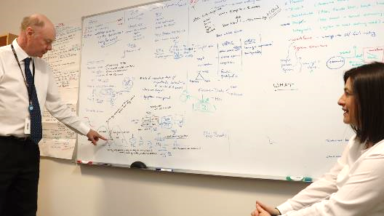

*Northern Health's Director of Data Science and Analytics Anthony Gust and Director, Project Management Office/HRO Sophie Argiriou discussing the ACDC project*

## Key activity

Northern Health will build two models:

* one to predict patients who are likely to have unplanned readmissions to hospital
* one to detect deterioration of patients in their home after they have been discharged.

These models will be developed using machine learning, with the models drawing on large amounts of historic data as the basis for their initial predictions, then continually adjusting their algorithms to improve their accuracy as they encounter new data.

### Predicting readmission

Northern Health will analyse all its data to determine which variables are important for building the model to predict hospital readmissions.

This will include looking at demographics, clinical disease profiles, how patients use community-based programs, and which patients have the highest use of inpatient resources.

The health service will build a number of models that include and exclude different sets of data to measure the impact on the model’s accuracy.

### Detecting deterioration

Development of this model will be delayed until the Staying Well initiative has been further established to determine what data will be available.

One of the elements of Staying Well that will form an initial basis for the model is data from regularly scripted phone calls that will be made to patients three to four times a week.

In addition to looking at yes/no responses, Northern Health will analyse the data for keywords or patterns of words. The health service will also be looking at pauses after specific questions. For example, a patient hesitating before saying they are feeling fine might indicate that they do not want to admit they are feeling unwell.

## Status

This innovation project was accepted in the Better Care Victoria 2019–20 funding round and is currently underway.