Educating patients on where to access appropriate urgent care

A creative marketing and communications campaign led by Numurkah District Health Service helped to educate the local community on alternatives to the emergency department when seeking urgent care.

## Background

In 2017, approximately 10 per cent of all Goulburn Valley Health (GVH) emergency department (ED) presentations were patients from outlying rural areas with lower complexity conditions. These patients potentially could have been treated at their local urgent care centre (UCC) or primary health service, releasing the regional ED’s resources for other patients with more urgent or higher complexity needs.

In this project, ‘lower complexity’ was broadly defined as presentations classified under Australasian Triage Scale categories 3, 4 and 5 – that is, patients ranging from urgent, with severe illness and trauma and requiring treatment within 30 minutes, to non-urgent, with minor illness and symptoms that may have been present for more than a week.

Seeking to divert these patients to more appropriate avenues to relieve pressure on both the GVH ED as well as Ambulance Victoria, Numurkah District Health Service (NDHS) partnered with a number of neighbouring rural health services to develop a marketing and communications campaign that encouraged the community to seek treatment at their local UCC or primary health centre when appropriate.

By educating patients on a range of conditions and informing them of the appropriate healthcare providers available, the project team aimed to reduce the number of GVH ED lower complexity case presentations from 10 target postcodes covering the towns of Nathalia, Numurkah, Cobram, Kyabram and the immediate surrounds.

Lower complexity urgent care: a new paradigm for rural health services

**Lead** Numurkah District Health Service

**Partners** Nathalia District Hospital, Cobram District Health, Kyabram District Health Service, Goulburn Valley Health, Ambulance Victoria, Murray Primary Health Network, University of Melbourne Rural Health Academic Network

**Duration** October 2017 – November 2018

**Key outcomes**

* Reduced the number of lower complexity presentations to the local regional ED from target postcodes by 18 per cent
* Established a Facebook page and website informing the community of appropriate avenues to seek lower complexity urgent care
* Developed a text message-based platform to capture ongoing feedback and experience data from patients of four rural UCCs
* Developed seven urgent care clinical pathways and a strong community of practice among project partners

‘…we are seeing greater partnerships. It has strengthened our joined-up services, our model of care.’

**– Health service provider**

## Key activity

### Community of practice

A partnership was established between four rural UCCs (Nathalia, Numurkah, Cobram and Kyabram), Goulburn Valley Health, Ambulance Victoria, the Murray Primary Health Network, and the University of Melbourne Rural Health Academic Network.

In addition to collaborating on the project’s key strategy, a marketing and communications campaign, the organisations met monthly to conduct clinical reviews of urgent care cases and identify other quality and safety improvements that could be implemented across all sites.

### Marketing and communications campaign

The project team engaged a communications and marketing specialist to design and implement the ‘Choose well, feel better’ campaign, which was informed by research conducted during the project’s baseline data collection and service audit phase. It included:

* a **Facebook page** aimed at educating and informing people who were not actively seeking care for a health concern. Content included basic advice and information on a range of health conditions and local health services; interviews, stories and videos with local health staff and prominent members of the community; details of events where project staff would be promoting the campaign; competitions; and quizzes that tested the community’s knowledge while also informing the content posted on the Facebook page
* a **website** designed to direct people actively seeking advice for a health concern to an appropriate channel. The website included links to the national health services directory, the national healthdirect symptom checker and 24-hour helplines such as Nurse on Call, the Maternal and Child Health Line, and Lifeline
* **Google advertisements** to drive residents of the target postcodes to the website. Ads involved specific search terms such as ‘emergency department’ and ‘24hr clinic near me’ as well as variations of longer phrases, such as ‘Who should I see for…’ and ‘Symptoms of…’
* **printed promotional materials and attendance at live community events**. These strategies were aimed at people who had already attended the GVH ED with a lower complexity health concern to inform them about what they should do next time. Printed assets included posters, postcards and magnets which were displayed in GP clinics, pharmacies, UCCs and local businesses. Press packs and a community email were also sent out to promote the initiative.

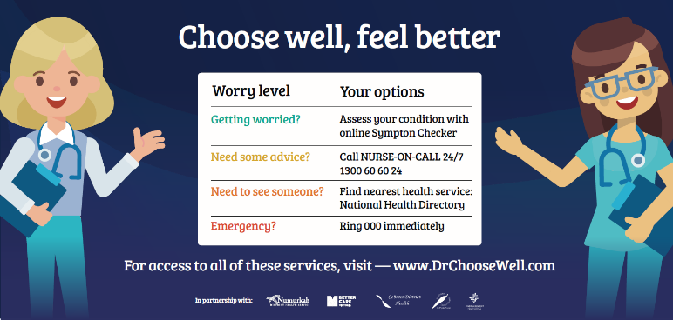

## Outcomes

### ED, UCC and ambulance presentations

The marketing and communications campaign launched in March 2018 and the project was evaluated from July to November 2018 against baseline data collected for the same period in the previous year.

Although there was an overall increase in GVH ED presentations over the course of the project, early results showed a decreasing trend in the number of patients presenting with lower complexity conditions from the target postcodes (see Figure 1).

During the evaluation period, 680 potentially divertible presentations attended the GVH ED, an 18 per cent reduction in potentially divertible presentations compared with the 828 who presented during the baseline period. The greatest change occurred in category 3 (‘urgent’) presentations, which reduced by 28 per cent.

Presentations to the four project UCCs from target postcodes also increased over the evaluation period, particularly at Cobram UCC, which saw presentations increase by 73 per cent to 1,786 presentations compared with 1,031 presentations during the baseline period.

The proportion of potentially divertible presentations to GVH ED that arrived via road ambulance increased during the evaluation period, which was contrary to the project’s objective. Despite this, there were indications that patients were receiving more timely access to care compared with those during the baseline period.

Figure 1. Lower complexity GVH ED presentations from target postcodes

### Other key outcomes

* A patient experience monitor using SMS text messaging technology was implemented to capture feedback from patients who had attended a project UCC (paper-based surveys with reply-paid envelopes were also made available for access equity). This showed growth in the number of people influenced by the Facebook campaign to attend their local UCC.
* The monthly clinical review meetings established as part of the project were a significant achievement, yielding several positive inter-agency outcomes and quality improvements. For example, seven urgent care clinical pathways were developed and are being implemented across all project sites.
* The sharing of data as part of the project also led to overall improvements in data capture at the project UCCs, and the strong community of practice that has developed has paved the way for further partnership and collaboration in future.

## Key learnings

* Service mapping and auditing helped to identify similarities between the UCCs’ operations and where there were gaps. Some system-level gaps identified were out of the project’s scope, such as the lack of a statewide strategy for telehealth specific to the ED/urgent care model. Telehealth could prevent unnecessary presentations of lower complexity cases by enabling UCC staff and GPs to video call the ED. It could also facilitate direct patient admissions where appropriate, negating the need to present to the ED.
* Evaluation of the project identified that the marketing and communications campaign could have benefited from input from health consumers, local community members, and a health literacy expert.
* Staff and community member stories had the highest engagement on the Facebook page, with video performing significantly higher than any other form of content. Quizzes were the next most engaging, with competitions being the least effective content.
* A focus group indicated that: newspapers, television and seniors’ magazines might be more effective for reaching older people; the Facebook posts contained too much text and might work better with limited copy linking to further information; and the campaign characters could be more diverse.
* The increase in ambulance ED presentations suggests opportunities to increase public education on when it is appropriate to call an ambulance, and to educate ambulance staff on UCCs’ capabilities in treating lower complexity patients.