|  |
| --- |
| June 2021 |
| Victorian perinatal services performance indicators  2019–20 |

|  |  |  |
| --- | --- | --- |
| To receive this publication in an accessible format phone  03 9096 1384, using the National Relay Service 13 36 77 if required, or email info@safercare.vic.gov.au | Authorised and published by the Victorian Government, 1 Treasury Place, Melbourne.  © State of Victoria, Australia, Safer Care Victoria, June 2021  ISSN 2207-3558 (online)  Available at [www.safercare.vic](http://www.safercare.vic).gov.au | Victorian Government logo |



# Contents

Contents 1

About this report 2

Summary of results 6

1a: Induction of labour in standard primiparae 9

1b: Caesarean sections in primiparae 13

1c: Perineal tears in primiparae 18

2: Term babies without congenital anomalies who required additional care 23

3: Severe fetal growth restriction 27

5: Five-year gestation standardised perinatal mortality ratio 33

6a and 6b: Readmissions during the postnatal period 37

7: Smoking cessation 45

10: Low Apgar score 49

11a and 11b: Women’s experiences of care 53

12b: Maternal vaccination 59

13: Women who had a severe postpartum haemorrhage within the 24 hours following birth, 2019 62

Appendix 1: Data sources and reporting rules 65

Appendix 2: Total women and babies in Victorian maternity services 2019 66

Appendix 3: Overview of results 69

Terminology 72

References 75

# About this report

This report provides insights into where we are providing exceptional care and where improvements can be made across our maternity services in Victoria. It provides data allowing health services to compare results and monitor variation within their own services over time and also against their peers. This report also helps health services prioritise their performance improvements by reviewing their practices and identifying areas of improvements for the care provided to women and their babies – from antenatal, through intrapartum (labour and birth) to postnatal care.

These performance indicators are widely accepted as appropriate, useful and insightful measures of the quality of care. They continue to be refined over time.

Figure 1. Perinatal services performance indicators by key performance area

Antenatal

Intrapartum

Postnatal

Indicator 3:   
Severe growth restriction

Indicators 1a, 1b and 1c:   
Outcomes for primiparae

Indicators 6a, 6b: Readmission during the postnatal period

Indicator 7:   
Smoking cessation

Indicator 2:   
Term babies without congenital anomalies who required additional care

Indicator 12b:   
Maternal immunisation

Indicator 10:   
Low Apgar score

Indicators 11a, 11b:   
Women’s experience

Indicator 5:   
Five-year gestation standardised perinatal mortality ratio

Trial indicator 13:   
Postpartum haemorrhage

## How to use this report

The main section of this report details statewide data observations and key information for clinicians and health services.

Outcomes are reported here by comparing services with each other and over time. We call this comparison ‘benchmarking’. It can be used to identify high performing services, performance of practices within a multi-site health service and compare practice over time.

Benchmarking can:

* allow you to assess performance relative to other health services
* identify services that are providing best practice that you may want to connect with
* highlight opportunities for improvements, particularly where improvement activities have led to success in other organisations.

Further detail is provided in the appendices.

* **Appendix 1** details the data sources for this report.
* **Appendix 2** lists Victoria’s maternity services and the number of women and babies cared for in 2019.
* **Appendix 3** contains an overview of results for each individual health service.

## What is different this year?

### Some indicators have not been included

Due to the impact of the coronavirus (COVID-19) pandemic – both at Safer Care Victoria and in health services - this year we have prioritised 16 indicators from the 25 indicators reported previously. Indicators not reported this year include:

* Indicators 1di and 1dii: Episiotomies in primiparae
* Indicators 4a and 4b: Vaginal birth after primary caesarean section
* Indicators 8a, 8b and 8c: Breastfeeding in hospital
* Indicator 9: First antenatal visit
* Indicator 12a: the rate of women vaccinated for pertussis.

### Funnel plots have been provided for all indicators

Funnel plots consider the size of the maternity service which is an advantage over the interquartile ranges in identifying most favourable and least favourable outcomes. Please note that only the gestation standardised perinatal mortality ratio (GSPMR) funnel plot includes risk-adjusted rates. All other funnel plots present rates that have not been risk adjusted.

Only hospitals with at least 30 records (mothers or newborns) have been included in the funnel plots with the exclusion of the GSPMR funnel plot which applied a different threshold. For the GSPMR funnel plot, only hospitals with at least five deaths during the pooled five-year period (2015–2019) have been included.

## About the data

Data for this report comes from the Victorian Perinatal Data Collection (VPDC), the Victorian Healthcare Experience Survey (VHES) and the Victorian Admitted Episodes Dataset (VAED).

* VPDC and VHES data is from the 2019 calendar year.
* The VPDC and VHES are used as source for indicators 1a, 1bi, 1bii, 1ci, 1cii, 3, 5, 7, 10, 12b and 13.
* VAED data is reported for the financial year 2019–20 and is used as source for indicators 2, 6a and 6b.

How to interpret the data

**Statewide rates**   
These provide an average of all hospitals combined (public and private). The **public rate** is the average of all public hospitals combined and the **private rate** is the average of all private hospitals combined. They do not represent a desired target. In most cases, even where a hospital appears to be doing well in comparison to others, opportunities for improvement remain.

**Interquartile ranges**   
These represent variation between services. The graphs throughout this report use red and green vertical lines and shading to show the least (red) and most (green) favourable 25 per cent of services. The most favourable rate may be high or low depending on the indicator. For example, we want rates of severe fetal growth restriction to be low and rates of smoking cessation to be high.

**Funnel plots**   
These provide a good visualisation of each hospital’s rate compared to other hospitals and to a target or an average rate (usually the state rate or the median rate across hospitals) and take into consideration the size of the hospital. Each dot represents a hospital’s rate for the given indicator.

The solid horizontal line represents the average rate (median of hospital rates for all indicators except for indicators 5, 6a, 6b, 11a, 11b in which the state rate is used as the average rate). Hospitals (dots) that are above this line have a rate that is higher than the average rate. Hospitals below this line have a rate that is lower than the average rate.

The dashed and solid blue lines represent 95 per cent and 99 per cent control limits, respectively. Control limits can be used to test how different each hospital’s rate is from the average rate, taking the size of the hospital into consideration. If a hospital falls outside of the 95 per cent control limits of the funnel plot, its rate is considered to be statistically significantly different from the average rate. Hospitals that fall above the 95 per cent upper control limit have a rate that is statistically significantly higher compared to the average rate. Conversely, those that fall below the 95 per cent lower control limit have a rate that is statistically significantly lower compared to the average rate. A favourable outcome for most indicators is to be lower than the average rate except for indicators 7, 11a, 11b, and 12b. For these indicators, a rate that is higher than the average rate is most desirable.

**p-values**   
In comparing the rate for a given indicator with the previous year’s rate, or comparing the rate for public hospitals with the corresponding rate for private hospitals, statistical tests have been done to determine if there’s enough evidence in the data to conclude difference in the rates. A large sample is much better able to detect small differences in the rates compared to a small sample. All tests applied a five per cent significance level which means that the chance of error in concluding a non-significant result, when there is a difference in the rates is limited to five per cent. A p-value   
< 0.05 indicates a statistically significant result. Note that a statistically significant result does not imply clinical significance. However, being able to establish statistical significance means one can then do the next step of assessing clinical significance since it has been established that the difference in the rates is not likely to be due to chance.

## Compare your performance

Each health service will receive their own profile detailing their individual results. These are confidential to each health service although some services choose to share their results with others. Consider sharing your service profile with others to help identify trends and opportunities for learning together, particularly services within your region and services of similar capability.

### Capability levels

We have clustered health services by capability level so you can easily compare your service with others that care for mothers and babies with a similar level of complexity.

Figure 2. Levels of maternity and neonatal care

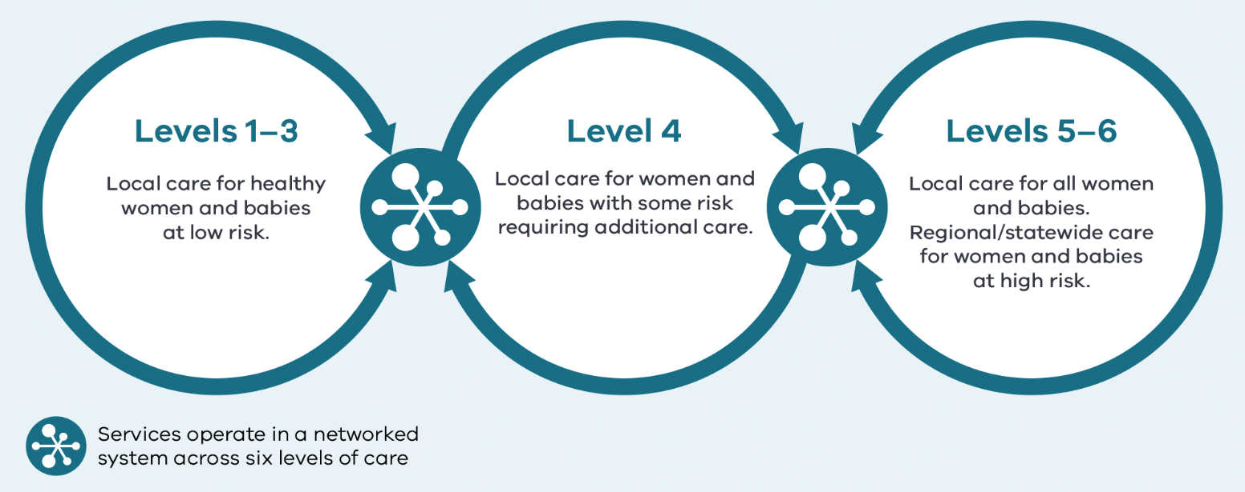

Source: Capability framework for Victorian maternity and newborn services.

## Inform quality improvement activities

Analysis provided in this report can guide, inform and help you prioritise local audits.

To further identify areas to implement improvement programs and measure the impact of your programs, you can share this with your:

* quality and safety, mortality and morbidity, and consumer advisory committees
* clinicians, managers, executive and board.

# Summary of results

## Where we are getting better

Compared with previous years, the following indicators have improved in 2019.

### Indicator 2: Term babies without congenital anomalies who required additional care

The rate across public hospitals of term babies without congenital anomalies who required additional care was 8.1 per cent. This is about one percentage point lower when compared to the rate of 9.2 per cent in 2018–19. This difference was statistically significant (p<0.001).

### Indicator 3: Severe fetal growth restriction

For the fourth consecutive year there was a decrease in the statewide rate of severe fetal growth restricted (FGR) babies undelivered by 40 weeks’ gestation.

The statewide (combined public and private) rate of undetected FGR dropped from 24.3 per cent in 2018 to 23.0 per cent in 2019. Although this difference was not statistically significant (p=0.208), FGR has improved significantly over time (35.6 per cent in 2013 to 23.0 per cent in 2019). In public hospitals the rate decreased from 23.0 per cent in 2018 to 22.1 per cent in 2019 (p=0.301). There was greater improvement in private hospitals with the rate decreasing form 30.2 in 2018 to 26.4 in 2019, however, given the lower count in private hospitals, this difference was not statistically significant (p=0.175).

### Indicator 12b Maternal vaccination for influenza

The statewide rate of women vaccinated for influenza (flu) during pregnancy has increased from 67.1 per cent in 2018 to 74.6 per cent in 2019 (p<0.001). In public hospitals this rate increased from 67.8 per cent in 2018 to 75.8 per cent in 2019 (p<0.001). In private hospitals this rate increased from 65.0 per cent in 2018 to 70.9 per cent in 2019 (p<0.001).

The influenza vaccine protects pregnant women from infections that can cause serious complications during pregnancy and affect the health of their babies. The ideal immunisation rate is 100 per cent.

## Where we are doing less well

The following outcomes suggest the need for health services to comprehensively review their practices and then implement and monitor programs to improve performance.

### Indicator 1a Induction of labour

The statewide rate of induction of labour in standard primiparae increased by nearly four percentage points from 13.6 per cent in 2018 to 17.3 per cent in 2019 (p<0.001). The rate across public hospitals increased from 9.4 per cent in 2018 to 11.8 per cent in 2019 (p<0.001). The rate in private hospitals also increased significantly from 21.1 per cent in 2018 to 26.5 per cent in 2019 (p<0.001).

While induction of labour is sometimes necessary, it can increase the need for further intervention. Safely reducing the number of primiparous women who have an induced labour may reduce the number who require interventions during labour and birth.

### Indicators 1bi and 1bii Caesarean sections in primiparae

The statewide rate of primiparae in Robson group 1 who gave birth by caesarean section (Indicator 1bi) increased slightly from 16.7 per cent in 2018 to 18.0 per cent in 2019 (p=0.007). In public hospitals the rate increased from 15.3 per cent in 2018 to 16.9 per cent in 2019 (p=0.001). The rate in private hospitals changed only slightly from 21.8 per cent in 2018 to 22.0 per cent in 2019 (p=0.561).

The statewide rate of primiparae in modified Robson group 2 who gave birth by caesarean section (Indicator 1bii) also increased from 30.6 per cent in 2018 to 31.6 per cent in 2019 (p=0.031). In public hospitals the rate was 30.2 per cent in 2018 and 31.2 per cent in 2019 (p=0.062). The change in private hospitals was similar at 31.9 per cent in 2018 and 33.2 per cent in 2019 (p=0.853).

### Indicator 11b Women’s experiences of care – consistent advice from midwives and other professionals about feeding baby

The proportion of women who felt they received consistent advice from midwives and other professionals about feeding their baby decreased from 49.0 per cent in 2018 to 47.2 per cent in 2019. This decrease was statistically significant (p=0.017).

Table 1. Summary of statewide public and private maternity hospital rates

|  |  |  |  |  |  |  |  |
| --- | --- | --- | --- | --- | --- | --- | --- |
| Indicator | | Statewide 2018 | Statewide 2019 | Statewide public | Statewide private | Least favourable quartile | Most favourable quartile |
| 1a | Rate of induction of labour in standard primiparae | 13.6% | 17.3% | 11.8% | 26.5% | 25.6% | 11.1% |
| 1bi | Rate of caesarean section in Robson group 1 | 16.7% | 18.0% | 16.9% | 22.0% | 23.7% | 14.6% |
| 1bii | Rate of caesarean section in modified Robson group 2 | 30.6% | 31.6% | 31.2% | 33.2% | 40.4% | 29.2% |
| 1ci | Rate of third and fourth-degree perineal tears during unassisted vaginal births to primiparae | 3.8% | 4.2% | 4.7% | 1.4% | 5.6% | 1.2% |
| 1cii | Rate of third and fourth-degree perineal tears during assisted vaginal births to primiparae | 5.0% | 5.6% | 6.5% | 2.8% | 7.4% | 2.6% |
| 2 | Rate of term babies without congenital anomalies who required additional care*† | NA | 8.1% | 8.1% | NA | 9.4% | 3.5% |
| 3 | Rate of severe fetal growth restriction in a singleton pregnancy undelivered by 40 weeks | 24.3% | 23.0% | 22.1% | 26.4% | 27.3% | 17.6% |
| 5 | Five-year gestation standardised perinatal mortality ratio (GSPMR) for babies born at ≥ 32 weeks | 1.0 | 1.0 | NA | NA | NA | NA |
| 6a | Rate of maternal readmissions during the postnatal period† | 2.6% | 2.3% | 2.4% | 1.7% | NA | NA |
| 6b | Rate of newborn readmissions during the postnatal period*† | NA | 4.1% | 4.1% | NA | NA | NA |
| 7 | Rate of smoking cessation during pregnancy | 28.0% | 28.0% | 26.8% | 59.3% | 12.5% | 35.1% |
| 10 | Rate of term babies without congenital anomalies with an Apgar score < 7 at five minutes | 1.3% | 1.3% | 1.3% | 1.0% | 1.8% | 0.9% |
| 11a | Rate of women who felt involved, as much as they wanted to be, in decisions about their care during labour and birth* | NA | NA | 80.0% | NA | NA | NA |
| 11b | Rate of women who felt that midwives and other health professionals gave them consistent advice about feeding their baby* | NA | NA | 47.2% | NA | NA | NA |
| 12b | Rate of women vaccinated for influenza during pregnancy | 67.1% | 74.6% | 75.8% | 70.9% | 71.1% | 80.5% |
| 13 | Rate of women with severe postpartum haemorrhage | 2.2% | 2.5% | 2.9% | 0.9% | 3.0% | 1.0% |

Notes:

Quartiles are calculated for statewide public and private health services combined, unless stated otherwise.

* Result includes public hospitals only

† Results shown are for 2018–19, 2019–20 FY as they are sourced from the VAED

NA – not applicable

# 1a: Induction of labour in standard primiparae

Induction of labour is sometimes necessary. However, Victorian data shows it can increase the need for further intervention, such as caesarean (refer to Indicator 1bii). Safely reducing the number of primiparous women who have an induced labour may reduce the number who require birthing interventions overall.

## About this indicator

This indicator shows the rate of induction of labour for the standard woman giving birth to her first child (primipara).

Excluding women with complicated pregnancies, this indicator takes into account patient complexity and compares between low risk women at all hospitals. These women are expected to need little intervention.

## Observations on the data

Similar to the previous years, the rate in 2019 of standard primiparae having an induced labour in private hospitals was significantly higher compared to public hospitals (26.5% and 11.8% respectively, p<0.001).

The statewide rate for 2019 was 17.3 per cent, which is nearly four percentage points higher than last year’s rate which was 13.6 per cent.

Similar to the previous year’s results, there was considerable variation in hospital rates for this indicator, from 0 to 37.8 per cent (**Figure 3**).

Figure 3. Indicator 1a: Rate of induction of labour in standard primiparae, 2019

Figure 4. Funnel plot of the rate of induction of labour in standard primiparae, 2019

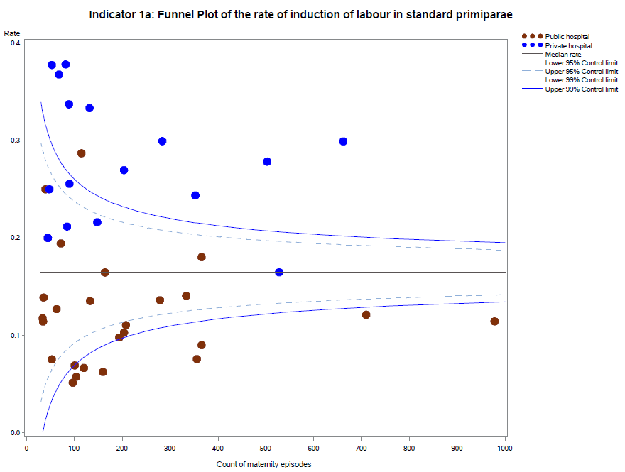

Please refer to page 4 for a guide on how to interpret funnel plots.

## Definitions and data sources

The standard primipara in this indicator is defined as a woman, 20 to 39 years of age, free of obstetric and specified medical complications (pre-existing hypertension, diabetes, cardiac disease or serious psychiatric conditions), giving birth for the first time with a singleton pregnancy between 37 and 40 weeks completed gestation (259–286 days), with a non-small for gestational age (greater than tenth centile) infant and a cephalic presentation.

#### Data source: Victorian Perinatal Data Collection (VPDC)

Data for this indicator is sourced from the VPDC for the calendar year from 1 January 2019 to 31 December 2019.

This indicator is derived using the following VPDC variables: ‘parity’, ‘maternal age’, ‘plurality’, ‘estimated gestational age’, ‘birth presentation’, ‘obstetric complications-ICD-10-AM code’, ‘maternal medical conditions-ICD-10-AM code’, ‘indication for induction-ICD-10-AM code’, ‘indications for operative delivery-ICD-10-AM code’, ‘birthweight’, and ‘labour type’.

The inclusion criteria for the standard primipara have been reviewed. The upper age limit has been increased to 39 years. The medical conditions that exclude women are now limited to pre-existing hypertension, diabetes, cardiac disease or serious psychiatric conditions (schizophrenia, other psychotic disorders and bipolar disorder). Women are excluded if they have any obstetric conditions recorded in the ‘complications of pregnancy’ or ‘indication for induction’ field (any condition listed in the ‘O’ chapter of ICD-10 that occurs before the onset of labour, but not those related to gestation or spurious labour).

Numerator/denominator

|  |  |  |
| --- | --- | --- |
| **Indicator** | **Numerator** | **Denominator** |
| Indicator 1a: Rate of induction of labour in standard primiparae | The number of standard primiparae who give birth undergoing induction of labour | The number of standard primiparae |

# 1b: Caesarean sections in primiparae

Caesarean sections are vital for the outcome of mothers and babies in some situations. However, they are accompanied by higher morbidity for women and babies, slower recovery, increased risk of placental complications in subsequent births and increased cost to the healthcare system. A caesarean birth for the first baby increases the risk of caesarean birth for subsequent babies.

## About this indicator

Indicator 1b measures outcomes for women having their first birth (primiparae), either spontaneous or induced (but not by pre-labour, caesarean section). It includes only those that are singleton, presenting head-first, and at least 37 weeks’ gestation. The Robson classification system (also known as the 10-group classification) categorises all women into one of 10 groups that are mutually exclusive and exhaustive based on basic obstetric characteristics.

* Indicator 1bi (Robson group 1) considers the proportion of caesarean sections in women whose labour commenced spontaneously.
* Indicator 1bii (modified Robson Group 2) considers the proportion of caesarean sections in women whose labour was induced (but excludes those undergoing pre-labour caesarean).

## Observations on the data

The statewide rate of primiparae in Robson group 1 who gave birth by caesarean section (Indicator 1bi) was 18.0 per cent. This is slightly higher compared to the rate in 2018 which was 16.7 per cent. The rate was lower across public hospitals (16.9 per cent) than private hospitals (22.0 per cent, p-value <0.001).

The statewide rate of primiparae in modified Robson group 2 who gave birth by caesarean section (Indicator 1bii) was 31.6 per cent and is one percentage point higher compared to the rate in 2018 which was 30.6 per cent. The rate across public hospitals was also lower compared to private hospitals (31.2 and 33.2 per cent respectively, p-value=0.019).

There was considerable variation between hospitals across the state and within maternity capability levels as shown in **Figures 5** and **6** (Indicator 1bi) and **Figures 7** and **8** (Indicator 1bii).

Figure 5. Indicator 1bi: Rate of caesarean section in Robson group 1, 2019

Figure 6. Funnel plot of the rate of caesarean section in Robson group 1, 2019

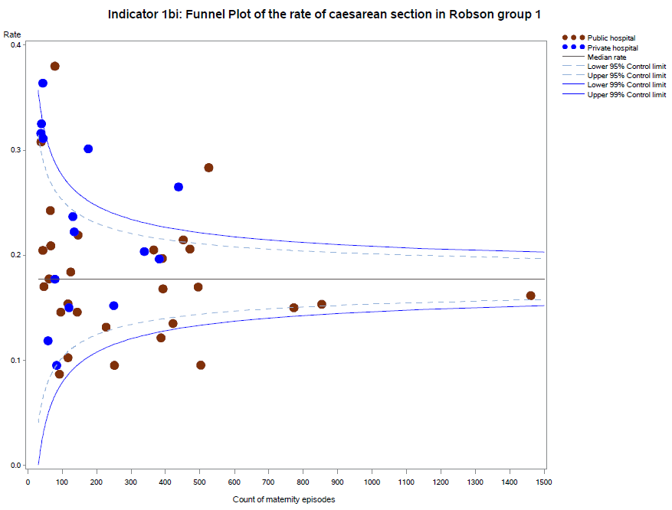

Figure 7. Funnel plot of the rate of caesarean section in modified Robson group 2, 2019

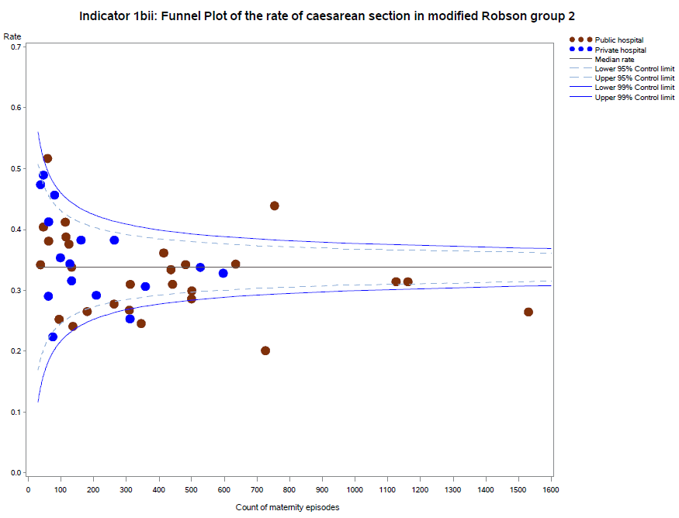

Please refer to page 4 for a guide on how to interpret funnel plots.

Figure 8. Indicator 1bii: Rate of caesarean section in modified Robson group 2, 2019

Table 2. Rate of caesarean section in Robson groups 1 and 2, 2016–19

|  |  |  |  |  |  |  |  |  |
| --- | --- | --- | --- | --- | --- | --- | --- | --- |
|  | Robson Group 1 | | |  | Robson Group 2 | | |  |
|  | 2016 | 2017 | 2018 | 2019 | 2016 | 2017 | 2018 | 2019 |
| Public | 14.9% | 15.0% | 15.3% | 16.9% | 30.4% | 29.6% | 30.2% | 31.2% |
| Private | 21.7% | 22.5% | 21.8% | 22.0% | 32.8% | 32.3% | 31.9% | 33.2% |
| Combined | 16.4% | 16.7% | 16.7% | 18.0% | 31.0% | 30.1% | 30.6% | 31.6% |

## Definitions and data sources

Robson group 1 (Indicator 1bi) includes first-time birthing women with a singleton cephalic pregnancy, at greater than or equal to 37 weeks’ gestation in spontaneous labour.

Modified Robson group 2 (Indicator 1bii) includes women having their first baby with a singleton cephalic pregnancy, at greater than or equal to 37 weeks’ gestation who had labour induced. Modified Robson group 2 excludes pre-labour caesareans, which are included in the standard Robson group 2.

#### Data source: Victorian Perinatal Data Collection

Data for these indicators are sourced from the VPDC for the calendar year from 1 January 2019 to   
31 December 2019.

The indicators are derived using the following VPDC variables: ‘parity’, ‘plurality’, ‘birth presentation’, ‘estimated gestational age’, ‘onset of labour’ and ‘method of birth’.

Numerator/denominator

|  |  |  |
| --- | --- | --- |
| Indicator | Numerator | Denominator |
| Indicator 1bi: Rate of caesarean section in Robson group 1 | The number of women giving birth for the first time, with spontaneous onset of labour and a singleton, cephalic-presenting baby born at 37 or more weeks by caesarean section | The number of women giving birth for the first time, with spontaneous onset of labour and a singleton, cephalic-presenting baby born at 37 or more weeks |
| Indicator 1bi: Rate of caesarean section in Robson group 1 | The number of women giving birth for the first time, with spontaneous onset of labour and a singleton, cephalic-presenting baby born at 37 or more weeks by caesarean section | The number of women giving birth for the first time, with spontaneous onset of labour and a singleton, cephalic-presenting baby born at 37 or more weeks |

# 1c: Perineal tears in primiparae

Third- and fourth-degree perineal tears are a significant birth-related complication that may lead to long-term disability. Women having their first birth vaginally in Victoria are four times more likely to experience a severe (third- or fourth-degree) perineal laceration compared to those having a subsequent birth vaginally. It is important that, where possible, they are prevented from happening and, when they do happen, they are recognised and appropriately treated. Third- and fourth-degree tear rates may reflect the quality of care or reflect differences in the accuracy of identification and reporting.

Maternity services participating in the SCV Better Births for Women collaborative are using improvement science methods and have introduced an evidence-based bundle of clinical interventions. This bundle of interventions includes practices before, during and after birth to better prevent and recognise severe perineal trauma and reduce the rate of third- and fourth-degree tears and associated sequelae for all women giving birth vaginally.

## About this indicator

This indicator shows the rate of third and fourth-degree perineal tears in women who gave birth for the first time and who had a vaginal birth (with or without the use of instruments).

An assisted (or operative/instrumental) vaginal birth refers to a forceps- or vacuum-assisted birth. Operative intervention in the second stage of labour may be indicated by conditions of the fetus or the mother.

An unassisted vaginal birth is one that occurs without the use of instruments (forceps or vacuum).

* Indicator 1ci refers to unassisted vaginal births
* Indicator 1cii refers to assisted vaginal births.

## Observations on the data

The statewide rate of third- and fourth-degree perineal tears in unassisted vaginal births (Indicator 1ci) was 4.2 per cent, a slight increase from the previous year’s rate of 3.8 per cent. The rate was significantly higher in public hospitals (4.7 per cent) compared to private hospitals (1.4 per cent, p-value<0.001).

The statewide rate of third- and fourth-degree tears in assisted vaginal births (Indicator 1cii) was   
5.6 per cent, also slightly higher compared to the previous year’s rate of 5.0 per cent. The rate was again significantly higher in public hospitals (6.5 per cent) compared to private hospitals (2.8 per cent,   
p-value<0.001).

**Figures 9** and **10** (Indicator 1ci) and **Figures 10** and **11** (Indicator 1cii) show that there is significant variation between hospitals across the state and within maternity capability levels, also within private hospitals in the rate of third- and fourth-degree perineal tears in both assisted and unassisted vaginal births.

Figure 9. Indicator 1ci: Rate of third- and fourth-degree perineal tears during unassisted vaginal births to primiparae, 2019

Figure 10. Funnel plot of the rate of third- and fourth-degree perineal tears during unassisted vaginal births to primiparae, 2019

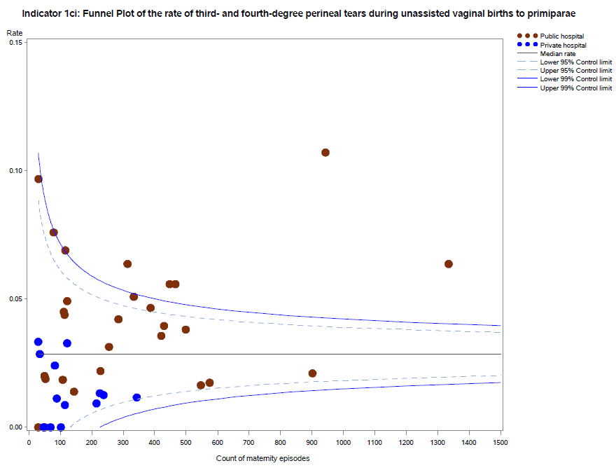

Figure 11. Funnel plot of the rate of third- and fourth-degree perineal tears during assisted vaginal births to primiparae, 2019

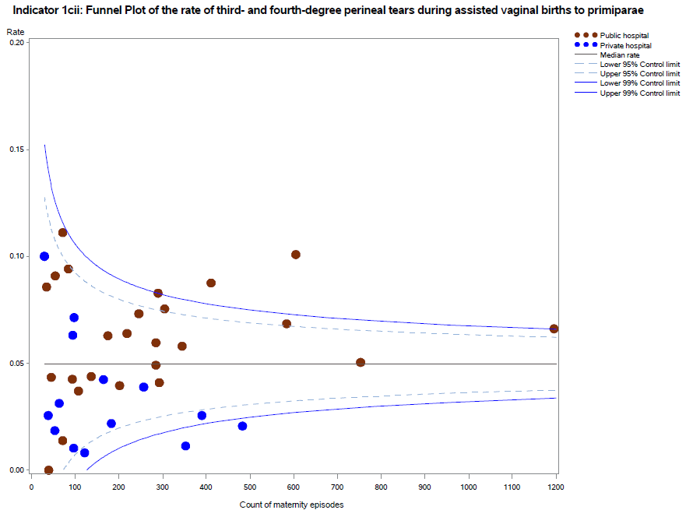

Please refer to page 4 for a guide on how to interpret funnel plots.

Figure 12. Indicator 1cii: Rate of third- and fourth-degree perineal tears during assisted vaginal births to primiparae, 2019

Table 3. Rate of third- and fourth-degree perineal tears, 2016–19

|  |  |  |  |  |  |  |  |  |
| --- | --- | --- | --- | --- | --- | --- | --- | --- |
|  | During unassisted vaginal births | | |  | During assisted vaginal births | | |  |
|  | 2016 | 2017 | 2018 | 2019 | 2016 | 2017 | 2018 | 2019 |
| Public | 4.9% | 3.6% | 4.4% | 4.7% | 7.7% | 5.5% | 6.0% | 6.5% |
| Private | 1.3% | 1.0% | 1.0% | 1.4% | 2.5% | 2.5% | 2.4% | 2.8% |
| Combined | 4.3% | 3.2% | 3.8% | 4.2% | 6.2% | 4.7% | 5.0% | 5.6% |

## Definitions and data sources

For all primiparae, (i) the proportion who have a third- or fourth-degree perineal tear during an unassisted vaginal birth, and (ii) the proportion who had a third- or fourth-degree perineal tear during an assisted vaginal birth.

Included are those women who gave birth for the first time and had a vaginal birth, with or without instruments. Women who had a multiple birth are included if this was the first time they had given birth.

Excluded are those women who did not give birth for the first time or gave birth by caesarean section.

Third-degree perineal tear means a perineal laceration, rupture or tear also involving anal sphincter, rectovaginal septum and/or sphincter not otherwise specified. Excludes lacerations involving the anal or rectal mucosa.

Fourth-degree perineal tear means a perineal laceration, rupture or tear occurring during delivery, also involving anal mucosa and/or rectal mucosa.

The rates for third- and fourth-degree tears includes episiotomies extended by a laceration of a third- and fourth-degree type.

#### Data source: Victorian Perinatal Data Collection

Data for these indicators are sourced from the VPDC for the calendar year from 1 January 2019 to   
31 December 2019.

Numerator/denominator

|  |  |  |
| --- | --- | --- |
| Indicator | Numerator | Denominator |
| Indicator 1ci: Rate of third- or fourth-degree perineal tears during unassisted vaginal births to primiparae | The number of primiparae who had a third- or fourth-degree perineal laceration during an unassisted vaginal birth | The number of primiparae who had an unassisted vaginal birth |
| Indicator 1cii: Rate of third- or fourth-degree perineal tears during assisted vaginal births to primiparae | The number of primiparae who had a third- or fourth-degree perineal laceration during an assisted (instrumental) vaginal birth | The number of primiparae who had an assisted vaginal birth |

# 2: Term babies without congenital anomalies who required additional care

Most inborn babies, born at 37 weeks or more, with a birthweight of at least 2,500 grams and without the presence of a congenital anomaly are not expected to require additional care following birth. As such, the indicator indirectly measures the quality of care provided during pregnancy, labour and birth and in the early neonatal period.

## About this indicator

This indicator aims to highlight variations in the care required for term babies (born at 37 weeks or more) without congenital anomalies.

While we know some babies will experience medical conditions following birth that require admission to hospital for additional care (for example, jaundice, low Apgar score, sepsis, seizures), we expect the need for additional care and treatment in this cohort to be low.

Higher rates may indicate quality of care issues during labour, birth and/or the immediate neonatal period.

## Observations on the data

The statewide public hospital rate of term babies without congenital anomalies who required additional care in 2019–20 was 8.1 per cent. This is around one percentage point lower compared to the 9.2 per cent rate in 2018–19. This is also the lowest rate for this indicator over the past five years (the rate during the previous five years ranged from 8.5 per cent to 9.4 per cent).

**Figures 13** and **14** show significant variation between hospitals, ranging from zero to 14.9 per cent.

Figure 13. Indicator 2: Rate of term babies without congenital anomalies who required additional care, 2019–20

Note: Reporting of unqualified neonate admissions to the VAED for private hospitals is optional. It is therefore not possible to establish an accurate denominator (that includes public and private hospitals) for this indicator. As such, only public hospitals are included in the results.

Figure 14. Funnel plot of the rate of term babies without congenital anomalies who required additional care, 2019–20

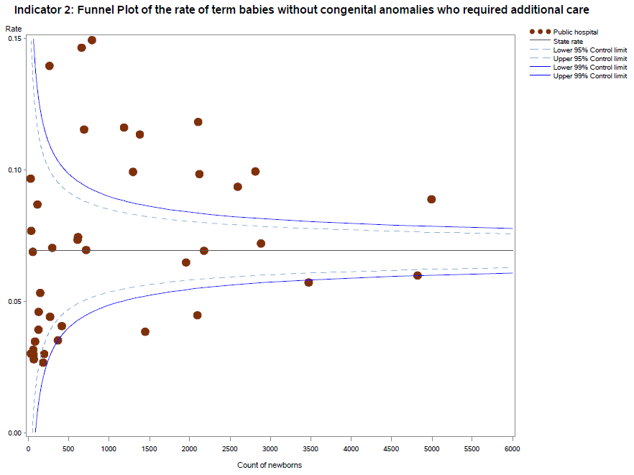

Please refer to page 4 for a guide on how to interpret funnel plots.

Table 4. Rate of term babies without congenital anomalies who required additional care, by financial year, 2015–20

|  |  |  |  |  |  |
| --- | --- | --- | --- | --- | --- |
|  | 2015–16 | 2016–17 | 2017–18 | 2018–19 | 2019–20 |
| Public | 8.6% | 9.4% | 8.7% | 9.2% | 8.1% |

## Definitions and Data Sources

This indicator includes inborn term babies. An inborn term baby is an infant born at the reporting hospital at a gestational age of 37 weeks or more. Term babies without congenital anomalies who require additional care are defined as newborns who:

* are not less than 37 weeks 0 days’ gestation
* weigh not less than 2,500 grams
* are without congenital anomalies
* are grouped to Victorian diagnostic-related groups (VIC-DRGs) representing the need for more than normal care (see list of VIC-DRGs provided below).

Excluded are:

* babies born at another hospital
* pre-term newborn babies
* infants with congenital anomalies
* birthweight less than 2,500 grams
* stillborn babies
* readmission (separation not related to the birth episode).

The denominator for the 2019–20 reporting period is episodes grouped to the Version 9.0 VIC-DRGs:

* P68A (v7): Neonate, AdmWt >=2500g W/O Sig OR Proc >=37 Comp Wks Gest W Mult Major Probs
* P68B (v7): Neonate, AdmWt >=2500g W/O Sig OR Proc >=37 Comp Wks Gest W Major Problem
* P68C (v7) Neonate, AdmWt >=2500g W/O Sig OR Proc >=37 Comp Wks Gest W Other Problem
* P68D (v7) Neonate, AdmWt >=2500g W/O Sig OR Proc >=37 Comp Wks Gest W/O Problem
* P06A Neonate, Admission weight > 2499g with Significant Operating Room Procedure with Multi Major Problems
* P06B Neonate, Admission weight > 2499g with Significant Operating Room Procedure without Multi Major Problems
* P60A Neonate, Died or Transferred < 5 days of admission, without Significant Operating Room Procedure, Newborn
* P60B Neonate, Neonate W/O Sig OR Proc, Died or Transferred to Acute Facility Same Day.

#### Data source: Victorian Admitted Episodes Dataset

Data for this indicator is sourced from the VAED for the financial year from 1 July 2019 to 30 June 2020.

Numerator/denominator

|  |  |  |
| --- | --- | --- |
| Indicator | Numerator | Denominator |
| Indicator 2: Rate of term babies without congenital anomalies who required additional care | The number of inborn term babies without birth defects grouped to VIC‑DRG P68A, P68B, P68C, P06A, P06B, P60A# and P60B# | The number of inborn term babies without congenital anomalies grouped to VIC-DRG P68A, P68B, P68C, P68D, P06A, P06B, P60A# and P60B# |

#All newborns initially grouped to P60A and P60B were regrouped to the next logical VIC-DRG following removal of the separation mode ‘Died or Transferred’ and replaced with the separation mode of ‘Home’. This was done so that only those babies in P60A and P60B who require additional care are counted in the numerator. To include the whole of P60A and P60B in the numerator would overestimate the rate of newborns requiring additional care because some healthy newborns are transferred for other reasons.

# 3: Severe fetal growth restriction

Undetected fetal growth restriction (FGR) is the strongest risk factor for stillbirth and is associated with poor perinatal and long-term outcomes, including low Apgar scores, birth asphyxia and neurodevelopmental delay. These risks are heightened in severe FGR.

The timely detection of severe FGR allows appropriate fetal surveillance and timing of birth to optimise short and longer-term outcomes, including reducing the risk of stillbirth. The Safer Baby Collaborative is a key piece of improvement work being undertaken in some Victorian maternity services, aimed at reducing the rate of stillbirths. This work has a strong focus on FGR, with the evidence-based bundle of interventions including consistent, reliable practices to assess the risk of FGR and screen for, and diagnose, slow or static fetal growth, enabling timely intervention.

## About this indicator

This indicator shows the proportion of singleton babies with severe growth restriction who were born at or after 40 weeks’ gestation. Birth after 40 weeks’ gestation suggests that the growth restriction may not have been detected and acted on in a timely way.

## Observations on the data

The rate of singleton babies with severe FGR who were born at 40 or more weeks’ gestation in public and private hospitals in 2019 was 23.0 per cent. This is more than one percentage point lower compared to the rate in 2018 which was 24.3 per cent. It is worth noting that the rate for this indicator in public hospitals has been steadily decreasing over the past five years. There has also been a considerable decline in the rate in private hospitals over this period.

The rate was lower in public hospitals (22.1 per cent) compared to private hospitals (26.4 per cent), although the difference was not statistically significant (p-value = 0.069).

**Figure 15** shows there is significant variation between hospitals, however, this is partly driven by low numbers. The funnel plot in **Figure 16** shows only four hospitals with a rate that is statistically significantly different from the median rate.

Figure 15. Indicator 3: Rate of severe fetal growth restriction in a singleton pregnancy undelivered by 40 weeks, 2019

Figure 16. Funnel plot of the rate of severe fetal growth restriction in a singleton pregnancy undelivered by 40 weeks, 2019

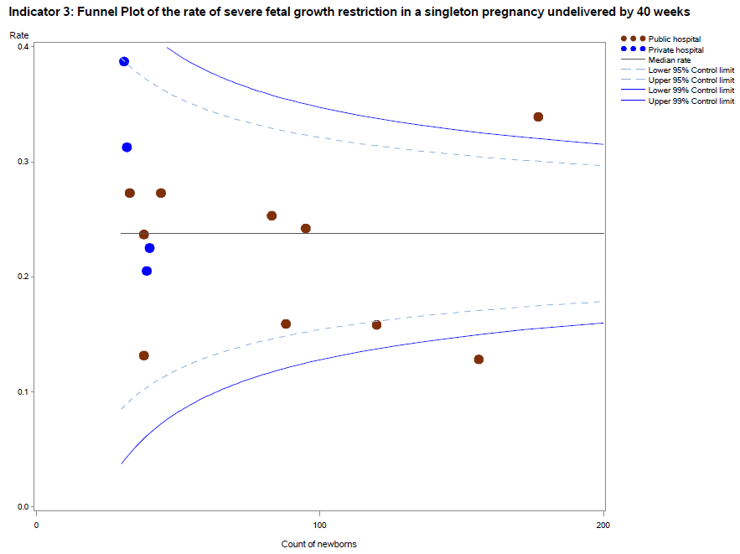

Please refer to page 4 for a guide on how to interpret funnel plots.

Table 5. Rate of severe fetal growth restriction in a singleton pregnancy undelivered by 40 weeks, 2015–18

|  |  |  |  |  |  |
| --- | --- | --- | --- | --- | --- |
|  | 2015 | 2016 | 2017 | 2018 | 2019 |
| Public | 34.9% | 30.6% | 28.0% | 23.0% | 22.1% |
| Private | 36.3% | 31.1% | 28.8% | 30.2% | 26.4% |
| Combined | NA | 30.8% | 28.1% | 24.3% | 23.0% |

## Definitions and data sources

Severe FGR is defined as a birthweight less than the third centile for gestation and sex whether liveborn or stillborn.

Excluded are:

* babies without severe FGR
* multiple births
* births at earlier gestations (less than 32 weeks).

#### Data source: Victorian Perinatal Data Collection

Data for this indicator is sourced from the VPDC for the calendar year from 1 January 2019 to   
31 December 2019.

The indicator is derived using the following VPDC variables: ‘baby sex’, ‘gestation’, ‘birth weight’ and ‘plurality’.

Numerator/denominator

|  |  |  |
| --- | --- | --- |
| Indicator | Numerator | Denominator |
| Indicator 3: Rate of severe FGR in a singleton pregnancy undelivered by 40 weeks | Birth at 40 or more weeks’ gestation of a singleton baby with severe FGR | Singleton births (live and stillborn) with severe FGR born at and beyond 32 weeks’ gestation |

For this indicator, a baby is considered to be severely growth-restricted when their birthweight is below the third centile for gestation, sex and plurality. It is calculated based on the study by Dobbins et al.[1], which gives the tables for birthweight centiles according to the gestational week for live singleton male and female babies in Australia. If a male singleton baby weighing 1,700 grams is born at 35 weeks, it falls below the third centile for gestation, sex and plurality. The baby is then considered severely growth restricted (Indicator 3). *The Australian national birthweight percentiles by sex and gestational age, 1998–2007* (Dobbins et al. 2012) is used to calculate the birthweight centiles for this indicator (see **Tables 6** and **7**).

Table 6. Birthweight centiles for live singleton male infants, Australia, 1998–2007

|  |  |  |  |  |  |  |  |  |  |  |  |  |  |
| --- | --- | --- | --- | --- | --- | --- | --- | --- | --- | --- | --- | --- | --- |
| Gestational age (weeks) | Number of births | Mean (SD) birthweight (g) | Birthweight percentile (g) | | | | | | | | | | |
|  |  |  | 1st | 3rd | 5th | 10th | 25th | 50th | 75th | 90th | 95th | 97th | 99th |
| 20 | 230 | 349 (60) | 210 | 248 | 254 | 273 | 310 | 340 | 390 | 430 | 450 | 470 | 500 |
| 21 | 335 | 418 (66) | 270 | 290 | 300 | 335 | 375 | 420 | 460 | 500 | 540 | 542 | 575 |
| 22 | 401 | 505 (76) | 350 | 370 | 390 | 410 | 460 | 500 | 554 | 600 | 630 | 650 | 690 |
| 23 | 395 | 595 (82) | 390 | 450 | 470 | 500 | 540 | 588 | 650 | 700 | 730 | 756 | 800 |
| 24 | 640 | 681 (105) | 426 | 470 | 500 | 550 | 618 | 684 | 750 | 810 | 850 | 875 | 970 |
| 25 | 715 | 783 (131) | 440 | 505 | 530 | 620 | 700 | 785 | 865 | 944 | 995 | 1,030 | 1,100 |
| 26 | 937 | 894 (152) | 500 | 576 | 621 | 680 | 802 | 900 | 996 | 1,078 | 1,130 | 1,155 | 1,210 |
| 27 | 1,069 | 1,016 (194) | 510 | 605 | 660 | 752 | 904 | 1,030 | 1,138 | 1,250 | 1,320 | 1,352 | 1,440 |
| 28 | 1,345 | 1,146 (217) | 591 | 680 | 735 | 844 | 1,030 | 1,165 | 1,295 | 1,395 | 1,470 | 1,522 | 1,640 |
| 29 | 1,524 | 1,301 (252) | 662 | 782 | 860 | 964 | 1,150 | 1,311 | 1,463 | 1,620 | 1,700 | 1,757 | 1,860 |
| 30 | 2,105 | 1,474 (283) | 774 | 900 | 984 | 1,091 | 1,300 | 1,498 | 1,650 | 1,800 | 1,920 | 1,980 | 2,182 |
| 31 | 2,576 | 1,666 (304) | 915 | 1,055 | 1,126 | 1,270 | 1,480 | 1,680 | 1,855 | 2,028 | 2,142 | 2,230 | 2,435 |
| 32 | 3,895 | 1,867 (331) | 1,075 | 1,214 | 1,294 | 1,430 | 1,659 | 1,880 | 2,080 | 2,270 | 2,405 | 2,503 | 2,710 |
| 33 | 5,599 | 2,106 (371) | 1,200 | 1,381 | 1,473 | 1,638 | 1,880 | 2,106 | 2,340 | 2,560 | 2,710 | 2,845 | 3,070 |
| 34 | 9,824 | 2,340 (385) | 1,400 | 1,580 | 1,690 | 1,860 | 2,100 | 2,340 | 2,580 | 2,810 | 2,990 | 3,120 | 3,343 |
| 35 | 16,054 | 2,585 (408) | 1,600 | 1,795 | 1,920 | 2,080 | 2,330 | 2,578 | 2,835 | 3,095 | 3,275 | 3,410 | 3,665 |
| 36 | 32,747 | 2,826 (428) | 1,805 | 2,015 | 2,120 | 2,295 | 2,550 | 2,820 | 3,095 | 3,360 | 3,550 | 3,690 | 3,930 |
| 37 | 73,986 | 3,093 (449) | 2,050 | 2,265 | 2,372 | 2,540 | 2,800 | 3,080 | 3,378 | 3,670 | 3,865 | 3,990 | 4,235 |
| 38 | 230,003 | 3,344 (439) | 2,340 | 2,540 | 2,640 | 2,800 | 3,050 | 3,330 | 3,625 | 3,910 | 4,090 | 4,215 | 4,445 |
| 39 | 293,109 | 3,486 (430) | 2,510 | 2,700 | 2,800 | 2,950 | 3,195 | 3,470 | 3,765 | 4,040 | 4,220 | 4,335 | 4,560 |
| 40 | 409,976 | 3,632 (434) | 2,650 | 2,840 | 2,940 | 3,090 | 3,340 | 3,620 | 3,915 | 4,195 | 4,370 | 4,490 | 4,708 |
| 41 | 192,154 | 3,769 (438) | 2,780 | 2,970 | 3,070 | 3,220 | 3,470 | 3,755 | 4,060 | 4,340 | 4,515 | 4,630 | 4,850 |
| 42 | 19,804 | 3,832 (462) | 2,760 | 2,980 | 3,095 | 3,250 | 3,520 | 3,820 | 4,130 | 4,430 | 4,615 | 4,740 | 4,970 |
| 43 | 797 | 3,761 (540) | 2,615 | 2,785 | 2935 | 3085 | 3,380 | 3,750 | 4,100 | 4,470 | 4,670 | 4,825 | 5,180 |
| 44 | 53 | 3,715 (563) | — | — | — | 3,110 | 3,300 | 3,620 | 4,070 | 4,415 | — | — | — |

Table 7. Birthweight centiles for live singleton female infants, Australia, 1998–2007

|  |  |  |  |  |  |  |  |  |  |  |  |  |  |
| --- | --- | --- | --- | --- | --- | --- | --- | --- | --- | --- | --- | --- | --- |
| Gestational age (weeks) | Number of births | Mean (SD) birthweight (g) | Birthweight percentile (g) | | | | | | | | | | |
|  |  |  | 1st | 3rd | 5th | 10th | 25th | 50th | 75th | 90th | 95th | 97th | 99th | |
| 20 | 197 | 333 (65) | 190 | 210 | 230 | 265 | 290 | 320 | 374 | 410 | 450 | 490 | 525 | |
| 21 | 256 | 386 (69) | 210 | 250 | 270 | 300 | 340 | 390 | 433 | 470 | 510 | 515 | 530 | |
| 22 | 333 | 474 (72) | 260 | 325 | 355 | 400 | 425 | 480 | 520 | 560 | 589 | 610 | 620 | |
| 23 | 376 | 558 (89) | 320 | 375 | 400 | 445 | 506 | 560 | 615 | 660 | 700 | 725 | 800 | |
| 24 | 528 | 637 (95) | 380 | 430 | 480 | 520 | 580 | 641 | 700 | 754 | 793 | 815 | 860 | |
| 25 | 599 | 730 (128) | 410 | 470 | 498 | 559 | 645 | 740 | 817 | 884 | 940 | 975 | 992 | |
| 26 | 809 | 825 (166) | 428 | 490 | 520 | 594 | 717 | 840 | 940 | 1,026 | 1,072 | 1,106 | 1,186 | |
| 27 | 879 | 949 (188) | 500 | 568 | 598 | 675 | 840 | 965 | 1,077 | 1,175 | 1,240 | 1,280 | 1,390 | |
| 28 | 1,136 | 1,073 (230) | 495 | 622 | 675 | 764 | 928 | 1,090 | 1,230 | 1,347 | 1,410 | 1,470 | 1,610 | |
| 29 | 1,188 | 1,215 (252) | 572 | 712 | 790 | 870 | 1,055 | 1,240 | 1,380 | 1,494 | 1,595 | 1,680 | 1,840 | |
| 30 | 1,656 | 1,394 (277) | 725 | 870 | 918 | 1,030 | 1,220 | 1,400 | 1,571 | 1,715 | 1,840 | 1,920 | 2,130 | |
| 31 | 2,052 | 1,582 (302) | 880 | 1,000 | 1,060 | 1,190 | 1,385 | 1,590 | 1,780 | 1,948 | 2,065 | 2,146 | 2,338 | |
| 32 | 3,119 | 1,772 (322) | 970 | 1,140 | 1,230 | 1,348 | 1,570 | 1,780 | 1,970 | 2,170 | 2,290 | 2,400 | 2,620 | |
| 33 | 4,421 | 2,014 (356) | 1,180 | 1,330 | 1,424 | 1,560 | 1,790 | 2,011 | 2,235 | 2,450 | 2,616 | 2,746 | 2,970 | |
| 34 | 8,108 | 2,242 (375) | 1,331 | 1,525 | 1,615 | 1,764 | 2,005 | 2,240 | 2,470 | 2,705 | 2,870 | 2,995 | 3,220 | |
| 35 | 13,104 | 2,486 (403) | 1,525 | 1,710 | 1,820 | 1,980 | 2,230 | 2,480 | 2,735 | 2,995 | 3,175 | 3,300 | 3,516 | |
| 36 | 28,386 | 2,720 (420) | 1,750 | 1,940 | 2,040 | 2,198 | 2,445 | 2,710 | 2,980 | 3,250 | 3,450 | 3,575 | 3,810 | |
| 37 | 66,928 | 2,979 (439) | 1,970 | 2,175 | 2,275 | 2,430 | 2,690 | 2,965 | 3,255 | 3,545 | 3,735 | 3,865 | 4,100 | |
| 38 | 214,002 | 3,215 (425) | 2,256 | 2,440 | 2,540 | 2,690 | 2,930 | 3,200 | 3,490 | 3,770 | 3,945 | 4,062 | 4,290 | |
| 39 | 282,046 | 3,351 (415) | 2,420 | 2,600 | 2,690 | 2,830 | 3,070 | 3,340 | 3,620 | 3,890 | 4,060 | 4,175 | 4,390 | |
| 40 | 398,257 | 3,493 (416) | 2,566 | 2,740 | 2,830 | 2,975 | 3,210 | 3,480 | 3,765 | 4,030 | 4,200 | 4,316 | 4,525 | |
| 41 | 181,434 | 3,619 (424) | 2,680 | 2,855 | 2,945 | 3,090 | 3,330 | 3,605 | 3,900 | 4,170 | 4,340 | 4,455 | 4,670 | |
| 42 | 17,701 | 3,665 (445) | 2,670 | 2,850 | 2,950 | 3,110 | 3,360 | 3,650 | 3,955 | 4,240 | 4,420 | 4,545 | 4,760 | |
| 43 | 801 | 3,579 (463) | 2,660 | 2,800 | 2,865 | 3,010 | 3,240 | 3,560 | 3,880 | 4,210 | 4,385 | 4,560 | 4,760 | |
| 44 | 52 | 3,705 (523) | — | — | — | 3,070 | 3,403 | 3,695 | 3,965 | 4,230 | — | — | — | |

# 5: Five-year gestation standardised perinatal mortality ratio

Gestation standardised perinatal mortality ratio (GSPMR) is a measure of perinatal mortality that compares the observed perinatal mortality rate for babies born at individual hospitals with what would be expected, accounting for the gestation at birth. It is a partially risk-adjusted calculation, enabling hospitals with higher proportions of births at lower gestations (and therefore higher likelihood of perinatal mortality) to be validly compared with hospitals that have a different case mix.

## About this indicator

Perinatal mortality includes stillbirths (death before birth) and deaths in the first 28 days of babies born alive.

Pooling the data over five-year periods adds stability to the data and reduces the risk of over-interpretation of chance fluctuations.

The indicator provides a visual representation of the variation in perinatal mortality occurring across Victorian public and private hospitals compared with the statewide rate.

### How to interpret the ratio

The statewide ratio (the reference population) is set at ‘1’. A GSPMR of 1 indicates that the observed number of perinatal deaths at that hospital is exactly what would be expected, considering the gestation of babies born there.

An individual hospital with a ratio of:

* **0.5** has a perinatal mortality that is half the statewide rate
* **1** has a perinatal mortality that is equal to the statewide rate
* **1.5** has a perinatal mortality that is 50 per cent above the statewide rate
* **2** represents perinatal mortality that is double the statewide rate.

These rates include only babies who were born at 32 or more weeks’ gestation.

The statewide rate (1) does not necessarily represent the optimal or clinically appropriate rate for perinatal mortality. A rate greater than 1 indicates more deaths occurred than were expected, and a rate less than 1 indicates fewer deaths occurred than were expected.

### What does the GSPMR tell us?

It shows where there is variation in perinatal mortality rates for hospitals of similar capability or size.

It adjusts for gestation, the most important risk factor for perinatal death.

### What can’t the GSPMR tell us?

The GSPMR does not indicate:

* statewide or individual hospital perinatal mortality rates
* whether the results for a given hospital are improving over the five-year period
* the reasons for the deaths or how the babies died (a baby may have died before arriving at the birth hospital, while in the hospital or following discharge from hospital, for example, due to SIDS, a car accident or injury)
* whether the death could have been avoided
* whether the care around the time of death was provided by a different hospital (transfer) or health professional than the birth hospital
* where the baby died – it only tells us where the baby was born
* the safety of a maternity service
* the contribution of important risk factors associated with perinatal mortality such as obesity, smoking, pre-existing illness of the mother, low socioeconomic status and ethnicity.

Figure 17. Funnel plot of five-year GSPMR compared to statewide public rate 2015–19

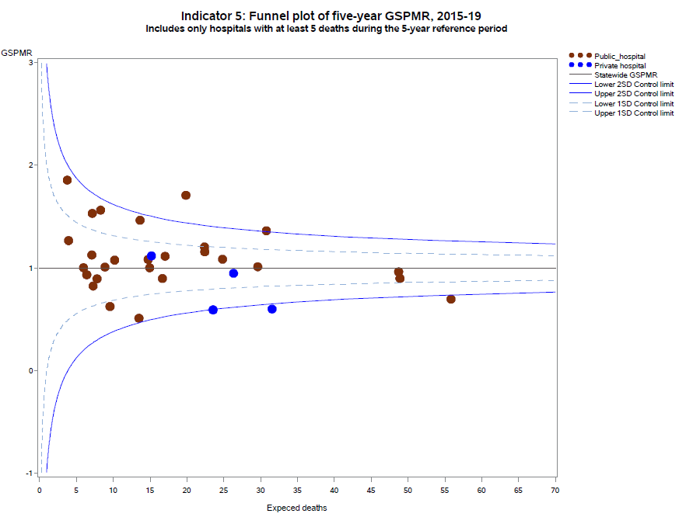

Only health services with at least five deaths during the five-year reference period are included in the funnel plot. The GSPMRs for individual health services are given in **Appendix 3**.

### How to read this plot

Note that the GSPMR is risk-adjusted, hence, interpretation of the funnel plot is slightly different. As with the other funnel plots, each dot represents one hospital. The solid horizontal line represents a GSPMR where the observed count of deaths is equal to the expected count of deaths (i.e. GSMPR=1). Hospitals (dots) that are above this line (i.e. above 1) have a GSPMR that suggests the observed count of deaths are higher than the expected count of deaths. Hospitals that are below this line have a GSPMR that suggests the observed count of deaths is lower than the expected count. It is desirable to have a GSPMR less than 1, however due to the nature of this indicator, around half of all hospitals will always have a GSPMR greater than 1 and around half will have a GSPMR less than 1.

The dashed and solid blue lines represent control limits based on one standard deviation (1SD) and two standard deviations (2SD) from the solid horizontal line, respectively. Control limits can be used to test how different a hospital’s GSPMR is from 1, taking the size of the hospital into consideration. If a hospital falls outside the 2SD control limits of the plot, its GSPMR is considered to be significantly different from 1. In the above funnel plot, hospitals that fall above the upper 2SD control limit have significantly higher than expected perinatal mortality. Hospitals that fall below the lower 2SD control limit have significantly lower than expected perinatal mortality.

It is important to note that the GSPMR is adjusted only for the gestation at birth. Many other factors also put babies at higher and lower risk of perinatal death, including the socio-economic situation of the woman. This may explain some of these results that are lower than average.

## Definitions and data sources

The GSPMR is standardised according to the gestational age-specific perinatal mortality rates of the total population in Victorian hospitals. The standardisation does not adjust for inter-hospital transfers, and deaths are ascribed to the birth hospital regardless of the timing of the death in relation to the transfer.[2]

The data in this report:

* is calculated from five years of pooled data between 2015 and 2019
* is standardised using gestational age
* excludes births earlier than 32 weeks 0 days
* excludes birthweights less than 150 grams regardless of gestation
* excludes all deaths due to congenital anomalies and all terminations of pregnancy.

These exclusions provide a more sensitive indicator to reflect the quality of care.

The GSPMR is presented with data for individual public and private hospitals being shown in relation to the statewide hospital perinatal mortality rate for each week of gestation as the standard or reference population. The GSPMR of the individual health service is published in this report only if there are five or more perinatal deaths (stillbirths and neonatal deaths) in the five pooled years (2015–2019).

#### Data source: Victorian Perinatal Data Collection

Data for this indicator is sourced from the VPDC for the calendar year from 1 January 2015 to 31 December 2019.

Observed/expected

|  |  |  |
| --- | --- | --- |
| Indicator | Observed | Expected |
| Indicator 5: Perinatal mortality ratio for babies born at 32 or more weeks (gestation standardised, excluding all terminations of pregnancy and deaths due to congenital anomalies) using five years’ pooled data in Victorian public and private hospitals (32 weeks or more GSMPR) | Observed perinatal deaths from 32 weeks 0 days (by weeks’ gestation at birth) | Expected perinatal deaths from 32 weeks 0 days (by weeks’ gestation at birth) |

# 6a and 6b: Readmissions during the postnatal period

Postnatal care supports women following birth, including establish breastfeeding and develop early parenting skills. Providing high quality and timely care following birth can have a positive effect on the long-term health and wellbeing of women and their families.

Higher readmission rates can be associated with inconsistent discharge practices, the care provided during the days following birth and/or limited support in the community. Ensuring that there is a successful transition from hospital to community-based care is important for the ongoing support of women, babies and families. For most women and babies admitted as public patients, this transition usually occurs after at least one home visit by a hospital midwife. This visit should occur between 24 to 48 hours after discharge from the hospital.

## About this indicator

These indicators measure the rate of unplanned and potentially preventable readmissions of pregnant women (6a) and newborns (6b) to any hospital within 28 days of discharge from birth hospital.

High-quality care means most women and their babies should not return to hospital during the postnatal period. Unplanned and preventable hospital stays during this period reflects a deviation from the normal course of postnatal recovery. This results in increased healthcare costs and possible impacts on health and wellbeing for women and their babies.

## Observations on the data

In 2019–20 the statewide rate of unplanned maternal readmissions within 28 days of discharge (Indicator 6a) was 2.3 per cent, a slight improvement from the previous year’s rate of 2.6 per cent.

As in previous years, the rate was higher in public hospitals at 2.4 per cent compared to private hospitals at 1.7 per cent (p<0.001).

The public hospital statewide average rate of unplanned newborn readmissions within 28 days of discharge (Indicator 6b) was the same as the previous year’s rate 4.1 per cent.

Figure 18. Indicator 6a: Rate of maternal readmissions during the postnatal period, 2019–20

Figure 19. Funnel plot of maternal readmissions during the postnatal period, 2019–20

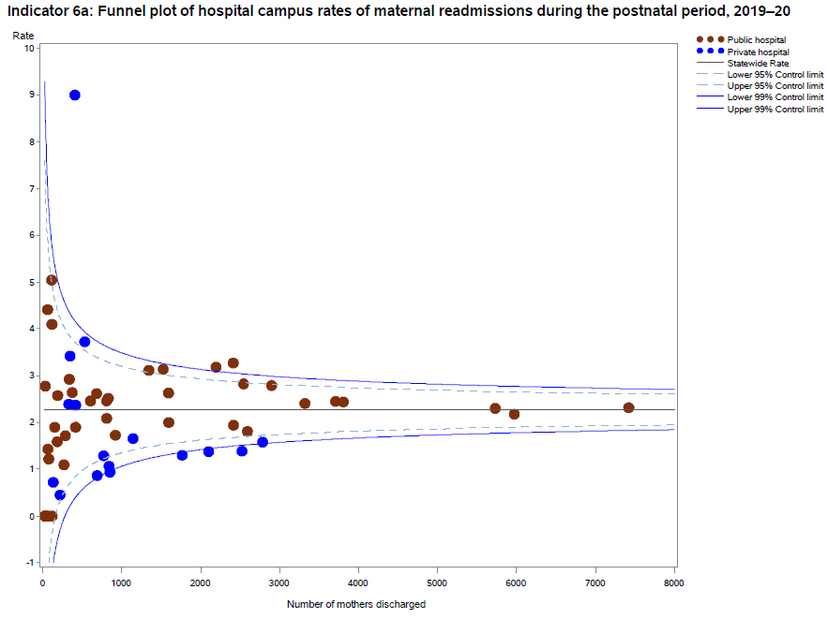

Please refer to page 4 for a guide on how to interpret funnel plots.

Table 8. Rate of maternal readmissions during the postnatal period, by financial year 2015–19

|  |  |  |  |  |  |
| --- | --- | --- | --- | --- | --- |
|  | 2015–16 | 2016–17 | 2017–18 | 2018–19 | 2019–20 |
| Public | 2.4% | 2.5% | 2.5% | 2.7% | 2.4% |
| Private | NA | 2.5% | 2.5% | 2.0% | 1.7% |
| Combined | NA | 2.5% | 2.5% | 2.6% | 2.3% |

Figure 20. Indicator 6b: Rate of newborn readmissions during the postnatal period, 2019–20

Note: Reporting of unqualified neonate admissions to the VAED for private hospitals is optional. It is therefore not possible to establish an accurate denominator (that includes public and private hospitals) for this indicator. As such, only public hospitals are included in the results.

Figure 21. Funnel plot of newborn readmissions during the postnatal period, 2018–19

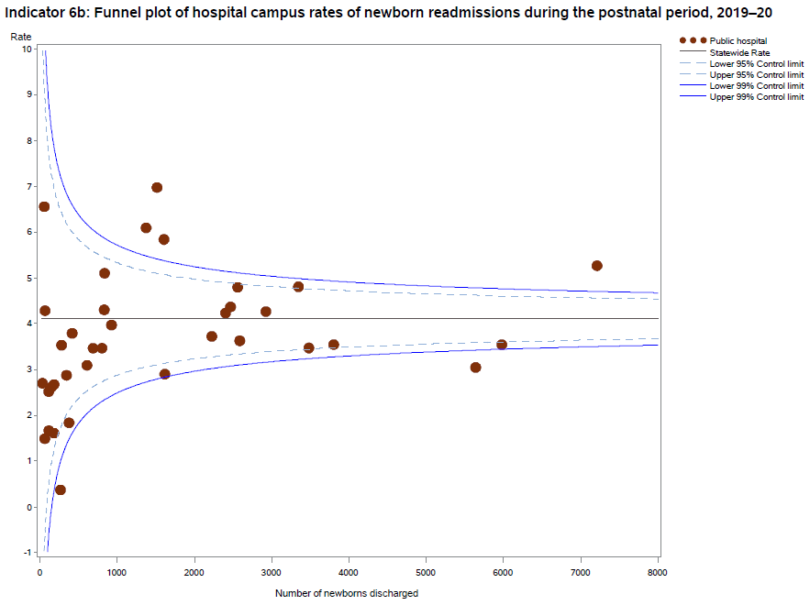

Please refer to page 4 for a guide on how to interpret funnel plots.

Table 9. Rate of newborn readmissions during the postnatal period, by financial year 2015–19

|  |  |  |  |  |  |
| --- | --- | --- | --- | --- | --- |
|  | 2015–16 | 2016–17 | 2017–18 | 2018–19 | 2019–20 |
| Public | 4.0% | 4.2% | 4.1% | 4.1% | 4.1% |

## Definitions and data sources

### Indicator 6a: Maternal readmissions during the postnatal period

The readmission rate is calculated for the hospital that discharged the mother from the birth episode. The rate includes admissions to any Victorian health service after the birth episode, not just a readmission to the birthing service.

Women transferred to another health service following a birth separation are excluded from the numerator total. Women who present to an emergency department or urgent care centre, but who are not admitted, are excluded from the numerator total. Women who are readmitted and have a primary diagnosis related to their pregnancy and/or birth are included in the numerator total. However, diagnosis codes that are associated with a complexity that cannot be prevented (or managed) through postnatal care and/or that are associated with a condition(s) that manifests after discharge from hospital without any indication of its presence prior to this time are excluded (see list below).

The denominator is the total number of birth episodes at a health service. The only exclusion is maternal death.

Potentially preventable readmission primary diagnosis codes are limited to the following:

* O722 – Delayed and secondary postpartum haemorrhage
* O860 – Infection of obstetric surgical wound
* O85 – Puerperal sepsis
* O9120 – Non-purulent mastitis without attachment difficulties
* Z466 – Fitting and adjustment of urinary device
* O901 – Disruption of perineal obstetric wound
* O149 – Pre-eclampsia (unspecified)
* O16 – Unspecified maternal hypertension
* O9903 – Anaemia complicating childbirth and the puerperium
* O731 – Retained portion placenta and membranes without haemorrhage
* O721 – Other immediate postpartum haemorrhage
* O902 – Haematoma of obstetric wound
* O862 – Urinary tract infection following delivery
* O900 – Disruption of caesarean section wound
* Z391 – Care and examination of lactating mother
* O13 – Gestational hypertension
* N390 – Urinary tract infection (site not specified)
* O9121 – Non-purulent mastitis with attachment difficulty
* F531 – Severe mental and behavioural disorder associated with puerperium (not elsewhere classified)
* F530 – Mild mental and behavioural disorder associated with puerperium (not elsewhere classified)
* G971 – Other reaction to spinal and lumbar puncture
* R509 – Fever (unspecified)
* R33 – Retention of urine
* O152 – Eclampsia in the puerperium
* O720 – Third-stage haemorrhage
* T8852 - Failed moderate sedation during procedure.

#### Data source: Victorian Admitted Episodes Dataset

Data for this indicator is sourced from the VAED for the financial year 1 July 2019 to 30 June 2020.

Numerator/denominator

|  |  |  |
| --- | --- | --- |
| Indicator | Numerator | Denominator |
| Indicator 6a: Readmission of a mother within 28 days of discharge from a birthing episode admission in a Victorian public or private hospital | The number of women readmitted to any health service within 28 days with a potentially preventable readmission diagnosis code | The total number of birth episodes at a health service |

### Indicator 6b: Newborn readmissions during the postnatal period

Readmissions that meet the criteria for inclusion are attributed to the health service that provided postnatal care as part of the birthing episode.

The readmission rate is calculated for the hospital that discharged the neonate from the birth episode. The rate includes admissions to any Victorian health service after birth, not just a readmission to the birthing service. Babies transferred to another health services following a birth separation are excluded from the numerator total.

Neonates who are readmitted on the same day of discharge are also excluded. This is because it is not possible to determine from the dataset whether these are genuine readmissions or a new separation following a planned transfer of care.

Neonates who present to an emergency department or urgent care centre, but who are not admitted, are excluded from the numerator total.

Neonates who are readmitted and have a primary diagnosis related to their pregnancy and/or birth are included in the numerator total. However, diagnosis codes that are associated with a complexity that cannot be prevented (or managed) through postnatal care and/or that are associated with a condition(s) that manifests after discharge from hospital without any indication of its presence prior to this time are excluded (see list below).

The denominator includes the total number of neonates discharged from a health service. Stillbirths and neonatal deaths prior to discharge are excluded. Qualified and unqualified neonates are included – irrespective of their accommodation type during the birth episode (if they spent time in neonatal intensive care or in a special care nursery).

Potentially preventable readmissions are limited to the following list of primary diagnoses:

* P599 – Neonatal jaundice (unspecified)
* P929 – Feeding problem of newborn (unspecified)
* R628 – Other lack of expected normal physiological deviation
* P369 – Bacterial sepsis of newborn (unspecified)
* P928 – Other feeding problems of newborn
* P590 – Neonatal jaundice with pre-term delivery
* P598 – Neonatal jaundice from other specific causes
* P0732 – Other pre-term infant ≥ 32 weeks’ gestation but < 37 completed weeks
* P551 – ABO isoimmunisation of fetus and newborn
* Z0371 – Observation of newborn for suspected infectious condition
* P2840 – Apnoea of newborn, unspecified
* P282 – Cyanotic attacks of newborn
* A870 – Enteroviral meningitis
* P38 – Omphalitis newborn with or without mild haemorrhage
* P741 – Dehydration of newborn
* P809 – Hypothermia of newborn unspecified
* P90 – Convulsions of newborn
* R634 – Abnormal weight loss.

#### Data source: Victorian Admitted Episodes Dataset

Data for this indicator is sourced from the VAED for the financial year 1 July 2019 to 30 June 2020.

Numerator/denominator

|  |  |  |
| --- | --- | --- |
| Indicator | Numerator | Denominator |
| Indicator 6b: Readmission of a newborn within 28 days of discharge from a birthing episode admission in a Victorian public hospital | The number of neonates readmitted to any health service with a potentially preventable readmissions diagnosis code within 28 days of birth | The number of neonates provided with admitted postnatal care prior to discharge |

# 7: Smoking cessation

Women who smoke while pregnant, and their babies, are at risk of various preventable adverse outcomes and health complications including stillbirth, fetal growth restriction and pre-term birth. During pregnancy, women are motivated to protect their baby’s health. It is therefore an important time for health professionals to assist women to quit smoking. This indicator can be used by hospitals to measure how effective their interventions are and recognises hospitals making the greatest impact towards smoking cessation.

## About this indicator

This indicator assesses the effectiveness of health services in providing support for women who smoke in early pregnancy to quit. This includes smoking cessation advice, assistance and follow-up during the antenatal period. The aim is to reduce both the rate of smoking among pregnant women and the risk of smoking-associated adverse health outcomes for women and their babies.

The data in this report relates to the percentage of women who were reported as not smoking after 20 weeks’ gestation among those who smoked before 20 weeks.

This indicator has limited focus on smoking cessation during pregnancy and does not capture data on whether women continue to not smoke after pregnancy.

## Observations on the data

The percentage of women who smoked in the first 20 weeks of their pregnancy and did not smoke in the last 20 weeks of their pregnancy across all hospitals, and within public and public hospitals, has not changed in 2019 compared to 2018 (**Table 10**). The rate for private hospitals continued to be significantly higher compared to public hospitals (59.3 per cent and 26.8 per cent, respectively; p<0.001).

The smoking cessation rate between individual hospitals ranged from zero to 85.3 per cent (**Figure 22**). Also note some significant outliers as shown in **Figure 23**.

Figure 22. Indicator 7: Rate of smoking cessation during pregnancy, 2019

Note: The following services had greater than 20 per cent missing data for smoking in the second half of pregnancy. As such they have been excluded from the publishable range. Monash Medical Centre (Clayton), St John of God Berwick Hospital.

Figure 23. Funnel plot of the rate of smoking cessation during pregnancy, 2019

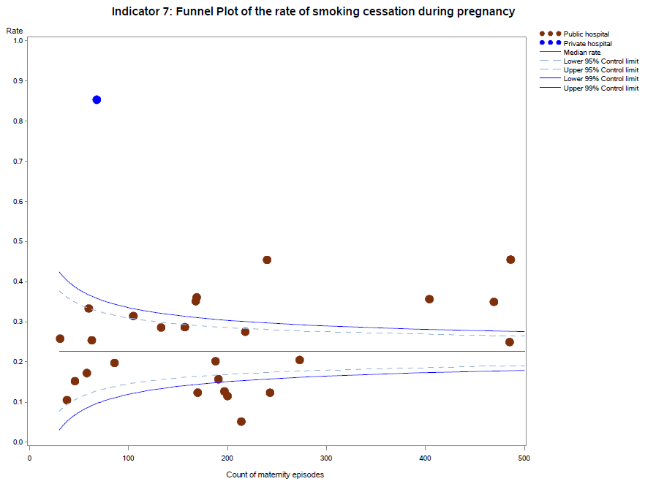

Please refer to page 4 for a guide on how to interpret funnel plots.

Table 10. Rate of smoking cessation during pregnancy, 2016–19

|  |  |  |  |  |
| --- | --- | --- | --- | --- |
|  | 2016 | 2017 | 2018 | 2019 |
| Public | 24.4% | 25.5% | 26.6% | 26.8% |
| Private | 66.1% | 65.2% | 60.3% | 59.3% |
| Combined | 26.1% | 27.1% | 28.0% | 28.0% |

## Definitions and data source

The percentage of women who were reported as not smoking after 20 weeks’ gestation among those who were reported as having smoked before 20 weeks. Women who were reported as not smoking before 20 weeks and women whose smoking status before 20 weeks was missing are excluded from the denominator. Women whose smoking status at 20 or more weeks was not reported are included in the denominator.

Services with less than 10 women who reported as having smoked before 20 weeks’ gestation are excluded from public reporting. Services with 10 or more women who reported as having smoked before 20 weeks’ gestation are only included if they are missing less than 20 per cent of data about smoking in the second half of pregnancy. Missing data in individual services ranged from zero to 75 per cent.

#### Data source: Victorian Perinatal Data Collection

Data for this indicator is sourced from the VPDC for the calendar year from 1 January 2019 to   
31 December 2019.

This indicator is derived using the following VPDC variables: ‘maternal smoking at less than 20 weeks’ and ‘maternal smoking at more than or equal to 20 weeks’.

Numerator/denominator

|  |  |  |
| --- | --- | --- |
| Indicator | Numerator | Denominator |
| Indicator 7: Rate of smoking cessation during pregnancy | The number of women who were reported as having stopped smoking after 20 weeks’ gestation among those who smoked before 20 weeks | The number of women who smoked before 20 weeks’ gestation |

# 10: Low Apgar score

We expect babies who are born at 37 or more weeks’ gestation and without congenital anomalies to show a healthy physiological adaption to birth (be born in a healthy state) and not require significant resuscitation or immediate medical care.

The Apgar score is an assessment of a newborn’s wellbeing at birth based on five physiological attributes. This is recorded at one and five minutes (and longer if applicable). The five attributes are colour (circulation), breathing, heart rate, muscle tone and reflexes.

Each attribute is given a score of 0, 1 or 2, with a total minimum score of 0 (indicating no or greatly diminished signs of life) and a maximum score of 10 (indicating optimal outcome). An Apgar score below 7 at five minutes indicates a baby who requires ongoing resuscitation measures or additional care. This may be due to avoidable factors during labour, birth or resuscitation.

## About this indicator

This indicator measures the wellbeing of babies who are born in hospital or as planned home births at 37 or more weeks’ gestation and without congenital anomalies at birth. It is used as a proxy for the quality of care during labour and birth and neonatal resuscitation, where necessary, following birth. The Apgar score is a validated measure of adverse long-term outcomes. This is potentially an important indicator for longer-term infant outcomes.

## Observatons on the data

In 2019 a five-minute Apgar score less than 7 was reported for 1.3 per cent of singleton, term babies across public and private hospitals combined. This was unchanged from the rate reported for 2018. The rate for private hospitals is slightly lower compared to public hospitals, however, the difference was statistically significant (1.0 per cent and 1.3 per cent, respectively; p<0.001).

The rate varied between individual hospitals, from 0 per cent to 3.4 per cent (**Figure 24**); however, overall rates continued to remain stable over time (**Table 11**).

Figure 24. Indicator 10: Rate of term inborn babies without congenital anomalies with an Apgar score   
< 7 at five minutes, 2019

Figure 25. Funnel plot of the rate of term babies without congenital anomalies with an Apgar score < 7 at five minutes, 2019

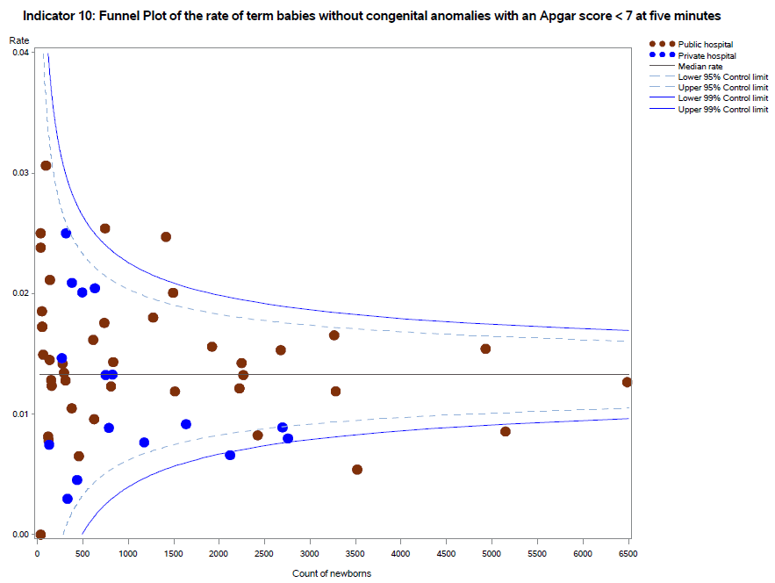

Please refer to page 4 for a guide on how to interpret funnel plots.

Table 11. Rate of term inborn babies without congenital anomalies with an Apgar score < 7 at five minutes, 2015–19

|  |  |  |  |  |  |
| --- | --- | --- | --- | --- | --- |
|  | 2015 | 2016 | 2017 | 2018 | 2019 |
| Public | 1.5% | 1.6% | 1.5% | 1.3% | 1.3% |
| Private | 0.9% | 0.9% | 1.0% | 1.1% | 1.0% |
| Combined | NA | 1.4% | 1.3% | 1.3% | 1.3% |

## Definitions and data sources

The rate of term babies without congenital anomalies with an Apgar score of less than 7 at five minutes in Victorian hospitals.

Excludes babies born at less than 37 weeks’ gestation, infants born with congenital anomalies, stillbirths and babies born before arrival at hospital.

The Apgar score is used to evaluate the fitness of a newborn infant based on heart rate, respiration, muscle tone, reflexes and colour. The maximum or best score is 10. The Apgar score should be determined consistently and reliably according to best practice guidelines. Rates for this indicator should show little variation among peer-group services, and inter-rater reliability should be high within health services. This supports quality reporting of neonatal outcomes for meaningful comparisons.

Inborn is defined as a baby born at the reporting hospital.

#### Data source: Victorian Perinatal Data Collection

Data for this indicator is sourced from the VPDC for the calendar year from 1 January 2019 to 31 December 2019.

This indicator is derived using the following VPDC variables: ‘Apgar score at 5 minutes’, ‘estimated gestational age’, ‘birth status’, ‘setting of birth actual’ and ‘congenital anomalies indicator’.

Numerator/denominator

|  |  |  |
| --- | --- | --- |
| Indicator | Numerator | Denominator |
| Indicator 10: Rate of term babies without congenital anomalies with an Apgar score < 7 at five minutes | The number of inborn, liveborn, term babies without congenital anomalies with an Apgar score less than 7 at five minutes | The number of inborn, liveborn, term babies without congenital anomalies |

# 11a and 11b: Women’s experiences of care

Any report on maternity and newborn outcomes cannot be complete without women’s voices being present, guiding plans for future improvement. Women are uniquely positioned to provide insightful comments about their care. Acknowledging that health outcomes and perceptions are not only influenced by the nature and quality of the clinical care provided but how that care is delivered, patient experience is critical to providing and improving healthcare. Through monitoring indicators of experience, it is possible to improve our understanding of women’s’ experience of care and identify areas for quality improvements and service redesign.

## About these indicators

These indicators assess the experience of women who participated in the Victorian Healthcare Experience Survey and who received care from Victorian public hospital services during their labour and birth episode. The indicators are derived from two questions in the maternity questionnaire of the VHES:

* Indicator 11a: Question 36: Thinking about your care during labour and birth, were you involved, as much as you wanted to be, in decisions about your care?
* Indicator 11b: Question 51: Did you feel that midwives and other health professionals gave you consistent advice about feeding your baby?

## Observations on the data

In 2019, 80.0 per cent of women responded that they felt involved, as much as they wanted to be, in decisions about their care (Indicator 11a). This rate was unchanged from the previous year’s rate. The rate across public hospitals was also relatively consistent (**Figure 26**). The funnel plot in **Figure 27** shows a few hospitals with rates that were significantly different from the state rate.

The proportion of women who felt they received consistent advice about feeding their baby from midwives and other health professionals (Indicator 11b) decreased in 2019 to 47.2 per cent from a rate of 49.0 per in 2018. This was statistically significant (p=0.017). **Figures 28** and **29** show considerable variation between hospitals.

Figure 26. Indicator 11a: Rate of women who felt involved, as much as they wanted to be, in decisions about their care during labour and birth, 2019

Note: No quartiles are presented for Indicator 11 since the measure is calculated from survey data and a different method of determining least and most favourable outcomes was applied (i.e. tested for significant difference compared to the rate for public hospitals).

The VHES only collects data from public hospitals and reports only on services with more than 10 responses in a year. As such, this indicator is only reported for public health services.

Figure 27. Funnel plot of the rate of women who felt involved, as much as they wanted to be, in decisions about their care during labour and birth, 2019

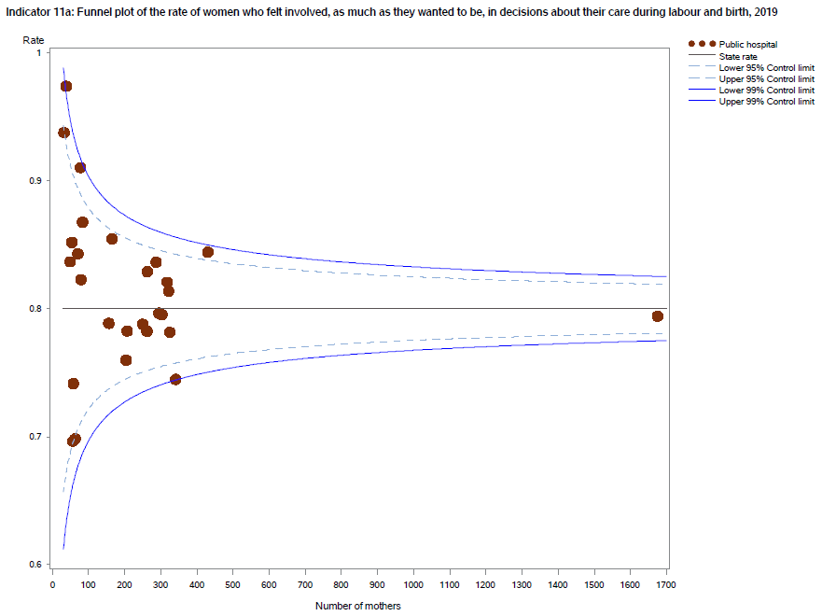

Please refer to page 4 for a guide on how to interpret funnel plots.

Table 12. Rate of women who felt involved, as much as they wanted to be, in decisions about their care during labour and birth, 2016–19

|  |  |  |  |  |
| --- | --- | --- | --- | --- |
|  | 2016 | 2017 | 2018 | 2019 |
| Public | 80.0% | 78.9% | 80.0% | 80.0% |

Figure 28. Indicator 11b: Rate of women who felt that midwives and other health professionals gave them consistent advice about feeding their baby, 2019

Note: No quartiles are presented for Indicator 11 since the measure is calculated from survey data and a different method of determining least and most favourable outcomes was applied (i.e. tested for significant difference compared to the rate for public hospitals).

The VHES only collects data from public hospitals and reports only on services with more than 10 responses in a year. As such, this indicator is only reported for public health services.

Figure 29. Funnel plot of the rate of women who felt that midwives and other health professionals gave them consistent advice about feeing their baby, 2019

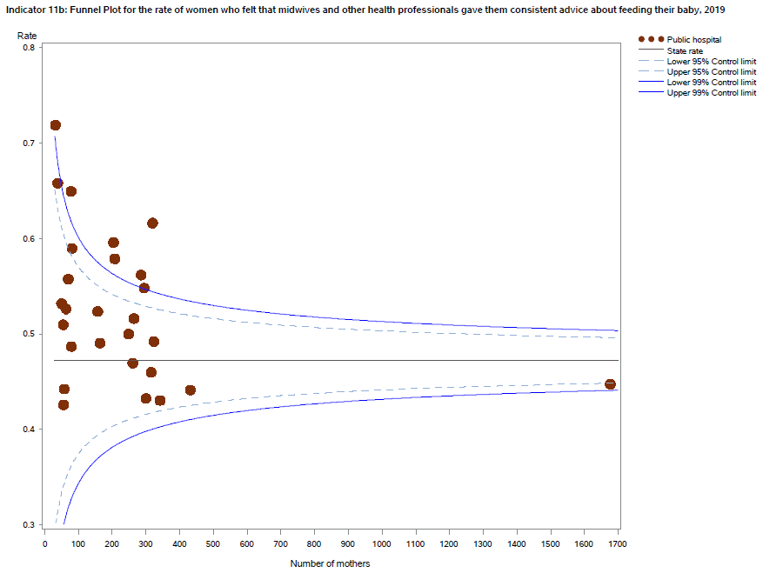

Please refer to page 4 for a guide on how to interpret funnel plots.

Table 13. Rate of women who felt that midwives and other health professionals gave them consistent advice about feeding their baby, 2016–19

|  |  |  |  |  |
| --- | --- | --- | --- | --- |
|  | 2016 | 2017 | 2018 | 2019 |
| Public | 51.0% | 49.5% | 49.0% | 47.2% |

## Definitions and data sources

#### Data source: IPSOS Social Research Institute analysis of the Victorian Healthcare Experience Survey

Data for this indicator is sourced from VHES for the calendar year from 1 January 2019 to 31 December 2019.

Results are not reported when there are fewer than 10 responses for a health service over a year, or when data were not provided by the health service.

Note: The VHES maternity questionnaire is distributed to a random sample of consumers following a hospital admission for pregnancy and birth.

Numerator/denominator

|  |  |  |
| --- | --- | --- |
| Indicator | Numerator | Denominator |
| Indicator 11a: Rate of women who felt involved, as much as they wanted to be, in decisions about their care during labour and birth | The number of women who answered ‘yes, always’ to question 36 of the VHES maternity questionnaire | The number of women who answered question 36 of the VHES maternity questionnaire |
| Indicator 11b: Rate of women who felt that midwives and other health professionals gave them consistent advice about feeding their baby | The number of women who answered ‘yes, always’ to question 51 of the VHES maternity questionnaire | The number of women who answered question 51 of the VHES maternity questionnaire |

# 12b: Maternal vaccination

Influenza vaccinations protects pregnant women and babies and are free to all pregnant women in Victoria. Influenza vaccination is recommended for all pregnant women during any trimester. The indicator includes women vaccinated at any point during their pregnancy.

## About this indicator

This indicator (Indicator 12b) presents the proportion of women who were vaccinated against influenza (flu) at any time during their pregnancy.

Influenza vaccine protects pregnant women from viral and bacterial infections, complications while pregnant and serious complications in their babies.

The influenza vaccine is available free to all pregnant women in Victoria. Influenza vaccination is recommended for all pregnant women during any trimester. The indicator includes women vaccinated at any point during their pregnancy.

Note that Indicator 12a, the rate of women vaccinated for pertussis, is not included in this year’s report.

## Observations on the data

In 2019, 74.6 per cent of women were vaccinated for influenza during pregnancy (Indicator 12b). This was a significant increase from the previous year’s rate of 67.1 per cent (p<0.001). The vaccination rate for public hospitals was higher compared to private hospitals (75.8 per cent and 70.9 per cent, respectively, p<0.001).

It is worth noting that there were significant numbers of missing data in some hospitals. This affects the accuracy of the data and reduces the extent to which this indicator can be used. It is important for hospitals to minimise missing data to increase the validity of the data.

Figure 30. Indicator 12b: Rate of women vaccinated for influenza during pregnancy, 2019

Figure 31. Funnel plot of the rate of women vaccinated for influenza during pregnancy, 2019

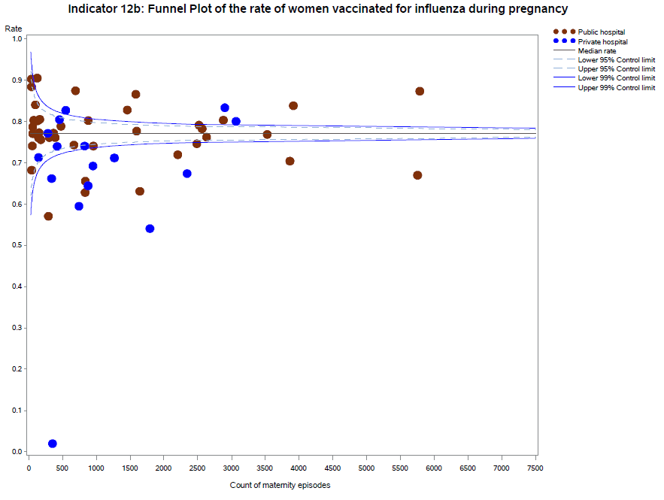

Please refer to page 4 for a guide on how to interpret funnel plots.

## Definitions and data sources

The proportion of women who were vaccinated for influenza at any time during their pregnancy.

#### Data source: Victorian Perinatal Data Collection

Data for this indicator is sourced from the VPDC for the calendar year from 1 January 2019 to 31 December 2019.

This indicator is derived using the following VPDC variables: ‘influenza vaccination status’ and ‘birth order’.

Numerator/denominator

|  |  |  |
| --- | --- | --- |
| Indicator | Numerator | Denominator |
| Indicator 12b: The rate of women vaccinated for influenza during pregnancy | The number of women who received an influenza vaccine at any point during pregnancy | The number of women who gave birth in Victoria |

# 13: Women who had a severe postpartum haemorrhage within the 24 hours following birth, 2019

Postpartum haemorrhage (PPH) is a common and potentially serious complication of pregnancy. While the majority of PPH cases are minor, severe PPH (defined in this report as blood loss of 1,500 mls or more) is a major cause of maternal mortality and morbidity in Australia. It is important that clinicians can prevent, recognise and treat PPH.

## About this indicator

This indicator presents the proportion of women who had a severe postpartum haemorrhage (defined as blood loss over 1,500 mls) within the 24 hours following birth. This indicator was introduced as a trial indicator in the 2018-19 report.

## Observations on the data

In 2019, 2.4 per cent of women had a severe postpartum haemorrhage. This was a slight increase from the previous year’s rate of 2.2 per cent. The rate for public hospitals was significantly higher compared to private hospitals (2.9 per cent and 0.9 per cent, respectively; p<0.001). **Figures 32** and **33** show significant variation between individual hospitals.

Figure 32. Trial indicator 13: Rate of women with severe postpartum haemorrhage, 2019

Figure 33. Funnel plot of the rate of women with severe postpartum haemorrhage, 2019

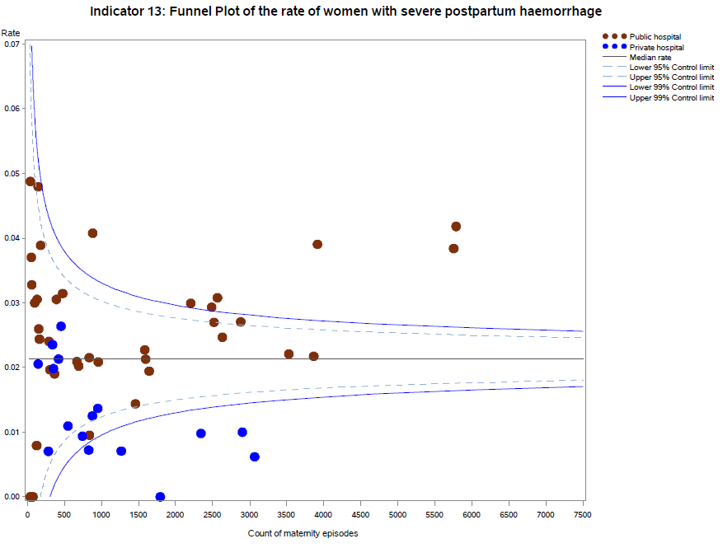

Please refer to page 4 for a guide on how to interpret funnel plots.

## Definitions and data sources

The proportion of women who had a severe postpartum haemorrhage (blood loss over 1,500 mls) within the 24 hours following birth.

#### Data source: Victorian Perinatal Data Collection

Data for this indicator is sourced from the VPDC for the calendar year from 1 January 2019 to 31 December 2019.

The indicator is derived using the following VPDC variables: ‘estimated blood loss’.

Numerator/denominator

|  |  |  |
| --- | --- | --- |
| Indicator | Numerator | Denominator |
| Trial indicator 13: The rate of women with severe postpartum haemorrhage | The number of women with blood loss greater than 1,500 mls | The number of women who gave birth in Victoria |

# Appendix 1: Data sources and reporting rules

Safer Care Victoria (SCV) and the Department of Health manage the health data collections used for this report:

* **Victorian Perinatal Data Collection** (VPDC) Victorian public and private health services are required to submit specific data to the Consultative Council on Obstetric and Paediatric Mortality and Morbidity (CCOPMM).
* **Victorian Healthcare Experience Survey** (VHES) collects data for public health services only.
* **Victorian Admitted Episodes Dataset** (VAED) Victorian public and private health services are required to submit specific data.

Further information on the data sources and the business rules for each indicator can be found under each indicator.

When interpreting the data in this report, it is important to note the following:

* Apart from Indicator 5, data is only reported when a health service has had a minimum of 10 occasions for an event (denominator). For example, a hospital that has not had 10 standard primiparae give birth in 2019 (denominator) will not be included in the results for Indicator 1a.
* Due to small numbers, data from smaller health services are subject to wide variation and should be interpreted with caution.
* Private patients admitted to a public health service are reported in the results for the relevant public health service.
* Outcomes for public health services are presented in order of clustered maternity service capability and then by the number of women who gave birth at each health service in 2019 (in descending order so hospitals with more births in each capability level appear first).
* Outcomes for private health services are presented in descending order according to the number of women who gave birth at each health service in 2019.
* Although the statewide rates provided for each indicator are a suitable measure for comparing health services, they do not necessarily represent the optimal rate.
* The indicators in this report do not adjust for maternal characteristics such as obesity, mental health conditions, chronic illnesses, socioeconomic status or IVF pregnancies. Health services should consider individual patient profiles when reviewing their data.
* Some of the variation between hospitals may reflect incomplete reporting. To ensure the accuracy of indicators, health services should make sure they have accurate capture and reporting of diagnostic and treatment codes.

# Appendix 2: Total women and babies in Victorian maternity services 2019

Table 14. Total number of women and babies, by maternity service of birth, 2019

| Health service | Maternal capability level of service* | Number of women | Number of babies |
| --- | --- | --- | --- |
| The Royal Women's Hospital | 6 | 7,610 | 7,779 |
| Mercy Hospital for Women | 6 | 5,754 | 5,886 |
| Monash Medical Centre (Clayton) | 6 | 3,917 | 4,088 |
| Sunshine Hospital | 6 | 5,787 | 5,875 |
| Northern Hospital Epping | 5 | 3,530 | 3,557 |
| Frankston Hospital | 5 | 2,881 | 2,926 |
| Box Hill Hospital | 5 | 2,566 | 2,599 |
| University Hospital Geelong | 5 | 2,519 | 2,563 |
| Wodonga Hospital | 5 | 1,645 | 1,671 |
| Bendigo Hospital | 5 | 1,597 | 1,612 |
| Ballarat Base Hospital | 5 | 1,460 | 1,474 |
| Goulburn Valley Health (Shepparton) | 5 | 958 | 968 |
| Latrobe Regional Hospital | 5 | 836 | 850 |
| Werribee Mercy Hospital | 4 | 3,865 | 3,897 |
| Dandenong Hospital | 4 | 2,633 | 2,633 |
| Casey Hospital | 4 | 2,489 | 2,491 |
| Angliss Hospital | 4 | 2,206 | 2,215 |
| Women's at Sandringham | 4 | 1,584 | 1,584 |
| West Gippsland Hospital | 4 | 883 | 893 |
| Mildura Base Hospital | 4 | 839 | 847 |
| Warrnambool Base Hospital | 4 | 669 | 683 |
| Northeast Health Wangaratta | 4 | 692 | 699 |
| Sale Hospital | 4 | 368 | 373 |
| Wimmera Base Hospital | 4 | 291 | 295 |
| Bacchus Marsh & Melton Regional Hospital | 3 | 477 | 477 |
| Echuca Hospital | 3 | 393 | 394 |
| Bairnsdale Hospital | 3 | 305 | 305 |
| Kilmore & District Hospital | 3 | 180 | 181 |
| Swan Hill Hospital | 3 | 164 | 164 |
| Leongatha Hospital | 3 | 154 | 154 |
| Wonthaggi Hospital | 3 | 146 | 146 |
| Hamilton Base Hospital | 3 | 126 | 126 |
| Colac Hospital | 3 | 131 | 131 |
| Benalla & District Memorial Hospital | 3 | 61 | 61 |
| Ararat Hospital | 3 | 100 | 100 |
| South Gippsland Hospital | 3 | 54 | 54 |
| Mansfield District Hospital | 3 | 61 | 61 |
| Camperdown Hospital | 3 | 29 | 29 |
| Portland Hospital | 2 | 76 | 77 |
| Maryborough Hospital | 2 | 43 | 43 |
| Castlemaine Hospital | 2 | 44 | 44 |
| Cohuna District Hospital | 2 | 41 | 41 |
| Terang Hospital | 2 | 19 | 19 |
| Kyneton Hospital | 1 | 21 | 21 |
| Yarrawonga Hospital | 1 | 29 | 29 |
| Other public hospitals | N/A | 10 | 10 |
| Frances Perry House | Private | 3,068 | 3,148 |
| Epworth Freemasons | Private | 2,903 | 2,941 |
| St Vincent's Private Hospital (Melbourne) | Private | 2,344 | 2,385 |
| Cabrini (Malvern) | Private | 1,794 | 1,818 |
| Mitcham Private Hospital | Private | 1,268 | 1,282 |
| Jessie McPherson | Private | 951 | 996 |
| Waverley Private Hospital | Private | 879 | 885 |
| St John of God Berwick Hospital | Private | 828 | 837 |
| Northpark Private Hospital | Private | 745 | 750 |
| St John of God Geelong Hospital | Private | 548 | 553 |
| Knox Private Hospital | Private | 15 | 15 |
| The Bays Hospital (Mornington) | Private | 455 | 461 |
| St John of God Ballarat Hospital | Private | 422 | 430 |
| Epworth Geelong | Private | 340 | 344 |
| Peninsula Private Hospital | Private | 353 | 356 |
| St John of God Bendigo Hospital | Private | 284 | 289 |
| St Vincent's Private Hospital (Werribee) | Private | 146 | 146 |
| Total public |  | 60,243 | 61,125 |
| Total private |  | 17,343 | 17,636 |
| Unknown (may include private home birth) |  | 193 | 193 |
| Statewide total |  | 77,779 | 78,954 |

Notes: Excludes babies born ≤ 20 weeks’ gestation, all terminations of pregnancy and birthweight ≤ 150 g. Babies born before arrival are counted at the hospital the mother and baby are subsequently transported to. Public hospitals with ≤ five births are included in ‘Other public hospitals’. Non-maternity public hospitals with occasional births are also included in ‘Other public hospitals’.

* Capability service as at 2019–20.

# Appendix 3: Overview of results

Table 15. Overview of indicator results, 2019–20

| Hospital campus | Mat capability level | Number of births (babies, 2019) | Indicator 1a | Indicator 1bi | Indicator 1bii | Indicator 1ci | Indicator 1cii | Indicator 2 | Indicator 3 | Indicator 5* | Indicator 6a* | Indicator 6b* | Indicator 7 | Indicator 10 | Indicator 11a* | Indicator 11b* | Indicator 12b | Trial indicator 13 | Indicators in most favourable | Indicators in least favourable |
| --- | --- | --- | --- | --- | --- | --- | --- | --- | --- | --- | --- | --- | --- | --- | --- | --- | --- | --- | --- | --- |
| Statewide | NA | 78,954 | 17.3% | 18.0% | 31.6% | 4.2% | 5.6% | NA | 23.0% | 1.0 | 2.3% | NA | 28.0% | 1.3% | NA | NA | 74.6% | 2.4% | NA | NA | |
| Public hospitals | NA | 61,125 | 11.8% | 16.9% | 31.2% | 4.7% | 6.5% | 8.1% | 22.1% | NA | 2.4% | 4.1% | 26.8% | 1.3% | 80.0% | 47.2% | 75.8% | 2.9% | NA | NA | |
| Private hospitals | NA | 17,636 | 26.5% | 22.0% | 33.2% | 1.4% | 2.8% | NA | 26.4% | NA | 1.7% | NA | 59.3% | 1.0% | NA | NA | 70.9% | 0.9% | NA | NA | |
| Lower quartile | NA | NA | 11.1% | 14.6% | 29.2% | 1.2% | 2.6% | 3.5% | 17.6% | NA | NA | NA | 12.6% | 0.9% | NA | NA | 71.1% | 1.0% | NA | NA | |
| Upper quartile | NA | NA | 25.6% | 23.7% | 40.4% | 5.6% | 7.4% | 9.4% | 27.3% | NA | NA | NA | 35.4% | 1.8% | NA | NA | 80.5% | 3.0% | NA | NA | |
| The Royal Women's Hospital | 6 | 7,779 | 11.5% | 16.2% | 26.5% | 6.4% | 6.6% | 8.7% | 33.9% | 1.0 | 2.3% | 5.3% | 45.5% | 1.3% | 79.4% | 44.8% | 69.7% | 2.6% | 5 | 2 | |
| Mercy Hospital for Women | 6 | 5,886 | 12.1% | 15.3% | 31.4% | 2.1% | 5.0% | 6.0% | 24.2% | 0.7 | 2.3% | 3.0% | 11.5% | 1.5% | 84.4% | 44.1% | 67.0% | 3.8% | 3 | 3 | |
| Sunshine Hospital | 6 | 5,875 | 9.0% | 15.0% | 31.4% | 10.7% | 10.1% | 8.9% | 12.8% | 0.9 | 2.2% | 3.5% | 24.9% | 0.9% | 76.0% | 59.6% | 87.3% | 4.2% | 5 | 3 | |
| Monash Medical Centre (Clayton) | 6 | 4,088 | 13.5% | 9.5% | 20.1% | 1.7% | 6.8% | 9.9% | 15.8% | 1.0 | 2.5% | 3.5% | NA | 1.7% | 82.1% | 46.0% | 83.8% | 3.9% | 4 | 2 | |
| Northern Hospital Epping | 5 | 3,557 | 13.6% | 20.6% | 34.3% | 3.8% | 5.8% | 7.2% | 25.3% | 1.4 | 2.4% | 4.8% | 35.6% | 1.2% | 78.3% | 57.9% | 76.9% | 2.2% | 2 | 2 | |
| Frankston Hospital | 5 | 2,926 | 18.0% | 17.0% | 28.6% | 1.6% | 6.0% | 9.4% | 13.2% | 1.1 | 2.8% | 4.3% | 35.0% | 1.5% | 74.5% | 43.0% | 80.3% | 2.7% | 2 | 1 | |
| Box Hill Hospital | 5 | 2,599 | 10.3% | 21.5% | 34.2% | 3.6% | 4.9% | 9.8% | 27.3% | 1.2 | 3.3% | 4.4% | 35.1% | 1.2% | 78.2% | 49.2% | 78.2% | 3.1% | 1 | 3 | |
| University Hospital Geelong | 5 | 2,563 | 6.3% | 20.5% | 33.4% | 5.1% | 4.1% | 11.8% | 23.7% | 1.2 | 2.8% | 4.8% | 5.1% | 1.4% | 79.5% | 43.3% | 79.1% | 2.7% | 1 | 2 | |
| Wodonga Hospital | 5 | 1,671 | 11.1% | 9.5% | 27.8% | 3.1% | 4.0% | 9.9% | 30.8% | 1.1 | 2.0% | 2.9% | 12.7% | 1.2% | 85.5% | 49.0% | 63.1% | 1.9% | 3 | 3 | |
| Bendigo Hospital | 5 | 1,612 | 16.5% | 13.2% | 26.8% | 4.2% | 6.3% | 11.4% | 22.2% | 1.5 | 2.6% | 5.8% | 20.5% | 2.5% | 78.8% | 52.3% | 77.6% | 2.1% | 2 | 3 | |
| Ballarat Base Hospital | 5 | 1,474 | 28.7% | 14.6% | 31.0% | 2.2% | 4.4% | 11.6% | 26.3% | 1.0 | 3.1% | 6.1% | 12.3% | 1.8% | 79.7% | 54.8% | 82.7% | 1.4% | 2 | 6 | |
| Goulburn Valley Health (Shepparton) | 5 | 968 | 5.2% | 21.9% | 41.2% | 4.9% | 1.4% | 14.9% | 17.6% | 1.0 | 1.7% | 4.0% | 20.2% | 1.4% | 69.6% | 42.6% | 74.0% | 2.1% | 2 | 2 | |
| Latrobe Regional Hospital | 5 | 850 | 7.5% | 18.4% | 33.8% | 4.5% | 4.3% | 14.7% | 25.0% | 1.6 | 2.1% | 3.5% | 15.7% | 1.8% | 69.8% | 52.6% | 62.8% | 2.2% | 1 | 3 | |
| Werribee Mercy Hospital | 4 | 3,897 | 7.6% | 28.3% | 43.9% | 5.6% | 8.8% | 5.7% | 15.9% | 1.0 | 2.4% | 3.5% | 12.4% | 0.5% | 78.8% | 50.0% | 70.4% | 2.2% | 3 | 6 | |
| Dandenong Hospital | 4 | 2,633 | 5.8% | 13.5% | 29.9% | 5.6% | 8.3% | 6.9% | 27.3% | 1.7 | 1.8% | 3.6% | 36.1% | 0.8% | 81.4% | 61.6% | 76.2% | 2.5% | 5 | 2 | |
| Casey Hospital | 4 | 2,491 | 6.7% | 16.8% | 31.0% | 4.0% | 7.3% | 4.5% | 26.9% | 1.1 | 1.9% | 4.2% | 45.4% | 1.3% | 82.9% | 51.6% | 74.6% | 2.9% | 2 | 0 | |
| Angliss Hospital | 4 | 2,215 | 9.8% | 19.7% | 36.1% | 4.7% | 6.4% | 6.5% | 13.6% | 0.9 | 3.2% | 3.7% | 27.5% | 1.6% | 83.6% | 56.2% | 71.9% | 3.0% | 3 | 1 | |
| Women's at Sandringham | 4 | 1,584 | 14.1% | 12.1% | 24.6% | 6.4% | 7.5% | 3.9% | 20.8% | 1.1 | 3.1% | 7.0% | 25.8% | 2.0% | 78.2% | 47.0% | 86.6% | 2.3% | 3 | 5 | |
| West Gippsland Hospital | 4 | 893 | 20.0% | 10.3% | 26.5% | 1.4% | 3.7% | 11.5% | 8.3% | 0.8 | 2.5% | 5.1% | 28.6% | 1.2% | 84.3% | 55.7% | 80.2% | 4.1% | 3 | 2 | |
| Mildura Base Hospital | 4 | 847 | 6.9% | 15.4% | 37.6% | 6.9% | 11.1% | 7.0% | 28.6% | 1.1 | 2.5% | 4.3% | 28.7% | 2.5% | NA | NA | 65.6% | 1.0% | 1 | 5 | |
| Northeast Health Wangaratta | 4 | 699 | 13.9% | 14.6% | 38.8% | 1.9% | 9.1% | 7.5% | 0.0% | NA | 2.5% | 3.1% | 19.8% | 1.6% | 85.2% | 51.0% | 87.4% | 2.0% | 2 | 1 | |
| Warrnambool Base Hospital | 4 | 683 | 19.4% | 8.7% | 24.1% | 4.4% | 9.4% | 7.4% | 0.0% | 1.0 | 2.6% | 3.5% | 31.4% | 1.0% | 82.3% | 48.7% | 74.3% | 2.1% | 3 | 1 | |
| Sale Hospital | 4 | 373 | 0.0% | 17.7% | 51.7% | 0.0% | 0.0% | 7.0% | 14.3% | 1.9 | 2.9% | 2.9% | 33.3% | 1.3% | 85.2% | 68.0% | 77.2% | 1.9% | 4 | 1 | |
| Wimmera Base Hospital | 4 | 295 | 25.0% | 17.0% | 40.4% | 2.0% | 0.0% | 14.0% | 20.0% | NA | 1.7% | 3.5% | 15.2% | 1.4% | 97.4% | 65.8% | 57.0% | 2.4% | 3 | 2 | |
| Bacchus Marsh & Melton Regional Hospital | 3 | 477 | 11.4% | 20.9% | 25.3% | 7.6% | 4.3% | 4.1% | 33.3% | NA | 1.9% | 3.8% | 25.4% | 0.7% | 91.0% | 64.9% | 78.8% | 3.1% | 4 | 3 | |
| Echuca Hospital | 3 | 394 | 12.7% | 38.0% | 38.1% | 1.9% | 8.6% | 3.5% | 14.3% | NA | 2.6% | 1.8% | 17.2% | 1.0% | 86.7% | 59.0% | 76.1% | 3.1% | 3 | 3 | |
| Bairnsdale Hospital | 3 | 305 | 0.0% | 24.2% | 34.2% | 2.0% | 3.8% | 4.4% | 0.0% | NA | 1.1% | 0.4% | 10.5% | 1.3% | 74.1% | 44.2% | 76.1% | 2.0% | 3 | 2 | |
| Kilmore & District Hospital | 3 | 181 | 11.8% | 30.8% | 33.3% | 0.0% | 6.3% | 3.0% | 50.0% | 0.8 | 2.6% | 1.6% | 18.2% | 1.2% | 83.7% | 53.2% | 75.6% | 3.9% | 1 | 3 | |
| Swan Hill Hospital | 3 | 164 | 7.4% | 20.5% | 29.4% | 9.7% | 6.3% | 2.7% | 0.0% | NA | 1.6% | 2.7% | 12.5% | 1.3% | 81.5% | 72.0% | 80.5% | 2.4% | 2 | 2 | |
| Leongatha Hospital | 3 | 154 | 16.0% | 14.8% | 54.5% | 7.7% | NA | 5.3% | NA | NA | 1.9% | 2.6% | 0.0% | 2.1% | NA | NA | 77.3% | 2.6% | 0 | 4 | |
| Wonthaggi Hospital | 3 | 146 | 21.1% | 11.5% | 44.0% | 7.4% | 0.0% | 8.7% | NA | NA | 5.0% | 2.5% | 17.4% | 1.4% | 93.8% | 71.9% | 76.0% | 4.8% | 3 | 4 | |
| Colac Hospital | 3 | 131 | 0.0% | 12.5% | 47.6% | 0.0% | 18.2% | 4.6% | 100.0% | NA | 4.1% | 1.7% | 36.4% | 0.8% | 89.3% | 51.9% | 80.2% | 3.1% | 5 | 4 | |
| Hamilton Base Hospital | 3 | 126 | NA | 21.1% | 36.4% | 6.7% | 14.3% | 3.9% | NA | NA | 0.0% | 0.0% | 8.3% | 0.8% | 89.3% | 54.5% | 90.5% | 0.8% | 3 | 3 | |
| Ararat Hospital | 3 | 100 | NA | 28.0% | 70.0% | 0.0% | NA | 3.5% | 100.0% | NA | 1.2% | 0.0% | 18.8% | 3.1% | NA | NA | 84.0% | 3.0% | 2 | 5 | |
| Mansfield District Hospital | 3 | 61 | 30.8% | 16.7% | NA | 0.0% | NA | 6.9% | NA | NA | 0.0% | 0.0% | NA | 1.7% | NA | NA | 77.0% | 0.0% | 2 | 1 | |
| Benalla & District Memorial Hospital | 3 | 61 | 0.0% | 28.6% | NA | NA | NA | 3.0% | NA | NA | 4.4% | 1.5% | NA | 1.7% | 77.8% | 58.8% | 78.7% | 3.3% | 1 | 2 | |
| South Gippsland Hospital | 3 | 54 | NA | NA | 46.2% | NA | NA | 3.2% | NA | NA | 0.0% | 6.6% | NA | 1.9% | NA | NA | 74.1% | 3.7% | 0 | 3 | |
| Camperdown Hospital | 3 | 29 | NA | NA | NA | NA | NA | 3.7% | NA | NA | 4.2% | 4.2% | NA | 3.4% | NA | NA | 86.2% | 0.0% | 2 | 1 | |
| Portland Hospital | 2 | 77 | 0.0% | 16.7% | NA | 9.1% | NA | 2.8% | NA | NA | 1.4% | 4.3% | 0.0% | 1.5% | NA | NA | 80.3% | 0.0% | 2 | 2 | |
| Castlemaine Hospital | 2 | 44 | NA | 0.0% | NA | 10.0% | NA | 7.7% | 100.0% | NA | 2.8% | 2.7% | NA | 2.4% | NA | NA | 68.2% | 0.0% | 2 | 4 | |
| Maryborough Hospital | 2 | 43 | NA | NA | NA | NA | NA | 3.0% | NA | NA | 0.0% | 0.0% | 0.0% | 0.0% | NA | NA | 88.4% | 0.0% | 3 | 1 | |
| Cohuna District Hospital | 2 | 41 | NA | NA | NA | NA | NA | 9.7% | NA | NA | 0.0% | 0.0% | NA | 2.5% | NA | NA | 90.2% | 4.9% | 1 | 3 | |
| Terang Hospital | 2 | 19 | NA | NA | NA | NA | NA | 0.0% | NA | NA | 0.0% | 0.0% | NA | 0.0% | 90.9% | 70.0% | 84.2% | 0.0% | 3 | 0 | |
| Yarrawonga Hospital | 1 | 29 | NA | NA | NA | NA | NA | 0.0% | NA | NA | 0.0% | 0.0% | NA | 3.7% | 91.7 | 72.7 | 89.7% | 6.9% | 2 | 2 | |
| Kyneton Hospital | 1 | 21 | NA | NA | NA | NA | NA | NA | NA | NA | NA | NA | NA | 0.0% | NA | NA | 95.2% | 0.0% | 3 | 0 | |
| Frances Perry | Private | 3,148 | 29.9% | 26.5% | 33.8% | 1.2% | 2.6% | NA | 22.5% | 0.6 | 1.4% | NA | 50.0% | 0.8% | NA | NA | 80.0% | 0.6% | 5 | 2 | |
| Freemasons | Private | 2,941 | 27.8% | 20.4% | 32.8% | 1.3% | 2.1% | NA | 20.5% | 1.0 | 1.6% | NA | NA | 0.9% | NA | NA | 83.3% | 1.0% | 3 | 1 | |
| St Vincents Private | Private | 2,385 | 16.5% | 19.6% | 30.6% | 1.3% | 1.1% | NA | 31.3% | 0.6 | 1.4% | NA | 85.3% | 0.7% | NA | NA | 67.4% | 1.0% | 5 | 2 | |
| Cabrini M | Private | 1,818 | 24.4% | 15.2% | 25.3% | 0.9% | 3.9% | NA | 38.7% | 1.1 | 1.3% | NA | 82.4% | 0.9% | NA | NA | 54.1% | 0.0% | 5 | 2 | |
| Mitcham Private | Private | 1,282 | 29.9% | 30.1% | 38.3% | 0.9% | 2.2% | NA | 23.8% | 0.6 | 1.7% | NA | 60.0% | 0.8% | NA | NA | 71.1% | 0.7% | 5 | 2 | |
| Jessie McPherson | Private | 996 | 25.6% | 15.0% | 29.2% | 3.3% | 4.2% | NA | 20.0% | 0.5 | 1.1% | NA | NA | 0.9% | NA | NA | 69.2% | 1.4% | 1 | 1 | |
| Waverley Private | Private | 885 | 27.0% | 23.7% | 38.3% | 1.1% | 0.8% | NA | 36.8% | 1.5 | 0.9% | NA | NA | 1.3% | NA | NA | 64.4% | 1.3% | 3 | 3 | |
| St JOG Berwick | Private | 837 | 21.6% | 22.2% | 34.4% | 0.0% | 1.0% | NA | 12.5% | 0.9 | 1.3% | NA | NA | 1.3% | NA | NA | 74.0% | 0.7% | 4 | 0 | |
| Northpark Private | Private | 750 | 33.3% | 9.5% | 31.6% | 2.4% | 7.1% | NA | 37.5% | NA | 0.9% | NA | 65.4% | 2.0% | NA | NA | 59.5% | 0.9% | 4 | 4 | |
| St JOG Geelong | Private | 553 | 37.8% | 36.4% | 45.7% | 0.0% | 3.1% | NA | 0.0% | 0.9 | 3.7% | NA | NA | 2.0% | NA | NA | 82.7% | 1.1% | 3 | 5 | |
| Bays Mornington | Private | 461 | 33.7% | 11.9% | 35.4% | 0.0% | 1.9% | NA | 20.0% | NA | 9.0% | NA | NA | 0.5% | NA | NA | 80.4% | 2.6% | 4 | 2 | |
| St JOG Ballarat | Private | 430 | 37.7% | 31.6% | 41.3% | 3.3% | 2.6% | NA | 0.0% | NA | 2.4% | NA | NA | 2.1% | NA | NA | 73.9% | 2.1% | 1 | 4 | |
| Peninsula Private | Private | 356 | 36.8% | 32.5% | 29.0% | 0.0% | 10.0% | NA | 0.0% | NA | 2.4% | NA | NA | 0.3% | NA | NA | 2.0% | 2.0% | 4 | 4 | |
| Epworth Geelong | Private | 344 | 21.2% | 17.7% | 22.4% | 2.9% | 6.3% | NA | 75.0% | NA | 3.4% | NA | NA | 2.5% | NA | NA | 66.2% | 2.4% | 1 | 3 | |
| St JOG Bendigo | Private | 289 | 20.0% | 31.1% | 48.9% | 7.1% | 10.0% | NA | 50.0% | NA | 0.4% | NA | NA | 1.5% | NA | NA | 77.1% | 0.7% | 1 | 5 | |
| St Vincents Private Hospital Werribee | Private | 146 | 25.0% | 39.3% | 47.4% | 0.0% | 0.0% | NA | 0.0% | NA | 0.7% | NA | NA | 0.7% | NA | NA | 71.2% | 2.1% | 4 | 3 | |
| Knox Private | Private | 15 | NA | NA | NA | NA | NA | NA | NA | NA | NA | NA | NA | NA | NA | NA | NA | NA | NA | NA | |

*For these indicators, funnel plots were used to determine most favourable and least favourable outcomes.

Most favourable outcomes are shown in green; least favourable quartiles are shown in red. Yellow cells indicate a result that is poorer than the statewide average but not in the least performing quartile.

NA indicates the service did not meet the threshold for public reporting for that indicator or that the indicator is not relevant to the service; all numbers presented are percentages except for Inidcator 5 results which are a ratio.

# Terminology

**Antenatal:** Before birth – the period between conception and birth. Also called prenatal.

**Apgar score:** A measure of the physical condition of a newborn based on several factors including baby’s colour, pulse rate, tone, reflex, irritability and respiration at 1, 5 and 10 minutes after birth. Scores range from 0 to 10, with 10 representing the best possible condition.

**Assisted vaginal birth:** A method that may be used to speed up birth by either using forceps or vacuum extraction (gentle suction applied following placement of a large suction cap on the baby’s head)

**Caesarean section:** A surgical operation by which the baby is extracted through an incision in the abdominal and uterine walls.

**Centile:** A measure used in statistics indicating the value below which a given percentage of observations fall. For example, the 10th centile is the value (or score) below which 10 per cent of the observations may be found.

**CCOPMM:** Consultative Council on Obstetric and Paediatric Mortality and Morbidity.

**Congenital anomaly:** An anomaly occurring before birth including structural, functional, genetic, chromosomal and biochemical abnormalities. Also called birth defect, congenital malformation or ‘congenital disorder’.

**Cephalic:** A baby presenting head-first.

**Cervix:** The part of the uterus that protrudes into the vagina, often referred to as the ‘neck of the uterus’.

**Episiotomy:** A surgical incision of the perineum and the posterior vaginal wall usually performed to quickly enlarge the opening for the baby to pass through.

**FGR:** Fetal growth restriction.

**Forceps:** Special large curved tongs placed around the baby’s head to assist movement through the birth canal; sometimes used in an assisted vaginal birth.

**Fourth-degree tear:** A tear of the perineum into the anal sphincter, extending into the lining of the anus.

**Gestation:** The number of weeks pregnancy is calculated from the first day of the mother’s last normal menstrual period.

**Gestation standardised perinatal mortality rate (GSPMR):** The GSPMR is a measure of perinatal mortality that compares the observed perinatal mortality rate for babies born at individual hospitals with what would be expected, accounting for the gestation at birth.

**ICU:** Intensive care unit.

**Inborn:** Baby born at the reporting hospital.

**Induction of labour:** Use of interventions (medications, rupture of membranes or mechanical means) to assist the process of labour to begin.

**Intrapartum:** During labour.

**Live birth:** The birth of a baby, at any stage of maturity, who has breathed or shown other signs of life after being born.

**Maternity care provider:** A clinician who provides maternity care.

**Morbidity:** Having a disease, a symptom of disease, or ill health, including medical problems caused by a treatment.

**Mortality:** Term used to describe death, including death rates or the number of deaths in a certain group of people during a certain time.

**Neonatal:** Newborn; from birth until the 28th day.

**Nullipara/nulliparae:** A woman who has not given birth previously.

**Perinatal:** The period before, during and after birth – antenatal, intrapartum and postnatal periods.

**Perinatal mortality:** Stillbirths and neonatal deaths. Deaths between 20 weeks’ gestation and birth are referred to as stillbirths, and deaths in the first 28 days after birth are referred to as neonatal deaths.

**Perineal tear:** A tear or rupture of the pelvic floor and associated structures.

**Perineum:** The area between the anus and the vagina.

**Postnatal:** The period after birth (and generally accepted to last for six weeks).

**Postpartum haemorrhage:** Blood loss of 500 mls or more in the 24 hours following childbirth

**Prenatal:** Before birth – the period between conception and birth. Also called antenatal.

**Pre-term:** Prior to 37 weeks’ gestation.

**Primipara/primiparae:** A woman who has given or is giving birth for the first time.

**Puerperium:** The period of about six weeks after childbirth during which the mother’s reproductive organs return to their original (non-pregnant) condition.

**Qualified neonate:** An infant who is the second or subsequent live born infant of a multiple birth, whose mother is currently an admitted patient or who is admitted to an intensive care facility in a hospital, or who is admitted to, or remains in, hospital without their mother.

**Robson classification system:** The Robson classification system (also known as the 10-group classification) categorises all women into one of 10 groups that are mutually exclusive and exhaustive based on basic obstetric characteristics.

**Robson group 1:** Robson group 1 includes women giving birth for the first time, with a singleton cephalic pregnancy, at greater than or equal to 37 weeks’ gestation in spontaneous labour.

**Robson group 2 (modified):** Modified Robson group 2 includes women giving birth for the first time, with a singleton cephalic pregnancy, at greater than or equal to 37 weeks’ gestation who had labour induced. Modified Robson group 2 excludes pre-labour caesareans, which are included in the standard Robson group 2.

**Severe fetal growth restriction:** Birthweight below the third centile for gestational age, plurality and sex.

**Severe postpartum haemorrhage:** Blood loss of 1,500 mls or in the 24 hours following childbirth.

**Singleton pregnancy:** The birth of only one child during a single delivery, as opposed to twins, triplets, etc.

**Standard primipara:** A woman, 20 to 39 years of age, free of obstetric and specified medical complications (pre-existing hypertension, diabetes, cardiac disease or serious psychiatric conditions), giving birth for the first time with a singleton pregnancy between 37 and 40 weeks’ completed gestation (259–286 days), with a non-small for gestational age (greater than tenth centile) infant and a cephalic presentation.

**Stillbirth:** The birth of an infant at least 20 weeks’ gestation, or if gestation is unknown, weighing at least 400 grams, who shows no signs of life at birth.

**Term infant/term baby:** An infant born between 37 and 42 weeks’ gestation (259–283 days).

**Third-degree tear:** A tear of the perineum into the anal sphincter that does not extend to the lining of the anus.

**Unqualified neonate:** A neonate who does not meet at least one of the criteria of a qualified neonate.

**Uterus:** The hollow, pear-shaped muscular organ in which the baby grows throughout pregnancy. Also referred to as ‘the womb’.

**Vacuum extraction:** Gentle suction applied following placement of a large suction cap on the baby’s head; sometimes used in an assisted vaginal birth.

**VAED:** Victorian Admitted Episodes Dataset.

**Vaginal birth:** A birth of a baby via the vagina whether or not it was assisted.

**Vaginal birth after caesarean (VBAC):** A woman who has a normal vaginal birth, forceps birth or vacuum birth following a previous caesarean section birth.

**VHES:** Victorian Healthcare Experience Survey.

**VPDC:** Victorian Perinatal Data Collection.

# References

Dobbins T, Sullivan E, Roberts C, Simpson J 2012, [‘Australian national birthweight percentiles by sex and gestational age, 1998–2007’, *The Medical Journal of Australia*](https://www.mja.com.au/journal/2012/197/5/australian-national-birthweight-percentiles-sex-and-gestational-age-1998-2007)*,* viewed 15 November 2016, <https://www.mja.com.au/journal/2012/197/5/australian-national-birthweight-percentiles-sex-and-gestational-age-1998-2007>

Duckett S, Cuddihy M, Newnham H 2016, Targeting zero: supporting the Victorian hospital system to eliminate avoidable harm and strengthen quality of care: report of the review of hospital safety and quality assurance in Victoria, Victorian Government, Melbourne.

Robson MS 2001, [*Classification of caesarean sections, Fetal and Maternal Medicine Review*](https://www.cambridge.org/core/journals/fetal-and-maternal-medicine-review/article/classification-of-caesarean-sections/1489F66B41725CF7719525EC11655D4C)*,* <https://www.cambridge.org/core/journals/fetal-and-maternal-medicine-review/article/classification-of-caesarean-sections/1489F66B41725CF7719525EC11655D4C>

Victorian Government Department of Health 2011, [*Capability framework for Victorian maternity and newborn services*](https://www2.health.vic.gov.au/hospitals-and-health-services/patient-care/perinatal-reproductive/maternity-newborn-services/maternity-newborn-care)*,* Victorian Government, Melbourne. < https://www2.health.vic.gov.au/hospitals-and-health-services/patient-care/perinatal-reproductive/maternity-newborn-services/maternity-newborn-care >

Zhang J, Geerts C, Hukkelhoven C, Offerhaus P, Zwart J, de Jonge A 2016, [*Caesarean section rates in subgroups of women and perinatal outcomes, British Journal of Obstetrics and Gynaecology*](https://obgyn.onlinelibrary.wiley.com/doi/full/10.1111/1471-0528.13520)*,* <https://obgyn.onlinelibrary.wiley.com/doi/full/10.1111/1471-0528.13520>



1. Dobbins T, Sullivan E, Roberts C, Simpson J 2012, ‘Australian national birthweight percentiles by sex and gestational age, 1998–2007’, [*The Medical Journal of Australia*,](https://www.mja.com.au/journal/2012/197/5/australian-national-birthweight-percentiles-sex-and-gestational-age-1998–2007) viewed 15 November 2016, <https://www.mja.com.au/journal/2012/197/5/australian-national-birthweight-percentiles-sex-and-gestational-age-1998–2007>.
2. Adjusting for transfers has been tested and has been found to not to affect the results significantly.