**Building your healthy community**

A guide for health service community advisory committees

OFFICIAL

### ACKNOWLEDGEMENT

We acknowledge Victoria’s Aboriginal and Torres Strait Islander peoples and communities and their rich culture. We pay our respect to Elders past and present and to emerging leaders. We acknowledge Aboriginal and Torres Strait Islander peoples as Australia’s first peoples and Traditional Owners and custodians of the land and water on which we live and rely. We value the long history and ongoing contribution of Aboriginal and Torres Strait Islander peoples and communities to Victorian life and caring for our precious environment and how this enriches us all.

To receive this publication in an accessible format phone 03 9096 1384, using the National Relay Service 13 36 77 if required, or email [info@safercare.vic.gov.au](mailto:info@safercare.vic.gov.au)

Authorised and published by the Victorian Government, 1 Treasury Place, Melbourne.

© State of Victoria, Australia, Safer Care Victoria, August 2020.

ISBN 978-1-76096-130-5 (online) Available at [www.safercare.vic.gov.au](http://www.safercare.vic.gov.au)

# About this guide

This guide provides practical advice on how health services can support community advisory committees that represent the communities they serve. Featuring some tips, examples, and case studies, you can use this guide to review the way your committee is currently operating and improve how you formally seek community input to key services, initiatives, and decisions.

## The benefits of building your community

To achieve better health outcomes for Victorians, health services and professionals must work with their communities and listen to their needs. Community advisory committees provide a formal way to do this. Community advisory committees are at the heart and the coalface of consumer, patient and carer participation in the design and delivery of health services.

Beyond its role in advocating for their community and advising the board on community needs, your committee will help you to:

* implement the **Partnering in healthcare framework** and meet national standards and accreditation requirements around partnering with consumers
* co-develop responses and possible solutions to your health service issues and challenges
* test patient and family resources and surveys before they are released.

|  |
| --- |
| **Have you read our Partnering in healthcare framework?**   * Your committee is not the only way you should seek input from consumers or your community. * Victoria’s Partnering in healthcare framework lists a whole range of ways your health service can work with consumers to design and deliver services, including through working groups, quality and safety committees, and service design working groups. * Download it at [bettersafercare.vic.gov.au/resources/tools/partnering-in-healthcare](http://bettersafercare.vic.gov.au/resources/tools/partnering-in-healthcare) |

## Public health services must have a community advisory committee

Under the *Health Services Act 1988,* public health service boards must appoint at least one community advisory committee to provide a forum for consumer, carer, and community participation. For a list of health services, see **Appendix 1.** The relevant sections of the Act are included at **Appendix 2**. However, all health services may use this guide to adopt a consistent approach to partnering with consumers.

## This guide replaces Community advisory committee guidelines (2006)

This is the third revision of Victoria’s community advisory guidelines, first developed in 2000 when committees were mandated. Safer Care Victoria commissioned the Health Issues Centre to review the guidelines, seeking feedback from consumers, consumer groups and health service staff. Following review, diverse stakeholders contributed to the development of the guidelines. The consultation process was extensive and included health services, the patient experience network, council of board chairs, consumers and consumer organisations and the Safer Care Victoria Patient and Family Council. We acknowledge and thank all our stakeholders for their contribution to the guidelines.

# Health service checklist

Use this quick reference checklist guide to find information you need. It’s also a handy reminder of health service responsibilities, committee roles, recruitment for diversity and supports for success.

## Is your committee set up optimally?

* **Purpose and membership:** an understanding of the committee’s purpose and membership (page 3)
* **Governance:** a terms of reference and workplan for the committee which aligns with your strategic plan and the **Partnering in healthcare framework** Statement of Intent (page 4)
* **Accountability:** regular reports to the board on committee activities and achievements in annual report (page 4)

## Have you defined the roles of the committee?

* Clearly defined position descriptions for:
  + **Chair** (page 6)
  + Health service roles (page 6)
  + Executive sponsor (page 7)
  + Secretariat (page 8)
  + Committee members (page 8)

## Are you recruiting your committee to represent the diversity of your community?

* **Recruitment:** a transparent and open recruitment process with selection criteria reflecting legal requirements (page 10)
* **Diversity:** commitment to recruiting a committee that represents the diversity of your community, including supports for members to enable access (pages 10–11)

## Are you supporting your committee to succeed?

* **Orientation:** a structured orientation program for new members (page 13)
* **Training:** ongoing assessment of members’ training needs and response to meet these needs (page 13)
* **Payment:** payment for committee members and reimbursement for associated costs (page 13)
* **Strong links to health service board and other committees** (page 14)
* **An achievable program of work** (page 15)
* **Delegating project delivery to working groups** (page 16)

# Setting up your committee

Use this section to make sure your committee is set up optimally. This includes making sure they have a clear purpose at your health service, an up-to-date terms of reference and a clear workplan to progress.

## PURPOSE AND MEMBERSHIP

Community advisory committees provide a voice for the community and consumers

Your community advisory committee helps you to coordinate your community engagement and consumer feedback strategies. They can also provide insights/ advice about how your health service is meeting the needs of its consumers/ community.

The role of the committee is to:

* represent and advocate for the community
* engage with the community to understand their needs, including the consumers and carers who use the health service
* advise the board and the health service on consumer, carer, and community views on health service development, planning and quality improvement.

### Membership

The committee should have:

* at least **eight to 12** community members, appointed by the health service board
  + Committee members should ideally not be registered practitioners or current or former employees of health services
  + Committee members should be able to represent the diversity of the community served.
* representatives from the health service board, executive and staff.

For more information on membership roles and responsibilities, see page 8.

Characteristics of consumer representatives should include:

* the perspective of a patient, family or carer and community connections
* an interest in creating safer systems and better care.

### Terms of appointment

Initial appointments are for three years. Members can be reappointed for up to three terms. This helps ensure continuity of membership. If a member is seeking reappointment for a third consecutive term, they should have a break from the committee for one year before starting that term.

### Vacancies

Vacancies must be filled within **three months**. For information on recruiting committee members, see page 10.

## GOVERNANCE

### Terms of reference and workplan

The terms of reference and the workplan are aligned with your health service’s strategic plan, as well as the **Partnering in healthcare framework**, in particular, the Statement of Intent which outlines the **Partnering in healthcare** domains and priorities on which the health service will focus.

The health services board should set and oversee the committee’s terms of reference. The committee should develop the workplan to:

* be submitted to the board annually
* reconcile with time available at meetings
* address how consumers, carers and community members are actively involved and supported to participate in service development, planning and quality improvement.

### Meeting frequency

The committee should meet at least every two months, with a minimum of four to six meetings a year.

The meetings should run from 90 minutes to three hours.   
Meeting attendance

Members must attend at least **75 per cent** of scheduled meetings unless there are exceptional circumstances agreed to by the executive sponsor.

## ACCOUNTABILITY

The committee is accountable to the health service board, which in turn is accountable to the Minister for Health. The board must:

* consult with the committee in relation to major strategic changes to hospital policy or services
* monitor and keep the committee informed of the health service’s implementation of the committee’s workplan and **Partnering in healthcare framework** Statement of Intent
* ensure performance planning includes:
  + benchmarks for staff members whose roles have a clear link to consumer participation
  + Aboriginal cultural safety training for all health service staff involved in the committee.

### Reporting

Health services should report on the activities of its community advisory committee in its annual report every year. The executive sponsor or chair also must regularly report to the board.

The executive sponsor of the committee should also report to the board every two years on the committee’s effectiveness. For information on this reporting obligation, see page 7.

|  |
| --- |
| **Case study: Albury Wodonga Health**  Integration  Albury Wodonga Health (AWH) ([www.awh.org.au](http://www.awh.org.au)) is the only cross border health service in Australia and is the largest regional healthcare service between Sydney and Melbourne. There is a strong connection between the committee and the board with members represented on other board subcommittees including quality and safety, and primary care and population health. The committee is also represented on key governance committees, including the person-centred care committee, clinical communication committee and patient experience working group.  Scope of work  The committee led the development of AWH’s consumer and community engagement framework and its annual workplan is linked to the organisational strategic and business plans. The committee receives regular reports on the implementation of the plans. The committee alternates formal and informal meetings and currently meets monthly. Other key activities in which the committee has been involved include helping to prepare for accreditation review, defining AWH’s consumer engagement approach, reviewing, and updating the organisation’s website and providing advice for service and master plans. Committee members were also instrumental designing a community survey regarding AWH’s master plan.  Diversity  Senior staff at AWH have conducted outreach to culturally and linguistically diverse (CALD) communities about what it means to be a member of a committee, to encourage diverse applicants to apply and build skills. At AWH, committee members are recruited not as members or spokespeople of a particular group but are asked to bring their own individual and diverse perspectives. Nonetheless, the committee has included an Aboriginal Elder, individuals from CALD communities, older people, young parents, and people with disabilities. On an as-needed basis, the committee may consult with communities, but does so in a structured rather than an informal way, so as not to be collecting information that will not inform service provision.  Surveys, training, and evaluation  For AWH, it is all about recruiting the right people, supporting committee members in the role, and helping them feel confident within the health service. Building capacity and skills means not throwing people in the deep end and not expecting that all people will have the necessary knowledge and skills for the role. Therefore, AWH is working to identify, and tailor training needs to all members. AWH also sees that committees can be the conduit between the service and community and is looking into training to support the committee to build their skills in community engagement.  Patient experience surveys inform the committee workplan, as well as other mechanisms for feedback. The committee uses this information to gain a sense of any issues that may arise in the service from the consumer perspectives. A recent evaluation provided evidence to the organisation of the work the committee is doing and highlighted their successes, including that committee members were satisfied with the work they were doing. |

# Defining the roles of your committee

This section defines the roles of committee members and health service employees who provide necessary support. Use this section to ensure that everyone involved in the committee clearly understands their responsibilities through position descriptions. An executive sponsor must champion the committee so that it has a high level of support throughout all levels of the health service.

## CHAIR

### Appointment

The chair of your committee may be either a community member or a representative from the health service. The chair should be selected through a transparent recruitment process. The role may be split (i.e. co-chairs). A co-chair arrangement between a consumer and a health service representative may assist in fostering a strong partnership approach between community and health service.

### Term

Chairs should be appointed for **at least two years.**

### Responsibilities

The chair is responsible for:

* welcoming all members and running the meeting to an agreed agenda
* making sure meetings are accessible, user-friendly, run on time, culturally safe and includes appropriate breaks
* explaining each agenda item so that all members understand the issue and the decision to be made (if any)
* giving everyone the opportunity to speak, ensuring all members feel they have equal say and that their opinions are valued
* summarising the discussion and agreed actions
* seeking feedback at the end of every meeting on how successful it was.

Health services should support chair(s) with their responsibilities, in through training on governance. Consider how you can help them run inclusive and effective meetings.

## HEALTH SERVICES ROLES

Committees should have some representation from the health service, including:

* an executive sponsor
* one to two representatives from the board, ideally with a community perspective
* one representative from the quality and safety subcommittee of the board
* a dedicated staff member to be the committee’s secretariat.

All health service members, including the chair, should undergo Aboriginal cultural awareness training and maintain a culturally safe environment at all times.

### Executive sponsor

The executive sponsor is your committee champion at the health service. This may be your CEO or a senior staff member.

Each health service board and leadership team must nominate an Executive sponsor for the committee.

The executive sponsor supports and mentors the chair (where the chair is an external representative) and members to fulfil the functions set out in their position descriptions.

#### Responsibilities

The executive sponsor is responsible for:

* supporting the chair during meetings (except during sessions closed from health service staff – see Tips, page 15) or acting as co-chair
* ensuring committee membership represents the diversity of the health service’s community
* removing any barriers that community members may face in serving on the committee
* providing the committee with timely and relevant information so it can provide meaningful advice
* promoting the committee at the health service (ensuring that training incorporates information about committee and staff performance indicators include goals related to the committee)
* supporting the committee to develop a workplan that aligns to the health service’s strategic plan and **Partnering in healthcare** Statement of Intent
* reporting regularly to the board on the health service’s implementation of the committee’s workplan
* overseeing evaluation for board of the committee’s effectiveness every two years, including:
  + workplan achievements
  + advice sought by and offered to the board appropriately and in a timely manner
  + recommendations to the board that have been considered, responded to, and resulted in a change of practice
  + effectiveness as judged by members and staff.

The executive sponsor may choose to delegate some responsibilities to senior staff.

## Secretariat

The committee should receive secretariat support and resourcing from a dedicated senior staff member, such as the patient experience manager or equivalent.

### Responsibilities

This staff member is responsible for:

* recruiting committee members
* running the orientation and induction program and sourcing training
* supporting the committee’s efficient operations, including:
  + offering access to interpreters and car parking
  + scheduling meetings at times suitable for members
  + reimbursing members
  + developing agendas with committee input
  + assisting in work planning and evaluation activities
* drafting submissions and responses on the committee’s behalf
* helping to develop community networks
* making professional advice available to the committee as needed, including mentoring arrangements.

The staff member may choose to delegate some responsibilities to other staff.

COMMITTEE MEMBER ROLES

Committee members are appointed by your health service board. By law, membership must be able to represent the diversity of the health service’s community.

For more on recruitment, see page 10.

### Responsibilities

Committee members are responsible for:

* contributing specialist knowledge and expertise by providing consumer, carer, and community perspectives, whether through lived, personal or professional experience
* using their strong community networks and/or their good understanding of local issues to inform planning
* reflecting on and presenting community issues (rather than focusing on personal concerns or individual issues).

You may want committee members to communicate health service information to consumers. Make sure there is mutual trust and confidence, that individual privacy and confidentiality will be protected and that there is public interest in access to any information provided.

|  |
| --- |
| **Case study: The Alfred**  Integration  Alfred Health (AH) is a large metropolitan service in the heart of Melbourne. It has been an almost 20-year journey to fully integrate the committee into AH. Over that time, healthcare workers have come to understand more and more that listening to the consumer voice leads to safer, better quality healthcare evidenced by the increasing requests for consumer participation in organisational design and governance.  The AH committee has 10 consumers from diverse backgrounds with lived experience of the health service and reports to the board. The committee focuses on understanding the needs of diverse patients/community and uses relevant data to inform discussion and board recommendations. Alongside the committee, there are three other consumer advisory groups: HIV Services, Cystic Fibrosis and Acquired Brain Injury. The membership of these groups is mainly consumers with lived experience of those services and key staff involved in service delivery. There is also consumer representation on a range of sub-board committees, governance and national standard committees and working groups, to bring the voice of the patient to decision making and support safe quality care.  Scope of work  The work of the committee is strongly connected to AH’s four-year Patients Come First (PCF) Strategy – a 'roadmap' for putting patients and their families at the centre of care through supporting their individual healthcare needs, preferences and rights. The committee was instrumental in its development and regularly receives updates as to progress in its strategic advisory role. The committee’s workplan is aligned to the PCF plan to ensure consumers are engaged in governance from point-of-care to systems wide. The workplan is reviewed and set every year. There is considerable effort made to involve consumers in activities that match their interest and experience. For example, a recent redevelopment of the trauma ward – an operational activity outside the more strategic focus of the committee – involved a committee member and a consumer with engineering experience.  Diversity  Much work has been done to draw committee members from different communities, including CALD, LGBTIQ and people with disabilities. An existing consumer/volunteer database is a resource through which staff track engagement. A unique mode of recruitment that AH uses to ensure consumer participation is to approach consumers who have provided constructive feedback to the health service and gauge their interest in ongoing participation to drive service improvements.  Surveys, training and evaluation  AH conducts its own internal patient experience survey in order to incorporate broad community views in driving continuous improvement. Consumers and volunteers are trained to conduct the survey with patients and carers to facilitate honest feedback.  AH regularly undertakes surveys of its volunteers and consumers to understand if they feel their contribution is valued, respected and makes a difference. The outcomes inform training and support requirements for staff and consumers. This has led to a re-design of the consumer/volunteer database and tracking mechanisms. It has also driven the review of our Partnering in healthcare Statement of Intent and role statements to better support staff engagement with consumers in all aspects of service delivery design and improvement. |

# Recruiting your committee to represent your diverse community

Your committee must represent the general demographics of your community. To achieve this, you need to understand your community. Local population demographics and projections should inform both service planning and recruitment for your committee. Run targeted recruitment to find members who reflect or are able to represent the diversity of your community, including people from communities which may be underrepresented in participatory structures of your health service. This section runs you through your obligations and tips on recruitment.

## RECRUITMENT

There are several ways health services can source community members who have enough interest to undertake this work.

* Publicise and share the recruitment opportunity with relevant people or groups and encourage prospective members to apply.
* Transparently include the selection process, position descriptions and criteria in an information pack for members on the website.

The committee also provides a useful skills and capacity-building opportunity for members. Recruitment should focus on the benefits to the members.

### Selection criteria

Your health service board may determine selection criteria when recruiting committee members. However, there is a legal requirement to appoint members who:

* are not registered practitioners (or people formerly or currently involved in health service provision)
* represent the views of the community in their personal capacity (rather than as members of an organisation).

## DIVERSITY

By law, your committee membership should be able to represent the diversity of the patients using the health service, including age, cultural background, socio-economic status, and education. To do this you need to understand the demographics of the community you serve. You can then use a range of strategies to recruit diverse membership. Certainly, connecting to local organisations that serve diverse communities is a good starting point for targeted recruitment.

Members should preferably have some connection to established formal or informal consumer networks. But the committee will not be able to represent every community. When you have made all attempts to appoint diverse membership and cannot find anyone, consider people who can develop links with those networks. The committee should also make engaging diverse network a priority.

|  |
| --- |
| Tips: Recruiting a diverse committee   * Seek recommendations from staff who have links to communities, peak bodies, and non-government organisations. They could know someone you can approach and ask to be on your committee. * Target advertising to newspapers or other publications that reach specific communities. * Consider the time of your meetings and how you run them to make them accessible to all. There may be barrier that prevents some committee members from attending. * Carer requirements may prevent a member from attending during work hours so meeting scheduling should be flexible and responsive to the needs of committee members, including virtual meetings. * Linguistic barriers may make it difficult for people for whom English is not a first language to participate but can be overcome through use of interpreters. * Establish relationships with peak bodies (i.e. for Aboriginal and Torres Strait Islander people, newly arrived migrants and refugees, people with disabilities, people from CALD backgrounds, as well as lesbian, gay, bisexual, trans, intersex, gender diverse and queer people).   Seek recommendations from the Traditional Owner Group, Registered Aboriginal Party or Aboriginal community-controlled health organisation (ACCHO) in your catchment. |

|  |
| --- |
| **Case study: Peninsula Health**  Integration  As the only health service in a large catchment area, Peninsula Health (PH) has been successful in capitalising on the loyalty of consumers for its engagement. PH has integrated their committee with several other community advisory groups (CAGs) that work together to achieve better healthcare. PH’s model ensures it is best positioned and connected to influence all levels of the health service. The model ensures that the committee has representation from committees that promote culturally appropriate healthcare to diverse communities. Senior staff members convene all the CAGs. The committee and CAGs meet at times agreed to by all members to ensure that attendance is convenient.  Scope of work  The areas of interest to committee members inform the meeting agenda for the year. In addition, the strategic role of the committee is enriched by the many sources of information that the committee receives, including data, finance, customer relations reports and performance monitoring data reports. Clarity in role description and onboarding ensures that committee members clearly understand their roles.  Diversity  The community advisory groups (CAGs) have at least one representative on the committee which ensures diverse representation. The work of the CAGs also drives service improvements. For example, the LGBTIQ group drove the process for PH to obtain a Rainbow Tick accreditation. PH also taps into staff with strong links to community networks for recruitment and engagement. PH recognises the need to tailor opportunities to communities. Formal structures do not always work. For example, to gain insights from younger people, given the generally older demographic of the committee, PH has worked with students obtaining the Victorian Certificate of Applied Learning over a period of 12 months.  Surveys, training and evaluation  PH has focused on training staff about the Partnering with Consumers Standard and incorporating consumers into the clinical governance framework. In order to increase staff and public awareness of consumers and visibility, representatives are being integrated on every ward to work with staff and patients. One of their responsibilities being to collect consumer experience surveys electronically in real time, a process which is modelled on Alfred Health’s. |

# Supporting your committee to succeed

A strong orientation and training program engages committee members and assists them to perform their roles. But there is no one size fits all way to building an effective community advisory committee. There will be unique challenges for each committee. Use this information to understand how to get the most out of your committee by:

* **developing structures for orientation, training, payment and reimbursement**
* **connecting with other areas of your health service to share information and understanding**
* **driving meaningful partnerships through work planning.**

## ORIENTATION

Your health service should develop a formal orientation program for new members. At a minimum, it should include an overview of:

* the history of your health service
* how it operates, including your organisational structure and communication systems
* the role of the board and your senior management team
* any local health issues, services, initiatives, and consumer participation
* your codes of ethics and conduct.

The orientation program should be flexible enough to meet the needs of members. You may also want to ask experienced members to mentor new members.

## TRAINING

Health services should source training for committee members and regularly assess the training needs of the members. Suggested training topics are:

* effective representation
* effective negotiating skills
* influencing decision making
* storytelling for quality improvement
* information and health literacy
* how the health system works
* governance and strategic planning
* patient safety adverse event review (incident investigation)
* clinical governance
* Aboriginal cultural safety training.

## PAYMENT

Committee members provide a valuable service and should be paid by the health service for their time to attend meetings.

Guidance on providing payment to consumer representative can be found at [www.bettersafercare.vic.gov.au/our-work/partnering-with-consumers/for-health-services/how-to-engage-a-consumer-representative](http://www.bettersafercare.vic.gov.au/our-work/partnering-with-consumers/for-health-services/how-to-engage-a-consumer-representative) and [www.vic.gov.au/guidelines-appointment-remuneration.](http://www.vic.gov.au/guidelines-appointment-remuneration.)

## REIMBURSEMENT FOR EXPENSES

Members should also be reimbursed for any reasonable expenses from their role, including:

* public or private transport costs
* parking expenses
* meals (if not provided) and accommodation
* training costs and out-of-pocket expenses
* printing expenses and incidental costs
* childcare or expenses associated with carer responsibilities.

## STRONG LINKS TO HEALTH SERVICE BOARD AND OTHER COMMITTEES

Boards need to ensure that committees are integrated with the health service. One way to do this is to have structured links with other health service bodies.

Along with regularly reporting to the board, the committee must also exchange information and work with other committees, including (but not limited to):

* the quality committee
* the primary care and population health advisory committee
* the cultural diversity committee and Aboriginal reference group/committee (if applicable).

|  |
| --- |
| **Tips: Connecting the committee to your health service**   * Include information about the committee and its role in health service information for staff and patients and induction pack for all new staff. * Contact other health services with well-established and effective committees to share ideas, resources, and reflect on the shared challenges and achievements. * Develop a committee workplan that flows from the health service’s strategic plan. * Permit the committee to have closed sessions if requested, without any health service representatives being present, for confidential discussions. * Allow committee members to table agenda items aligned with organisational and strategic priorities, in consultation with secretariat support. * Introduce a standing agenda item at board or its subcommittee meetings, allowing the chair or the committee to update on their activities. * Provide time at committee meetings for an executive sponsor to update members on the progress on action items. |

For example, structures of how committees are integrated, see **Appendix 3.**

## AN ACHIEVABLE PROGRAM OF WORK

### Setting the agenda

Health services should seek to enable consumers participation in all aspects of policy, planning, monitoring and capacity building. The committee is an ‘oversight’ or coordinating body responsible for consumer participation across the whole health service.

The role of your committee is to promote consumer participation throughout the health service, but it is important to note the committee also does not have capacity to take on every project that requires consumer inputs.

|  |
| --- |
| Tips: Supporting an effective committee  **Different sources to keep committee informed** – Informal advisory groups, working parties for different issues feed up to the committee. Appropriate advice from senior staff or external professionals (legal, financial) should be available to the committee when required.  **Active dialogue with the community** – People should be aware that they can raise issues with the committee, and members should be visible and approachable at the health service.  **Feeder groups from the community** – Committee members develop and maintain links with groups that reflect different perspectives.  **Closing the loop after community consultation** – If the committee seeks input from members of the community, feeding back to those consulted is a key step in meaningful engagement and respectful relationships.  **Institutional support for committee influence** – Committee members should be given the opportunity to provide advice on priorities and allocation of resources. The committee workplan should be aligned and linked to the health services’ strategic plan. |

### Delegating to working groups

The committee does not have responsibility for project delivery. The board should delegate inputs and outputs to defined working groups and subcommittees (see **Appendix 3**). The committee is a strategic oversight partner for these working groups and subcommittees tasked with project delivery.

Key areas for the committee’s strategic oversight include:

* the coordination of consumer inputs
* policy development or review
* prioritisation of projects
* monitoring or co-design of service solutions.

The committee is a partner of the health service. Above all, the health service and the committee should work together to create a productive relationship that reflects shared goals on governance, organisational planning, design, measurement and evaluation.

# Appendix 1

## SCHEDULE 5 PUBLIC HEALTH SERVICES

### Metropolitan and regional public health services

Albury Wodonga Health

Alfred Health

Austin Health

Ballarat Health Services

Barwon Health

Bendigo Health Care Group

Dental Health Services Victoria

Eastern Health

Goulburn Valley Health

Latrobe Regional Hospital

Melbourne Health

Monash Health

Northern Health

Peninsula Health

Peter MacCallum Cancer Institute

The Royal Children's Hospital

The Royal Victorian Eye and Ear Hospital

The Royal Women's Hospital

Western Health

# Appendix 2

## RELEVANT LEGISLATIVE EXTRACT – *HEALTH SERVICES ACT 1988*

### 65ZA Advisory committees

1. The board of a public health service [as listed in Schedule 5]—

a. must appoint at least one community advisory committee

1. The board of a public health service must appoint its community advisory committee within 6 months after the establishment of the public health service.
2. The board of a public health service must include in its report of operations under Part 7 of the *Financial Management Act 1994*, a report on the activities of its advisory committees.

### 65ZB Community advisory committee

1) Subject to this section, a community advisory committee consists of such number of members as the board of the public health service determines.

2) The board of a public health service must ensure that the persons appointed to a CAC are persons who are able to represent the views of the communities served by the public health service.

3) In appointing persons to a CAC, a board must give preference to a person—

1. who is not a registered provider within the meaning of the Health Practitioner Regulation National Law, and
2. who is not currently or has not recently been employed or engaged in the provision of health services.

4) The board of a public health service must appoint a person to fill a vacancy in the membership of a community advisory committee within 3 months after the vacancy arises.

# Appendix 3

Figure 1: Example integration of committee with other subcommittees at Alfred Health

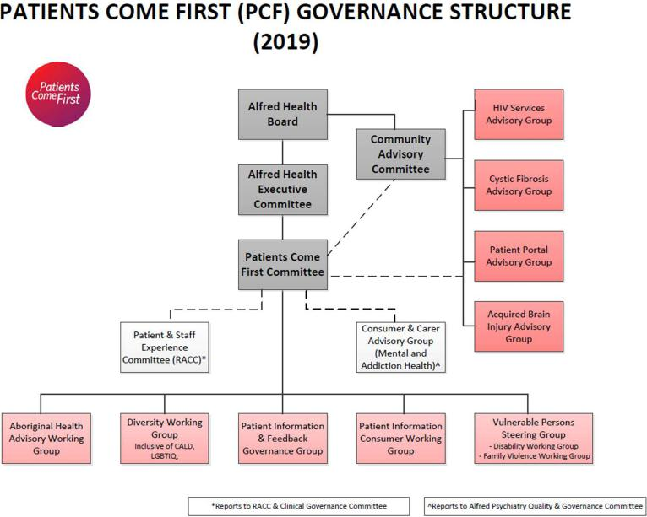

Figure 2: Example integration of committee with other subcommittees at Peninsula Health

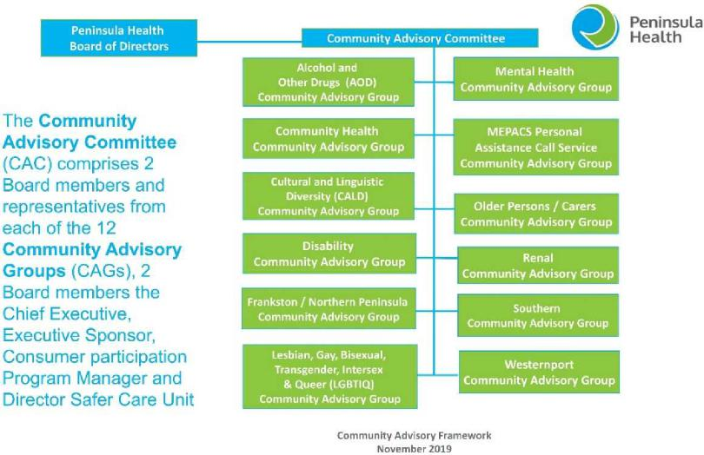

Figure 3 – Sources of information for the committee

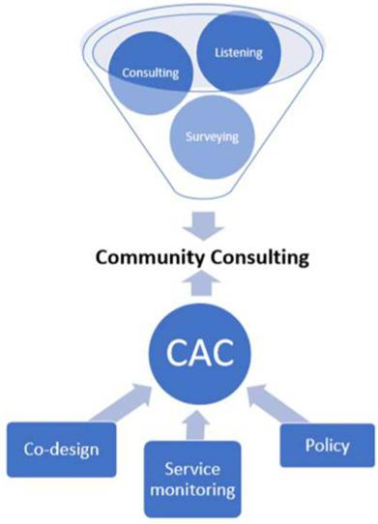

This diagram, from the Health Issues Centre, the peak body for consumer participation, depicts how the community advisory committee (CAC) receives information and inputs.