



Annual report

July 2022 to June 2023

|  |
| --- |
| This is the second annual report from the independent Voluntary Assisted Dying Review Board. The previous reports were referred to as the Report of Operations. Future reports will be referred to as an Annual Report.  It details:   * activity from 1 July 2022 to 30 June 2023 in addition to activity since the commencement of the *Voluntary Assisted Dying Act 2017* (Vic) on 19 June 2019 * Board reflections drawn from case reviews and feedback.   This report contains quotes and feedback from people who have chosen to die from taking the voluntary assisted dying substance, those who were with them when they died, and trained medical practitioners involved in voluntary assisted dying cases. The quotes have been de-identified to protect the privacy of individuals. This content may be upsetting to some. Contact details for support organisations can be found on page 33.  By law, the Board is required to report at the end of each financial year. The next report will be submitted by the end of September 2024 and will cover the reporting period 1 July 2023 to 30 June 2024.  Information on financial reporting  It should be noted that the Board does not operate a budget associated with the delivery or operation of the Act. Therefore, no financial reporting is required or provided within this report. More information [www.safercare.vic.gov.au/about/vadrb](http://www.safercare.vic.gov.au/about/vadrb) |
| To receive this publication in an accessible format phone 1300 758 551,  using the National Relay Service 13 36 77 if required, or [email Safer Care Victoria](mailto:info@safercarevictoria.vic.gov.au) <info@[safercare.vic](mailto:safercarevictoria@dhhs.vic).gov.au>  Authorised and published by the Victorian Government, 1 Treasury Place, Melbourne.  © State of Victoria, Australia, Safer Care Victoria, June 2023  ISSN 2652-1962 – Print  ISSN 2652-1970 – Online (pdf/word)  Victoria State GovernmentAvailable at the [Safer Care Victoria website](https://www.safercare.vic.gov.au) <https://[www.safercare.vic](http://www.safercare.vic).gov.au> |

# Foreword

The Voluntary Assisted Dying Act 2017, enacted on 19 June 2019, has now been in operation in Victoria for four years. During that time, it has operated safely in providing a compassionate option for end of life care. There has been a steady increase in the number of Victorians making an informed and voluntary choice to access voluntary assisted dying at a time when they are near death and experiencing suffering. The Board continues to monitor the operation of the system in Victoria and welcomes feedback provided by those who have been involved in the process.

In this reporting period, the number of applications has risen by 6 per cent to 649 compared with the previous year. The number of deaths from people accessing a voluntary assisted dying substance has risen by 11 per cent to 306.

It is emphasised that this number of people accessing a voluntary assisted dying substance does not represent the full beneficial impacts of the voluntary assisted dying program. There are, in addition, people who obtain the substance but choose not to use it, who receive comfort and relief from suffering by knowing that they have the option.

Furthermore, there are people who never apply for voluntary assisted dying but receive comfort from knowing that there is an option to do so. Also, there are family members and loved ones who report comfort from seeing a person relieved of suffering and being able to access a dignified end of life on their own terms.

The Board are concerned that a significant proportion of applicants die before they obtain the substance. Applicants may not realise that the approval process can be lengthy and leave their request too late in the progression of their illness.

It is noted that although the number of applications has increased only slightly over the past year, the proportion of applicants who progressed through to the dispense of a voluntary assisted dying substance increased by 7%. There has been an increase of 34 per cent compared to the previous reporting year, of applicants proceeding though a practitioner administration process.

Research and data

Working with Safer Care Victoria and the Department of Health, the Board acknowledge the progression of data management and governance agreements regarding the use of voluntary assisted dying data for research. Discussions on developing a minimum dataset across all Australian jurisdictions and New Zealand have been positive.

The Research Advisory Working Group will be able to use these key progressions in the coming year.

Review of the operation of the Act

As we head into the fifth year of the operation of the Act, the Minister is required by the Act to ‘cause’ a review of the operation of the Act. While the voluntary assisted dying scheme has operated safely and in accordance with the law, the Board considers that timely and compassionate access to the scheme could be improved.

The review of the operation of the Act provides an opportunity to understand these barriers with a view to promoting improvements. The Board will prepare a submission to the review which will draw upon the insights collected to date, including feedback from applicants, loved ones, carers, families and medical practitioners involved in the program.

The Board encourages all interested parties to provide feedback and input into this review.

Working with other Australian jurisdictions

Similar legislation is now in operation, or will soon be, in all jurisdictions across Australia. Arrangements for discussions between the respective review bodies, including New Zealand, have been established. The Board looks forward to sharing insights between jurisdictions with the objective of improving services for Victorians.

Already there are clear alignments, and some distinct differences in the experience of each jurisdiction. For example, in the 2022-23 period, the number of voluntary assisted dying related deaths represents 0.65% of registered deaths in Victoria. This compares with 1.1% in Western Australia in 2021-22. While it is not possible to be definitive about the reasons for this difference, the fact that health practitioners in WA are not prohibited from initiating discussions about voluntary assisted dying provided that they provide advice on all other options for treatment, may explain a higher access rate in the initial implementation period than experienced in Victoria.

The Board welcomes the opportunity to continue strengthening engagements across jurisdictions as they progress legislation, to work together on the impacts of all Australians who have access to voluntary assisted dying through the different legislations.

Reflections on Board activity

The Board adopted new Terms of Reference in April 2023. These terms of reference align the Board activity more closely to the intent of the legislation and are available on the Safer Care Victoria website at [www.safercare.vic.gov.au/vad](http://www.safercare.vic.gov.au/vad)

Board members have been invited to attend and participate across many diverse events over the past year. These have included academic, operational and legal events relating to end of life care, professional development events and the provision of analysis of the application of the law. The Board welcome the opportunity to speak and engage with the community around the operation of the Act.

I would like to extend my thanks to Associate Professor Margaret Bird and Ms Molly Carlile AM, who resigned during the year. As foundation Board members, they both made a substantial contribution to the establishment of the operation of voluntary assisted dying in Victoria and to the work of the Board.

Medical practitioners play a key role in assessing eligibility in strict compliance with the law and in supporting people to access palliative care and voluntary assisted dying at difficult and significant points in their lives. The Board extends its thanks to those practitioners, to other health practitioners, to the Statewide Pharmacy Service and the Care Navigator Service, to contact persons and family members for the support and care provided to those who wish to access voluntary assisted dying.

Thank you also to the Board’s Secretariat, supported by Safer Care Victoria, for their professional support of the program and administration of the process. Your dedication continues to allow the effective operation of the Act and Board activities.



**Julian Gardner AM**Chairperson  
Voluntary Assisted Dying Review Board

# Snapshot

Figure 1: Agreed national voluntary assisted dying minimum dataset 19 June 2019 – 30 June 2023

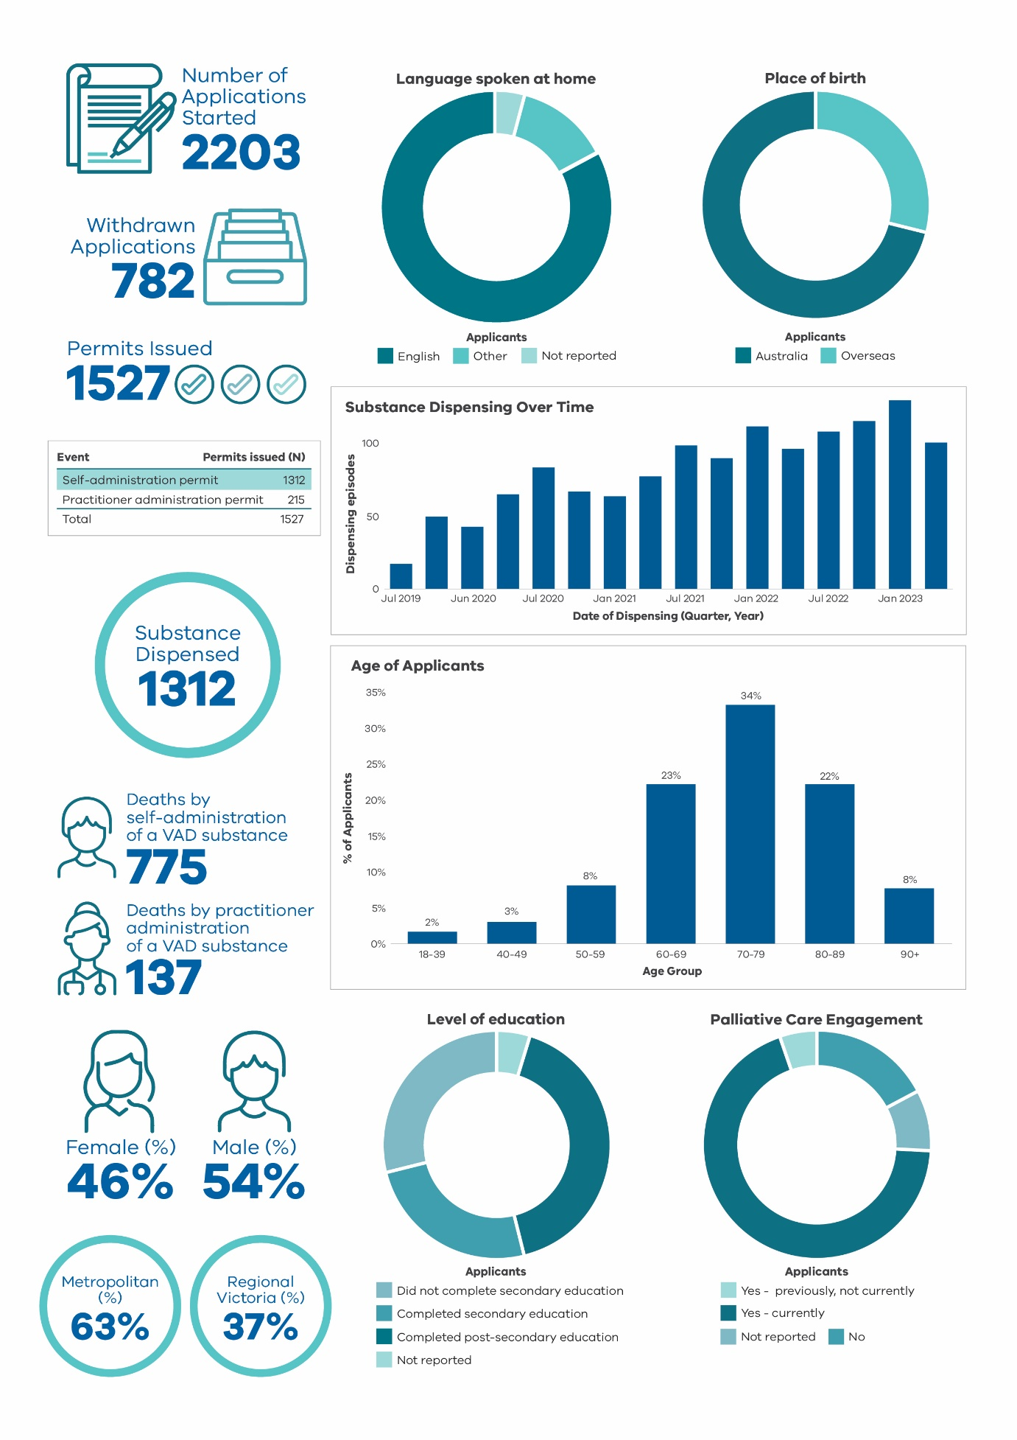

Table 1: Outcomes of each application stage for voluntary assisted dying*

|  |  |  |  |  |  |  |  |  |
| --- | --- | --- | --- | --- | --- | --- | --- | --- |
| **Stage** | **2019-20\*\*** | **2020-21** | **2021-22** | **2022-23** | | **Total to date #** | **Change from previous year** | |
| **First assessment completed** | **353** | **487** | **585** | **610** | | **2035** | **+4%** | |
| Eligible | 346 | 465 | 552 | 600 | | 1963 | +9% | |
| Ineligible## | 7 | 22 | 33 | 10 | | 72 | -70% | |
| **Consulting assessment completed** | **299** | **404** | **491** | **529** | | **1723** | **+8%** | |
| Eligible | 297 | 398 | 486 | 524 | | 1705 | +8% | |
| Ineligible## | 2 | 6 | 5 | 5 | | 18 | 0% | |
| **Self-administration permit processed** | **239** | **350** | **390** | **403** | | **1382** | **+3%** | |
| Permit Issued^ | 207 | 323 | 379 | 403 | | 1312 | +6% | |
| Permit Not Issued | 32 | 27 | 11 | 0 | | 70 | -100% | |
| **Substance dispensed for self-administration** | **155** | **260** | **356** | **401** | | **1172** | **+13%** | |
| **Practitioner administration permit processed** | **39** | **52** | **65** | **82** | | **238** | **+26%** | |
| Permit Issued^ | 30 | 43 | 60 | 82 | | 215 | +37% | |
| Permit Not Issued | 9 | 9 | 5 | 0 | 23 | | | -100% |
| **Substance dispensed for practitioner administration** | **20** | **31** | **38** | **51** | **140** | | | **+34%** |

*This table counts unique applications. A single individual may be linked to more than one application, and some applications may have the same form submitted multiple times.

**This column includes 12 days of 2018-19 financial year as the program commenced on 19 June 2019.

#Total figures are since the commencement of the Act in June 2019.

##There is no requirement in the Act for a medical practitioner to record a case that is considered ineligible. Therefore, this number is not considered an accurate reflection of true ineligible assessments conducted over this reporting period.

^There are circumstances where one applicant is issued with two permits; firstly, for self-administration and subsequently if there is a change to practitioner administration.

Table 2: Deaths of applicants issued with permits

|  |  |  |  |  |  |  |
| --- | --- | --- | --- | --- | --- | --- |
| Manner of death | 2019-20* | 2020-21 | 2021-22 | 2022-23 | Total to date | Change from previous year |
| **Deaths from administration of voluntary assisted dying substance** | **129** | **202** | **275** | **306** | **912** |  |
| Self-administration of the voluntary assisted dying substance | 108 | 174 | 236 | 257 | 775 | 9% |
| Practitioner administration of the voluntary assisted dying substance | 21 | 28 | 39 | 49 | 137 | 26% |
| **Deaths of permit holders not from administration of voluntary assisted dying substance** | **50** | **113** | **130** | **137** | **430** | **5%** |
| **Total deaths\*\*** | **179** | **315** | **407** | **443** | **1344** | **9%** |
| * This column includes 12 days of 2018-19 financial year as the program commenced on 19 June 2019. ** Two applicants who died near 30 June 2023 did not have their manner of death reported to the Board at the time of analysis. This means that the totals for 2022/23 and to date equal two more than the sum of the columns presented. | | | | | | |

**In the 2022-23 reporting year**

**610**

First assessments completed

**485**

Permits issued to prescribe a self or practitioner administration of voluntary assisted dying substance

**306**

Deaths from administration of voluntary assisted dying substance **28%**

of permit holders died without administration of a voluntary assisted dying substance

**50%**

of applicants with a first assessment died from administration of a voluntary assisted dying substance

# The request and assessment process

Access to voluntary assisted dying has strict eligibility requirements and is a highly controlled process. The below diagram explains the steps a person, their medical practitioners and nominated contact person must take to apply for and obtain a permit. The full process is detailed in the Act.



Applicant requesting voluntary assisted dying

Co-ordinating and consulting medical practitioner



FORMS

Assess eligibility

Confirm eligibility*

*\*Specialist opinion may be required*

Written declaration by person applying

Final request

Contact person nominated



Medical practitioner enters information in portal

DH Secretary reviews permit

If approved



Statewide Pharmacy Service receives prescription



Delivers medication

Applicant or   
co-ordinating medical practitioner



Applying for voluntary assisted dying

The experience of people who have accessed, supported, or provided care to applicants throughout the process provides insight on key considerations related to the process. The information below has been highlighted as important to previous applicants as they have progressed through an application.

How to access voluntary assisted dying

The Statewide Care Navigator Service can provide information and support to find a trained medical practitioner to discuss the process with you. Contact the service on vadcarenavigator@petermac.org or call 03 8559 5823 / 0436 848 344.

A potential applicant must ask a medical practitioner directly about voluntary assisted dying to commence a conversation on the subject. Medical practitioners, by law, are unable to start a conversation about the process without a direct request from a person who wishes to make an application.

Seeking support to make a request for voluntary assisted dying from an interpreter or speech pathologist is encouraged should it be required.

Who is eligible to access voluntary assisted dying?

The Act outlines the eligibility criteria. A medical practitioner who has completed voluntary assisted dying training will conduct an assessment to determine eligibility to progress with a request.

The medical practitioner will need to assess both demographic and medical information. This must determine that an applicant is over 18; an Australian citizen or permanent resident; and has ordinarily been a resident of Victoria for at least 12 months at the time of the first request.

The applicant must have decision-making capacity and be diagnosed with a disease, illness or medical condition that is incurable; is advanced, progressive and will cause death within 6 months (or 12 months for a neurodegenerative condition); and is causing suffering to the person that cannot be relieved in a manner that the applicant considers tolerable.

What should be prepared before a first request?

Preparation of identity documentation is encouraged. An applicant will need to provide documentation to demonstrate they are over 18 years of age, that they are an Australian citizen or permanent resident, and that they have resided in Victoria for 12 months or more in advance of the first request date. Medical practitioners will have to sight and provide a copy of this documentation as part of the process.

How long will the process take?

Voluntary assisted dying is not an emergency medical procedure and requires time and thoughtful planning.

The voluntary assisted dying assessments can take time to complete, even if all the documentation and information is available from the initial appointment. There is provision in the Act to shorten the process. However, this is only for people who are unlikely to survive more than 9 days after their first request.

Once the application process is complete, the Permit will take up to 3 business days to be approved and a booking with the Statewide Pharmacy for delivery of the substance can be made.

Why is a contact person required?

Applicants are required to appoint a contact person. A contact person has the responsibility to return an unused substance to the Statewide Pharmacy. You may wish to have the contact person support you in preparing the substance before it is administered.

The contact person is invited to provide feedback on the process and experience to the Board.

Access to voluntary assisted dying in aged care or palliative care

Voluntary assisted dying is a legislated process in Victoria. However, individual medical practitioners have the right to conscientiously object to involvement in the process.

Should you be unable to access information or support for progressing an application, contact the Statewide Care Navigator service to discuss your options. In some cases, they may require you to move to another hospital or palliative care setting to complete the process.

The Board supports the right of individuals to conscientiously object to the process, however, it encourages those who do not wish to be involved to provide information on the Statewide Care Navigator service to any potential applicant in this circumstance.

Why do people need to see more than two medical practitioners to complete an application?

Applicants with a neurodegenerative disease, illness or medical condition with a prognosis of 6-12 months will be referred by the co-ordinating medical practitioner for a specialist opinion as part of the assessment process.

A specialist medical opinion may also be sought by either medical practitioner on decision-making capacity if for example, the applicant has experienced a past or current mental illness or whose disease, illness or medical condition is known to impact the ability to make decisions.

Should the applicant have a disease, illness or medical condition which is rare or that the assessing medical practitioner does not have the relevant experience or expertise to assess in relation to eligibility to access voluntary assisted dying, the medical practitioner may refer for a specialist opinion to inform their assessment process.

Why are applicants required to see medical practitioners in person?

Commonwealth law prohibits the use of a carriage service (such as telephone or telehealth) for suicide-related material which may include voluntary assisted dying. This means that across Australia where voluntary assisted dying is legislated, medical practitioners must see an applicant in-person to complete the assessment process.

The Board, alongside our peers in other Australian jurisdictions, is aware of the impact this has on regional and rural patients and for those who are unable to travel due to limited mobility or other reasons. The Board has raised this issue with the Attorney-General and discussed the impact with other jurisdictions. Although we are confident a resolution to this restriction will be reached, we empathise that this currently has an adverse impact on applicants.

People unable to travel to see a medical practitioner in person, are encouraged to contact the Statewide Care Navigator Service to see if there are other options to complete an assessment.

# Medical practitioner involvement

Compassionate and dedicated medical practitioners continue to provide care and support to Victorians seeking access to voluntary assisted dying. Statewide service delivery has been strengthened and system wide improvements have been informed by the medical practitioners who willingly provide feedback.

Medical practitioners are required to successfully complete Victoria’s mandated training program prior to providing voluntary assisted dying eligibility assessments.

There has been continual growth in the number of medical practitioners who have registered to complete the online training program over the four years since voluntary assisted dying became available in Victoria.

There were 347 medical practitioners with active profiles in the portal as at 30 June 2023. Practitioner profiles may become inactive after registration if a practitioner retires or ceases to be involved in voluntary assisted dying.

General practitioners make up 59 percent of all registered practitioners, and 71 percent of practitioners registered to provide voluntary assisted dying in regional Victoria.

Table 3: Medical practitioner training and involvement since commencement of training availability*

|  |  |  |  |  |  |  |
| --- | --- | --- | --- | --- | --- | --- |
| Stage | Description | | Total as of 30 June 2021 | Total as of 30 June 2022 | Total as of 30 June 2023 | Change (%) |
| Online training | | Medical practitioners registered for the online training program | 511 | 618 | 734 | +19% |
| Portal **registration** | | Trained medical practitioner registration within the Voluntary Assisted Dying portal | 234 | 326 | 347 | +6% |
| Case **involvement\*** | | Participation by the medical practitioner in at least one case as either the co-ordinating or consulting medical practitioner | 154 | 185 | 208 | +12% |

* Figures presented in previous reports have provided total numbers to date. This report provides trends over time and provides numbers per reporting year.

Figure 2: Clinical specialties of medical practitioners by primary location of practice

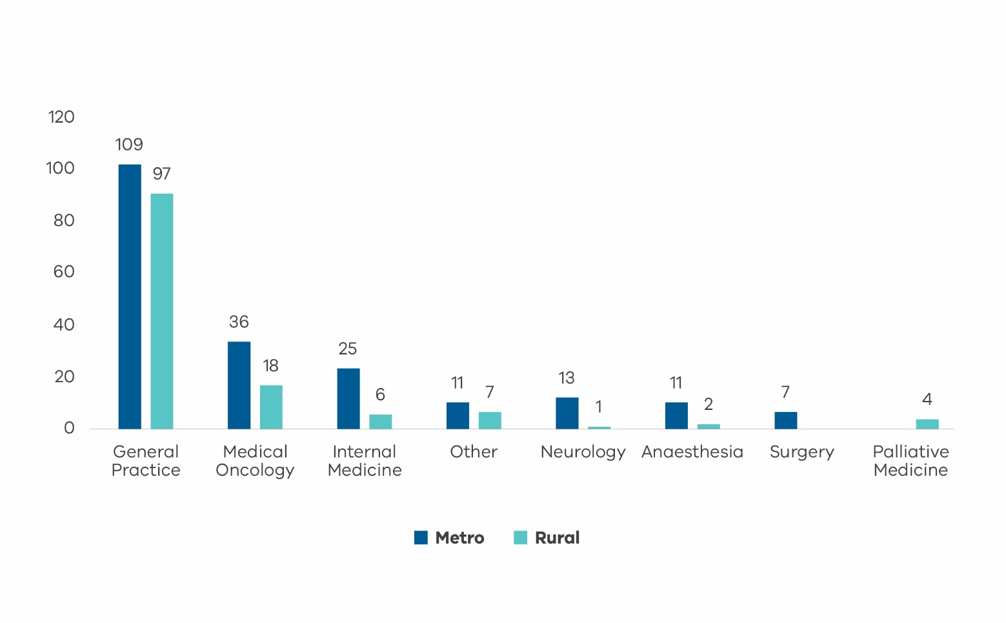

Please note: Other specialty areas include psychiatry and urology, or do not have a specialty area(s) listed by Australian Health Practitioner Regulation Authority. ‘Internal medicine’ includes associated subspecialties including cardiology, gastroenterology and hepatology, geriatric medicine, infectious diseases, intensive care medicine and nephrology.

Figure 3: Number of practitioners newly registered in the Voluntary Assisted Dying portal

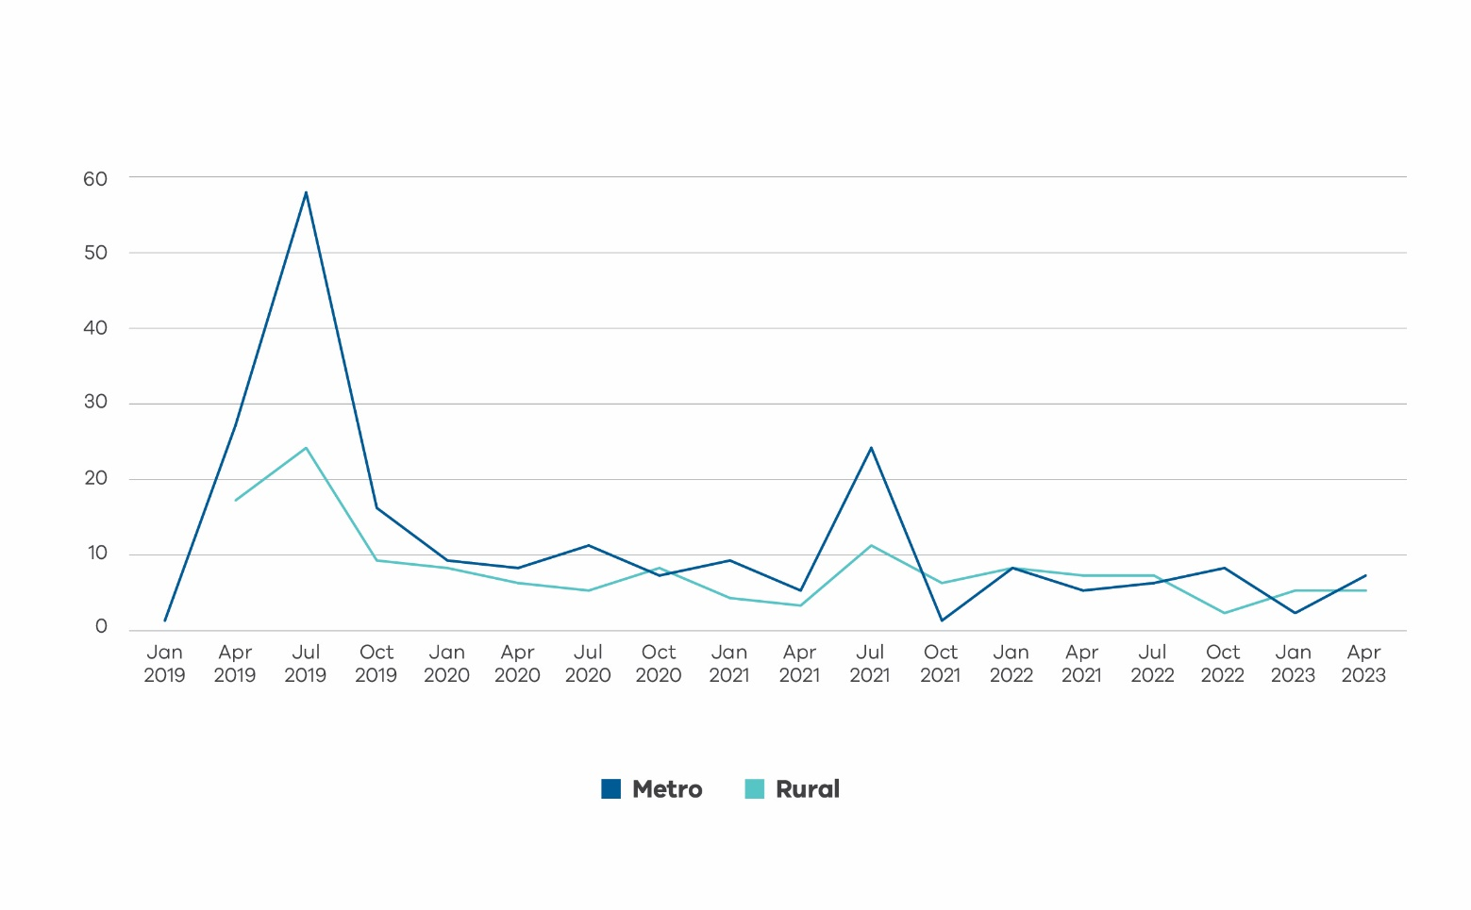

In total, 60 percent of active medical practitioners are in metropolitan Melbourne, and 40 percent practice in regional Victoria. Practitioners in regional Victoria are concentrated around the larger towns in central Victoria, Geelong and the Bellarine peninsula, and the Hume region. There are very few practitioners in Western Victoria.

The distribution of practitioners is broadly consistent with the distribution of the population in Victoria. Although there are some large geographic areas with few, if any, medical practitioners. This means regional patients and medical practitioners may have to travel significant distances to facilitate the required in-person assessments and discussions about voluntary assisted dying.

We were lucky that we had a doctor in town because it really got to the point that dad couldn’t have travelled if we had needed to do that for appointments. The doctor had trained specifically for one of her long-term patients and we got in touch, and she agreed to do it for us too. She came to see us on her day off. She was wonderful. Contact person

Figure 4: Geographic distribution of medical practitioners*

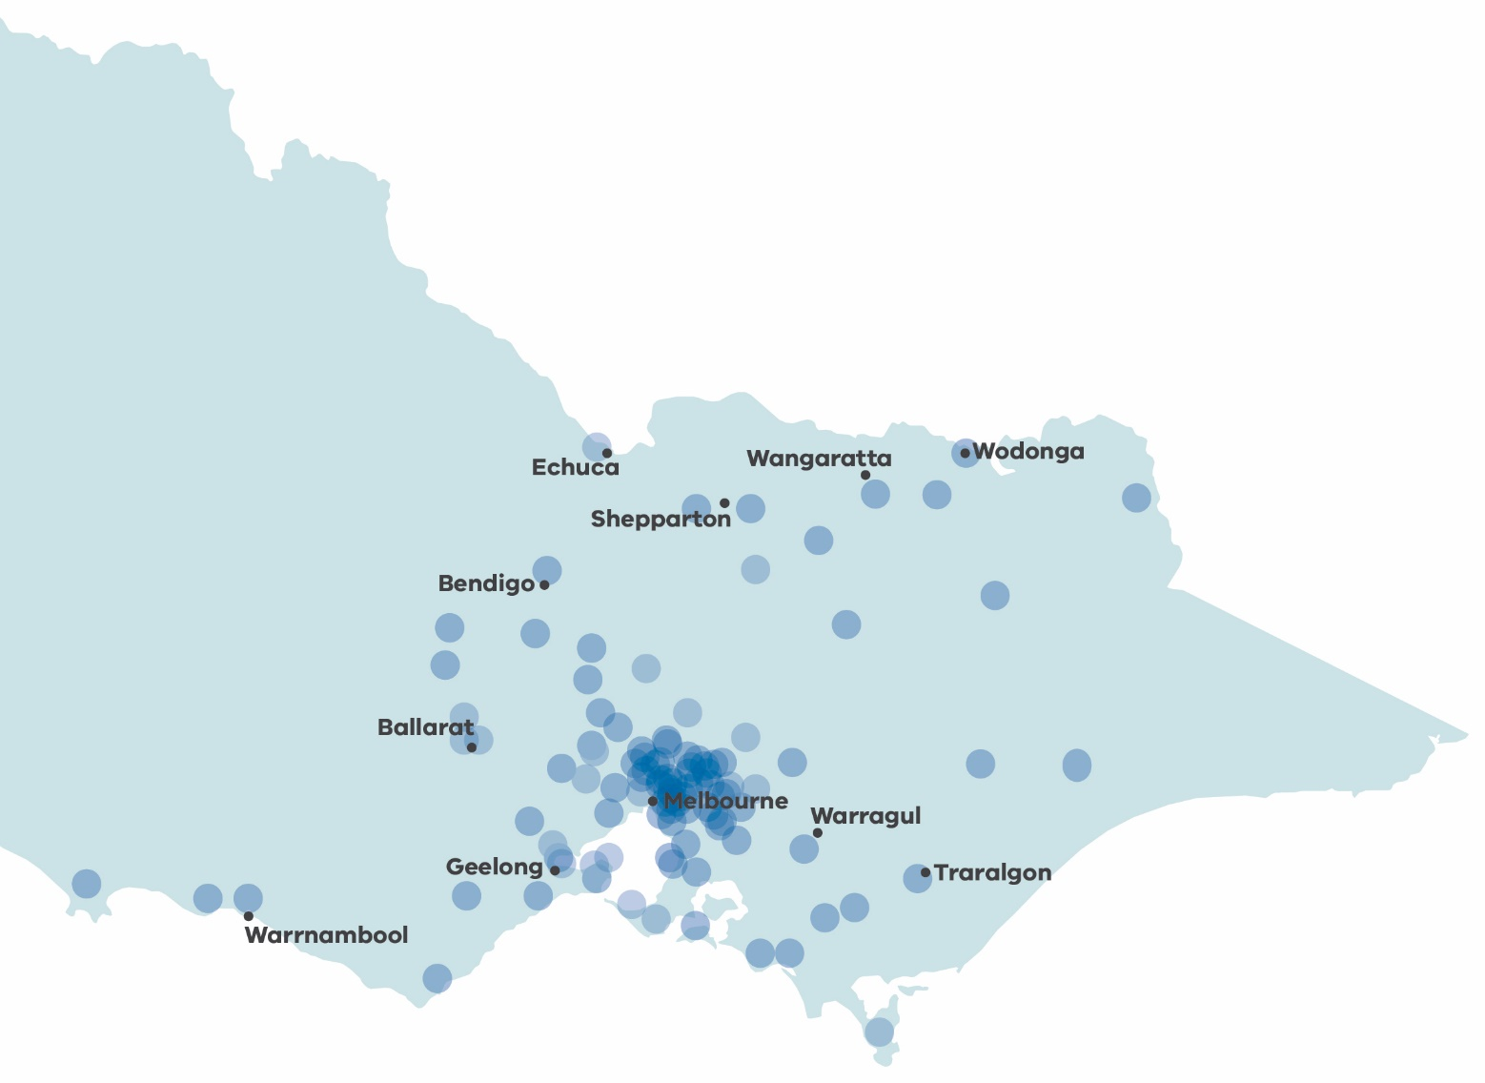

* Locations are approximate, based on the centroid of postcodes.

## Community of practice

Medical practitioners who have completed voluntary assisted dying training are encouraged to join the community of practice, which is an online peer support network with 63 members. The community of practice offers support to medical practitioners who are involved in providing services related to voluntary assisted dying.

The community of practice is a supportive resource for medical practitioners and current membership includes specialists in oncology, palliative care, geriatrics, anaesthetics, and general practice.

Medical practitioners can join the community of practice after completing the voluntary assisted dying training. Those wishing to join are encouraged to contact [vadcommunity@westvicphn.com.au](mailto:vadcommunity@westvicphn.com.au).

I am pleased that there is a community of people providing voluntary assisted dying as I feel it could be an isolating experience without this support in a more complicated case. **Medical practitioner**

For my first practitioner administration case, having background info from experienced practitioners through the community of practice was very reassuring and helpful to be confident enough during the actual administration. **Medical practitioner**

.

# Applications and assessments

An applicant is a person seeking to access voluntary assisted dying. They must meet all eligibility criteria, as assessed by their co-ordinating and consulting medical practitioners. The Statewide Care Navigator Service and the Statewide Pharmacy Service provide support to applicants and their families, medical practitioners, and health services throughout the application process. As more Victorians are aware of this end-of-life choice there is a continued need for these statewide services. Additional resourcing has been dedicated to ensuring Victorians considering accessing voluntary assisted dying have their needs met when they need it most.

### Statewide Care Navigator Service

The Statewide Care Navigator Service has provided advice and support to Victorians, medical practitioners, and health care teams across Victoria over the last four years.

The care navigator service continues to grow to meet the needs of Victorians. There are nine care navigators located across metropolitan and regional Victoria. These skilled and highly experienced nurses and social workers provide advice and support to Victorians who may be considering voluntary assisted dying. If required, the service will connect people with medical practitioners who have completed the online training program.

From 1 July 2022 to 30 June 2023, there were 957 contacts made to the care navigator service seeking information or support. This is a decrease of 9 percent compared to 1046 contacts made from the previous year. Of these:

* 24 percent were from applicants
* 25 percent were from a family member or friend
* 22 percent were from the usual treating doctor
* 6 percent were from a voluntary assisted dying clinician (medical practitioner or coordinator)
* 23 percent were from other sources.

Of contacts to the care navigator service, 40 percent were from regional or rural Victoria.

Of all the contacts made from 1 July 2022 – 30 June 2023:

* 42 percent were for support for applicants who were planning or were in the process of applying for voluntary assisted dying
* 54 percent were requests for information from those who were considering voluntary assisted dying
* 3 percent were for assistance in finding a second trained medical practitioner to complete the applicant’s eligibility assessment
* 1 percent were for other reasons.

The care navigator service also provides a variety of education and training sessions across Victoria including:

* training days to support medical practitioners who choose to complete the online training program in a group environment
* webinars and education sessions for healthcare professionals specific to their clinical context such as aged care or palliative care services
* assistance to health services, enabling them to support a person in their care who is seeking voluntary assisted dying.

During 2022-23, the care navigator service provided 178 webinars, education sessions and activities across Victoria.

Contact people and medical practitioners continue to provide positive feedback about the Care Navigator Service.

The Care Navigator Service can be contacted on [vadcarenavigator@petermac.org](mailto:vadcarenavigator@petermac.org) or (03) 8559 5823 / 0436 848 344.

The navigator was compassionate, professional, and provided a very much appreciated service with an offer of ongoing support. **Service user**

There was no judgement, just compassion and support. The navigator was absolutely amazing. **Service user**

He didn't actively participate in the administrative side of things. I assisted him to organise it - he just made the decision. Initially, it was difficult to get the ball rolling, but once we were referred to a Care Navigator, it was all very quick and smooth. **Contact person**

#### Voluntary assisted dying applications

After a person makes a first request to access voluntary assisted dying, the co-ordinating medical practitioner lodges an application through the voluntary assisted dying Portal. The following graph represents the total number of forms submitted to the Portal as part of the application process, since the commencement of the legislation.

Figure 5: Applications over time (forms submitted by quarter)

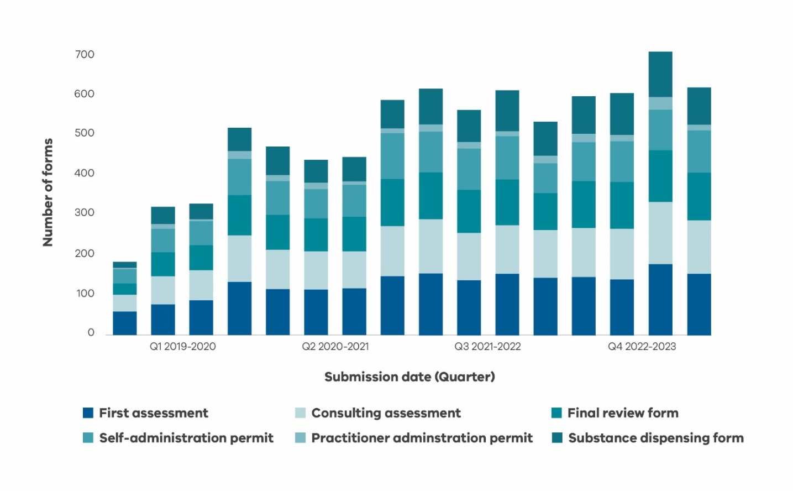

#### Timeframes during the application process

The Act requires that a final request is made at least nine days after the first request, unless both assessing medical practitioners consider that the applicant’s death is likely to occur within the nine-day timeframe.

The median timeframe from first to last request is 16 days, and from first request to dispensing of the substance is 34 days.

Table 4: Timeframes – key events

|  |  |
| --- | --- |
| Timeframes | Days elapsed |
| First to final request |  |
| Median | 16 |
| Interquartile range | 11-30 |
| First request to dispensing for self-administration |  |
| Median | 34 |
| Interquartile range | 23-53 |

## People who applied for voluntary assisted dying

Since the commencement of the Act, 2082 people have applied for access to voluntary assisted dying. The median age of applicants was 74 years, and half of all applicants were aged 65-81 years. Just over half of the applicants were male (54 percent male, 46 percent female).

Over one third (36 percent) of applicants lived in regional Victoria, despite only 22 percent of the Victorian population living in regional areas.

According to the 2021 census, 39 percent of people aged 55 years and older have completed year twelve or equivalent, compared to at least 59 percent of voluntary assisted dying applicants.

The demographic characteristics of applicants have been consistent over the time period of the operation of the Act.

Table 5: Applicant demographics 19 June 2019 – 30 June 2023 (n=2096)

| Characteristics | Number | % |
| --- | --- | --- |
| Sex |  |  |
| Female | 967 | 46% |
| Male | 1,128 | 54% |
| Self-described | 1 | 0% |
| Age |  |  |
| 18-39 | 39 | 2% |
| 40-49 | 68 | 3% |
| 50-59 | 177 | 8% |
| 60-69 | 475 | 23% |
| 70-79 | 707 | 34% |
| 80-89 | 466 | 22% |
| 90+ | 164 | 8% |
| Median age (IQR) | 74 | (65-81) |
| Country of birth |  |  |
| Australia | 1,433 | 68% |
| Overseas | 663 | 32% |
| Identification as Aboriginal or Torres Strait Islander |  |  |
| Yes | 11 | 1% |
| No | 1,985 | 95% |
| Not reported | 100 | 5% |
| Language spoken at home |  |  |
| English | 1,937 | 92% |
| Other | 79 | 4% |
| Not reported | 80 | 4% |
| Interpreter required |  |  |
| Yes | 47 | 2% |
| No | 2001 | 95% |
| Not reported | 48 | 3% |
| Highest level of education completed* |  |  |
| Did not complete secondary education | 537 | 26% |
| Completed secondary education | 461 | 22% |
| Completed post-secondary education | 771 | 37% |
| Not reported | 327 | 16% |
| Area of residence |  |  |
| Greater Melbourne | 1332 | 64% |
| Regional Victoria | 764 | 36% |
| Living situation |  |  |
| Private household | 1793 | 86% |
| Long term care or assisted living facility | 164 | 8% |
| Health service | 93 | 4% |
| Not reported | 46 | 2% |

Figure 6: Geographic distribution of applicants*

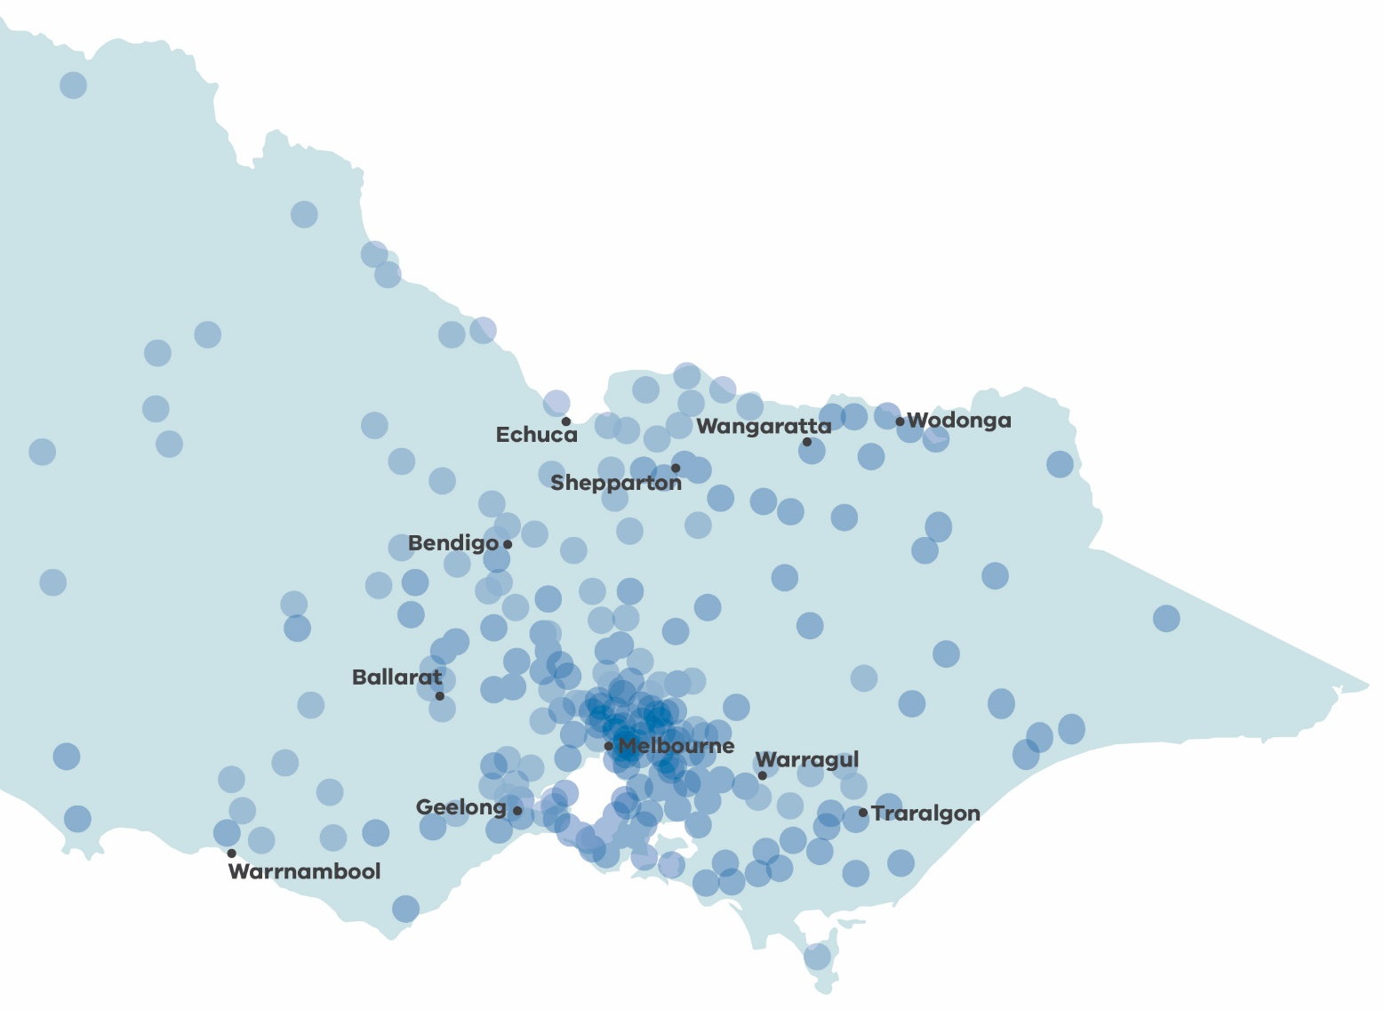

* Locations are approximate, based on the centroid of postcodes.

## Life limiting conditions

Following enhanced data collection practices, data on life limiting conditions is now available for the majority of applicants. Data in previous reports was limited to cause of death data reported by the Registrar of Births, Deaths and Marriages.

A large majority (76 percent) of people applying for voluntary assisted dying have cancer, with lung, colorectal, pancreatic and other gastrointestinal malignancies being the most common. The next largest group of patients are those with a neurological condition, most often Motor Neurone Disease.

Table 6: Life limiting conditions of applicants 19 June 2019 – 30 June 2023 (n=2096)

|  |  |  |
| --- | --- | --- |
| Life limiting condition | Number | % |
| Cancer | **1574** | **76%** |
| Lung malignancy | 304 | 15% |
| Colorectal malignancy | 174 | 8% |
| Other gastrointestinal tract malignancy* | 169 | 8% |
| Pancreas malignancy | 138 | 7% |
| Breast malignancy | 133 | 6% |
| Prostate malignancy | 122 | 6% |
| Gynaecological malignancy | 97 | 5% |
| Central nervous system malignancy | 71 | 3% |
| Haematological malignancy | 70 | 3% |
| Other urological malignancy | 64 | 3% |
| Head and neck malignancy | 55 | 3% |
| Skin malignancy | 55 | 3% |
| Other primary malignancy | 44 | 2% |
| Bone and soft tissue malignancy | 44 | 2% |
| Unknown primary malignancy | 18 | 1% |
| Malignant - not further defined | 13 | 1% |
| Neurological | **196** | **9%** |
| Motor Neurone Disease | 147 | 7% |
| Other neurological disease | 49 | 2% |
| Respiratory | **72** | **3%** |
| Other** | **112** | **5%** |
| Not yet assigned# | **142** | **7%** |

* “Other gastrointestinal tract malignancies” includes primary liver cancers.

** “Other” causes include HIV/AIDS, diabetes, chronic cardiovascular disease, advanced liver disease (excluding liver cancer), end-stage kidney disease, and other rare conditions.

#A data consolidation exercise is underway, and these may be captured in future reporting

## Palliative care

Palliative care services are available to all Victorians, with care available dependent on individual need. This may include hospital-based care or care delivered in a person’s home or residential facility. It is important to recognise that voluntary assisted dying is not an alternative to palliative care. This is underscored by the fact that 81 per cent of applicants applying for voluntary assisted dying have accessed or are being cared for by a palliative care service. Palliative care is an essential service, and the integration of palliative care options remains an important aspect of the end-of-life care delivery model.

Palliative care services provide bereavement services for their registered family and carers. Other bereavement services are available including the Australian Centre for Grief and Bereavement. Further contact details for bereavement support are available on page 33.

Table 7: Use of palliative care by applicants 19 June 2019 – 30 June 2023 (n=2096)

|  |  |  |
| --- | --- | --- |
| Palliative care services | Number | % |
| Accessed | **1707** | **81%** |
| Yes - currently | 1677 | 80% |
| Yes - previously, not currently | 30 | 1% |
| No | **299** | **14%** |
| Not reported | **90** | **4%** |
| Duration of engagement with palliative care (n = 1707) |  |  |
| Less than 12 months | 1245 | 73% |
| Greater than 12 months | 297 | 17% |
| Duration of engagement not reported | 165 | 10% |
| Median months (interquartile range) | 3 months | (1-8 months) |

## Additional assessments

Additional specialist opinion may be sought by a co-ordinating or consulting medical practitioner as part of the assessment process to determine whether a person has decision making capacity.

Specialist opinion may also be sought by either medical practitioner to confirm a diagnosis or prognosis as part of the assessment process.

It is a requirement for applicants with neurodegenerative conditions with a prognosis of 6-12 months to seek a further specialist opinion at the co-ordinating assessment stage.

Table 8: Referrals for additional assessments 19 June 2019 – 30 June 2023

|  |  |
| --- | --- |
| Referrals for additional assessments | Number of applicants |
| Decision making capacity | 31 |
| Neurodegenerative assessment if prognosis is 6-12 months | 126 |

## Appointment of a contact person

The Act requires that a contact person is appointed once a final request is made. A contact person has a duty under the Act to return any unused or remaining voluntary assisted dying substance within 15 days after the date of death of the applicant, or if the applicant decides to request a practitioner administration permit.

The Act requires the Board to provide information on the requirement to return the substance and outline support information available to assist the contact person within seven days of being notified of the death of an applicant. As part of this, the Board requests feedback on the experience of the process. The Board thanks all those who provided valuable insights on their experience of voluntary assisted dying. Feedback has been incorporated throughout this report and informs the quality and safety reviews conducted by the Board.

## Withdrawal of cases

Since the commencement of the Act, a total of 765 applications (35 per cent of all applications) have been withdrawn before the substance was dispensed. Of these, 45 per cent were withdrawn because the applicant died less than two weeks after making the first request. This represents 16% of all applications and signifies that many patients begin the application process very late in the course of their illness. Further analysis of these cases is underway.

Reasons for withdrawal include:

* the death of applicant prior to the voluntary assisted dying substance being dispensed
* deterioration in condition resulting in loss of decision-making capacity, or being too unwell to continue the assessment process
* duplicate applications created in error for a single applicant.

Table 9: Reason for withdrawal 19 June 2019 – 30 June 2023 (n = 765)

|  |  |  |
| --- | --- | --- |
| Reason for withdrawal | Number | % |
| Applicant died | 579 | 76% |
| Clinical deterioration / loss of capacity | 56 | 7% |
| Other | 26 | 3% |
| Applicant decided not to proceed | 9 | 1% |
| Not reported | 95 | 12% |

# Permit approvals and substance dispensing

Once the assessment process has been finalised and the applicant is found to be eligible, the co-ordinating medical practitioner must apply for a permit to dispense the substance. The Secretary, Department of Health, or their delegate, reviews and considers all voluntary assisted dying permit applications. It is the applicant’s choice to decide if and when they want to access the voluntary assisted dying substance. The Statewide Pharmacy Service will visit applicants anywhere in Victoria to dispense the substance.

Between 1 July 2022 and 30 June 2023, the Secretary, Department of Health issued 485 permits, for either self-administration or practitioner-administration.

In this reporting cycle there were zero permit applications with an outcome of ‘permit not issued’. This is a result of the growing experience of medical practitioners in completing the application forms as well as the Voluntary Assisted Dying Portal Enhancements Project completed in 2021-22.

## Timeliness

The *Voluntary Assisted Dying Regulations 2018* state that the Secretary, Department of Health has three business days to determine the outcome of a permit application. Outcomes for 99 percent of permit applications were determined within this timeframe, with 95 percent approved within two business days.

Delays to a permit application may occur when incomplete paperwork is provided as part of the assessment process, or the Secretary seeks further information to assess the application.

The Secretariat for the Board conducts an administrative check on all assessment forms as they are lodged. If necessary, the Secretariat provides feedback to medical practitioners to promote compliance with the Act. It is entirely a matter for the medical practitioners to act on this feedback. However, the Secretary, in making the final determination to grant or not grant the permit considers the application when it is complete. This is when all relevant information has been provided and checks for compliance with the Act are completed.

Once all required application steps have been completed, the Secretary of the Department of Health grants a voluntary assisted dying permit. Then the applicant decides if, and when, they want to access the voluntary assisted dying substance.

## Statewide Pharmacy Service

The Pharmacy Service continues to develop and respond to the needs of Victorians, and during 2021-22 increased the training of pharmacists and administration support. This expansion ensured the Pharmacy Service continues to provide a sustainable, timely, patient-centred service.

The Pharmacy Service dispenses the voluntary assisted dying substance to each applicant at a time and location of the person’s choosing. To do this, pharmacists travel throughout the state to provide education and support to applicants, their families, and medical practitioners. They also dispose of any unused substance returned by the contact person or medical practitioner.

During 2022–23*:

* 89 percent of applicants had the substance provided on their preferred delivery day
* 99 percent of applicants had the substance provided within two business days of their preferred delivery day
* 68 percent of dispenses were to metropolitan applicants
* 32 percent of dispenses were to regional applicants.

* These figures represent all pharmacy visits to applicants and medical practitioners with a permit who have requested to receive the substance. It may not result in the dispensing of the substance due to patient choice or deterioration.

Feedback provided by contact people and applicants about the pharmacy service enables continuous performance monitoring and evaluation. Feedback from those who provided a response showed:

* 97 percent reported excellent service from the pharmacist(s)
* 91 percent said the pharmacist visited at a time that suited them.

Both my wife and I were overwhelmed with this experience. Kind and meticulous pharmacists who ensured I understood the process. Demonstrations and written information outstanding. Thank you for the opportunity to end my suffering on my own terms with dignity. I feel no pressure to use [the substance] and will remember you both, as my wife will, for your act of humanity and kindness. **Service user**

The whole experience was calm and informative. Two lovely people who valued my beliefs made me feel comfortable. **Service user**

My wife and I are very grateful to the team for coming to our home and taking us through step by step of the process. From their demonstration of what is involved in the preparation, to their patience with answering our questions. The simplicity of the Patient Information Booklet was easy to understand and will definitely be a help when the time comes. The bottles marked with 1 hour and the one with 30 minutes is so easy to understand, when I'm sure the mind will be racing. Thank you for giving me this choice of a peaceful ending, to a life well lived. **Service user**

# Deaths

Since the commencement of the Act, 1344 applicants who were issued with a permit for self-administration or practitioner administration of a voluntary assisted dying substance subsequently died. Of these, 775 died after self-administration, 137 after practitioner administration and 430 without administration of the substance.

Practitioner administration permits may be applied for when an applicant is physically incapable of self-administration or digestion of the substance.

Among the permit holders who died:

* 58 percent died through self-administration of a voluntary assisted dying substance
* 10 percent died by administration of a voluntary assisted dying substance by a medical practitioner
* 32 percent died without the administration of a voluntary assisted dying substance

These proportions have been stable over time, although the number of people granted permits and taking the substance has increased each year since the Act commenced.

Figure 7: Manner of death for all permit holders who died (n = 1344)*

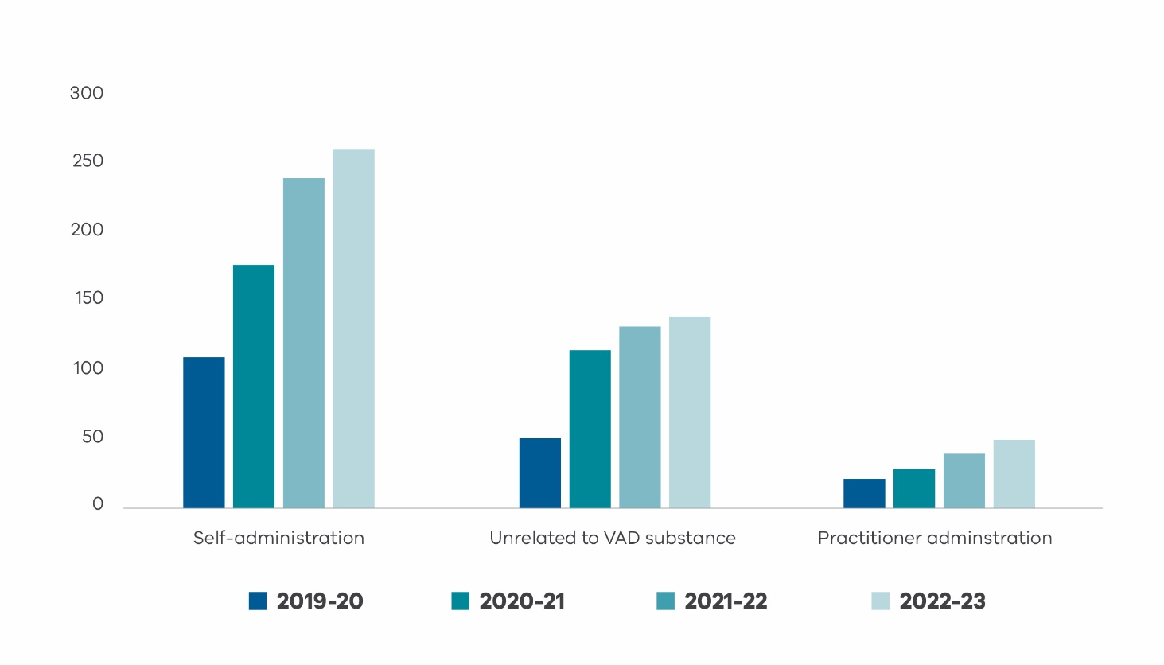

* Note that data from 2018-19 has not been presented in this figure as only one death occurred in the nine days of operation of the Act in this financial year. Two permit holders who died recently have not yet had their manner of death reported to the Board.

## Everyone involved in the program was amazing, the doctors, pharmacists, care navigators. Everyone went above and beyond. The doctors came on a Sunday. Their final wish was for the family to get the word out there about being able to access voluntary assisted dying. The option should be known to everyone who needs it. **Contact person**

## Voluntary assisted dying should be discussed more openly in the community. Health care providers can’t mention it unless the patient brings it up. This means people can’t make informed decisions as they don’t have all the information - it's important for people to know it's an option. Whilst voluntary assisted dying is hard, I’ve watched people go through long illness due to cancer and this was so much better. I think it should be easier to access and it should have shorter processing times. **Contact person**

## I cannot find the words to express my gratitude for this service. [The applicant] expressed a sense of profound relief once the substance was ordered and the date chosen. He was so grateful to be given the chance to take control of his life again and end the pain and indignity of a prolonged death. **Contact person**

# Compliance reviews

The *Voluntary Assisted Dying Act 2017* (Vic) has 68 safeguards and a scrupulous oversight scheme in place. The Act is interpreted strictly, consistent with maintaining public safety and confidence. The Board is vigilant that errors do not impact on compliance with the legislation.

## Case compliance

Between 1 July 2022 and 30 June 2023, the Board found two cases to be non-compliant with the Act.

Both cases were determined as non-compliant because there was a delay with the return of the substance to the Statewide Pharmacy. The contact person is required by Section 39(2)(a) of the Act to return any outstanding substance within 15 days of the death of an applicant, or when a substance has been dispensed for self-administration and then a practitioner permit request commences (Section 55).

## Return of substance

There are sometimes delays to in the notification of voluntary assisted dying deaths to the Board. As a result, it is not always possible to follow up with contact people within the initial 15 day period post death required by Section 106 of the Act. Having regard to the fact that in both instances the substance was returned soon after the required period, and a reason for the delay provided, no further action will be taken. It is clear in the legislation that the penalty associated with this oversight can be severe. Therefore, a focus on the provision of appropriate information and support for contact people is paramount.

For those involved in the assessment process, it is important to ensure the contact person is aware of this obligation when they are appointed.

## Referral to other agencies

During this reporting period, no deaths were considered to require further investigation by the State Coroner. There were no referrals made to the Chief Commissioner of Police or the Australian Health Practitioner Regulation Agency.

## Access to voluntary assisted dying

As part of the compliance review process, the Board reflects on individual cases. Issues that impede access to voluntary assisted dying are identified and discussed. These reviews allow the Board to perform one of its key functions in supporting continuous improvement of the program.

## Commonwealth Criminal Code

The existing Commonwealth Law creates barriers to accessing care and, in some cases, creates situations resulting in unreasonable travel demands for people suffering from life-ending medical conditions. The law currently precludes the use of telehealth for the conduct of voluntary assisted dying assessments. The Board will continue to advocate for a change in the Commonwealth Law to promote access to voluntary assisted dying for all Victorians, regardless of their location or mobility.

Access to voluntary assisted dying in the Aged Care sector

The Board is aware that some residents in aged care facilities in Victoria have encountered barriers to accessing voluntary assisted dying. This includes examples where facilities have refused to cooperate in the application process or have refused to allow the voluntary assisted dying substance to be delivered or administered on the premises.

It is understood that some aged care facilities may not be aware of the functioning of voluntary assisted dying. The Board has contacted the Aged and Community Care Providers Association to better understand the policies and procedures that an aged care facility could be expected to implement. This includes supporting these providers to better understand voluntary assisted dying as a choice for eligible residents.

The Board recommends that all health and aged care services have plans and policies in place for staff to respond to a request for information on voluntary assisted dying. This includes understanding requests for assessment of eligibility for voluntary assisted dying to take place within or outside the health service, understanding requests to have a voluntary assisted dying substance delivered to the premises and for the applicant to possess and/or administer the voluntary assisted dying substance on the premises.

Review of a previous ineligible assessment

Over time, it has been noted that applicants who have previously been considered ineligible due to their prognosis timeframes, have returned for subsequent assessment to access voluntary assisted dying. It is appropriate that a medical practitioner review a patient should the applicant wish to commence a new request process following a previous ineligible assessment.

The Act states that if a co-ordinating medical practitioner is not satisfied that the person is eligible then the request and assessment process ends. If an applicant returns for a subsequent assessment, a new ‘first request’ date is recorded to reflect commencement of a new application.

Information on medical practitioner experience and expertise

The Act requires that at least one of the medical practitioners who completes an assessment must have relevant expertise and experience in the disease, illness or medical condition expected to cause the applicant’s death.

Both co-ordinating and consulting medical practitioners must hold a fellowship with a specialist medical college or be a vocationally registered general practitioner. Either practitioner must have practised as a registered medical practitioner for at least 5 years after completing a fellowship or vocational registration.

Primarily, a specialist’s expertise can be identified through their Australian Health Practitioner Regulation Agency profile. Some practitioners provide further evidence of their expertise through peer endorsement.

In complex cases, or where a trained specialist medical practitioner is not immediately available, a medical practitioner may consider referring to a practitioner with the appropriate expertise for advice on a diagnosis and/or prognosis. The specialist to whom the applicant is referred for this limited purpose does not need to complete voluntary assisted dying training. The medical practitioner who made the referral must adopt the opinion of the specialist in this instance.

Providing a diagnosis and prognosis for the purposes of a voluntary assisted dying assessment

The Act requires that an applicant must be diagnosed with a disease, illness or medical condition that is expected to cause death within weeks or months, not exceeding 6 months, or for a neurodegenerative primary diagnosis, not exceeding 12 months. This prognosis timeframe is required to be stated as part of the completion of the co-ordinating and consulting assessment process.

Although some applicants may have multiple diagnoses or co-morbidities, the Act requires that a primary diagnosis with an eligible prognosis be provided.

It is recognised that prognostication is not an exact science – and in complex cases, it is considered that a prognosis should be assessed on the balance of probability, based on the information to hand.

Assessing capacity and capability for applicants with neurological conditions

The Act outlines requirements for medical practitioners to determine that an applicant has decision making capacity in relation to a request for voluntary assisted dying. Medical practitioners are required to determine that an applicant has decision making capacity as part of an assessment.

The Board recommends that medical practitioners assessing applicants who have experienced treatment or illness that may affect the brain (such as primary or secondary brain tumours or radiotherapy to the brain) to provide information on their assessment of decision-making capacity. Should further review from a neurologist or specialist be required, the Act allows for the specialist opinion to be adopted to inform the applicant’s eligibility.

Consideration of practitioner administration for neurodegenerative disease

The Board has reviewed a number of cases where the time to death following administration of the substance has been prolonged.

The majority of these have been applicants diagnosed with a neurodegenerative disease that causes autonomic nervous system failure in addition to a progressive movement disorder. For these applicants, gastric emptying will have been slow and gut motility reduced and this may have been a contributing factor to the prolonged time to death.

The Board advises that medical practitioners should consider discussing with an applicant this potential impact when considering the permit application. Practitioner administration could be considered for applicants with these diagnoses.

Reporting a voluntary assisted dying death

Following a death, a Medical Certificate Cause of Death (MCCD) will need to be completed within 48 hours by any doctor that knows the person’s medical history and is prepared to certify the cause and manner of death. This is the person’s usual doctor, or if the person was receiving palliative care - through the respective service.

The MCCD will indicate the manner of death being as a result of taking the voluntary assisted dying substance. This information is provided to the Registry of Births, Deaths and Marriages, who will issue a death certificate. The certificate does not include any details about voluntary assisted dying and can be used for insurance and other legal requirements.

It is a requirement of the Act that the medical practitioner makes a notification to the Coroner of a voluntary assisted dying death via the Coronial Admissions and Enquiries Office. In normal circumstances a coronial investigation will not be required.

The Board is aware of some instances of obstruction to certifying a voluntary assisted dying death by individual practitioners and some palliative care services. Should this occur, it is recommended that those impacted contact the co-ordinating medical practitioner for further support.

# Research and data

During 2022-23 the program has undertaken several significant projects related to data and research.

## Publication

This year, members of the Board published a perspective paper in the Australian Health Review regarding the restriction of using telehealth for voluntary assisted dying in Victoria. The paper presents an argument to revise the *Commonwealth Criminal Code 2005* to enable equitable and timely access to voluntary assisted dying. Furness K *et al.* (2022) *Australian Health Review* doi:10.1071/AH22192

## Portal Enhancements

Several enhancements have been made to the Voluntary Assisted Dying Portal, the platform where assessments are recorded and submitted to the Board, with the aim of improving data reporting. These have included new features to identify duplicate records, as well as revised recording processes for withdrawn cases to provide more detail on the reasons for withdrawal.

## Data audit

A comprehensive data audit was undertaken to identify issues with data on historical applications. Data issues can arise through changes to the Portal over time, for example the addition of new fields and features or changes in reporting practices. Regular audit and consolidation will allow for consistent and accurate reporting over time. As a result of this process, which included correction and harmonisation of historical records, there may be minor discrepancies between the figures in this report compared to previous years.

## Data governance

The voluntary assisted dying data governance arrangements have been formalised, including a framework for approval of research collaborations. The Board is authorised by the Act to undertake research with data, and to share de-identified data in order to facilitate this.

Board members have contributed to a number of research collaborations and articles over the past year and will continue to expand the research environment moving forward.

## National Minimum Dataset definitions

The Board and Secretariat have been working with the other Australian jurisdictions and New Zealand to harmonise recording and reporting practices that will facilitate interjurisdictional comparisons of voluntary assisted dying data. An agreed set of key data items and definitions has been developed – the first presentation of these is included in the Snapshot section of this report.

The Board gratefully acknowledges the assistance and collaboration from program staff and Board members in the other states on this program of work, which will continue to develop as the other jurisdictions move forward with implementation and reporting. As a result of this work, some new definitions and categories are used in this year’s report, for example for age groups, life limiting condition and level of education.

# Review of the operations of the Act

The *Voluntary Assisted Dying Act* 2017 (Vic)requires that the Minister for Health must cause a review of the operation of the Act in its fifth year. The Board appreciates the feedback and experience of all people involved in voluntary assisted dying. This will form the basis of some of the Board recommendations on the operation of the Act with a focus on improvements in access and safety.

**The Board has received the following feedback. It should be noted the Board does not provide this information as a representation of Board opinion, rather as a demonstration of the feedback that has been received to date about the operation of the Act.**

Financial burden

Medical practitioners have expressed that the clinical time required to complete a voluntary assisted dying assessment process is not adequately compensated through the existing Medicare Benefits Schedule remuneration items. Some practitioners choose to apply private fees to complete these assessments.

Conversely, some applicants have indicated that the financial burden associated with the process has impeded access or put pressure on finances for those supporting them through the process. To note, should any applicant be experiencing financial hardship relating to accessing voluntary assisted dying, please contact the Statewide Care Navigator Service who can provide information and support to ensure access is not impacted.

Consideration should be given to a revision of the Medicare Benefits Schedule to include additional item numbers to compensate medical practitioners for the type of assessment completed as part of the voluntary assisted dying process.

Deteriorating patients with self-administration permits requiring practitioner permit

Although it is clear that voluntary assisted dying is not considered to be an emergency process, it is an application that is made at the stage that a person is considered to be at the end-of-life. Illness and disease can fluctuate, and it is recognised that some applicants deteriorate faster than anticipated at the beginning of the process or after they have been granted a self-administration permit.

Although the legislation allows for a request process to be completed within 9 days, the Regulations provide the Secretary 3 business days to sign off a permit. Should a medical practitioner have been granted a self-administration prescribing permit, they would still need to re-apply for a practitioner administration permit if the applicant is no longer able to take the self-administered substance. This process requires approximately 3 days to process.

Consideration could be taken to review the process of changing a permit type once a permit has been granted. This would ensure timely access to voluntary assisted dying is not impeded for those applicants whose ability to self-administer may change.

Applicants across Australian and New Zealand jurisdictions

The review may wish to consider the changes in the legislative environment since the commencement of voluntary assisted dying in Victoria. The review will provide insight on the impact of voluntary assisted dying being accessible to all Australians in the near future.

This could include the rights of applicants or permit holders to cross jurisdictional borders; the rights of medical practitioners to practice across jurisdictional borders; and the rights of applicants who are considered ordinarily a resident of a jurisdiction other than where they are currently residing (such as New Zealand citizens residing long-term in Australia)

.

# Key contacts

## Safer Care Victoria Secretariat

VADboard@safercare.vic.gov.au

03 9668 7016

## Statewide Care Navigator Service

vadcarenavigator@petermac.org

03 8559 5823

0436 848 344

## Statewide Pharmacy Service

statewidepharmacy@alfred.org.au

03 9076 5270

## End of Life and Palliative Services Team, Department of Health

EndofLifecare@health.vic.gov.au

## Join a community of practice

For healthcare professionals who support people to access voluntary assisted dying. vadcarenavigator@petermac.org

For medical practitioners who have completed the voluntary assisted dying training. vadcommunity@westvicphn.com.au

## Grief and bereavement services

Lifeline (call 13 11 14) provides telephone or online support and counselling 24 hours a day, 7 days a week.

Australian Centre for Grief and Bereavement (Tel. 1800 642 066) provides a statewide specialist bereavement service (including counselling and support groups) for individuals, children, and families.

Beyond Blue (Tel. 1300 224 636) provides support 24 hours a day, 7 days a week, with options including telephone, online, email and forums.

Palliative Care Victoria (www.pallcarevic.asn.au) provides information and resources about grief and loss, including details for grief and bereavement services.

# Board members

The Board currently has 9 members representing a wide range of expertise and skills to help perform the functions and duties of the Board.

## Chairperson

Julian Gardner AM  
Lawyer

## Deputy Chairperson

Charlie Corke  
Intensive care specialist

## Members

Mitchell Chipman  
Medical oncologist and palliative care physician

John Clements  
Consumer and IT consultant

Sally Cockburn  
Specialist general practitioner (VR) and health educator

Jim Howe  
Neurologist

Margaret O’Connor AM  
Emeritus Professor of Nursing

Nirasha Parsotam  
Medication safety specialist

Paula Shelton  
Lawyer

Resignations

**Margaret Bird** resigned 1 February 2023

Consultant physician in geriatric medicine

**Molly Carlisle AM** resigned 19 January 2023

Senior Healthcare Leader and palliative care expert

Table 10: Record of 2022-23 attendance for current Board membership on June 30 2023

|  |  |  |  |  |  |  |  |  |  |
| --- | --- | --- | --- | --- | --- | --- | --- | --- | --- |
| **Board member** | Julian  Gardner | Charlie Corke | Mitchell  Chipman | John  Clements | Sally Cockburn | Jim Howe | Margaret O’Connor | Nirasha Parsotam | Paula Shelton |
| **Attendance record** | 100% | 91% | 91% | 100% | 83% | 91% | 83% | 83% | 100% |