Maternity and Newborn Learning Health Network - Advisory and Data Groups

Frequently Asked Questions

# What is Safer Care Victoria’s purpose?

Safer Care Victoria (SCV) is Victoria’s healthcare safety and quality improvement agency. We work with consumers, families, carers, clinicians, and health services to monitor and improve care for patients across our health system.   
  
SCV was established in 2017 in response to the recommendations within the report *Targeting Zero: the review of hospital safety and quality assurance in Victoria.* SCV works to eliminate avoidable harm and strengthen quality of care. SCV puts patient safety front and centre, supporting health services to provide the safest and best care to patients, always.

## Relevant resources

Follow the links below to learn more about the work we do:

* [Safer Care Victoria website](https://www.bettersafercare.vic.gov.au/)
* [Partnering in Healthcare Framework](https://www.bettersafercare.vic.gov.au/sites/default/files/2019-02/Partnering%20in%20healthcare%20framework%202019_WEB.pdf).

# What is the Centre of Clinical Excellence?

The Centre of Clinical Excellence (CoCE) is our primary mechanism for engaging clinicians and consumers to drive and promote quality improvement and innovation programs and address variation in clinical practice. Meaningful engagement with clinicians, healthcare leaders, consumers and the wider health sector will enable sustained improvement in the safety and quality of health care. The CoCE works collaboratively across SCV drawing on expertise in leadership development, innovation, system improvement, and consumer experience to achieve improvement objectives.

# What is a Learning Health Network?

SCV has established Learning Health Network (LHNs) to drive and deliver priority quality improvement work, for a sustainable impact across the health system. LHNs bring together clinicians, consumers, and improvement specialists, using data and evidence to improve clinical care and patient outcomes. A LHN functions to gather and analyse evidence to implement decisions and monitor the effectiveness of the decision.

Characteristics of a LHN include:

* **shared vision:** to align multiple stakeholders around a common goal
* **co-production:** facilitate collaboration, at scale, among multiple stakeholders to co-produce information, knowledge, and resources for creating improvement.
* **transparent data sharing:** generate a rich data stream to gain insights and rapidly respond to the gap between current and desired performance
* **widespread capacity to change systems:** apply a quality improvement method to rapidly test, spread, and scale ideas to achieve new levels of performance
* **culture of trust:** encourage curiosity, shared learning, contribution, and respect
* **governance:** operate within a framework for governance and management for the design, implementation, and cycles of evaluation to improve outcomes.

The LHNs will play an essential role in fostering purposeful engagement with consumers and the sector. Each LHN will have an Advisory Group and a Data Group, comprising of clinicians and consumers with diverse expertise and interest in the target speciality areas.

Learning Health Network Structure

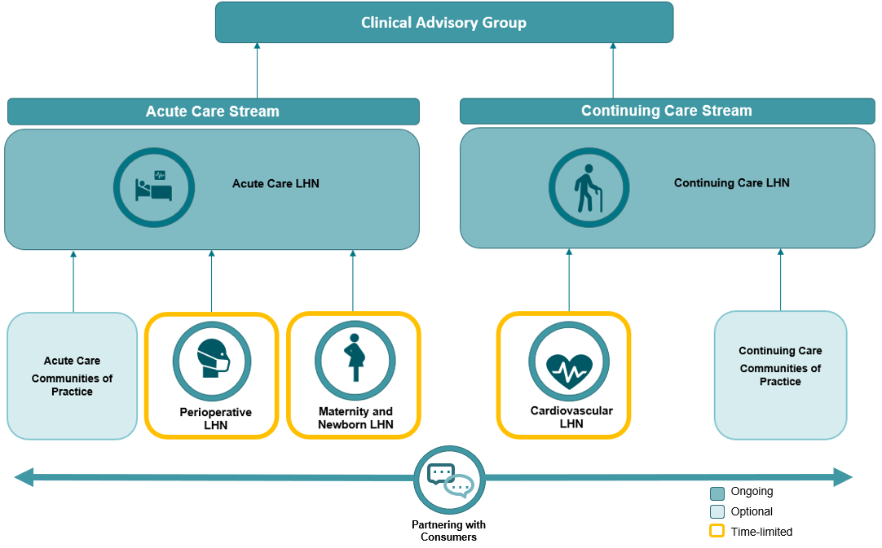

# What is a LHN Advisory Group?

An LHN Advisory Group will consist of clinicians, consumers, data experts, researchers and health system leaders to oversee the LHNs. The LHN Advisory Group will drive and facilitate purposeful consumer and sector engagement mainly through quality improvement programs. LHN Advisory Group will provide advice on the identified priority works of the LHN, with a focus on system level issues, and provide advice and direction to support SCV and the Department of Health (DH), as required.

The LHN Advisory Group will support the identification and escalation of system-level issues relevant to their specialty and respond to specific data or safety and quality issues identified.

LHN Advisory Group membership and function may vary based on programs of work and will act in the best interests of consumers, health care workers and the wider Victorian community to provide a mechanism for broader sector consultation.

# What is an LHN Data Group?

LHNs use data and evidence to improve clinical care and patient outcomes, with a system level view. Data will be accessible to all time limited LHNs through the establishment of their respective LHN Data Group, to ensure that the priority work of the LHN is informed by current data, variation and trends. The Group will review, interpret, and provide advice to the LHNs and SCV more broadly about data, evidence, and safety and quality measures to help inform decisions and measure outcomes. The duration of the time limited LHN Data Group will align with the time length of the associated LHN. The LHN Data Group will be governed by the LHN Advisory Group.

# What is the time commitment for this role?

All Maternity and Newborn Learning Health Network (MNLHN) meetings will be held via the Microsoft Teams platform for approximately 90 minutes. Please note that there may be occasions where face-to-face meetings, may be required.

MNLHN Advisory Group meets approximately 4 times per year and the MNLHN Data Group meets approximately 6 times per year. It is planned that at least one of these meeting with be a joint MNLHN Advisory and Data Group meeting for a longer duration. Members are expected to actively participate in meetings and attend a minimum of 75 percent of the meetings.

Members will be sent a meeting pack, including an agenda and meeting papers to be read prior to, and for discussion at the meetings. Document review and some out of session feedback and decisions may be required on an ad hoc basis.

Prior to scheduled MNLHN Advisory or Data Group meetings, a pre-meeting for consumers is arranged. These meetings are voluntary and are designed for consumers to network, raise queries and/or seek clarification regarding the upcoming meeting. The Consumer Lead and MNLHN manager also attend these meetings.

We will support the organisation and running of the meetings, including onboarding of all members.

# How many positions are available in the Advisory and Data Groups?

The MNLHN Advisory Group will include 2 Co-chairs (the Clinical Lead and Consumer Lead) and there will be 10 to 15 members comprising of clinicians, researchers, health system leaders and consumers. However, this number may vary depending on skills needed.

The MNLHN Data Group will have one Chair, who also is a member of the MNLHN Advisory Group, and there will be 10 to 15 other members comprising of clinicians, researchers, data experts, researchers, health system leaders, improvement specialists and consumers. However, this number may vary depending on skills needed.

# Will I be remunerated for my time?

Yes. Consumers and private practitioners such as general practitioners will be eligible for remuneration for attending MNLHN Advisory or Data Group meetings. The respective manager will review and approve renumeration requests in line with the Victorian Government [Appointment and remuneration guidelines](https://www.vic.gov.au/guidelines-appointment-remuneration). Time spent on pre-reading and pre-meetings will be bundled together with attendance at the MNLHN Advisory or Data Group meeting.

Consumers working with SCV for the first time need to follow a process to get set up as a vendor. This can be done with or without an Australian Business Number (ABN), however vendors without and ABN have a $1650 tax-free limit, after that tax will be withheld. The MNLHN will provide support to get new consumers set up as a vendor.

## On occasion, there may be some activities unable to be remunerated and are voluntary. This is made clear to consumers who may choose whether they would like to participate in the activity in a voluntary capacity.

# Can I apply if I live and work in a regional or rural area?

Yes, people living in regional and rural areas are strongly encouraged to apply. Meetings wherever possible will be held virtually (via Microsoft Teams platform). Should in-person meetings be required, reasonable travel expenses will be considered for reimbursement.

Please refer to the above section *“What is the time commitment for this role?”* for details surrounding virtual meetings and expectations.

# When do I start?

Successful applicants will be onboarded with the hope that they can attend the next scheduled meeting. We are expecting the first MNLHN Advisory Group meeting to be on Friday 23 February 2024. An in-person MNLHN Joint meeting is planned for November 2024.

# Who do I contact if I would like more information?

For further information, please see the [MNLHN website](https://www.safercare.vic.gov.au/best-practice-improvement/learning-health-networks/maternity-newborn-lhn). You can also email [maternityandnewbornlhn@safercare.vic.gov.au](mailto:maternityandnewbornlhn@safercare.vic.gov.au).