February 2024
Victorian perinatal services performance indicators
2021

To receive this publication in an accessible format phone (03) 9096 1384, using the National Relay Service 13 36 77 if required, or email Safer Care Victoria <info@safercare.vic.gov.au>. | Authorised and published by the Victorian Government, 1 Treasury Place, Melbourne.  © State of Victoria, Australia, Safer Care Victoria, February 2024  ISSN 2207-3558 (online)  Available from the Safer Care Victoria website <https://bettersafercare.vic.gov.au>. | 


Acknowledgement of Country
We proudly acknowledge Victoria’s Aboriginal communities and their rich culture and pay respect to their Elders past and present.
We acknowledge Aboriginal people as Australia’s First Peoples and as the Traditional Owners and custodians of the land and water on which we rely.
We recognise and value the ongoing contribution of Aboriginal people and communities to Victorian life and how this enriches us.
We embrace the spirit of reconciliation, working towards the equality of outcomes and ensuring an equal voice.

Acknowledgement of lived experience
We acknowledge the lived experience of mothers, babies and families who receive care in Victorian maternity and newborn services.
We are committed to improving and creating a system that is safe for all.

Foreword
As the Consumer and Clinical Leads for the Maternity and Newborn Learning Health Network (MNLHN), we are delighted to present the 2021 Victorian Perinatal Services Performance Indicators (PSPI) report for the consideration of consumers (women and families), clinicians and health services.
We have worked with our MNLHN Advisory Group and Data Group members to prepare the narrative to this report. Our consumers have provided insightful observations, suggested improvement strategies and ensured the language used in the report is consumer-friendly. This has been a welcome opportunity and approach, and we thank them for their input and support. We are also grateful for the expertise of our clinicians, academics and researchers. The data for this report was provided by Safer Care Victoria’s Technical Development Support and Consultative Councils Unit teams.
The information contained in the 2021 report is from a time when the whole healthcare system was experiencing pressure from the long-anticipated COVID-19 wave working its way through our community after 18 months of intermittent lockdowns. This was certainly a year of extraordinary circumstances, and we acknowledge the challenges women and their families faced and the hard work and dedication of our health professionals. The PSPI data enables us to work together on identifying the challenges facing Victoria’s maternity and newborn services. It is intended to be a catalyst for opportunities for improvement and for identifying innovations in practice that can be shared between services. This report provides a year-on-year view of key outcomes from our largest tertiary metropolitan services to smaller rural health services, including private and public hospitals. Although the number of indicators could be considered daunting, consumers should be encouraged to look at each health service across all indicators, rather than by a single indicator, reflecting on overall strengths. This report represents an attempt to measure care in a standardised way – for example, looking at the outcomes for women who have had a pregnancy without any complications, who should experience similar care at any service.
We are particularly pleased this year to introduce ‘balance measures’. These measures recognise that striving for excellence in one area may have unintended consequences on outcomes in another. It is important that these measures are considered together when hospitals review their performance.
The PSPI report has been a fixture in Victorian maternity and newborn services calendar for many years. In future, we are looking forward to the indicators contained in the report moving to a dashboard, which will facilitate review of health service performance close to real time.
This year, Safer Care Victoria’s MNLHN has started its improvement program with a cohort of 6 health services and we look forward to working with many more. We also hope to inspire women and families to connect with health service providers to discuss the findings of the report and explore opportunities to contribute to improvement work. After all, consumers are at the heart of everything we do.
Bronwyn Hogan
MNLHN Consumer Lead
Dr Penny Sheehan
MNLHN Clinical Lead

Contents
Foreword 3
Introduction to this report 9
Who is this report for? 10
What doesn’t this report do? 10
How to use this report 10
About the data 11
Comparing health service performance 15
Capability levels of maternity and newborn health services 15
Informing quality improvement activities 16
Summary of results 17
New indicator – fetal growth restriction 17
Where we are getting better 17
Where we can improve 17
1a: Induction of labour in standard primiparae 20
About this indicator 20
Observations on the data 21
Strategies for improvement 21
Definition and data source 24
1bi and 1bii: Caesarean sections in 25
About this indicator 25
Observations on the data 26
Strategies for improvement 26
Definition and data source 31
1ci and 1cii: Perineal tears in primiparae 32
About this indicator 32
Observations on the data 33
Strategies for improvement 33
Definition and data source 38
1di and 1dii: Episiotomies in primiparae 39
About this indicator 39
Observations on the data 39
Strategies for improvement 40
Definition and data source 45
2: Term babies without congenital anomalies who required additional care 46
About this indicator 46
Observations on the data 46
Strategies for improvement 47
Definition and data source 50
3a and 3b: Severe fetal growth restriction 52
About this indicator 52
Observations on the data 53
Strategies for improvement 53
Definition and data source 58
4a and 4b: Vaginal birth after primary caesarean section 59
About this indicator 59
Observations on the data 60
Strategies for improvement 60
Definition and data source 65
5: Five-year gestation standardised perinatal mortality ratio 66
About this indicator 66
Definition and data source 71
6a and 6b: Readmissions during the 72
About this indicator 72
Observations on the data 72
Definitions and data sources 78
7: Smoking cessation 81
About this indicator 81
Observations on the data 81
Strategies for improvement 82
Definition and data source 85
8a, 8b and 8c: Breastfeeding in hospital 86
About this indicator 86
Observations on the data 87
Strategies for improvement 87
Definitions and data source 94
9: First antenatal visit 95
About this indicator 95
Observations on the data 95
Strategies for improvement 96
Definition and data source 99
10: Low Apgar score 100
About this indicator 100
Observations on the data 100
Strategies for improvement 101
Definition and data source 104
11a and 11b: Women’s experiences of care 105
About these indicators 105
Observations on the data 105
Strategies for improvement 106
Data source 110
12a and 12b: Maternal vaccination 112
About this indicator 112
Observations on the data 113
Strategies for improvement 113
Definition and data source 118
13: Women who had a severe postpartum haemorrhage within the 24 hours following 119
About this indicator 119
Observations on the data 119
Strategies for improvement 119
Definition and data source 123
Appendix 1: Data sources and 124
Appendix 2: Total women and babies in 125
Appendix 3: Overview of results 127
Appendix 4: Robson classifications 132
Appendix 5: Terminology 133
Appendix 6: Australian birthweight tables 136
Acknowledgements 138
Further reading 139
Useful online resources 140

Introduction to this report
This report provides insights into where maternity and newborn services across Victoria are delivering high-quality care and where improvements can be made. The information allows health services to compare results and monitor variation within their own services over time and against their peers. This report also helps health services prioritise their performance improvements by reviewing their practices and identifying areas of improvements for the care provided to women and their babies – from antenatal, through intrapartum (labour and birth) to postnatal care.
These performance indicators (refer to Figure 1) are widely accepted as appropriate, useful and insightful measures of the quality of care. They continue to be refined over time.
Figure 1. Perinatal services performance indicators by key performance area
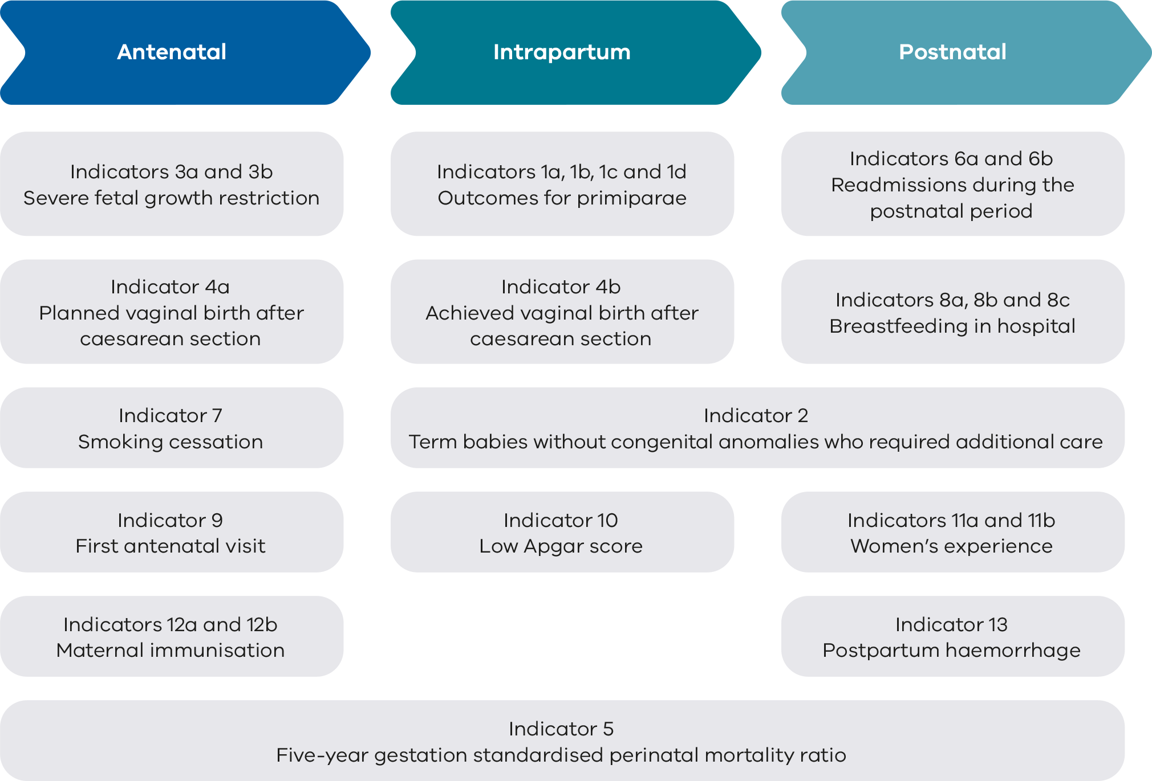

Who is this report for?
This report is for health professionals and health services to monitor their performance across a range of maternity and newborn indicators.
Pregnant women and their families might also use this report for information about maternity care in Victoria. We want to make sure women and their families can read and understand this report too.
[Break out box text:
Look for break out box text in each indicator for a description to help women and their families understand what it means. If you would like more information, please speak with your health professional (doctor or midwife) or refer to the healthdirect website <www.healthdirect.gov.au> or Better Health Channel website <www.betterhealth.vic.gov.au>. If you would like more information about the results of your maternity service, please speak to them about the information in this document.
End of break out box text.]
Decisions about maternity and newborn care should be based on published high quality evidence, clinical expertise and the woman’s needs, preferences, values and beliefs. Shared decision making <https://www.betterhealth.vic.gov.au/health/servicesandsupport/healthcare-decision-making-options-benefits-and-risks> is a process of communication and collaboration, meaning that women and their families have a right to make decisions about their care, guided by the advice of health professionals. Women and their families should discuss what their options are, and the benefits and risks of these, with their health professional.
A list of terminology can be found at the end of this report for your information.

What doesn’t this report do?
This report is not intended to set targets for individual health services to achieve, compare Victorian data with other states nor provide national benchmarking.
For more information you may wish to look at the following similar reports:
- Australian Institute of Health and Welfare Australia’s mothers and babies report
<https://www.aihw.gov.au/reports-data/population-groups/mothers-babies/reports>
- New South Wales Health Mothers and babies reports
<https://www.health.nsw.gov.au/hsnsw/Pages/mothers-and-babies-reports.aspx>.

How to use this report
The main section of this report details statewide data observations and key information about Victorian maternity health services. The report includes summary tables, bar graphs, funnel plots, trend tables and a clinical narrative (data observations, strategies for improvement).
Outcomes are reported by comparing health services with each other and across the state over 12 months. We call this comparison ‘benchmarking’. It can be used to identify higher performing services, performance of practices within a multi-site health service and compare practice over time. It is important to note that this report provides a snapshot in time and longitudinal trends should be cautiously interpreted. A health service may have improved its performance, but if peers of similar capability have also improved, they may appear to be underperforming in comparison.
Benchmarking can:
- allow you to assess performance relative to other health services,
- identify other services that are providing those practices that your health service may want to learn from,
- highlight opportunities for improvements, particularly where improvement activities have led to success in other organisations.
More detail is provided in the appendices.
- Appendix 1 details the data sources for this report.
- Appendix 2 lists Victoria’s maternity services and the number of women and babies cared for in 2021.
- Appendix 3 has an overview of results for each health service.
- Appendix 4 provides an infographic on Robson group categories.
- Appendix 5 lists terminology and abbreviations.
- Appendix 6 lists the Australian birthweight tables.

About the data
Data for this report comes from a number of sources including the Victorian Perinatal Data Collection (VPDC), the Victorian Healthcare Experience Survey (VHES) and the Victorian Admitted Episodes Dataset (VAED).
- VPDC data is from the 2021 calendar year and is used for indicators 1, 3, 4, 5, 7, 8, 9, 10, 12 and 13.
- VHES data is from July to December 2021 and is used for indicator 11.
- VAED data is reported for the 2021–22 financial year and is used for indicators 2 and 6.
This report uses the terms ‘woman’ and ‘women’ when referring to data collected in the VPDC, VHES and VAED. Information on gender is not recorded in these data collections. The terms ’women’ and ‘mothers’ refers to people who were pregnant and within the scope of these data collections. We respectfully acknowledge that this report includes people who do not identify as women or mothers and that individual parents and families may use different words from those used in this report. This may include women, transgender men, intersex people, non-binary and gender diverse people.

How to interpret the data
- The data relies on accurate reporting by health services to VPDC mandatory fields.
- This report uses the terms numerator and denominator. In this context, denominator is the entire pool of women or babies included, and numerator is the group that have had the intervention or event. For example, at a particular hospital, 100 women had babies (denominator) and 20 of those women had excess bleeding (numerator). The rate of excess bleeding is the numerator over the denominator, expressed as 20/100 or 20%.
- Information is only reported when a health service has a minimum of 10 occasions for an event (denominator). For example, a hospital that had fewer than 10 women (standard primiparae) give birth in 2021 (denominator) will not be included in the results for Indicator 1a.
- Due to smaller numbers, data from smaller health services are subject to wide variation and should be interpreted with caution.
- Indicators 11a and 11b using VHES survey data is limited by the small number of respondents to the survey. As such, the data should be cautiously interpreted. The VHES questions are different this year due to a change in the survey questions and are not comparable to the previous year.

Statewide rates
The statewide rates provide an average of all hospitals combined (public and private). The public rate is the average of all public hospitals combined and the private rate is the average of all private hospitals combined. They do not represent a desired target. In most cases, even where a hospital appears to be doing well in comparison with others, opportunities for improvement remain.

Interquartile ranges
Interquartile ranges show the variation between services and can be used to find outliers in the data. The graphs throughout this report use red and green vertical lines and shading to show the least (red) and most (green) favourable 25% of services. The most favourable rate may be high or low depending on the indicator. For example, we want rates of severe fetal growth restriction to be low and rates of smoking cessation to be high.

Funnel plots
Funnel plots provide a visualisation of each hospital’s rate compared with other hospitals and to an average rate (usually the state rate or the median rate across hospitals) and take into consideration the size of the hospital. Refer to Figure 2 for an example of a funnel plot. The example used in this graph is Indicator 6a (Rate of maternal readmissions).
Funnel plots consider the size of the maternity service, which is an advantage over the interquartile ranges in identifying most favourable and least favourable outcomes.
Figure 2. Example funnel plot
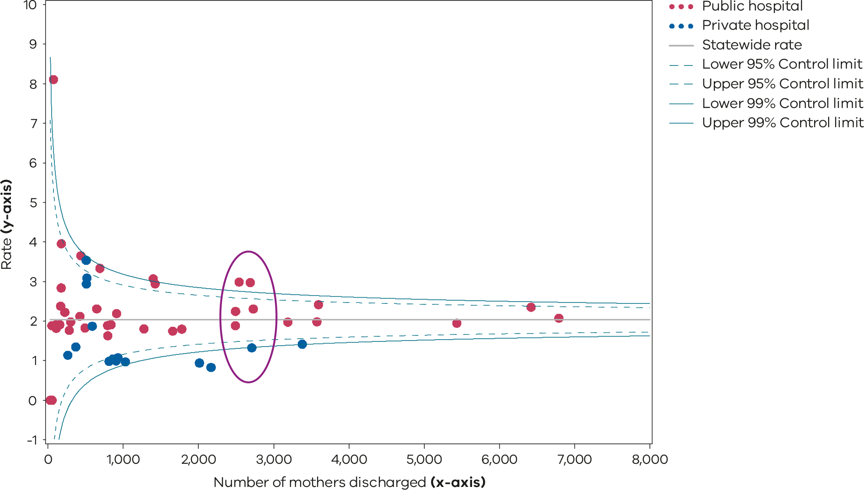

The dots
Each dot represents a hospital’s rate for the given indicator. The dots are relative to denominator (e.g. number of women discharged) and its rate. It is best to compare hospitals of a similar size and capability level. In this example, hospitals within the purple oval have a similar number of women discharged (x-axis) and are in general, more readily comparable.

The x and y-axis
The x-axis (the bottom horizontal line) shows the denominator, which in this example is the number of women discharged from the health service.
The y-axis (vertical line on the left) shows the rate, which in this example is the rate of maternal readmissions.

The horizontal line
The solid grey horizontal line in the middle of the funnel represents the statewide median (rate) or average rate for the indicator. For most indicators, this is the median of the hospital rate, except for indicators 5, 6a, 6b, 11a, 11b in which the state rate is used as the average rate.
Hospitals (dots) that are above this line have a rate that is higher than the median or average rate. Hospitals below this line have a rate that is lower than the average rate.

The curved lines
The dashed and solid blue lines represent 95% and 99% control limits, respectively. Control limits can be used to test how different each hospital’s rate is from the average rate, taking the size of the hospital into consideration with the observed denominator.
If a hospital falls outside of the 95% control limits of the funnel plot, its rate is considered statistically significantly different from the average rate. A statistically significant result means the value is unlikely to be due to chance variation.
Hospitals that fall above the 95% upper control limit have a rate that is statistically significantly higher compared with the average rate. Conversely, those that fall below the 95% lower control limit have a rate that is statistically significantly lower compared with the average rate.
A favourable outcome for most indicators is to be lower than the average rate except for indicators 1dii, 4a, 4b, 7, 8a, 8c, 9, 11a, 11b, 12a and 12b. For these indicators, a rate that is higher than the average rate is most desirable.
Please note that only the gestation standardised perinatal mortality ratio (GSPMR) funnel plot includes risk-adjusted rates. All other funnel plots present rates that have not been adjusted for the risk profile of the population.
Only hospitals with at least 10 mothers or babies in the denominator in 2021 for the individual indicator have been included in the funnel plots, with the exclusion of the GSPMR funnel plot, which applied a different threshold. For the GSPMR funnel plot (Indicator 5), only hospitals with at least 5 deaths during the pooled 5-year period (2017–2021) have been included.

Comparing health service performance
Each health service will receive its own profile detailing its individual results. These are confidential, although some services choose to share their results with others including consumers. Sharing the service profiles with others can help identify trends and opportunities for learning, particularly for services within similar rural, remote and metropolitan areas and those of similar capability.

Capability levels of maternity and newborn health services
We have clustered health services by maternity capability level so you can easily compare your service with others that care for mothers and babies with a similar level of complexity. Indicator 6b (Rate of newborn readmissions during the postnatal period) is the exception, where health services are clustered by neonatal capability levels.
Victorian maternity and newborn services operate in a networked system across 6 levels of care (Figure 3):
- Levels 1–3: Local care for healthy women and babies at low risk
- Level 4: Local care for women and babies with some risk requiring additional care
- Level 5–6: Local care for all women and babies. Regional/statewide care for women and babies at high risk.
Victoria’s network of services means that, for most women and families, maternity and newborn care is provided as close to home as is safe and practicable and includes prompt transfer to local and/or specialised services as appropriate.
Figure 3. Levels of maternity and neonatal care
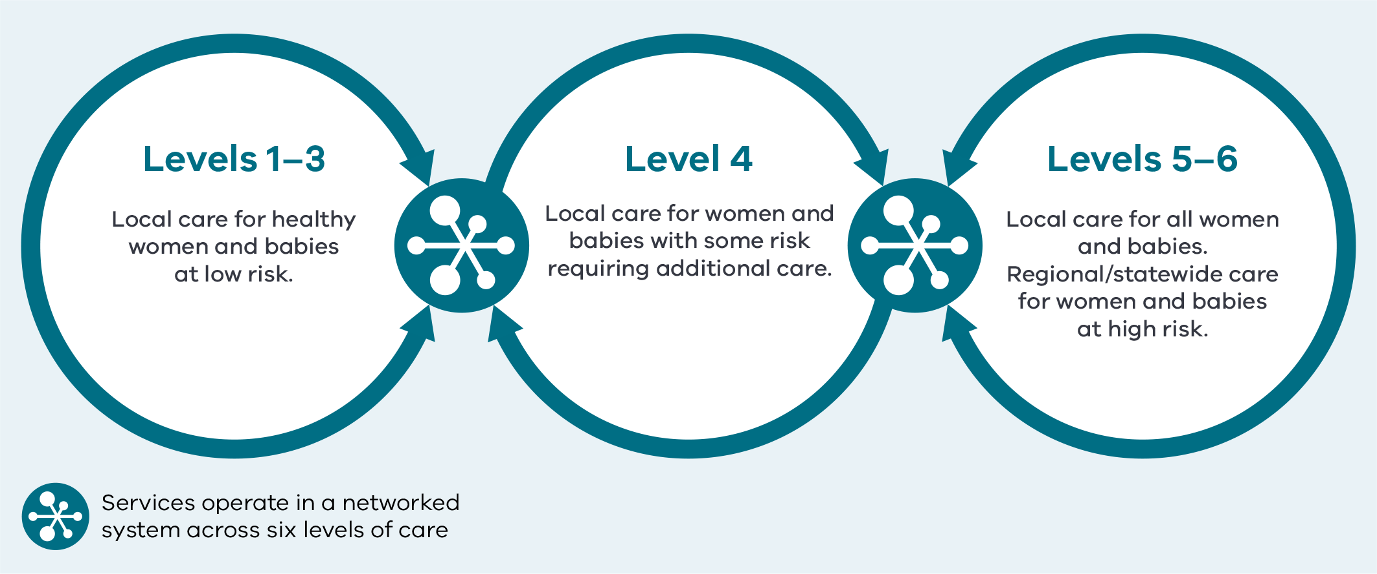
Source: Department of Health 2022, Capability frameworks for Victorian maternity and newborn services, State Government of Victoria, Melbourne.

Informing quality improvement activities
Analysis provided in this report can guide, inform and help you prioritise local audits and improvement activities.
Individual health services are encouraged to:
- further identify areas to implement improvement programs and measure the impact by sharing and discussing this report with:
  - consumer advisory committees
  - clinicians, managers, executive and health service boards
  - quality and safety and mortality and morbidity committees.
- engage women, families and consumers with opportunities for improvement. Involving consumers will strengthen the improvement practice and approach across health services.

Summary of results

New indicator – fetal growth restriction
Indicator 3b (Rate of babies with a birthweight above the 25th centile actively delivered for fetal growth restriction before 39 weeks’ gestation) is being reported for the first time. It shows the proportion of singleton babies actively delivered for suspected fetal growth restriction before 39 weeks whose birthweight was above the 25th centile. This new indicator is a balance measure to bring greater awareness to any possible unintended harm associated with indicator 3a (Rate of severe fetal growth restriction in a singleton pregnancy undelivered by 40 weeks). This balance measure is to monitor unwarranted early delivery of healthy babies.

Where we are getting better
- Rates of induction of labour or prelabour caesarean section for severe fetal growth restriction in babies before 40 weeks’ gestation (Indicator 3a) have increased (we will continue to monitor this against the new indicator 3b).
- Rates of maternal readmission (Indicator 6a) have reduced.
- Rates of postpartum haemorrhage (Indicator 13) have reduced.

Where we can improve
The following outcomes suggest the need for health services to comprehensively review their practices and then implement and monitor programs to improve performance.
- Maternal pertussis and influenza vaccination (Indicator 12) rates have reduced. This has been impacted by events of 2021.
- Rates of neonatal readmission (Indicator 6b) have increased.
Table 1 summarises results in statewide public and private maternity hospital rates.
Table 1. Summary of statewide public and private maternity hospital rates
Indicator | Statewide 2020 | Statewide 2021 | Statewide public | Statewide private | Least favourable quartile | Most favourable quartile
1a Rate of induction of labour in standard primiparae | 13.9% | 15.0% | 11.0% | 21.7% | 23.0% | 6.8%
1bi Rate of caesarean section in Robson group 1 | 18.3% | 18.3% | 17.2% | 23.5% | 26.8% | 15.3%
1bii Rate of caesarean section in modified Robson group 2 | 32.3% | 32.4% | 32.4% | 32.6% | 41.6% | 29.7%
1ci Rate of third and fourth-degree perineal tears during unassisted vaginal births to primiparae | 3.7% | 4.0% | 4.6% | 1.1% | 5.2% | 0.9%
1cii Rate of third and fourth-degree perineal tears during assisted vaginal births to primiparae | 5.4% | 5.0% | 5.8% | 2.7% | 6.6% | 2.8%
1di Rate of primiparae who received an episiotomy during unassisted vaginal births | 27.5% | 26.6% | 26.2% | 30.3% | 31.8% | 20.5%
1dii Rate of primiparae who received an episiotomy during assisted vaginal births | 86.4% | 86.5% | 91.2% | 73.1% | 78.8% | 92.0%
2 Rate of term babies without congenital anomalies who required additional care*† | 11.7%* | NA | 11.0% | NA | 12.4% | 8.4%
3a Rate of severe fetal growth restriction in a singleton pregnancy undelivered by 40 weeks | 20.8% | 20.0% | 20.6% | 17.5% | 24.0%^ | 14.0%^
3b Rate of babies with a birthweight above the 25th centile actively delivered for fetal growth restriction before 39 weeks’ gestation | NA | 18.2% | 16.8% | 22.1% | 24.2% | 12.0%
4a Rate of women who planned a vaginal birth after a primary caesarean section | 22.9% | 21.5% | 26.0% | 11.3% | 13.9% | 27.5%
4b Rate of women who achieved a planned vaginal birth after a primary caesarean section | 52.2% | 54.3% | 54.1% | 52.6% | 49.3% | 62.3%
5 Five-year gestation standardised perinatal mortality ratio (GSPMR) for babies born at ≥ 32 weeks | 1.0 | 1.0 | NA | NA | NA | NA
6a Rate of maternal readmissions during the postnatal period† | 2.3% | 2.0% | 2.2% | 1.3% | 2.4% | 1.4%
6b Rate of newborn readmissions during the postnatal period*† | 4.6%* | NA | 4.9% | NA | 5.0% | 2.7%
7 Rate of smoking cessation during pregnancy | 33.5% | 31.4% | 30.5% | 57.3% | 19.7%^ | 38.9%^
8a Rate of breastfeeding initiation for babies born at ≥ 37 weeks’ gestation | 95.6% | 95.5% | 95.4% | 95.8% | 93.8% | 96.6%
8b Rate of use of infant formula in hospital by breastfed babies born at ≥ 37 weeks’ gestation | 30.5% | 30.0% | 26.7% | 42.0% | 35.6% | 17.9%
8c Rate of final feed being taken directly from the breast by breastfed babies born at ≥ 37 weeks’ gestation | 73.1% | 74.2% | 76.6% | 65.4% | 71.3% | 85.4%
9 Rate of women attending their first antenatal visit prior to 12 weeks’ gestation | 73.6% | 76.5% | 73.4% | 87.6% | 73.3% | 90.4%
10 Rate of term babies without congenital anomalies with an Apgar score < 7 at 5 minutes | 1.2% | 1.2% | 1.3% | 0.9% | 1.5% | 0.8%
11a Rate of women who felt involved as much as they wanted to be in making decisions about their care* | NA | NA | 71.2% | NA | NA | NA
11b Rate of women who felt that staff gave them active support and encouragement to feed their baby in the way they wanted to* | NA | NA | 87.2% | NA | NA | NA
12a Rate of women vaccinated for pertussis during pregnancy | 84.3% | 81.4% | 87.3% | 62.4% | 89.7% | 95.2%
12b Rate of women vaccinated for influenza during pregnancy | 81.8% | 73.7% | 73.7% | 74.7% | 69.5% | 83.1%
13 Rate of women with severe postpartum haemorrhage | 2.6% | 2.3% | 2.7% | 1.1% | 2.9% | 1.3%
Notes:
Quartiles are calculated for statewide public and private health services combined, unless stated otherwise.
* Result includes public hospitals only.
† Results shown are for 2021–22 FY as they are sourced from the VAED.
^ Results include hospitals that meet thresholds only.
NA – not applicable

1a: Induction of labour in standard primiparae
Induction of labour is the stimulation of the process of cervical effacement/dilatation and uterine contractions during pregnancy before labour begins on its own with the aim of achieving a vaginal birth. A clinician may recommend induction of labour for various reasons when there is concern for the health of the mother or fetus.

About this indicator
For indicator 1a the term standard primipara is used to describe a low-risk woman who is giving birth to her first child (primipara) and expected to need little intervention. By excluding women with complicated pregnancies, this indicator considers hospital-to-hospital variation only instead of individual patient populations (complexity).
This indicator shows the rate of induction of labour for the standard primipara.
[Break out box text:

What pregnant women and families need to know
Labour will usually start on its own between 37 and 42 weeks for most women. If you and your baby are healthy, then waiting for labour to begin on its own is recommended. If you or your baby are unwell, your doctor or midwife might recommend bringing on or inducing labour. Inducing labour may be associated with more interventions that need help from doctors and midwives, such as an epidural for pain relief or instrumental birth (also known as an assisted birth [vacuum or forceps]).
However, recent studies suggest that for some women there may be some benefit for mothers and babies in considering an induction of labour from 39 weeks., The risks and benefits of induction should be thoroughly discussed with your doctor or midwife.
When possible, for pregnancies without complications, being born as close as possible to your due date and waiting for labour to start on its own is usually best for you and the development of your baby.
The graph on the following page (Figure 4) shows there are differences between Victorian hospitals in how many low-risk, first time mothers have labour induced.
End of break out box text.]

Observations on the data
The statewide rate for 2021 was 15.0%, which is slightly higher than the previous year’s rate which was 13.9%. Of note, the rate was 17.3% in 2019. The impact of the COVID-19 pandemic on rates of induction of labour is yet to be determined.
Like previous years, the rate in 2021 of standard primiparae having an induced labour in private hospitals was higher compared with public hospitals (21.7% and 11.0%, respectively).
There remains considerable variation in hospital rates for this indicator, from zero to 37.9% (Figure 4, Figure 5, Figure 6 and Table 2). While this indicator attempts to account for different patient populations, each health service should consider its rate in relation to others of a similar capability level and reflect on their own practice for improvement.

Strategies for improvement
- Individual health services are encouraged to understand this data by undertaking a deep dive analysis with women, families and health service staff to determine the most appropriate improvement and prevention strategies.
- Individual health services should provide women with verbal and written evidence-based information about timing of birth <https://stillbirthcre.org.au/parents/safer-baby/timing-of-birth>.
- Individual health services are encouraged to review their current booking processes for induction of labour, ensuring it is consistent with the principles of shared decision making.

Figure 4. Indicator 1a: Rate of induction of labour in standard primiparae, 2021
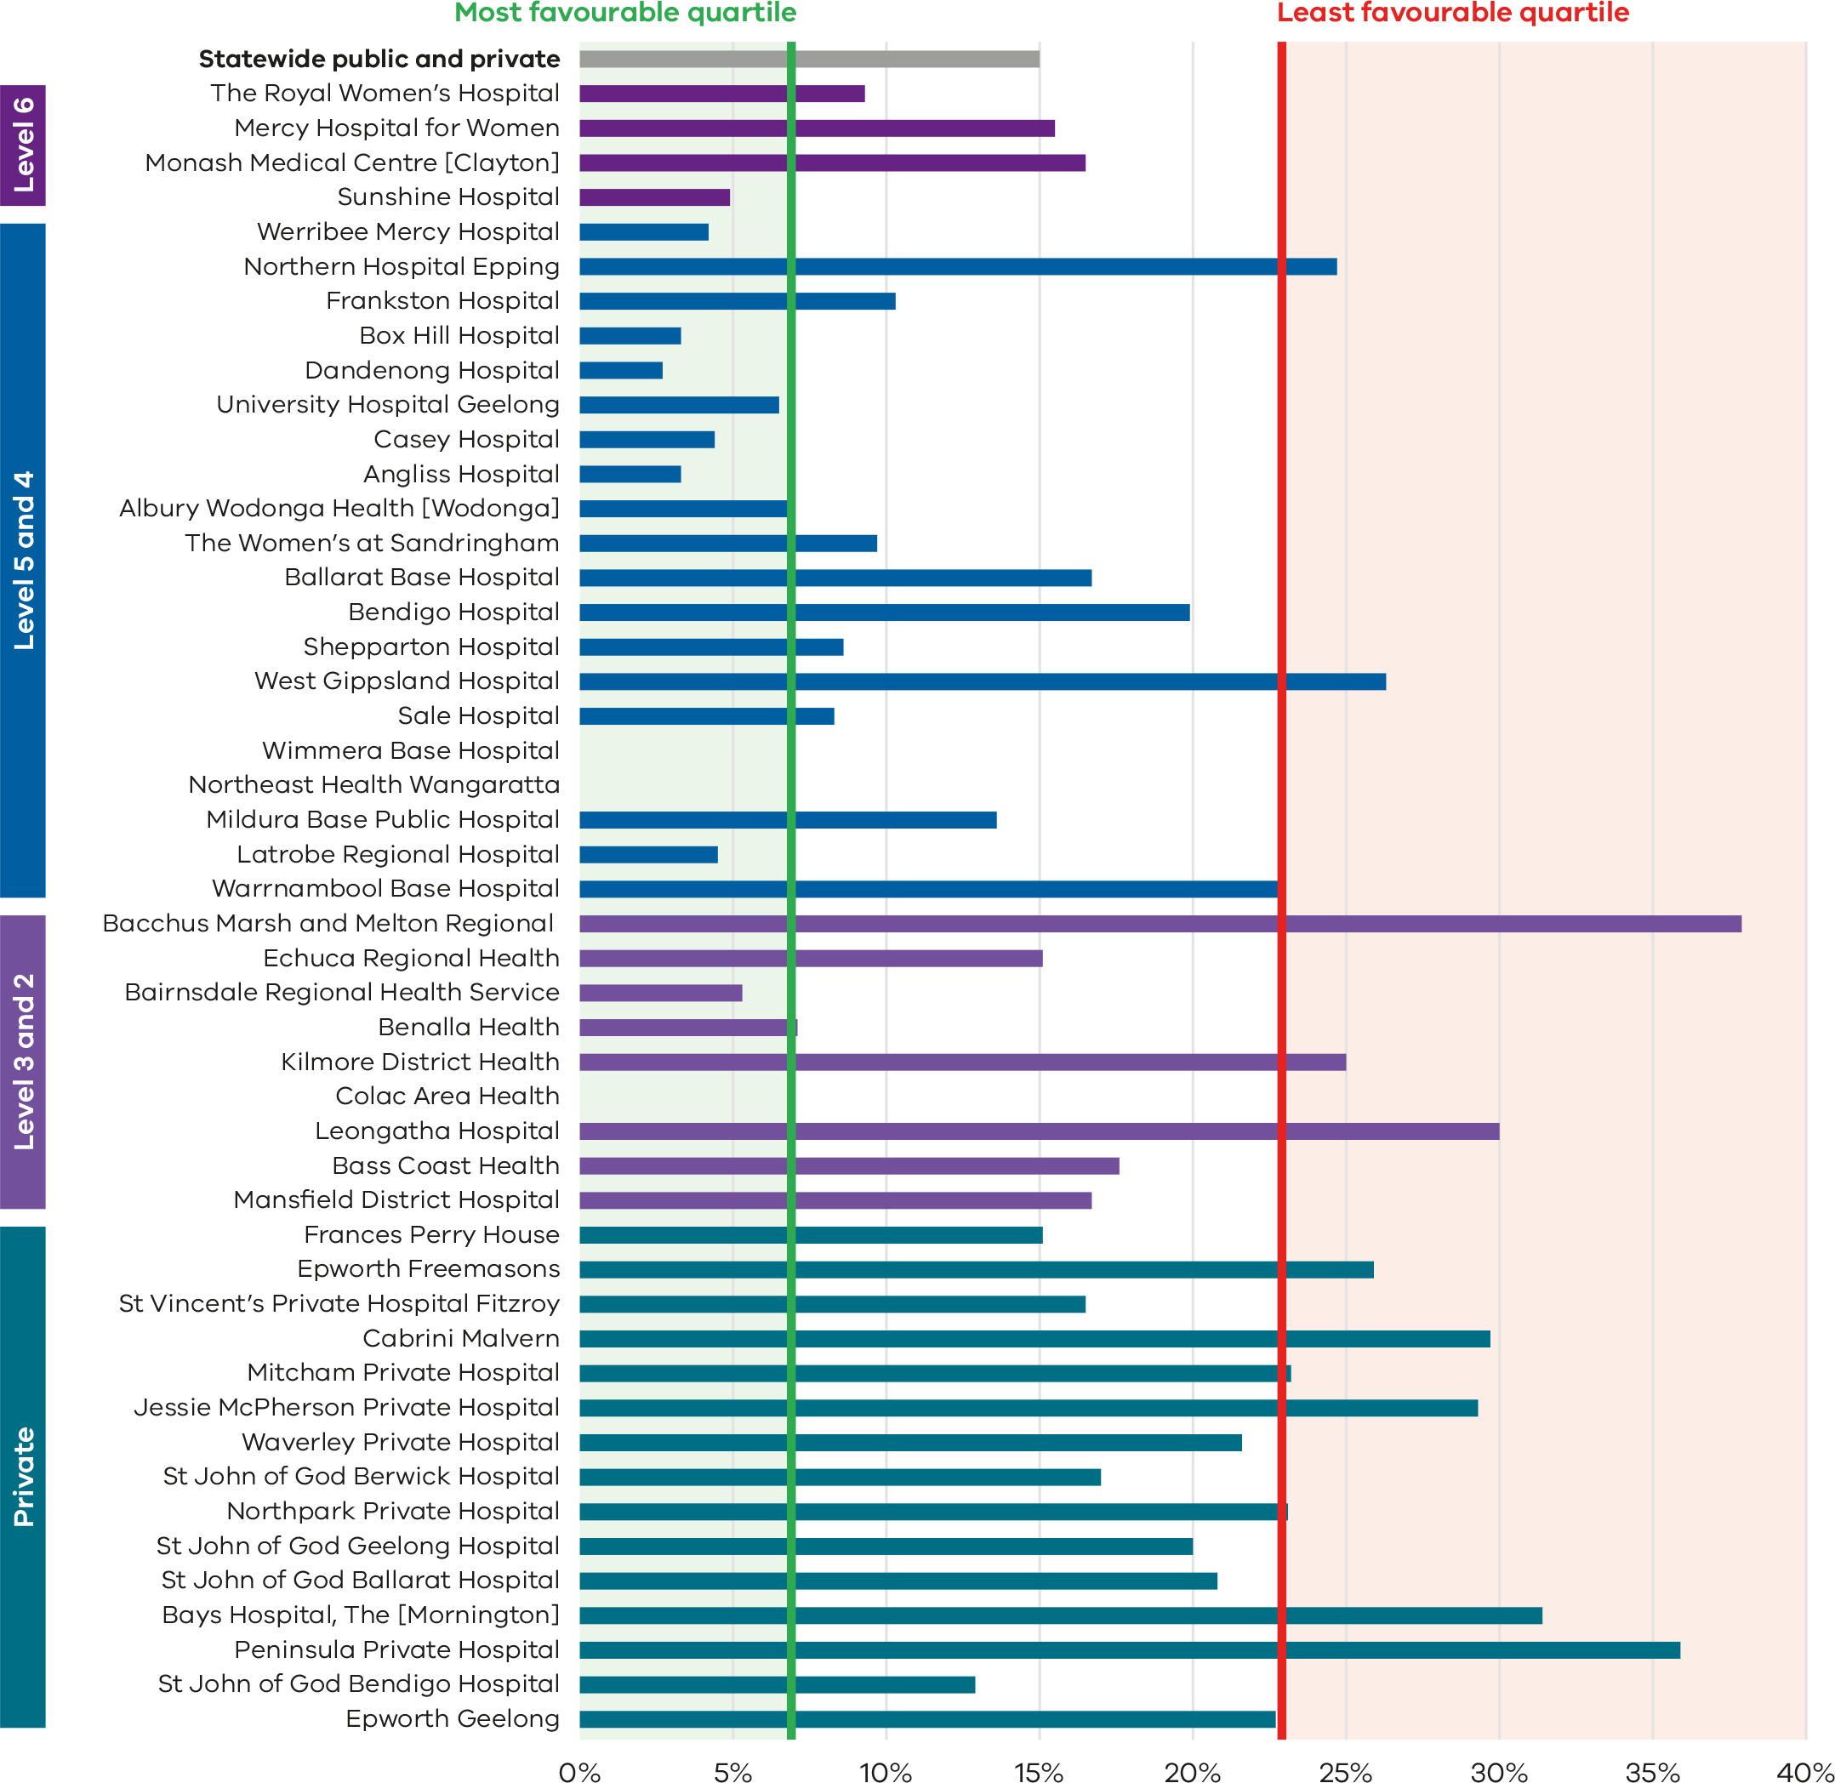

Figure 5. Funnel plot of rate of induction of labour in standard primiparae, 2021
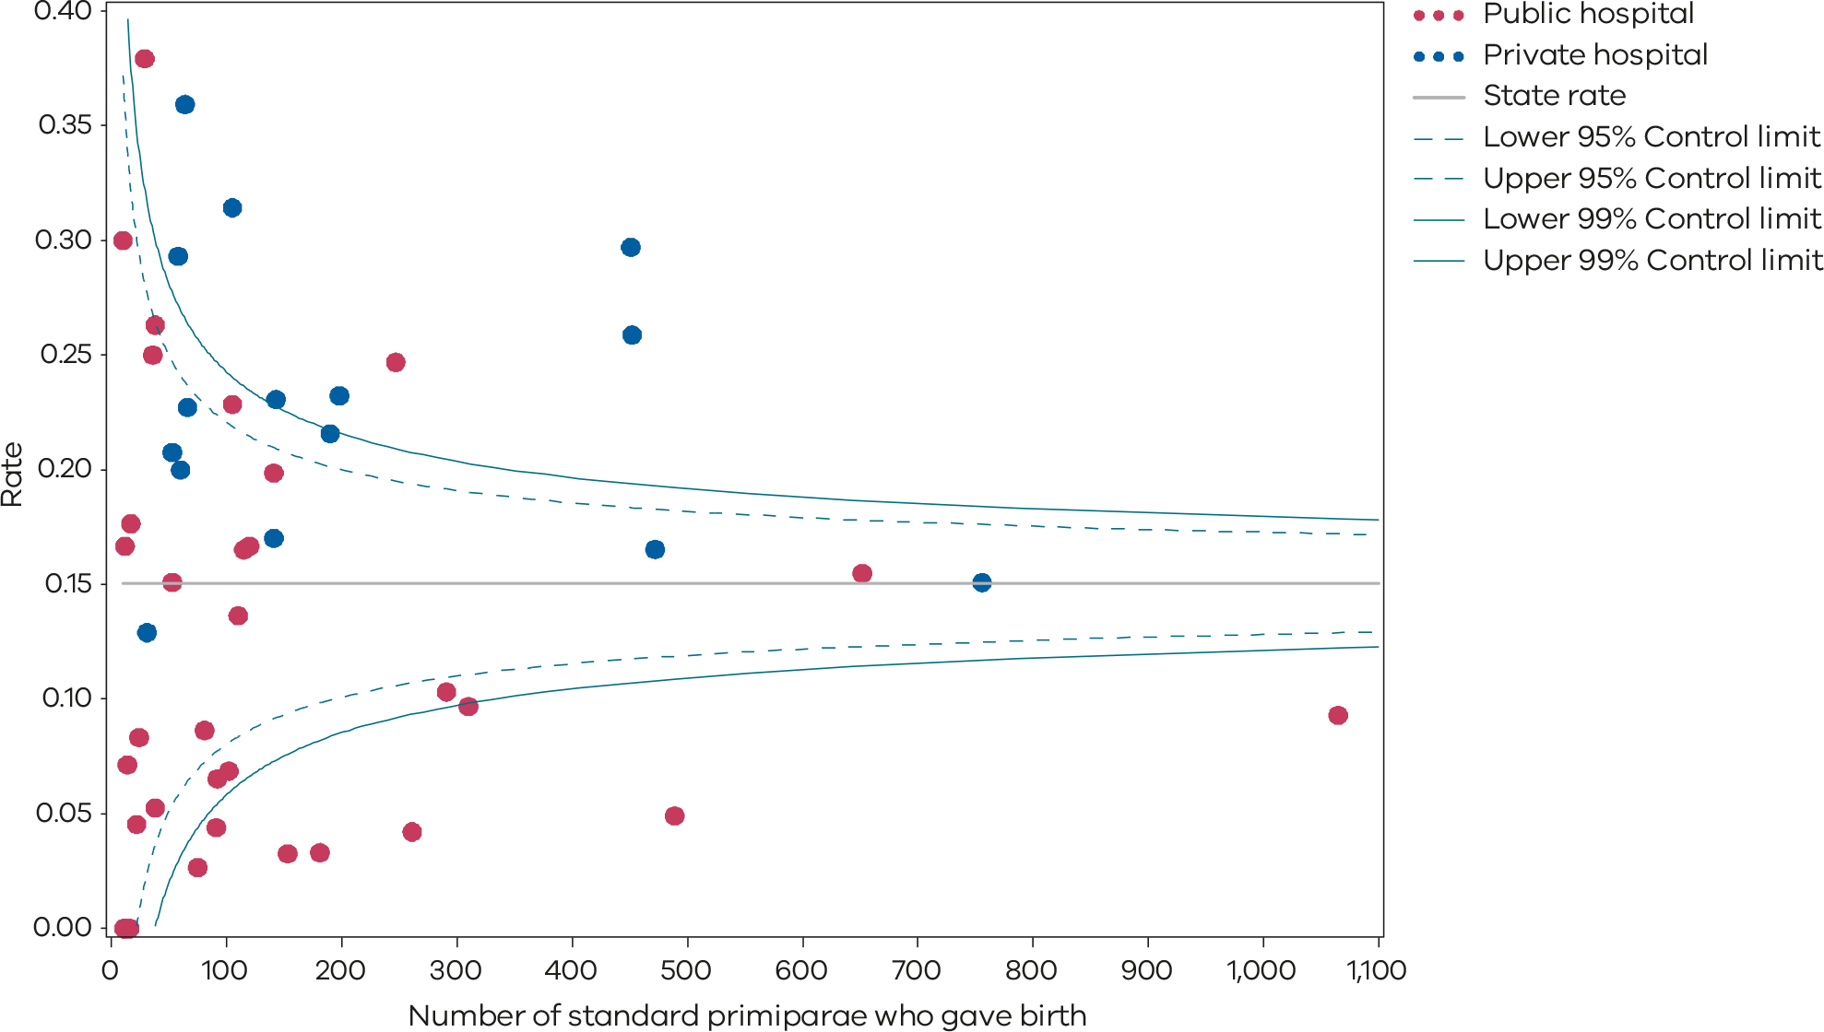
Please refer to the guide on how to interpret funnel plots.
Table 2. Rate of induction of labour in standard primiparae, 2017–2021
 | 2017 | 2018 | 2019 | 2020 | 2021
Public | 7.4% | 9.4% | 11.8% | 8.1% | 11.0%
Private | 18.1% | 21.1% | 26.5% | 23.7% | 21.7%
Statewide | 11.3% | 13.6% | 17.3% | 13.9% | 15.0%
Figure 6. Time trend of Indicator 1a, 2017–2021
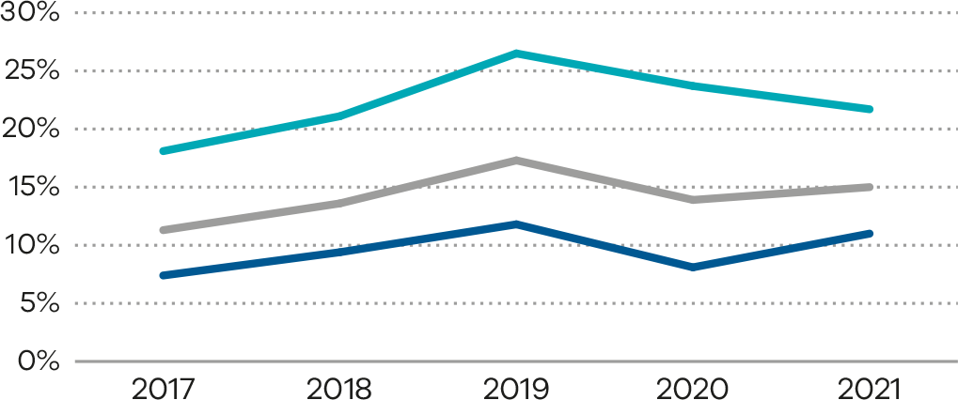

Definition and data source

Definition
The standard primipara in this indicator is defined as a woman, 20 to 39 years of age, with a BMI less than 40 kg/m² and free of obstetric and specified medical complications (pre-existing hypertension, diabetes, cardiac disease or serious psychiatric conditions), giving birth for the first time with a singleton pregnancy between 37 and 40 weeks’ completed gestation (259–286 days), with a non-small for gestational age (greater than 10th centile) infant and a vertex presentation.

Data source: Victorian Perinatal Data Collection (VPDC)
Data for this indicator is sourced from the VPDC for the calendar year from 1 January 2021 to 31 December 2021.
This indicator is derived using the following VPDC variables and the International Classification of Diseases and Related Health Problems, 10th edition, Australian Modification (ICD-10-AM) codes: ‘Parity’, ‘Maternal age’, ‘Height – self reported – mother’, ‘Weight – self reported – mother’, ‘Plurality’, ‘Estimated gestational age’, ‘Birth presentation’, ‘Obstetric complications – ICD-10-AM code’, ‘Maternal medical conditions – ICD-10-AM code’, ‘Indication for induction (main reason) – ICD-10-AM code’, ‘Birthweight’, ‘Sex’ and ‘Labour type’.
The inclusion criteria for the standard primipara were reviewed for the 2020–21 PSPI report. The upper age limit was increased to 39 years. The medical conditions that exclude women are now limited to pre‑existing hypertension, diabetes (type 1, type 2 and gestational diabetes), cardiac disease, BMI > 40 or serious psychiatric conditions (schizophrenia, other psychotic disorders and bipolar disorder). Women are excluded if they have any obstetric conditions recorded in the ‘obstetric complications’ or ‘indication for induction (main reason)’ variable (any condition listed in the ‘O’ chapter of ICD-10-AM that occurs before the onset of labour, but not those related to gestation or spurious [false] labour).
Numerator/denominator
Indicator | Numerator | Denominator
Indicator 1a: Rate of induction of labour in standard primiparae | The number of standard primiparae who give birth undergoing induction of labour | The number of standard primiparae

1bi and 1bii: Caesarean sections in primiparae
Caesarean section is a surgical procedure in which a baby is born through an incision in the mother’s abdominal wall and uterus. Caesarean sections are recommended when vaginal birth may pose a risk to the mother or baby and are also sometimes carried out on request from the mother. Although a caesarean section is a relatively safe operation, there is the potential for complications for both mother and baby and an increased risk of complications in future births as well as an increased cost to the healthcare system.

About this indicator
This indicator shows the rate of caesarean section for women having their first birth (primiparae), following spontaneous or induced onset of labour. It includes only those that are singleton, presenting head-first (cephalic), and at least 37 weeks’ gestation. It excludes women who have a caesarean section before labour begins. The Robson classification system (also known as the 10-group classification) categorises all women having a caesarean section into one of 10 groups that are mutually exclusive based on basic obstetric characteristics (refer to Appendix 4: Robson classifications).
- Indicator 1bi (Robson group 1) considers the proportion of caesarean sections in women whose labour began spontaneously.
- Indicator 1bii (modified Robson Group 2) considers the proportion of caesarean sections in women whose labour was induced (but excludes those undergoing caesarean section without labour).
[Break out box text:

What pregnant women and families need to know
A caesarean section (‘c-section’ or ‘caesarean’) is a surgical procedure in which a baby is born through a cut (incision) made in the mother’s abdominal wall and the wall of the womb (uterus) your baby will need to be born by caesarean section if there are problems that prevent the baby being born by a vaginal birth.
Most women who have started labour should be able to have a vaginal birth. If you have no serious problems with your pregnancy or labour, a vaginal birth is usually the safest way for your baby to be born.
A caesarean section may be planned before the start of labour (elective) if there are health problems or pregnancy complications that mean that a caesarean birth would be safer than a vaginal birth. A caesarean section may be needed in an emergency (unplanned) if there are urgent concerns for the mother or the baby’s wellbeing before or during labour.
The graphs on the following pages show the rates of caesarean section for first-time mothers having a baby at 37 or more weeks of pregnancy.
In this indicator:
- 1bi looks at the number of first-time mothers who have a caesarean section after going into labour naturally (‘spontaneously’) or on their own.
- 1bii looks at the number of first-time mothers who have a caesarean section after having their labour induced (or brought on).
There is a lot of variation between hospitals. Ideally this should be similar between hospitals.
More information can be found on the Better Health Channel website <https://www.betterhealth.vic.gov.au/health/healthyliving/caesarean-section>. Discuss the information contained in this document with your doctor or midwife if you have any questions.
End of break out box text.]

Observations on the data
The statewide rate of primiparae who gave birth by caesarean section (Indicator 1bi: Robson group 1) was 18.3%. This rate remained the same as 2020 (the rate was 16.4% in 2016). The rate was lower across public hospitals (17.2%) than private hospitals (23.5%).
The statewide rate of primiparae who gave birth by caesarean section following induction of labour (Indicator 1bii: Modified Robson group 2) was 32.4% and has remained steady compared with 2020 (32.3%). The rate across public hospitals was comparable to private hospitals (32.4% and 32.6%, respectively).
There was considerable variation between hospitals across the state and within maternity capability levels as shown in Figures 7 to 9 and Table 3 (Indicator 1bi) and Figures 10 to 12 and Table 4 (Indicator 1bii). This variation may reflect differences in practice but may also reflect the influence of low birthing numbers in some rural or regional services.

Strategies for improvement
- Health services should develop processes to ensure women are part of the shared decision-making process about mode of birth and are informed of the benefits and risks for each of the options with both written and verbal information provided.
- Health services should develop strategies to monitor and review their caesarean rates. Each service should develop triggers for reviewing individual cases as part of governance of ongoing quality improvement.
- Health services should review their management of labour and birth particularly in relation to management of synthetic oxytocin, uterine contractility and cervical ripening.

Figure 7. Indicator 1bi: Rate of caesarean section in Robson group 1, 2021
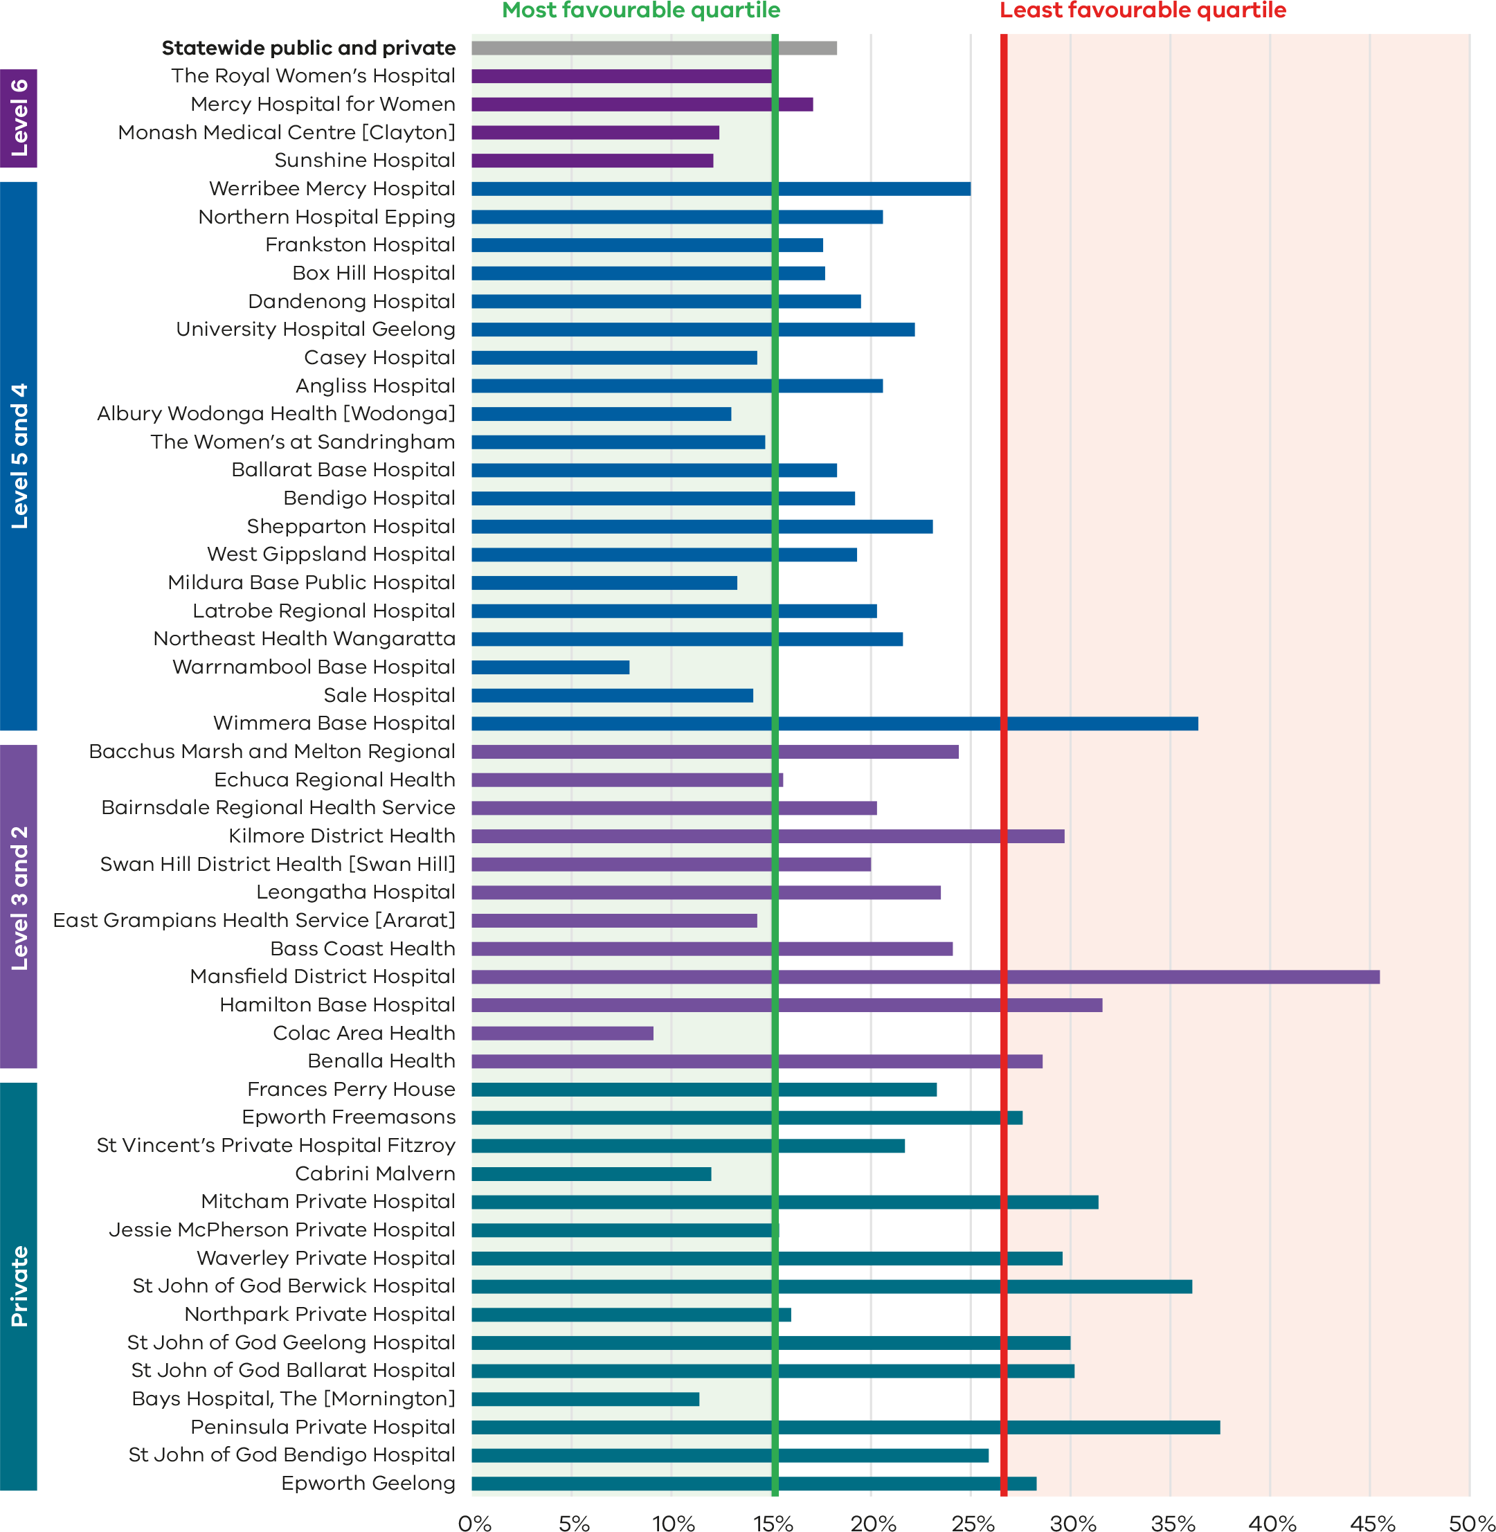

Figure 8. Funnel plot of the rate of caesarean section in Robson group 1, 2021
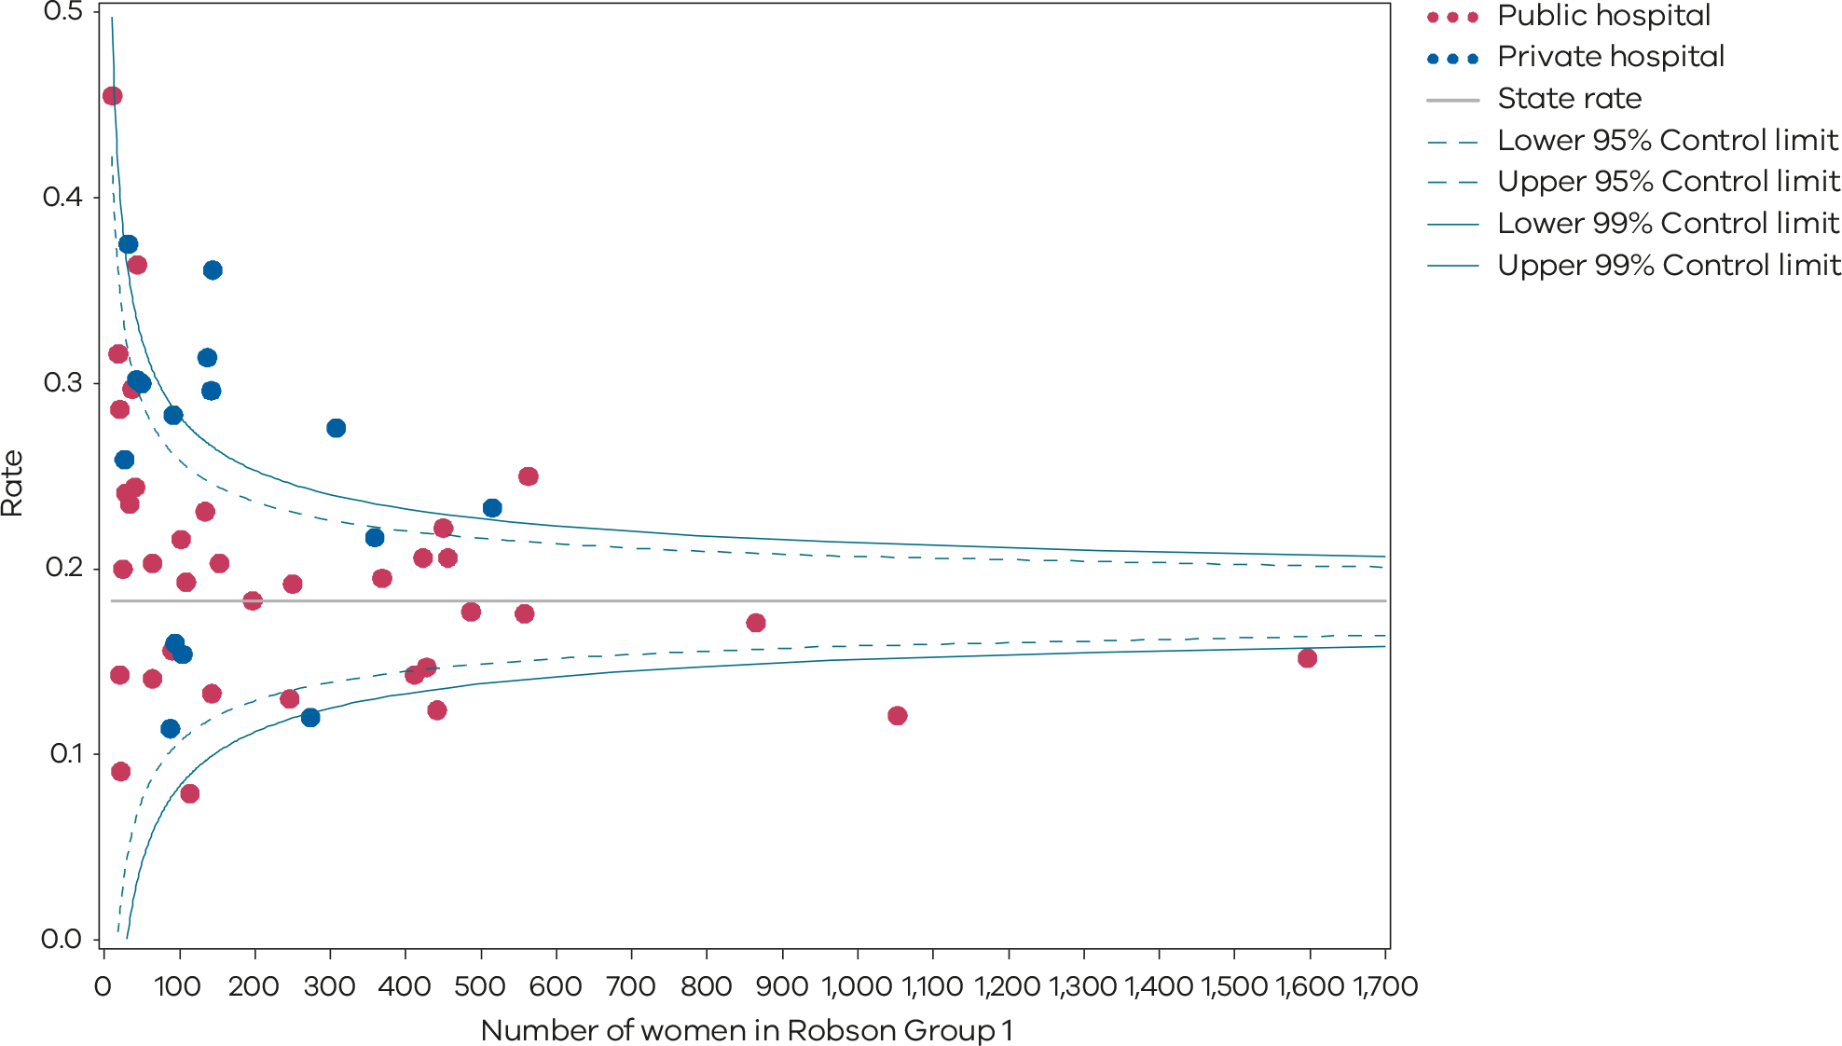
Please refer to the guide on how to interpret funnel plots.
Table 3. Rate of caesarean section in Robson group 1, 2017–2021
Indicator 1bi: Robson group 1
 | 2017 | 2018 | 2019 | 2020 | 2021
Public | 15.0% | 15.3% | 16.9% | 17.0% | 17.2%
Private | 22.5% | 21.8% | 22.0% | 24.2% | 23.5%
Statewide | 16.7% | 16.7% | 18.0% | 18.3% | 18.3%
Figure 9. Time trend of Indicator 1bi, 2017–2021
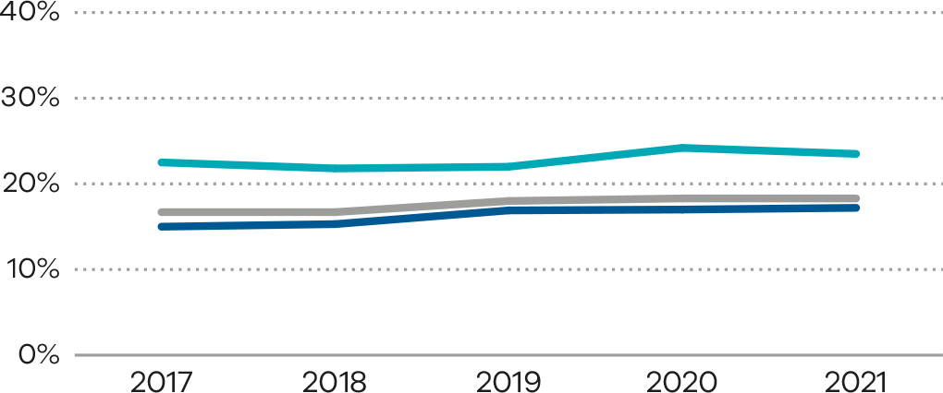
Figure 10. Indicator 1bii: Rate of caesarean section in modified Robson group 2, 2021
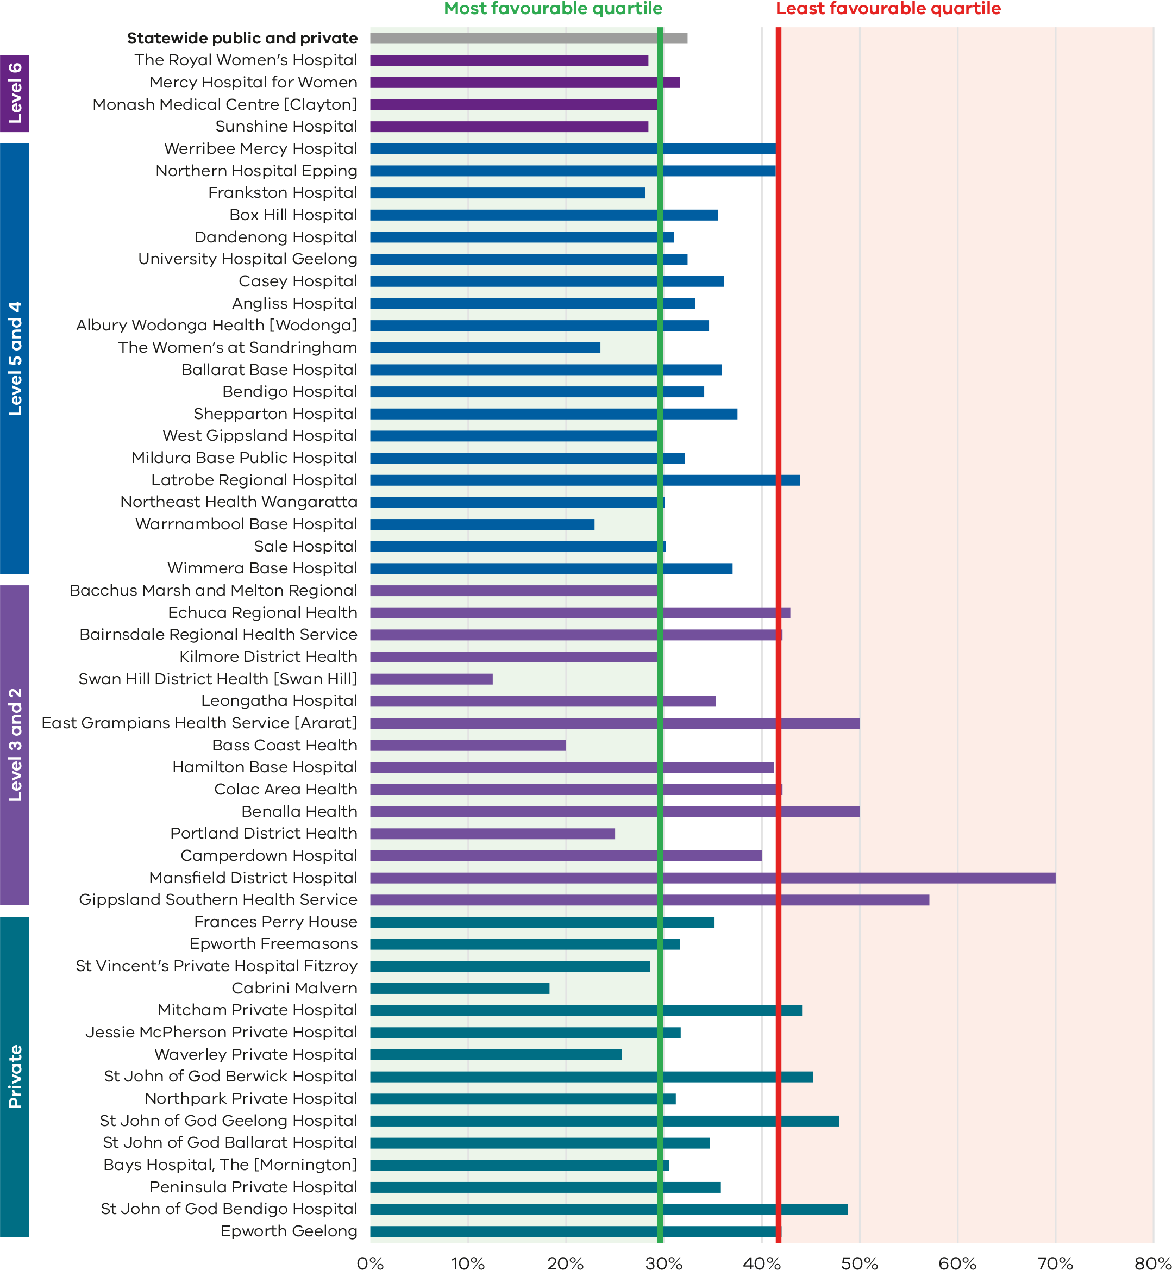
Figure 11. Funnel plot of the rate of caesarean section in modified Robson group 2, 2021
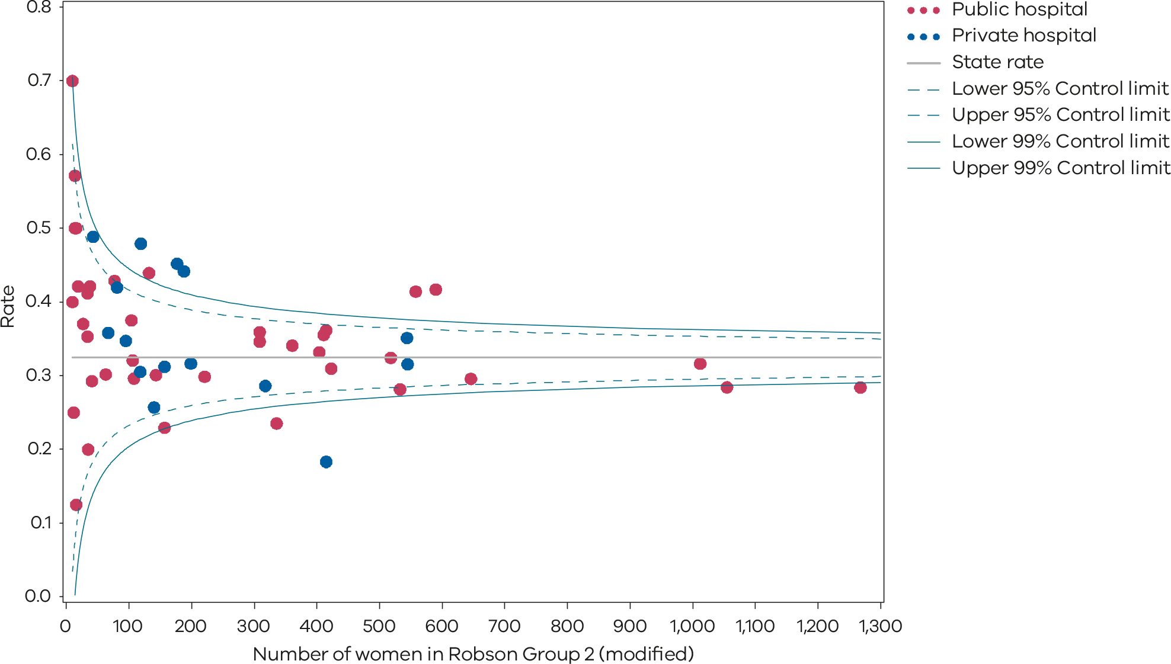
Please refer to the guide on how to interpret funnel plots.
Table 4. Rate of caesarean section in modified Robson group 2, 2017–2021
Indicator 1bii: Modified Robson group 2
 | 2017 | 2018 | 2019 | 2020 | 2021
Public | 29.6% | 30.2% | 31.2% | 32.2% | 32.4%
Private | 32.3% | 31.9% | 33.2% | 32.6% | 32.6%
Statewide | 30.1% | 30.6% | 31.6% | 32.3% | 32.4%
Figure 12. Time trend of Indicator 1bii, 2017–2021
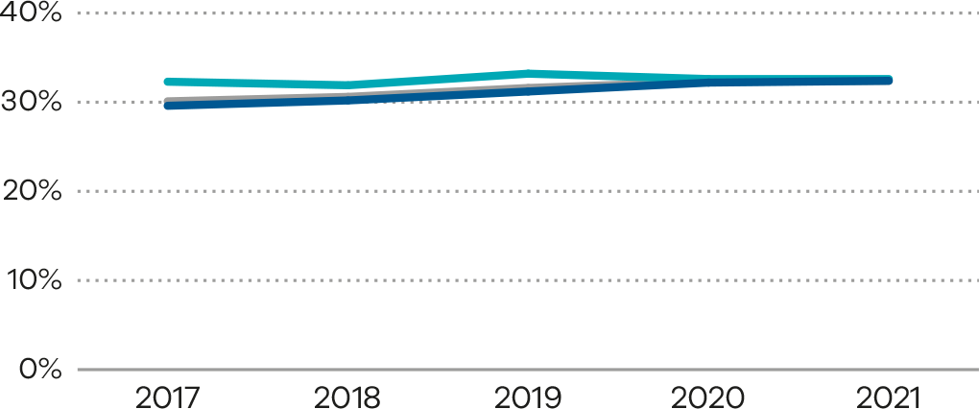

Definition and data source

Definition
Robson group 1 (Indicator 1bi) includes first-time birthing women with a singleton cephalic pregnancy, at greater than or equal to 37 weeks’ gestation in spontaneous labour.
Modified Robson group 2 (Indicator 1bii) includes women having their first baby with a singleton cephalic pregnancy, at greater than or equal to 37 weeks’ gestation who had labour induced. Modified Robson group 2 excludes pre-labour caesareans, which are included in the standard Robson group 2.

Data source: Victorian Perinatal Data Collection
Data for these indicators are sourced from the VPDC for the calendar year from 1 January 2021 to 31 December 2021.
The indicators are derived using the following VPDC variables: ‘Parity’, ‘Plurality’, ‘Birth presentation’, ‘Estimated gestational age’, ‘Labour type’ and ‘Method of birth’.
Numerator/denominator
Indicator | Numerator | Denominator
Indicator 1bi: Rate of caesarean section in Robson group 1 | The number of women giving birth for the first time, with spontaneous onset of labour and a singleton, cephalic-presenting baby born at 37 or more weeks by caesarean section | The number of women giving birth for the first time, with spontaneous onset of labour and a singleton, cephalic-presenting baby born at 37 or more weeks
Indicator 1bii: Rate of caesarean section in modified Robson group 2 | The number of women giving birth for the first time, with induced labour (excluding pre-labour caesarean) and a singleton, cephalic-presenting baby born at 37 or more weeks by caesarean section | The number of women giving birth for the first time, with induced labour (excluding pre-labour caesarean) and a singleton, cephalic-presenting baby born at 37 or more weeks

1ci and 1cii: Perineal tears in primiparae
A perineal tear is a laceration of the skin and other soft tissue structures in the area between the vagina and the anus. Perineal tears that are classified as third- or fourth-degree tears (severe perineal tears) are a significant birth-related complication that can have long-term consequences if not diagnosed and managed appropriately. Women having their first vaginal birth are 4 times more likely to experience a severe perineal tear than women having their second or subsequent birth. There is significant variation in the rate of severe perineal tears between healthcare services in Victoria. This may indicate differences in the detection of severe tears and the accuracy of reporting but may also reflect variations in quality of care. Detection of severe perineal tears is critical for women to receive appropriate therapy and advice after birth. The rate of detection is a variable that is not considered in this indicator.
From 2019 until 2021, Safer Care Victoria and the Institute for Healthcare Improvement partnered to deliver the Better births for women collaborative <https://www.safercare.vic.gov.au/improvement/projects/mbc/better-births>. The collaborative aimed to reduce the rate of third- or fourth-degree perineal tears by introducing an evidence-based clinical care bundle. This bundle of interventions includes practices before, during and after birth to better prevent and recognise severe perineal trauma and reduce the rate of third- and fourth-degree tears and associated consequences for all women giving birth vaginally. Safer Care Victoria’s Maternity and Newborn Learning Health Network (MNLHN) is partnering with Victorian health services to reduce the incidence of severe perineal trauma for Victorian women (refer to the MNLHN webpage <https://www.safercare.vic.gov.au/improvement/learning-health-networks/maternity-and-newborn-lhn> for information).
The Australian Commission on Safety and Quality in Health Care’s Third and Fourth Degree Perineal Tears Clinical Care Standard <https://www.safetyandquality.gov.au/standards/clinical-care-standards/third-and-fourth-degree-perineal-tears-clinical-care-standard>, released in 2021, recognises the significant clinical variation and aims to provide safe and appropriate care.

About this indicator
This indicator, 1c, shows the rate of third- and fourth-degree perineal tears in women who gave birth for the first time and who had a vaginal birth (with or without the use of instruments).
- Indicator 1ci refers to unassisted vaginal births. An unassisted vaginal birth is one that occurs without instruments (forceps or vacuum).
- Indicator 1cii refers to assisted vaginal births. An assisted (or operative/instrumental) vaginal birth refers to a forceps- or vacuum-assisted birth. Operative intervention in the second stage of labour may be indicated by conditions of the fetus or the mother.
[Break out box text:

What pregnant women and families need to know
A perineal tear occurs when the skin and tissue between the vaginal opening and the anus (perineum) tears during childbirth. This is sometimes unavoidable with a vaginal birth. Doctors and midwives will do their best to reduce the chances of a severe tear happening.
When needed, an episiotomy may be cut to reduce the chance of severe tearing and to make the opening bigger to allow the baby to fit through. The risk of a tear is slightly higher if an assisted birth is needed (using obstetrics forceps or vacuum).
More severe tears (referred to as third- or fourth-degree) can result in long-term complications if they are not identified and correctly repaired. The graphs on the following pages (Figure 13 and Figure 16) show differences between hospitals in how often severe tearing occurs. We aim to have the rate of severe tearing as low as possible, with the results similar between hospitals.
End of break out box text.]

Observations on the data
The statewide rate of third- and fourth-degree perineal tears in unassisted vaginal births (Indicator 1ci) was 4.0%, an increase from the previous year’s rate of 3.7%. The rate in 2017 was 3.2%. The rate was higher in public hospitals (4.6%) compared with private hospitals (1.1%). Refer to Table 5 for year‑on‑year rates.
The statewide rate of third- and fourth-degree tears in assisted vaginal births (Indicator 1cii) was 5.0%, slightly lower compared with the previous year’s rate of 5.4%. The rate was higher in public hospitals (5.8%) compared with private hospitals (2.7%). Refer to Table 6 for year-on-year rates.
The bar graphs and funnel plots (Figure 13 and Figure 14 (Indicator 1ci) and Figure 16 and Figure 17 (Indicator 1cii)) show that there is variation (zero to 13.7%) between hospitals across the state and within maternity capability levels, also within private hospitals in the rate of third- and fourth-degree perineal tears in both assisted and unassisted vaginal births. Figures 15 and 18 show trends over time.

Strategies for improvement
- Health services should review and align current practices with the Third and Fourth Degree Perineal Tears Clinical Care Standard <https://www.safetyandquality.gov.au/publications-and-resources/resource-library/third-and-fourth-degree-perineal-tears-clinical-care-standard>.
- Health services could consider implementing the Safer Care Victoria Better Births for Women toolkit <https://www.safercare.vic.gov.au/improvement/projects/mbc/better-births> and the perineal tear audit tool.
- Visit the MNLHN webpage <https://www.safercare.vic.gov.au/improvement/learning-health-networks/maternity-and-newborn-lhn> for more resources.
- Provide antenatal information (verbal and written) to women about reducing the risk of perineal tears and counsel, debrief and support women who have sustained a perineal tear.

Figure 13. Indicator 1ci: Rate of third- and fourth-degree perineal tears during unassisted vaginal births to primiparae, 2021
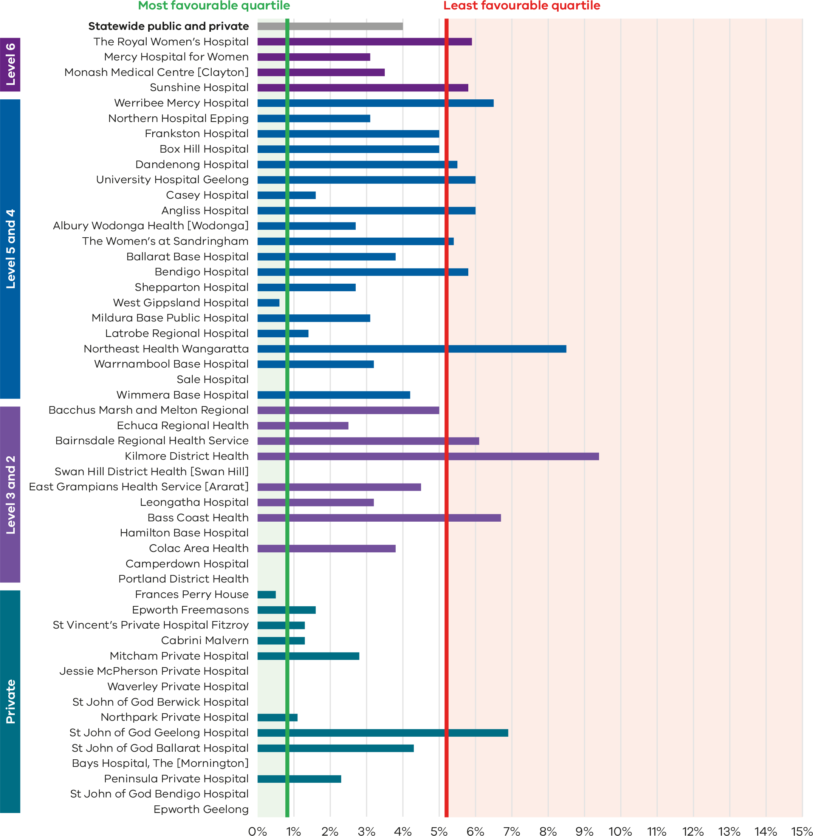
Figure 14. Funnel plot of the rate of third- and fourth-degree perineal tears during unassisted vaginal births to primiparae, 2021
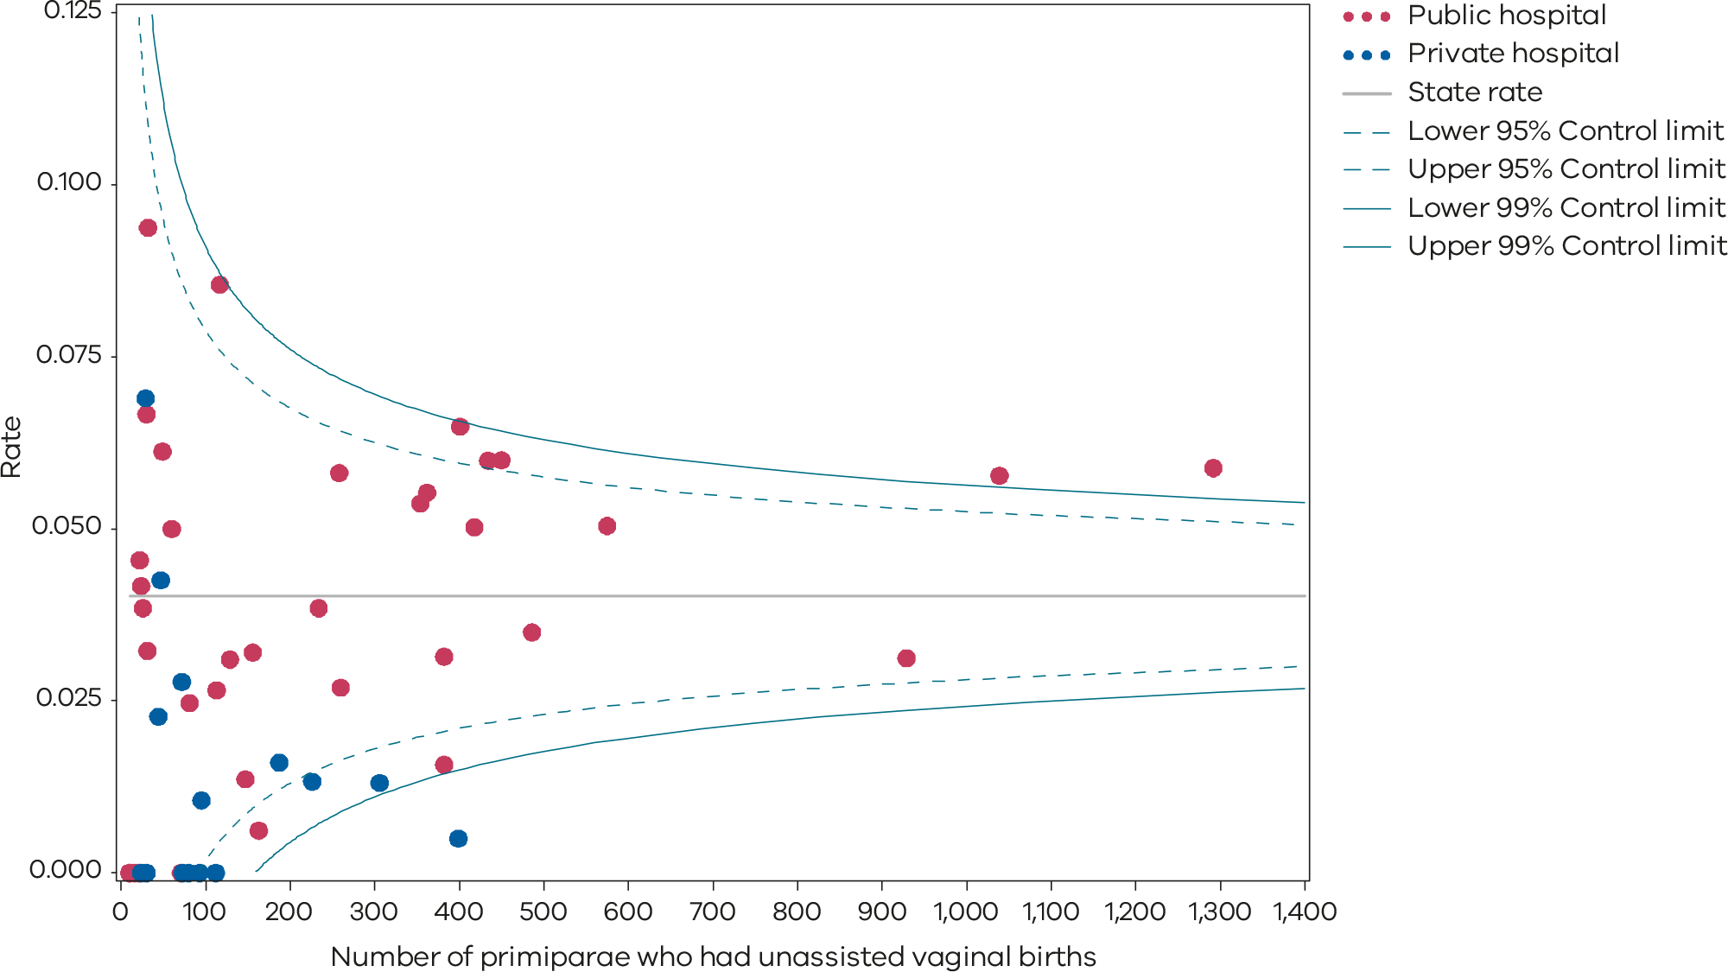
Please refer to the guide on how to interpret funnel plots.
Table 5. Rate of third- and fourth-degree perineal tears during unassisted vaginal births, 2017–2021
Indicator 1ci: Rate of third- and fourth-degree perineal tears during unassisted vaginal births
 | 2017 | 2018 | 2019 | 2020 | 2021
Public | 3.6% | 4.4% | 4.7% | 4.3% | 4.6%
Private | 1.0% | 1.0% | 1.4% | 0.8% | 1.1%
Statewide | 3.2% | 3.8% | 4.2% | 3.7% | 4.0%
Figure 15. Time trend of Indicator 1ci, 2017–2021
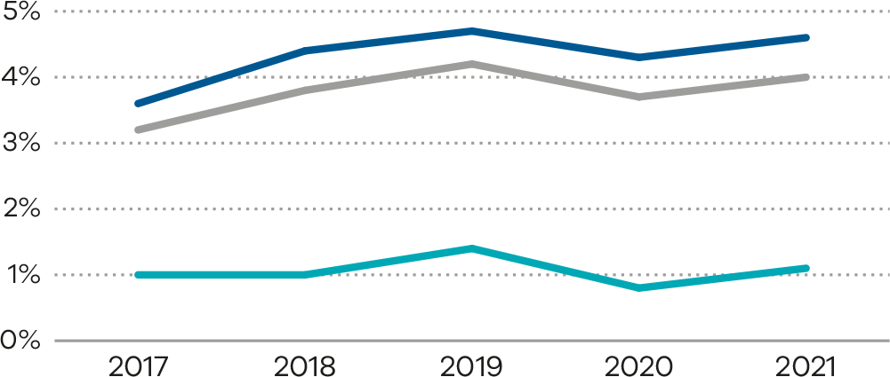
Figure 16. Indicator 1cii: Rate of third- and fourth-degree perineal tears during assisted vaginal births to primiparae, 2021
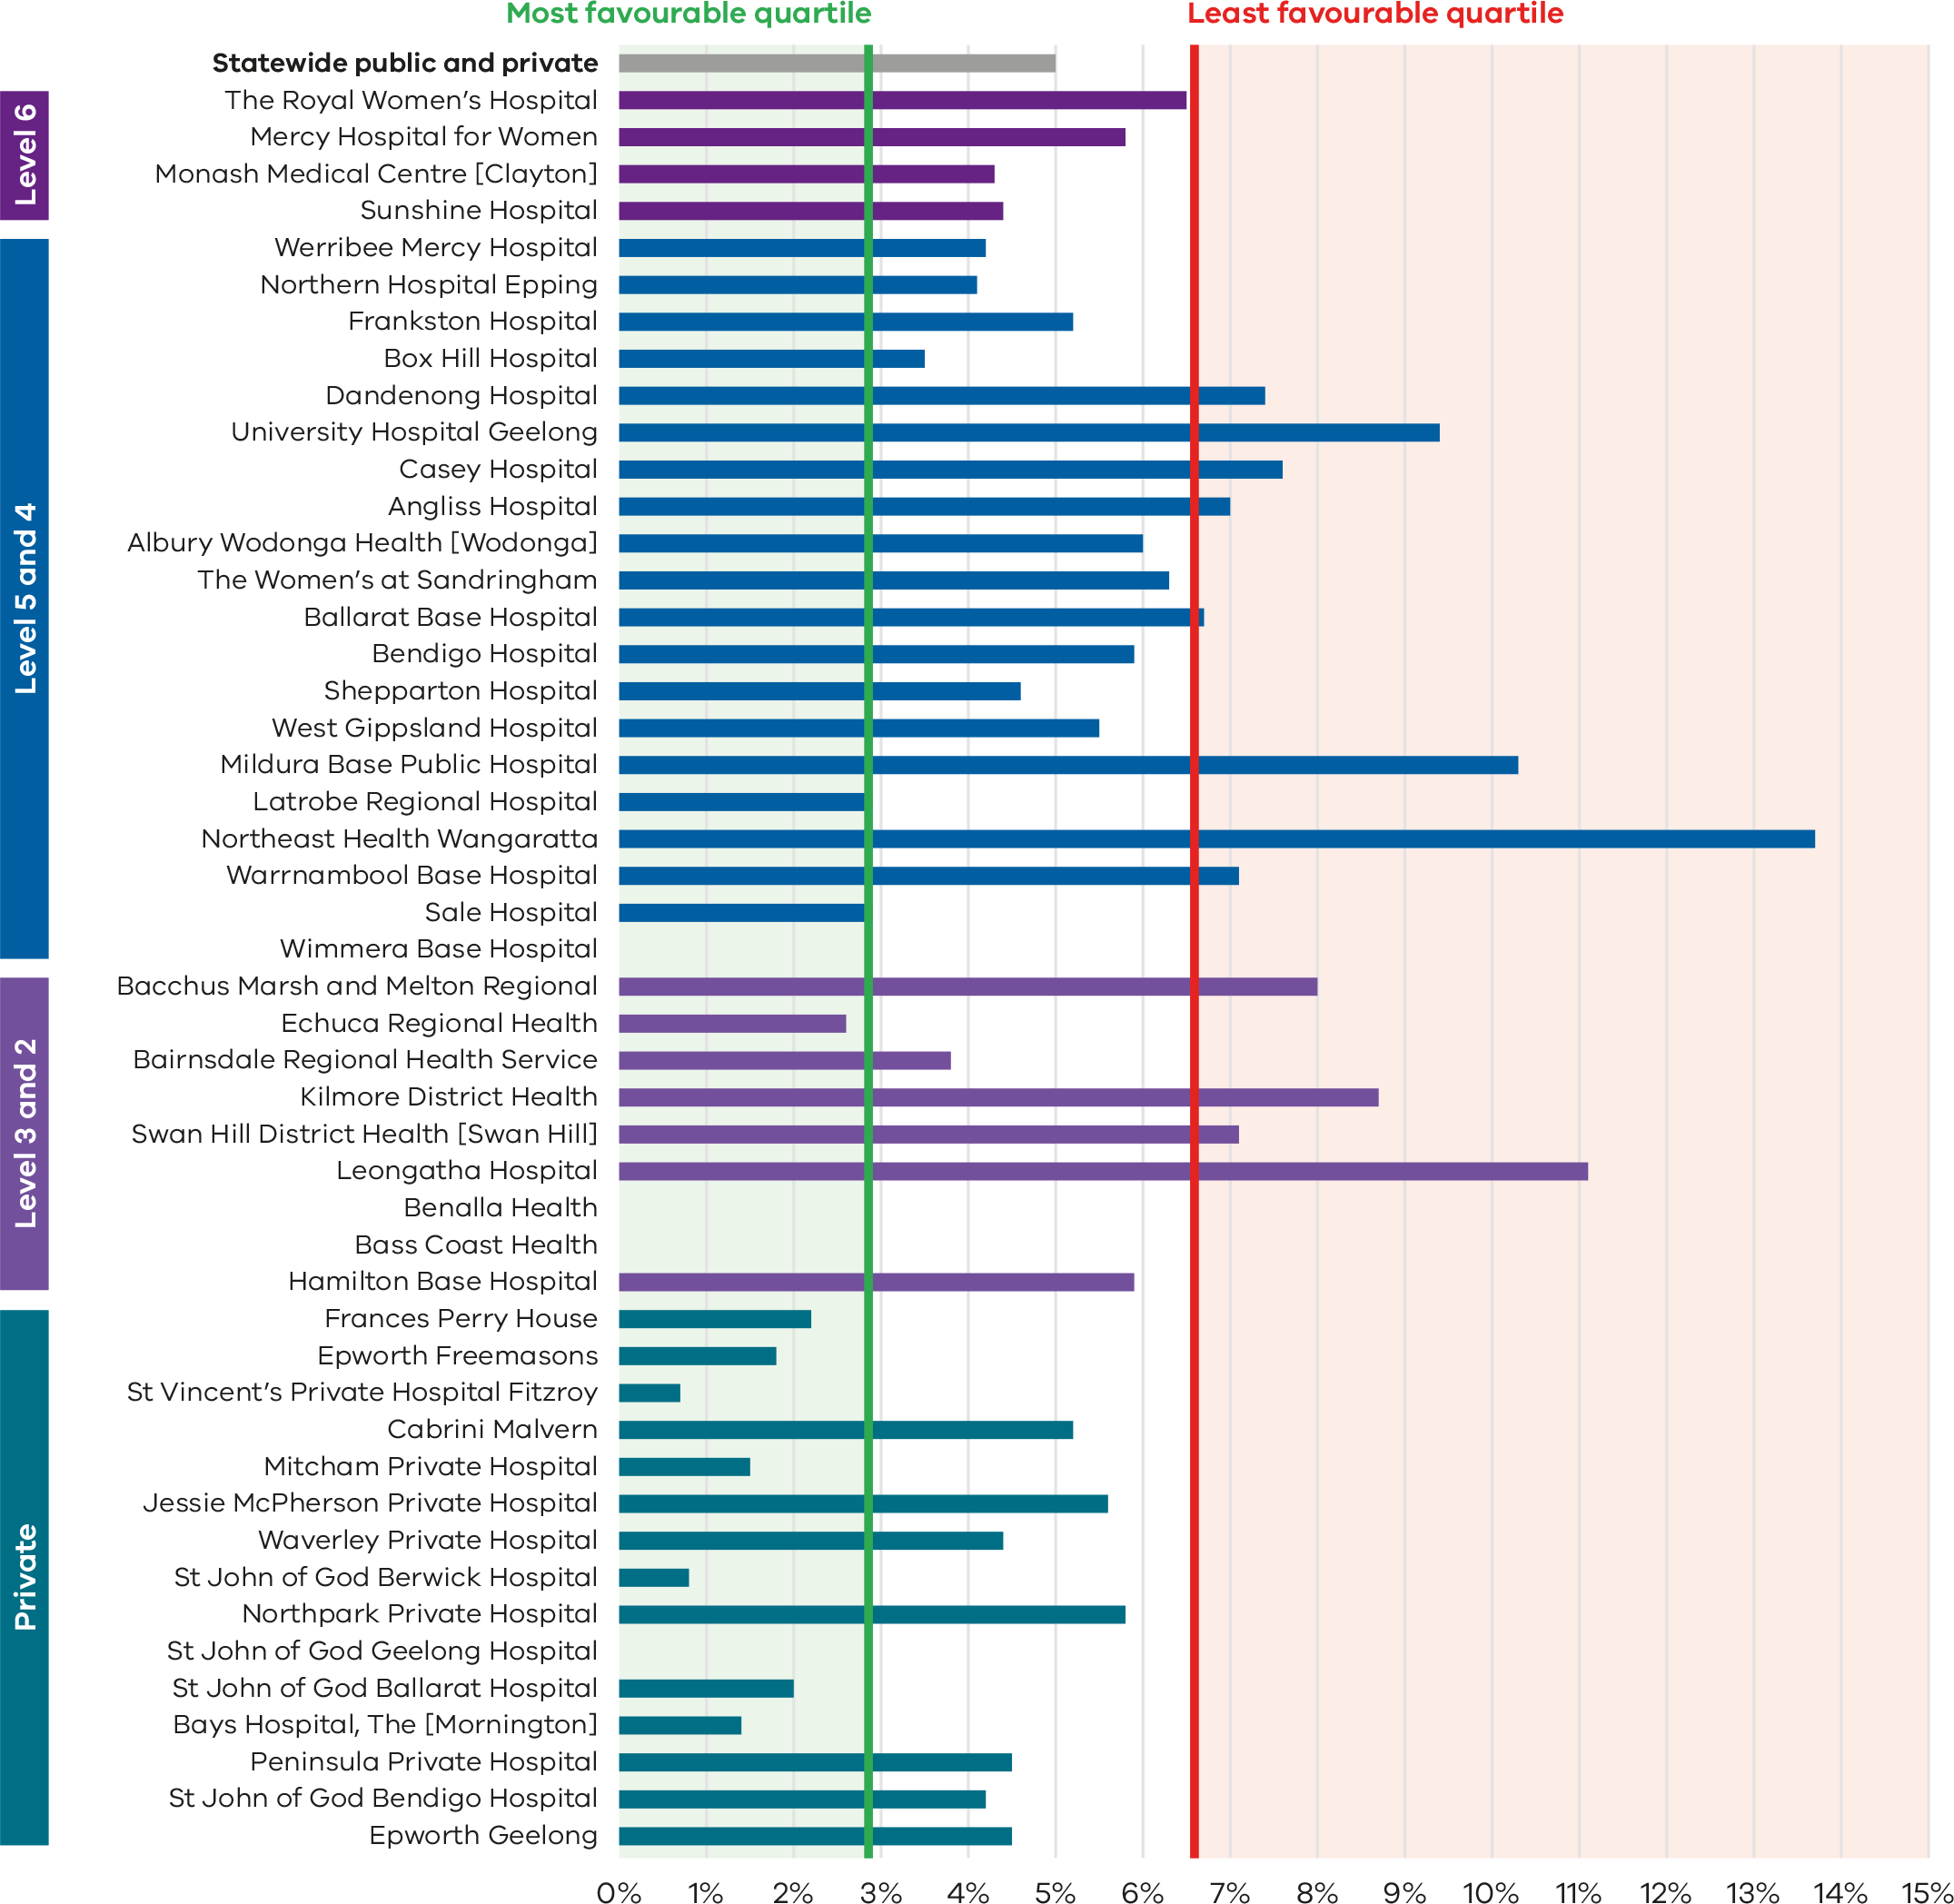

Figure 17. Funnel plot of the rate of third- and fourth-degree perineal tears during assisted vaginal births to primiparae, 2021
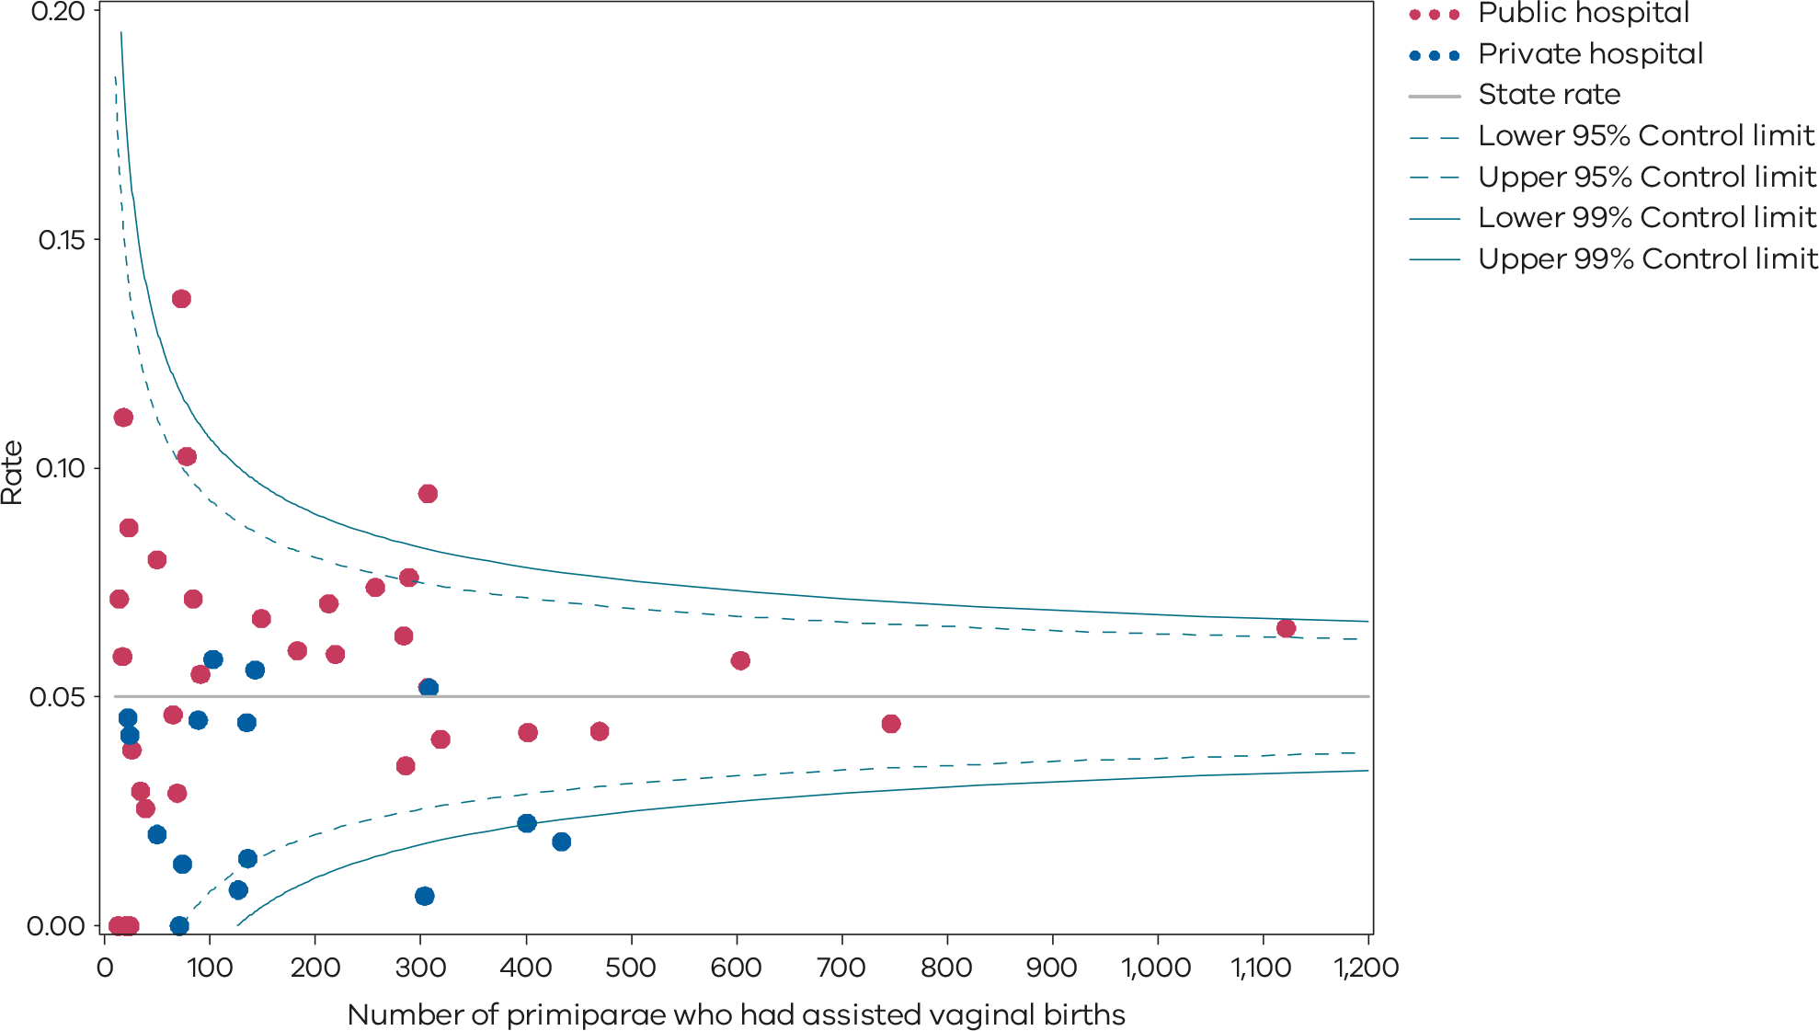
Please refer to the guide on how to interpret funnel plots.
Table 6. Rate of third- and fourth-degree perineal tears during assisted vaginal births, 2017–2021
Indicator 1cii: Rate of third- and fourth-degree perineal tears during assisted vaginal births
 | 2017 | 2018 | 2019 | 2020 | 2021
Public | 5.5% | 6.0% | 6.5% | 6.4% | 5.8%
Private | 2.5% | 2.4% | 2.8% | 2.6% | 2.7%
Statewide | 4.7% | 5.0% | 5.6% | 5.4% | 5.0%
Figure 18. Time trend of Indicator 1cii, 2017–2021
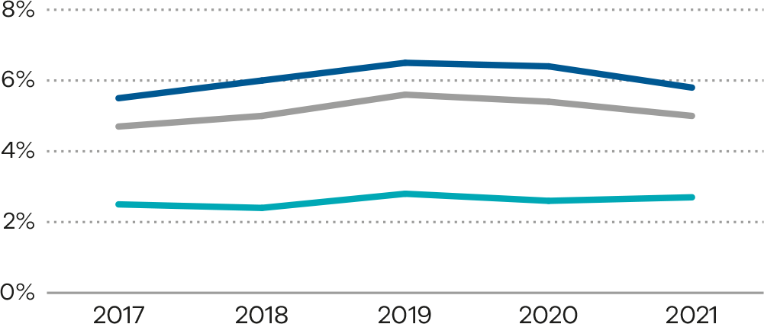

Definition and data source

Definition
For all primiparae, (1ci) the proportion who have a third- or fourth-degree perineal tear during an unassisted vaginal birth, and (1cii) the proportion who had a third- or fourth-degree perineal tear during an assisted vaginal birth.
Included are those women who gave birth for the first time and had a vaginal birth, with or without instruments. Women who had a multiple birth are included if this was the first time they had given birth.
Excluded are those women who did not give birth for the first time or gave birth by caesarean section.
Third-degree perineal tear means a perineal laceration, rupture or tear also involving anal sphincter, rectovaginal septum and/or sphincter not otherwise specified. Excludes lacerations involving the anal or rectal mucosa.
Fourth-degree perineal tear means a perineal laceration, rupture or tear occurring during delivery, also involving anal mucosa and/or rectal mucosa.
The rates for third- and fourth-degree tears includes episiotomies extended by a laceration of a third- and fourth-degree type.

Data source: Victorian Perinatal Data Collection
Data for these indicators are sourced from the VPDC for the calendar year from 1 January 2021 to 31 December 2021.
The indicators are derived using the following VPDC variables: ‘Estimated gestational age’, ‘Birthweight’, ‘Method of birth’, ‘Birth order’, ‘Parity’ and ‘Perineal/genital laceration’.
Numerator/denominator
Indicator | Numerator | Denominator
Indicator 1ci: Rate of third- or fourth-degree perineal tears during unassisted vaginal births to primiparae | The number of primiparae who had a third- or fourth-degree perineal laceration during an unassisted vaginal birth | The number of primiparae who had an unassisted vaginal birth
Indicator 1cii: Rate of third- or fourth-degree perineal tears during assisted vaginal births to primiparae | The number of primiparae who had a third- or fourth-degree perineal laceration during an assisted (instrumental) vaginal birth | The number of primiparae who had an assisted vaginal birth

1di and 1dii: Episiotomies in primiparae
An episiotomy is a surgical incision made in the perineum, the skin and muscle between the vaginal opening and the anus, during childbirth. Episiotomy is not routinely performed but may help with the birth of the baby as well as preventing severe perineal tears. Episiotomy rates need to be considered as a balancing measure against the rate of severe perineal tears.

About this indicator
This indicator shows the rate of episiotomy in primiparae for:
- (1di) unassisted vaginal births
- (1dii) assisted vaginal births.
An episiotomy should only be performed when clinically indicated, such as in an instrumental birth, suspected fetal compromise or when severe perineal trauma is anticipated.
[Break out box text:

What pregnant women and families need to know
Midwives and doctors looking after women in labour will sometimes recommend cutting the perineum, which is the area between the vaginal opening and the anus. This is called an episiotomy. Midwives and doctors may do this if they think the baby needs to be born quickly or if the mother’s perineum might tear excessively if it isn’t cut.
Almost all women having an assisted vaginal birth (forceps or vacuum) will need an episiotomy to reduce the risk of a severe tear or to speed up the birth if the baby needs to be born quickly. If an episiotomy is recommended, this should be discussed with the woman and informed consent given.
The following graphs (Figure 19 and Figure 22) show there is a difference between hospitals in the rates of episiotomy in first-time mothers having a vaginal birth.
End of break out box text.]

Observations on the data
The statewide rate of episiotomy in unassisted vaginal births (Indicator 1di) decreased from 27.5% in 2020 to 26.6% in 2021 (Figure 19, Figure 20 and Figure 21). The rate was lower in public hospitals (26.2%) than private hospitals (30.3%).
The statewide rate of episiotomy in assisted vaginal births (Indicator 1dii) was 86.5% in 2021. The rate was higher in public hospitals than private hospitals at 91.2 and 73.1% respectively (Figure 22, Figure 23 and Table 8).
Figures 19 and 20 (Indicator 1di) and Figures 22 and 23 (Indicator 1dii) show there is a large variation in episiotomy rates between hospitals across the state and within maternity capability levels, also within private hospitals, in the rate of episiotomies in both unassisted and assisted vaginal births.
Figures 21 and 24 show trends over time.

Strategies for improvement
- Health services should refer to the Third and Fourth Degree Perineal Tears Clinical Care Standard <https://www.safetyandquality.gov.au/publications-and-resources/resource-library/third-and-fourth-degree-perineal-tears-clinical-care-standard>, which states an episiotomy should be offered to primiparae in assisted vaginal births.
- Health services could engage with Safer Care Victoria’s MNLHN improvement program <https://www.safercare.vic.gov.au/improvement/learning-health-networks/maternity-and-newborn-lhn>.
- Provide antenatal information (verbal and written) to women about the indications for and the benefits and risks of an episiotomy based on best evidence.
- Health services should review their rates of episiotomy along with their rates of third- and fourth-degree tears.
- Implement processes to review clinical practices through case review.
- Health services should provide opportunities for education to ensure all birth suite clinicians are skilled in episiotomy.
Figure 19. Indicator 1di: Rate of primiparae who received an episiotomy during unassisted vaginal births, 2021
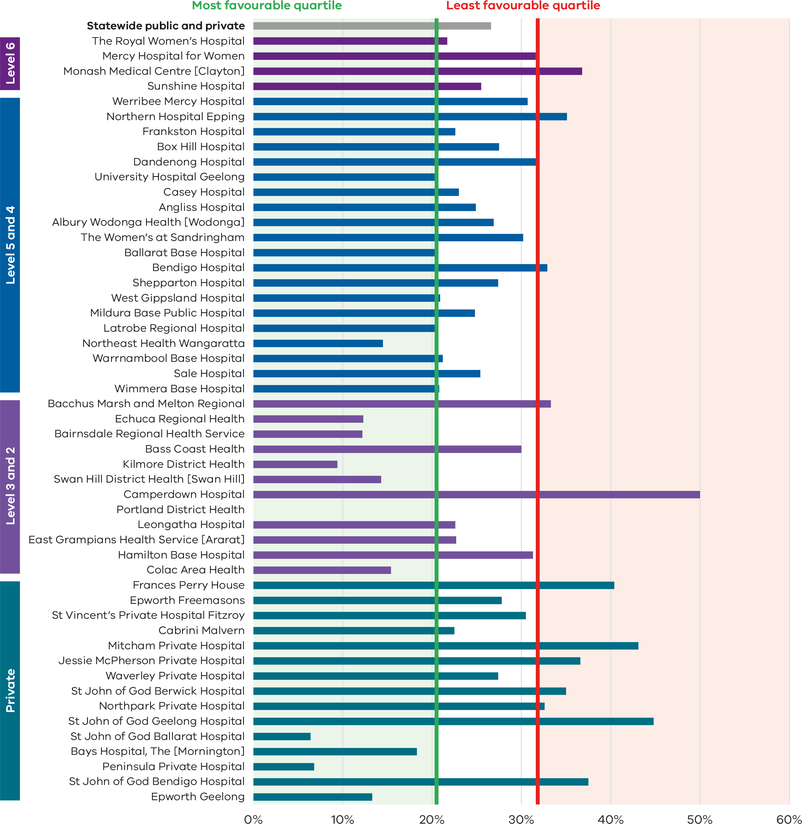
Figure 20. Funnel plot of the rate of primiparae who received an episiotomy during unassisted vaginal births, 2021
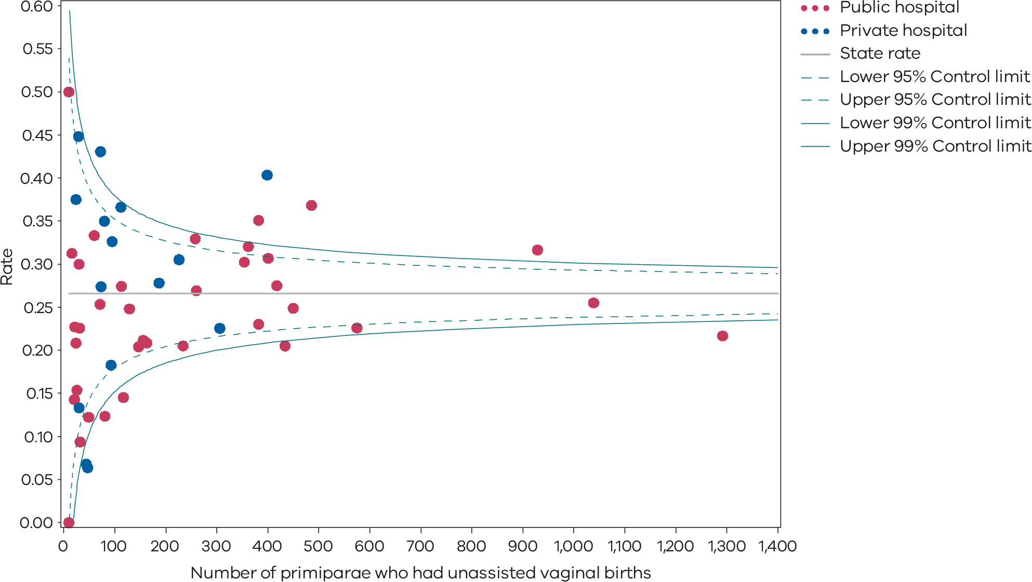
Please refer to the guide on how to interpret funnel plots.
Table 7. Rate of primiparae who received an episiotomy during an unassisted vaginal birth, 2017–2021
Indicator 1di: Rate of episiotomy during unassisted vaginal births
 | 2017 | 2018 | 2019 | 2020 | 2021
Public | 25.4% | 25.3% | 26.9% | 27.3% | 26.2%
Private | 31.1% | 33.9% | 32.7% | 30.4% | 30.3%
Statewide | 26.2% | 26.5% | 27.7% | 27.5% | 26.6%
Figure 21. Time trend of Indicator 1di, 2017–2021
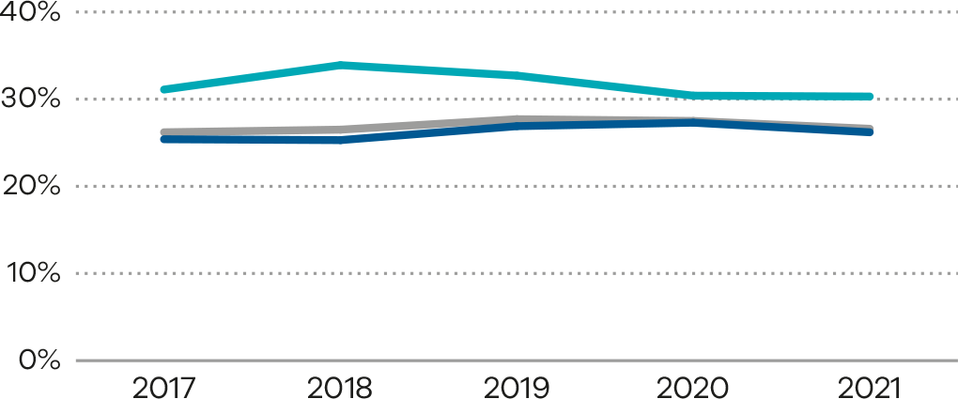
Figure 22. Indicator 1dii: Rate of primiparae who received an episiotomy during assisted vaginal births, 2021
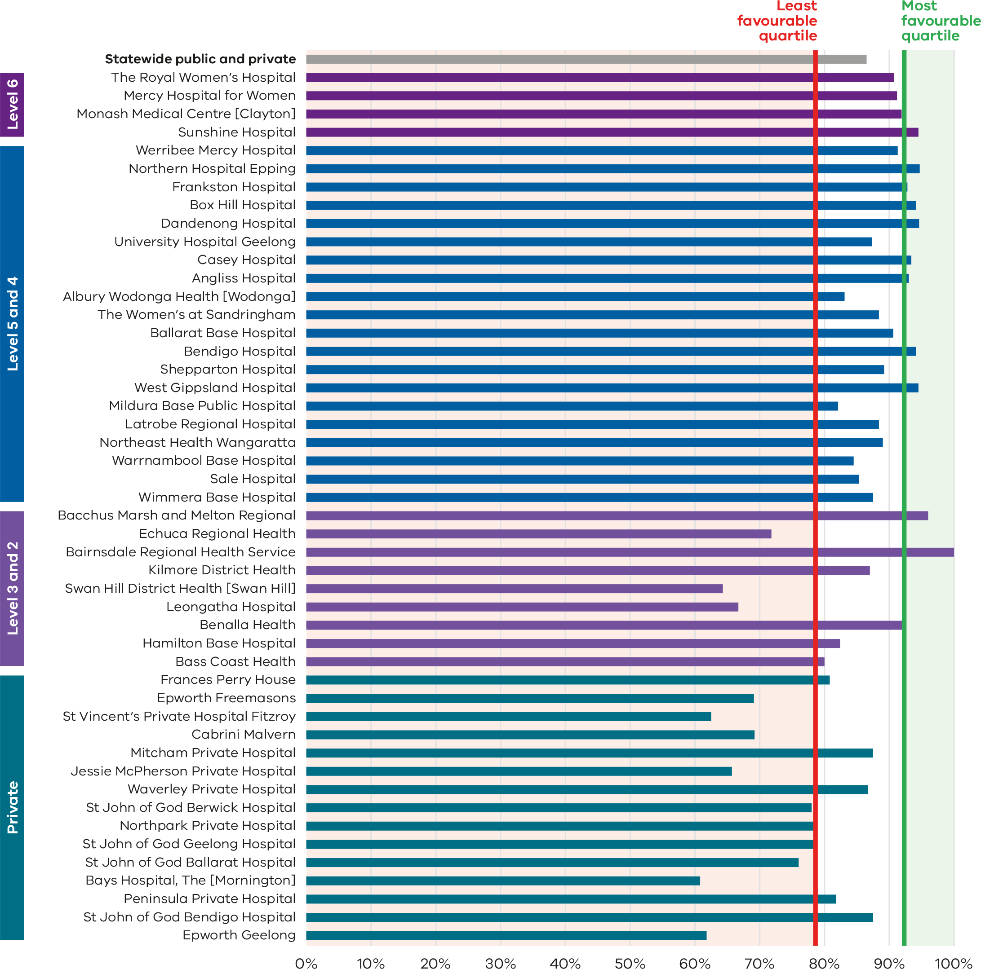
Figure 23. Funnel plot of the rate of primiparae who received an episiotomy during assisted vaginal births, 2021
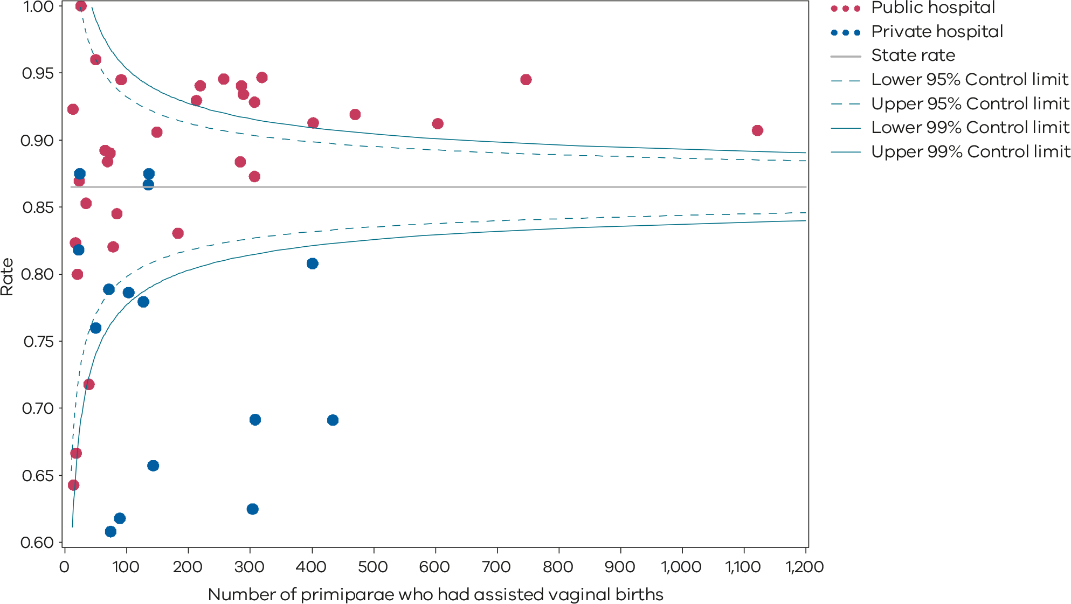
Please refer to the guide on how to interpret funnel plots.
Table 8. Rate of primiparae who received an episiotomy during an assisted vaginal birth, 2017–2021
Indicator 1dii: Rate of episiotomy during assisted vaginal births
 | 2017 | 2018 | 2019 | 2020 | 2021
Public | 85.7% | 87.0% | 88.7% | 90.8% | 91.2%
Private | 71.7% | 72.3% | 70.6% | 73.2% | 73.1%
Statewide | 81.9% | 83.1% | 84.0% | 86.4% | 86.5%
Figure 24. Time trend of Indicator 1dii, 2017–2021
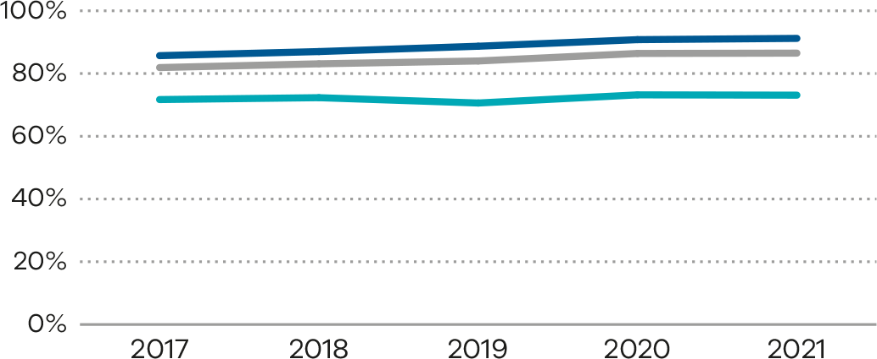

Definition and data source

Definition
For all primiparae, the proportion who received an episiotomy during an unassisted vaginal birth (Indicator 1di), and the proportion who received an episiotomy during an assisted vaginal birth (Indicator 1dii).
Episiotomy is defined as an incision of the perineum and vagina made during vaginal birth.
Included are those women who gave birth for the first time and had a vaginal birth, with or without instruments. Women who had a multiple birth are included if this was the first time they had given birth. Excluded are those women who did not give birth for the first time or gave birth by caesarean section.
Assisted (or operative/instrumental) vaginal birth refers to a forceps- or vacuum-assisted birth. Operative intervention in the second stage of labour may be indicated by conditions of the fetus (baby) or the mother. The most common indication for an instrumental birth is inadequate progress in labour or concerns about fetal wellbeing (abnormal heart rate).

Data source: Victorian Perinatal Data Collection
Data for these indicators are sourced from the VPDC for the calendar year from 1 January 2021 to 31 December 2021.
The indicators are derived using the following VPDC variables: ‘Estimated gestational age’, ‘Birthweight’, ‘Method of birth’, ‘Birth order’, ‘Parity’ and ‘Episiotomy – indicator’.
Numerator/denominator
Indicator | Numerator | Denominator
Indicator 1di: Rate of primiparae who received an episiotomy during unassisted vaginal births | The number of primiparae who had an episiotomy during an unassisted vaginal birth | The number of primiparae who had an unassisted vaginal birth
Indicator 1dii: Rate of primiparae who received an episiotomy during assisted vaginal births | The number of primiparae who had an episiotomy during an assisted vaginal birth | The number of primiparae who had an assisted (instrumental) vaginal birth

2: Term babies without congenital anomalies who required additional care
Most inborn babies, born at 37 weeks or more, with a birthweight of at least 2,500 grams and without the presence of a congenital anomaly are not expected to need additional care requiring admission to a neonatal unit (special care nursery or neonatal intensive care unit) following birth. This indicator indirectly measures the quality of care provided during pregnancy, labour and birth, and in the early neonatal period. Babies born with a congenital anomaly may need more individualised care and so they are not included.

About this indicator
This indicator aims to highlight variations in the care required for term babies (born at 37 weeks’ gestation or more) without congenital anomalies. We expect the need for additional care and treatment in most term babies to be low. The data for this indicator is only available for public hospitals.
We know some babies will experience medical conditions following birth that require admission to a neonatal unit for additional care – for example, jaundice, low Apgar score, sepsis and seizures.
Higher rates may indicate quality of care issues during labour, birth and/or the immediate neonatal period. It may also reflect differing models of care or practice from hospital to hospital.
[Break out box text:

What pregnant women and families need to know
Healthy term babies should be with their mothers after birth, therefore, the rate of admission of babies to a neonatal unit (intensive care or special care nursery) should be low. We measure how many babies we would expect to stay with their mother but end up being admitted to a neonatal unit for specialised care.
This measure looks at babies who are born without any congenital anomalies because these babies should not need extra care. Sometimes admission to a neonatal unit is needed – for example, if the baby develops jaundice or signs of an infection and needs to be treated.
There is variation between hospitals across Victoria, but this may be an indication of different newborn care provided within individual hospitals.
End of break out box text.]

Observations on the data
The statewide public hospital rate of term babies without congenital anomalies who required additional care in 2021–22 was 11.0%. This is a slight reduction from 2020–21 (11.7%).
The graphs on the following page (Figure 25 and Figure 26) show variation between hospitals in rates of babies without congenital anomalies who required additional care, ranging from zero to 23.7%.
Some hospitals are expected to have higher rates of babies that require additional care if they look after higher risk pregnancies. There are a variety of models of care across health services, and some hospitals may keep mothers and babies together on postnatal wards for management and treatment, while others provide that care in a neonatal unit – for example, phototherapy for jaundice.
Note there has been a change in the data derivation for this indicator in 2020–21 and 2021–22, reflecting the higher rates for the past 2 years compared with previous years (Table 9).

Strategies for improvement
- Health services should ensure there are adequate mechanisms (policies, processes and communication) to capture, review and report on adverse intrapartum events and outcomes.
- All services are expected to:
  - undertake multidisciplinary reviews of adverse events and outcomes to identify areas for clinical practice or system improvement
  - monitor the competency and confidence of their clinicians in fetal surveillance during labour and in neonatal resuscitation
  - review the availability of senior clinicians to both supervise junior staff and be available to rapidly escalate care after hours
  - provide women and their families information about what happened in a timely, open and honest manner (open disclosure).
Figure 25. Indicator 2: Rate of term babies without congenital anomalies who required additional care, 2021–22
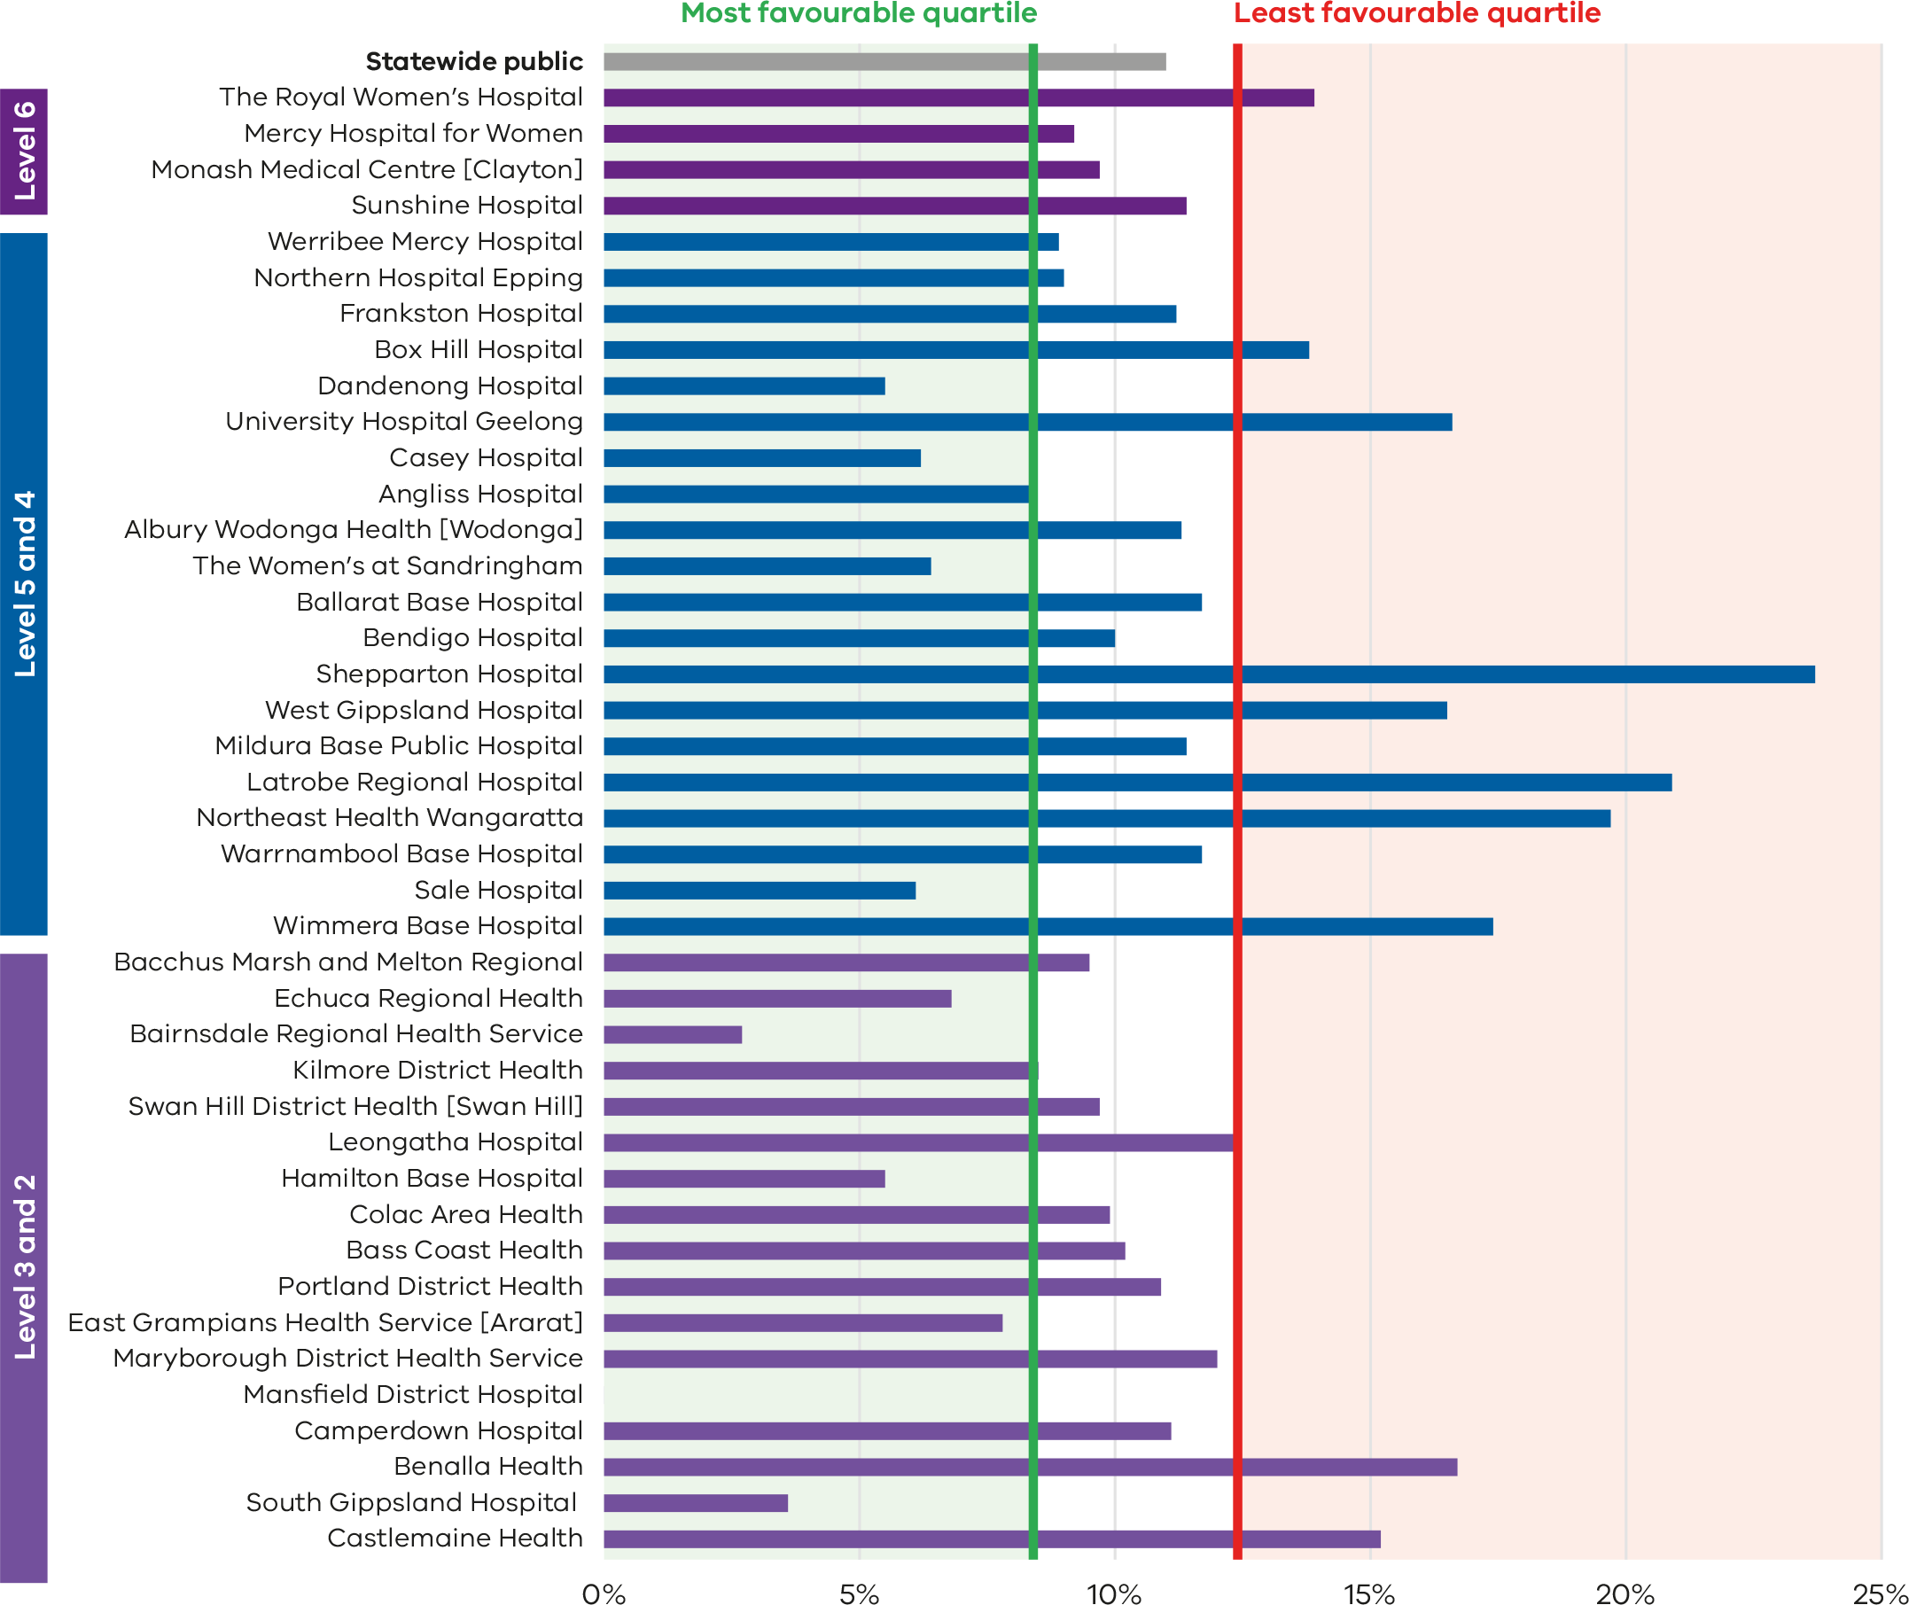
Note 1: Reporting of unqualified neonate admissions to the VAED for private hospitals is optional. It is therefore not possible to establish an accurate denominator (that includes public and private hospitals) for this indicator. As such, only public hospitals are included in the results.
Note 2: A result of 0% indicates that a health service met the reporting criteria of 10 or more inborn term infants without congenital anomalies; however, none of these infants required additional care.

Figure 26. Funnel plot of the rate of term babies without congenital anomalies who required additional care, 2021–22
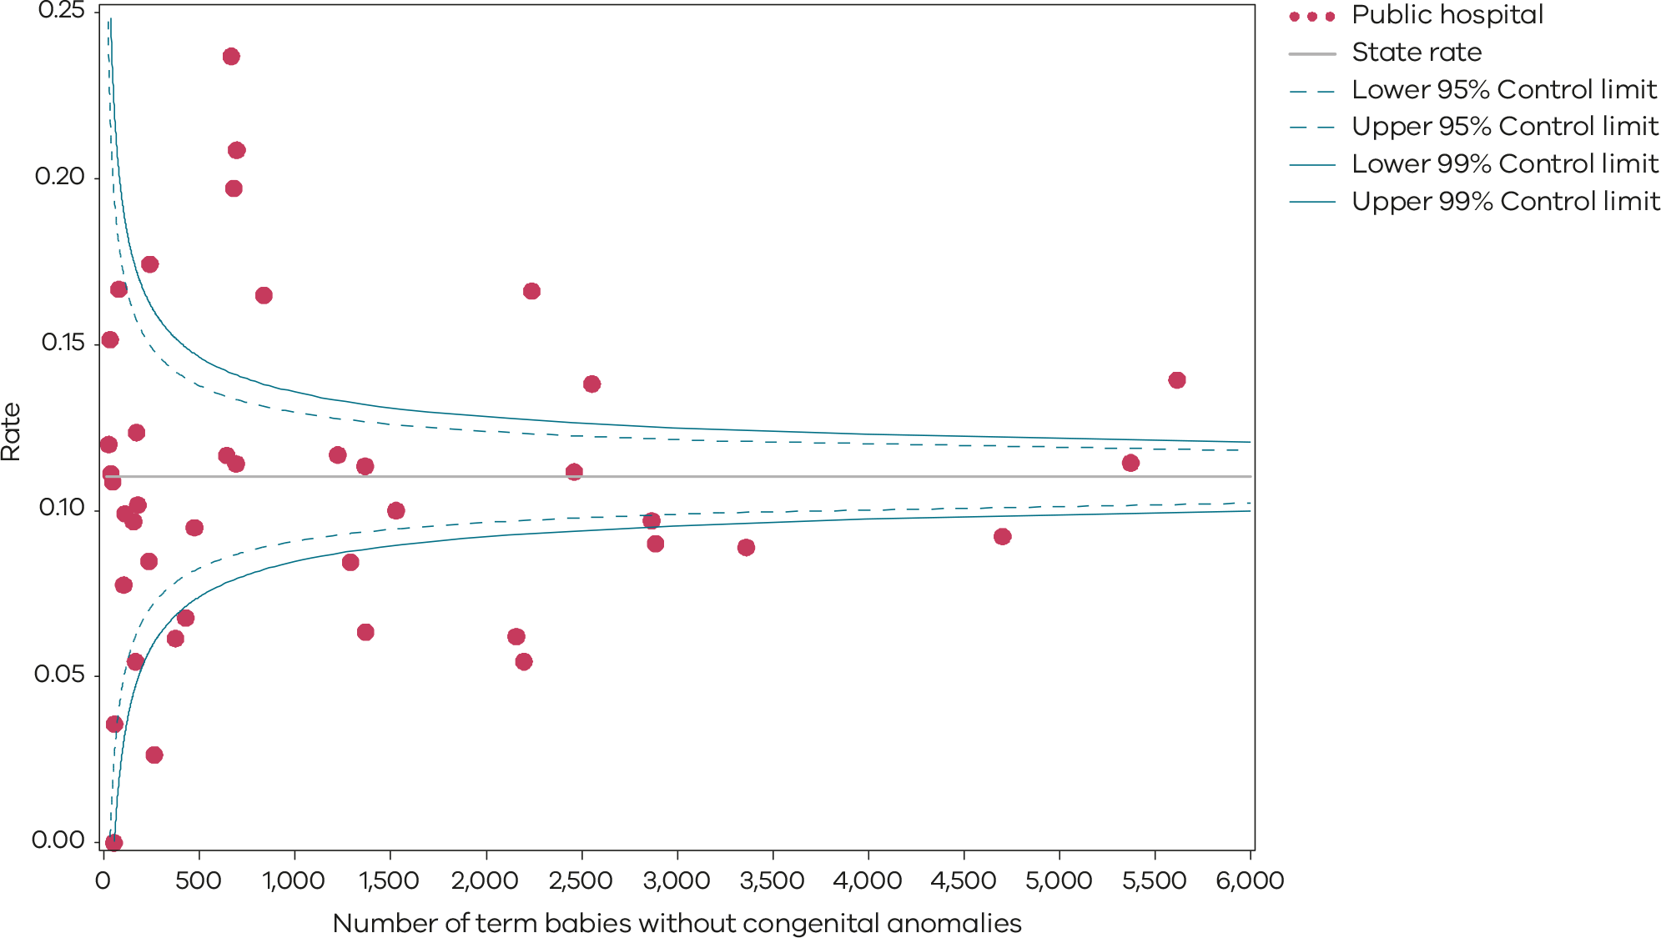
Please refer to the guide on how to interpret funnel plots.
Table 9. Rate of term babies without congenital anomalies who required additional care, by financial year, 2017–18 to 2021–22
 | 2017–18 | 2018–19 | 2019–20 | 2020–21* | 2021–22*
Public | 8.7% | 9.2% | 8.1% | 11.7% | 11.0%
* Note a change in the method of data collection means that results for 2020–21 and 2021–22 are not directly comparable with 2018–19 and 2019–20 and as such a trend line is not included here.

Definition and data source

Definition
This indicator includes inborn term babies. An inborn term baby is an infant born at the reporting hospital at a gestational age of 37 weeks or more. Term babies without congenital anomalies who require additional care are defined as newborns who:
- are not less than 37 weeks, 0 days’ gestation
- weigh not less than 2,500 grams
- are without congenital anomalies
- are grouped to Victorian diagnostic-related groups (VIC-DRGs) representing the need for more than normal care (refer to list of VIC-DRGs provided below).
Excluded are:
- babies born at another hospital or born before arrival
- pre-term newborn babies
- infants with congenital anomalies
- birthweight less than 2,500 grams
- stillborn babies
- readmission (separation not related to the birth episode).
The denominator for the 2021–22 reporting period is episodes grouped to the Version 10.0 VIC-DRGs:
- P68A (v7): Neonate, AdmWt ≥ 2,500 g W/O Sig OR Proc ≥ 37 Comp Wks Gest W Multi Major Problems
- P68B (v7): Neonate, AdmWt ≥ 2,500 g W/O Sig OR Proc ≥ 37 Comp Wks Gest W Major Problem
- P68C (v7) Neonate, AdmWt ≥ 2,500 g W/O Sig OR Proc ≥ 37 Comp Wks Gest W Other Problem
- P68D (v7) Neonate, AdmWt ≥ 2,500 g W/O Sig OR Proc ≥ 37 Comp Wks Gest W/O Problem
- P06A Neonate, AdmWt > 2,499 g W Sig OR Proc W Multi Major Problems
- P06B Neonate, AdmWt > 2,499 g W Sig OR Proc W/O Multi Major Problems
- P60A Neonate, Died or Transferred < 5 days of admission, without Sig OR Proc, Newborn
- P60B Neonate, Neonate W/O Sig OR Proc, Died or Transf to Acute Facility Same Day.
Abbreviations:
VIC-DRGs: Victorian diagnostic related group; AdmWt: admission weight; W: with W/O: without; Sig: significant
OR: operating room; Proc: procedures; Multi: Multiple; Transf: transferred; Gest: Gestation; Comp Wks: completed weeks g: grams

Data source: Victorian Admitted Episodes Dataset
Data for this indicator is sourced from the VAED for the financial year from 1 July 2021 to 30 June 2022.
Numerator/denominator
Indicator | Numerator | Denominator
Indicator 2: Rate of term babies without congenital anomalies who required additional care | The number of inborn term babies without congenital anomalies grouped to VIC-DRG P68A, P68B, P68C, P06A, P06B, P60A and P60B | The number of inborn term babies without congenital anomalies grouped to VIC-DRG P68A, P68B, P68C, P68D, P06A, P06B, P60A and P60B
Regrouping of some newborns initially grouped to P60A and P60B occurred prior to 2019–20. There has been a change to the reporting method and regrouping did not occur for the PSPI report for 2021–22 and 2020–21. This may mean that there is an overestimation of the rate of newborns requiring additional care because some healthy newborns are transferred for other reasons.

3a and 3b: Severe fetal growth restriction
Birthweight for gestational age is an important indicator of infant health that is used as both an outcome measure for antenatal maternal health and a prognostic indicator for a baby’s health, wellbeing and development. Fetal growth restriction (FGR) is associated with increased risks of stillbirth and fetal compromise in labour.
The timely detection of severe FGR allows appropriate fetal surveillance and timing of birth to optimise outcomes, including reducing the risk of stillbirth. Safer Care Victoria’s Safer Baby Collaborative <https://www.safercare.vic.gov.au/improvement/projects/mbc/safer-baby> was a key piece of improvement work undertaken in some Victorian maternity services aimed at reducing the rate of stillbirths. The work had a strong focus on FGR, with the evidence-based bundle of interventions including consistent, reliable practices to assess the risk of FGR and screen for, and diagnose, slow or static fetal growth, enabling timely intervention. Safer Care Victoria’s MNLHN <https://www.safercare.vic.gov.au/improvement/learning-health-networks/maternity-and-newborn-lhn> is continuing to partner with Victorian health services with the Safer Baby improvement program.

About this indicator
FGR is where the fetus (baby) is smaller than expected for the number of weeks of pregnancy.
- FGR is defined here as the estimated fetal weight less than the 10th centile or less than 90% of all the other babies of the same gestational age.
- Severe FGR is defined as the birthweight less than the third centile or less than 97% of all the other babies of the same gestational age.
Indicator 3a shows the proportion of singleton babies with severe growth restriction who were born at or after 40 weeks’ gestation. Birth after 40 weeks’ gestation suggests that the growth restriction may not have been detected and acted on in a timely way. Babies that are very small are usually born as a planned birth (through induction of labour or prelabour caesarean section) close to 39–40 weeks due to the increased risk of stillbirth.³
Indicator 3b shows the proportion of singleton babies who are suspected to have FGR and whose mothers have labour induced or have a prelabour caesarean section for FGR before 39 weeks whose birthweight was above the 25th centile, so not actually FGR. This new indicator is a balance measure to bring greater awareness to the unintended harm that may be associated with an increased focus on detection of FGR and induction prior to 40 weeks. This balance measure is to monitor unwarranted early birth of healthy babies. This is the first year this indicator has been reported in the PSPI.
[Break out box text:

What pregnant women and families need to know
Sometimes babies don’t grow as well as expected during pregnancy for various reasons including the ability of the placenta to provide nutrients, infections and other medical conditions. Studies have shown that these babies are at risk of dying or being born unwell if they are not recognised and carefully monitored.
This risk is highest if the pregnancy continues after the expected due date. Doctors and midwives monitor the growth of babies during a pregnancy by measuring fundal height and sometimes using ultrasound. If the baby is not growing as well as expected, pregnant women and their doctors and midwives should consider the safest time for the baby to be born. This may be before the due date if the baby is thought to be severely growth restricted.
Recognising very small unborn babies is not always easy. However, we want to see very low rates of these babies being born past their due date. On the other hand, we want to see low rates of babies being born early for a suspicion of being small but who did not actually have FGR.
End of break out box text.]

Observations on the data
The rate of singleton babies with severe FGR who were born at 40 or more weeks’ gestation (Indicator 3a) in public and private hospitals in 2021 was 20.0% (Figures 27 and 28). It is worth noting that the rate for this indicator in public hospitals has been steadily decreasing over the past 5 years (Table 10 and Figure 29). There has also been a consistent decline in the rate in private hospitals over this period.
The rate was lower in private hospitals (17.5%) compared with public hospitals (20.6%) for the first time since this indicator has been reported.
Indicator 3b is being reported for the first time. The statewide rate of singleton babies actively delivered for FGR before 39 weeks but who were above the 25th centile was 18.2% in 2021 (Figures 30 and 31 and Table 11). The rate was lower in public hospitals at 16.8%, while the rate in private hospitals was 22.1%. This balance measure is to monitor unwarranted early delivery of healthy babies. An additional balance measure is the increasing rate of induction of labour in standard primiparae (Indicator 1a).
Babies may be suspected to be small on measurement and serial review of the fundal height or on ultrasound estimation of fetal weight. However, while used for screening, these tests are not always accurate, and some babies are born for FGR when they are not as small as suspected. This is why we have introduced the balancing measure (Indicator 3b) to monitor this.

Strategies for improvement
- Heath services should ensure guidance and escalation follows the Stillbirth Centre for Research Excellence’s Fetal Growth Restriction Care Pathway <https://learn.stillbirthcre.org.au/wp-content/uploads/2023/05/FGR-Management-Pathway_v3.0.pdf>.
- Risk assessment for FGR should be undertaken in early pregnancy and at each antenatal visit.
- Measure and record fundal height in a standardised way at each pregnancy care visit.
- Monitor and review cases where FGR is undetected antenatally in a multidisciplinary team.
- Health services should refer to the FGR webinar on the MNLHN webpage <https://www.safercare.vic.gov.au/best-practice-improvement/learning-health-networks/maternity-newborn-lhn>.
- Support, inform and communicate with women and their families of the increased risk of preterm birth and stillbirth and ensure a shared decision making approach is utilised around the timing of birth.
Figure 27. Indicator 3a: Rate of severe fetal growth restriction in a singleton pregnancy undelivered by 40 weeks, 2021
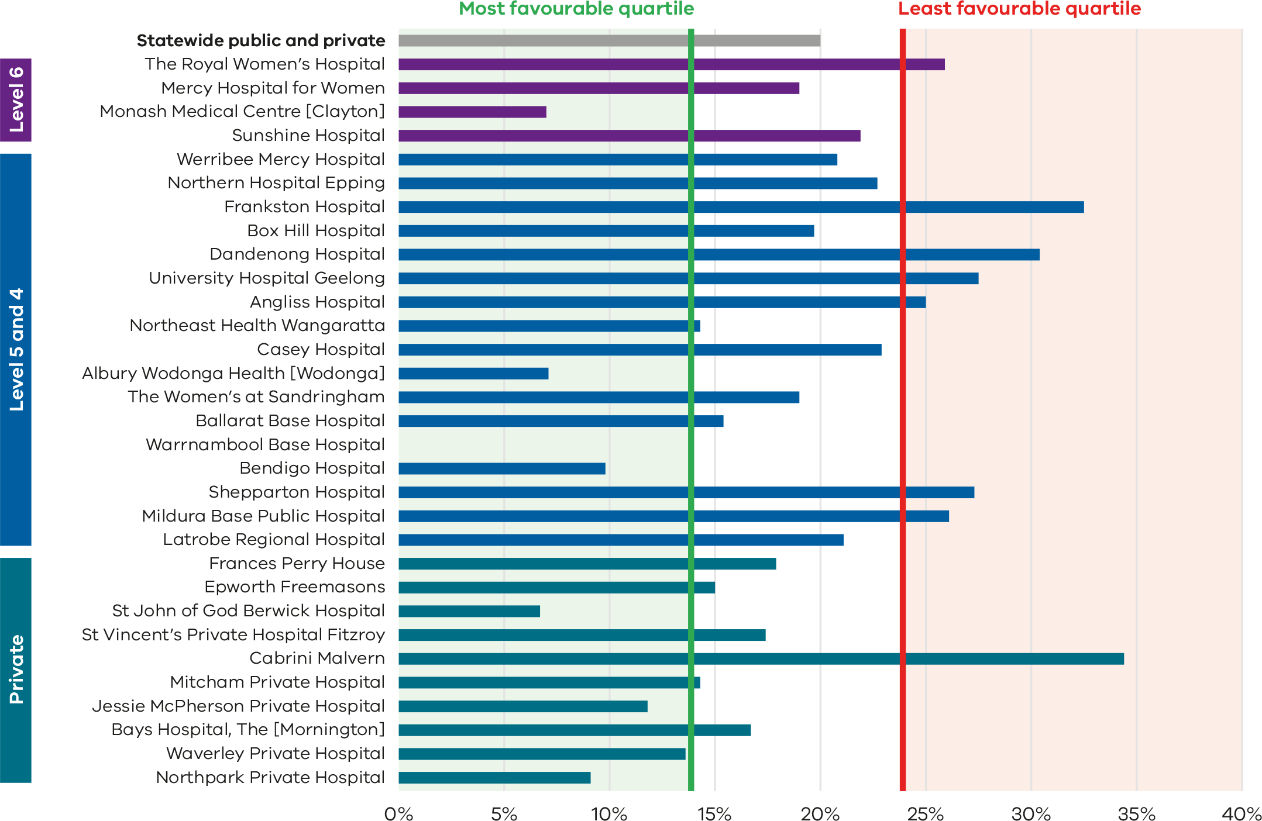
Figure 28. Funnel plot of the rate of severe fetal growth restriction in a singleton pregnancy undelivered by 40 weeks, 2021
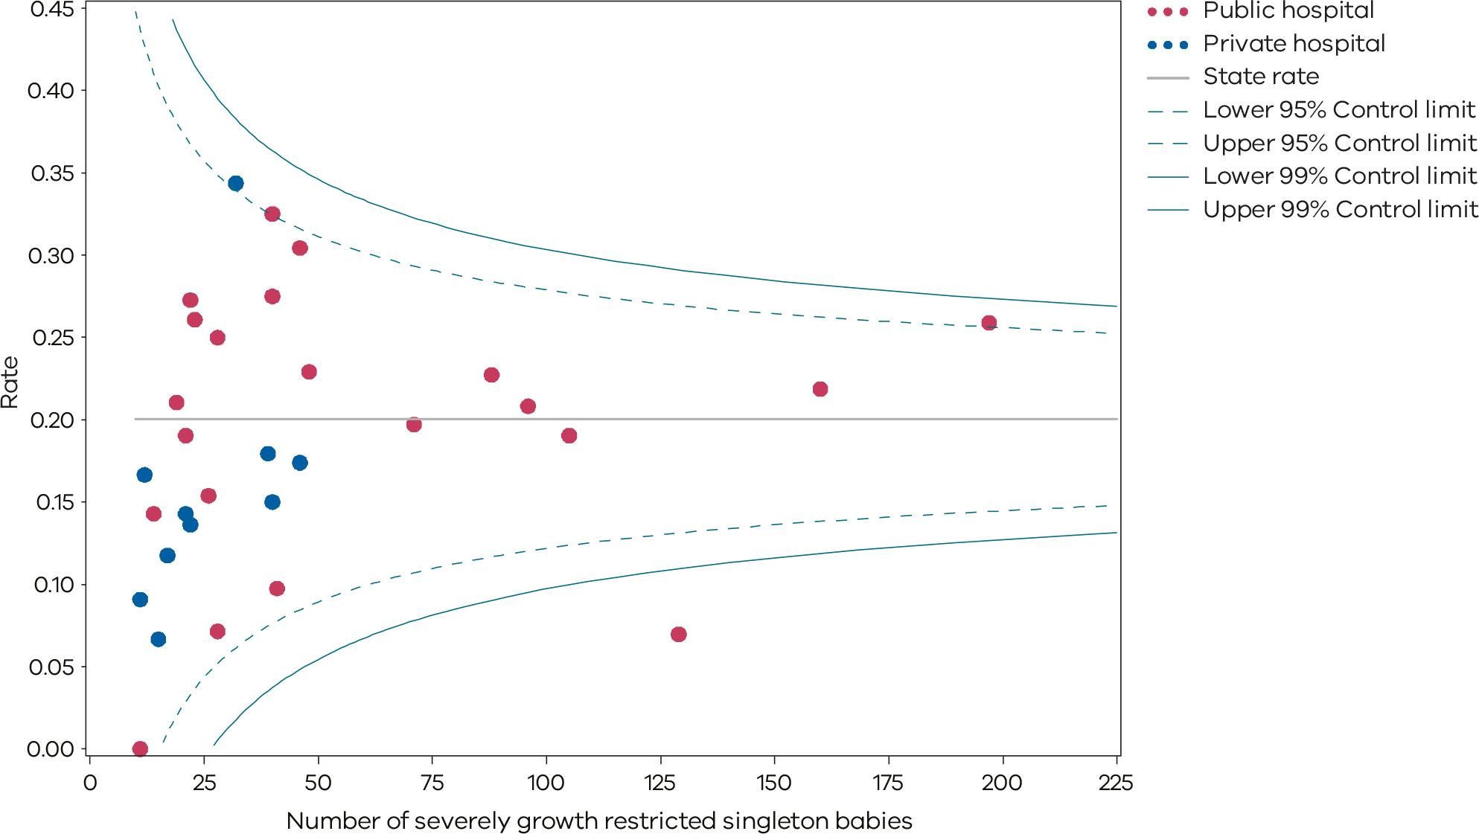
Please refer to the guide on how to interpret funnel plots.
Table 10. Rate of severe fetal growth restriction in a singleton pregnancy undelivered by 40 weeks, 2017–2021
 | 2017 | 2018 | 2019 | 2020 | 2021
Public | 28.0% | 23.0% | 22.1% | 20.5% | 20.6%
Private | 28.8% | 30.2% | 26.4% | 21.3% | 17.5%
Statewide | 28.1% | 24.3% | 23.0% | 20.8% | 20.0%
Figure 29. Time trend of Indicator 3a, 2017–2021
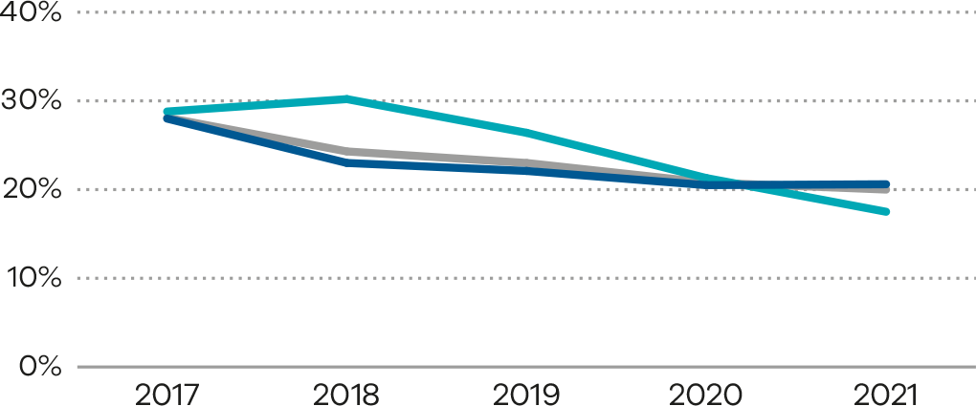
Figure 30. Indicator 3b: Rate of babies with a birthweight above the 25th centile actively delivered for fetal growth restriction before 39 weeks’ gestation (FGR balance measure), 2021
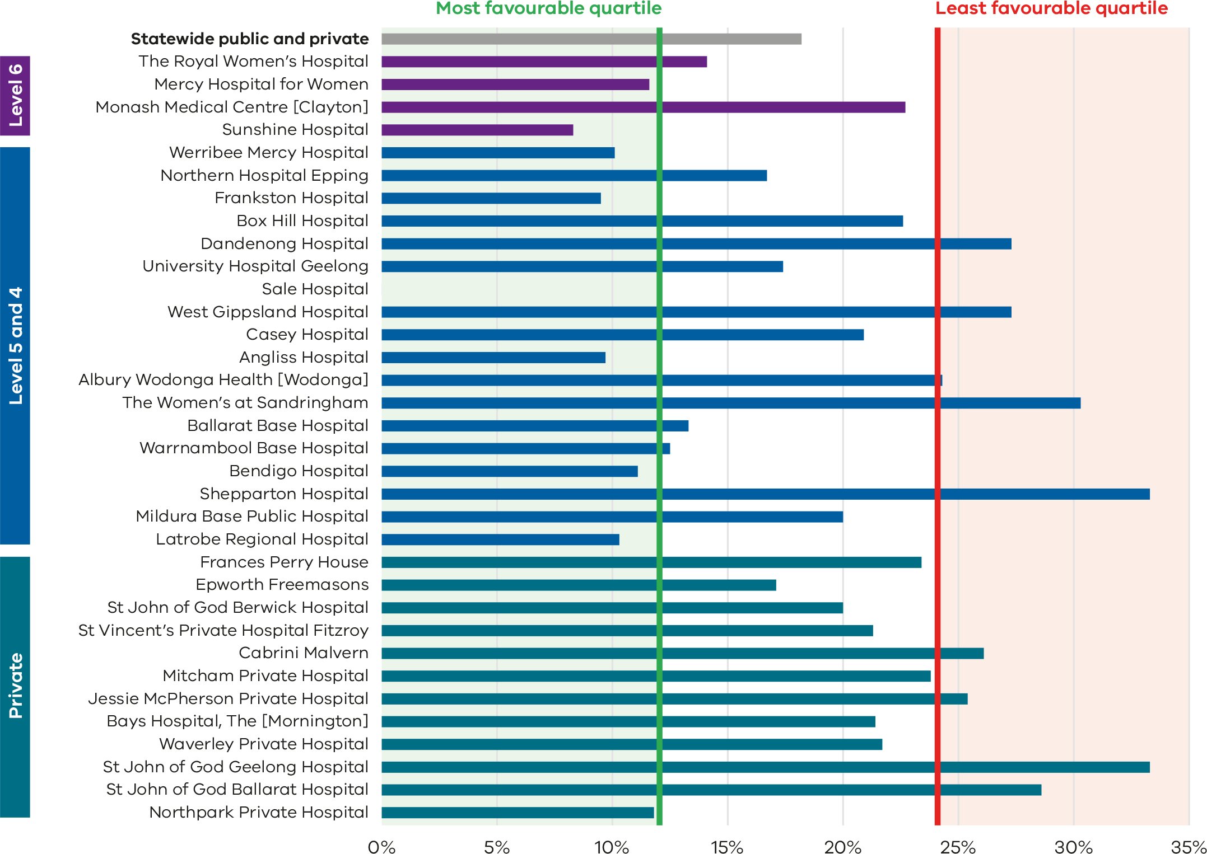
Figure 31. Funnel plot of rate of babies with a birthweight above the 25th centile actively delivered for fetal growth restriction before 39 weeks’ gestation (FGR balance measure), 2021
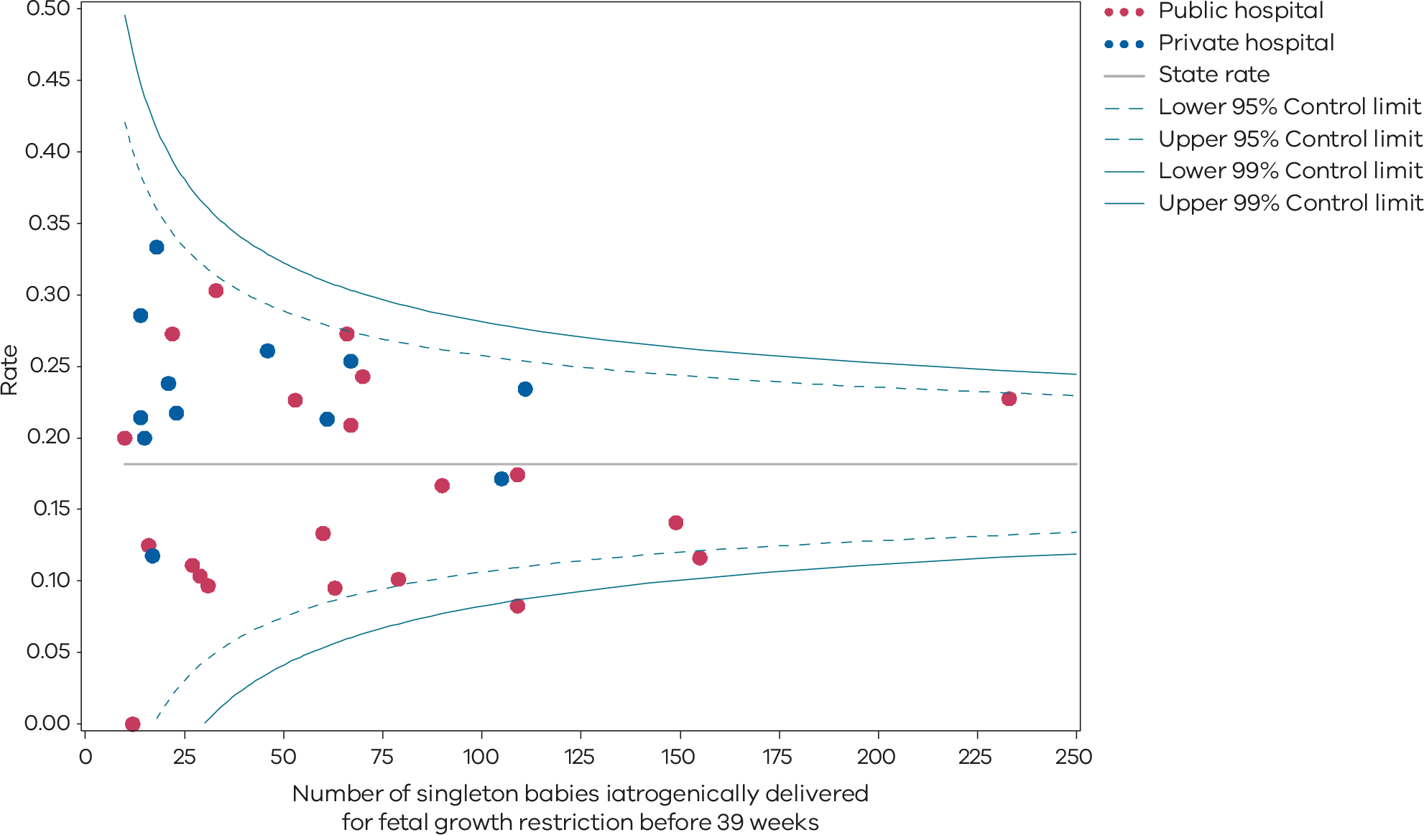
Please refer to the guide on how to interpret funnel plots.
Table 11. Rate of babies with a birthweight above the 25th centile actively delivered for fetal growth restriction before 39 weeks’ gestation (FGR balance measure), 2021
 | 2021
Public | 16.8%
Private | 22.1%
Statewide | 18.2%

Definition and data source

Definition
Severe FGR is defined as a birthweight less than the third centile for gestation and sex whether liveborn or stillborn.
For indicator 3a, exclusions are:
- babies without severe FGR
- multiple births
- births at earlier gestations (less than 32 weeks).
For indicator 3b, exclusions are:
- babies not delivered for suspected FGR
- multiple births
- births less than 32 weeks’ gestation and births greater than or equal to 39 weeks’ gestation.

Data source: Victorian Perinatal Data Collection
Data for this indicator is sourced from the VPDC for the calendar year from 1 January 2021 to 31 December 2021.
Indicator 3a is derived using the following VPDC variables: ‘Sex – baby’, ‘Estimated gestational age’, ‘Birthweight’ and ‘Plurality’.
Indicator 3b is derived using the following VPDC variables: ‘Sex – baby’, ‘Estimated gestational age’, ‘Birthweight’, ‘Plurality’ and ‘Labour type’.
Numerator/denominator
Indicator | Numerator | Denominator
Indicator 3a: Rate of severe fetal growth restriction in a singleton pregnancy undelivered by 40 weeks | Birth at 40 or more weeks’ gestation of a singleton baby with severe FGR | Singleton births (live and stillborn) with severe FGR born at and beyond 32 weeks’ gestation
Indicator 3b: Rate of babies with a birthweight above the 25th centile actively delivered for fetal growth restriction before 39 weeks’ gestation | Singleton births iatrogenically delivered for FGR before 39 weeks’ gestation whose birthweight was above the 25th centile | Singleton births iatrogenically delivered for FGR before 39 weeks’ gestation
For indicator 3a, a baby is considered to be severely growth-restricted when their birthweight is below the third centile for gestation, sex and plurality. It is calculated based on the Australian Institute of Health and Welfare’s national birthweight percentiles by sex and gestation, 2004 to 2013 tables (refer to Tables 26 and 27). For example, if a male singleton baby weighing 1,600 grams is born at 35 weeks, it falls below the third centile for gestation, sex and plurality. The baby is then considered severely growth restricted (Indicator 3a).
For indicator 3b, a baby is considered to be normally growing if their birthweight was above the 25th centile for gestation, sex and plurality. It is calculated based on the Australian Institute of Health and Welfare’s national birthweight percentiles by sex and gestation, 2004 to 2013 tables (refer to Tables 26 and 27).

4a and 4b: Vaginal birth after primary caesarean section
Vaginal birth after caesarean section (VBAC) describes a successful vaginal birth in a woman who has had a caesarean section in a previous pregnancy. Labour in women desiring a VBAC without contraindications is accepted and generally safe.
When successful, VBAC is associated with a decrease in maternal morbidity and avoidance of surgical recovery in the postpartum period as well as a decreased risk of complications in future pregnancies. There is a risk of serious potential complications including uterine rupture or dehiscence and associated maternal or neonatal morbidity.

About this indicator
Indicator 4a identifies the proportion of women who planned for a vaginal birth for their second baby after a caesarean section for their first (VBAC).
Indicator 4b shows the proportion of women who achieved a planned vaginal birth for their second baby after a caesarean section for their first (VBAC).
Caesarean sections can improve outcomes for women and babies in certain circumstances. However, a caesarean section can prolong recovery after birth and may increase the chance of complications in subsequent pregnancies. If there are no contraindications, women who have had a previous caesarean section should be encouraged to consider and plan a VBAC.
For health services, caesarean sections require additional resources and add costs. Level 1 and 2 services are not able to provide women with the opportunity for VBAC under the 2021 Capability frameworks for Victorian maternity and newborn services <https://www.health.vic.gov.au/patient-care/capability-frameworks-for-maternity-and-newborn-care-in-victoria>. These services should support a woman’s wish to attempt a VBAC and refer to a service that has this capability.
[Break out box text:

What pregnant women and families need to know
Most women who have had a caesarean section in a previous pregnancy can try to have a vaginal birth for their next baby. This indicator measures how many of these women intended to have a vaginal birth, and how many actually had a vaginal birth. In Victoria more than half of women who try a VBAC will give birth to their baby vaginally. Talk to your healthcare provider about what is best for you.
End of break out box text.]

Observations on the data
The proportion of women planning a VBAC (Indicator 4a) decreased from 22.9% in 2020 to 21.5% in 2021 (Figure 34). This has been a steady reduction from 2017 when 23.7% planned a VBAC (Table 12). Women in public hospitals were more likely to plan a VBAC (26.0%) compared with women in private hospitals (11.3%). There was wide variation across the hospitals and capability levels (Figure 32 and Figure 33).
The proportion of women who achieved a planned VBAC (Indicator 4b) increased in 2021 to 54.3% from 52.2% in 2020. The proportion who achieved a planned VBAC increased in both public hospitals (54.1% in 2021 compared with 52.5% in 2020) and private hospitals (52.6% in 2021 compared with 48.8% in 2020) (Table 13). The proportion who achieved a VBAC showed variation across the state (from 27.8% to 77.2%) (Figure 35 and Figure 36).

Strategies for improvement
- Women who have a primary caesarean section should be provided adequate information before discharge from hospital about considerations for future pregnancies and birth.
- Health services should provide women with individualised counselling about their options for birth if they have had one previous caesarean section and a clear management plan for labour and birth documented in the medical record.
- Women requesting a VBAC should be supported and may need referral to a service with the capability to offer this.
- Health services should review VBAC pathways offered to women and review identified deficiencies to accessing facilities, specialists or standards of care.
- Provide evidence-based information (verbal and written) to women about the benefits and risks of VBACs.
Figure 32. Indicator 4a: Rate of women who planned a vaginal birth after a primary caesarean section, 2021
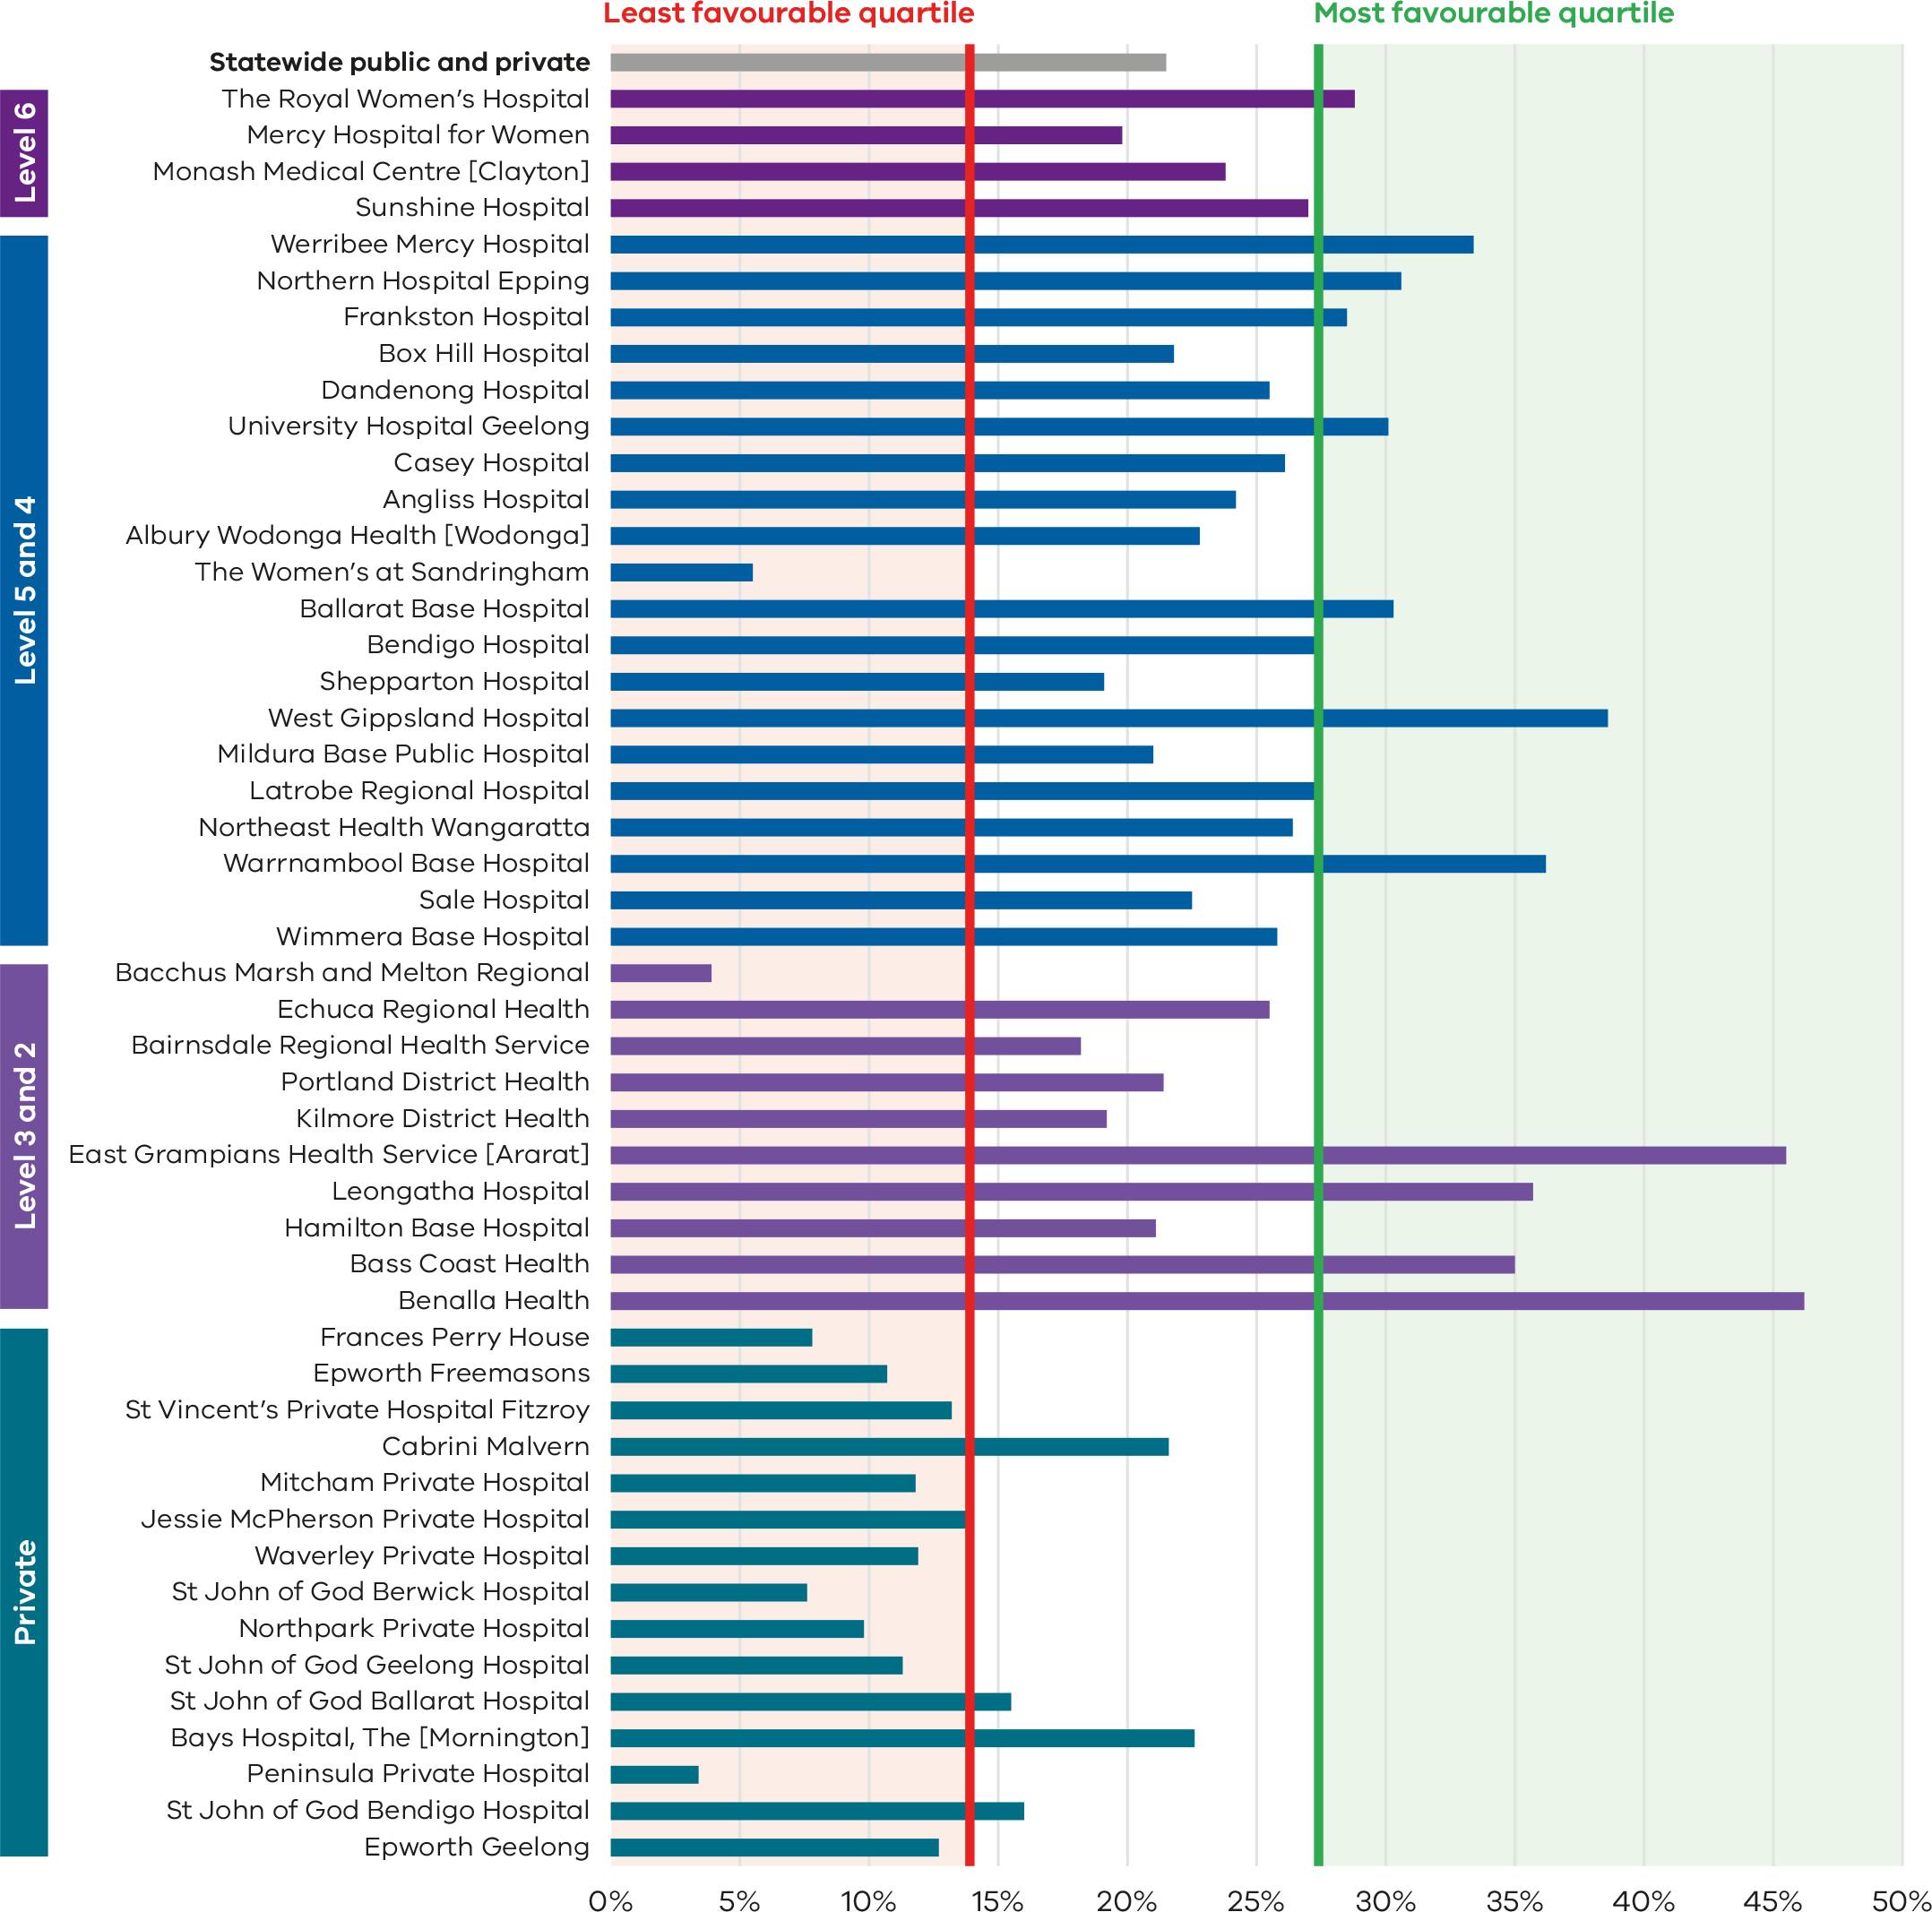
Figure 33. Funnel plot of the rate of women who planned a vaginal birth after a primary caesarean section, 2021
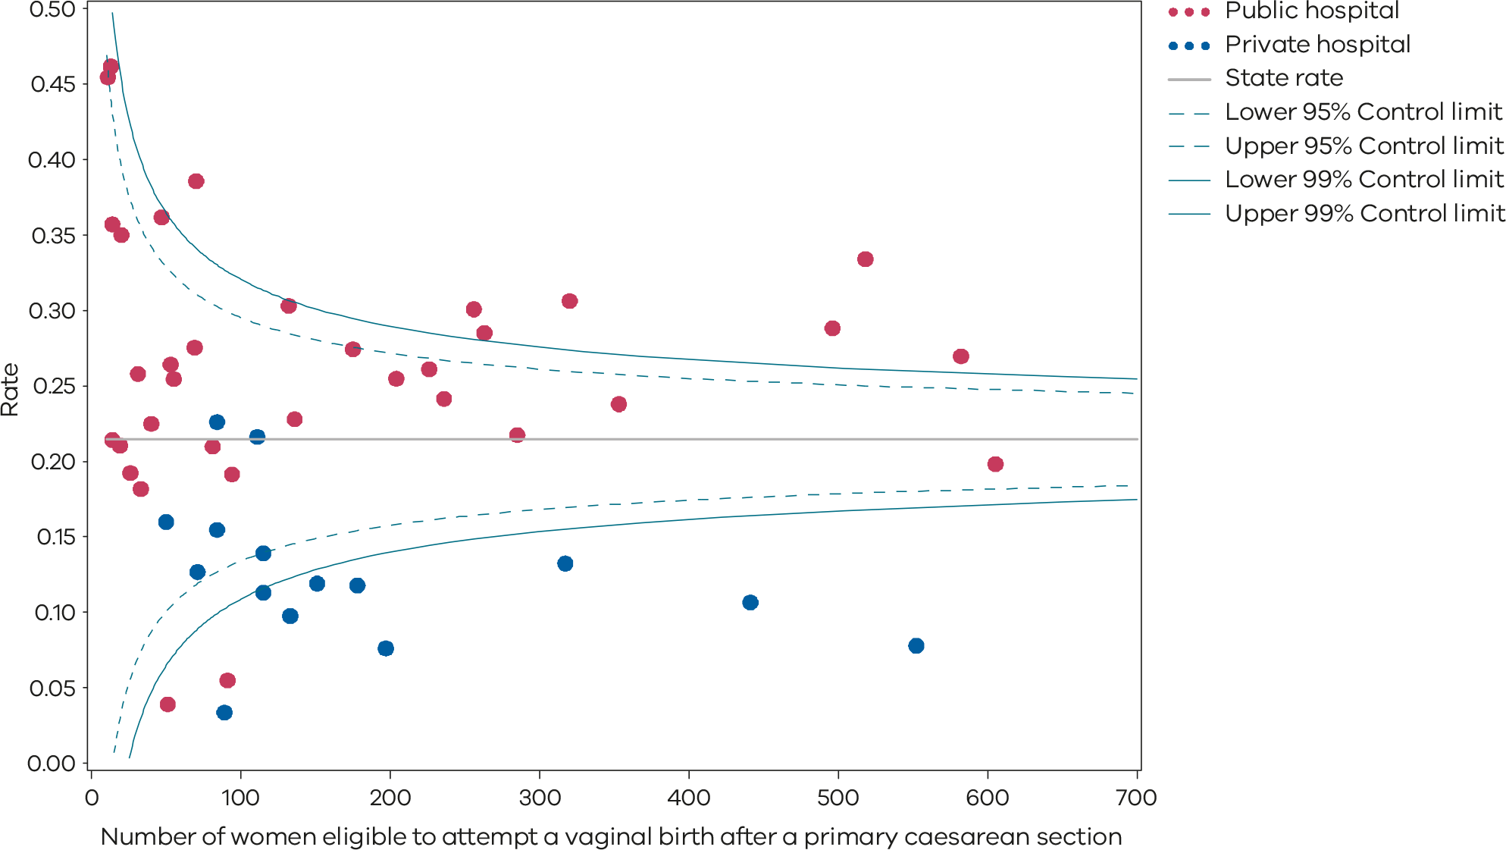
Please refer to the guide on how to interpret funnel plots.
Table 12. Rate of women who planned a vaginal birth after a primary caesarean section, 2017–2021
 | 2017 | 2018 | 2019 | 2020 | 2021
Public | 27.8% | 27.1% | 26.3% | 27.8% | 26.0%
Private | 14.7% | 14.7% | 13.2% | 11.2% | 11.3%
Statewide | 23.7% | 23.4% | 22.3% | 22.9% | 21.5%
Figure 34. Time trend of Indicator 4a, 2017–2021
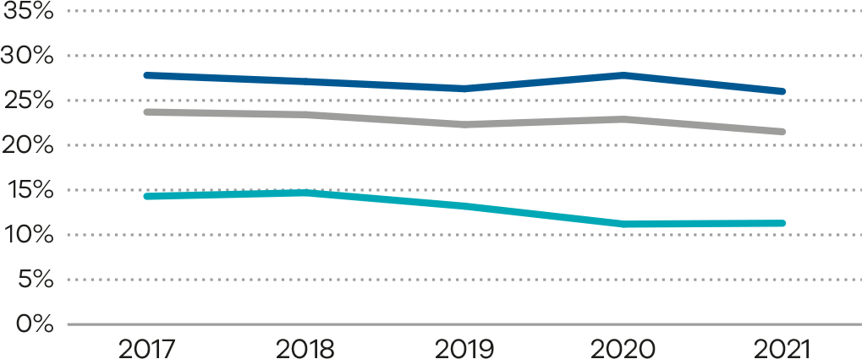
Figure 35. Indicator 4b: Rate of women who achieved a planned vaginal birth after a primary caesarean section, 2021
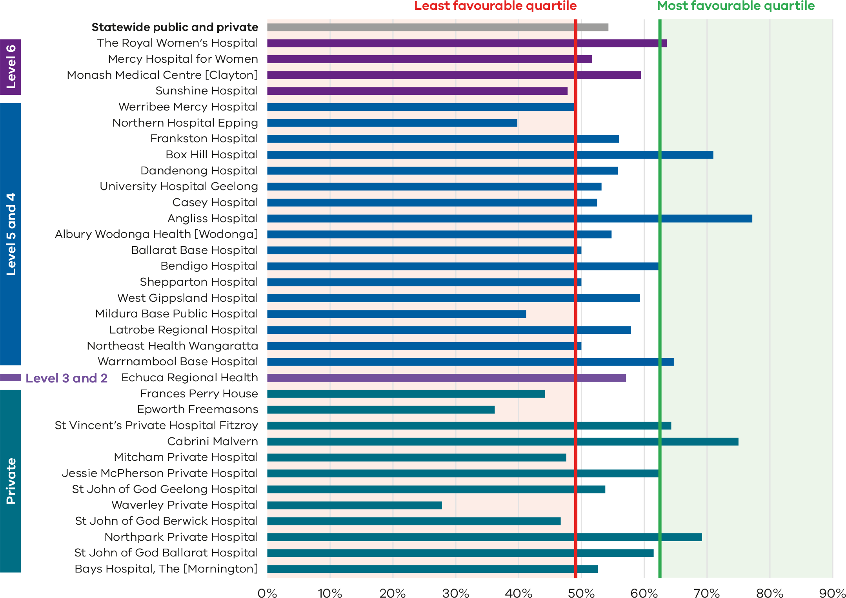

Figure 36. Funnel plot of the rate of women who achieved a planned vaginal birth after a primary caesarean section, 2021
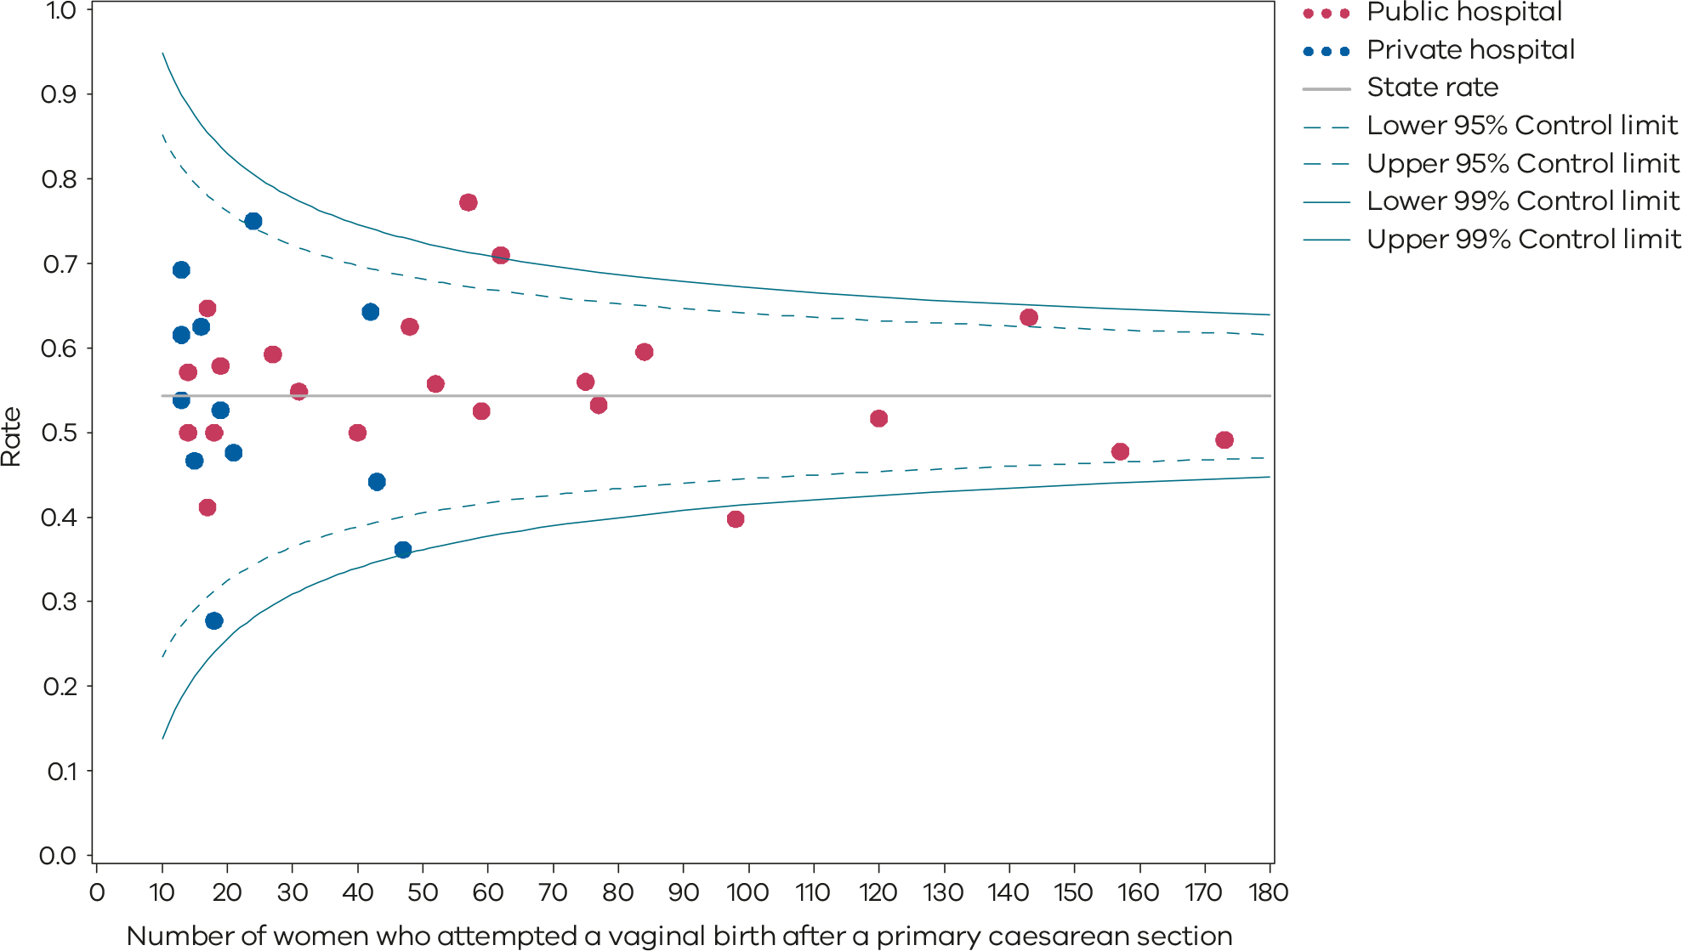
Please refer to the guide on how to interpret funnel plots.
Table 13. Rate of women who achieved a planned vaginal birth after a primary caesarean section, 2017–2021
 | 2017 | 2018 | 2019 | 2020 | 2021
Public | 54.4% | 55.0% | 54.1% | 52.5% | 54.1%
Private | 48.8% | 46.9% | 48.1% | 48.8% | 52.6%
Statewide | 54.8% | 53.5% | 53.2% | 52.2% | 54.3%
Figure 37. Time trend of Indicator 4b, 2017–2021
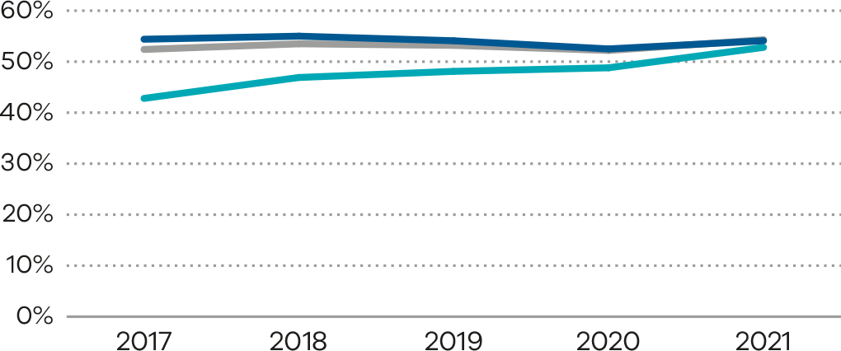

Definition and data source

Definitions
Definitions for this indicator may differ from VBAC indicators reported by other organisations. Primary caesarean is often defined as the first caesarean regardless of parity, whereas this indicator selects women having a singleton second birth at term, whose only prior birth was by caesarean.
The VPDC collects outcomes for women at term whose only previous birth was a caesarean section; any of these women who entered labour and did not have a subsequent planned caesarean is assumed to have planned a VBAC.
Excluded are:
- some hospitals – not all hospitals in Victoria offer VBAC, and those that do not have been excluded from the indicator
- women who had a pre-labour unplanned caesarean
- multiple births (more than one baby – for example, twins or triplets)
- women who had a vaginal birth for their previous birth
- women not having their second birth.

Data source: Victorian Perinatal Data Collection
Data for these indicators are sourced from the VPDC for the calendar year from 1 January 2021 to 31 December 2021.
The indicators are derived using the following VPDC variables: ‘Parity’, ‘Total number of previous caesareans’, ‘Last birth – caesarean section indicator’, ‘Plurality’, ‘Estimated gestational age’, ‘Birthweight’, ‘Birth order’, ‘Labour type’ and ‘Method of birth’.
Numerator/denominator
Indicator | Numerator | Denominator
Indicator 4a: Rate of women who planned a vaginal birth after a primary caesarean section | The number of women (second time mothers and at term with a singleton pregnancy) whose previous birth was a caesarean section and who enter labour with a plan for a vaginal birth | The number of women (second time mothers and at term with a singleton pregnancy) whose previous birth was a caesarean section
Indicator 4b: Rate of women who achieved a planned vaginal birth after a primary caesarean section | The number of women (second time mothers at term with a singleton pregnancy) whose previous birth was a caesarean and who enter labour with a plan for a vaginal birth and who achieve a vaginal birth | The number of women (second time mothers at term with a singleton pregnancy) whose previous birth was a caesarean and who enter labour with a plan for a vaginal birth

5: Five-year gestation standardised perinatal mortality ratio
Gestation standardised perinatal mortality ratio (GSPMR) is a measure of perinatal mortality that compares the observed perinatal mortality rate for babies born at individual hospitals with what would be expected, accounting for the gestation at birth. It is a partially risk-adjusted calculation, enabling hospitals with higher proportions of births at lower gestations (and therefore higher likelihood of perinatal mortality) to be validly compared with hospitals with a different distribution of gestations.

About this indicator
Perinatal mortality includes stillbirths (death before birth) and deaths in the first 28 days for babies born alive.
Pooling the data over 5-year periods adds stability to the data and reduces the risk of over-interpretation of chance fluctuations.
The indicator provides a visual representation of the variation in perinatal mortality occurring across Victorian public and private hospitals compared with the statewide rate.
The GSPMR of the individual health services are published in this report only if there are 5 or more perinatal deaths (stillbirths and neonatal deaths) in the 5 pooled years (2017–2021). More services are included in the current report because in previous reports only individual health services with at least 5 perinatal deaths in any one of the 5 included years were published. Only hospitals with at least 10 babies in the denominator in 2021 are reported.
It is important to note that the GSPMR is adjusted only for the gestation at birth. Many other factors also put babies at higher and lower risk of perinatal death, including the socioeconomic situation of the woman. This may explain some of these results that are lower than expected.
[Break out box text:

What pregnant women and families need to know
Counting how many unborn and newborn babies die tells us part of the story about the quality of care for new mothers and babies.
We know some deaths are unexpected and could not have been prevented. We average the number of deaths over a 5-year period to get a better sense of the overall care that a hospital provides. For this indicator we only look at babies born at or after 32 weeks’ gestation and up until 28 days after birth. Not all these deaths occur within the healthcare system.
There should be very little difference between hospitals.
End of break out box text.]

How to interpret the ratio
The statewide ratio (the reference population) is set at ‘1’. A GSPMR of 1 indicates that the observed number of perinatal deaths at that hospital is exactly what would be expected, considering the gestation of babies born there.
An individual hospital with a ratio of:
- 0.5 has a perinatal mortality that is half the statewide rate
- 1 has a perinatal mortality that is equal to the statewide rate
- 1.5 has a perinatal mortality that is 50% above the statewide rate
- 2 represents perinatal mortality that is double the statewide rate.
These rates include only babies who were born at 32 or more weeks’ gestation.
The statewide rate (1) does not necessarily represent the optimal or clinically appropriate rate for perinatal mortality. A rate greater than 1 indicates more deaths occurred than were expected, and a rate less than 1 indicates fewer deaths occurred than were expected.

What does the GSPMR tell us?
- It shows where there is variation in perinatal mortality rates for hospitals of similar capability or size.
- It adjusts for gestation, the most important risk factor for perinatal death.

What can’t the GSPMR tell us?
The GSPMR does not indicate:
- statewide or individual hospital perinatal mortality rates
- whether the results for a given hospital are improving over the 5-year period
- the reasons for the deaths or how the babies died (a baby may have died before arriving at the birth hospital, while in the hospital or following discharge from hospital – for example, due to sudden unexpected death in infancy, a car accident or injury)
- whether the death could have been avoided
- whether the care around the time of death was provided by a different hospital (transfer) or health professional than the birth hospital
- where the baby died – it only tells us where the baby was born
- the safety of a maternity service
- the contribution of important risk factors associated with perinatal mortality such as obesity, smoking, pre-existing illness of the mother, low socioeconomic status and ethnicity.

How to read these plots
Each dot on Figure 38 and Figure 39 represents one hospital. The horizontal line on each graph represents a GSPMR where the observed count of deaths is equal to the expected count of deaths (GSMPR = 1).
Hospitals (dots) that are above this line (above 1) have a GSPMR that suggests the observed count of deaths are higher than the expected count of deaths. Hospitals that are below this line have a GSPMR that suggests the observed count of deaths is lower than the expected count. It is desirable to have a GSPMR less than 1; however, due to the nature of this indicator, around half of all hospitals will always have a GSPMR greater than 1 and around half will have a GSPMR less than 1.
The dashed and solid blue lines in the funnel plot (Figure 39) represent control limits based on one standard deviation (1SD) and 2 standard deviations (2SD) from the solid horizontal line, respectively. Control limits can be used to test how different a hospital’s GSPMR is from 1, taking the size of the hospital into consideration. If a hospital falls outside the 2SD control limits of the plot, its GSPMR is considered to be significantly different from 1. In the above funnel plot, hospitals that fall above the upper 2SD control limit have significantly higher than expected perinatal mortality. Hospitals that fall below the lower 2SD control limit have significantly lower than expected perinatal mortality.
It is important to note that the GSPMR is adjusted only for the gestation at birth. Many other factors also put babies at higher and lower risk of perinatal death, including the socioeconomic situation of the woman. This may explain some of these results that are lower than average.
Figure 38. Five-year gestation standardised perinatal mortality rate, 2017–2021
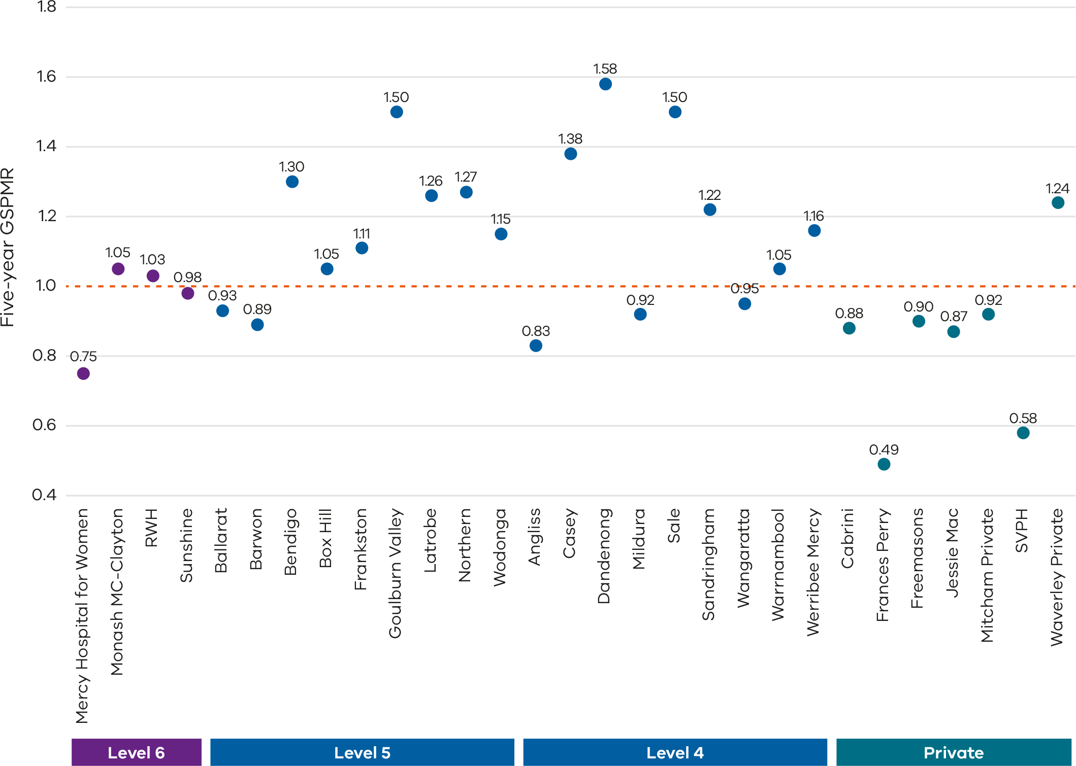
Only health services with at least 5 deaths during the 5-year reference period are included in this plot.
The GSPMRs for individual health services are given in Appendix 3: Overview of results.
Figure 39. Funnel plot of 5-year GSPMR compared with the statewide public rate 2017–2021
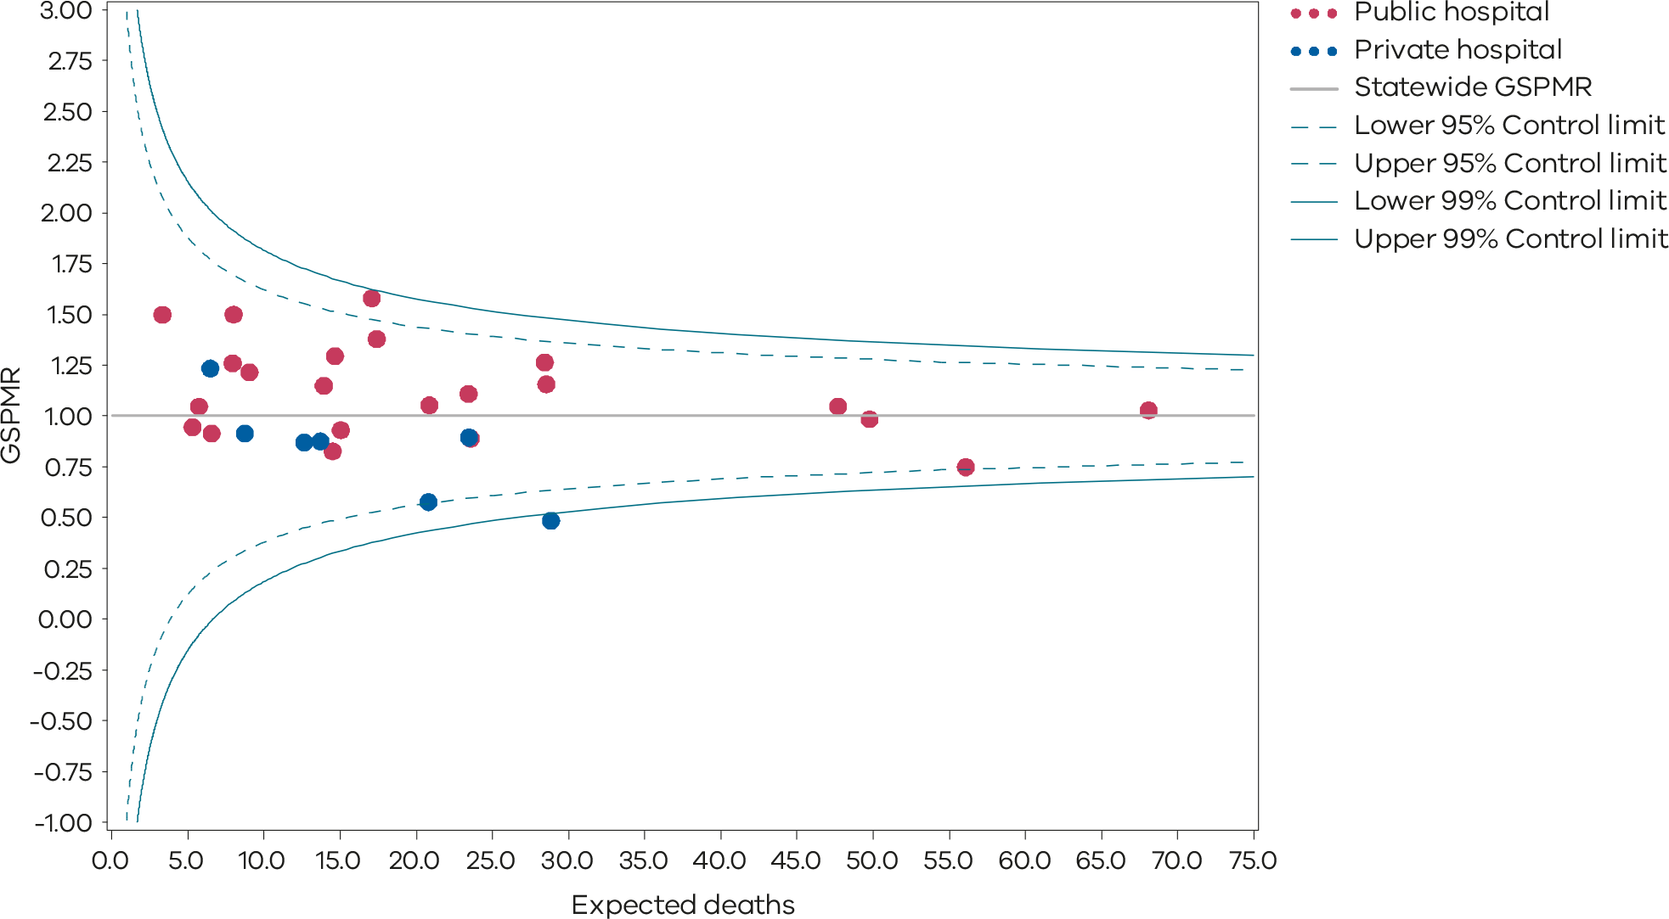
Only health services with at least 5 deaths during the 5-year reference period are included in the funnel plot.
The GSPMRs for individual health services are given in Appendix 3: Overview of results.

Definition and data source

Definition
The GSPMR is standardised according to the gestational age-specific perinatal mortality rates of the total population in Victorian hospitals. The standardisation does not adjust for inter-hospital transfers, and deaths are ascribed to the birth hospital regardless of the timing of the death in relation to the transfer.
The data in this report:
- is calculated from 5 years of pooled data between 2017 and 2021
- is standardised using gestational age
- excludes births earlier than 32 weeks, 0 days
- excludes birthweights less than 150 grams regardless of gestation
- excludes all deaths due to congenital anomalies and all terminations of pregnancy.
These exclusions provide a more sensitive indicator to reflect the quality of care.
The GSPMR is presented with data for individual public and private hospitals being shown in relation to the statewide hospital perinatal mortality rate for each week of gestation as the standard or reference population.

Data source: Victorian Perinatal Data Collection
Data for this indicator is sourced from the VPDC for the calendar year from 1 January 2017 to 31 December 2021.
Observed/expected
Indicator | Observed | Expected
Indicator 5: Perinatal mortality ratio for babies born at 32 or more weeks (gestation standardised, excluding all terminations of pregnancy and deaths due to congenital anomalies) using 5 years’ pooled data in Victorian public and private hospitals (32 weeks or more GSMPR) | Observed perinatal deaths from 32 weeks, 0 days (by weeks’ gestation at birth) | Expected perinatal deaths from 32 weeks, 0 days (by weeks’ gestation at birth)

6a and 6b: Readmissions during the postnatal period
The postnatal period is a period of adjustment to early parenting and recovery that may include establishing breastfeeding. Readmissions to hospital in the postnatal period are usually unplanned and may be avoidable. Reducing avoidable hospital readmissions supports better health outcomes, improves patient safety and leads to greater efficiency in the healthcare system.
Higher readmission rates can be associated with discharge practices, the care provided during the days following birth and/or limited support in the community. Ensuring a successful transition from hospital to community-based care (maternal and child health services and general practitioners) is important for the ongoing support of women, babies and families. For most women and babies admitted as public patients, this transition usually occurs after at least one home visit following discharge, by a hospital midwife. This visit should occur between 24 to 48 hours after discharge from the hospital.

About this indicator
These indicators measure the rate of unplanned and potentially preventable postpartum readmissions of women (6a) and newborns (6b) to any hospital within 28 days of discharge from the birth hospital.
High-quality care means most women and their babies should not return to hospital during the postnatal period. While not all unplanned readmissions are as a result of poor-quality care and not all complications are avoidable, unplanned and potentially preventable hospital stays during this period reflects a deviation from the normal course of postnatal recovery. This results in increased healthcare costs and possible impacts on health and wellbeing for women and their babies.
[Break out box text:

What pregnant women and families need to know
Healthy babies born to healthy mothers generally don’t need to go back to hospital in their first month. Sometimes readmitting the baby or the mother is unavoidable and is the safest thing to do because a condition has developed since discharge. The graphs on the following pages (Figure 40 and Figure 43) show how many mothers and babies needed to go back to hospital within 28 days of birth for each hospital. The rate should be low.
End of break out box text.]

Observations on the data
In 2021, the statewide rate of unplanned maternal readmissions within 28 days of discharge (Indicator 6a) was 2.0%, a slight reduction from the previous year’s rate of 2.3% (Figure 40, Figure 41, Figure 42 and Table 14).
As in previous years, the rate was higher in public hospitals at 2.2% compared with private hospitals at 1.3% which may reflect an average longer length of stay in private hospitals during the birth admission.
The public hospital statewide average rate of unplanned newborn readmissions within 28 days of discharge (Indicator 6b) was 4.9%, which has remained steady since 2020 (Figure 43, Figure 44 and Table 15). The rate of readmissions for newborns has increased since 2017–18 when the rate of unplanned readmissions was 4.1% (Table 15).
The reduction in length of stay for mothers and babies has been persistent since the end of pandemic restrictions. The rate of unplanned readmissions may be a balance measure for reduction in length of stay. The recently released CCOPMM 2023 COVID-19 communique <https://www.safercare.vic.gov.au/sites/default/files/2023-09/Final%20CCOPMM%20COVID%20communique.pdf> notes a reduction in readmission for women with infections and lactation problems but an increase in hypertensive disorders, while noting an increase in readmission for babies with feeding problems.
It is worth noting that health services may be reporting readmission differently due to different policies around domiciliary or hospital in the home care.

Strategies for improvement
Health services should consider:
- whether the length of stay in hospital following birth is appropriate to the individual needs of women and babies
- auditing and identifying the groups of women and babies who have higher readmission rates for the purpose of implementing improvement initiatives
- providing individualised (verbal and written) information in the discharge plan and education tools for women and their families at discharge and use an interpreter if needed
- the number of home-based domiciliary visits and the extent of care different groups of women can expect from hospital midwives
- an analysis of the reasons for readmission of women and newborns, noting that readmissions are not always a result of poor care and that quick detection of postnatal complications is important and constitutes good care such as jaundice in a newborn or hypertension in a mother (hospitals should take steps to avoid preventable complications such as wound infections post caesarean section)
- a review of the effectiveness of postnatal programs, identifying areas of risk to women and babies, those at increased risk of readmission and trialling interventions to prevent readmission
- access to local services and pathways across health services to support regional and rural areas
- implementing models of care that promote continuity through the antenatal and postnatal period
- ensuring transitions of care to community-based services (for example, maternal child health, perinatal mental health and general practitioner care) are timely.
Figure 40. Indicator 6a: Rate of maternal readmissions during the postnatal period, 2021–22
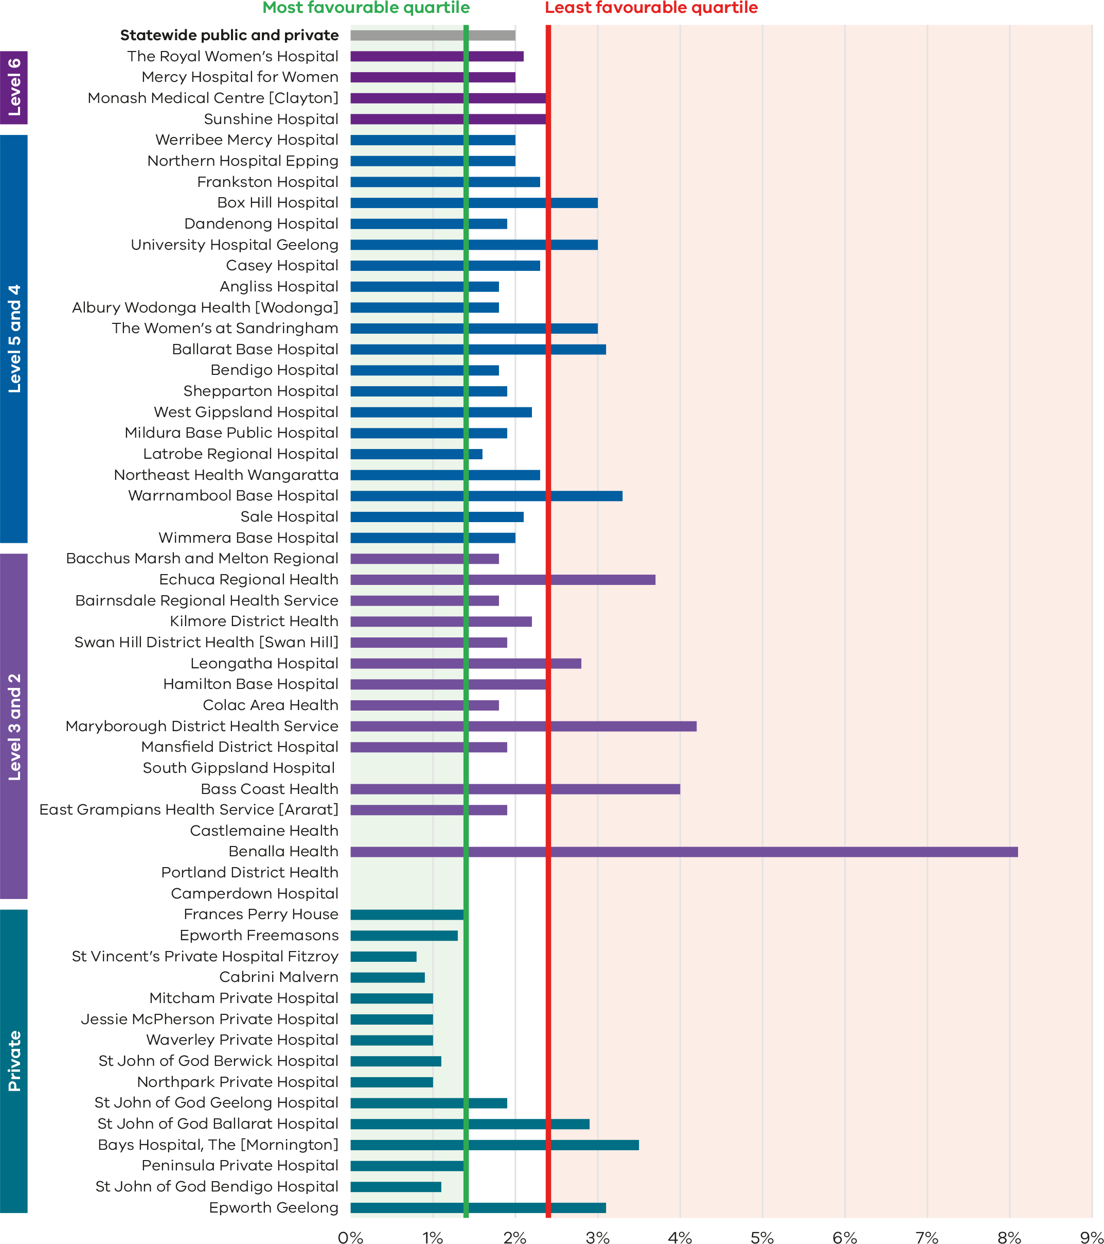
Figure 41. Funnel plot of maternal readmissions during the postnatal period, 2021–22
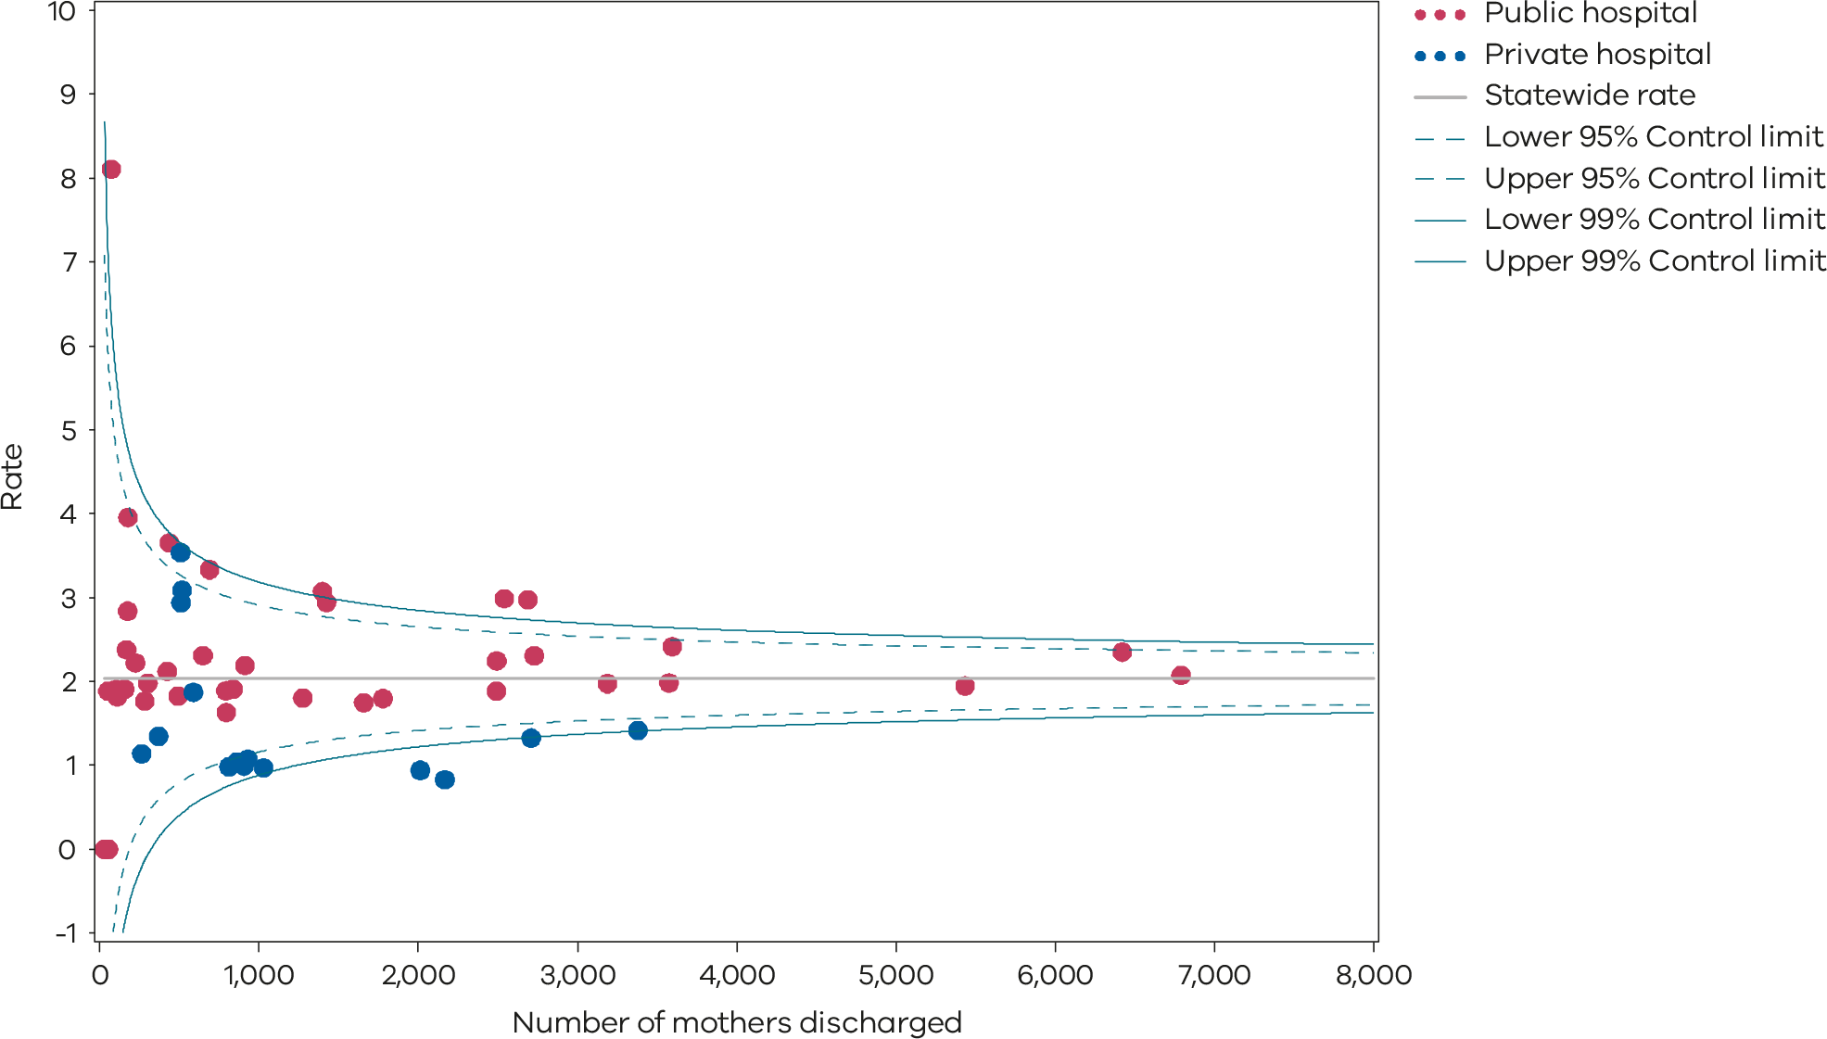
Please refer to the guide on how to interpret funnel plots.
Table 14. Rate of maternal readmissions during the postnatal period, by financial year 2017–18 to 2021–22
 | 2017–18 | 2018–19 | 2019–20 | 2020–21 | 2021–22
Public | 2.5% | 2.7% | 2.4% | 2.5% | 2.2%
Private | 2.5% | 2.0% | 1.7% | 1.7% | 1.3%
Statewide | 2.5% | 2.6% | 2.3% | 2.3% | 2.0%
Figure 42. Time trend of Indicator 6a, 2017–2021
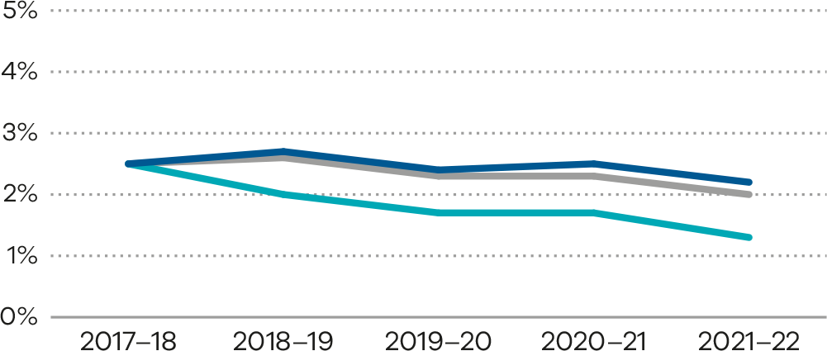
Figure 43. Indicator 6b: Rate of newborn readmissions during the postnatal period, 2021–22
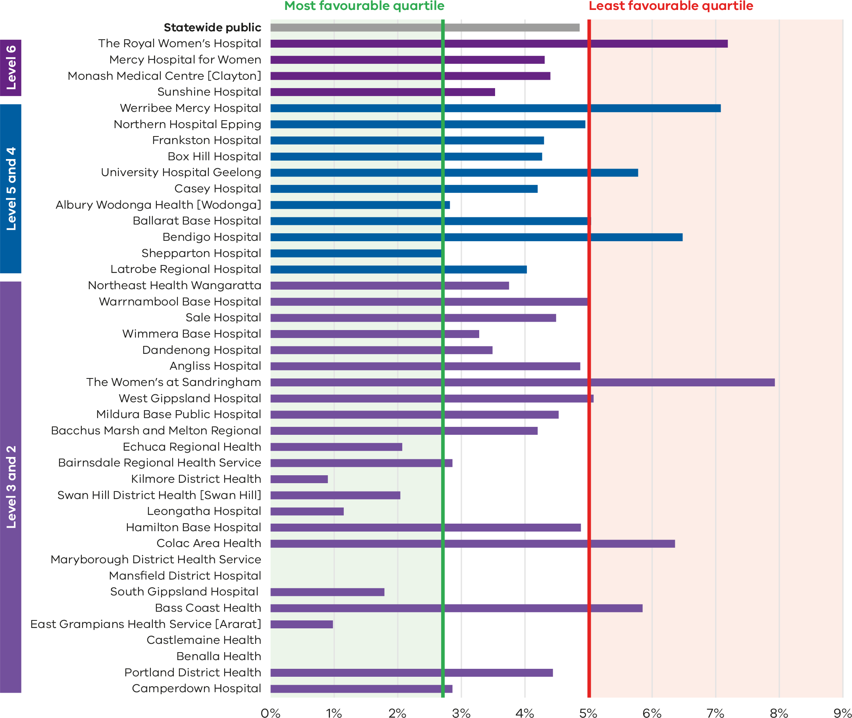
Note: Reporting of unqualified neonate admissions to the VAED for private hospitals is optional. It is therefore not possible to establish an accurate denominator (that includes public and private hospitals) for this indicator. As such, only public hospitals are included in the results.
Hospitals presented in this bar chart (Figure 43) are reported by neonatal capability levels.
Figure 44. Funnel plot of newborn readmissions during the postnatal period, 2021–22
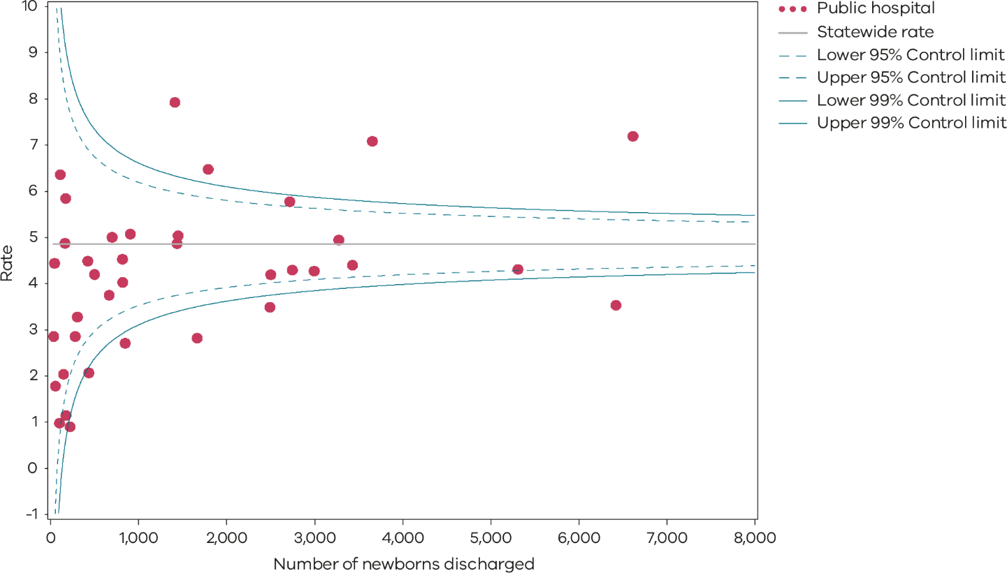
Please refer to the guide on how to interpret funnel plots.
Table 15. Rate of newborn readmissions during the postnatal period, by financial year 2017–18 to 2021–22
 | 2017–18 | 2018–19 | 2019–20 | 2020–21 | 2021–22
Public | 4.1% | 4.1% | 4.1% | 4.9% | 4.9%
Figure 45. Time trend of Indicator 6b, 2017–2021
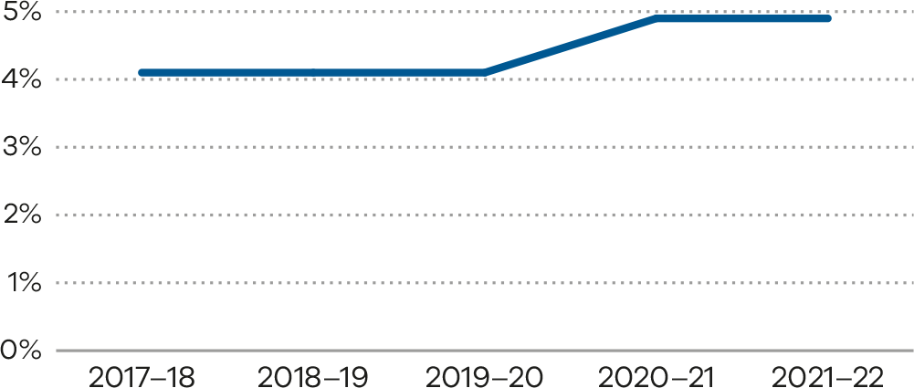

Definitions and data sources

Definition: Indicator 6a
The readmission rate is calculated for the hospital that discharged the mother from the birth episode. The rate includes admissions to any Victorian health service after the birth episode, not just a readmission to the birthing service.
Women transferred to another health service following a birth are excluded from the numerator total. Women who present to an emergency department or urgent care centre, but who are not admitted, are excluded from the numerator total. Women who are readmitted and have a principal diagnosis related to their pregnancy and/or birth are included in the numerator total. However, diagnosis codes that are associated with a complexity that cannot be prevented (or managed) through postnatal care and/or that are associated with a condition(s) that manifests after discharge from hospital without any indication of its presence prior to this time are excluded (refer to list below).
The denominator is the total number of birth episodes at a health service. The only exclusion is maternal death.
Potentially preventable readmission principal diagnosis codes are limited to the following:
- O722 – Delayed and secondary postpartum haemorrhage
- O860 – Infection of obstetric surgical wound
- O85 – Puerperal sepsis
- O9120 – Non-purulent mastitis without attachment difficulties
- Z466 – Fitting and adjustment of urinary device
- O901 – Disruption of perineal obstetric wound
- O149 – Pre-eclampsia (unspecified)
- O16 – Unspecified maternal hypertension
- O9903 – Anaemia complicating childbirth and the puerperium
- O731 – Retained portion placenta and membranes without haemorrhage
- O721 – Other immediate postpartum haemorrhage
- O902 – Haematoma of obstetric wound
- O862 – Urinary tract infection following delivery
- O900 – Disruption of caesarean section wound
- Z391 – Care and examination of lactating mother
- O13 – Gestational hypertension
- N390 – Urinary tract infection (site not specified)
- O9121 – Non-purulent mastitis with attachment difficulty
- F531 – Severe mental and behavioural disorder associated with puerperium (not elsewhere classified)
- F530 – Mild mental and behavioural disorder associated with puerperium (not elsewhere classified)
- G9719 – Reaction spinal and lumbar puncture (not elsewhere classified)
- R509 – Fever (unspecified)
- R33 – Retention of urine
- O152 – Eclampsia in the puerperium
- O720 – Third-stage haemorrhage
- T8852 – Failed moderate sedation during procedure.

Data source: Victorian Admitted Episodes Dataset (VAED)
Data for this indicator is sourced from the VAED for the financial year 1 July 2021 to 30 June 2022.
Numerator/denominator
Indicator | Numerator | Denominator
Indicator 6a: Readmission of a mother within 28 days of discharge from a birthing episode admission in a Victorian public or private hospital | The number of women readmitted to any health service within 28 days with a potentially preventable readmission diagnosis code | The total number of birth episodes at a health service

Definition: Indicator 6b
Readmissions that meet the criteria for inclusion are attributed to the health service that provided postnatal care as part of the birthing episode.
The readmission rate is calculated for the hospital that discharged the baby from the birth episode. The rate includes admissions to any Victorian health service after birth, not just a readmission to the birthing service. Babies transferred to another health services following a birth separation are excluded from the numerator total.
Babies who are readmitted on the same day of discharge are also excluded. This is because it is not possible to determine from the dataset whether these are genuine readmissions or a new separation following a planned transfer of care.
Babies who present to an emergency department or urgent care centre, but who are not admitted, are excluded from the numerator total.
Babies who are readmitted and have a principal diagnosis related to the pregnancy and/or birth are included in the numerator total (refer to list below). However, diagnosis codes that are associated with a complexity that cannot be prevented (or managed) through postnatal care and/or that are associated with a condition(s) that manifests after discharge from hospital without any indication of its presence prior to this time are excluded.
The denominator includes the total number of babies discharged from a health service. Stillbirths and neonatal deaths prior to discharge are excluded. Qualified and unqualified neonates are included – irrespective of their accommodation type during the birth episode (if they spent time in neonatal unit).
Potentially preventable readmissions are limited to the following list of principal diagnoses:
- P599 – Neonatal jaundice (unspecified)
- P929 – Feeding problem of newborn (unspecified)
- R628 – Other lack of expected normal physiological deviation
- P369 – Bacterial sepsis of newborn (unspecified)
- P928 – Other feeding problems of newborn
- P590 – Neonatal jaundice with pre-term delivery
- P598 – Neonatal jaundice from other specific causes
- P0732 – Other pre-term infant ≥ 32 weeks’ gestation but < 37 completed weeks
- P551 – ABO isoimmunisation of fetus and newborn
- Z0371 – Observation of newborn for suspected infectious condition
- P2840 – Apnoea of newborn (unspecified)
- P282 – Cyanotic attacks of newborn
- A870 – Enteroviral meningitis
- P38 – Omphalitis newborn with or without mild haemorrhage
- P741 – Dehydration of newborn
- P809 – Hypothermia of newborn (unspecified)
- P90 – Convulsions of newborn
- R634 – Abnormal weight loss.

Data source: Victorian Admitted Episodes Dataset
Data for this indicator is sourced from the VAED for the financial year 1 July 2021 to 30 June 2022.
Reporting of unqualified neonate admissions to the VAED for private hospitals is optional. It is therefore not possible to establish an accurate denominator (that includes public and private hospitals) for this indicator. As such, only public hospitals are included in the results. Homebirths are not included in the VAED.
Numerator/denominator
Indicator | Numerator | Denominator
Indicator 6b: Readmission of a newborn within 28 days of discharge from a birthing episode admission in a Victorian public hospital | The number of neonates readmitted to any health service with a potentially preventable readmissions diagnosis code within 28 days of birth | The number of neonates provided with admitted postnatal care prior to discharge

7: Smoking cessation
Smoking affects maternal health and babies born to women who smoke while pregnant are at risk of various preventable adverse outcomes and health complications including stillbirth, FGR and pre‑term birth. During pregnancy, women are motivated to protect their baby’s health. It is therefore an important time for health professionals to assist women to quit smoking. This indicator can be used by hospitals to measure how effective their interventions are and recognises the hospitals making the greatest impact towards smoking cessation.

About this indicator
This indicator assesses the effectiveness of health services in providing support for women who smoke in early pregnancy to quit. This includes smoking cessation advice, assistance and follow-up during the antenatal period. The aim is to reduce both the rate of smoking among pregnant women and the risk of smoking-associated adverse health outcomes for women and their babies.
The data in this report relates to the percentage of women who were reported as not smoking at or after 20 weeks’ gestation among those who smoked before 20 weeks.
This indicator has limitations as it does not capture data on whether women continue to not smoke after pregnancy.
[Break out box text:

What pregnant women and families need to know
Smoking is bad for your health. If you smoke while you are pregnant, then there is a risk that this will harm your baby. Smoking during pregnancy is one of the main causes of stillbirth. Your baby may be born small or born early. Quitting at any time during pregnancy can reduce the risk of harm to your baby. For help quitting smoking or vaping during pregnancy, women can speak to their maternity health professional or call Quitline on 13 78 48 or visit the following websites: Quitline <https://www.quit.org.au> or iSISTAQUIT <https://isistaquit.org.au>.
Health services monitor how many pregnant women in antenatal clinics smoke and provide advice and support to help women stop smoking while they are pregnant. We measure how many women stop smoking while they are pregnant, and the results on the graphs below are very different between hospitals.
End of break out box text.]

Observations on the data
The statewide percentage of women who smoked in the first 20 weeks of their pregnancy and did not smoke in the last 20 weeks of their pregnancy has decreased from 33.5% in 2020 to 31.4% in 2021 (Table 16). The rate for private hospitals continued to be higher compared with public hospitals (57.3% and 30.5%, respectively), although private hospital cessation rate also decreased from 2020 (64.0%).
The smoking cessation rate between individual hospitals ranged from zero to 95.6% (Figure 46). Also note some outliers as shown in Figure 47. Figure 48 shows trends over time.
The smoking cessation rates for hospitals in capability level 2 and 3 are, in general, lower than higher capability levels and private hospitals. These hospitals should review their smoking cessation programs.
The Safer Baby Collaborative <https://www.safercare.vic.gov.au/best-practice-improvement/improvement-projects/mothers-babies-children/safer-baby-collaborative>, which included a smoking cessation component, concluded in May 2021. Despite unprecedented circumstances, including a global pandemic and devastating bushfires, the participating health services achieved exceptional outcomes for Victorians, with the participating health services reporting an increase in smoking cessation rates of women during pregnancy by 200%, from an average rate of 11% to 33%. Safer Care Victoria would like to extend our sincere gratitude to those who contributed to this work under such exceptional circumstances.

Strategies for improvement
- Assess and screen all pregnant women for smoking at all pregnancy care appointments and in the postnatal period and offer referral to support programs such as Quitline.
- Data on vaping will be collected by VPDC from July 2024. Health services should ensure their processes for assessing and screening includes vaping.
- Implement Stillbirth CRE Smoking Cessation <https://stillbirthcre.org.au/about-us/our-work/the-safer-baby-bundle/smoking-cessation/> strategies including implementation of the 3-step Ask, Advise, Help model and referral processes.
- Encourage clinicians to complete the modules within the Stillbirth CRE Safer Baby Bundle E-learning <https://learn.stillbirthcre.org.au>.
- Provide individualised (written and verbal) information to pregnant women and their partners on benefits of quitting smoking. Resources for pregnant women include Safer Baby Bundle, which has translated resources, QuitLine <https://www.quit.org.au> and culturally appropriate resources for pregnant Aboriginal and Torres Strait Islander women from iSISTAQUIT <https://isistaquit.org.au>.
- Develop processes for accurately recording smoking status and the advice that is provided to women.

Figure 46. Indicator 7: Rate of smoking cessation during pregnancy, 2021
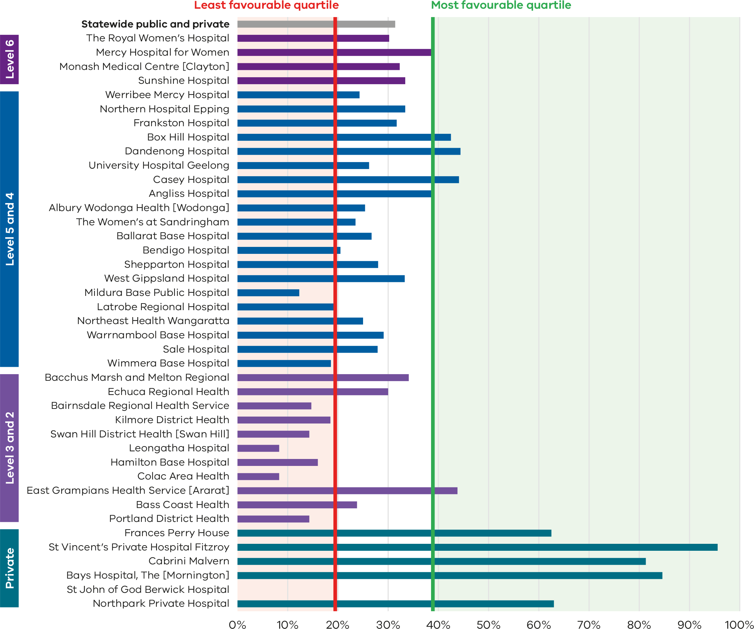

Figure 47. Funnel plot of the rate of smoking cessation during pregnancy, 2021
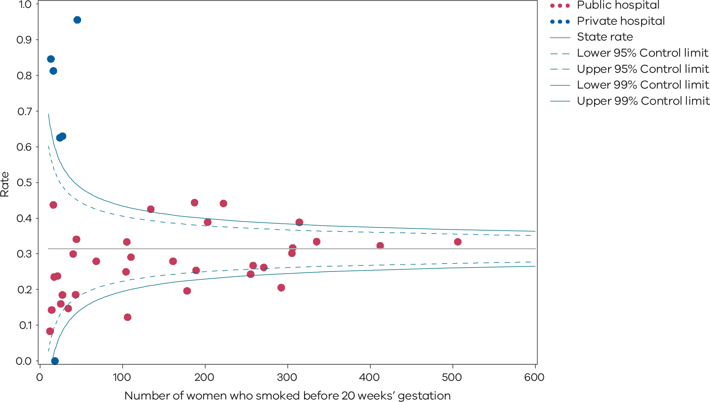
Please refer to the guide on how to interpret funnel plots.
Table 16. Rate of smoking cessation during pregnancy, 2017–21
 | 2017 | 2018 | 2019 | 2020 | 2021
Public | 25.5% | 26.6% | 26.8% | 32.6% | 30.5%
Private | 65.2% | 60.3% | 59.3% | 64.0% | 57.3%
Statewide | 27.1% | 28.0% | 28.0% | 33.5% | 31.4%
Figure 48. Time trend of Indicator 7, 2017–2021
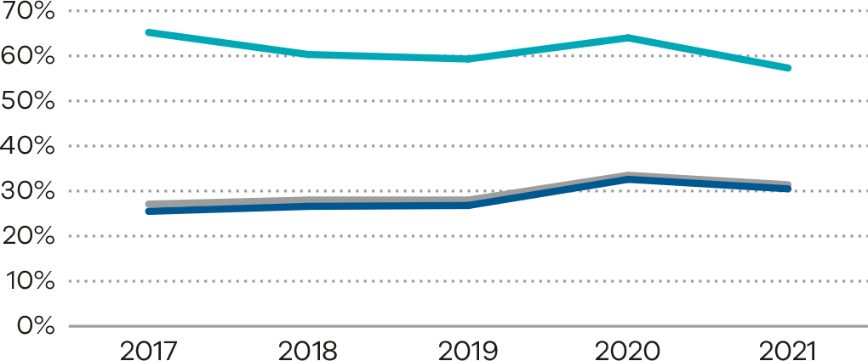

Definition and data source

Definition
The percentage of women who were reported as not smoking at or after 20 weeks’ gestation among those who were reported as having smoked before 20 weeks. Women who were reported as not smoking before 20 weeks and women whose smoking status before 20 weeks was missing are excluded from the denominator. Women whose smoking status at 20 or more weeks was not reported are included in the denominator.
Services with fewer than 10 women who reported as having smoked before 20 weeks’ gestation are excluded from public reporting.

Data source: Victorian Perinatal Data Collection
Data for this indicator is sourced from the VPDC for the calendar year from 1 January 2021 to 31 December 2021.
This indicator is derived using the following VPDC variables: ‘Estimated gestational age’, ‘Birthweight’, ‘Birth order’, ‘Maternal smoking at less than 20 weeks’ and ‘Maternal smoking at more than or equal to 20 weeks’.
Numerator/denominator
Indicator | Numerator | Denominator
Indicator 7: Rate of smoking cessation during pregnancy | The number of women who were reported as having not smoked at or after 20 weeks’ gestation among those who smoked before 20 weeks | The number of women who smoked before 20 weeks’ gestation

8a, 8b and 8c: Breastfeeding in hospital
The health benefits for women and their babies associated with breastfeeding are well-established. Breastfeeding helps reduce the risks of infections, diabetes and obesity in babies and is protective for mothers against diabetes and breast and ovarian cancer. Breastfeeding also reduced the risk of sudden unexpected death in infancy. Monitoring indicators of breastfeeding practices is important to protect and evaluate progress of breastfeeding promotion efforts.

About this indicator
These indicators assess the initiation of breastfeeding in Victorian hospitals during the birthing episode (hospital admission only), namely:
- Indicator 8a: rate of breastfeeding initiation in mothers of term babies
- Indicator 8b: rate of use of infant formula in hospital in term breastfed babies
- Indicator 8c: rate of final feed before discharge taken exclusively from the breast for term breastfed babies.
These indicators do not capture data on whether breastfeeding is maintained longer term.
There are short- and long-term health benefits for women and their babies associated with breastfeeding. Breastfeeding provides optimal nourishment for a growing baby’s physical, cognitive and immunological development. It improves the bond between mother and baby and lowers the risk of various long-term health issues for both mothers and babies.
Health services have a responsibility to promote and support breastfeeding. Clinicians should assist women to recognise when their babies need feeding and offer help if required. Providing women with accurate information about the importance of breastfeeding to their health and their babies’ health can influence infant feeding decisions.
[Break out box text:

What pregnant women and families need to know
Breastfeeding is best for newborn babies because it has the perfect nutrients for a baby’s needs and has both short and long-term benefits for the health of babies and their mothers. The World Health Organization recommends exclusive breastfeeding under 6 months and continued breastfeeding until 2 years. Health professionals should support new mothers to breastfeed by promoting and assisting with early skin-to-skin contact immediately after birth, supporting feeding within an hour of birth, providing the right environment and the right support from midwives and breastfeeding specialists.
We measure 3 things:
(a) how many women start feeding their babies with breast milk
(b) the use of infant formula in breastfed babies in hospital
(c) how many women give their baby’s last feed completely from the breast before they go home from hospital.
Most babies are fed first with breast milk and this rate is high across nearly all hospitals. However, some hospitals have a high rate of breastfed babies who are supplemented with infant formula while in hospital. This might mean that hospitals do not provide enough support for new mothers to breastfeed.
Many new mothers need support to breastfeed after they are discharged home from hospital because establishing breastfeeding takes time, patience and practice. The Australian Breastfeeding Association <https://www.breastfeeding.asn.au/> website is a useful resource.
End of break out box text.]

Observations on the data
The statewide rate of women with term babies who initiated breastfeeding (Indicator 8a) in 2021 was 95.5% (Figure 49, Figure 50 and Table 17). This rate has been relatively consistent over time (Figure 51).
Thirty per cent of term breastfed babies were given infant formula in hospital (Indicator 8b). The rate varied between hospitals including those providing a similar level of care (Figure 52, Figure 53 and Table 18). Overall, private hospitals had a higher rate of infant formula use compared with public hospitals (42.0 and 26.7%, respectively). Figure 54 shows trends over time.
The statewide rate of final feed exclusively from the breast for term breastfed babies (Indicator 8c) rose slightly in 2021 compared with the steady reductions over the previous years (Figure 55, Figure 56 and Table 19). The individual hospital rates varied from 47.8% to 100% in 2021. Figure 57 shows trends over time.

Strategies for improvement
- Consider achieving and maintaining up-to-date evidence-based policies and practices that align with the Baby Friendly Health Initiative <https://bfhi.org.au>.
- Ensure referral pathways to specialist lactation services are clear and accessible.
- Analyse the factors associated with reduced rates of breastfeeding in hospital.
- Ensure infant formula use for breastfed babies is limited to those who have a clear medical indication. Educate women on the reasons for this and gain verbal and written consent.
- Promote the competency and confidence of midwives and other clinicians in providing breastfeeding support and education. Ensure there is enough time for clinicians to provide breastfeeding support on wards.
- Provide women of culturally diverse backgrounds with extra support. This may include providing accurate and appropriately translated (verbal and written) information about the importance of breastfeeding.
- Monitor breastfeeding rates as continuous quality improvement through multidisciplinary review.

Figure 49. Indicator 8a: Rate of breastfeeding initiation by women who gave birth at ≥ 37 weeks’
gestation, 2021
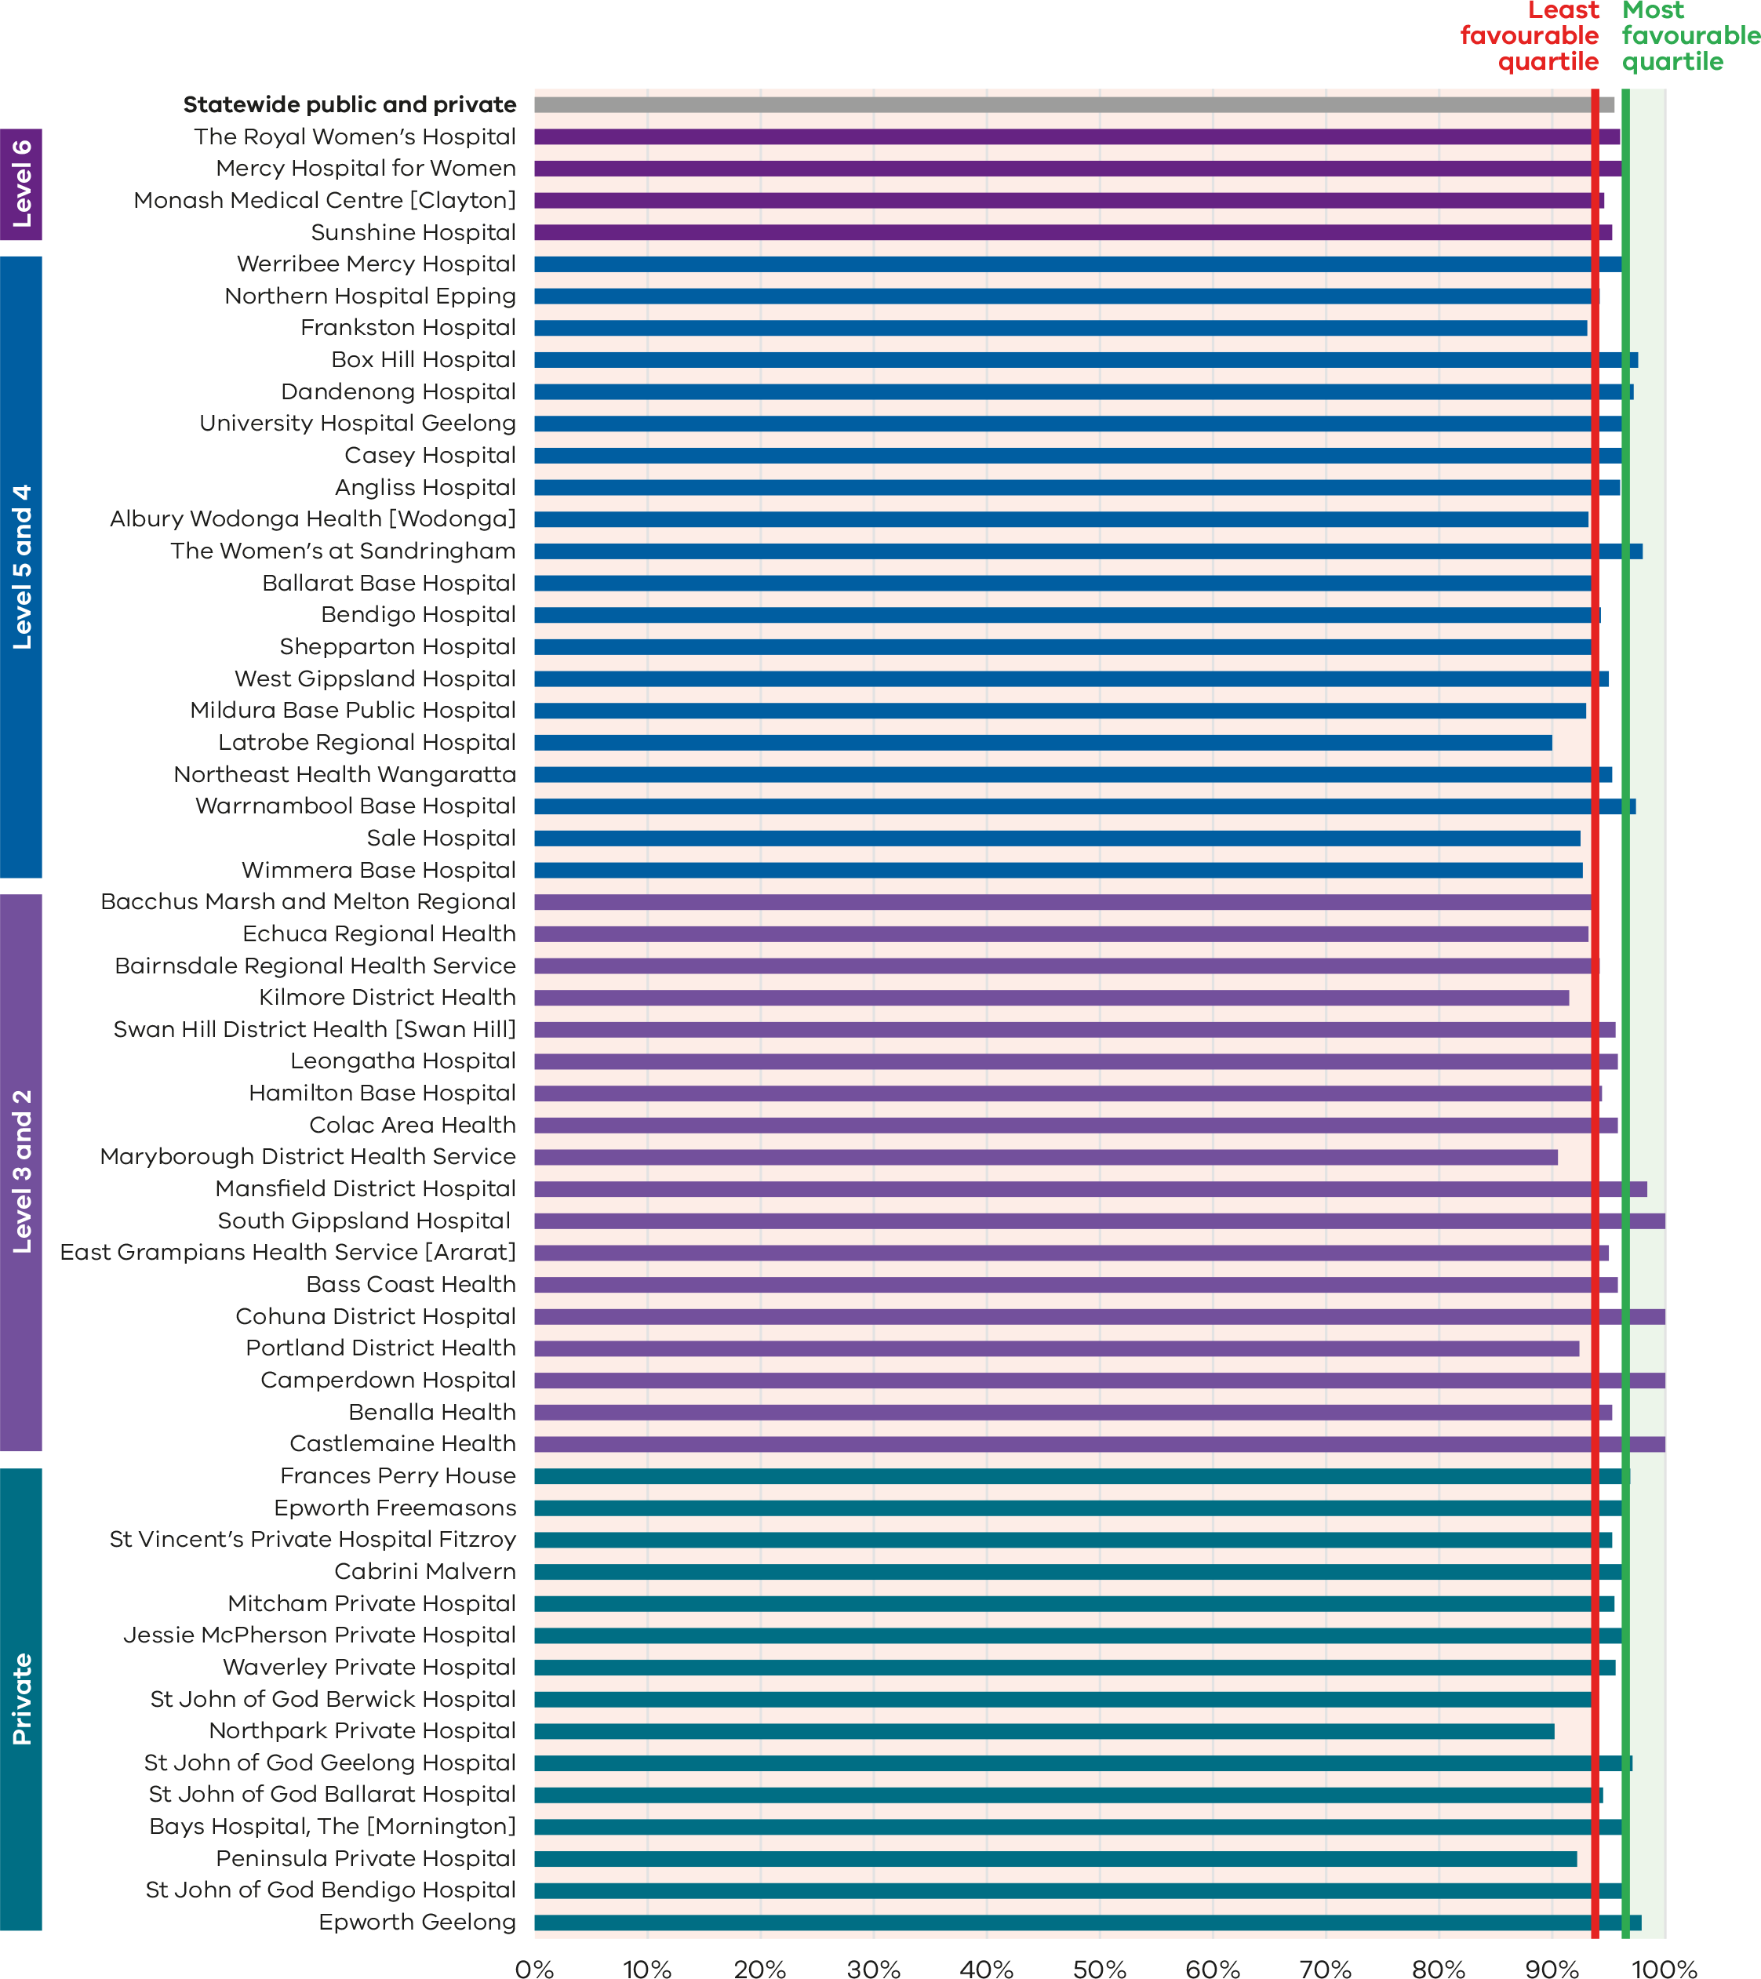
Figure 50. Funnel plot of the rate of breastfeeding initiation by women who gave birth at ≥ 37 weeks’ gestation, 2021
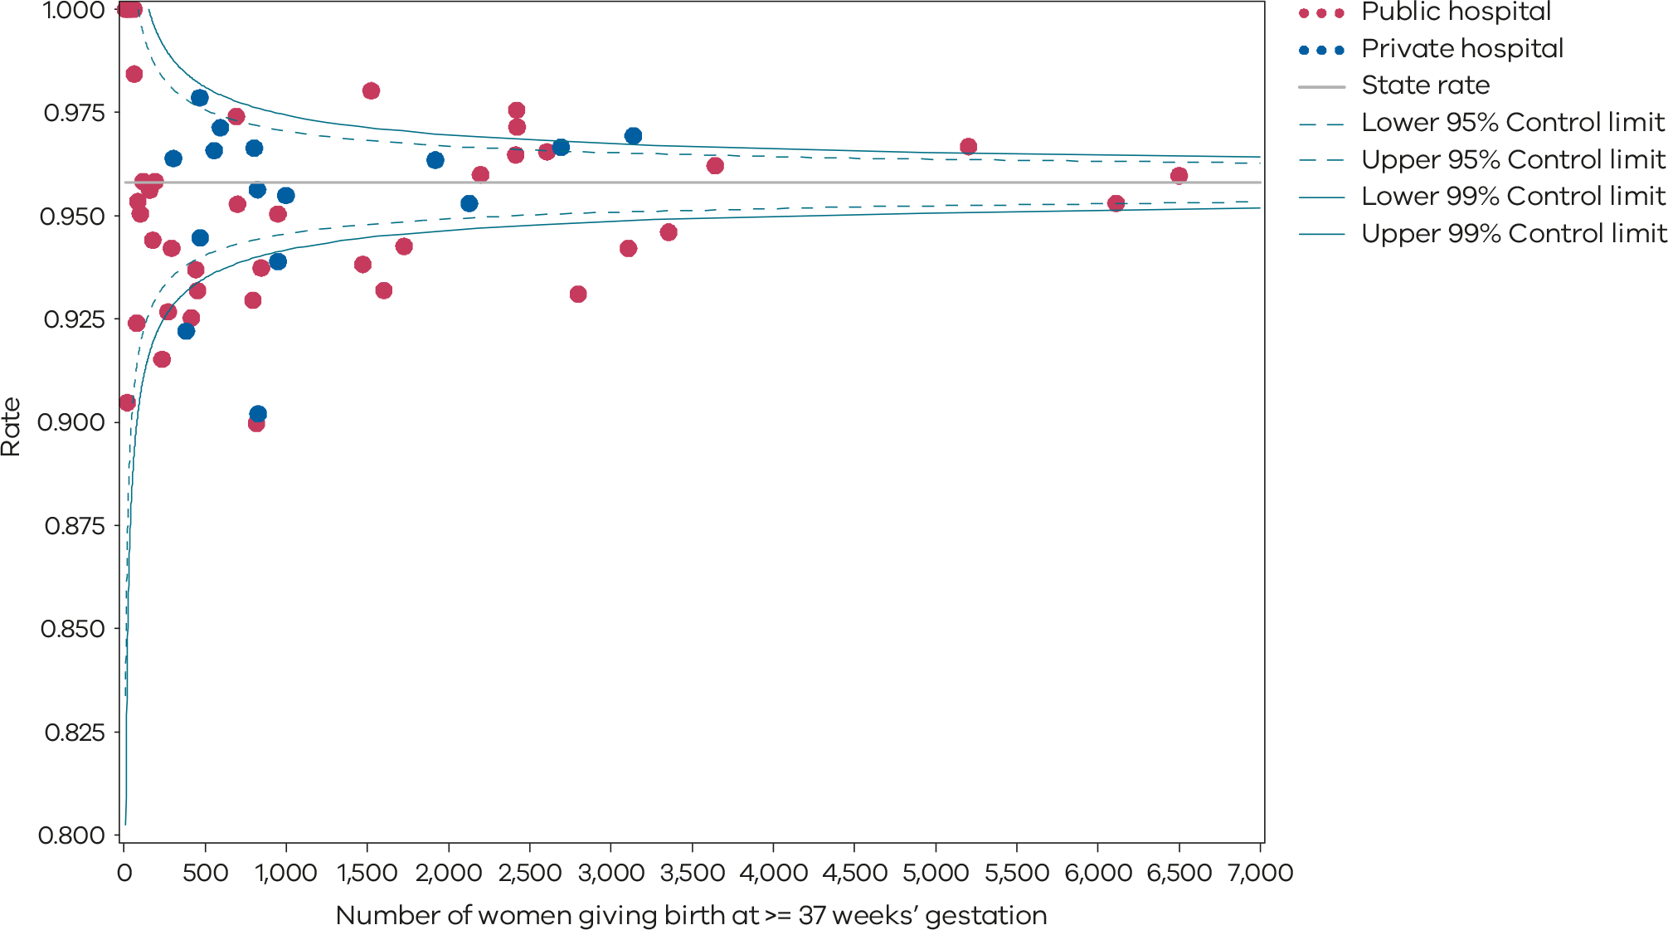
Please refer to the guide on how to interpret funnel plots.
Table 17. Rate of breastfeeding initiation for babies born at ≥ 37 weeks’ gestation, 2017–2021
 | 2017 | 2018 | 2019 | 2020 | 2021
Public | 95.0% | 95.4% | 95.6% | 95.4% | 95.4%
Private | 96.5% | 96.7% | 97.0% | 95.9% | 95.8%
Statewide | 95.4% | 95.7% | 95.9% | 95.6% | 95.5%
Figure 51. Time trend of indicator 8a, 2017–2021
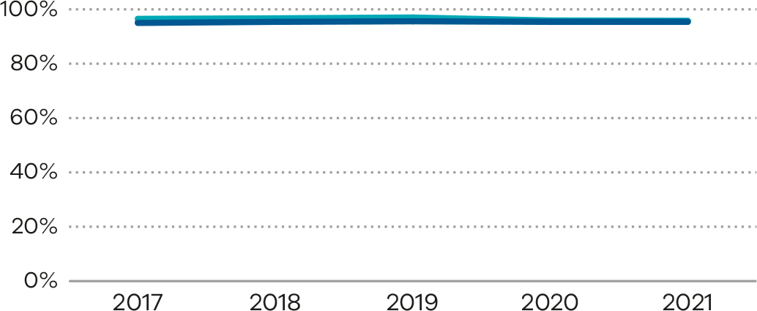
Figure 52. Indicator 8b: Rate of use of infant formula in hospital by breastfed babies born at ≥ 37 weeks’ gestation, 2021
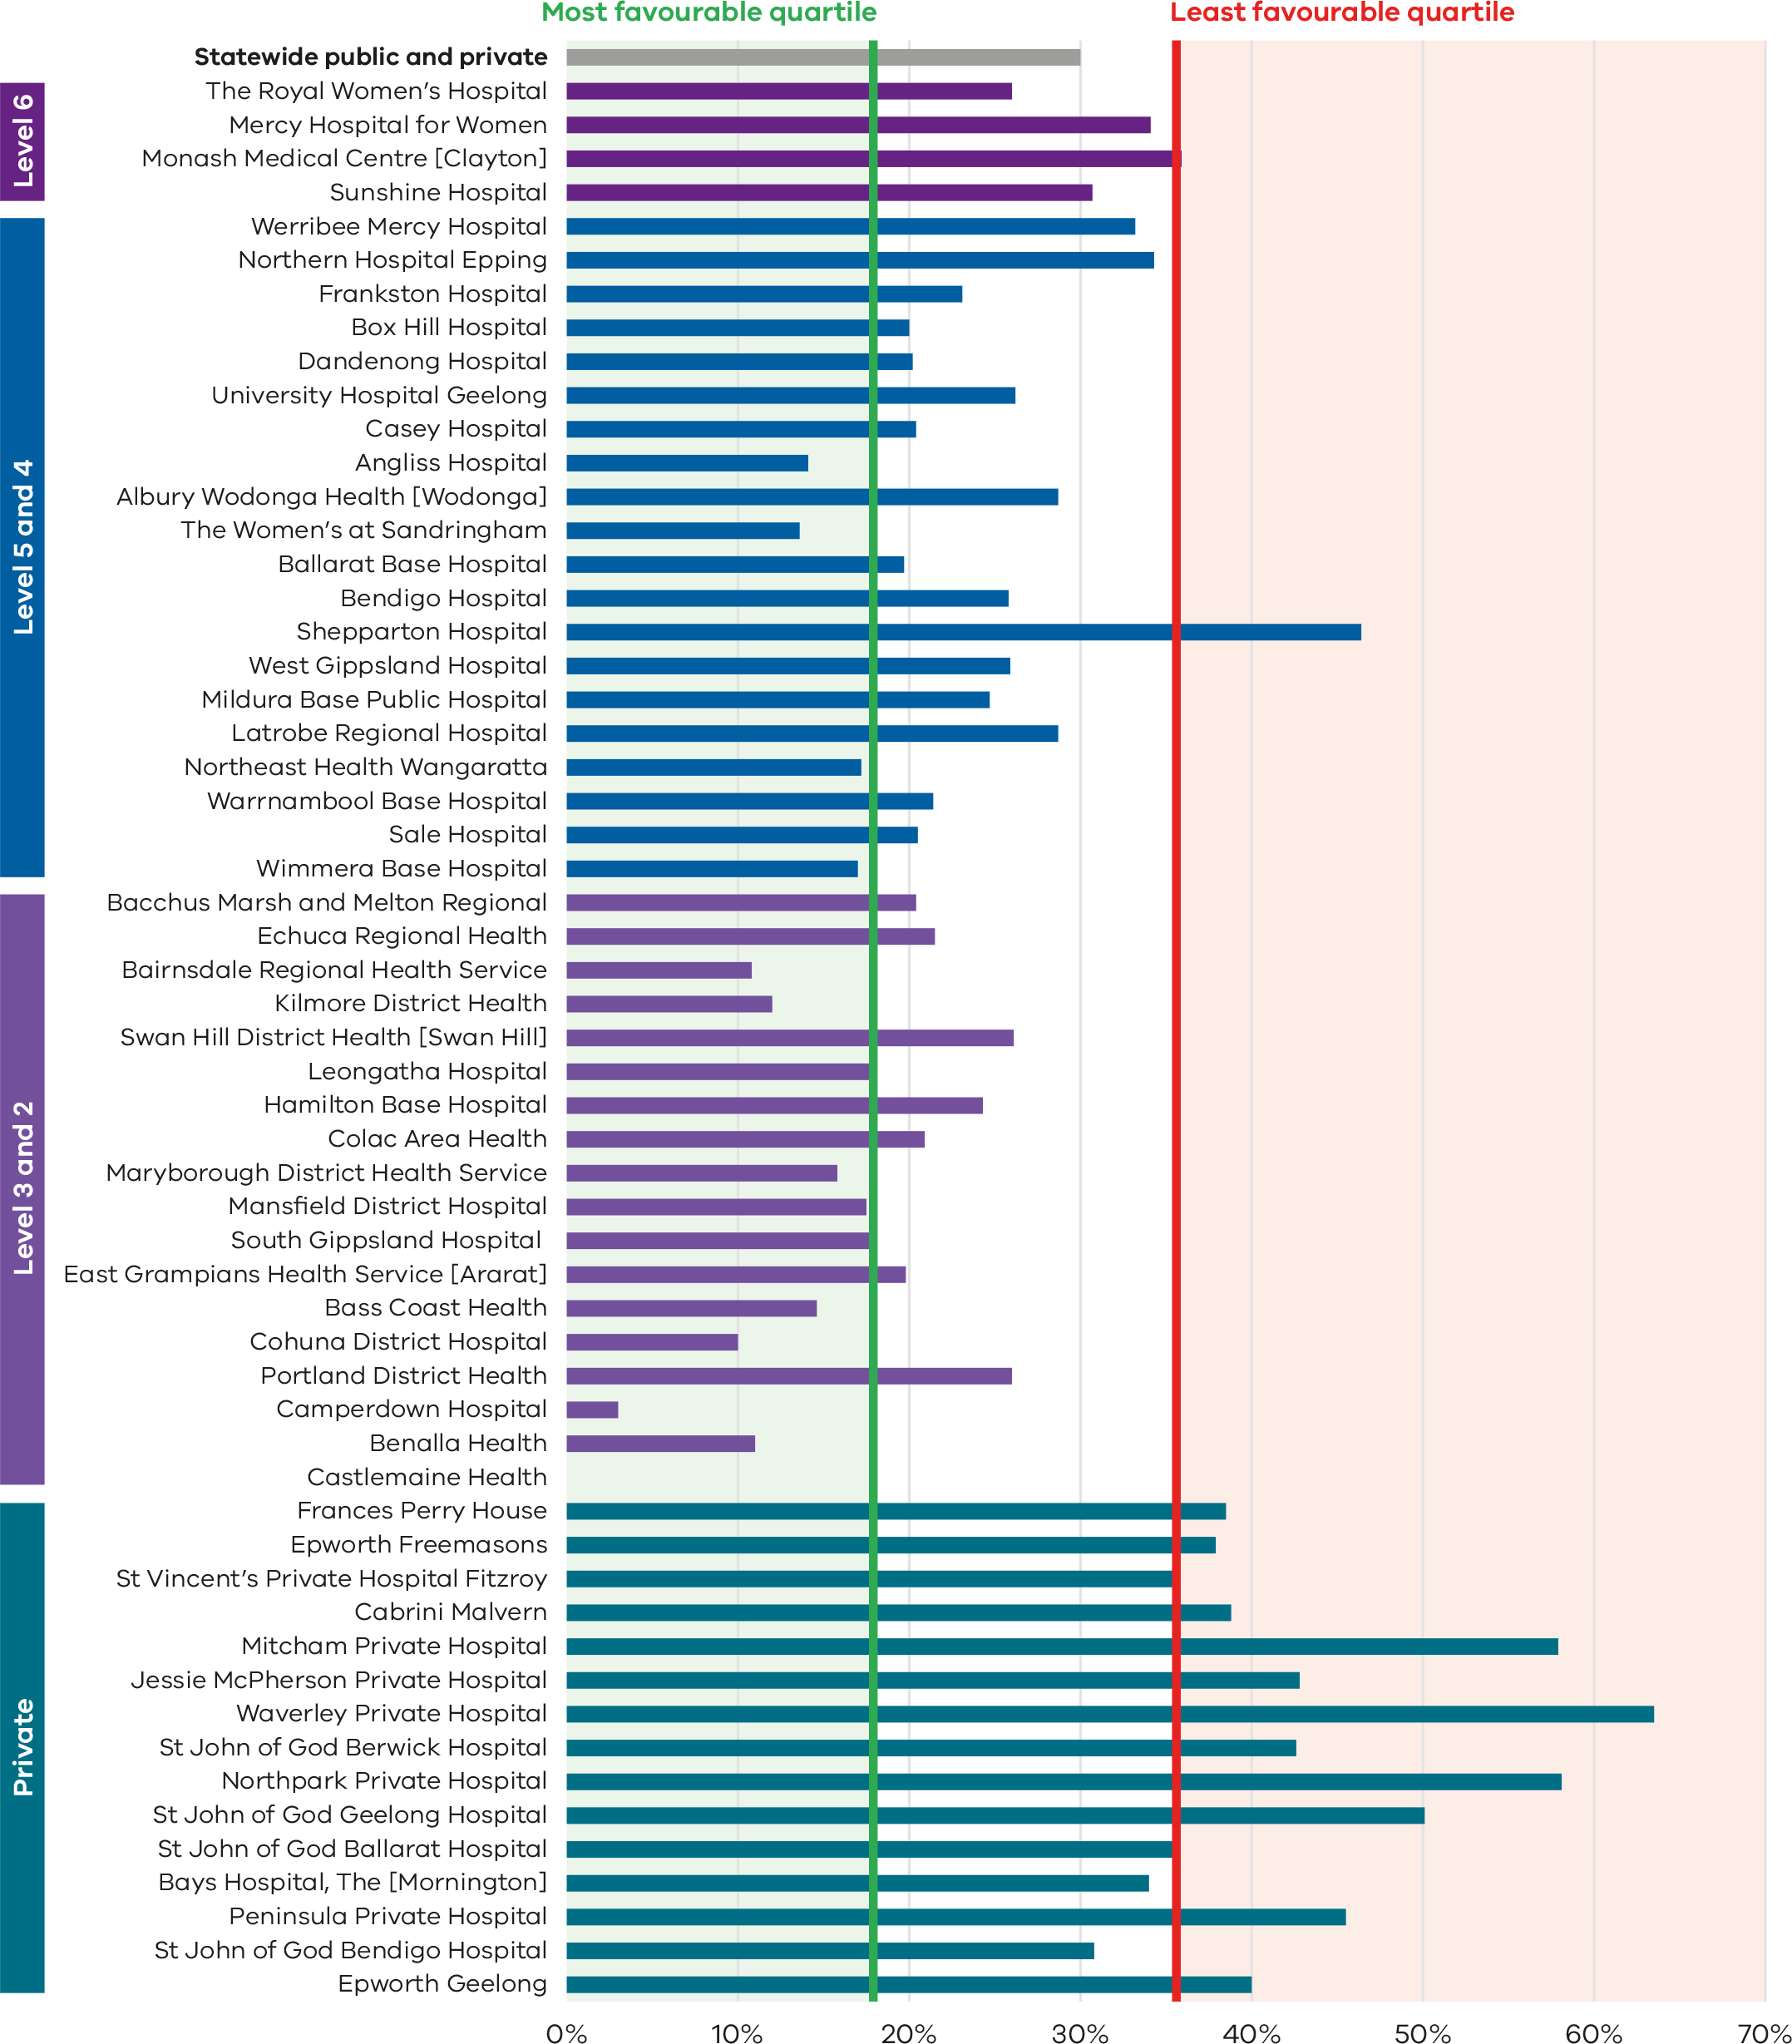
Figure 53. Funnel plot of the rate of use of infant formula in hospital by breastfed babies born at ≥ 37 weeks’ gestation, 2021
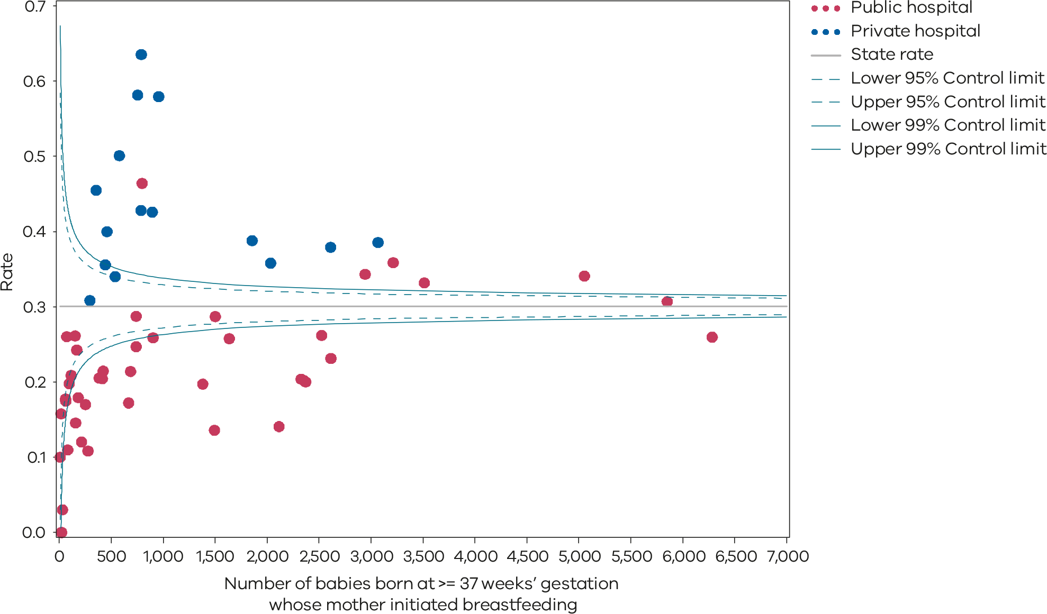
Please refer to the guide on how to interpret funnel plots.
Table 18. Rate of use of infant formula in hospital by breastfed babies born at ≥ 37 weeks’ gestation, 2017–2021
 | 2017 | 2018 | 2019 | 2020 | 2021
Public | 25.2% | 27.0% | 27.6% | 27.8% | 26.7%
Private | 38.2% | 37.8% | 38.5% | 40.5% | 42.0%
Statewide | 28.2% | 29.4% | 30.0% | 30.5% | 30.0%
Figure 54. Time trend of Indicator 8b, 2017–2021
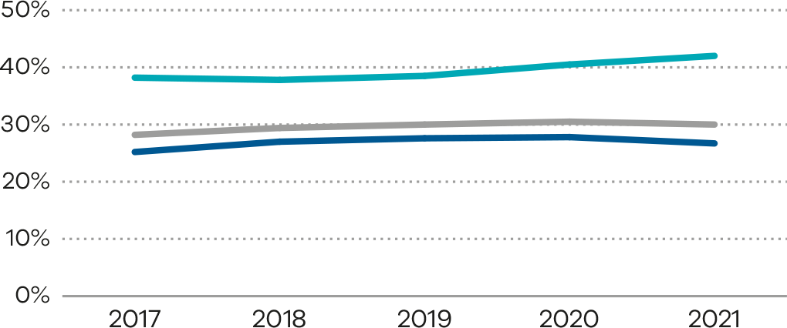
Figure 55. Indicator 8c: Rate of final feed being taken directly from the breast by breastfed babies born at ≥ 37 weeks’ gestation, 2021.
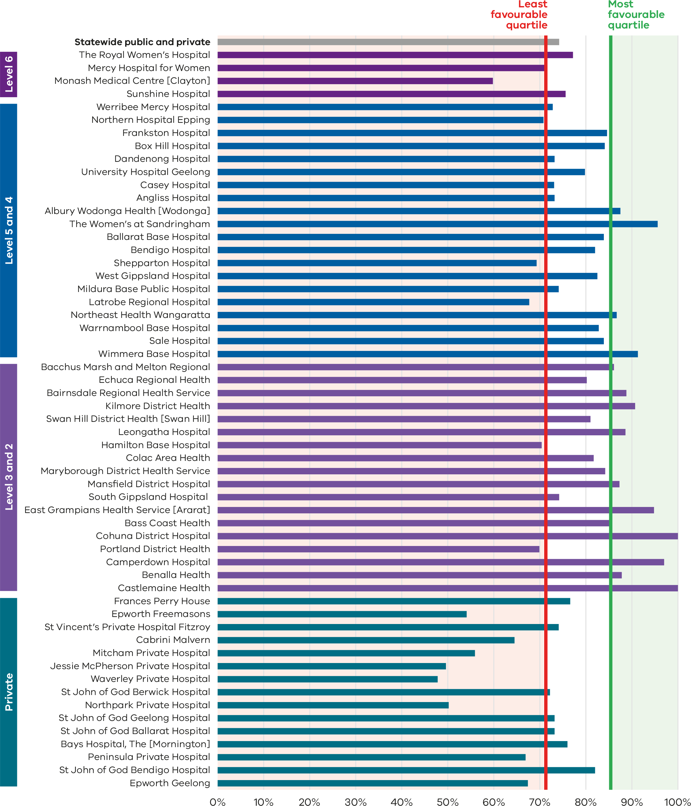
Figure 56. Funnel plot of the rate of final feed being taken directly from the breast by breastfed babies born at ≥ 37 weeks’ gestation, 2021
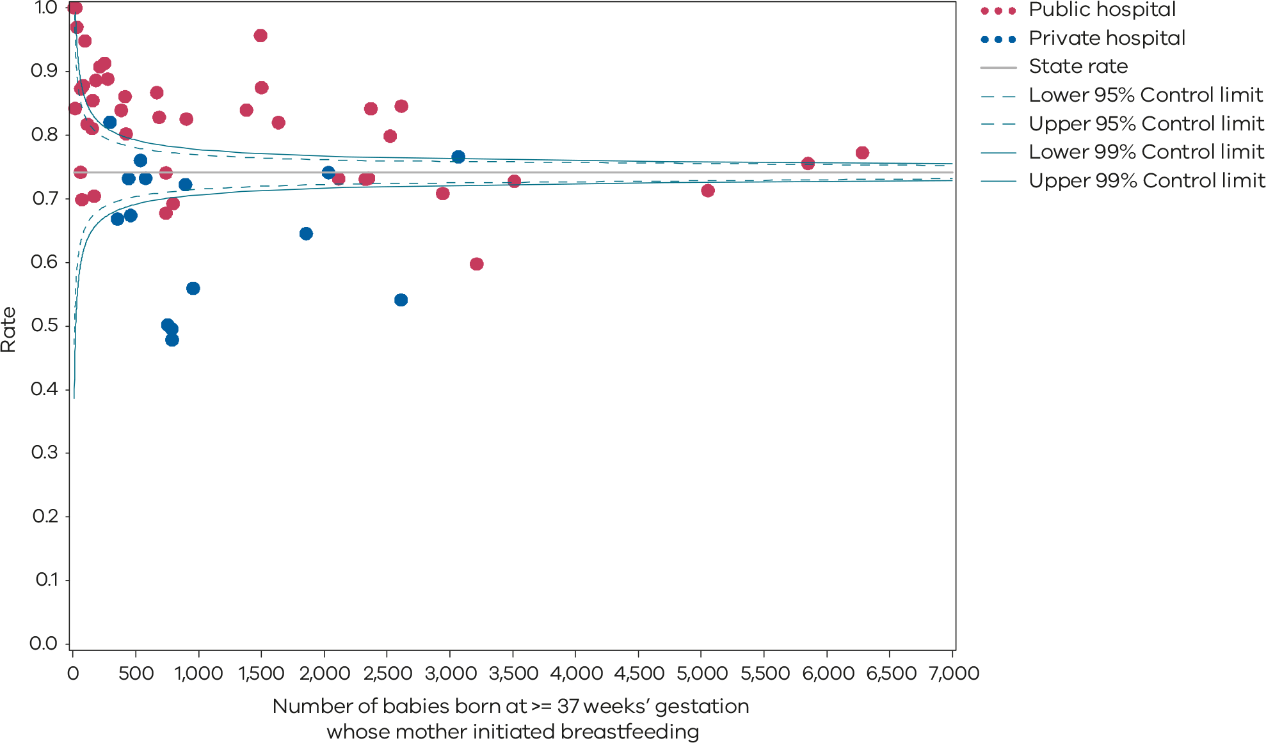
Please refer to the guide on how to interpret funnel plots.
Table 19. Rate of final feed being taken directly from the breast by breastfed babies born at ≥ 37 weeks’ gestation, 2017–2021
 | 2017 | 2018 | 2019 | 2020 | 2021
Public | 76.1% | 75.3% | 74.9% | 75.0% | 76.6%
Private | 71.5% | 69.6% | 68.1% | 65.8% | 65.4%
Statewide | 75.1% | 74.1% | 73.4% | 73.1% | 74.2%
Figure 57. Time trend of Indicator 8c, 2017–2021
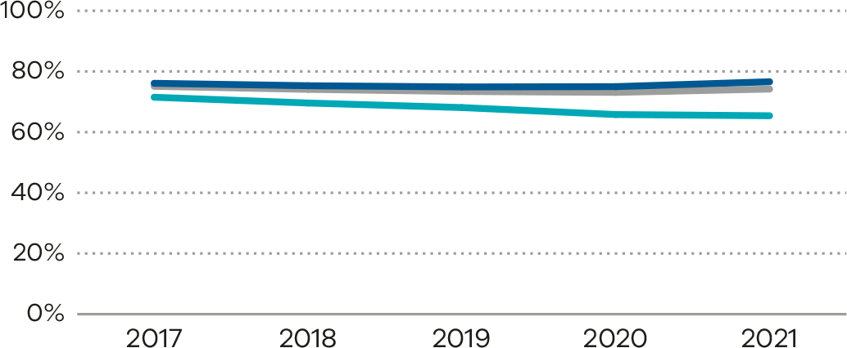

Definitions and data source

Definitions
This group of measures assesses aspects of breastfeeding in Victorian hospitals during the birthing episode, namely:
- Indicator 8a: rate of breastfeeding initiation for babies born at ≥ 37 weeks’ gestation
- Indicator 8b: rate of use of infant formula in hospital by breastfed babies born at ≥ 37 weeks’ gestation
- Indicator 8c: rate of final feed being taken directly from the breast by breastfed babies born at ≥ 37 weeks’ gestation.

Data source: Victorian Perinatal Data Collection
Data for this indicator is sourced from the VPDC for the calendar year from 1 January 2021 to 31 December 2021.
The indicators are derived using the following VPDC variables: ‘Breastfeeding attempted’, ‘Formula given in hospital’, ‘Last feed before discharge taken exclusively from the breast’, ‘Estimated gestational age’, ‘Birthweight’, ‘Birth status’ and ‘Birth order’.
Numerator/denominator
Indicator | Numerator | Denominator
Indicator 8a: Rate of breastfeeding initiation for babies born at ≥ 37 weeks’ gestation | The number of women giving birth to a liveborn at 37 or more weeks’ gestation attempting to breastfeed at least once (regardless of the success of the attempt) | The number of women giving birth to a liveborn at 37 or more weeks’ gestation
Indicator 8b: Rate of use of infant formula in hospital by breastfed babies born at ≥ 37 weeks’ gestation | The number of liveborn babies born at 37 or more weeks’ gestation whose mother initiated breastfeeding and was given infant formula in hospital | The number of liveborn babies born at 37 or more weeks’ gestation whose mother initiated breastfeeding
Indicator 8c: Rate of final feed being taken directly from the breast by breastfed babies born at ≥ 37 weeks’ gestation | The number of liveborn babies born at 37 or more weeks’ gestation whose mother initiated breastfeeding and who fed directly and entirely from the breast at the last feed before discharge | The number of liveborn babies born at 37 or more weeks’ gestation whose mother initiated breastfeeding

9: First antenatal visit
Antenatal care is a planned visit between a pregnant woman and a maternity healthcare provider to assess and improve the health of the mother and baby during pregnancy. Early antenatal care represents an opportunity to treat and provide advice on existing health conditions and plan ongoing investigations and management. Regular antenatal care, and especially that starting in the first trimester, is associated with fewer pregnancy related complications and with positive maternal and child health outcomes.

About this indicator
This indicator reports the rate of women who had their first antenatal visit with a maternity care provider prior to 12 weeks’ gestation. The first antenatal visit is defined as the first visit to a midwife or doctor arranged specifically for providing pregnancy care.
This first antenatal visit may occur in the community or at a hospital and may be facilitated by a range of health professionals (midwives, general practitioners, obstetricians). This diversity is important because it allows different approaches to care and choices for women.
It is recommended that women attend their first antenatal care visit within the first 12 weeks of pregnancy. Timely access to care allows for early detection of certain conditions and appropriate management of the pregnancy.
Late access to antenatal care is associated with less favourable outcomes for women and their babies.
[Break out box text:

What pregnant women and families need to know
During pregnancy there are some very specific health issues that can arise, and it is important that women who are pregnant see their midwife or doctor early in the pregnancy.
This indicator measures how many women see their midwife or doctor before the pregnancy is 12 weeks so that any special needs can be met.
We aim for all pregnant women to attend an antenatal visit before the pregnancy is 12 weeks, but the graphs (Figure 58 and Figure 59) on the following pages show that in some areas the rate is quite low.
End of break out box text.]

Observations on the data
The overall proportion of women who had their first antenatal visit recorded as occurring before 12 weeks’ gestation increased to 76.5% in 2021 from 73.6% in 2020 (Table 20). The rate varied between public and private hospitals (73.4 and 87.6%, respectively). The overall state rate has increased significantly since 2018 when the rate was reported at 59.5% (Figure 60 and Table 20).
The data reported to the VPDC for this measure has limitations. Some health services may not include early antenatal visits to a general practitioner that include referral for antenatal investigations and others do include these visits. Some may include visits for reasons other than pregnancy care. Given this, hospitals should review their data collection processes to the VPDC reporting guideline <https://www.health.vic.gov.au/quality-safety-service/victorian-perinatal-data-collection> to ensure an accurate capture of care provided in the community.

Strategies for improvement
- Health services should work with women and their families to understand and develop strategies to address barriers to early antenatal care.
- Identify high-risk women who may require a more focused approach to ensure early and ongoing access to antenatal care. Health education campaigns should consider how they target vulnerable groups such as young mothers, Aboriginal and Torres Strait Islander women, culturally and linguistically diverse women and those with socioeconomic challenges.
- Improve the accuracy of data by educating maternity staff to ask about antenatal care provided in the community – for example, by a general practitioner. Ensure all staff entering antenatal data are familiar with the VPDC reporting rules.
- Agree on local targets to guide incremental improvement and monitor progress.
Figure 58. Indicator 9: Rate of women attending their first antenatal visit prior to 12 weeks’ gestation, 2021
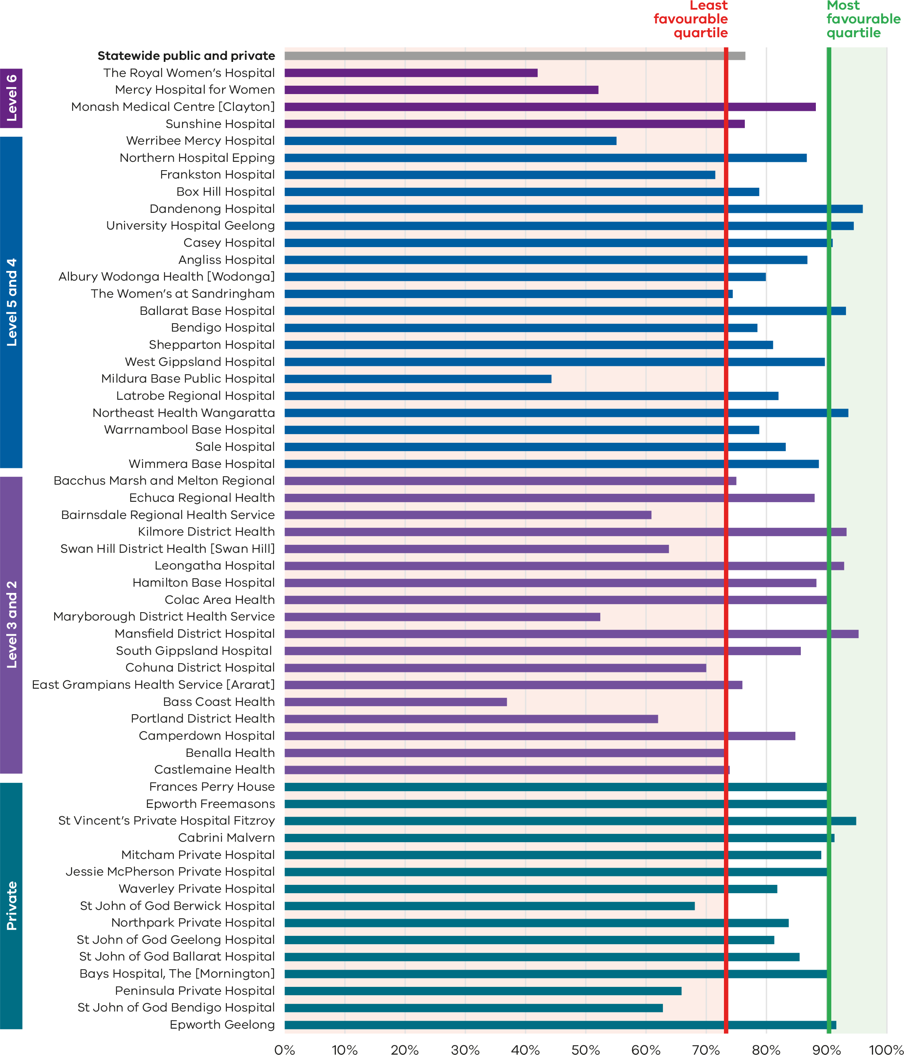
Figure 59. Funnel plot the rate of women attending their first antenatal visit prior to 12 weeks’ gestation, 2021
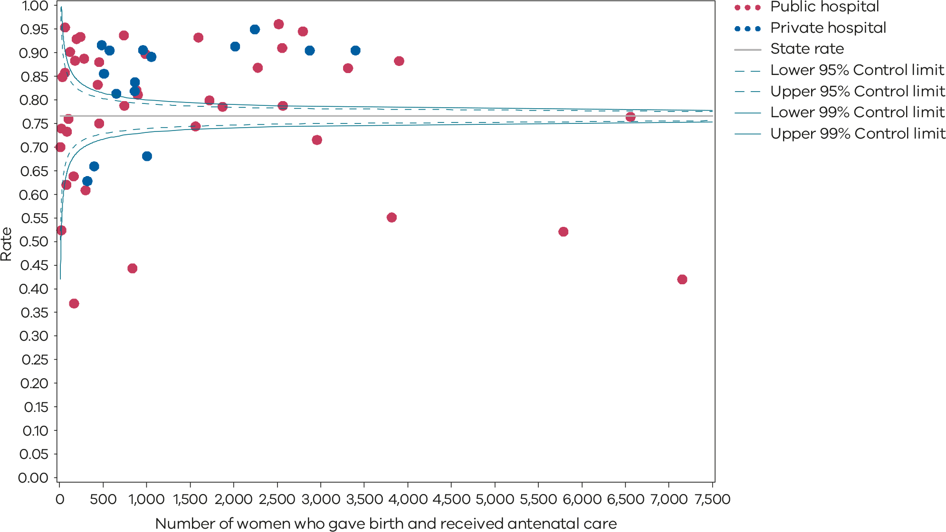
Please refer to the guide on how to interpret funnel plots.
Table 20. Rate of women attending their first antenatal visit prior to 12 weeks’ gestation,
2017–2021
 | 2017 | 2018 | 2019 | 2020 | 2021
Public | 44.5% | 51.5% | 59.9% | 70.1% | 73.4%
Private | 86.9% | 87.1% | 86.8% | 86.5% | 87.6%
Statewide | 54.1% | 59.5% | 65.9% | 73.6% | 76.5%
Figure 60. Time trend of Indicator 9, 2017–2021
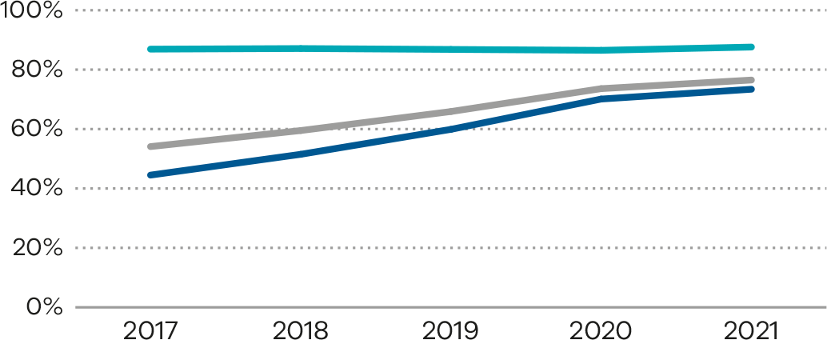

Definition and data source

Definition
The first antenatal visit is the first visit to a midwife or doctor arranged specifically for the purpose of providing maternity care. It excludes visits for confirmation of pregnancy unless some maternity care is provided (for example, referral for first-trimester screening) and medical visits for incidental problems while pregnant.
A maternity or antenatal care provider is defined as a clinician who provides care to pregnant women and includes midwives, general practitioners and obstetricians. This includes antenatal visits that may occur in the community (midwives, general practitioners or obstetricians practising privately or at a community health centre) and is not therefore necessarily the date of the first antenatal visit at the hospital.

Data source: Victorian Perinatal Data Collection
Data from the VPDC are reported by calendar year from 1 January 2021 to 31 December 2021.
The indicator is derived using the VPDC variables: ‘Gestational age at first antenatal visit’, ‘Estimated gestational age’, ‘Birthweight’, and ‘Birth order’.
Numerator/denominator
Indicator | Numerator | Denominator
Indicator 9: Rate of women attending their first antenatal visit prior to 12 weeks’ gestation | The number of women who had antenatal care prior to 12 weeks’ gestation with a maternity care provider (including care in the community by general practitioners) and who birthed at the health service | The number of women who gave birth and received antenatal care

10: Low Apgar score
Apgar scores are clinical indicators of a baby’s condition shortly after birth. We expect babies who are born at 37 or more weeks’ gestation and without congenital anomalies to show a healthy physiological adaption to birth (be born in a healthy state) and not require significant resuscitation or immediate medical care. A low Apgar score at 5 minutes may reflect congenital anomaly, prematurity, perinatal infection, effects of maternal drug administration, ineffective resuscitation or prolonged hypoxia before birth. Maternal factors including increased maternal age, obesity, morbidity, diabetes and smoking in pregnancy may contribute to a baby being born with a low Apgar score.
The Apgar score is an assessment of a newborn’s wellbeing at birth based on 5 physiological attributes. This is recorded at one and 5 minutes (and longer if applicable). The 5 attributes are colour (circulation), breathing, heart rate, muscle tone and reflexes.
Each attribute is given a score of 0, 1 or 2, with a total minimum score of 0 (indicating no or greatly diminished signs of life) and a maximum score of 10 (indicating optimal outcome). An Apgar score below 7 at 5 minutes indicates a baby who requires ongoing resuscitation measures or additional care. This may be due to avoidable factors during labour, birth or resuscitation.

About this indicator
This indicator measures the wellbeing of babies who are born in hospital or as planned public home births at 37 or more weeks’ gestation and without congenital anomalies at birth. Private home births are not reported separately but are included in the statewide rate.
It is used to give an overall guide for the quality of care during labour and birth and neonatal resuscitation following birth, where necessary, but can’t differentiate where the problem is (if there is a problem). The Apgar score is a validated measure of adverse long-term outcomes. This is potentially an important indicator for longer term infant outcomes.
[Break out box text:

What pregnant women and families need to know
The Apgar score is a score out of 10 used to measure how well a baby is soon after birth. It is usually measured twice – at one minute of age and again at 5 minutes of age. If the score at 5 minutes is less than 7, babies need extra attention. The rate of babies born with a 5-minute Apgar score of less than 7 should be very low. The graphs on the following pages show that there is lots of variation between different hospitals.
End of break out box text.]

Observations on the data
In 2021, a 5-minute Apgar score less than 7 was reported for 1.2% of singleton, term babies across public and private hospitals combined. This was the same as the rate reported for 2020. The rate for private hospitals is lower compared with public hospitals (0.9% and 1.3%, respectively).
The rate varied between individual hospitals, from zero to 3.6% (Figure 61 and Figure 62); however, overall state rates continued to remain stable over time (Table 21). Figure 63 shows trends over time.

Strategies for improvement
- Health services should facilitate education and multidisciplinary simulation training for all clinicians who may be involved in neonatal resuscitation. This may include midwives, doctors, code blue teams, emergency doctors and nurses. Safer Care Victoria endorses the Australian Resuscitation Council Neonatal Guidelines (Section 13) <https://www.anzcor.org/> for guidance on the resuscitation of neonates and the neoResus training program <https://www.neoresus.org.au/>, which standardises the way newborn resuscitation is taught.
- Health services should provide mandatory annual fetal surveillance education and competency.
- Undertake multidisciplinary review of all cases with low Apgar scores at local level, ensuring a review that includes intrapartum care including cardiotocograph (CTG) interpretation.
- Consider 2 clinicians scoring the Apgar scores independently.
- Have clear escalation pathways – for example, fetal compromise in labour and neonatal code blue calls for deteriorating neonates.
- Encourage regional and/or multiservice reviews of all neonates with an Apgar less than 7 at 5 minutes.
Figure 61. Indicator 10: Rate of term inborn babies without congenital anomalies with an Apgar score < 7 at 5 minutes, 2021
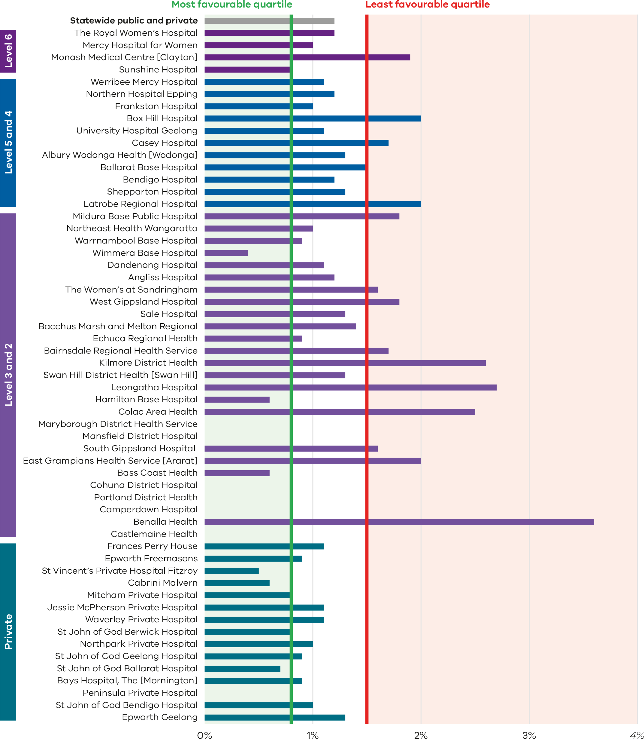
Figure 62. Funnel plot of the rate of term inborn babies without congenital anomalies with an Apgar score < 7 at 5 minutes, 2021
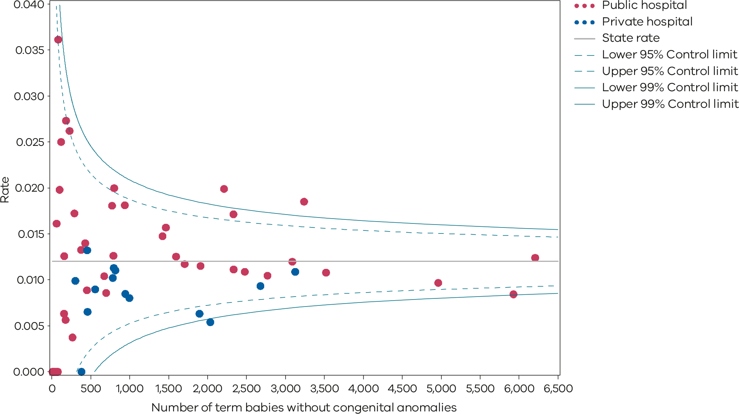
Please refer to the guide on how to interpret funnel plots.
Table 21. Rate of term inborn babies without congenital anomalies with an Apgar score < 7 at 5 minutes, 2017–2021
 | 2017 | 2018 | 2019 | 2020 | 2021
Public | 1.5% | 1.3% | 1.3% | 1.3% | 1.3%
Private | 1.0% | 1.1% | 1.0% | 0.8% | 0.9%
Statewide | 1.3% | 1.3% | 1.3% | 1.2% | 1.2%
Figure 63. Time trend of Indicator 10, 2017–2021
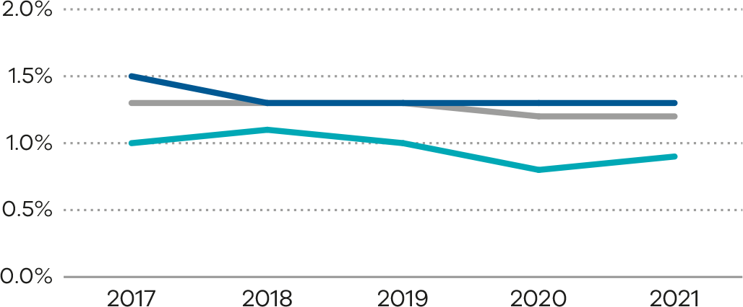

Definition and data source

Definition
The rate of term babies without congenital anomalies with an Apgar score of less than 7 at 5 minutes in Victorian hospitals.
The score excludes babies born at less than 37 weeks’ gestation, infants born with congenital anomalies, stillbirths and babies born before arrival at hospital.
The Apgar score is used to evaluate the fitness of a newborn infant based on heart rate, respiration, muscle tone, reflexes and colour. The maximum or best score is 10. The Apgar score should be determined consistently and reliably according to best practice guidelines. Rates for this indicator should show little variation among peer-group services, and inter-rater reliability should be high within health services. This supports quality reporting of neonatal outcomes for meaningful comparisons.
Inborn is defined as a baby born at the reporting hospital.

Data source: Victorian Perinatal Data Collection
Data for this indicator is sourced from the VPDC for the calendar year from 1 January 2021 to 31 December 2021.
This indicator is derived using the following VPDC variables: ‘Apgar score at 5 minutes’, ‘Estimated gestational age’, ‘Birthweight’, ‘Birth status’, ‘Setting of birth – actual’ and ‘Congenital anomalies – indicator’.
Numerator/denominator
Indicator | Numerator | Denominator
Indicator 10: Rate of term babies without congenital anomalies with an Apgar score < 7 at 5 minutes | The number of inborn, liveborn, 37 or more weeks’ gestation babies without congenital anomalies with an Apgar score less than 7 at 5 minutes | The number of inborn, liveborn, 37 or more weeks’ gestation babies without congenital anomalies

11a and 11b: Women’s experiences of care
Any report on maternity and newborn outcomes cannot be complete without women’s voices being present, guiding plans for future improvement. Women are uniquely positioned to provide insightful comments about their care. Acknowledging that health outcomes and perceptions are not only influenced by the nature and quality of the clinical care provided but how that care is delivered, women’s experience is critical to providing and improving health care. Through monitoring indicators of experience, it is possible to improve our understanding of women’s experience of care and identify areas for quality improvements and service redesign.

About these indicators
These indicators assess the experience of women who took part in the Victorian Healthcare Experience Survey (VHES) and who received care from a Victorian public hospital during their labour and birth episode. The indicators are derived from responses of ‘yes, definitely’ to 2 of the questions in the maternity questionnaire of the VHES:
- Indicator 11a: Question 6: Were you involved as much as you wanted to be in making decisions about your care?
- Indicator 11b: Question 29: Did staff give you active support and encouragement to feed your baby in the way you wanted to?
In 2021, the VHES program revised several maternity questions and new questions have been included in this report. The data included in these indicators covers the timeframe of 6 months, from July 2021 to December 2021, and cannot be directly compared with data from preceding years. Therefore, this report does not include any information for the previous years.
[Break out box text:

What pregnant women and families need to know
We care what women think about the care they receive during pregnancy and birth. A survey is sent to a small number of women who gave birth at a Victorian public health service (the VHES). Not all women choose to answer this survey.
We specifically measure what women think about how much their carers listened to their wishes, and the information they received about feeding their babies.
Most women who answered the VHES survey are satisfied with the care they received; however, we recognise that the survey is not sent to all women. We hope to see women’s satisfaction with their birthing experience improve further and we encourage all women and their families to reach out to their maternity service to provide feedback.
End of break out box text.]

Observations on the data
In 2021, 71.2% of women who completed the survey across public hospitals responded that they felt involved, as much as they wanted to be, in decisions about their care (Figure 64). The funnel plot in Figure 65 shows variation across hospitals.
Greater variation in the observed data for indicators 11a and 11b may be ascribed to (i) a smaller sample size with only 6 months of survey data and (ii) voluntary data collection practices of the VHES, meaning data are not always collected for every Victorian birth.
The proportion of women who felt they were given active support and encouragement to feed their baby the way they wanted to (Indicator 11b) across public hospitals was 87.2% (Figure 66). The funnel plot shows variation in this indicator (Figure 67).
The data for these indicators is limited, as only a small proportion of women who birthed in the public hospital system are sent the survey and the response rate is low. This report includes only those health services with more than 10 responses over the time period. Data should be interpreted cautiously and used in conjunction with additional feedback provided directly to the health service.

Strategies for improvement
- Work in partnership with women to deliver woman-centred, coordinated care by promoting discussion about plans and expectations of labour and birth.
- Ensure there are adequate mechanisms to capture, review, report and act on feedback.
- Engage with women, carers and families to hear first-hand about their experiences.
- Ensure there is adequate time during both the antenatal and postnatal period to discuss and express concerns related to the information being provided.
- Work in partnership with women to support them with feeding their babies the way they want.
- Encourage women and their families to provide feedback to the health service in a way that suits them, including the survey or by contacting the health service directly.
Figure 64. Indicator 11a: Rate of women who felt involved as much as they wanted to be in making decisions about their care, 2021
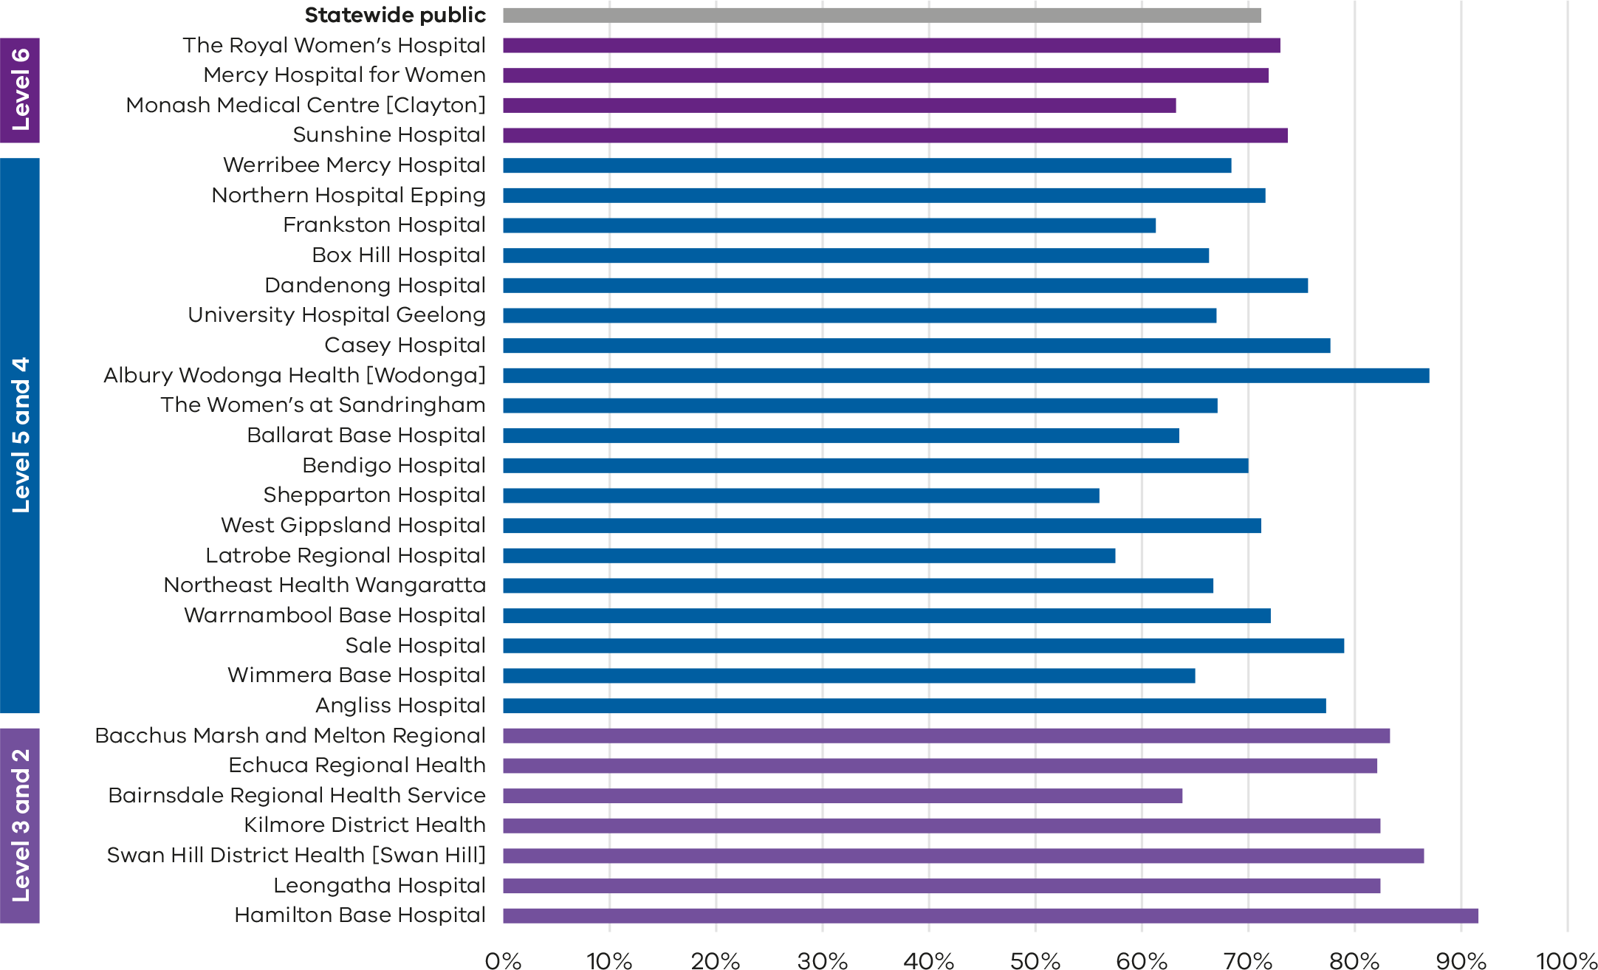
Note: No quartiles are presented for Indicator 11 since the measure is calculated from survey data and a different method of determining least and most favourable outcomes was applied (tested for significant difference compared with the rate for public hospitals).
The VHES only collects data from public hospitals and reports only on services with more than 10 responses in a year. As such, this indicator is only reported for public health services and not all services meet the criteria for reporting in this indicator.
Figure 65. Funnel plot of the rate of women who felt involved as much as they wanted to be in decisions about their care, 2021
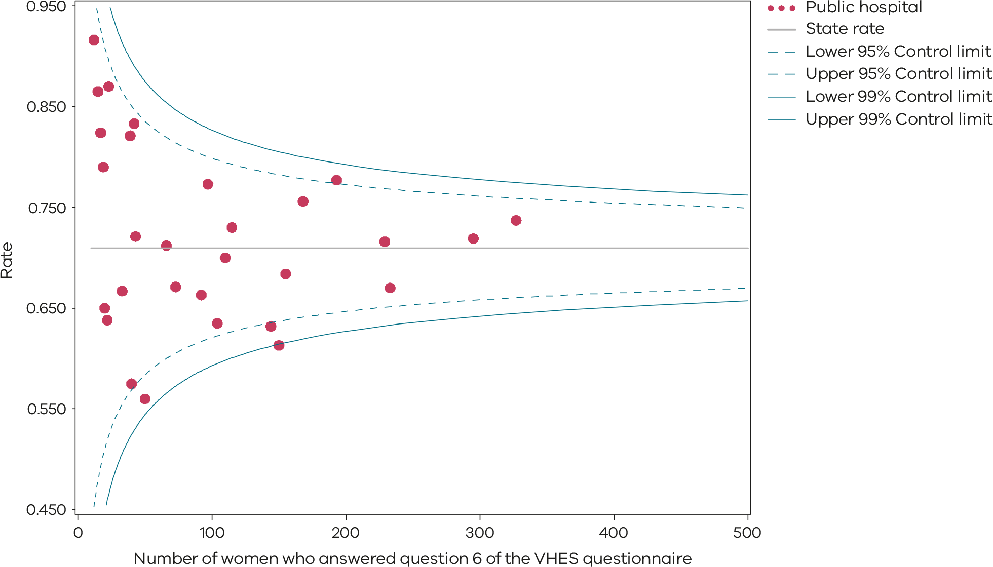
Please refer to the guide on how to interpret funnel plots.
Figure 66. Indicator 11b: Rate of women who felt that staff gave them active support and encouragement to feed their baby in the way they wanted to, 2021
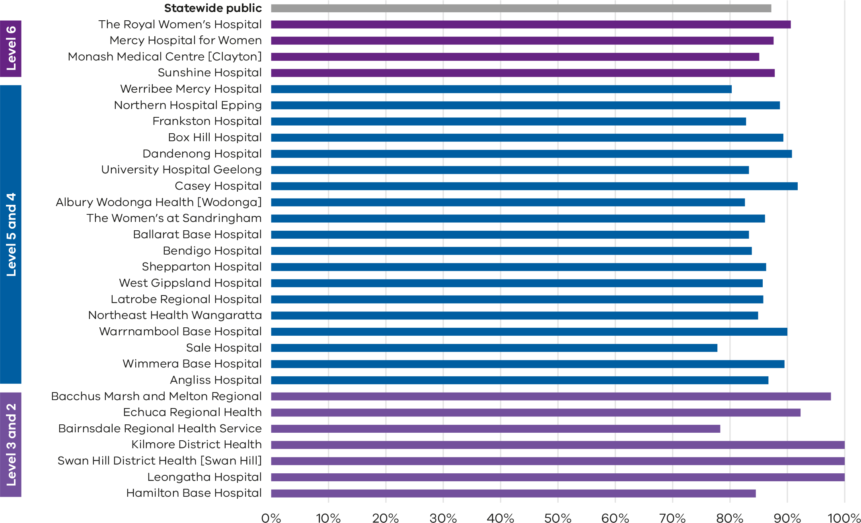
Note: No quartiles are presented for Indicator 11 since the measure is calculated from survey data and a different method of determining least and most favourable outcomes was applied (i.e., tested for significant difference compared with the rate for public hospitals).
The VHES only collects data from public hospitals and reports only on services with more than 10 responses in a year. As such, this indicator is only reported for public health services and not all services meet the criteria for reporting in this indicator.
Figure 67. Funnel plot of the rate of women who felt that staff gave them active support and encouragement to feed their baby in the way they wanted to, 2021
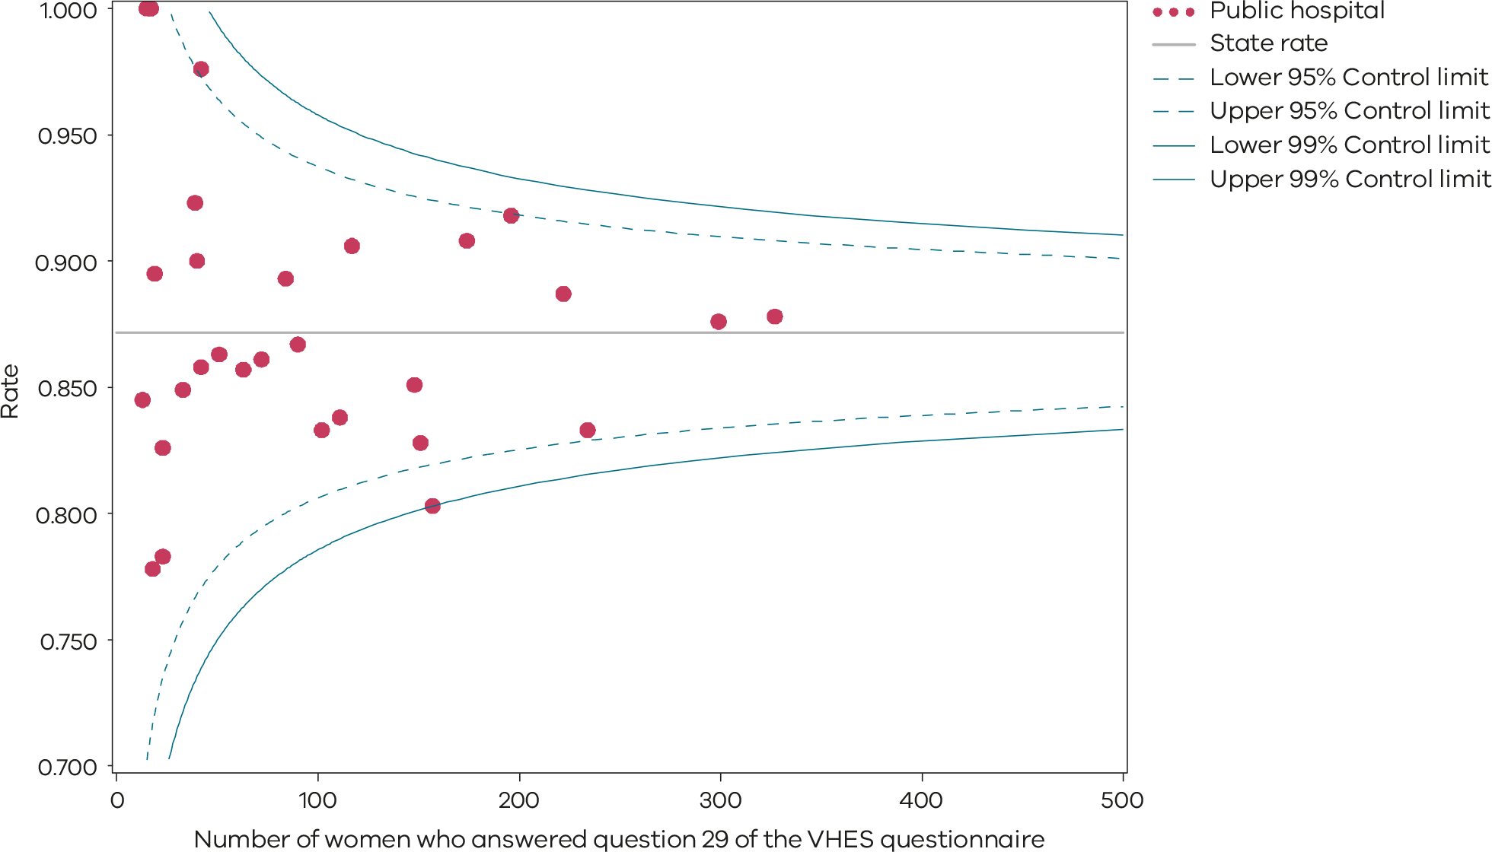
Please refer to the guide on how to interpret funnel plots.

Data source

Data source: IPSOS Social Research Institute analysis of the Victorian Healthcare Experience Survey
Data for this indicator is sourced from VHES for the period from 1 July 2021 to 31 December 2021.
Results are not reported when there are fewer than 10 responses for a health service over the time period, or when data were not provided by the health service.
Note: The VHES maternity questionnaire is distributed to a random sample of consumers following a hospital admission for pregnancy and birth.
Numerator/denominator
Indicator | Numerator | Denominator
Indicator 11a: Rate of women who reported that they felt involved as much as they wanted to be in making decisions about their care | The number of women who answered ‘yes, definitely’ to question 6 of the VHES maternity questionnaire | The number of women who answered question 6 of the VHES maternity questionnaire
Indicator 11b: Rate of women who felt that staff gave them active support and encouragement to feed their baby in the way they wanted to | The number of women who answered ‘yes, definitely’ to question 29 of the VHES maternity questionnaire | The number of women who answered question 29 of the VHES maternity questionnaire

12a and 12b: Maternal vaccination
Pertussis and influenza vaccinations protect pregnant women and babies and are free to all pregnant women in Victoria.
Pertussis can cause serious complications including brain damage, pneumonia and sometimes death. Babies under 6 weeks of age are too young to be vaccinated, so the best way of protecting young babies from pertussis is to vaccinate the mother during pregnancy. Vaccination during pregnancy reduced whooping cough disease in babies under 3 months by over 90%.
Influenza is a serious disease for pregnant women and the developing and newborn baby. Changes to immune, heart and lung function during pregnancy makes pregnant women more vulnerable to severe disease from influenza and pregnant women are twice as likely to require hospital admission for influenza. Influenza vaccine protects pregnant women from influenza and the risk of secondary bacterial infections and other complications while pregnant and reduces the risk of serious complications in their babies.
Influenza vaccination is recommended for all pregnant women during any trimester. Pertussis vaccination is recommended to all pregnant women as a single dose between 20 and 32 weeks’ gestation.

About this indicator
These indicators present the proportion of women who were vaccinated against pertussis (whooping cough) and influenza (flu) at any time during their pregnancy. Specifically:
- Indicator 12a: the rate of women vaccinated for pertussis
- Indicator 12b: the rate of women vaccinated for influenza.
Influenza and pertussis vaccines protect pregnant women and babies from infections. These vaccines are available free to all pregnant women in Victoria. The indicator includes women vaccinated at any point during their pregnancy.
[Break out box text:

What pregnant women and families need to know
Whooping cough (pertussis) and flu (influenza) are dangerous infections for pregnant women and their newborn babies. Whooping cough and flu vaccines are strongly recommended and free for all pregnant women in Victoria under the National Immunisation Program <https://www.health.gov.au/topics/immunisation>.
Getting vaccinated reduces the chance of women or babies suffering any bad effects from these infections. Health services should promote and enable all pregnant women to get vaccinated for whooping cough and flu. This is the best way we currently have to protect mothers and babies from these infections. The rates of vaccination are very different between hospitals. Vaccination rates for the flu fell in 2021. We hope more hospitals have higher vaccination rates in the future.
More information can be found on the Sharing Knowledge About Immunisation website <https://skai.org.au/pregnancy-and-newborn/resources/factsheets> or the Victorian Government Department of Health Immunisation website <https://www.health.vic.gov.au/public-health/immunisation>.
End of break out box text.]

Observations on the data
In 2021, 81.4% of women were vaccinated for pertussis during pregnancy (Indicator 12a). This was a decrease from 2020 where 84.3% of women received vaccination for pertussis. The rate varied between public and private hospitals, with 87.3% and 62.4%, respectively. There was significant variation between individual hospitals, ranging from 5.4 to 100.0% (Figure 68, Figure 69 and Table 22). The wide variation may indicate the data is captured inaccurately in some hospitals, particularly in private hospitals, and doesn’t necessarily indicate that vaccination rates in those hospitals are low. Figure 70 shows trends over time for Indicator 12a.
The rate for influenza was lower in 2021 with only 73.7% of women receiving vaccination for influenza during their pregnancy (Indicator 12b). This was a decline from 2020 where 81.8% of women received vaccination for influenza. The rate was similar between public and private hospitals, at 73.7 and 74.7%, respectively. There was variation between individual hospitals, ranging from 45.6% to 100.0% (Figure 71, Figure 72 and Table 23). It is important to note the context of these rates. The rate of influenza infection was low, Victoria was in lockdown for much of 2021, and the public health focus at the time was on COVID-19 vaccination. Figure 73 shows trends over time for Indicator 12b.

Strategies for improvement
- Provide women and their families with information about the risks associated with pertussis and influenza during pregnancy and the risks of these infections to their baby after birth.
- Health services and maternity care providers should promote the importance of pertussis and influenza vaccination during pregnancy and routinely offer all women vaccination at antenatal appointments or refer to them to where they can get vaccinated for free. This can help to minimise potential barriers to accessing immunisations by reducing cost, travel and time.
- All health services should review and monitor their processes for accurate recording of influenza and pertussis vaccinations.
- Health services and maternity care providers should consider referring to the Australian Government Department of Health and Aged Care Immunisations for pregnancy, with translated resources available on their website <https://www.health.gov.au/topics/immunisation/when-to-get-vaccinated/immunisation-for-pregnancy>.
- Sharing Knowledge About Immunisation <https://skai.org.au/> aims to support conversations that pregnant women and their families have with health professionals about vaccination.
Figure 68. Indicator 12a: Rate of women vaccinated for pertussis during pregnancy, 2021
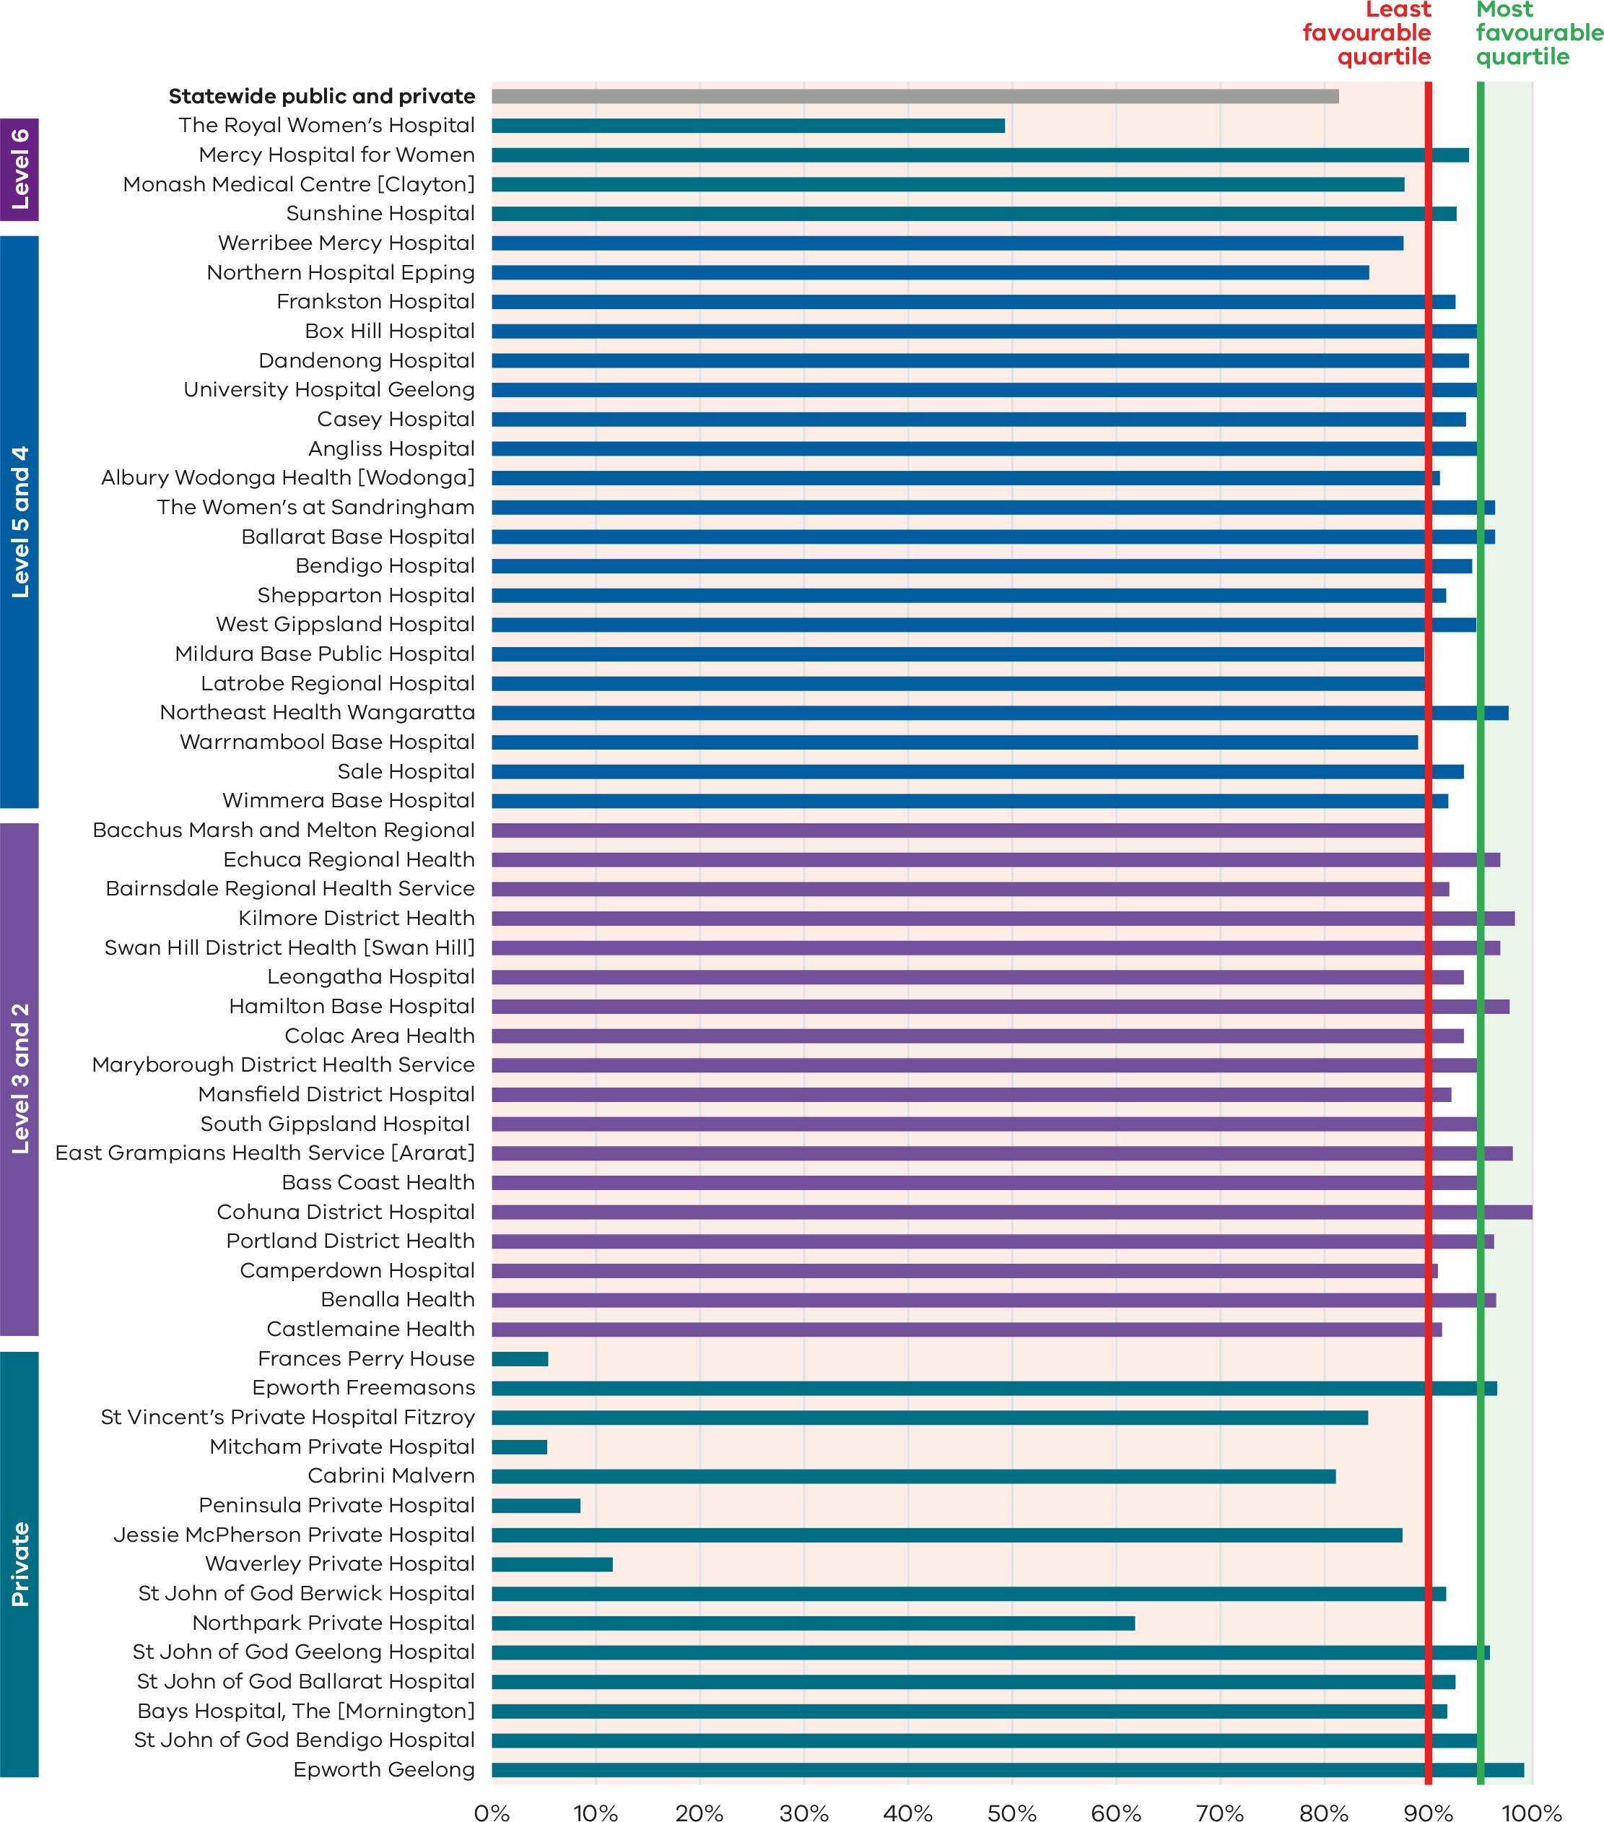
Figure 69. Funnel plot of the rate of women vaccinated for pertussis during pregnancy, 2021
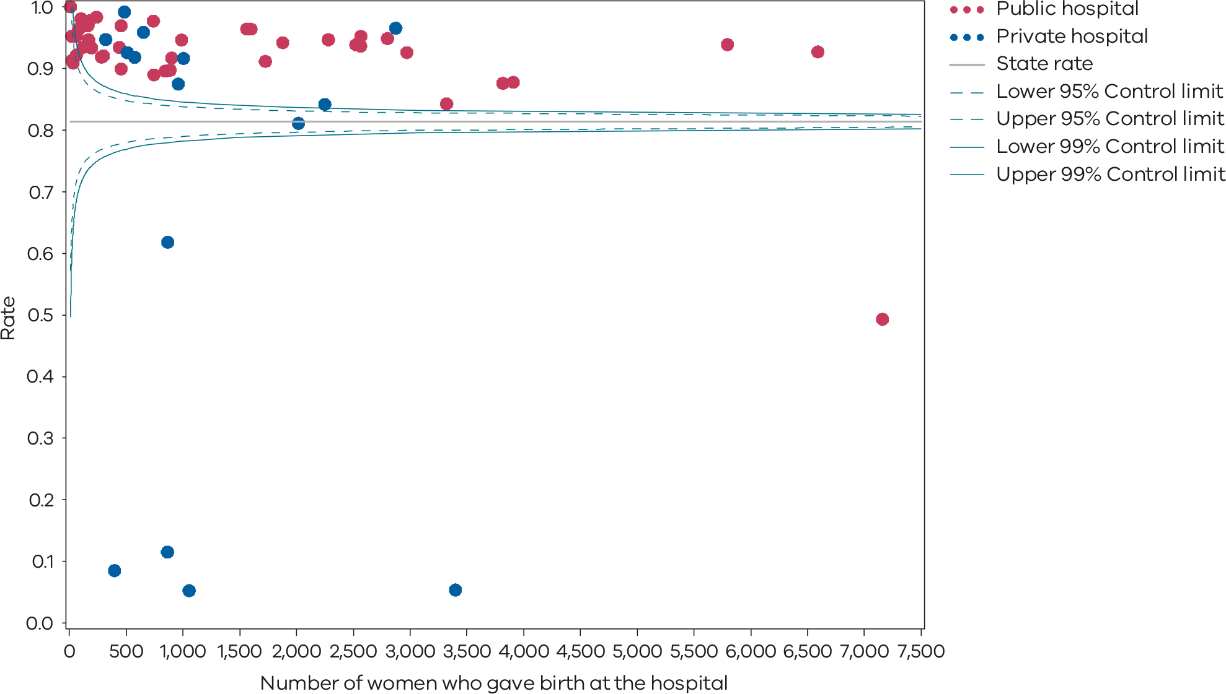
Please refer to the guide on how to interpret funnel plots.
Table 22. Rate of women vaccinated for pertussis during pregnancy, 2017–2021
 | 2017 | 2018 | 2019 | 2020 | 2021
Public | 83.0% | 88.2% | 91.5% | 91.1% | 87.3%
Private | 59.9% | 60.4% | 57.7% | 60.7% | 62.4%
Statewide | 77.5% | 81.8% | 83.8% | 84.3% | 81.4%
Figure 70. Time trend of Indicator 12a, 2017–2021
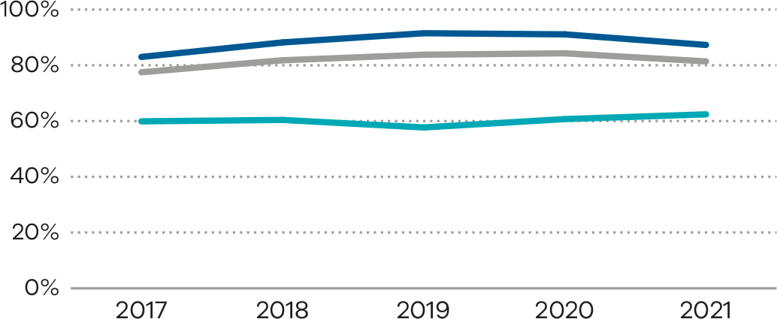
Figure 71. Indicator 12b: Rate of women vaccinated for influenza during pregnancy, 2021
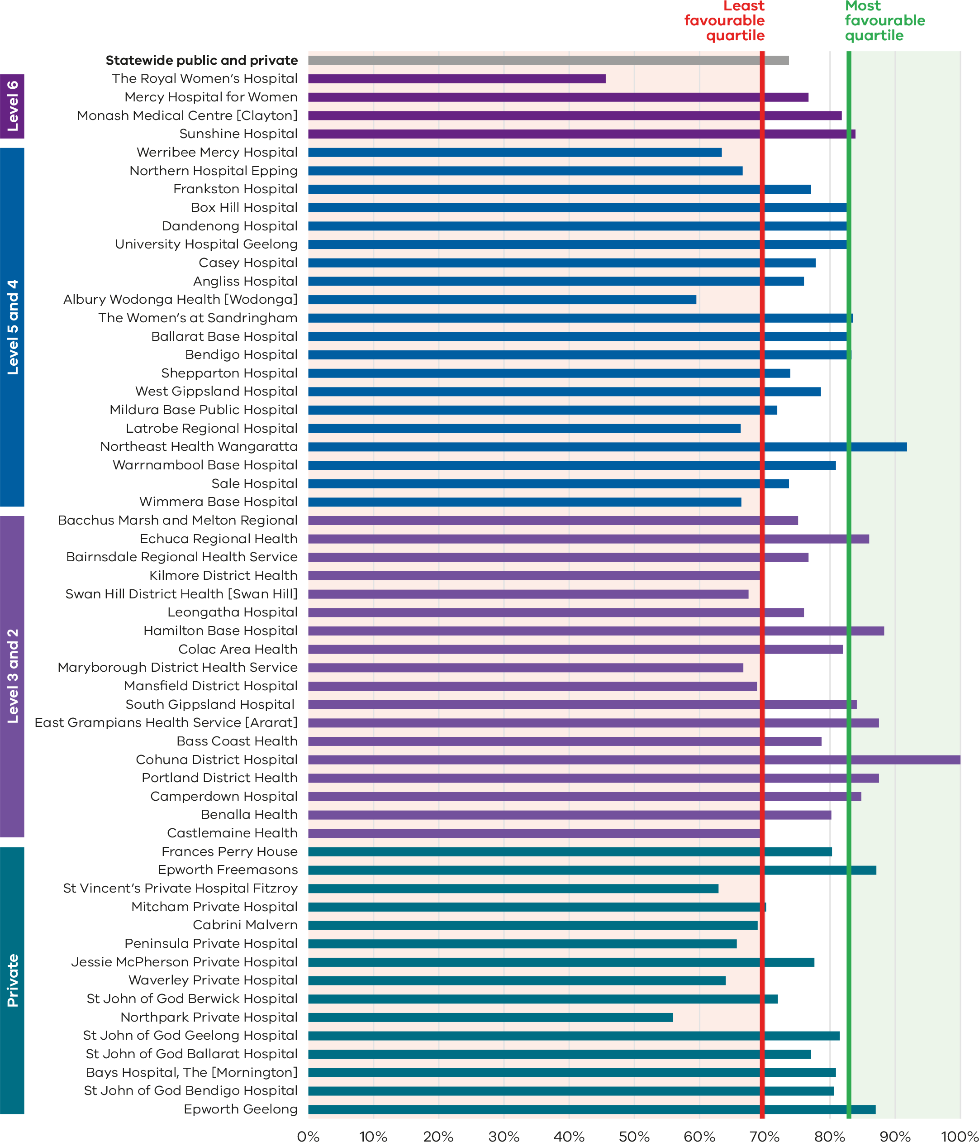
Figure 72. Funnel plot of the rate of women vaccinated for influenza during pregnancy, 2021
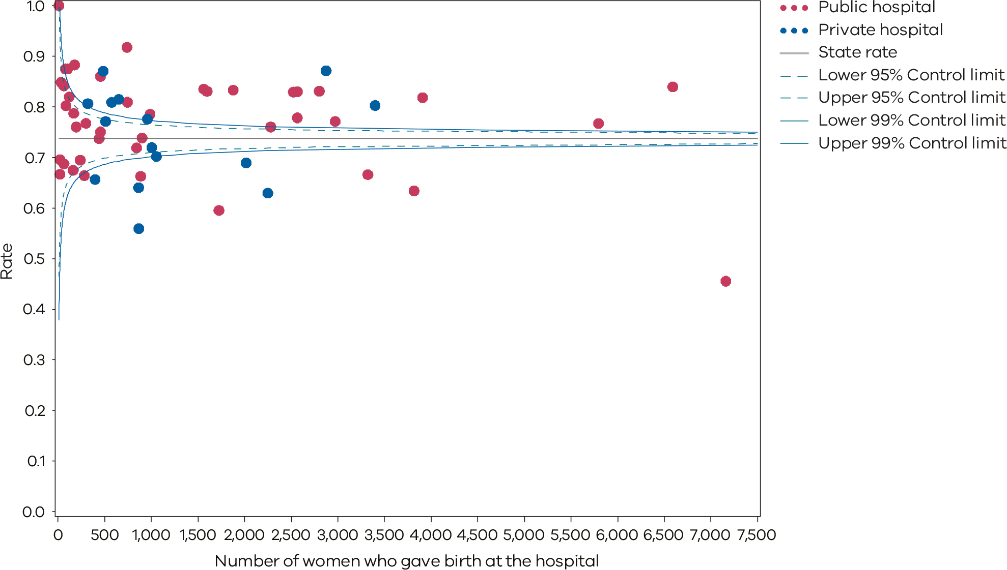
Please refer to the guide on how to interpret funnel plots.
Table 23. Rate of women vaccinated for influenza during pregnancy, 2017–2021
 | 2017 | 2018 | 2019 | 2020 | 2021
Public | 53.9% | 67.8% | 75.8% | 82.3% | 73.7%
Private | 53.4% | 65.0% | 70.9% | 80.7% | 74.7%
Statewide | 53.7% | 67.1% | 74.6% | 81.8% | 73.7%
Figure 73. Time trend of Indicator 12b, 2017–2021
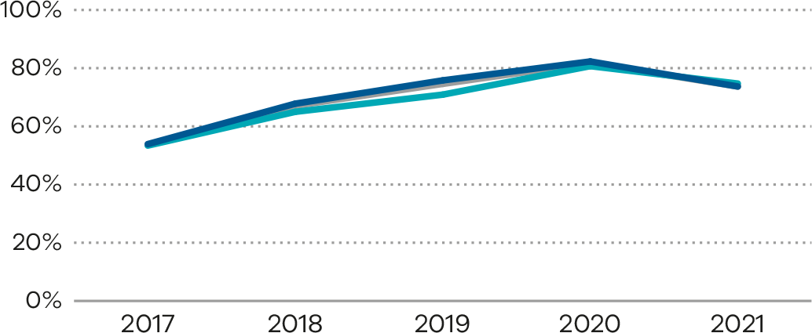

Definition and data source

Definition
The proportion of women who were vaccinated for influenza and pertussis at any time during their pregnancy.

Data source: Victorian Perinatal Data Collection
Data for this indicator is sourced from the VPDC for the calendar year from 1 January 2021 to 31 December 2021.
This indicator is derived using the following VPDC variables: ‘Estimated gestational age’, ‘Birthweight’, ‘Influenza vaccination status’, ‘Pertussis (whooping cough) vaccination status’ and ‘Birth order’.
Numerator/denominator
Indicator | Numerator | Denominator
Indicator 12a: The rate of women vaccinated for pertussis during pregnancy | The number of women who received a pertussis vaccine at any point during pregnancy | The number of women who gave birth in Victoria
Indicator 12b: The rate of women vaccinated for influenza during pregnancy | The number of women who received an influenza vaccine at any point during pregnancy | The number of women who gave birth in Victoria

13: Women who had a severe postpartum haemorrhage within the 24 hours following birth
Postpartum haemorrhage (PPH) is a common and potentially serious complication of childbirth. Although most PPH cases are minor, severe PPH is a risk factor for maternal mortality and morbidity in Australia. It is important that clinicians can prevent, recognise and treat PPH.

About this indicator
PPH is defined as blood loss of 500 mL or more. Severe primary PPH is defined as a blood loss of 1,500 mL or more within the 24 hours following birth.
This indicator presents the proportion of women who had a severe PPH within the 24 hours following birth.
[Break out box text:

What pregnant women and families need to know
Most women will have some bleeding after the birth of their baby. A small number of women will have excess bleeding. This can be very dangerous for the woman, requiring more treatment by their doctors and midwives and longer time in hospital. Severe excess bleeding can also affect breastfeeding and bonding with their baby.
Sometimes bleeding after birth cannot be avoided, but if it does happen, it should be picked up and treated quickly. The rate of excess bleeding defined as 1,500 mL (1.5 litres) or more should be low.
End of break out box text.]

Observations on the data
In 2021, 2.3% of women had a severe primary PPH. This was a slight reduction from the previous year’s rate of 2.6%. The rate for public hospitals was higher compared with private hospitals (2.7% and 1.1%, respectively). Figure 74 and Figure 75 show variation between individual hospitals. Some health services look after women with conditions that are at higher risk of bleeding – for example, placenta previa or placenta accreta – and this may account for the higher rate at certain health services. Table 24 compares rates of women with PPH across private and public hospitals. Figure 76 shows trends over time.

Strategies for improvement
Safer Care Victoria and more than 30 health services began the Postpartum Haemorrhage Collaborative <https://www.safercare.vic.gov.au/100000lives/projects/postpartum-haemorrhage-collaborative> in April 2022. We look forward to seeing the impact of this improvement work in the future as variations in clinical practice such as the method used to estimate PPH (visual estimation versus accurate measurement with weighing) may explain some of the variation in rates.
- Health services should have robust processes for recognising and responding to PPH.
- Health services should review their standard practice in measuring accurate blood loss.
- Weighing all blood loss (rather than visual estimate) is recommended as a good practice point when a PPH occurs (1 mL of blood equals 1 g).
- Include PPH in multidisciplinary obstetric emergency training, including clinicians and staff from teams outside the maternity service who may respond to a PPH.
- Health services should ensure they have a clinical practice guideline for PPH identification and management. Health services can refer to the Maternity e-Handbook Postpartum haemorrhage guidance <https://www.safercare.vic.gov.au/clinical-guidance/maternity/postpartum-haemorrhage-pph-prevention-assessment-and-management>.
- Health services should monitor their own data for trends and investigate and action accordingly.
- Health services should conduct case reviews of patients with PPH. Health services should have an agreed trigger for the review, whether this is any PPH ≥ 1,500 mL or requirement for blood transfusion and should include a review of antenatal care as well as intrapartum care.
- All PPHs greater than or equal to 1,500 mL should be reviewed.
Figure 74. Indicator 13: Rate of women with severe postpartum haemorrhage, 2021
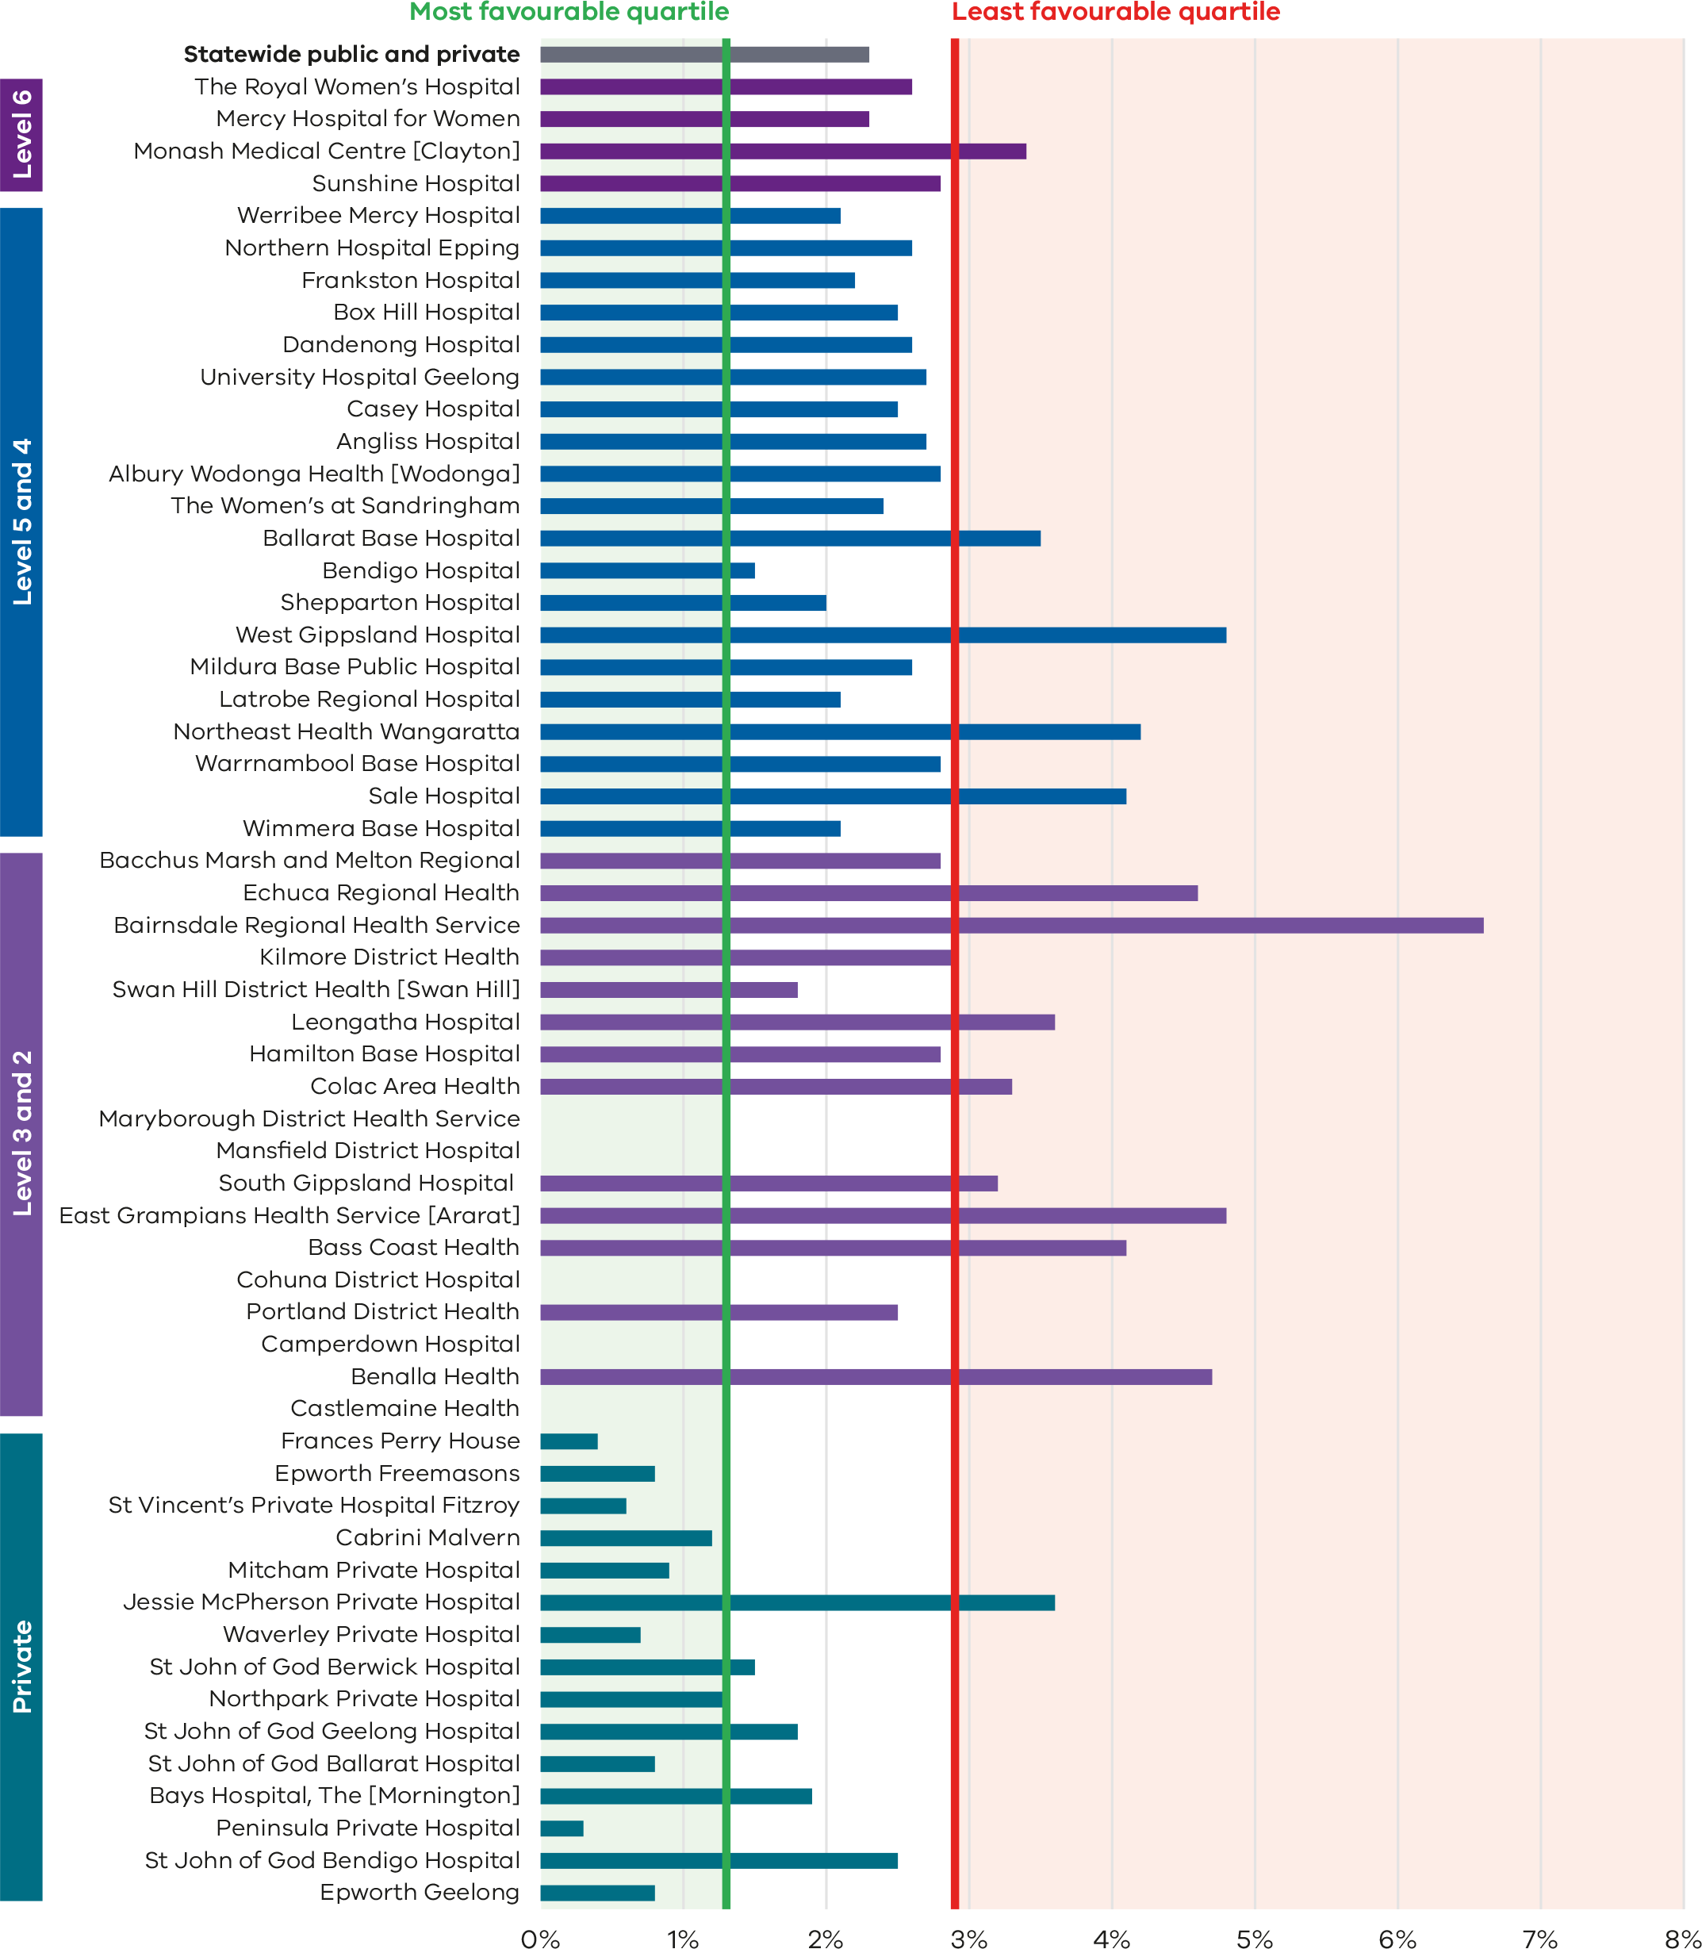
Figure 75. Funnel plot of the rate of women with severe postpartum haemorrhage, 2021
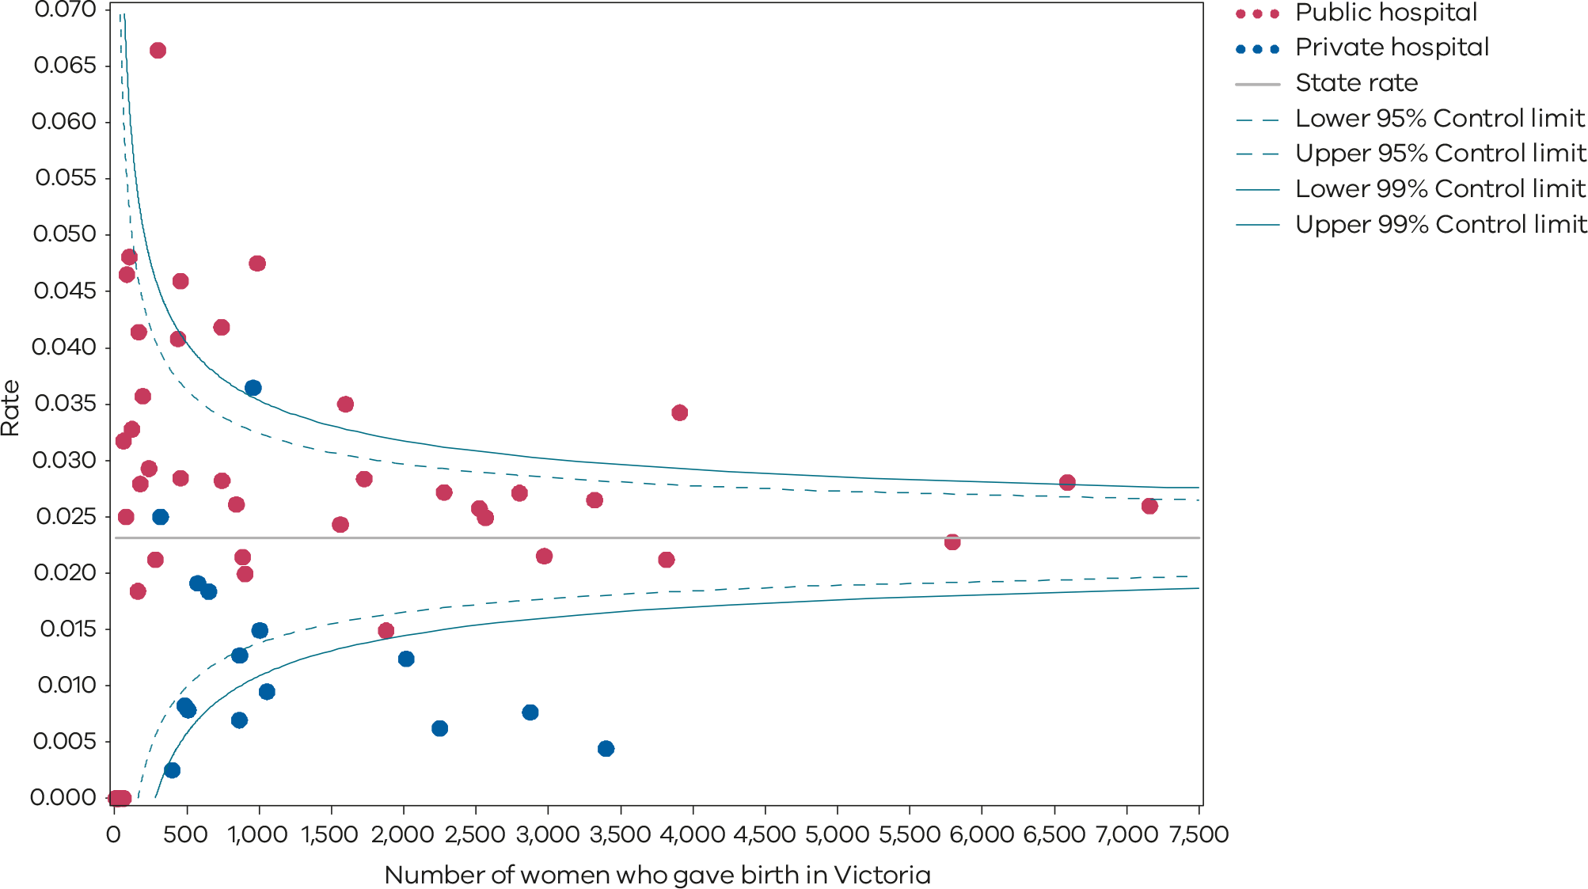
Please refer to the guide on how to interpret funnel plots.
Table 24. Rate of women with severe postpartum haemorrhage, 2018–2021
 | 2018 | 2019 | 2020 | 2021
Public | 2.5% | 2.9% | 3.0% | 2.7%
Private | 1.0% | 0.9% | 1.1% | 1.1%
Statewide | 2.2% | 2.4% | 2.6% | 2.3%
Figure 76. Time trend of Indicator 13, 2017–2021
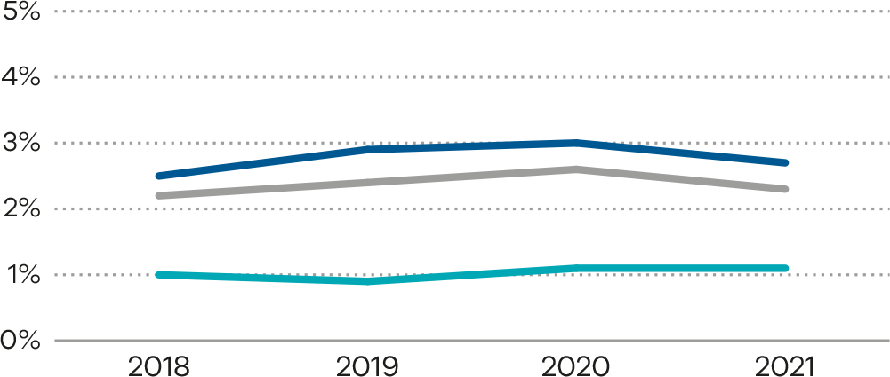

Definition and data source

Definition
The proportion of women who had a severe PPH (blood loss of 1,500 mL or more) within the 24 hours following birth.

Data source: Victorian Perinatal Data Collection
Data for this indicator is sourced from the VPDC for the calendar year from 1 January 2021 to 31 December 2021.
The indicator is derived using the following VPDC variables: ‘Estimated gestational age’, ‘Birthweight’, ‘Birth order’ and ‘Blood loss (mL)’.
Numerator/denominator
Indicator | Numerator | Denominator
Indicator 13: The rate of women with severe postpartum haemorrhage | The number of women with blood loss of at least 1,500 mL | The number of women who gave birth in Victoria

Appendix 1: Data sources and reporting rules
Safer Care Victoria, the Victorian Agency for Health Information and the Department of Health manage the health data collections used for this report:
- Victorian Perinatal Data Collection: Victorian public and private health services are required to submit specific data to the Consultative Council on Obstetric and Paediatric Mortality and Morbidity.
- Victorian Healthcare Experience Survey collects data for public health services only.
- Victorian Admitted Episodes Dataset: Victorian public and private health services are required to submit specific hospital admissions data.
More information on the data sources and the business rules for each indicator can be found under each indicator.
When interpreting the data in this report, it is important to note the following:
- Apart from Indicator 5, data is only reported when a health service has had a minimum of 10 occasions for an event (denominator). For example, a hospital that has had fewer than 10 standard primiparae give birth in 2021 (denominator) will not be included in the results for Indicator 1a.
- Due to small numbers, data from smaller health services are subject to wide variation and should be interpreted with caution.
- Private patients admitted to a public health service are reported in the results for the relevant public health service.
- Outcomes for public health services are presented in order of clustered maternity service capability and then by the number of women who gave birth at each health service in 2021 (in descending order so hospitals with more births in each capability level appear first).
Outcomes for private health services are presented in descending order according to the number of women who gave birth at each health service in 2021.
- Although the statewide rates provided for each indicator are a suitable measure for comparing health services, they do not necessarily represent the optimal rate.
- The indicators in this report do not adjust for maternal characteristics such as obesity, mental health conditions, chronic illnesses, socioeconomic status or IVF pregnancies. Health services should consider individual patient profiles when reviewing their data.
- Some of the variation between hospitals may reflect incomplete reporting. To ensure the accuracy of indicators, health services should make sure they have accurate capture and reporting of diagnostic and treatment codes.

Appendix 2: Total women and babies in Victorian maternity services 2021
Table 25. Total number of women and babies, by maternity service of birth, 2021
Health service | Hospital campus | Maternal capability level of service* | Number of women | Number of babies
The Royal Women’s Hospital | The Royal Women’s Hospital | 6 | 7,161 | 7,353
Western Health | Sunshine Hospital | 6 | 6,592 | 6,676
Mercy Hospitals Victoria Ltd | Mercy Hospital for Women | 6 | 5,796 | 5,919
Monash Health | Monash Medical Centre [Clayton] | 6 | 3,910 | 4,063
Northern Health | Northern Hospital Epping | 5 | 3,322 | 3,361
Peninsula Health | Frankston Hospital | 5 | 2,973 | 3,017
Barwon Health | University Hospital Geelong | 5 | 2,802 | 2,840
Eastern Health | Box Hill Hospital | 5 | 2,568 | 2,595
Bendigo Health Care Group | Bendigo Hospital | 5 | 1,879 | 1,905
Albury Wodonga Health | Albury Wodonga Health [Wodonga] | 5 | 1,727 | 1,745
Grampians Health Ballarat | Ballarat Base Hospital | 5 | 1,599 | 1,616
Goulburn Valley Health | Shepparton Hospital | 5 | 903 | 916
Latrobe Regional Hospital | Latrobe Regional Hospital | 5 | 887 | 898
Mercy Hospitals Victoria Ltd | Werribee Mercy Hospital | 4 | 3,819 | 3,836
Monash Health | Casey Hospital | 4 | 2,566 | 2,566
Monash Health | Dandenong Hospital | 4 | 2,525 | 2,525
Eastern Health | Angliss Hospital | 4 | 2,281 | 2,295
The Royal Women’s Hospital | The Women’s at Sandringham | 4 | 1,563 | 1,563
West Gippsland Healthcare Group | West Gippsland Hospital | 4 | 989 | 994
Mildura Base Hospital | Mildura Base Public Hospital | 4 | 843 | 853
South West Healthcare | Warrnambool Base Hospital | 4 | 744 | 760
Northeast Health Wangaratta | Northeast Health Wangaratta | 4 | 741 | 748
Central Gippsland Health Service | Sale Hospital | 4 | 441 | 447
Grampians Health – Wimmera Health Care Group | Wimmera Base Hospital | 4 | 283 | 284
Western Health BM&M | Bacchus Marsh and Melton Regional | 3 | 457 | 457
Echuca Regional Health | Echuca Regional Health | 3 | 457 | 457
Bairnsdale Regional Health Service | Bairnsdale Regional Health Service | 3 | 301 | 302
Kilmore District Health | Kilmore District Health | 3 | 239 | 239
Gippsland Southern Health Service | Leongatha Hospital | 3 | 196 | 196
Western District Health Service | Hamilton Base Hospital | 3 | 179 | 179
Bass Coast Health | Bass Coast Health | 3 | 169 | 169
Swan Hill District Health | Swan Hill District Health [Swan Hill] | 3 | 163 | 163
Colac Area Health | Colac Area Health | 3 | 122 | 122
East Grampians Health Service | East Grampians Health Service [Ararat] | 3 | 104 | 104
Benalla Health | Benalla Health | 3 | 86 | 86
Mansfield District Hospital | Mansfield District Hospital | 3 | 64 | 64
South Gippsland Hospital | South Gippsland Hospital | 3 | 63 | 63
South West Healthcare | Camperdown Hospital | 3 | 33 | 33
Portland District Health | Portland District Health | 2 | 80 | 80
Dhelkaya Health – Castlemaine | Castlemaine Health | 2 | 23 | 23
Maryborough District Health Service | Maryborough District Health Service [Maryborough] | 2 | 21 | 21
Cohuna District Hospital | Cohuna District Hospital | 1 | 10 | 10
Non-maternity public hospitalsª |  | NA | 7 | 7
Ramsay Health Care | Frances Perry House | Private | 3,401 | 3,472
Epworth HealthCare | Epworth Freemasons | Private | 2,876 | 2,904
St Vincent’s Private Hospital Melbourne Limited | St Vincent’s Private Hospital Fitzroy | Private | 2,251 | 2,275
Cabrini Health Limited | Cabrini Malvern | Private | 2,018 | 2,039
Ramsay Health Care | Mitcham Private Hospital | Private | 1,056 | 1,064
St John of God Health Care Inc. | St John of God Berwick Hospital | Private | 1,006 | 1,018
Jessie McPherson Private Hospital | Jessie McPherson Private Hospital | Private | 960 | 1,002
Healthscope | Northpark Private Hospital | Private | 867 | 878
Ramsay Health Care | Waverley Private Hospital | Private | 865 | 870
St John of God Health Care Inc. | St John of God Geelong Hospital | Private | 653 | 662
The Bays Hospital Group Inc. | Bays Hospital, The [Mornington] | Private | 576 | 579
St John of God Health Care Inc. | St John of God Ballarat Hospital | Private | 511 | 518
Epworth HealthCare | Epworth Geelong | Private | 486 | 490
Ramsay Health Care | Peninsula Private Hospital | Private | 399 | 401
St John of God Health Care Inc. | St John of God Bendigo Hospital | Private | 320 | 323
Total public |  | NA | 61,688 | 62,550
Total private |  | NA | 18,245 | 18,495
Private home births |  | NA | 386 | 386
Free births^{b} |  | NA | 3 | 3
Statewide total |  | NA | 80,322 | 81,434
Notes: Excludes babies born ≤ 20 weeks’ gestation, all terminations of pregnancy and birthweight ≤ 150 g. Babies born before arrival are counted at the hospital the mother and baby are subsequently transported to.
* Capability service as at 2021–22
a Includes the Royal Melbourne Hospital (women: n = 5; births: n = 5) and Heathcote (women: n = 1; births: n = 1)
b Free birth is a birth without medical or midwifery assistance.

Appendix 3: Overview of results

Table 26. Overview of indicator results, 2021
Hospital campus | Mat capability level | Number of births (babies, 2021) | Indicator 1a | Indicator 1bi | Indicator 1bii | Indicator 1ci | Indicator 1cii | Indicator 1di | Indicator 1dii | Indicator 2 | Indicator 3a | Indicator 3b | Indicator 4a | Indicator 4b | Indicator 5* | Indicator 6a | Indicator 6b | Indicator 7 | Indicator 8a | Indicator 8b | Indicator 8c | Indicator 9 | Indicator 10 | Indicator 11a* | Indicator 11b* | Indicator 12a | Indicator 12b | Indicator 13 | Indicators in most favourable | Indicators in least favourable
Statewide | – | 81,434 | 15.0% | 18.3% | 32.4% | 4.0% | 5.0% | 26.6% | 86.5% | NA | 20.0% | 18.2% | 21.5% | 54.3% | 1.0 | 2.0% | NA | 31.4% | 95.5% | 30.0% | 74.2% | 76.5% | 1.2% | NA | NA | 81.4% | 73.7% | 2.3% | - | -
Public hospitals | – | 62,550 | 11.0% | 17.2% | 32.4% | 4.6% | 5.8% | 26.2% | 91.2% | 11.0% | 20.6% | 16.8% | 26.0% | 54.1% | NA | 2.2% | 4.9% | 30.5% | 95.4% | 26.7% | 76.6% | 73.4% | 1.3% | 71.2% | 87.2% | 87.3% | 73.7% | 2.7% | - | -
Private hospitals | – | 18,495 | 21.7% | 23.5% | 32.6% | 1.1% | 2.7% | 30.3% | 73.1% | NA | 17.5% | 22.1% | 11.3% | 52.6% | NA | 1.3% | NA | 57.3% | 95.8% | 42.0% | 65.4% | 87.6% | 0.9% | NA | NA | 62.4% | 74.7% | 1.1% | - | -
Least favourable quartile | – | – | 23.0% | 26.8% | 41.6% | 5.2% | 6.6% | 31.8% | 78.8% | 12.4% | 24.0% | 24.2% | 13.9% | 49.3% | NA | 2.4% | 5.0% | 19.7% | 93.8% | 35.6% | 71.3% | 73.5% | 1.5% | NA | NA | 89.7% | 69.5% | 2.9% | - | -
Most favourable quartile | – | – | 6.8% | 15.3% | 29.7% | 0.9% | 2.8% | 20.5% | 92.0% | 8.4% | 14.0% | 12.0% | 27.5% | 62.3% | NA | 1.4% | 2.7% | 38.9% | 96.6% | 17.9% | 85.4% | 90.4% | 0.8% | NA | NA | 95.2% | 83.1% | 1.3% | - | -
The Royal Women’s Hospital | 6 | 7,353 | 9.3% | 15.2% | 28.4% | 5.9% | 6.5% | 21.7% | 90.7% | 13.9% | 25.9% | 14.1% | 28.8% | 63.6% | 1.0 | 2.1% | 7.2% | 30.2% | 96.0% | 26.0% | 77.2% | 42.0% | 1.2% | 73.0% | 90.6% | 49.3% | 45.6% | 2.6% | 4 | 7
Sunshine Hospital | 6 | 6,676 | 4.9% | 12.1% | 28.4% | 5.8% | 4.4% | 25.5% | 94.5% | 11.4% | 21.9% | 8.3% | 27.0% | 47.8% | 1.0 | 2.4% | 3.5% | 33.4% | 95.3% | 30.7% | 75.6% | 76.4% | 0.8% | 73.7% | 87.8% | 92.7% | 83.9% | 2.8% | 7 | 3
Mercy Hospital for Women | 6 | 5,919 | 15.5% | 17.1% | 31.6% | 3.1% | 5.8% | 31.6% | 91.2% | 9.2% | 19.0% | 11.6% | 19.8% | 51.7% | 0.7 | 2.0% | 4.3% | 38.9% | 96.7% | 34.1% | 71.3% | 52.1% | 1.0% | 71.9% | 87.6% | 93.9% | 76.7% | 2.3% | 3 | 2
Monash Medical Centre [Clayton] | 6 | 4,063 | 16.5% | 12.4% | 29.6% | 3.5% | 4.3% | 36.8% | 91.9% | 9.7% | 7.0% | 22.7% | 23.8% | 59.5% | 1.0 | 2.4% | 4.4% | 32.3% | 94.6% | 35.9% | 59.8% | 88.2% | 1.9% | 63.2% | 85.1% | 87.7% | 81.8% | 3.4% | 4 | 7
Northern Hospital Epping | 5 | 3,361 | 24.7% | 20.6% | 41.4% | 3.1% | 4.1% | 35.1% | 94.7% | 9.0% | 22.7% | 16.7% | 30.6% | 39.8% | 1.3 | 2.0% | 5.0% | 33.4% | 94.2% | 34.3% | 70.8% | 86.7% | 1.2% | 71.6% | 88.7% | 84.3% | 66.6% | 2.6% | 2 | 7
Frankston Hospital | 5 | 3,017 | 10.3% | 17.6% | 28.1% | 5.0% | 5.2% | 22.6% | 92.8% | 11.2% | 32.5% | 9.5% | 28.5% | 56.0% | 1.1 | 2.3% | 4.3% | 31.7% | 93.1% | 23.1% | 84.6% | 71.5% | 1.0% | 61.3% | 82.8% | 92.6% | 77.1% | 2.2% | 5 | 3
University Hospital Geelong | 5 | 2,840 | 6.5% | 22.2% | 32.4% | 6.0% | 9.4% | 20.5% | 87.3% | 16.6% | 27.5% | 17.4% | 30.1% | 53.2% | 0.9 | 3.0% | 5.8% | 26.2% | 96.5% | 26.2% | 79.8% | 94.5% | 1.1% | 67.0% | 83.3% | 94.9% | 83.1% | 2.7% | 5 | 6
Box Hill Hospital | 5 | 2,595 | 3.3% | 17.7% | 35.5% | 5.0% | 3.5% | 27.5% | 94.1% | 13.8% | 19.7% | 22.6% | 21.8% | 71.0% | 1.1 | 3.0% | 4.3% | 42.5% | 97.6% | 20.0% | 84.1% | 78.8% | 2.0% | 66.3% | 89.3% | 95.2% | 83.0% | 2.5% | 6 | 3
Bendigo Hospital | 5 | 1,905 | 19.9% | 19.2% | 34.1% | 5.8% | 5.9% | 32.9% | 94.1% | 10.0% | 9.8% | 11.1% | 27.4% | 62.5% | 1.3 | 1.8% | 6.5% | 20.5% | 94.3% | 25.8% | 82.0% | 78.5% | 1.2% | 70.0% | 83.8% | 94.2% | 83.3% | 1.5% | 5 | 3
Albury Wodonga Health [Wodonga] | 5 | 1,745 | 6.9% | 13.0% | 34.6% | 2.7% | 6.0% | 26.9% | 83.1% | 11.3% | 7.1% | 24.3% | 22.8% | 54.8% | 1.1 | 1.8% | 2.8% | 25.4% | 93.2% | 28.7% | 87.5% | 79.9% | 1.3% | 87.0% | 82.6% | 91.1% | 59.5% | 2.8% | 3 | 3
Ballarat Base Hospital | 5 | 1,616 | 16.7% | 18.3% | 35.9% | 3.8% | 6.7% | 20.5% | 90.6% | 11.7% | 15.4% | 13.3% | 30.3% | 50.0% | 0.9 | 3.1% | 5.0% | 26.7% | 93.8% | 19.7% | 83.9% | 93.2% | 1.5% | 63.5% | 83.3% | 96.4% | 83.1% | 3.5% | 5 | 6
Shepparton Hospital | 5 | 916 | 8.6% | 23.1% | 37.5% | 2.7% | 4.6% | 27.4% | 89.2% | 23.7% | 27.3% | 33.3% | 19.1% | 50.0% | 1.5 | 1.9% | 2.7% | 28.0% | 93.7% | 46.4% | 69.3% | 81.1% | 1.3% | 56.0% | 86.3% | 91.7% | 73.9% | 2.0% | 2 | 6
Latrobe Regional Hospital | 5 | 898 | 4.5% | 20.3% | 43.9% | 1.4% | 2.9% | 20.4% | 88.4% | 20.9% | 21.1% | 10.3% | 27.5% | 57.9% | 1.3 | 1.6% | 4.0% | 19.7% | 90.0% | 28.7% | 67.7% | 82.0% | 2.0% | 57.5% | 85.8% | 89.7% | 66.3% | 2.1% | 4 | 8
Werribee Mercy Hospital | 4 | 3,836 | 4.2% | 25.0% | 41.7% | 6.5% | 4.2% | 30.7% | 91.3% | 8.9% | 20.8% | 10.1% | 33.4% | 49.1% | 1.2 | 2.0% | 7.1% | 24.3% | 96.2% | 33.2% | 72.8% | 55.1% | 1.1% | 68.4% | 80.3% | 87.6% | 63.4% | 2.1% | 4 | 7
Casey Hospital | 4 | 2,566 | 4.4% | 14.3% | 36.1% | 1.6% | 7.6% | 23.0% | 93.4% | 6.2% | 22.9% | 20.9% | 26.1% | 52.5% | 1.4 | 2.3% | 4.2% | 44.1% | 96.5% | 20.4% | 73.1% | 91.0% | 1.7% | 77.7% | 91.8% | 93.6% | 77.8% | 2.5% | 6 | 3
Dandenong Hospital | 4 | 2,525 | 2.7% | 19.5% | 31.0% | 5.5% | 7.4% | 32.0% | 94.6% | 5.5% | 30.4% | 27.3% | 25.5% | 55.8% | 1.6 | 1.9% | 3.5% | 44.4% | 97.2% | 20.2% | 73.2% | 96.0% | 1.1% | 75.6% | 90.8% | 93.9% | 82.9% | 2.6% | 6 | 5
Angliss Hospital | 4 | 2,295 | 3.3% | 20.6% | 33.2% | 6.0% | 7.0% | 24.9% | 93.0% | 8.5% | 25.0% | 9.7% | 24.2% | 77.2% | 0.8 | 1.8% | 4.9% | 38.9% | 96.0% | 14.1% | 73.2% | 86.8% | 1.2% | 77.3% | 86.7% | 94.7% | 76.0% | 2.7% | 6 | 3
The Women’s at Sandringham | 4 | 1,563 | 9.7% | 14.7% | 23.5% | 5.4% | 6.3% | 30.2% | 88.4% | 6.4% | 19.0% | 30.3% | 5.5% | NA | 1.2 | 3.0% | 7.9% | 23.5% | 98.0% | 13.6% | 95.6% | 74.4% | 1.6% | 67.1% | 86.1% | 96.4% | 83.5% | 2.4% | 8 | 6
West Gippsland Hospital | 4 | 994 | 26.3% | 19.3% | 29.9% | 0.6% | 5.5% | 20.9% | 94.5% | 16.5% | NA | 27.3% | 38.6% | 59.3% | NA | 2.2% | 5.1% | 33.3% | 95.0% | 25.9% | 82.5% | 89.7% | 1.8% | 71.2% | 85.7% | 94.6% | 78.6% | 4.8% | 3 | 6
Mildura Base Public Hospital | 4 | 853 | 13.6% | 13.3% | 32.1% | 3.1% | 10.3% | 24.8% | 82.1% | 11.4% | 26.1% | 20.0% | 21.0% | 41.2% | 0.9 | 1.9% | 4.5% | 12.3% | 93.0% | 24.7% | 74.1% | 44.3% | 1.8% | NA | NA | 89.6% | 71.9% | 2.6% | 1 | 8
Warrnambool Base Hospital | 4 | 760 | 22.9% | 7.9% | 22.9% | 3.2% | 7.1% | 21.2% | 84.5% | 11.7% | 0.0% | 12.5% | 36.2% | 64.7% | 1.0 | 3.3% | 5.0% | 29.1% | 97.4% | 21.4% | 82.8% | 78.8% | 0.9% | 72.1% | 90.0% | 89.0% | 80.9% | 2.8% | 6 | 4
Northeast Health Wangaratta | 4 | 748 | 0.0% | 21.6% | 30.1% | 8.5% | 13.7% | 14.5% | 89.0% | 19.7% | 14.3% | NA | 26.4% | 50.0% | 0.9 | 2.3% | 3.8% | 25.0% | 95.3% | 17.2% | 86.7% | 93.6% | 1.0% | 66.7% | 84.9% | 97.7% | 91.8% | 4.2% | 7 | 4
Sale Hospital | 4 | 447 | 8.3% | 14.1% | 30.2% | 0.0% | 2.9% | 25.4% | 85.3% | 6.2% | NA | 0.0% | 22.5% | NA | 1.5 | 2.1% | 4.5% | 27.9% | 92.5% | 20.5% | 83.9% | 83.2% | 1.3% | 79.0% | 77.8% | 93.4% | 73.7% | 4.1% | 5 | 2
Wimmera Base Hospital | 4 | 284 | 0.0% | 36.4% | 37.0% | 4.2% | 0.0 | 20.8% | 87.5% | 17.4% | NA | NA | 25.8% | NA | NA | 2.0% | 3.3% | 18.6% | 92.7% | 17.0% | 91.3% | 88.7% | 0.4% | 65.0% | 89.5% | 91.9% | 66.4% | 2.1% | 5 | 5
Bacchus Marsh and Melton Regional | 3 | 457 | 37.9% | 24.4% | 29.6% | 5.0% | 8.0% | 33.3% | 96.0% | 9.5% | NA | NA | 3.9% | NA | NA | 1.8% | 4.2% | 34.1% | 93.7% | 20.4% | 86.1% | 75.0% | 1.4% | 83.3% | 97.6% | 89.9% | 75.1% | 2.8% | 3 | 6
Echuca Regional Hospital | 3 | 457 | 15.1% | 15.6% | 42.9% | 2.5% | 2.6% | 12.3% | 71.8% | 6.8% | NA | NA | 25.5% | 57.1% | NA | 3.7% | 2.1% | 30.0% | 93.2% | 21.5% | 80.2% | 88.0% | 0.9% | 82.1% | 92.3% | 96.9% | 86.0% | 4.6% | 6 | 5
Bairnsdale Regional Health Service | 3 | 302 | 5.3% | 20.3% | 42.1% | 6.1% | 3.8% | 12.2% | 100.0% | 2.7% | NA | NA | 18.2% | NA | NA | 1.8% | 2.9% | 14.7% | 94.2% | 10.8% | 88.8% | 60.9% | 1.7% | 63.8% | 78.3% | 92.0% | 76.7% | 6.6% | 6 | 6
Kilmore District Health | 3 | 239 | 25.0% | 29.7% | 29.3% | 9.4% | 8.7% | 9.4% | 87.0% | 8.5% | NA | NA | 19.2% | NA | NA | 2.2% | 0.9% | 18.5% | 91.5% | 12.0% | 90.7% | 93.3% | 2.6% | 82.4% | 100.0% | 98.3% | 69.5% | 2.9% | 7 | 9
Leongatha Hospital | 3 | 196 | 30.0% | 23.5% | 35.3% | 3.2% | 11.1% | 22.6% | 66.7% | 12.4% | NA | NA | 35.7% | NA | NA | 2.8% | 1.2% | 8.3% | 95.8% | 17.9% | 88.6% | 92.9% | 2.7% | 82.4% | 100.0% | 93.4% | 76.0% | 3.6% | 4 | 8
Hamilton Base Hospital | 3 | 179 | NA | 31.6% | 41.2% | 0.0% | 5.9% | 31.3% | 82.4% | 5.5% | NA | NA | 21.1% | NA | NA | 2.4% | 4.9% | 16.0% | 94.4% | 24.3% | 70.4% | 88.3% | 0.6% | 91.6% | 84.5% | 97.8% | 88.3% | 2.8% | 5 | 4
Bass Coast Health | 3 | 169 | 17.6% | 24.1% | 20.0% | 6.7% | 0.0% | 30.0% | 80.0% | 10.2% | NA | NA | 35.0% | NA | NA | 4.0% | 5.9% | 23.8% | 95.8% | 14.6% | 85.4% | 36.9% | 0.6% | NA | NA | 94.7% | 78.7% | 4.1% | 6 | 5
Swan Hill District Health [Swan Hill] | 3 | 163 | NA | 20.0% | 12.5% | 0.0% | 7.1% | 14.3% | 64.3% | 9.7% | NA | NA | NA | NA | NA | 1.9% | 2.0% | 14.3% | 95.6% | 26.1% | 81.0% | 63.8% | 1.3% | 86.5% | 100.0% | 96.9% | 67.5% | 1.8% | 5 | 4
Colac Area Hospital | 3 | 122 | 0.0% | 9.1% | 42.1% | 3.8% | NA | 15.4% | NA | 9.9% | NA | NA | NA | NA | NA | 1.8% | 6.4% | 8.3% | 95.8% | 20.9% | 81.7% | 90.2% | 2.5% | NA | NA | 93.4% | 82.0% | 3.3% | 3 | 5
East Grampians Health Service [Ararat] | 3 | 104 | NA | 14.3% | 50.0% | 4.5% | NA | 22.7 | NA | 7.8% | NA | NA | 45.5% | NA | NA | 1.9% | 1.0% | 43.8% | 95.0% | 19.8% | 94.8% | 76.0% | 2.0% | NA | NA | 98.1% | 87.5% | 4.8% | 7 | 3
Benalla Health | 3 | 86 | 7.1% | 28.6% | 50.0% | NA | 0.0 | NA | 92.3 | 16.7% | NA | NA | 46.2% | NA | NA | 8.1% | 0.0% | NA | 95.3% | 11.0% | 87.8% | 73.3% | 3.6% | NA | NA | 96.5% | 80.2% | 4.7% | 7 | 7
Mansfield District Hospital | 3 | 64 | 16.7% | 45.5% | 70.0% | NA | NA | NA | NA | 0.0% | NA | NA | NA | NA | NA | 1.9% | 0.0% | NA | 98.4% | 17.5% | 87.3% | 95.3% | 0.0% | NA | NA | 92.2% | 68.8% | 0.0% | 8 | 3
South Gippsland Hospital | 3 | 63 | NA | NA | 57.1% | NA | NA | NA | NA | 3.6% | NA | NA | NA | NA | NA | 0.0% | 1.8% | NA | 100.0% | 17.7% | 74.2% | 85.7% | 1.6% | NA | NA | 95.2% | 84.1% | 3.2% | 7 | 3
Camperdown Hospital | 3 | 33 | NA | NA | 40.0% | 0.0% | NA | 50.0% | NA | 11.1% | NA | NA | NA | NA | NA | 0.0% | 2.9% | NA | 100.0% | 3.0% | 97.0% | 84.8% | 0.0% | NA | NA | 90.9% | 84.8% | 0.0% | 8 | 1
Portland District Hospital | 2 | 80 | NA | NA | 25.0% | 0.0% | NA | 0.0% | NA | 10.9% | NA | NA | 21.4% | NA | NA | 0.0% | 4.4% | 14.3% | 92.4% | 26.0% | 69.9% | 62.0% | 0.0% | NA | NA | 96.3% | 87.5% | 2.5% | 7 | 4
Castlemaine Health | 2 | 23 | NA | NA | NA | NA | NA | NA | NA | 15.2% | NA | NA | NA | NA | NA | 0.0% | 0.0% | NA | 100.0% | 0.0% | 100.0% | 73.9% | 0.0% | NA | NA | 91.3% | 69.6% | 0.0% | 7 | 1
Maryborough District Health Service [Maryborough] | 2 | 21 | NA | NA | NA | NA | NA | NA | NA | 12.0% | NA | NA | NA | NA | NA | 4.2% | 0.0% | NA | 90.5% | 15.8% | 84.2% | 52.4% | 0.0% | NA | NA | 95.2% | 66.7% | 0.0% | 5 | 4
Cohuna District Hospital | 1 | 10 | NA | NA | NA | NA | NA | NA | NA | NA | NA | NA | NA | NA | NA | NA | NA | NA | 100.0% | 10.0% | 100.0% | 70.0% | 0.0% | NA | NA | 100.0% | 100.0% | 0.0% | 7 | 1
Frances Perry House | P | 3,472 | 15.1% | 23.3% | 35.1% | 0.5% | 2.2% | 40.4% | 80.8% | NA | 17.9% | 23.4% | 7.8% | 44.2% | 0.5 | 1.4% | NA | 62.5% | 96.9% | 38.5% | 76.6% | 90.5% | 1.1% | NA | NA | 5.4% | 80.3% | 0.4% | 7 | 5
Epworth Freemasons | P | 2,904 | 25.9% | 27.6% | 31.6% | 1.6% | 1.8% | 27.8% | 69.1% | NA | 15.0% | 17.1% | 10.7% | 36.2% | 0.9 | 1.3% | NA | NA | 96.7% | 37.9% | 54.1% | 90.4% | 0.9% | NA | NA | 96.6% | 87.1% | 0.8% | 7 | 7
St Vincent’s Private Hospital Fitzroy | P | 2,275 | 16.5% | 21.7% | 28.6% | 1.3% | 0.7% | 30.5% | 62.5% | NA | 17.4% | 21.3% | 13.2% | 64.3% | 0.6 | 0.8% | NA | 95.6% | 95.3% | 35.8% | 74.1% | 94.9% | 0.5% | NA | NA | 84.2% | 62.9% | 0.6% | 8 | 5
Cabrini Malvern | P | 2,039 | 29.7% | 12.0% | 18.3% | 1.3% | 5.2% | 22.5% | 69.2% | NA | 34.4% | 26.1% | 21.6% | 75.0% | 0.9 | 0.9% | NA | 81.3% | 96.4% | 38.8% | 64.5% | 91.3% | 0.6% | NA | NA | 81.1% | 68.9% | 1.2% | 8 | 8
Mitcham Private Hospital | P | 1,064 | 23.2% | 31.4% | 44.1% | 2.8% | 1.5% | 43.1% | 87.5% | NA | 14.3% | 23.8% | 11.8% | 47.6% | 0.9 | 1.0% | NA | NA | 95.5% | 57.9% | 55.9% | 89.1% | 0.8% | NA | NA | 5.3% | 70.2% | 0.9% | 4 | 9
St John of God Berwick Hospital | P | 1,018 | 17.0% | 36.1% | 45.2% | 0.0% | 0.8% | 35.0% | 78.0% | NA | 6.7% | 20.0% | 7.6% | 46.7% | NA | 1.1% | NA | 0.0% | 93.9% | 42.6% | 72.2% | 68.1% | 0.8% | NA | NA | 91.7% | 72.0% | 1.5% | 5 | 9
Jessie McPherson Private Hospital | P | 1,002 | 29.3% | 15.4% | 31.7% | 0.0% | 5.6% | 36.6% | 65.7% | NA | 11.8% | 25.4% | 13.9% | 62.5% | 0.9 | 1.0% | NA | NA | 96.6% | 42.8% | 49.6% | 90.5% | 1.1% | NA | NA | 87.5% | 77.6% | 3.6% | 6 | 9
Northpark Private Hospital | P | 878 | 23.1% | 16.0% | 31.2% | 1.1% | 5.8% | 32.6% | 78.6% | NA | 9.1% | 11.8% | 9.8% | 69.2% | NA | 1.0% | NA | 63.0% | 90.2% | 58.1% | 50.2% | 83.7% | 1.0% | NA | NA | 61.8% | 55.9% | 1.3% | 6 | 9
Waverley Private Hospital | P | 870 | 21.6% | 29.6% | 25.7% | 0.0% | 4.4% | 27.4% | 86.7% | NA | 13.6% | 21.7% | 11.9% | 27.8% | 1.2 | 1.0% | NA | NA | 95.6% | 63.5% | 47.8% | 81.8% | 1.1% | NA | NA | 11.6% | 64.0% | 0.7% | 5 | 7
St John of God Geelong Hospital | P | 662 | 20.0% | 30.0% | 47.9% | 6.9% | 0.0% | 44.8% | 78.9% | NA | NA | 33.3% | 11.3% | 53.8% | NA | 1.9% | NA | NA | 97.1% | 50.1% | 73.2% | 81.3% | 0.9% | NA | NA | 95.9% | 81.5% | 1.8% | 3 | 7
The Bays Hospital [Mornington] | P | 579 | 31.4% | 11.4% | 30.5% | 0.0% | 1.4% | 18.3% | 60.8% | NA | 16.7% | 21.4% | 22.6% | 52.6% | NA | 3.5% | NA | 84.6% | 96.6% | 34.0% | 76.0% | 90.5% | 0.9% | NA | NA | 91.8% | 80.9% | 1.9% | 7 | 3
St John of God Ballarat Hospital | P | 518 | 20.8% | 30.2% | 34.7% | 4.3% | 2.0% | 6.4% | 76.0% | NA | NA | 28.6% | 15.5% | 61.5% | NA | 2.9% | NA | NA | 94.5% | 35.6% | 73.2% | 85.5% | 0.7% | NA | NA | 92.6% | 77.1% | 0.8% | 4 | 5
Epworth Geelong | P | 490 | 22.7% | 28.3% | 42.0% | 0.0% | 4.5% | 13.3% | 61.8% | NA | NA | NA | 12.7% | NA | NA | 3.1% | NA | NA | 97.9% | 40.0% | 67.4% | 91.6% | 1.3% | NA | NA | 99.2% | 87.0% | 0.8% | 7 | 7
Peninsula Private Hospital | P | 401 | 35.9% | 37.5% | 35.8% | 2.3% | 4.5% | 6.8% | 81.8% | NA | NA | NA | 3.4% | NA | NA | 1.4% | NA | NA | 92.2% | 45.5% | 66.9% | 65.9% | 0.0% | NA | NA | 8.5% | 65.7% | 0.3% | 4 | 9
St John of God Bendigo Hospital | P | 323 | 12.9% | 25.9% | 48.8% | 0.0% | 4.2% | 37.5% | 87.5% | NA | NA | NA | 16.0% | NA | NA | 1.1% | NA | NA | 96.4% | 30.8% | 82.0% | 62.8% | 1.0% | NA | NA | 94.7% | 80.6% | 2.5% | 2 | 3
* For these indicators, funnel plots were used to determine most favourable and least favourable outcomes. For indicators 11a and 11b, the most favourable are hospitals with a rate less than the lower 95% control limit and least favourable are hospitals
with a rate more than the upper 95% control limit.
Most favourable outcomes are shown in green; least favourable quartiles are shown in orange.
NA indicates the service did not meet the threshold for public reporting for that indicator or that the indicator is not relevant to the service; all numbers presented are percentages except for Indicator 5 results, which are a ratio.
P indicates private hospitals.

Appendix 4: Robson classifications
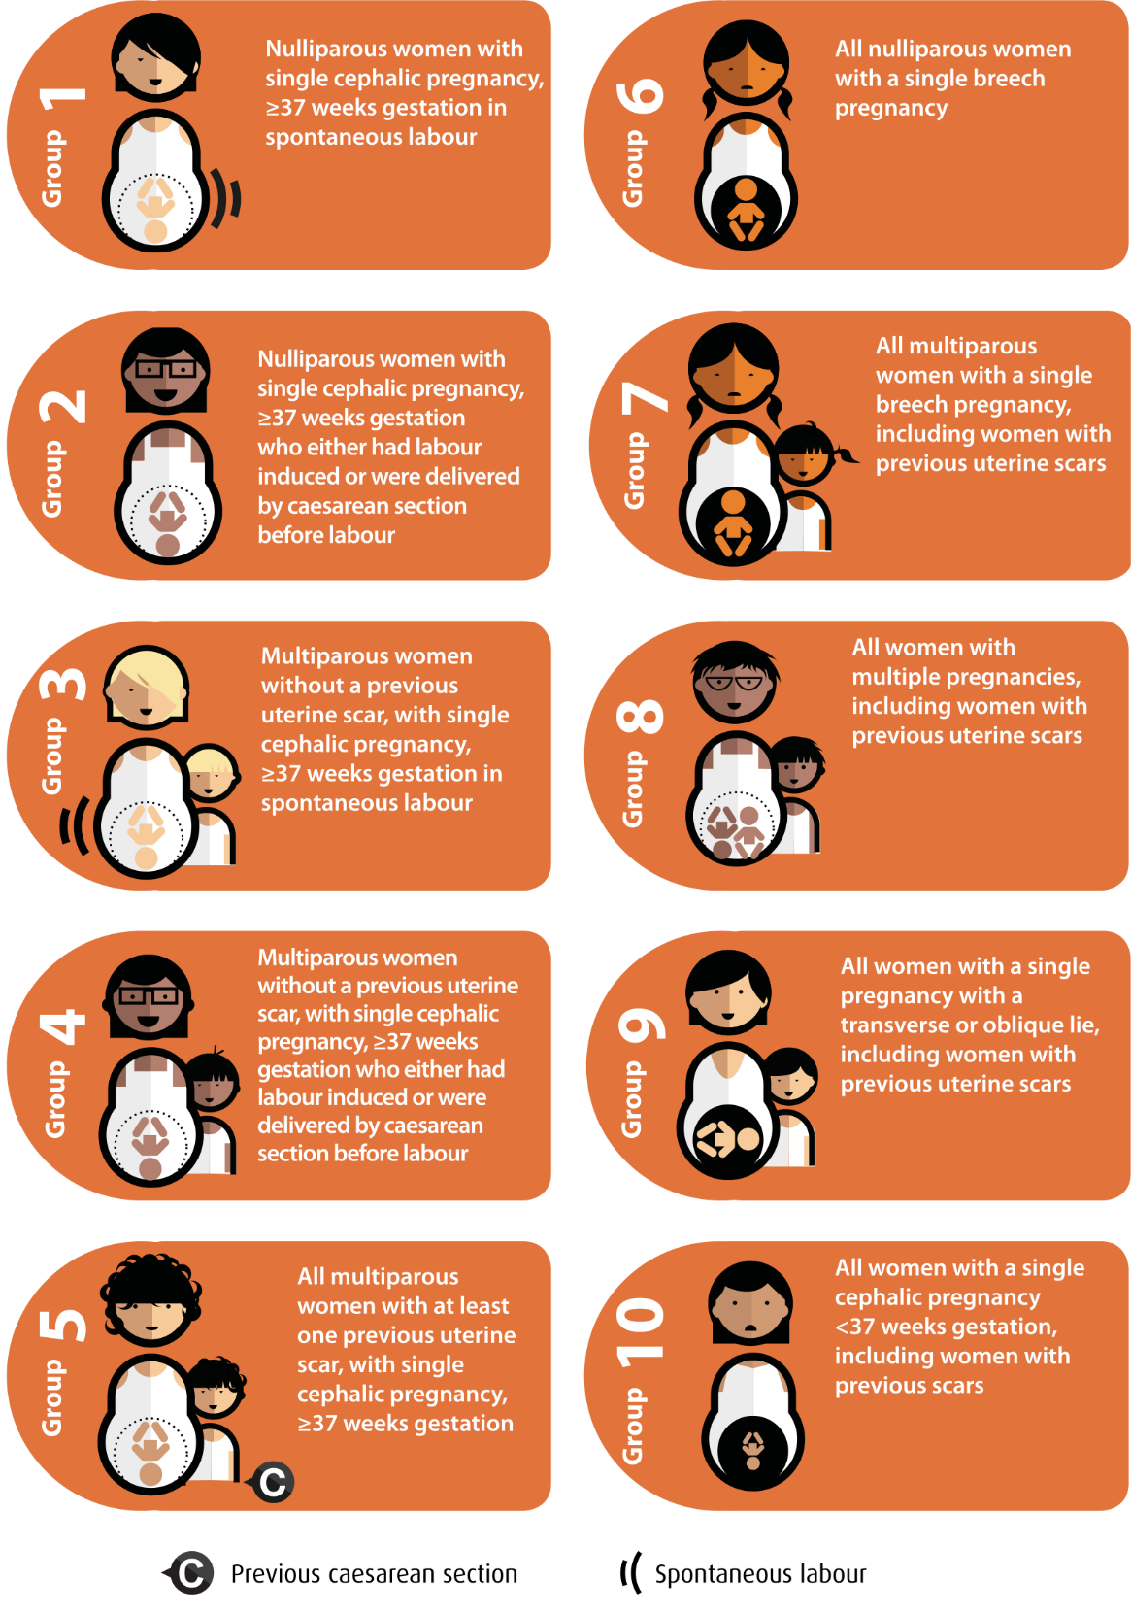
Boatin A, Cullinane F, Torloni M, Betrán A. 2018. Audit and feedback using the Robson classification to reduce caesarean section rates: a systematic review. BJOG: An International Journal of Obstetrics & Gynaecology. 125(1):36–42.

Appendix 5: Terminology
> : Greater than
≥ : Greater than or equal to
< : Less than
≤ : Less than or equal to
Antenatal: Before birth – the period between conception and birth. Also called prenatal.
Apgar score: A measure of the physical condition of a baby at birth based on measures including the baby’s colour, heart rate and breathing. Scores range from 0 to 10, where a higher number is better.
Assisted vaginal birth: Birth of a baby with forceps or vacuum. Also called instrumental birth.
Caesarean section: A surgical operation in which a baby is born.
Cardiotocography: A technique used to monitor the fetal heartbeat and uterine contractions during pregnancy and labour.
Centile: A measure indicating the value below which a given percentage of observations fall. For example, the 10th centile is the value (or score) below which 10% of the observations may be found.
Congenital anomaly: An abnormality present in the baby at birth. Also called birth defect, congenital malformation or congenital disorder.
Cephalic: The presentation of a baby head-first during vaginal birth
Denominator: The entire pool (or population) of women or babies included. The numerator is the group that have had the intervention or event. For example, at a particular hospital, 100 women had babies (denominator) and 20 of those had excess bleeding (numerator). The rate of excess bleeding is the numerator over the denominator, expressed as 20/100 or 20%.
Epidural: A procedure that injects a local anaesthetic into the space around the spinal nerves in the lower back to provide pain relief.
Episiotomy: A surgical cut at the opening of the vagina (the perineum) during childbirth to enlarge the opening for the baby to be born to aid a difficult birth and prevent rupture of tissues (perineal tear).
FGR (fetal growth restriction): A condition in which an unborn baby (fetus) is smaller than expected for the number of weeks of pregnancy (gestational age). Severe fetal growth restriction is birthweight below the third centile for gestational age and sex.
Forceps birth: Assisted vaginal birth using a metal instrument on each side of the baby’s head.
Fourth-degree tear: A tear of the perineum into the anal sphincter, extending into the lining of the anus.
Fundal height: The distance between the pubic bone (the symphysis pubis) and the top of the uterus (fundus) measured with a tape measure. Also known as symphysis fundal height.
Gestation: The number of weeks of pregnancy from the first day of the mother’s last normal menstrual period.
GSPMR (gestation standardised perinatal mortality rate): A measure of perinatal mortality that compares the observed perinatal mortality rate for babies born at individual hospitals with what would be expected, accounting for the gestation at birth.
ICD-10-AM (International Classification of Diseases and Related Health Problems, Tenth Revision, Australian Modification): A system healthcare providers use to classify and code all diagnoses and symptoms during admitted care.
Inborn: Baby born at the reporting hospital.
Induction of labour: Artificial means to start labour. The method of induction will depend on various factors and may include medications, rupture of membranes or mechanical means such as a balloon catheter to start labour.
Intrapartum: During labour and birth.
Live birth: The birth of a baby, at any gestational age, who has breathed or shown other signs of life after birth.
Maternity care provider: A clinician who provides maternity care, including doctors and midwives.
Mean: The average of a sample of numbers.
Median: A measure of the middle value of a given list of data.
Morbidity: Having a disease, a symptom of disease, or ill health, including medical problems caused by a treatment.
Mortality: Term used to describe death, including death rates or the number of deaths in a certain group of people during a certain time.
Neonatal: Referring to a newborn (from birth until the 28th day).
Neonate: A newborn; from birth until the 28th day.
Numerator: The group that have had the intervention or event. Refer also to ‘denominator’.
Perinatal: The period before, during and after birth.
Perinatal mortality: Stillbirths and neonatal deaths. Deaths between 20 weeks’ gestation and birth are referred to as stillbirths, and deaths in the first 28 days after birth are referred to as neonatal deaths.
Perineal tear: A tear of the perineum that may include the area of skin between the vagina and the anus, the vaginal mucosa and the muscles of the pelvic floor. Refer also to third-degree tear, fourth‑degree tear.
Postnatal/puerperium: The 6-week period after birth.
PPH (postpartum haemorrhage): Blood loss of more than 500 mL or severe PPH, which is blood loss more than 1,500 mL. A primary PPH occurs in the first 24 hours after childbirth. A secondary PPH is when blood loss occurs after 24 hours and up to 6 weeks following childbirth.
Prenatal: Before birth – the period between conception and birth. Also called antenatal.
Pre-term: Prior to 37 weeks’ gestation.
Primipara/primiparae: A woman/women who has given or is giving birth for the first time.
Qualified neonate: An infant who is the second or subsequent live born infant of a multiple birth, whose mother is currently an admitted patient; or who is admitted to a neonatal unit in a hospital; or who is admitted to, or remains in, hospital without their mother.
Robson classification system: A global standard for assessing, monitoring and comparing caesarean section rates for 10 groups of women based on obstetric characteristics. The system can be used to compare outcomes in different health services with different population demographics (refer to Appendix 4).
Robson group 1: Includes women giving birth for the first time, with a singleton cephalic pregnancy, at greater than or equal to 37 weeks’ gestation in spontaneous labour who have a caesarean section (refer to Appendix 4).
Robson group 2 (modified): Includes women giving birth for the first time, with a singleton cephalic pregnancy, at greater than or equal to 37 weeks’ gestation, who had labour induced and who have a caesarean section. Modified Robson group 2 excludes pre-labour caesareans, which are included in the standard Robson group 2 (refer to Appendix 4).
Singleton pregnancy: Pregnancy with one fetus (baby), as opposed to twins, triplets, etc.
Standard primipara: A woman, 20 to 39 years of age, free of obstetric and specified medical complications (pre-existing hypertension, diabetes, cardiac disease, BMI < 40 kg/m² or serious psychiatric conditions), giving birth for the first time with a singleton pregnancy between 37 and 40 weeks’ completed gestation (259–286 days), with a non-small for gestational age (greater than 10th centile) infant and a cephalic presentation.
Term infant/baby: An infant born between 37 and 42 weeks’ gestation (259–283 days).
Third-degree tear: A tear of the perineum into the anal sphincter that does not extend to the lining of the anus.
Unqualified neonate: A neonate who does not meet at least one of the criteria of a qualified neonate.
Vacuum birth: Assisted vaginal birth with a suction cup on the baby’s head.
VAED: Victorian Admitted Episodes Dataset.
Vaginal birth: A birth of a baby through the vagina.
VBAC (vaginal birth after caesarean): A woman who has a vaginal birth following a caesarean section birth.
Vertex: A baby born by vaginal birth presenting headfirst with chin tucked in.
VHES: Victorian Healthcare Experience Survey.
VPDC: Victorian Perinatal Data Collection.

Appendix 6: Australian birthweight tables
Table 27. Birthweight percentiles for live singleton male infants, Australia, 2004 to 2013
Gestational age (weeks) | Birthweight percentile (g)
 | 1st | 3rd | 5th | 10th | 25th | 50th | 75th | 90th | 95th | 97th | 99th
32 | 1,050 | 1,205 | 1,280 | 1,420 | 1,660 | 1,890 | 2,090 | 2,280 | 2,415 | 2,506 | 2,700
33 | 1,225 | 1,400 | 1,495 | 1,647 | 1,890 | 2,130 | 2,350 | 2,565 | 2,730 | 2,864 | 3,060
34 | 1,420 | 1,585 | 1,690 | 1,856 | 2,105 | 2,360 | 2,600 | 2,840 | 3,010 | 3,130 | 3,370
35 | 1,615 | 1,810 | 1,925 | 2,085 | 2,340 | 2,600 | 2,860 | 3,120 | 3,295 | 3,440 | 3,670
36 | 1,830 | 2,030 | 2,140 | 2,306 | 2,565 | 2,840 | 3,115 | 3,390 | 3,570 | 3,710 | 3,950
37 | 2,090 | 2,285 | 2,390 | 2,550 | 2,810 | 3,090 | 3,390 | 3,680 | 3,870 | 4,000 | 4,245
38 | 2,368 | 2,560 | 2,660 | 2,812 | 3,065 | 3,348 | 3,640 | 3,924 | 4,102 | 4,225 | 4,455
39 | 2,545 | 2,730 | 2,830 | 2,970 | 3,210 | 3,490 | 3,780 | 4,055 | 4,230 | 4,346 | 4,565
40 | 2,680 | 2,860 | 2,960 | 3,100 | 3,350 | 3,630 | 3,920 | 4,200 | 4,370 | 4,485 | 4,700
41 | 2,800 | 2,990 | 3,080 | 3,230 | 3,480 | 3,765 | 4,065 | 4,350 | 4,520 | 4,640 | 4,865
42 | 2,820 | 3,010 | 3,120 | 3,270 | 3,540 | 3,840 | 4,150 | 4,456 | 4,640 | 4,760 | 4,970
43 | 2,605 | 2,810 | 2,958 | 3,113 | 3,385 | 3,740 | 4,110 | 4,413 | 4,595 | 4,785 | 5,000
44 | – | – | – | 3,030 | 3,445 | 3,755 | 4,118 | 4,430 | – | – | –
Source: AIHW Data tables: National Perinatal Data Collection annual update 2021 <https://www.aihw.gov.au/reports/mothers-babies/australias-mothers-babies/data>

Table 28. Birthweight percentiles for live singleton female infants, Australia, 2004 to 2013
Gestational age (weeks) | Birthweight percentile (g)
 | 1st | 3rd | 5th | 10th | 25th | 50th | 75th | 90th | 95th | 97th | 99th
32 | 1,033 | 1,174 | 1,240 | 1,370 | 1,585 | 1,800 | 1,996 | 2,180 | 2,300 | 2,400 | 2,620
33 | 1,160 | 1,306 | 1,394 | 1,550 | 1,795 | 2,020 | 2,260 | 2,480 | 2,650 | 2,770 | 3,012
34 | 1,339 | 1,520 | 1,620 | 1,773 | 2,020 | 2,260 | 2,495 | 2,736 | 2,900 | 3,010 | 3,230
35 | 1,552 | 1,735 | 1,835 | 1,995 | 2,240 | 2,495 | 2,756 | 3,015 | 3,210 | 3,324 | 3,560
36 | 1,740 | 1,930 | 2,040 | 2,195 | 2,456 | 2,726 | 3,000 | 3,275 | 3,465 | 3,595 | 3,840
37 | 2,000 | 2,190 | 2,290 | 2,440 | 2,690 | 2,975 | 3,265 | 3,555 | 3,745 | 3,870 | 4,100
38 | 2,280 | 2,460 | 2,555 | 2,700 | 2,940 | 3,210 | 3,500 | 3,780 | 3,950 | 4,070 | 4,300
39 | 2,450 | 2,630 | 2,720 | 2,850 | 3,085 | 3,350 | 3,630 | 3,900 | 4,070 | 4,190 | 4,400
40 | 2,595 | 2,760 | 2,850 | 2,990 | 3,220 | 3,490 | 3,770 | 4,040 | 4,210 | 4,320 | 4,530
41 | 2,700 | 2,875 | 2,965 | 3,105 | 3,340 | 3,615 | 3,905 | 4,180 | 4,350 | 4,460 | 4,680
42 | 2,690 | 2,870 | 2,970 | 3,130 | 3,380 | 3,675 | 3,980 | 4,270 | 4,450 | 4,570 | 4,780
43 | 2,645 | 2,760 | 2,865 | 3,000 | 3,250 | 3,560 | 3,870 | 4,190 | 4,325 | 4,440 | 4,700
44 | – | – | – | 2,890 | 3,120 | 3,530 | 3,860 | 4,320 | – | – | –
Source: AIHW Data tables: National Perinatal Data Collection annual update 2021 <https://www.aihw.gov.au/reports/mothers-babies/australias-mothers-babies/data>

Acknowledgements
This report was produced by Safer Care Victoria by the Consultative Councils Unit and Technical Development Support – Safety Insights Program with expert advice from the Maternity and Newborn Learning Health Network (MNLHN) Data and Advisory Groups.
Member | Role | Affiliations
Dr Mary-Ann Davey | Senior Epidemiologist | Consultative Councils Unit  Safer Care Victoria
Dr Jake Valentine | Senior Project Officer | Safety Insights Program  Safer Care Victoria
Katherine Hunt | Clinical Fellow | Maternity and Newborn Learning Health Network  Safer Care Victoria
Melissah Burnett | Principal Project Officer | Consultative Councils Unit  Safer Care Victoria  Maternity and Newborn Learning Health Network
Selina Takanashi | Senior Project Officer | Safety Insights Program  Safer Care Victoria
Hope Deng | Manager | Safety Insights Program  Safer Care Victoria
Dr Adnan Ansar | Senior Project Officer | Consultative Councils Unit  Safer Care Victoria
Bronwyn Hogan | Consumer Lead | Maternity and Newborn Learning Health Network  Safer Care Victoria
Dr Penny Sheehan | Clinical Lead | Maternity and Newborn Learning Health Network  Safer Care Victoria
Tracy Firth | Senior Maternity Advisor | Safer Care Victoria
MNLHN Data Group Members | Maternity and Newborn Learning Health Network | Safer Care Victoria
MNLHN Advisory Group Members | Maternity and Newborn Learning Health Network | Safer Care Victoria
Joanna Gaston | Manager | Consultative Councils Unit  Safer Care Victoria
Dr Shirin Anil | Manager | Consultative Councils Unit  Safer Care Victoria
Prof. Mark Umstad | Chair | Consultative Council on Obstetric and Paediatric Mortality and Morbidity

Further reading
Boatin A, Cullinane F, Torloni M, Betrán A. 2018. Audit and feedback using the Robson classification to reduce caesarean section rates: a systematic review. BJOG: An International Journal of Obstetrics & Gynaecology. 125(1):36–42.
Department of Health, State Government of Victoria. Caesarean section [Internet] Australia: Better Health Channel, 2022. Available from: https://www.betterhealth.vic.gov.au/health/healthyliving/caesarean-section
Gavine A, Shinwell SC, Buchanan P, Farre A, Wade A, Lynn F, Marshall J, Cumming SE, Dare S, McFadden A. Support for healthy breastfeeding mothers with healthy term babies. Cochrane Database of Systematic Reviews. 2022(10).
Grobman WA, Rice MM, Reddy UM, Tita AT, Silver RM, Mallett G, Hill K, Thom EA, El-Sayed YY, Perez-Delboy A, Rouse DJ. Labor induction versus expectant management in low-risk nulliparous women. New England Journal of Medicine. 2018 Aug 9;379(6):513–523.
Hong J, Atkinson J, Mitchell AR, Tong S, Walker SP, Middleton A, Lindquist A, Hastie R, 2023. Comparison of maternal labor-related complications and neonatal outcomes following elective induction of labor at 39 weeks of gestation vs expectant management: a systematic Review and Meta-analysis. JAMA Network Open, 6(5), e2313162-e2313162.
Red Nose. National Scientific Advisory Group (Young J). Information Statement: Breastfeeding and the risk of sudden unexpected death in infancy. Melbourne: National SIDS Council of Australia, 2014. Available from: https://rednose.org.au/article/breastfeeding-and-the-risk-of-sudden-unexpected-death-in-infancy
Royal Australian and New Zealand College of Obstetricians and Gynaecologists (RANZCOG). Birth after previous caesarean section – Best Practice Statement. 2019. Available from: https://ranzcog.edu.au/wp-content/uploads/2022/05/Birth-after-previous-caesarean-section.pdf
Stillbirth Centre of Research Excellence. Timing of birth, 2023. Available from: https://stillbirthcre.org.au/parents/safer-baby/timing-of-birth/
World Health Organization. Health Topics – Breastfeeding recommendations. World Health Organization, 2023. Available from: https://www.who.int/health-topics/breastfeeding#tab=tab_1

Useful online resources

Victorian Department of Health
- Victorian Government, Department of Health. Capability frameworks for Victorian maternity and newborn services. Melbourne: State Government of Victoria. 2022.
<https://www.health.vic.gov.au/patient-care/capability-frameworks-for-maternity-and-newborn-care-in-victoria>
- Department of Health, State Government of Victoria. Healthcare decision-making – options, benefits and risks. Australia: Better Health Channel. 2018.
<https://www.betterhealth.vic.gov.au/health/servicesandsupport/healthcare-decision-making-options-benefits-and-risks>
- Victorian Government, Department of Health. Victorian Perinatal Data Collection. Melbourne: State Government of Victoria. 2023.
<https://www.health.vic.gov.au/quality-safety-service/victorian-perinatal-data-collection>

Safer Care Victoria
- Safer Care Victoria.
<https://safercare.vic.gov.au>
- Safer Care Victoria. COVID-19 communique. Consultative Council of Obstetric and Paediatric Morbidity and Mortality. 2023.
<https://www.safercare.vic.gov.au/sites/default/files/2023-09/Final%20CCOPMM%20COVID%20communique.pdf>
- Safer Care Victoria. Maternity and Newborn Learning Health Network. 2023.
<https://www.safercare.vic.gov.au/best-practice-improvement/learning-health-networks/maternity-newborn-lhn>

Breastfeeding
- Australian Breastfeeding Association.
<https://www.breastfeeding.asn.au/>
- BFHI Australia. Baby Friendly Health Initiative.
<https://bfhi.org.au/>

Immunisation
- Australian Government. Australian Immunisation Handbook. Pertussis (whooping cough). 2023.
<https://immunisationhandbook.health.gov.au/vaccine-preventable-diseases/pertussis-whooping-cough>
- Australian Government. Australian Immunisation Handbook. Influenza (flu). 2023.
<https://immunisationhandbook.health.gov.au/contents/vaccine-preventable-diseases/influenza-flu>
- Australian Government. Influenza and pertussis (whooping cough) vaccination in pregnancy. 2019.
<https://www.health.gov.au/news/influenza-and-pertussis-whooping-cough-vaccination-in-pregnancy>
- Australian Government. Immunisation. 2023.
<https://www.health.gov.au/topics/immunisation>
- Australian Government. Immunisation for pregnancy. 2023.
<https://www.health.gov.au/topics/immunisation/when-to-get-vaccinated/immunisation-for-pregnancy>
- Victorian Government, Department of Health. Immunisation. 2023.
<https://www.health.vic.gov.au/public-health/immunisation>
- Sharing Knowledge About Immunisation (SKAI). Pregnancy and newborn vaccinations. 2023.
<https://skai.org.au/pregnancy-and-newborn/resources/factsheets>

Perineal tears
- Safer Care Victoria. Better births for women collaborative. 2023.
<https://www.safercare.vic.gov.au/improvement/projects/mbc/better-births>
- Safer Care Victoria. Perineal protection project – audit tool. 2021.
<https://www.bettersafercare.vic.gov.au/improvement/projects/mbc/perineal-protection>
- Australian Commission on Safety and Quality in Health Care. Third and Fourth Degree Perineal Tears Clinical Care Standard. 2021.
<https://www.safetyandquality.gov.au/standards/clinical-care-standards/third-and-fourth-degree-perineal-tears-clinical-care-standard>
- Women’s Healthcare Australasia. The How to Guide: WHA CEC Perineal Protection Bundle. 2019.
<https://women.wcha.asn.au/wp-content/uploads/sites/3/2022/04/wha_national_collaborative_how_to_guide_21.1.20.pdf>

Postpartum haemorrhage
- Safer Care Victoria. Postpartum Haemorrhage Collaborative. 2022.
<https://www.safercare.vic.gov.au/100000lives/projects/postpartum-haemorrhage-collaborative>
- Safer Care Victoria. Clinical guidance: maternity. Postpartum haemorrhage (PPH) – prevention, assessment and management. 2018.
<https://www.safercare.vic.gov.au/clinical-guidance/maternity/postpartum-haemorrhage-pph-prevention-assessment-and-management>

Smoking cessation
- Quit Victoria.
<https://www.quit.org.au>
- iSISTAQUIT
<https://isistaquit.org.au>
- Stillbirth Centre of Research Excellence. The Safer Baby Bundle. Smoking Cessation.
<https://stillbirthcre.org.au/about-us/our-work/the-safer-baby-bundle/smoking-cessation/>

Stillbirth
- Safer Care Victoria. Safer baby collaborative. 2022.
<https://www.safercare.vic.gov.au/best-practice-improvement/improvement-projects/mothers-babies-children/safer-baby-collaborative>
- Stillbirth Centre of Research Excellence. The Safer Baby Bundle. Fetal Growth Restriction (FGR) Care Pathway for singleton pregnancies. 2023.
<https://learn.stillbirthcre.org.au/wp-content/uploads/2023/05/FGR-Management-Pathway_v3.0.pdf>
- Stillbirth Centre of Research Excellence. Safer Baby in Pregnancy. Timing of Birth.
<https://stillbirthcre.org.au/parents/safer-baby/timing-of-birth/>
- Stillbirth Centre of Research Excellence. Safer Baby Bundle eLearning module. 2023.
<https://learn.stillbirthcre.org.au>

Newborn resuscitation
- Australian Resuscitation Council. Neonatal resuscitation guidelines. 2023.
<https://www.anzcor.org>
- Victorian Newborn Resuscitation Project. 2023.
<https://www.neoresus.org.au>

Australian Institute of Health and Welfare
- Australian Institute of Health and Welfare. Australia’s mothers and babies. Canberra: Australian Institute of Health and Welfare. 2023.
<https://www.aihw.gov.au/reports/mothers-babies/australias-mothers-babies>

Centre for Epidemiology and Evidence
- Centre for Epidemiology and Evidence. New South Wales Mothers and Babies 2021. NSW Government: Centre for Epidemiology and Evidence. 2023.
<https://www.health.nsw.gov.au/hsnsw/Pages/mothers-and-babies-2021.aspx>



Hong J, Atkinson J, Mitchell AR, et al. 2023. Comparison of maternal labor-related complications and neonatal outcomes following elective induction of labor at 39 weeks of gestation vs expectant management: a systematic review and meta-analysis. JAMA Network Open, 6(5), e2313162-e2313162.
Grobman WA, Rice MM, Reddy UM, et al. 2018. Labor induction versus expectant management in low-risk nulliparous women. New England Journal of Medicine, 9;379(6):513–523.
Stillbirth Centre of Research Excellence, Timing of Birth <https://stillbirthcre.org.au/parents/safer-baby/timing-of-birth/>
Boatin A, Cullinane F, Torloni M, Betrán A. 2018. Audit and feedback using the Robson classification to reduce caesarean section rates: a systematic review. BJOG: An International Journal of Obstetrics & Gynaecology. 125(1):36–42.
Department of Health 2022, Caesarean section [Internet]. Better Health Channel, State Government of Victoria, Melbourne. Available: https://www.betterhealth.vic.gov.au/health/healthyliving/caesarean-section
Royal Australian and New Zealand College of Obstetricians and Gynaecologists (RANZCOG), 2019. Birth after previous caesarean section – Best Practice Statement <https://ranzcog.edu.au/wp-content/uploads/2022/05/Birth-after-previous-caesarean-section.pdf>.
Gavine A, Shinwell SC, Buchanan P, et al. 2022. Support for healthy breastfeeding mothers with healthy term babies. Cochrane Database of Systematic Reviews. (10).
Red Nose. National Scientific Advisory Group (Young J), 2014. Information Statement: Breastfeeding and the risk of sudden unexpected death in infancy. Melbourne: National SIDS Council of Australia.
World Health Organization, 2023. Health Topics – Breastfeeding Recommendations.
Vaccination during pregnancy reduces the risk of pertussis in young infants by 90% <https://immunisationhandbook.health.gov.au/vaccine-preventable-diseases/pertussis-whooping-cough>
Refer to the Department of Health and Aged Care website <https://www.health.gov.au/news/influenza-and-pertussis-whooping-cough-vaccination-in-pregnancy>.
Refer to the Department of Health and Aged Care website <https://www.health.gov.au/sites/default/files/documents/2022/10/aisr-2021-national-influenza-season-summary.pdf>.

