# Being transferred for EVT assessment?

|  |
| --- |
| Important information You have had a stroke. This type of stroke is called an ischaemic stroke. Your symptoms are caused by a blockage in one of the blood vessels in your brain or neck.  You have been assessed as a good candidate for endovascular clot retrieval (EVT), a specialised operation shown to reduce stroke symptoms. Research tells us this treatment will give you the greatest chance of recovery.  You will have EVT in an operating theatre and will be looked after by a team of doctors and nurses who have a lot of experience in stroke management.  Please ask your stroke team if you have any questions. |

### What is an ischaemic stroke?

An ischaemic stroke happens when a clot blocks a blood vessel in the brain or neck. This prevents blood flow to all parts of the brain.

When this happens, brain cells cannot function. If blood supply is not restored quickly, they will die from lack of oxygen.

Figure 1. A clot stopping blood flow in the brain.

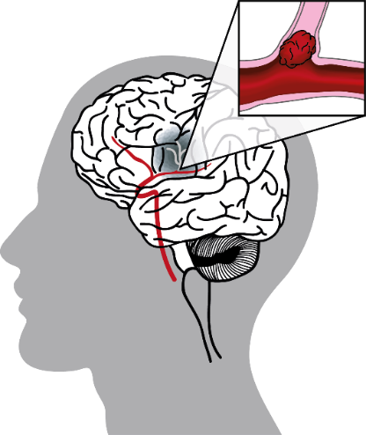

### What treatments are available?

Treatments for ischaemic stroke are called **reperfusion therapies.**

These treatments break down or remove the clot that is blocking the blood vessel. The aim is to restore blood flow and give you the best chance of recovery.

There are two types of treatment:

* Intravenous (IV) thrombolysis – aims to break down the clot.
* Endovascular clot retrieval (EVT) – aims to physically remove the clot.

#### IV thrombolysis

This treatment can be given up to 4.5 hours after a stroke. In some cases, it can still be given even beyond 4.5 hours after a stroke. It is available at most emergency departments.

A drug is injected into a vein (usually in the arm). The drug makes its way to the brain where it acts to break down the clot and restore blood flow. While it is a very effective treatment, it may not completely dissolve clots in big arteries. This is probably why you are being assessed for EVT.

#### Endovascular clot retrieval (EVT)

EVT is a specialised operation to remove a clot in an artery that supplies blood to the brain. It is only available in certain hospitals.

A small tube is inserted into an artery, normally in the leg, and fed into the brain. A special wire ‘net’ or suction device is fed through the tube to remove the blockage.

#### Figure 2 A tube is inserted in the leg to remove a clot in the brain

### An image showing how the blood clot is removed to allow blood flow into the brain.

**Not everyone benefits from EVT**

To figure out if EVT will help you, you will first have a brain scan. Your doctor may then refer you to a specialist team that performs the operation. They will decide if you are a good candidate to have EVT.

The operation will not be performed unless you will benefit from it.

Figure 3 How you will be assessed for EVT



Assessed by EVT team*

Brain scan

*Transfer to hospital where EVT is performed*

*EVT performed only if it will help



### Why can’t all hospitals offer EVT?

EVT is a very specialised operation that needs a highly trained team and specific equipment. Because of this, only a few hospitals can provide the care you might need before, during and after this operation.

### What are the outcomes of EVT?

50% of people can recover to live independently three months after their stroke.



45% have no change in outcome.

5% develop bleeding into the brain or have a blood vessel injured during the procedure. **3%** have problems with bleeding or an injured blood vessel close to where the EVT device is inserted (usually the leg). This does not typically lead to long term problems.

### What happens next?

You may have difficulty moving, thinking or communicating because of your stroke. You might need rehabilitation to help you recover as well as possible. If you need rehabilitation this will usually happen in the stroke unit closest to your home. This might mean you are transferred back to your local hospital.

|  |  |
| --- | --- |
| This fact sheet was developed by Safer Care Victoria and adapted with permission by [NAME OF HEALTH SERVICE].  [DATE] |  |