October 2024

Tachyarrhythmia in neonates

Clinical guidance

|  |
| --- |
|  |
| To receive this publication in an accessible format [email Safer Care Victoria](mailto:info@safercarevictoria.vic.gov.au) <info@[safercare.vic](mailto:safercarevictoria@dhhs.vic).gov.au>  Authorised and published by the Victorian Government, 1 Treasury Place, Melbourne.  © State of Victoria, Australia, Safer Care Victoria, October 2024  **ISBN 978-1-76131-685-2 (pdf/online)**  Available at the [Safer Care Victoria website](https://www.safercare.vic.gov.au) <https://[www.safercare.vic](http://www.safercare.vic).gov.au>Victoria State Government |



Contents

Key messages 4

Acknowledgement 4

Consumer Engagement Statement 4

Initial steps 4

ECG interpretation 5

Stabilisation 5

Differential diagnosis 5

Sinus tachycardia 5

Supraventricular tachycardia 6

SVT management 6

Vagal manoeuvres 6

Adenosine 6

Synchronised cardioversion 7

Other antiarrhythmics 7

Wide complex SVT 7

Ventricular tachycardia 8

VT management 8

Atrial flutter 8

Cardioversion 9

Ongoing management 9

Follow-up plan 10

References 10

Citation 10

**Key messages**

* Supraventricular tachycardia (SVT) is the most commonly seen tachyarrhythmia in neonates. It can develop in utero resulting in fetal hydrops.1
* Because neonates cannot report symptoms, tachyarrhythmias occurring after initial hospital discharge may go undetected for some time and only present to hospital when circulatory decompensation develops.
* Appropriate resuscitative measures should be instituted.
* Vagal stimulation or adenosine is effective in reverting most neonatal SVT caused by an atrioventricular re-entry pathway.
* Intravenous verapamil should never be given to infants because of the risk of refractory hypotension.

This is a guideline specifically for the management of tachyarrhythmias in neonates. Advanced Paediatric Life Support (APLS) guidelines are also commonly in use and have minor differences. Use of the guideline that treating clinicians have most familiarity with, is acceptable.

**Acknowledgement**

This guidance may use the terms ‘woman’ and ‘mother,’ which are intended to be inclusive of anyone who may use other self-identifying terms and aims to encompass all for whom this guidance is relevant.

**Consumer Engagement Statement**

All interactions between health care staff with consumers (women, mothers, patients, carers and families) should be undertaken with respect, dignity, empathy, honesty and compassion.  ​

​Health care staff should actively seek and support consumer participation and collaboration to empower them as equal partners in their care.

**Initial steps**

Support in the diagnosis and management of neonates with suspected tachyarrhythmia can be obtained initially by contacting PIPER on **1300 137 650** and the RCH Cardiologist can be added to the referral call.

It is helpful to have a 12 lead ECG to send electronically at this time but should not delay the referral call if urgent resuscitation guidance is required.

Cardiology consultation regarding diagnostic and therapeutic management issues is also available at any time through the switchboard of either Monash Medical Centre on (61 3) 9594 6666 or the Royal Children’s Hospital on (61 3) 9345 5522.

Obtain a 12 lead ECG if not already done.

**Correct placement of ECG leads**

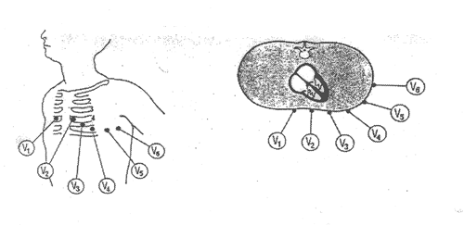

**ECG interpretation**

|  |
| --- |
| Normal rate   P wave: rate, rhythm, axis (P upright in I, aVF)  P-QRS relationship: 1:1 association, PR interval < 0.2sec  QRS complex: rate, axis, broad or narrow. Normal 0.02–0.08 sec  QTc = QT/√RR > 0.46 sec |

Continuous ECG monitoring is preferable (with printing facility if available).

Obtain blood to check blood gas – lactate, glucose, electrolytes including ionised calcium. Consider also collecting blood for full blood examination and thyroid function tests if able.

**Stabilisation**

Resuscitation takes priority over managing an arrhythmia.2

Assess patient for cardiopulmonary compromise or signs of heart failure, these include poor feeding, tachypnoea, pallor, delayed capillary refill, sweating, lethargy and irritability.

Obtain IV/IO access and give oxygen if saturations are below 92%.

**Differential diagnosis**

**Sinus tachycardia**

Usually up to 220bpm, p wave for every QRS. P wave upright in lead II, III and aVF.

Should vary with stimulation or temperature.

Usually associated with sepsis, fever, pain, hypovolaemia or anaemia.

Investigation and treatment are aimed at managing the underlying cause.

**Supraventricular tachycardia**

Most common spontaneous-onset arrhythmia in infancy.

Usually > 240 bpm and up to 300 bpm, narrow QRS complex, *p* waves may or may not be present, not upright in lead II, III and aVF.

Abrupt onset of tachycardia.

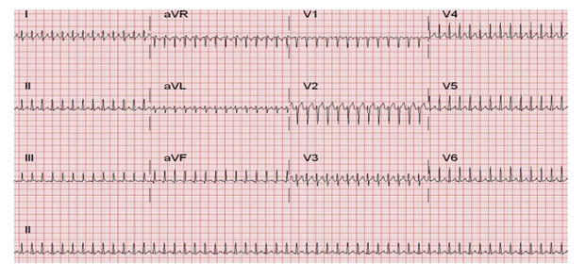

The most common mechanism of SVT in neonates is a re-entry atrioventricular SVT (AVRT) with the existence of an accessory pathway to allow retrograde transmission of the atrial contraction in addition to its usual transmission via the bundle of His.1

**SVT management**

**Vagal manoeuvres**

In haemodynamically stable patients, vagal stimulation should be attempted initially.

ECG monitoring should continue throughout these attempts.

This can be achieved by applying a plastic bag filled with ice and water to the face for 10 seconds. Inducing a gag by oropharyngeal suctioning or with a spatula may also be attempted if the resources to do so are more immediately available.

***Do not apply pressure to the eyeballs as this can result in retinal detachment.***

**Adenosine**

Is the preferred first-line medication for treatment of neonates with SVT with a palpable pulse. 2,3,4

It has a very short half-life and must be given rapidly via a cannula in a large bore vein or via an IO followed by a rapid flush of 5mL 0.9% normal saline. The antecubital vein is the preferred site with a 3-way tap attached to for administration of adenosine via one port and flush via the other.

* Initial dose: 100 mcg/kg
* Increase in increments of 100 mcg/kg every 2–3 minutes to a maximum of 300 mcg/kg until cardioversion is achieved (a short period of cardioversion with re-starting of the SVT is also a cardioversion and increase in dose is not helpful in this case).
* If patient remains in SVT seek further cardiology/PIPER advice following which doses of up to 500mcg/kg may be given.

Adenosine administration should always be done with ECG capture on paper or an electronic recording system.

Adenosine works by temporarily blocking the AV node. A brief pause will be seen on ECG before return of sinus rhythm. If this pause is not seen, and sinus rhythm is not achieved, SVT due to a re-entrant atrioventricular pathway is much less likely to be the cause of the observed tachyarrhythmia.

The only contraindication to adenosine is adenosine-deaminase deficiency, a rare form of severe combined immune deficiency, with a worldwide incidence of 1:200,000 to 1:1000,000.

**Synchronised cardioversion**

If the patient is profoundly hypotensive or pulseless and/or IV/IO access cannot be obtained rapidly, emergency synchronised cardioversion should be first-line management2 and performed in consultation with PIPER and Cardiology.

Synchronised cardioversion is also performed electively if the patient remains cardiovascularly stable but reversion to sinus arrythmia has not occurred after maximal dose of adenosine.2

**Other antiarrhythmics**

Esmolol may be given for refractory SVT after further Cardiology/PIPER consultation.4 It is given by a slow IV infusion with careful haemodynamic monitoring with an initial loading dose of 100–500mcg/kg over 1–2 minutes; followed by an infusion at 25–100 mcg/kg/min. This can be titrated to response in increments of 25–50 mcg/kg/min allowing at least 5 minutes between dose adjustments to assess for response. Maximum dose is 500–1000 mcg/kg/min.

**Verapamil must NEVER be given to neonates due to risk of profound hypotension and death.**

**Wide complex SVT**

Can be caused by an aberrant conduction (bundle branch block) or conduction through a pathway (antidromic AVRT) or ventricular tachycardia (VT).

If pulses and blood pressure are normal, treatment as per SVT can be instituted.2

If pulses are present but there is hypotension or inadequate systemic circulation, treatment should proceed as per VT with synchronised cardioversion.2

If pulses are absent, the rhythm should be managed as pulseless VT and managed with continuous CPR and defibrillation at doses of 4 J/kg.2

**Ventricular tachycardia**

VT is rare in neonates and when it does occur is often associated with an underlying electrolyte abnormality, congenital heart disease (including after surgical repair), cardiomyopathy or cardiac tumour.

**Three or more ventricular complexes without any p-waves and wide QRS complexes with abnormal morphology.**

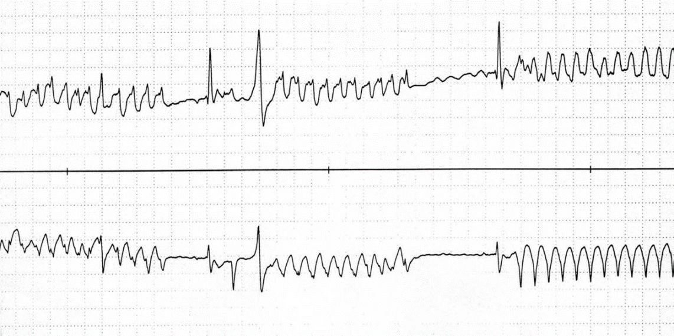

**VT management**

Synchronised cardioversion is recommended first-line management in a shocked patient.2

Amiodarone may be recommended following Cardiology consultation, dependent on the history and any identified underlying cause.

**Atrial flutter**

Can occur in the fetus in the third trimester and in the neonate. Rare later in infancy/childhood.5

Fetal atrial flutter can cause hydrops. If detected, it may be amenable to maternal beta blockade.

Irregular atrial activity of 280-500bpm with variable conduction (frequently 2:1 AV conduction)

Caused by re-entrant circuits within the right atrium.

Can be associated with structural congenital heart disease.

ECG shows typical ‘sawtooth’ pattern in leads II, III, aVF and V1. This may only become apparent when the AV node is temporarily blocked by adenosine administration.

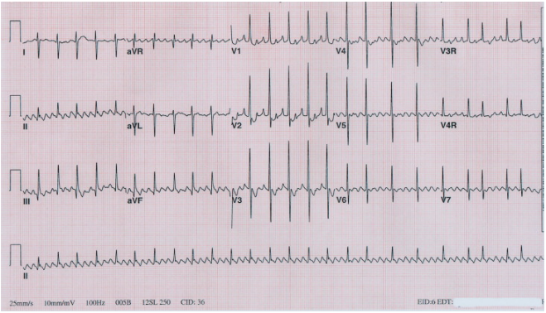

Treatment is in discussion with PIPER and Cardiology. If there is significant haemodynamic compromise, synchronised cardioversion may be necessary.

**Cardioversion**

If time and patient stability permits, the patient should be intubated and ventilated and sedated prior to commencement.

Delivery of DC shock must be synchronised with the QRS complex to minimise the risk of converting to another rhythm, including ventricular fibrillation or asystole.

Initial shock of 1 J/kg is recommended, followed by 2 J/kg if necessary.

It is important to be familiar with the defibrillator model and its safe operation in the institution where you work.

**Ongoing management**

Patients in level 4 or 5 units with access to echocardiography and who cardioverted rapidly with vagal manoeuvres or adenosine may be able to remain there and ongoing management occur in consultation with Cardiology.

All other patients will likely require PIPER retrieval to a centre with Paediatric Cardiology.

Subsequent investigations will include a Holter monitor and echocardiogram as there are four important structural associations of atrioventricular re-entry SVT; all may be silent to clinical examination. These are:

* Ebstein’s anomaly
* congenitally corrected transposition
* dilated and hypertrophic cardiomyopathy
* myocardial tumours.

**Follow-up plan**

The follow-up plan, including the prescription of maintenance medication, should be made in close consultation with a cardiologist.

* The first-line maintenance medication would likely be a beta-blocker. These should be initiated in hospital for neonates and monitoring for [hypoglycaemia](https://www.safercare.vic.gov.au/resources/clinical-guidance/maternity-and-newborn-clinical-network/hypoglycaemia-in-neonates) should be performed.
* The parents need to be taught how to take the pulse. It may be appropriate for this to be checked prior to putting the baby to sleep and the pulse can be checked if the baby is ‘off colour’.
* Accessory pathway function disappears in 40 per cent of patients by the age of one year. If pathway conduction persists symptoms may settle in the first year only to return at 7 or 8 years of age.

**References**

1. Abbasi E, Vijayshankar SS, Goldman RD. Management of acute supraventricular tachycardia in children. Can Fam Physician. 2023 Dec;69(12) e626-31
2. [APLS Algorithms](https://www.apls.org.au/algorithms)
3. Australian New Zealand Council on Resuscitation (ANZCOR). Guideline 12.3 – Management of other (non-arrest) arrhythmias in infants and children. Circulation. 2000;102:1291-342.
4. [Australian Neonatal Medicines Formulary, 2023](https://www.anmfonline.org/)
5. Wojtowicz-Marzec M *et al*. Successful treatment of neonatal atrial flutter by synchronized cardioversion: case report and literature review. BMC Pediatr. 202;20(1):370.

**Citation**

To cite this document use: Safer Care Victoria. Tachyarrhythmia in neonates [Internet]. Victoria: Neonatal eHandbook; 2024 [cited *xxxx*] Available from: <https://www.safercare.vic.gov.au/clinical-guidance/neonatal>